CLEO DIAGNOSTICS · CSP-01-001
Monthly trial summary
July 2026
Data to 31 July 2026 · Citrus export 03 Aug 2026 · Central lab inventory report 03AUG2026
● Sponsor version · Draft for review. Check every figure before sending to the sponsor.

66  Enrolled in Jul 2026  884 enrolled to date | 3.14  Enrolled per active site  in Jul 2026 · 0.71 per site per week | 40  Surgeries in Jul 2026  797 surgeries complete to date
86%  Pathology reports uploaded  687 of 797 surgeries complete | 87%  Samples inside window  108 of 124 registered in Jul 2026 | 181  Unresolved queries  median 97 days open

Highlights
- 66 participants enrolled in July 2026, up from 60 in June 2026. Total enrollment is now 884.
- 21 sites are active and enrolled an average of 3.1 participants each in July 2026.
- 678 participants have completed the study, 77% of those enrolled.
- Pathology reports are 86% complete: 687 of 797 participants with surgery have a report uploaded.
- 87% of blood samples registered in July 2026 reached the central lab within the required window.

Needs attention
- Sample shipping: 16 of 124 samples registered in July 2026 arrived outside the required window, and 4 sample pairs were shipped together instead of separately. Sites should ship each sample promptly after collection.
- Missing samples: 40 participants are missing one or both blood samples past the registration deadline.
- Pathology reports: 71 participants are more than 60 days past surgery without a report uploaded.

Inside this report
1 | Enrollment | 66 participants enrolled in July 2026, up from 60 in June 2026
2 | Post-surgical findings | Pathology reports are 86% complete; 71 of 110 still awaited are more than 60 days past surgery
3 | Blood samples | 87% of samples registered in July 2026 met the registration window, compared with 88% in June 2026
4 | Data queries | 181 queries were unresolved at month end; Women's Center of Nevada had the most (21)

1 | Enrollment  Enrollment activity in July 2026 and cumulative to month end.

66  Enrolled in Jul 2026  72 consented in Jul 2026 | 884  Enrolled to date  974 consented to date | 678  Completed the study  77% of enrolled | 21  Active sites  3.14 enrolled per site in Jul 2026

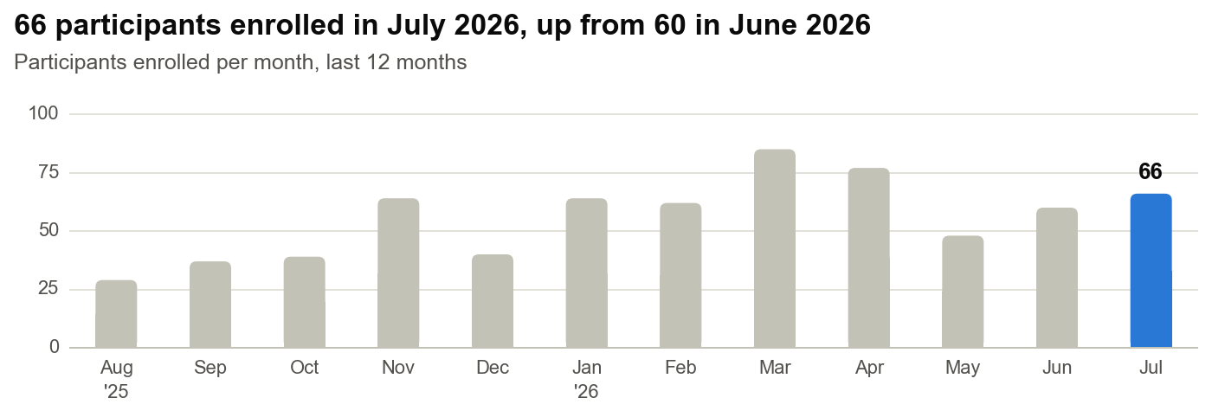
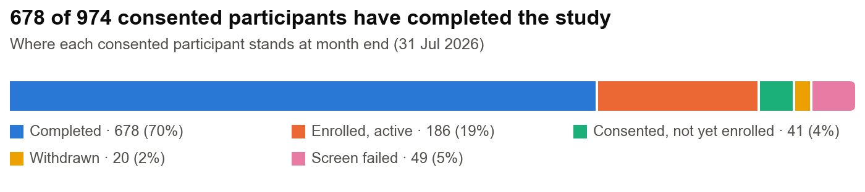
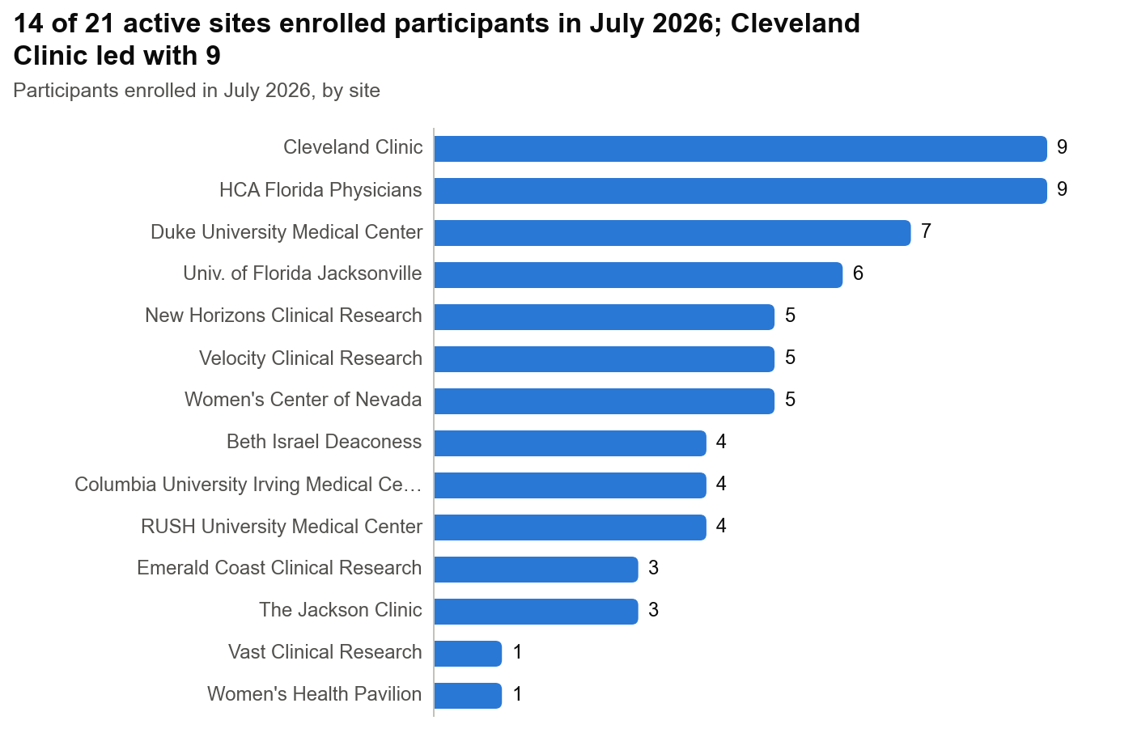
DETAIL TABLES
Recruitment summary
Measure | July 2026 | To date (to 31 Jul 2026)
Consented | 72 | 974
Enrolled | 66 | 884
Screen failures | 2 | 49
Withdrawals | 2 | 20
Completed study | 44 | 678
Counts use the date of each event. Citrus holds no pre-screening date, so pre-screening is not shown.
Consent to enrollment
Measure | n | Denominator | %
Consented in Jul 2026 and enrolled by month end | 63 | 72 consented in Jul 2026 | 88%
Enrolled to date | 884 | 974 consented to date | 91%
Screen failures to date | 49 | 974 consented to date | 5%
Participant status at month end (31 Jul 2026)
Status | Participants | % of consented
Consented, not yet enrolled | 41 | 4%
Enrolled, active | 186 | 19%
Completed | 678 | 70%
Withdrawn | 20 | 2%
Screen failed | 49 | 5%
Total consented | 974 | 100%
Denominator: 974 participants consented to date.
Enrollments by site and week, July 2026
Site | 29 Jun–5 Jul* | 6 Jul–12 Jul | 13 Jul–19 Jul | 20 Jul–26 Jul | 27 Jul–2 Aug* | Jul 2026 total | Per week | Enrolled to date | Per month since activation
AP Medical Research | 0 | 0 | 0 | 0 | 0 | 0 | 0.00 | 2 | 0.12
Beth Israel Deaconess | 0 | 1 | 1 | 1 | 1 | 4 | 0.90 | 59 | 6.05
Cleveland Clinic | 1 | 2 | 2 | 1 | 3 | 9 | 2.03 | 63 | 6.52
Columbia University Irving Medical Center | 0 | 2 | 0 | 1 | 1 | 4 | 0.90 | 68 | 7.04
Duke University Medical Center | 2 | 2 | 1 | 0 | 2 | 7 | 1.58 | 60 | 5.78
ES Clinical Research Group (terminated) | 0 | 0 | 0 | 0 | 0 | 0 | 0.00 | 1 | –
Eastern Carolina Women's | 0 | 0 | 0 | 0 | 0 | 0 | 0.00 | 1 | 0.06
Emerald Coast Clinical Research | 0 | 0 | 2 | 0 | 1 | 3 | 0.68 | 68 | 3.51
HCA Florida Physicians | 1 | 1 | 1 | 4 | 2 | 9 | 2.03 | 54 | 10.21
Maximos Obgyn | 0 | 0 | 0 | 0 | 0 | 0 | 0.00 | 29 | 1.92
New Horizons Clinical Research | 1 | 0 | 1 | 1 | 2 | 5 | 1.13 | 100 | 4.30
Next Innovative Clinical Research | 0 | 0 | 0 | 0 | 0 | 0 | 0.00 | 17 | 0.76
Prime Clinical Research | 0 | 0 | 0 | 0 | 0 | 0 | 0.00 | 17 | 0.78
RUSH University Medical Center | 0 | 2 | 2 | 0 | 0 | 4 | 0.90 | 44 | 4.67
Springfield Clinic | 0 | 0 | 0 | 0 | 0 | 0 | 0.00 | 40 | 2.74
The Jackson Clinic | 1 | 1 | 1 | 0 | 0 | 3 | 0.68 | 43 | 2.29
Univ. of Florida Jacksonville | 0 | 2 | 0 | 1 | 3 | 6 | 1.35 | 39 | 2.87
Vast Clinical Research | 1 | 0 | 0 | 0 | 0 | 1 | 0.23 | 14 | 0.61
Velocity Clinical Research | 1 | 1 | 1 | 0 | 2 | 5 | 1.13 | 40 | 2.71
Virginia Women's Health Associates | 0 | 0 | 0 | 0 | 0 | 0 | 0.00 | 17 | 0.94
Women's Center of Nevada | 0 | 2 | 0 | 1 | 2 | 5 | 1.13 | 90 | 3.94
Women's Health Pavilion | 1 | 0 | 0 | 0 | 0 | 1 | 0.23 | 18 | 1.18
All sites | 9 | 16 | 12 | 10 | 19 | 66 | 14.90 | 884 | –
Average per active site (21 sites) | 0.43 | 0.76 | 0.57 | 0.48 | 0.90 | 3.14 | 0.71 | 42.10 | –
Weeks run Monday to Sunday. * Part week: only days inside the month count. Per week = month total ÷ 4.43 weeks. Per month since activation = enrolled to date ÷ months since the site activation date. Activation dates and site types come from the site lookup table.
Enrollment by site type
Group | Active sites | Enrolled Jul 2026 | Per site per month | Per site per week | Enrolled to date | % of all enrolled to date
General Gyn | 10 | 13 | 1.30 | 0.29 | 325 | 37%
Gyn/Onc | 10 | 53 | 5.30 | 1.20 | 557 | 63%
General Onc | 1 | 0 | 0.00 | 0.00 | 2 | <1%
Academic | 6 | 34 | 5.67 | 1.28 | 333 | 38%
Non-academic | 15 | 32 | 2.13 | 0.48 | 551 | 62%
Denominator for %: 884 participants enrolled to date. Month rates use active sites only. Enrolled to date includes terminated sites. Site types come from the CLEO-001 site list.

2 | Post-surgical findings  Surgeries, pathology report uploads and turnaround for enrolled participants.

40  Surgeries in Jul 2026  797 to date | 48  Reports uploaded in Jul 2026  687 to date | 86%  Reports uploaded  of 797 surgeries complete | 45 days  Median enrollment to upload  range 18–92 days

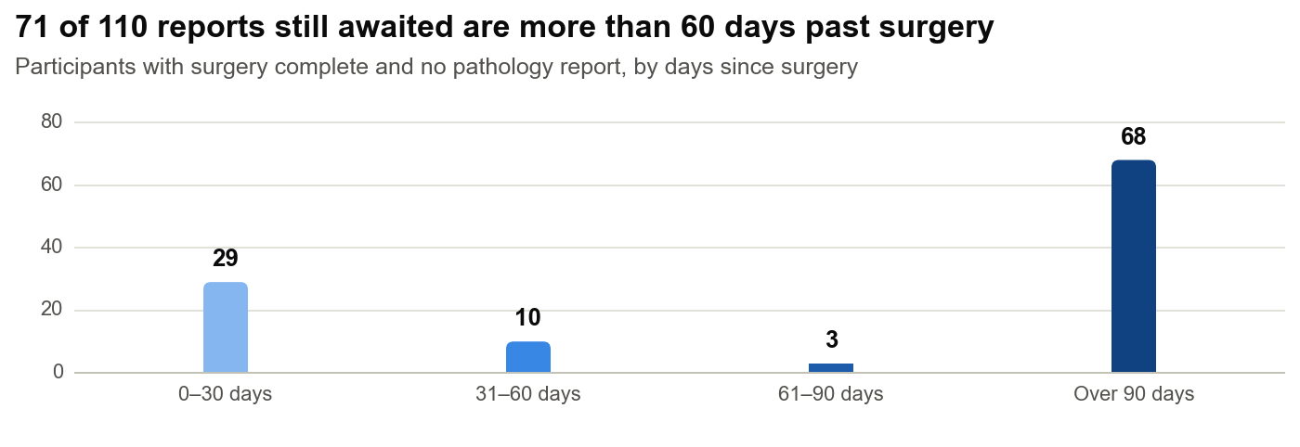
DETAIL TABLES
Surgery and pathology reports
Measure | July 2026 | To date | Denominator (to date) | % (to date)
Participants enrolled | 66 | 884 |  | –
Surgery complete | 40 | 797 | 884 enrolled | 90%
Pathology report uploaded | 48 | 687 | 797 with surgery complete | 86%
Awaiting pathology report | – | 110 | 797 with surgery complete | 14%
Surgery complete = a surgery date is entered. Report uploaded = Post-Surgical Findings form complete with a report file.
Days from enrollment to pathology report upload
Reports uploaded | Reports | Mean days | Median days | Shortest | Longest
In July 2026 | 48 | 48.0 | 44.9 | 21.9 | 91.8
To date | 687 | 46.3 | 45.1 | 17.9 | 91.8
Upload date = 'Completed At' on the Post-Surgical Findings form.
Surgery and pathology reports by site
Site | Enrolled | Surgery complete | % of enrolled | Report uploaded | % of surgeries | Awaiting report | Median days to upload | Mean days to upload
AP Medical Research | 2 | 2 | 100% | 2 | 100% | 0 | 51.1 | 51.1
Beth Israel Deaconess | 59 | 56 | 95% | 48 | 86% | 8 | 46.0 | 47.0
Cleveland Clinic | 63 | 50 | 79% | 41 | 82% | 9 | 45.0 | 45.5
Columbia University Irving Medical Center | 68 | 65 | 96% | 57 | 88% | 8 | 45.1 | 45.3
Duke University Medical Center | 60 | 50 | 83% | 35 | 70% | 15 | 45.9 | 48.1
ES Clinical Research Group | 1 | 0 | 0% | 0 | – | 0 | – | –
Eastern Carolina Women's | 1 | 1 | 100% | 0 | 0% | 1 | – | –
Emerald Coast Clinical Research | 68 | 65 | 96% | 64 | 98% | 1 | 48.0 | 48.2
HCA Florida Physicians | 54 | 44 | 81% | 40 | 91% | 4 | 39.5 | 42.6
Maximos Obgyn | 29 | 29 | 100% | 27 | 93% | 2 | 54.9 | 50.4
New Horizons Clinical Research | 100 | 92 | 92% | 78 | 85% | 14 | 45.6 | 48.0
Next Innovative Clinical Research | 17 | 17 | 100% | 12 | 71% | 5 | 38.0 | 43.2
Prime Clinical Research | 17 | 17 | 100% | 15 | 88% | 2 | 47.9 | 51.4
RUSH University Medical Center | 44 | 41 | 93% | 36 | 88% | 5 | 47.0 | 45.4
Springfield Clinic | 40 | 37 | 92% | 34 | 92% | 3 | 42.4 | 44.6
The Jackson Clinic | 43 | 39 | 91% | 31 | 79% | 8 | 44.2 | 44.2
Univ. of Florida Jacksonville | 39 | 29 | 74% | 27 | 93% | 2 | 46.3 | 48.8
Vast Clinical Research | 14 | 13 | 93% | 13 | 100% | 0 | 46.0 | 45.6
Velocity Clinical Research | 40 | 34 | 85% | 28 | 82% | 6 | 47.1 | 45.1
Virginia Women's Health Associates | 17 | 17 | 100% | 15 | 88% | 2 | 43.0 | 45.2
Women's Center of Nevada | 90 | 82 | 91% | 68 | 83% | 14 | 41.8 | 44.6
Women's Health Pavilion | 18 | 17 | 94% | 16 | 94% | 1 | 45.0 | 45.3
All sites | 884 | 797 | 90% | 687 | 86% | 110 | 45.1 | 46.3

3 | Blood samples  Central lab registration from the LabConnect inventory report dated 03AUG2026.

124  Samples registered in Jul 2026  1,655 to date | 87%  Inside registration window  108 of 124 in Jul 2026 | 40  Participants missing samples  past the registration deadline | 4  Pairs shipped together  registered on the same day in Jul 2026

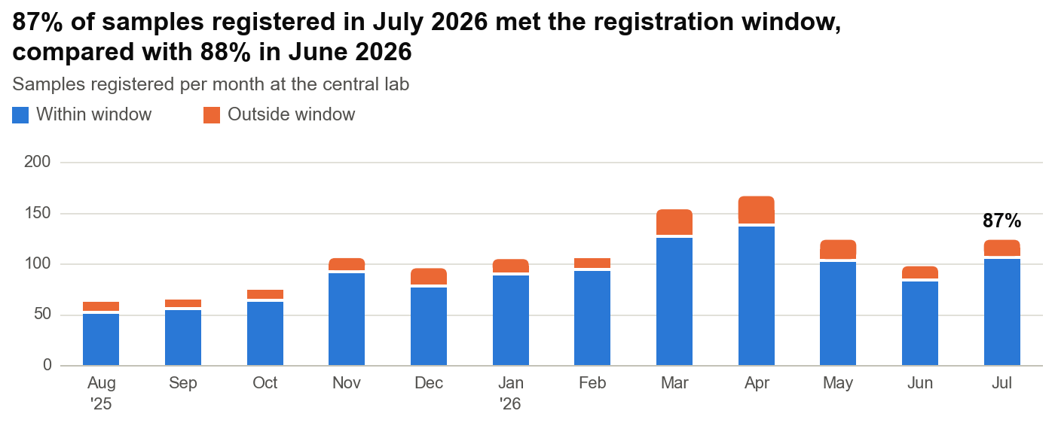
DETAIL TABLES
Sample registration at the central lab
Measure | Jul 2026 n | Jul 2026 denominator | Jul 2026 % | To date n | To date denominator | To date %
Samples registered (DX1 + DX2) | 124 | – | – | 1,655 | – | –
DX1 registered within 14 days of collection | 55 | 61 | 90% | 759 | 851 | 89%
DX2 registered within 28 days of collection | 53 | 63 | 84% | 666 | 804 | 83%
All samples within their window | 108 | 124 | 87% | 1,425 | 1,655 | 86%
Samples outside their window | 16 | 124 | 13% | 230 | 1,655 | 14%
DX1 and DX2 registered on the same day (pairs) | 4 | – | – | 42 | – | –
July 2026 counts samples registered in the month. Each DX1 must be registered within 14 days of collection and each DX2 within 28 days. DX1 and DX2 must ship separately, so a same-day registration is a deviation.
Sample pair status at month end
Status | Participants | % of enrolled
Both samples registered | 798 | 90%
DX2 missing: pending | 23 | 3%
DX2 missing: overdue | 30 | 3%
DX1 missing: pending | 0 | 0%
DX1 missing: overdue | 6 | 1%
No sample registered: pending | 19 | 2%
No sample registered: overdue | 4 | <1%
No sample: withdrawn, sample not obtained | 4 | <1%
Total enrolled | 884 | 100%
Denominator: 884 participants enrolled to date. Overdue = the registration window for the missing sample has passed. Pending = still inside the window.
Sample registration by site, to date
Site | Samples registered | DX1 registered | DX1 within 14 days | % DX1 in window | DX2 registered | DX2 within 28 days | % DX2 in window | Same-day pairs | Missing pair: overdue
AP Medical Research | 4 | 2 | 2 | 100% | 2 | 2 | 100% | 0 | 0
Beth Israel Deaconess | 113 | 58 | 49 | 84% | 55 | 41 | 75% | 1 | 1
Cleveland Clinic | 111 | 57 | 50 | 88% | 54 | 47 | 87% | 2 | 2
Columbia University Irving Medical Center | 129 | 66 | 57 | 86% | 63 | 50 | 79% | 2 | 2
Duke University Medical Center | 112 | 58 | 50 | 86% | 54 | 44 | 81% | 4 | 1
ES Clinical Research Group | 2 | 1 | 1 | 100% | 1 | 1 | 100% | 0 | 0
Eastern Carolina Women's | 2 | 1 | 1 | 100% | 1 | 0 | 0% | 0 | 0
Emerald Coast Clinical Research | 129 | 66 | 57 | 86% | 63 | 51 | 81% | 2 | 3
HCA Florida Physicians | 97 | 50 | 44 | 88% | 47 | 39 | 83% | 4 | 0
Maximos Obgyn | 58 | 29 | 25 | 86% | 29 | 25 | 86% | 1 | 0
New Horizons Clinical Research | 184 | 95 | 85 | 89% | 89 | 74 | 83% | 9 | 7
Next Innovative Clinical Research | 33 | 17 | 17 | 100% | 16 | 13 | 81% | 0 | 1
Prime Clinical Research | 33 | 17 | 16 | 94% | 16 | 14 | 88% | 1 | 1
RUSH University Medical Center | 83 | 43 | 40 | 93% | 40 | 30 | 75% | 2 | 2
Springfield Clinic | 77 | 40 | 37 | 92% | 37 | 32 | 86% | 3 | 3
The Jackson Clinic | 83 | 42 | 38 | 90% | 41 | 35 | 85% | 2 | 2
Univ. of Florida Jacksonville | 67 | 33 | 30 | 91% | 34 | 31 | 91% | 4 | 2
Vast Clinical Research | 27 | 14 | 13 | 93% | 13 | 12 | 92% | 0 | 1
Velocity Clinical Research | 73 | 38 | 28 | 74% | 35 | 25 | 71% | 3 | 2
Virginia Women's Health Associates | 34 | 17 | 16 | 94% | 17 | 13 | 76% | 1 | 0
Women's Center of Nevada | 169 | 89 | 85 | 96% | 80 | 70 | 88% | 1 | 5
Women's Health Pavilion | 35 | 18 | 18 | 100% | 17 | 17 | 100% | 0 | 1
All sites | 1,655 | 851 | 759 | 89% | 804 | 666 | 83% | 42 | 36

4 | Data queries  Query status at month end, built from each query's creation and last-update dates.

181  Unresolved queries  129 open, 52 reviewing | 133  Raised in Jul 2026  105 closed in Jul 2026 | 97 days  Median days open  open and reviewing queries | 93  Open more than 90 days  open or in review

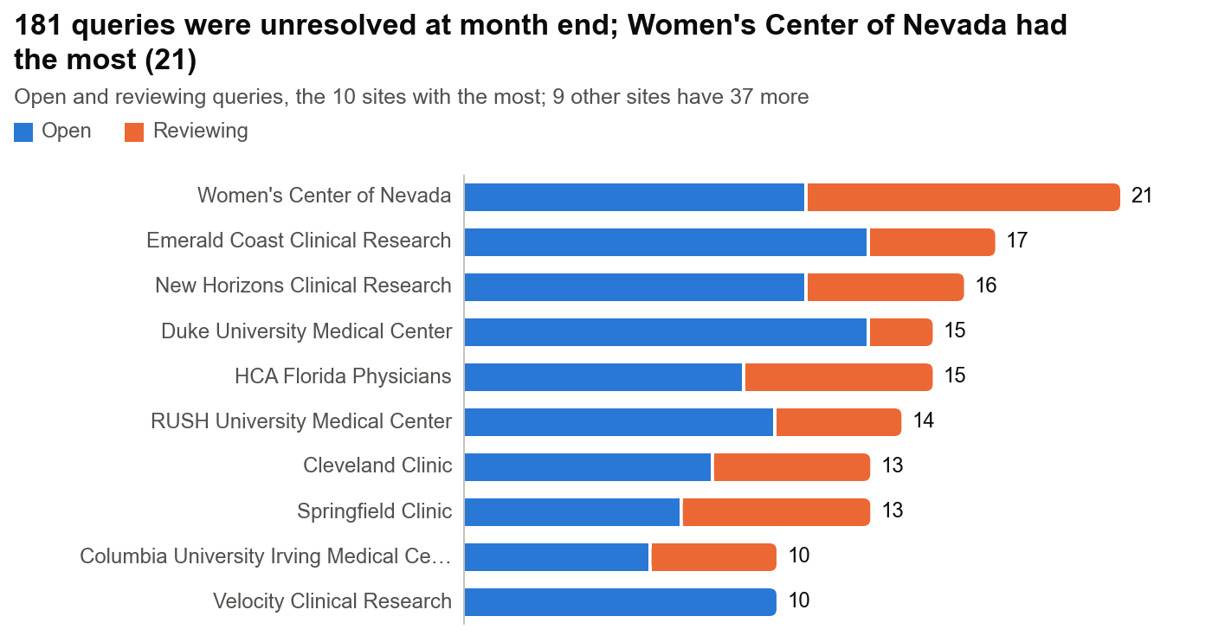
DETAIL TABLES
Query status at month end
Measure | Queries | % of all queries raised
Open | 129 | 13%
Reviewing | 52 | 5%
Closed | 823 | 82%
Total raised to date | 1,004 | 100%
Raised in July 2026 | 133 | –
Closed in July 2026 | 105 | –
Open or reviewing for more than 90 days | 93 | –
Denominator: 1004 queries raised to month end. Reviewing = the site responded and a reviewer is checking it.
Days open for unresolved queries
Status at month end | Queries | Mean days open | Median days open | Shortest | Longest
Open | 129 | 153.7 | 89.7 | 0.0 | 673.1
Reviewing | 52 | 168.1 | 128.1 | 0.2 | 607.2
Open and reviewing | 181 | 157.8 | 97.2 | 0.0 | 673.1
Days open = days from creation to the end of 31 Jul 2026.
Queries by site
Site | Total | Open | % open | Reviewing | % reviewing | Closed | % closed | Mean days open | Median days open
AP Medical Research | 1 | 0 | 0% | 0 | 0% | 1 | 100% | – | –
Beth Israel Deaconess | 68 | 6 | 9% | 1 | 1% | 61 | 90% | 137.4 | 182.5
Cleveland Clinic | 71 | 8 | 11% | 5 | 7% | 58 | 82% | 88.9 | 71.3
Columbia University Irving Medical Center | 68 | 6 | 9% | 4 | 6% | 58 | 85% | 141.2 | 150.9
Duke University Medical Center | 63 | 13 | 21% | 2 | 3% | 48 | 76% | 54.3 | 12.5
ES Clinical Research Group | 2 | 0 | 0% | 0 | 0% | 2 | 100% | – | –
Eastern Carolina Women's | 1 | 0 | 0% | 0 | 0% | 1 | 100% | – | –
Emerald Coast Clinical Research | 70 | 13 | 19% | 4 | 6% | 53 | 76% | 273.8 | 309.6
HCA Florida Physicians | 63 | 9 | 14% | 6 | 10% | 48 | 76% | 36.0 | 10.2
Maximos Obgyn | 41 | 3 | 7% | 1 | 2% | 37 | 90% | 90.2 | 38.7
New Horizons Clinical Research | 117 | 11 | 9% | 5 | 4% | 101 | 86% | 294.1 | 325.7
Next Innovative Clinical Research | 18 | 2 | 11% | 1 | 6% | 15 | 83% | 302.2 | 237.7
Prime Clinical Research | 19 | 2 | 11% | 0 | 0% | 17 | 89% | 342.7 | 342.7
RUSH University Medical Center | 55 | 10 | 18% | 4 | 7% | 41 | 75% | 88.7 | 94.6
Springfield Clinic | 54 | 7 | 13% | 6 | 11% | 41 | 76% | 137.9 | 78.7
The Jackson Clinic | 53 | 8 | 15% | 1 | 2% | 44 | 83% | 200.9 | 102.1
Univ. of Florida Jacksonville | 37 | 2 | 5% | 0 | 0% | 35 | 95% | 37.1 | 37.1
Vast Clinical Research | 23 | 5 | 22% | 0 | 0% | 18 | 78% | 537.7 | 627.8
Velocity Clinical Research | 44 | 10 | 23% | 0 | 0% | 34 | 77% | 143.7 | 81.7
Virginia Women's Health Associates | 24 | 1 | 4% | 1 | 4% | 22 | 92% | 309.5 | 309.5
Women's Center of Nevada | 97 | 11 | 11% | 10 | 10% | 76 | 78% | 108.9 | 41.5
Women's Health Pavilion | 15 | 2 | 13% | 1 | 7% | 12 | 80% | 140.2 | 143.1
All | 1,004 | 129 | 13% | 52 | 5% | 823 | 82% | 157.8 | 97.2
Percentages use the group's total queries. Days open covers open and reviewing queries.
Queries by type
Query type | Total | Open | % open | Reviewing | % reviewing | Closed | % closed | Mean days open | Median days open
Missing Data | 773 | 102 | 13% | 35 | 5% | 636 | 82% | 137.9 | 83.7
Standard | 231 | 27 | 12% | 17 | 7% | 187 | 81% | 219.8 | 179.1
All | 1,004 | 129 | 13% | 52 | 5% | 823 | 82% | 157.8 | 97.2
Percentages use the group's total queries. Days open covers open and reviewing queries.

Definitions and sources
Reporting month | July 2026. Month counts use events dated 1 to 31 July 2026 (UTC).
To date | All events up to the end of 31 July 2026.
Sources | Citrus exports from 03 Aug 2026 13:57 UTC. LabConnect inventory report dated 03AUG2026. Site lookup table for site type and activation date.
Weeks | Monday to Sunday. Part weeks at the start or end of the month count only days inside the month.
Enrollment rate | Per site per week = enrollments in the month ÷ 4.43 weeks. Per site per month = enrollments in the month. The 'per active site' rates divide by the number of sites activated by month end. Per month since activation = enrolled to date ÷ months since activation.
Surgery complete | A surgery date is entered on the Post-Surgical Findings form.
Pathology report uploaded | The Post-Surgical Findings form is complete with a report file. The upload date is the form's 'Completed At' time.
Sample registration window | DX1 within 14 days of collection. DX2 within 28 days of collection. DX1 and DX2 must be registered on different days because they ship separately.
Missing pair | One sample of the pair is registered and the other is not. Overdue when the missing sample's window has passed.
Blood sample month view | Counts samples registered at the central lab in the month.
Query status at month end | Closed if closed by month end. Reviewing if the last update before month end moved it to review. Open otherwise.
Days open | Days from query creation to the end of the month, for open and reviewing queries only.

