[https://iexcloud.io/cloud-login#/register](https://iexcloud.io/cloud-login" \l "/register" \t "_blank)

<https://iexcloud.io/console/home>

[o.zhao.0001@gmail.com](mailto:o.zhao.0001@gmail.com)

Y---8\*

API Tokens:

Publishable: pk\_df12fe8ef233400ba9c44f53dd5a237d

<https://algotrading101.com/learn/iex-api-guide/>

**Storing your API key as an environment variable on Windows**

Click on Start and then type in **environment variable**, from there click on the second option – **Edit environment variables** for your account.

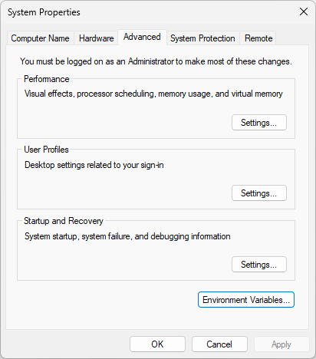

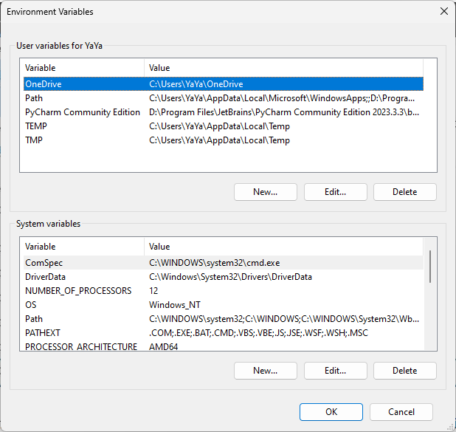

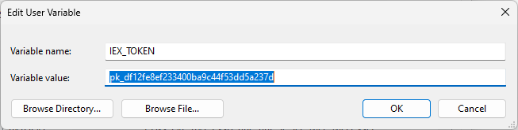

<https://iexcloud.io/blog/how-to-get-market-data-in-python>

pip install pyEX

Fix Import Error

1. check for \_\_init\_\_.py file in src folder
2. add the src folder as a source root

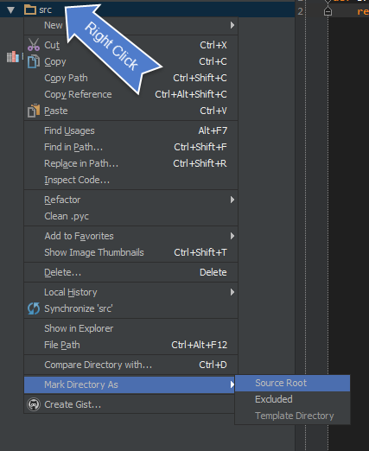

1. Then make sure to add sources to your PYTHONPATH

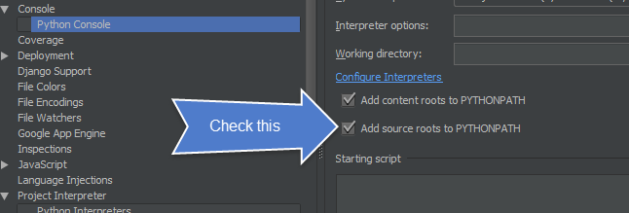

1. in PyCharm menu select: File --> Invalidate Caches --> Restart