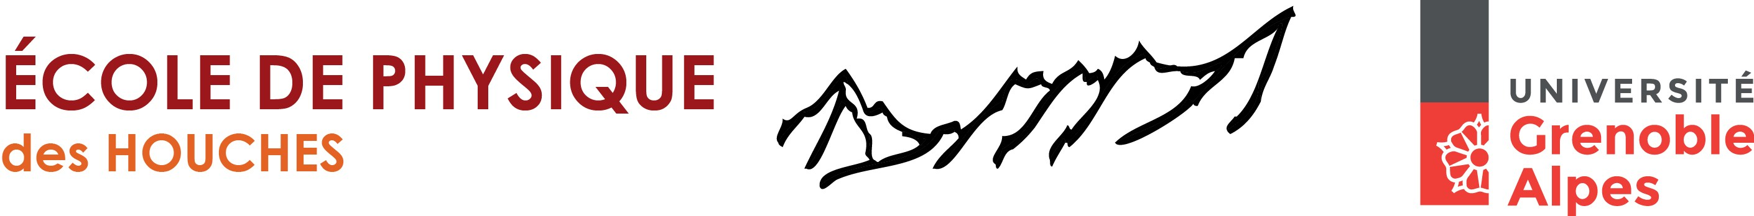

Spin-mechanics & nano-MRI research conference http://xxx
The Frontiers of Magnetic Resonance - Feb 11th to 16th, 2018
 | Sun. Feb 11th | Mon. Feb 12th | Tues. Feb 13th | Wedn. Feb 14th | Thurs. Feb 15th | Fri. Feb 16th
Breakfast
Morning 1  8:00am-9:45am | 8:00am-9:45am | 2 tutorial talks  8:00am-9:45am | 2 tutorial talks  8:00am-9:45am | 3 talks  8:00am-9:45am | 3 talks  8:00am-9:45am | 3 talks  8:00am-9:45am
Coffee Break | 9:45am-10:15am | Coffee Break | Coffee Break | Coffee Break | Coffee Break | Coffee Break
Morning 2  10:15am-12:00pm | 10:15am-12:00pm | 3 invited talks  10:15am-12:00pm | 3 invited talks  10:15am-12:00pm | 3 invited talks  10:15am-12:00pm | 3 talks  10:15am-12:00pm | 3 talks  10:15am-12:00pm
Lunch  12:00pm-1:30pm | 12:00pm-1:30pm | 12:00pm-1:30pm | 12:00pm-1:30pm | 12:00pm-1:30pm | 12:00pm-1:30 pm | 12:00pm-1:30 pm
Afternoon 1  12:00am-5:00pm | Shuttle from Geneva | Informal free time | Informal free time | Informal free time | Informal free time | Shuttle back to Geneva
Afternoon 1  12:00am-5:00pm | Registtation | Informal free time | Informal free time | 6 short talks  2:30am-4:30pm | Informal free time | 4 Tutorials 60'+10'  28 Invited talks: 30'+5'  15 Short talks: 15'+5'
Afternoon 2  5:15 pm-7:00 pm | Registtation | Informal free time | Informal free time | Coffee Break | Informal free time
Afternoon 2  5:15 pm-7:00 pm | Registtation | 3 invited talks  5:00 pm-6:45 pm | 3 invited talks  5:00 pm-6:45 pm | 6 short talks  5:00 pm-7:00 pm | Informal free time
Dinner | 7:00pm-8:30 pm | 7:00pm-8:30 pm | 7:00pm-8:30 pm | 7:00pm-8:30 pm | Banquet
Evening 1 | Welcome reception | Posters 1  8:30 pm-10:00pm | Posters 2  8:30 pm-10:00pm | 3 short talks  8:30pm-9:30pm | Banquet
 |  |  |  |  | Free time

