# **Summary**

# Titre 1

## Titre 2

### Titre 3

#### Titre 4

###### Titre 5

# PhATS Philippines

and 4.1 million people were displaced â€“ including 1.7 million children[1](http://ndrrmc.gov.ph/attachments/article/1329/FINAL_REPORT_re_Effects_of_Typhoon_YOLANDA_%28HAIYAN%29_06-09NOV2013.pdf). More than a million homes were damaged or destroyed, winds and surging seas wrecked over 20,000 classrooms and health centres were shut down across all affected areas while people were simultaneously cut off from assistance as land, air and sea access was close to impossible. Access to safe water and sanitation significantly decreased with damages to sanitation facilities and water supply systems, triggering concern on the potential outbreak of water-borne diseases.

The government estimated a total loss at US$ 12.9 billion in a country with 40 per cent of children living in poverty[1](http://ndrrmc.gov.ph/attachments/article/1329/FINAL_REPORT_re_Effects_of_Typhoon_YOLANDA_%28HAIYAN%29_06-09NOV2013.pdf)^. The country as a whole was is still recovering from other previous emergencies, including escalation of conflict in Zamboanga in September 2013 which displaced 120,000 people; and a 7.2 magnitude earthquake that struck Bohol province in October 2013 affecting more than 3.2 million people.

Given the scale of the devastation, the Government of the Philippines mounted an immediate response to deliver life-saving relief, accepting also the offer of assistance by the United Nations. UNICEF s Corporate Emergency Procedures for Level 3 Emergencies were triggered by the Executive Director, initiating an organisation-wide response mobilising resources regionally and globally. The cluster system, co-led by the Government and UN agencies, was also immediately made operational.

Based on a Multi-Cluster/Sector Initial Rapid Assessment (MIRA) an Inter-Agency Strategic Response Plan (SRP) was developed. The UN response was rolled out under the SRP, running from November 2013 to November 2014 with a total appeal of US$ 791 million, including a US$ 119 million UNICEF component. The inter-agency response complemented the Government-led efforts under the "Reconstruction Assistance for Yolanda" (RAY) plan for 2014-2015 and beyond, with requirements estimated at more than US$ 8 billion.

UNICEF's focus was on the most urgent needs for life saving measure in all affected areas, targeting now but not being limited to 40 selected municipalities where 1.34 million p.

A study on water use in Philippines from 2014, found that the choice to purchase bottled water for drinking over the regular source of water was mainly driven by the perceived lack of quality â€“ or lack of evidence of adequate quality â€“ of the household main water source[2](http://onlinelibrary.wiley.com/doi/10.1111/ijcs.12069/abstract). In the PhATS area, water quality control checks are scheduled on a quarterly basis by the province Department of Health [REF] Participants in FGDs in communities where bottled water was not relied on at all, reported that the quality of their drinking water sources was analysed on a regular basis and they trusted that the water from these sources was safe for drinking.

The increase in water bottle consumption could thus be mainly explained by a lack of trust by households in their improved water source, rather than the availability of improved water sources.

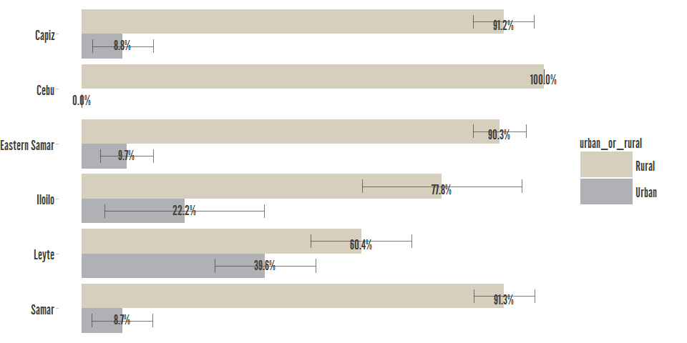

|  |  |  |  |  |  |
| --- | --- | --- | --- | --- | --- |
| province_assessed | variable | value | X2.5.. | X97.5.. | mid_y |
| Capiz | Rural | 91.2 | 84.66 | 97.81 | 45.6 |
| Capiz | Urban | 8.8 | 2.192 | 15.34 | 95.6 |
| Cebu | Rural | 100 | 100 | 100 | 50 |
| Cebu | Urban | 0 | 0 | 0 | 100 |
| Eastern Samar | Rural | 90.3 | 84.54 | 96.04 | 45.15 |
| Eastern Samar | Urban | 9.7 | 3.963 | 15.46 | 95.15 |
| Iloilo | Rural | 77.8 | 60.59 | 95.08 | 38.9 |
| Iloilo | Urban | 22.2 | 4.915 | 39.41 | 88.9 |
| Leyte | Rural | 60.4 | 49.47 | 71.29 | 30.2 |
| Leyte | Urban | 39.6 | 28.71 | 50.53 | 80.2 |
| Samar | Rural | 91.3 | 84.73 | 97.96 | 45.65 |
| Samar | Urban | 8.7 | 2.036 | 15.27 | 95.65 |

Table 1: x= province_assessed; y= urban_or_rural

Pearson's X^2: Rao & Scott adjustment, p-value=0; Valid n: 4819

The introduction is an important road map for the reader. The introduction is structured along the same line as the first three paragraphs of the Summary. As it does not include the overview of key findings and conclusions, it allows

### urban_or_rural / province_assessed



|  |  |  |  |  |  |
| --- | --- | --- | --- | --- | --- |
| province_assessed | variable | value | X2.5.. | X97.5.. | mid_y |
| Capiz | Rural | 91.2 | 84.66 | 97.81 | 45.6 |
| Capiz | Urban | 8.8 | 2.192 | 15.34 | 95.6 |
| Cebu | Rural | 100 | 100 | 100 | 50 |
| Cebu | Urban | 0 | 0 | 0 | 100 |
| Eastern Samar | Rural | 90.3 | 84.54 | 96.04 | 45.15 |
| Eastern Samar | Urban | 9.7 | 3.963 | 15.46 | 95.15 |
| Iloilo | Rural | 77.8 | 60.59 | 95.08 | 38.9 |
| Iloilo | Urban | 22.2 | 4.915 | 39.41 | 88.9 |
| Leyte | Rural | 60.4 | 49.47 | 71.29 | 30.2 |
| Leyte | Urban | 39.6 | 28.71 | 50.53 | 80.2 |
| Samar | Rural | 91.3 | 84.73 | 97.96 | 45.65 |
| Samar | Urban | 8.7 | 2.036 | 15.27 | 95.65 |

###### Table 1: x= province_assessed; y= urban_or_rural

Pearson's X^2: Rao & Scott adjustment, p-value=0; Valid n: 4819

### house_type / province_assessed

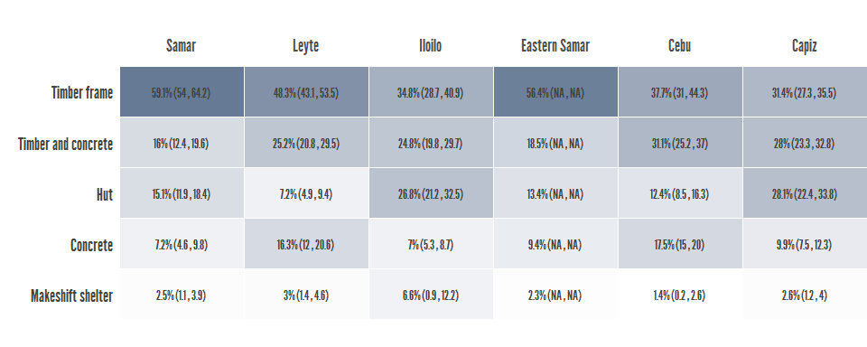

|  |  |  |  |  |  |
| --- | --- | --- | --- | --- | --- |
| province_assessed | variable | value | X2.5.. | X97.5.. | mid_y |
| Capiz | Concrete | 9.9 | 7.48 | 12.27 | 4.95 |
| Capiz | Hut | 28.1 | 22.36 | 33.82 | 23.95 |
| Capiz | Makeshift shelter | 2.6 | 1.157 | 3.988 | 39.3 |
| Capiz | Timber and concrete | 28 | 23.3 | 32.77 | 54.6 |
| Capiz | Timber frame | 31.4 | 27.33 | 35.52 | 84.3 |
| Cebu | Concrete | 17.5 | 14.96 | 19.97 | 8.75 |
| Cebu | Hut | 12.4 | 8.473 | 16.29 | 23.7 |
| Cebu | Makeshift shelter | 1.4 | 0.1824 | 2.599 | 30.6 |
| Cebu | Timber and concrete | 31.1 | 25.21 | 36.99 | 46.85 |
| Cebu | Timber frame | 37.7 | 31.01 | 44.31 | 81.25 |
| Eastern Samar | Concrete | 9.4 | NA | NA | 4.7 |
| Eastern Samar | Hut | 13.4 | NA | NA | 16.1 |
| Eastern Samar | Makeshift shelter | 2.3 | NA | NA | 23.95 |
| Eastern Samar | Timber and concrete | 18.5 | NA | NA | 34.35 |
| Eastern Samar | Timber frame | 56.4 | NA | NA | 71.8 |
| Iloilo | Concrete | 7 | 5.276 | 8.739 | 3.5 |
| Iloilo | Hut | 26.8 | 21.23 | 32.45 | 20.4 |
| Iloilo | Makeshift shelter | 6.6 | 0.8837 | 12.23 | 37.1 |
| Iloilo | Timber and concrete | 24.8 | 19.81 | 29.7 | 52.8 |
| Iloilo | Timber frame | 34.8 | 28.74 | 40.93 | 82.6 |
| Leyte | Concrete | 16.3 | 12.05 | 20.65 | 8.15 |
| Leyte | Hut | 7.2 | 4.896 | 9.429 | 19.9 |
| Leyte | Makeshift shelter | 3 | 1.361 | 4.577 | 25 |
| Leyte | Timber and concrete | 25.2 | 20.83 | 29.53 | 39.1 |
| Leyte | Timber frame | 48.3 | 43.13 | 53.54 | 75.85 |
| Samar | Concrete | 7.2 | 4.615 | 9.8 | 3.6 |
| Samar | Hut | 15.1 | 11.9 | 18.39 | 14.75 |
| Samar | Makeshift shelter | 2.5 | 1.126 | 3.875 | 23.55 |
| Samar | Timber and concrete | 16 | 12.44 | 19.63 | 32.8 |
| Samar | Timber frame | 59.1 | 54 | 64.22 | 70.35 |

###### Table 2: x= province_assessed; y= house_type

Pearson's X^2: Rao & Scott adjustment, p-value=0; Valid n: 4819

### HH.Now.... / province_assessed

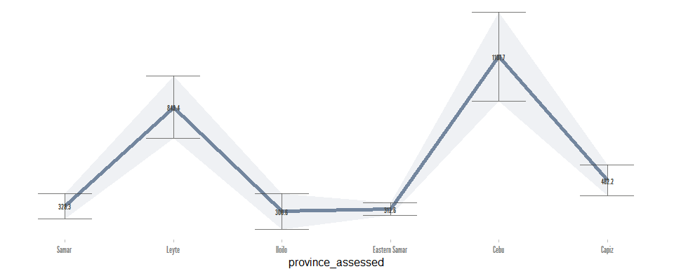

|  |  |  |  |  |
| --- | --- | --- | --- | --- |
|  | province_assessed | value | 2.5 % | 97.5 % |
| Capiz | Capiz | 462.2 | 382.3 | 542 |
| Cebu | Cebu | 1108 | 875.5 | 1340 |
| Eastern Samar | Eastern Samar | 312.6 | 280.3 | 344.9 |
| Iloilo | Iloilo | 300.6 | 207.7 | 393.5 |
| Leyte | Leyte | 843.4 | 681.6 | 1005 |
| Samar | Samar | 328.3 | 262.2 | 394.4 |

###### Table 3: x= HH.Now....; y= province_assessed

Analysis of Variance Model

|  |  |  |  |  |  |
| --- | --- | --- | --- | --- | --- |
|  | Df | Sum Sq | Mean Sq | F value | Pr(>F) |
| province_assessed | 5 | 365116010 | 73023202 | 758.1 | 0 |
| Residuals | 4813 | 463604140 | 96323 | NA | NA |

### HH.Now.... / province_assessed