Experimentation of openBarter

The order book is filled with limit orders where the mean of the ratio qtt_prov/qtt_requ is 1, and where qtt_prov = 10 000.
The number of orders varies between 30 and 900. 1000 orders are submitted to this order book and
we observe variations of foor indicators :
- the mean execution time of an order (delay),
- the number of movements per cycle (nbcycle),
- a measurement of the ratio between the output flow produced by quantities of movements and the input flow of quantities offered by order submitted to the order book (liquidity). Flows are measured by summing quantities of values for all qualities,
- the ration between omega realized and expected (gain)

Informations provided by quotations change the judgement of participants. This subjective behaviour is not considered for the measurement of the liquidity. The order book is obtained by producing first a big book with the desired statistic, then extracting the beginning of the book to obtain the chosen size.

Scenarii

Scenario Money
There is a special quality used by all orders we call money, as on a regular order book where a sell order asks for money and a buy order offers money. The quality that is not money is chosen randomly with a uniform law between 99 other qualities.

Scenario Uni100
Qualities are chosen randomly between 100 qualities using a uniform law.

Scenario Uni1000
Qualities are chosen randomly between 1000 qualities using a uniform law.

Findings

Money scenario produce multilateral cycles
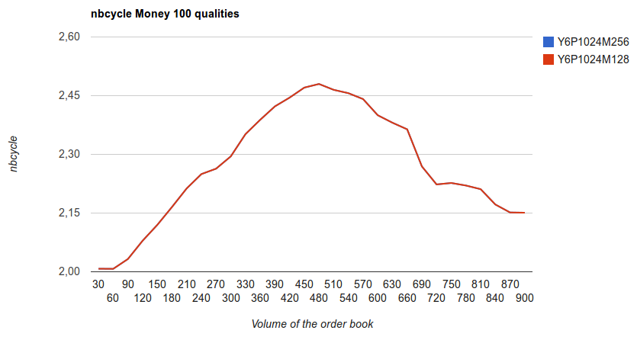
Cycles produced for the money scenario can have more than 2 partners. There are cycles with 4 partners where A provides Q1 to B providing Money to C providing Q2 to D providing Money to A. This cycle should be the best for partners than two separate bilateral cycles or the single exchange possibility.

Sensibility of limits of the model
Constants are defined by the model to limit computation load :
- The maximum number of movement per cycle (Y)
- The maximum number of movement per transaction (M)
- The maximum number of cycle explored (P)

The scenario uni1000 is used to show the sensibility of these limits.
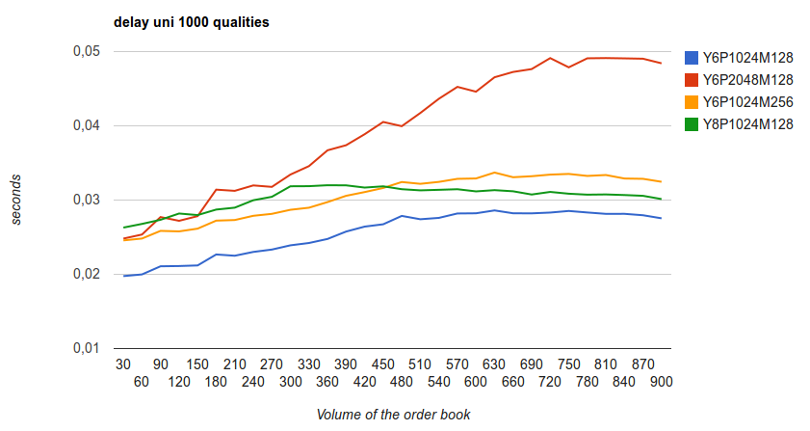
The execution time is sensible to P but not significantly dependant on other factors.
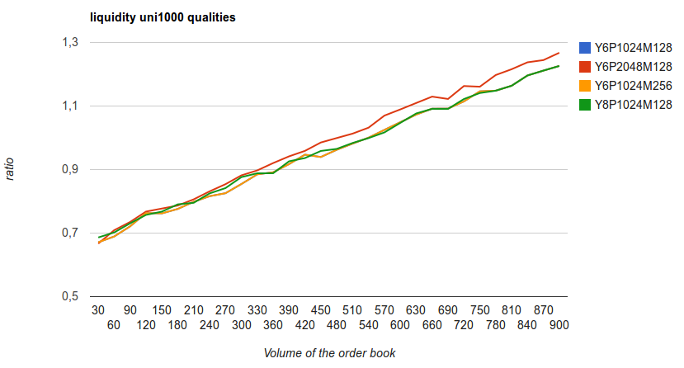
Liquidity is slightly improved by P, but is independant of other constants.

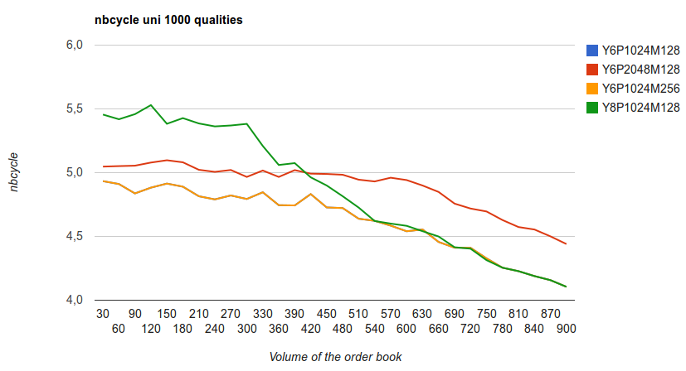
The number of movements per cycle is usually less than 6. Larger Y allow more exchanges with a small order book.

Diversity of qualities
We compare results obtained with scenario uni100 and uni1000 with a higher diversity of qualities.
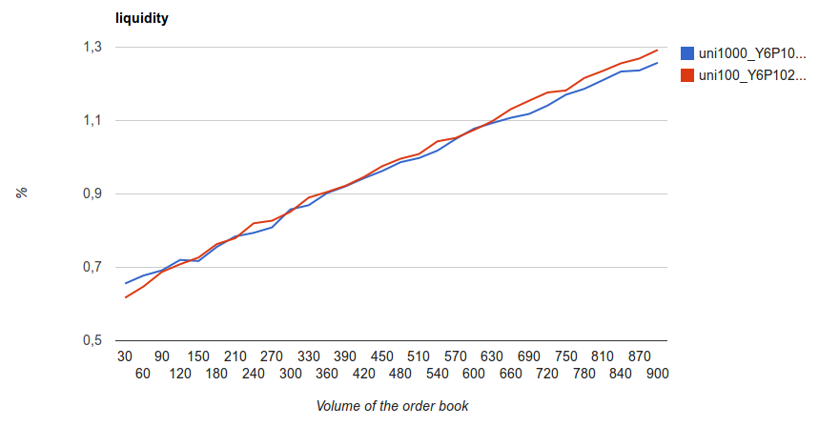
The liquidity exeeds 1 when the volume of the order book reaches 600 orders. This liquidity does not depend significantly on diversity of qualities.
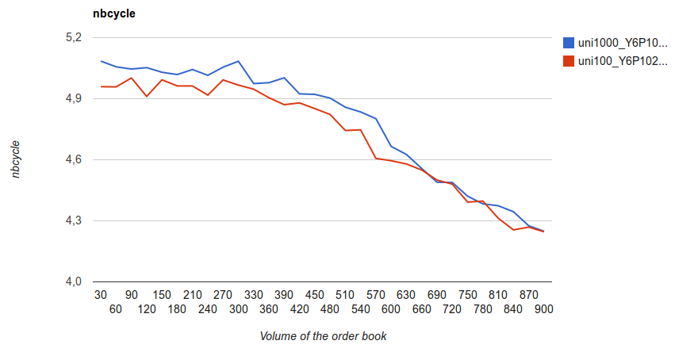
When the order book is small, the size of cycles increases when the diversity grows. But when the size of the book grows, the size of cycles decreases and become independent of the diversity of qualities.
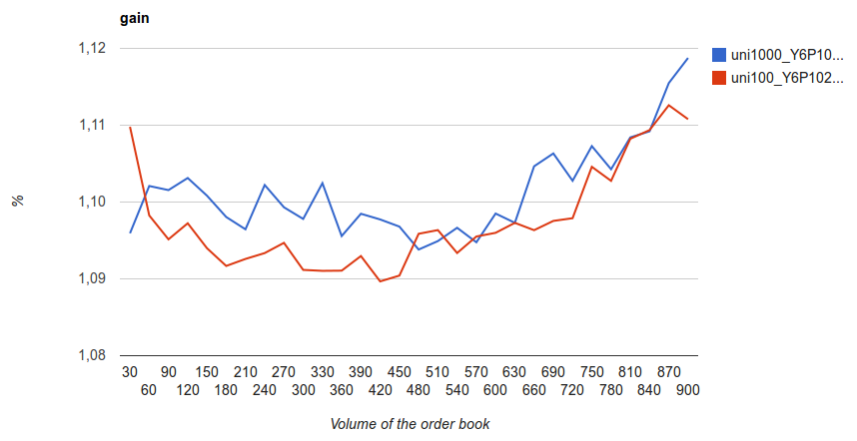
The gain is always better than 1 due to the order type (LIMIT). The gain grows as the size of the book due to competition increase. Small order books are not representative of a statistical population.

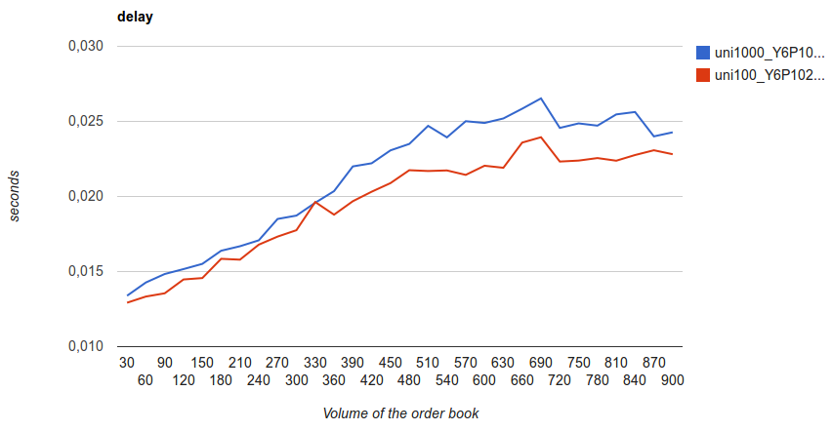
Computation time grows as the order book and is slightly higher for higher diversity.

High volume

With a diversity of 1000 qualities, an order book of 100 000 orders is considered.
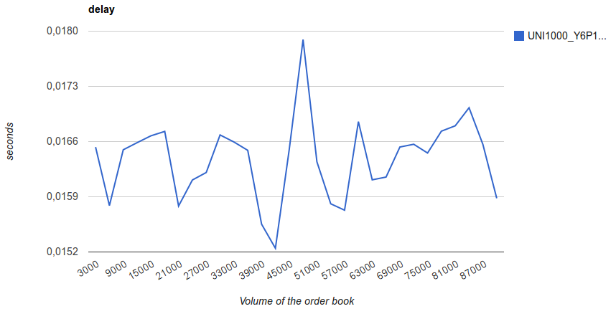
The variation of response time is low (between 15 and 18 ms) and independent of the volume.
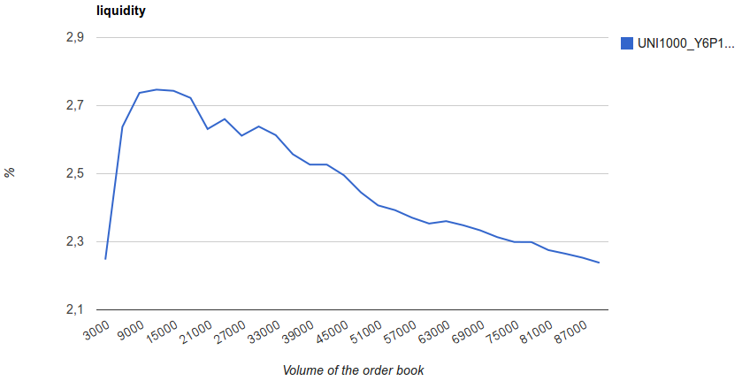
For the same flow of value brought by orders, the output flow is reduces by the gain increase.

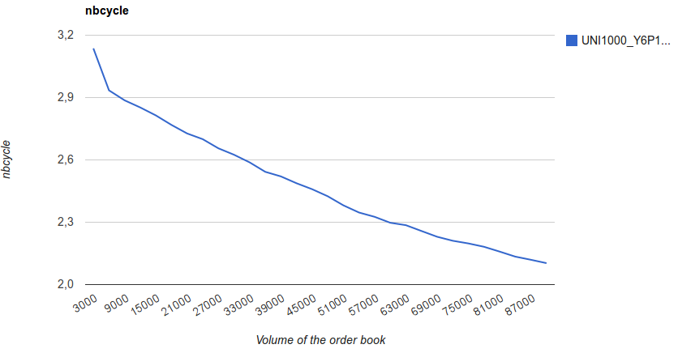

Limits of exploration are reached before cycles with more than two cycles can be explored.
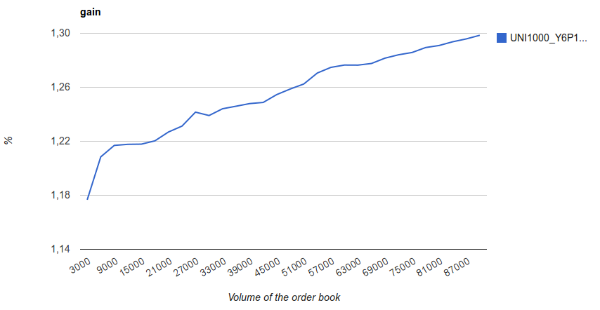
The competition grows as the order book.

Compare money and uni100
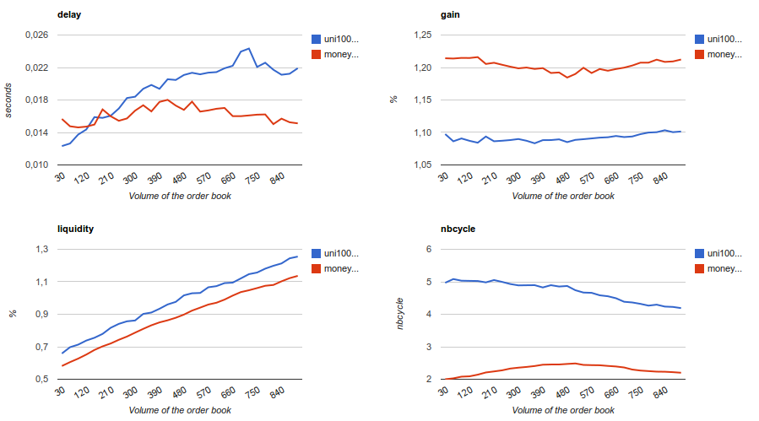
We compare an order book filled with buy and sell orders (scenario money) to one filled with barter orders (uni100), and observe that:
- For a given volume of the order book, the liquidity is 30% better with uni100 than with money,
- The computation is more expensive with uni100,
- The high gain of money is due to higher competition, and high nbcycle of uni100 to higher cooperation.

