Supporting information
The following Electronic Supporting Information is available for this article:

Appendix S1 Summary statistics for the wandering albatross pedigree used
Appendix S2 R script and OpenBUGS code for the Bayesian animal model
Fig. S1 Annual sample sizes of records of natal dispersal for wandering albastrosses on Possession Island.
Fig. S2 Mixing of the MCMC algorithm used to fit the Bayesian animal model to the wandering albatross data

Appendix S1 Summary statistics for the wandering albatross pedigree as produced by the pedigreeStats function in the R-package PEDANTICS (Morrissey & Wilson, 2009)
Statistics
number of records | 2797
number of maternities | 1051
number of paternities | 1073
number of full sibs relationships | 401
number of maternal sibs / halfsibs | 576 / 175
number of paternal sibs / halfsibs | 573 / 172
Maximum pedigree depth (number of ancestral generations) | 3

Appendix S2 OpenBUGS code for the Bayesian animal model (Damgaard, 2007, Waldmann, 2009, following Papaïx et al., 2010)

model
{
#### LIKELIHOOD
for (i in 1:nasc){
v[nd[i]] <- gam[nd[i]] * sq_D[nd[i]]
gam[nd[i]] ~ dnorm(0,1)
} # individuals without recorded parents
for (i in 1:ndesc) { # individuals with recorded parents

Y[ad[i]] ~ dbern(psi[i]) # Phenotypic values
psi[i] <- phi(z[ad[i]]) # use probit link on dispersal
z[ad[i]] <- mu + alpha*sex[ad[i]] + inprod(cob[i,], beta[]) + a[ad[i]]
# sex is the sex effect (1 for female, 0 for male)
# cob is the design matrix for the colony of birth effect
# Genetic effect
a[ad[i]] <- v[ad[i]] * sigma_a
v[ad[i]] <- gam[ad[i]] * sq_D[ad[i]] + (v[SID[ad[i]]] + v[DID[ad[i]]])/2
gam[ad[i]] ~ dnorm(0,1)
}
v[nU]<-0 # Null holder
#### PRIOR
mu ~ dnorm(0,0.001)# prior on intercept
alpha ~ dnorm(0,0.1) # prior for sex effect
for(c in 1:ncob) { beta[c] ~ dnorm(0,0.1) } # priors for colony of birth effect

# Prior on heritability
h2 ~dbeta(1,1) #h2 <- var_a /(var_a + 1)
# Prior on additive genetic variance
var_a <- h2/(1-h2)
sigma_a <- sqrt(var_a)
} # end
Fig. S1 Number of natal dispersal events recorded for cohorts of wandering albatrosses born between 1967 and 2002. In grey, years that were excluded from the analysis because of annual sample size of less than 30 birds.

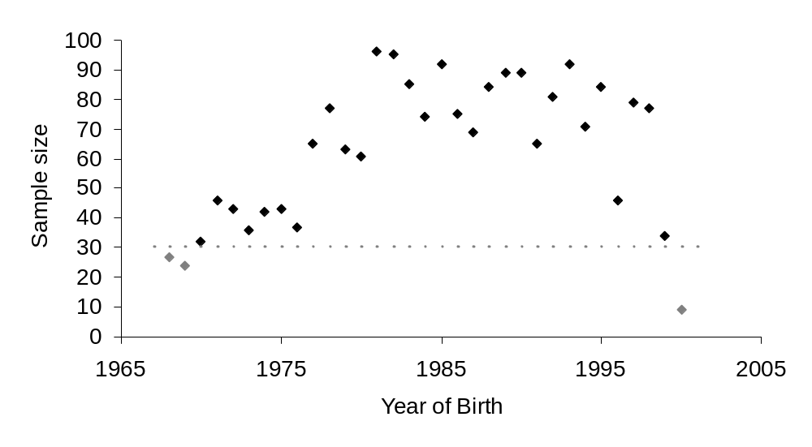
Fig. S2 Mixing of the MCMC algorithm used to fit the Bayesian animal model to the wandering albatross data. Two chains of 45 000 iterations were used, with a thinning of each 10th iteration, and 5000 iterations as a burn–in (one chain in red, the other in light grey) used to summarize the posterior results. Notation: V_{A} is the additive genetic variance and h_{c}² is the heritability estimated on an underlying continuous liability scale.

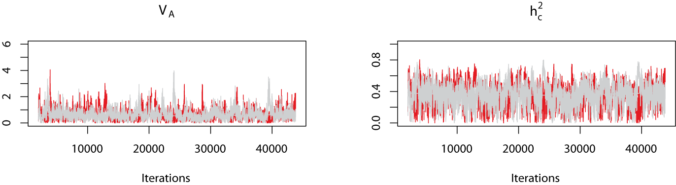

References for Supporting Information

Damgaard, L. H. 2007. Technical note: How to use Winbugs to draw inferences in animal models. Journal of Animal Science 85: 1363-1368.
Morrissey, M. B. & Wilson, A. J. 2009. pedantics: an r package for pedigree-based genetic simulation and pedigree manipulation, characterization and viewing. Molecular Ecology Resources 10: 711-719.
Papaïx, J., Cubaynes, S., Buoro, M., Charmantier, A., Perret, P. & Gimenez, O. 2010. Combining capture-recapture data and pedigree information to assess heritability of demographic parameters in the wild. J Evol Biol 23: 2176-2184.
Waldmann, P. 2009. Easy and Flexible Bayesian Inference of Quantitative Genetic Parameters. Evolution 63: 1640-1643.

