Media and wolves: Content analysis of French local/national newspapers

Olivier Gimenez

10 août 2016

# Introduction

Il s'agit d'une analyse de contenu des corpus loups Le Monde et Nice Matin constitués par Marie Chandelier. On adopte une Approche non-supervisée (on ne définit pas les topics à l’avance, ils sont déterminés statistiquement) récente connue sous le nom de structural topic modeling : voir [Westgate et al. (2015)](http://onlinelibrary.wiley.com/doi/10.1111/cobi.12605/abstract) pour une introduction et [Roberts et al. (2015)](https://cran.r-project.org/web/packages/stm/vignettes/stmVignette.pdf) pour une implémentation dans R.

Quelques définitions : un topic est un mélange de mots où chaque mot a une probabilité d’appartenir au topic. Un document (article) est un mélange de topics. La prévalence est la proportion d’un document associée à un topic, le contenu réfère aux mots utilisés dans un topic.

L’originalité ici est qu’on va essayer d’expliquer la variabilité dans la prévalence et le contenu en fonction de covariables, à savoir l’année (de 1993 à 2014) et le journal (Le Monde vs. Nice Matin).

On commence d'abord par mettre en forme les deux corpus en préparation des analyses statistiques. Chaque article est stocké dans un fichier texte. Tous les articles du Monde sur la période considérée sont dans un répertoire, idem pour Nice Matin.

Une fois le corpus mis au propre, on ajuste un modèle STM. Ici on considère 15 topics et un effet i) de l’interaction de l’année et du journal sur la prévalence, et ii) du journal sur le contenu.

# Création du corpus

On construit d'abord le jeu de données. On charge tous les package utiles.

library(tm)  
library(gdata)  
library(stm)

On lit les fichiers texte du monde qui sont dans le répertoire spécifié et en fait un corpus:

(base_monde <- Corpus(DirSource("/Users/gimenez/Dropbox/OG/BOULOT/ENCADREMENT/Marie CHANDELIER/stm_loup/analyses_finales/MONDE_thematique_principale",encoding="utf-8"),readerControl = list(reader=readPlain, language = "fr", load = TRUE)))

## <<VCorpus>>  
## Metadata: corpus specific: 0, document level (indexed): 0  
## Content: documents: 120

#names(base_monde)  
#lapply(base_monde, as.character)

On récupère les métadonnées puis ajoute les année (1993-2014) et journal (lemonde/nicematin):

dat_monde <- read.xls("metada_principale_monde_fonction_ratio.xlsx",header=T)  
dim(dat_monde)

## [1] 123 2

# supprime les 3 dernieres lignes qui sont bizarres  
dat_monde <- dat_monde[-c(121,122,123),]  
# on vire les modalités bizarres, puis on convertit année en numérique  
dat_monde$annee = factor(dat_monde$annee)  
dat_monde$annee = as.numeric(levels(dat_monde$annee))[dat_monde$annee] # astuce trouvée http://tinyurl.com/hfsqtze  
metadata <- data.frame(year= dat_monde$annee,title=rep('LeMonde',120))  
meta(base_monde,tag=c("year","title")) <- metadata  
#meta(base_monde)  
#base_monde

On lit les fichiers texte de Nice Matin qui sont dans le répertoire spécifié et en fait un corpus. A noter : j'ai supprimé les 2 articles de 1992 pour faire coincider la periode avec Le Monde.

(base_nice <- Corpus(DirSource("/Users/gimenez/Dropbox/OG/BOULOT/ENCADREMENT/Marie CHANDELIER/stm_loup/analyses_finales/NICE_thematique_principale",encoding="UTF-8"), readerControl = list(reader=readPlain, language = "fr", load = TRUE)))

## <<VCorpus>>  
## Metadata: corpus specific: 0, document level (indexed): 0  
## Content: documents: 744

#names(base_nice)  
#lapply(base_nice, as.character)

On récupère les métadonnées puis ajoute année (1993-2014) et journal (lemonde/nicematin):

dat_nice <- read.xls("/Users/gimenez/Dropbox/OG/BOULOT/ENCADREMENT/Marie CHANDELIER/stm_loup/analyses_finales/metadata-principale-nice-matin-fonction-ratio.xlsx",header=T)  
head(dat_nice)

## id annee  
## 1 LOU-NM-1992-05-02-va 1992  
## 2 LOU-NM-1992-11-29-ttes 1992  
## 3 LOU-NM-1993-01-09-ttes 1993  
## 4 LOU-NM-1993-04-02-ttes 1993  
## 5 LOU-NM-1993-04-14-ttes 1993  
## 6 LOU-NM-1993-04-15-am 1993

dim(dat_nice)

## [1] 746 2

# on supprime les deux premières lignes qui correspondent à 2 articles en 1992  
dat_nice = dat_nice[-c(1,2),]  
metadata = data.frame(year= dat_nice$annee,title=rep('NiceMatin',744))  
meta(base_nice,tag=c("year","title")) <- metadata  
#meta(base_nice)  
#base_nice

On joint joint les deux bases:

base = c(base_monde, base_nice)  
#base  
#str(base)  
#meta(base)

On jette un coup d'oeil à la base:

#inspect(base)  
#lapply(base, as.character)  
base2 <- base

On applique tout un tas de traitements aux textes

# remplace funny caracteres par un espace  
replace_chars <- content_transformer (function(x) gsub("<e0>","à", x))  
base2 <- tm_map (base2, replace_chars)  
replace_chars <- content_transformer (function(x) gsub("<ea>","ê", x))  
base2 <- tm_map (base2, replace_chars)  
replace_chars <- content_transformer (function(x) gsub("<e9>","é", x))  
base2 <- tm_map (base2, replace_chars)  
replace_chars <- content_transformer (function(x) gsub("<e8>","è", x))  
base2 <- tm_map (base2, replace_chars)  
replace_chars <- content_transformer (function(x) gsub("<ab>"," ", x))  
base2 <- tm_map (base2, replace_chars)  
replace_chars <- content_transformer (function(x) gsub("<bb>"," ", x))  
base2 <- tm_map (base2, replace_chars)  
replace_chars <- content_transformer (function(x) gsub("\u0092"," ", x))  
base2 <- tm_map (base2, replace_chars)  
replace_chars <- content_transformer (function(x) gsub("\u0085"," ", x))  
base2 <- tm_map (base2, replace_chars)  
replace_chars <- content_transformer (function(x) gsub("\u0093"," ", x))  
base2 <- tm_map (base2, replace_chars)  
replace_chars <- content_transformer (function(x) gsub("\u0094"," ", x))  
base2 <- tm_map (base2, replace_chars)  
replace_chars <- content_transformer (function(x) gsub("\u0096"," ", x))  
base2 <- tm_map (base2, replace_chars)  
replace_chars <- content_transformer (function(x) gsub("\u0095"," ", x))  
base2 <- tm_map (base2, replace_chars)  
replace_chars <- content_transformer (function(x) gsub("\u0091"," ", x))  
base2 <- tm_map (base2, replace_chars)  
replace_chars <- content_transformer (function(x) gsub("\""," ", x))  
base2 <- tm_map (base2, replace_chars)  
replace_chars <- content_transformer (function(x) gsub("\u009c","oe", x))  
base2 <- tm_map (base2, replace_chars)  
replace_chars <- content_transformer (function(x) gsub("patous","patou", x))  
base2 <- tm_map (base2, replace_chars)  
replace_chars <- content_transformer (function(x) gsub("ãª","ê", x))  
base2 <- tm_map (base2, replace_chars)  
replace_chars <- content_transformer (function(x) gsub("ã","é", x))  
base2 <- tm_map (base2, replace_chars)  
  
# capitales deviennent minuscules  
base2=tm_map(base2, content_transformer(tolower))  
#lapply(base2[1:10], as.character)  
  
# aujourd'hui -> aujourdhui  
replace_chars <- content_transformer (function(x) gsub("aujourd'hui","aujourdhui", x))  
base2 <- tm_map (base2, replace_chars)  
  
# remplace les apostrophes par des espaces  
replace_chars <- content_transformer (function(x) gsub("'"," ", x))  
base2 <- tm_map (base2, replace_chars)  
#lapply(base2[1:4], as.character)  
  
#Remplace la ponctuation par des espaces (garde les tirets)  
base2=tm_map(base2, content_transformer(removePunctuation), preserve_intra_word_dashes=T)  
#lapply(base2[1:5], as.character)  
  
#retire les articles, prépositions et autres mots analogues  
base2=tm_map(base2, content_transformer(removeWords), stopwords("french"))   
#lapply(base2[1:5], as.character)  
  
#retire les nombres  
base2=tm_map(base2,content_transformer(removeNumbers))   
  
# tronque à la racine  
base2=tm_map(base2,stemDocument,language="fr")  
  
#retire les espaces inutiles  
base2=tm_map(base2,content_transformer(stripWhitespace))   
#lapply(base2[100:500], as.character)  
#lapply(base2[800:864], as.character)

On crée un doc qu'on peut analyser par la suite, une matrice en gros:

dtm=DocumentTermMatrix(base2)  
str(dtm)

## List of 6  
## $ i : int [1:147639] 1 1 1 1 1 1 1 1 1 1 ...  
## $ j : int [1:147639] 71 220 264 335 413 438 561 571 652 965 ...  
## $ v : num [1:147639] 1 1 2 1 1 1 1 1 1 1 ...  
## $ nrow : int 864  
## $ ncol : int 12837  
## $ dimnames:List of 2  
## ..$ Docs : chr [1:864] "1993-04-16.txt" "1994-01-10.txt" "1994-08-01.txt" "1994-08-24.txt" ...  
## ..$ Terms: chr [1:12837] "---" "-abr" "-àdir" "-at" ...  
## - attr(*, "class")= chr [1:2] "DocumentTermMatrix" "simple_triplet_matrix"  
## - attr(*, "weighting")= chr [1:2] "term frequency" "tf"

On récupère le nombre de mots par texte

On calcule la proportion du mot loup

On obtient liste des mots présents au moins à 50 reprises

findFreqTerms(dtm,50)

## [1] "-dessus" "abattag" "abattr"   
## [4] "abattu" "abord" "abruzz"   
## [7] "accept" "accompagn" "accord"   
## [10] "accueil" "action" "activ"   
## [13] "actuel" "adapt" "administr"   
## [16] "adult" "affair" "affirm"   
## [19] "affût" "afin" "agent"   
## [22] "agiss" "agit" "agneau"   
## [25] "agress" "agricol" "agriculteur"   
## [28] "agricultur" "aid" "ailleur"   
## [31] "aim" "ains" "air"   
## [34] "ajout" "alain" "aller"   
## [37] "alor" "alpag" "alpe"   
## [40] "alpes--haute-provent" "alpes-maritim" "alpha"   
## [43] "alpin" "altitud" "aménag"   
## [46] "analys" "ancien" "anim"   
## [49] "animal" "animali" "anné"   
## [52] "annonc" "août" "appel"   
## [55] "apport" "approch" "apres"   
## [58] "après-mid" "arc" "arrêt"   
## [61] "arriv" "assembl" "assez"   
## [64] "assist" "associ" "assur"   
## [67] "attaqu" "atteint" "attend"   
## [70] "attent" "aucun" "augment"   
## [73] "aujourdhui" "aupres" "auss"   
## [76] "aut" "authion" "automn"   
## [79] "autor" "autoris" "autour"   
## [82] "autr" "avanc" "avant"   
## [85] "aven" "avis" "avoir"   
## [88] "avril" "bas" "battu"   
## [91] "baudin" "beaucoup" "bel"   
## [94] "belvéder" "berg" "berger"   
## [97] "bern" "bernard" "besoin"   
## [100] "bêt" "bien" "biodivers"   
## [103] "blanc" "bless" "bois"   
## [106] "bon" "boréon" "bout"   
## [109] "breb" "bruno" "caban"   
## [112] "cadavr" "cadr" "camp"   
## [115] "campagn" "can" "canid"   
## [118] "canjuer" "canton" "captur"   
## [121] "car" "carc" "cas"   
## [124] "caus" "cel" "celui"   
## [127] "cent" "centain" "centr"   
## [130] "central" "cepend" "certain"   
## [133] "ceux" "chacun" "chambr"   
## [136] "chamois" "chang" "chaqu"   
## [139] "charg" "chass" "chasseur"   
## [142] "chef" "cheptel" "cherch"   
## [145] "chevr" "chevreuil" "chez"   
## [148] "chien" "chiffr" "chois"   
## [151] "chos" "christian" "chut"   
## [154] "cinq" "cinqu" "clair"   
## [157] "class" "clôtur" "cœur"   
## [160] "cohabit" "col" "coler"   
## [163] "comit" "comm" "commenc"   
## [166] "comment" "commiss" "commun"   
## [169] "compagn" "comport" "compr"   
## [172] "compt" "concern" "conclus"   
## [175] "condit" "conduit" "confirm"   
## [178] "connaît" "connaîtr" "connu"   
## [181] "consacr" "conseil" "conséquent"   
## [184] "conserv" "consider" "constat"   
## [187] "constitu" "cont" "contact"   
## [190] "continu" "contr" "contrair"   
## [193] "convent" "côt" "coup"   
## [196] "coupl" "cour" "coût"   
## [199] "craint" "cré" "création"   
## [202] "crois" "dang" "daniel"   
## [205] "dat" "débat" "début"   
## [208] "décembr" "décid" "décis"   
## [211] "déclar" "découvert" "découvr"   
## [214] "défendr" "défens" "défenseur"   
## [217] "dégât" "déjà" "demand"   
## [220] "demeur" "dénonc" "départ"   
## [223] "départemental" "déplac" "dépos"   
## [226] "depuis" "déput" "derni"   
## [229] "déroul" "des" "désorm"   
## [232] "destin" "destruct" "détermin"   
## [235] "deux" "dev" "développ"   
## [238] "dévor" "devr" "dialogu"   
## [241] "différent" "difficil" "difficult"   
## [244] "dimanch" "diminu" "dir"   
## [247] "direct" "directeur" "directric"   
## [250] "disparaîtr" "disparit" "disparu"   
## [253] "disposit" "dit" "dix"   
## [256] "dizain" "doit" "doivent"   
## [259] "domest" "domin" "dommag"   
## [262] "don" "donc" "dont"   
## [265] "dossi" "dout" "douz"   
## [268] "droit" "dur" "durabl"   
## [271] "écolog" "économ" "édit"   
## [274] "effect" "effectu" "effet"   
## [277] "efficac" "égal" "égorg"   
## [280] "élev" "élevag" "éleveur"   
## [283] "élimin" "elle" "élus"   
## [286] "emploi" "empoison" "encadr"   
## [289] "enclos" "encor" "endroit"   
## [292] "enfant" "enfin" "engag"   
## [295] "enquêt" "ensembl" "ensuit"   
## [298] "entre" "entré" "environ"   
## [301] "envisag" "équilibr" "équip"   
## [304] "érad" "errant" "espac"   
## [307] "espagn" "espec" "estim"   
## [310] "estiv" "estros" "établ"   
## [313] "etat" "état" "être"   
## [316] "étud" "europ" "européen"   
## [319] "euros" "évident" "évolu"   
## [322] "évoqu" "exempl" "exist"   
## [325] "expliqu" "exploit" "exprim"   
## [328] "fac" "facil" "façon"   
## [331] "fair" "fais" "fait"   
## [334] "famill" "faudr" "faun"   
## [337] "faut" "favor" "fdse"   
## [340] "féder" "femel" "ferm"   
## [343] "fêt" "févri" "fil"   
## [346] "film" "fin" "final"   
## [349] "financ" "fix" "foir"   
## [352] "fois" "fonction" "fond"   
## [355] "font" "forc" "forêt"   
## [358] "form" "fort" "franc"   
## [361] "français" "franco" "fréquent"   
## [364] "fusil" "gagn" "gard"   
## [367] "gaston" "gen" "gendarm"   
## [370] "gendarmer" "général" "génet"   
## [373] "ger" "gestion" "gibi"   
## [376] "gouvern" "grâc" "grand"   
## [379] "gros" "group" "habit"   
## [382] "haut" "hautes-alp" "hauteur"   
## [385] "hectar" "hélicopter" "heur"   
## [388] "histoir" "hiv" "homm"   
## [391] "hor" "huit" "humain"   
## [394] "idé" "identifi" "imag"   
## [397] "immédiat" "import" "impossibl"   
## [400] "indemnis" "indiqu" "individus"   
## [403] "inform" "initi" "inquiet"   
## [406] "install" "instant" "intérêt"   
## [409] "interven" "invit" "iser"   
## [412] "isol" "issu" "ital"   
## [415] "italien" "jam" "janvi"   
## [418] "jean" "jean-claud" "jean-pierr"   
## [421] "jeud" "jeun" "jou"   
## [424] "jour" "journ" "jug"   
## [427] "juillet" "juin" "jusqu"   
## [430] "just" "kilometr" "laiss"   
## [433] "lanc" "larg" "lesquel"   
## [436] "libert" "lieu" "lieuten"   
## [439] "lieux" "lign" "limit"   
## [442] "lir" "livr" "local"   
## [445] "loi" "loin" "long"   
## [448] "longtemp" "lor" "lorsqu"   
## [451] "lou" "loup" "louv"   
## [454] "louveteau" "louveter" "lund"   
## [457] "lupus" "lynx" "mai"   
## [460] "mainten" "mair" "maison"   
## [463] "mal" "mâl" "malgr"   
## [466] "mang" "mani" "manifest"   
## [469] "manqu" "mar" "march"   
## [472] "mard" "massif" "mathieu"   
## [475] "matin" "meilleur" "membr"   
## [478] "men" "menac" "mercantour"   
## [481] "mercred" "mesur" "met"   
## [484] "méti" "metr" "mettr"   
## [487] "meut" "michel" "mieux"   
## [490] "milieu" "mill" "milli"   
## [493] "million" "minister" "ministr"   
## [496] "mis" "mission" "mme"   
## [499] "mobilis" "moin" "mois"   
## [502] "moment" "mond" "mont"   
## [505] "montagn" "montr" "mort"   
## [508] "mouflon" "mouton" "mouv"   
## [511] "moyen" "municipal" "national"   
## [514] "natur" "natural" "naturel"   
## [517] "nécessair" "neig" "nic"   
## [520] "niveau" "nom" "nombr"   
## [523] "nombreux" "non" "nord"   
## [526] "not" "nourr" "nouveau"   
## [529] "nouvel" "novembr" "nuit"   
## [532] "object" "objet" "observ"   
## [535] "occas" "octobr" "œuvr"   
## [538] "offic" "officiel" "oncf"   
## [541] "ongul" "oper" "oppos"   
## [544] "ordre" "organis" "origin"   
## [547] "oubli" "our" "outr"   
## [550] "ouvert" "ouvertur" "ouvr"   
## [553] "ovin" "parc" "parfois"   
## [556] "parl" "parlementair" "parm"   
## [559] "part" "particip" "particuli"   
## [562] "pass" "passag" "passion"   
## [565] "pastoral" "patou" "patt"   
## [568] "pâturag" "pay" "pend"   
## [571] "pens" "per" "perdu"   
## [574] "périod" "perm" "permanent"   
## [577] "permet" "permettr" "person"   
## [580] "pert" "pet" "petit"   
## [583] "peu" "peur" "peut"   
## [586] "peut-êtr" "peuvent" "philipp"   
## [589] "photo" "pieg" "pierr"   
## [592] "plac" "plaint" "plan"   
## [595] "plateau" "plein" "plupart"   
## [598] "plus" "plusieur" "plutôt"   
## [601] "point" "polem" "polit"   
## [604] "popul" "port" "pos"   
## [607] "posit" "possibil" "possibl"   
## [610] "pourquoi" "pourr" "pourront"   
## [613] "poursuit" "pourt" "pouv"   
## [616] "pouvoir" "pratiqu" "précédent"   
## [619] "précis" "prédat" "prédateur"   
## [622] "préfectoral" "préfectur" "préfet"   
## [625] "prélev" "premi" "prend"   
## [628] "prendr" "pres" "présenc"   
## [631] "présent" "préserv" "président"   
## [634] "presqu" "pression" "prêt"   
## [637] "preuv" "prévent" "prévu"   
## [640] "principal" "printemp" "pris"   
## [643] "prix" "probabl" "problem"   
## [646] "procédur" "prochain" "produit"   
## [649] "profess" "professionnel" "programm"   
## [652] "progress" "proi" "projet"   
## [655] "propos" "proposit" "propriétair"   
## [658] "protect" "proteg" "protocol"   
## [661] "provoqu" "proxim" "public"   
## [664] "publiqu" "puis" "puisqu"   
## [667] "pyren" "qualit" "quand"   
## [670] "quant" "quatr" "quelqu"   
## [673] "question" "quoi" "quot"   
## [676] "racont" "raison" "randonneur"   
## [679] "rapid" "rappel" "rapport"   
## [682] "rar" "rassembl" "réalis"   
## [685] "réalit" "recens" "récent"   
## [688] "recherch" "réclam" "réel"   
## [691] "refus" "regard" "région"   
## [694] "régional" "regl" "régul"   
## [697] "réguli" "réintroduct" "réintroduit"   
## [700] "relat" "relev" "remont"   
## [703] "ren" "rencontr" "rendr"   
## [706] "rendu" "reper" "répons"   
## [709] "représent" "réserv" "respect"   
## [712] "respons" "rest" "résultat"   
## [715] "retour" "retrouv" "réun"   
## [718] "réunion" "revenu" "rien"   
## [721] "risqu" "roi" "rôl"   
## [724] "rout" "rural" "saint-martin-vésub"   
## [727] "sais" "saison" "sait"   
## [730] "sall" "samed" "sangli"   
## [733] "sauvag" "savoi" "savoir"   
## [736] "scientif" "second" "secteur"   
## [739] "selon" "semain" "sembl"   
## [742] "sen" "sent" "sept"   
## [745] "septembr" "sérieux" "servic"   
## [748] "seul" "siecl" "sign"   
## [751] "simpl" "sit" "situ"   
## [754] "situat" "six" "societ"   
## [757] "soir" "solut" "sort"   
## [760] "souhait" "soulign" "sous"   
## [763] "sous-préfet" "soutien" "souvent"   
## [766] "spécial" "spectacl" "stress"   
## [769] "sub" "sud" "suit"   
## [772] "suiv" "suivr" "sujet"   
## [775] "sûr" "surtout" "surv"   
## [778] "surveil" "susceptibl" "suscit"   
## [781] "syndicat" "tant" "tard"   
## [784] "techniqu" "tel" "temp"   
## [787] "ten" "tend" "tent"   
## [790] "tenu" "term" "terr"   
## [793] "terrain" "territoir" "têt"   
## [796] "tin" "tir" "tomb"   
## [799] "total" "touch" "toujour"   
## [802] "tourism" "tourist" "tourn"   
## [805] "tous" "tout" "toutefois"   
## [808] "trac" "traditionnel" "train"   
## [811] "transhum" "traqu" "travail"   
## [814] "travaill" "traval" "traver"   
## [817] "trent" "trentain" "tres"   
## [820] "tribunal" "trois" "trop"   
## [823] "troupeau" "trouv" "utilis"   
## [826] "vacher" "vall" "var"   
## [829] "veil" "ven" "venc"   
## [832] "vendred" "venu" "venus"   
## [835] "ver" "vérit" "vers"   
## [838] "vert" "vésub" "vétérinair"   
## [841] "veut" "viand" "victim"   
## [844] "viennent" "vient" "vill"   
## [847] "villag" "vingt" "vingtain"   
## [850] "vis" "visit" "visiteur"   
## [853] "vit" "viv" "vivr"   
## [856] "voi" "voir" "voisin"   
## [859] "vont" "vosg" "vrai"   
## [862] "zon"

# On supprime mots rares  
dtm2 <- removeSparseTerms(dtm, 0.95)  
findFreqTerms(dtm2,50)

## [1] "-dessus" "abattag" "abattr"   
## [4] "abattu" "abord" "abruzz"   
## [7] "accept" "accompagn" "accord"   
## [10] "accueil" "action" "activ"   
## [13] "actuel" "adapt" "administr"   
## [16] "adult" "affair" "affirm"   
## [19] "afin" "agent" "agiss"   
## [22] "agit" "agneau" "agress"   
## [25] "agricol" "agriculteur" "agricultur"   
## [28] "aid" "ailleur" "ains"   
## [31] "ajout" "aller" "alor"   
## [34] "alpag" "alpe" "alpes--haute-provent"  
## [37] "alpes-maritim" "alpha" "alpin"   
## [40] "altitud" "aménag" "analys"   
## [43] "ancien" "anim" "animal"   
## [46] "animali" "anné" "annonc"   
## [49] "août" "appel" "apport"   
## [52] "approch" "apres" "après-mid"   
## [55] "arrêt" "arriv" "assembl"   
## [58] "assez" "assist" "associ"   
## [61] "assur" "attaqu" "atteint"   
## [64] "attend" "attent" "aucun"   
## [67] "augment" "aujourdhui" "aupres"   
## [70] "auss" "aut" "automn"   
## [73] "autor" "autoris" "autour"   
## [76] "autr" "avanc" "avant"   
## [79] "aven" "avoir" "avril"   
## [82] "bas" "battu" "beaucoup"   
## [85] "bel" "berg" "berger"   
## [88] "bern" "bernard" "bêt"   
## [91] "bien" "blanc" "bless"   
## [94] "bois" "bon" "boréon"   
## [97] "bout" "breb" "bruno"   
## [100] "caban" "cadavr" "cadr"   
## [103] "camp" "campagn" "can"   
## [106] "canid" "canton" "captur"   
## [109] "car" "carc" "cas"   
## [112] "caus" "cel" "celui"   
## [115] "cent" "centain" "centr"   
## [118] "cepend" "certain" "ceux"   
## [121] "chacun" "chambr" "chamois"   
## [124] "chang" "chaqu" "charg"   
## [127] "chass" "chasseur" "chef"   
## [130] "cheptel" "cherch" "chez"   
## [133] "chien" "chiffr" "chos"   
## [136] "christian" "chut" "cinq"   
## [139] "cinqu" "clair" "class"   
## [142] "clôtur" "cœur" "cohabit"   
## [145] "coler" "comm" "commenc"   
## [148] "comment" "commiss" "commun"   
## [151] "compagn" "comport" "compr"   
## [154] "compt" "concern" "conclus"   
## [157] "condit" "conduit" "confirm"   
## [160] "connaîtr" "connu" "consacr"   
## [163] "conseil" "conséquent" "conserv"   
## [166] "consider" "constat" "constitu"   
## [169] "cont" "contact" "continu"   
## [172] "contr" "contrair" "convent"   
## [175] "côt" "coup" "coupl"   
## [178] "cour" "coût" "craint"   
## [181] "cré" "création" "dang"   
## [184] "dat" "débat" "début"   
## [187] "décembr" "décid" "décis"   
## [190] "déclar" "découvert" "découvr"   
## [193] "défendr" "défens" "défenseur"   
## [196] "dégât" "déjà" "demand"   
## [199] "demeur" "dénonc" "départ"   
## [202] "départemental" "déplac" "dépos"   
## [205] "depuis" "déput" "derni"   
## [208] "déroul" "des" "désorm"   
## [211] "destin" "destruct" "détermin"   
## [214] "deux" "dev" "développ"   
## [217] "dévor" "devr" "dialogu"   
## [220] "différent" "difficil" "difficult"   
## [223] "dimanch" "diminu" "dir"   
## [226] "direct" "directeur" "directric"   
## [229] "disparaîtr" "disparit" "disparu"   
## [232] "disposit" "dit" "dix"   
## [235] "dizain" "doit" "doivent"   
## [238] "domest" "domin" "dommag"   
## [241] "don" "donc" "dont"   
## [244] "dossi" "dout" "droit"   
## [247] "dur" "écolog" "économ"   
## [250] "édit" "effect" "effectu"   
## [253] "effet" "efficac" "égal"   
## [256] "égorg" "élev" "élevag"   
## [259] "éleveur" "élimin" "elle"   
## [262] "élus" "enclos" "encor"   
## [265] "enfant" "enfin" "engag"   
## [268] "enquêt" "ensembl" "ensuit"   
## [271] "entre" "entré" "environ"   
## [274] "envisag" "équilibr" "équip"   
## [277] "érad" "errant" "espac"   
## [280] "espagn" "espec" "estim"   
## [283] "estiv" "estros" "établ"   
## [286] "etat" "état" "être"   
## [289] "étud" "europ" "européen"   
## [292] "euros" "évident" "évolu"   
## [295] "évoqu" "exempl" "exist"   
## [298] "expliqu" "exploit" "fac"   
## [301] "facil" "façon" "fair"   
## [304] "fais" "fait" "famill"   
## [307] "faudr" "faun" "faut"   
## [310] "favor" "féder" "femel"   
## [313] "ferm" "fêt" "févri"   
## [316] "fil" "film" "fin"   
## [319] "final" "financ" "fix"   
## [322] "fois" "fonction" "fond"   
## [325] "font" "forc" "forêt"   
## [328] "form" "fort" "franc"   
## [331] "français" "fréquent" "fusil"   
## [334] "gagn" "gard" "gen"   
## [337] "gendarm" "gendarmer" "général"   
## [340] "ger" "gestion" "gibi"   
## [343] "gouvern" "grâc" "grand"   
## [346] "gros" "group" "habit"   
## [349] "haut" "hautes-alp" "hauteur"   
## [352] "hectar" "heur" "histoir"   
## [355] "hiv" "homm" "hor"   
## [358] "huit" "humain" "idé"   
## [361] "imag" "import" "impossibl"   
## [364] "indemnis" "indiqu" "individus"   
## [367] "inform" "initi" "inquiet"   
## [370] "install" "instant" "intérêt"   
## [373] "interven" "invit" "iser"   
## [376] "isol" "issu" "ital"   
## [379] "italien" "jam" "janvi"   
## [382] "jean" "jeud" "jeun"   
## [385] "jou" "jour" "journ"   
## [388] "jug" "juillet" "juin"   
## [391] "jusqu" "just" "kilometr"   
## [394] "laiss" "lanc" "larg"   
## [397] "lesquel" "libert" "lieu"   
## [400] "lieuten" "lieux" "lign"   
## [403] "limit" "lir" "livr"   
## [406] "local" "loi" "loin"   
## [409] "long" "longtemp" "lor"   
## [412] "lorsqu" "lou" "loup"   
## [415] "louv" "louveteau" "louveter"   
## [418] "lund" "lupus" "lynx"   
## [421] "mai" "mainten" "mair"   
## [424] "maison" "mal" "mâl"   
## [427] "malgr" "mang" "mani"   
## [430] "manifest" "manqu" "mar"   
## [433] "march" "mard" "massif"   
## [436] "matin" "meilleur" "membr"   
## [439] "men" "menac" "mercantour"   
## [442] "mercred" "mesur" "met"   
## [445] "méti" "metr" "mettr"   
## [448] "meut" "michel" "mieux"   
## [451] "milieu" "mill" "million"   
## [454] "minister" "ministr" "mis"   
## [457] "mission" "mobilis" "moin"   
## [460] "mois" "moment" "mond"   
## [463] "mont" "montagn" "montr"   
## [466] "mort" "mouflon" "mouton"   
## [469] "mouv" "moyen" "municipal"   
## [472] "national" "natur" "naturel"   
## [475] "nécessair" "neig" "nic"   
## [478] "niveau" "nom" "nombr"   
## [481] "nombreux" "non" "nord"   
## [484] "not" "nourr" "nouveau"   
## [487] "nouvel" "novembr" "nuit"   
## [490] "object" "objet" "observ"   
## [493] "occas" "octobr" "œuvr"   
## [496] "offic" "officiel" "oncf"   
## [499] "oper" "oppos" "ordre"   
## [502] "organis" "origin" "oubli"   
## [505] "our" "outr" "ouvert"   
## [508] "ouvertur" "ouvr" "ovin"   
## [511] "parc" "parfois" "parl"   
## [514] "parlementair" "parm" "part"   
## [517] "particip" "particuli" "pass"   
## [520] "passag" "passion" "pastoral"   
## [523] "patou" "patt" "pâturag"   
## [526] "pay" "pend" "pens"   
## [529] "perdu" "périod" "perm"   
## [532] "permanent" "permet" "permettr"   
## [535] "person" "pert" "pet"   
## [538] "petit" "peu" "peur"   
## [541] "peut" "peut-êtr" "peuvent"   
## [544] "photo" "pierr" "plac"   
## [547] "plaint" "plan" "plateau"   
## [550] "plein" "plupart" "plus"   
## [553] "plusieur" "plutôt" "point"   
## [556] "polem" "polit" "popul"   
## [559] "port" "pos" "posit"   
## [562] "possibil" "possibl" "pourquoi"   
## [565] "pourr" "pourront" "poursuit"   
## [568] "pourt" "pouv" "pouvoir"   
## [571] "pratiqu" "précédent" "précis"   
## [574] "prédat" "prédateur" "préfectoral"   
## [577] "préfectur" "préfet" "prélev"   
## [580] "premi" "prend" "prendr"   
## [583] "pres" "présenc" "présent"   
## [586] "préserv" "président" "presqu"   
## [589] "pression" "prêt" "preuv"   
## [592] "prévu" "principal" "printemp"   
## [595] "pris" "prix" "probabl"   
## [598] "problem" "procédur" "prochain"   
## [601] "produit" "profess" "professionnel"   
## [604] "programm" "progress" "proi"   
## [607] "projet" "propos" "proposit"   
## [610] "propriétair" "protect" "proteg"   
## [613] "provoqu" "proxim" "public"   
## [616] "publiqu" "puis" "puisqu"   
## [619] "pyren" "qualit" "quand"   
## [622] "quant" "quatr" "quelqu"   
## [625] "question" "quoi" "racont"   
## [628] "raison" "rapid" "rappel"   
## [631] "rapport" "rar" "rassembl"   
## [634] "réalis" "réalit" "recens"   
## [637] "récent" "recherch" "réclam"   
## [640] "réel" "refus" "regard"   
## [643] "région" "régional" "regl"   
## [646] "régul" "réguli" "réintroduct"   
## [649] "réintroduit" "relat" "relev"   
## [652] "remont" "ren" "rencontr"   
## [655] "rendr" "rendu" "reper"   
## [658] "répons" "représent" "réserv"   
## [661] "respect" "respons" "rest"   
## [664] "résultat" "retour" "retrouv"   
## [667] "réun" "réunion" "revenu"   
## [670] "rien" "risqu" "roi"   
## [673] "rôl" "rout" "rural"   
## [676] "saint-martin-vésub" "sais" "saison"   
## [679] "sait" "samed" "sangli"   
## [682] "sauvag" "savoir" "scientif"   
## [685] "second" "secteur" "selon"   
## [688] "semain" "sembl" "sen"   
## [691] "sent" "sept" "septembr"   
## [694] "sérieux" "servic" "seul"   
## [697] "siecl" "sign" "simpl"   
## [700] "sit" "situ" "situat"   
## [703] "six" "societ" "soir"   
## [706] "solut" "sort" "souhait"   
## [709] "soulign" "sous" "soutien"   
## [712] "souvent" "spécial" "spectacl"   
## [715] "stress" "sub" "sud"   
## [718] "suit" "suiv" "suivr"   
## [721] "sujet" "sûr" "surtout"   
## [724] "surv" "surveil" "susceptibl"   
## [727] "suscit" "syndicat" "tant"   
## [730] "tard" "techniqu" "tel"   
## [733] "temp" "ten" "tend"   
## [736] "tent" "tenu" "term"   
## [739] "terrain" "territoir" "têt"   
## [742] "tin" "tir" "tomb"   
## [745] "total" "touch" "toujour"   
## [748] "tourist" "tourn" "tous"   
## [751] "tout" "toutefois" "trac"   
## [754] "train" "traqu" "travail"   
## [757] "travaill" "traver" "trent"   
## [760] "trentain" "tres" "tribunal"   
## [763] "trois" "trop" "troupeau"   
## [766] "trouv" "utilis" "vall"   
## [769] "var" "veil" "ven"   
## [772] "vendred" "venu" "venus"   
## [775] "ver" "vérit" "vers"   
## [778] "vert" "vésub" "vétérinair"   
## [781] "veut" "viand" "victim"   
## [784] "viennent" "vient" "vill"   
## [787] "villag" "vingt" "vingtain"   
## [790] "vis" "visit" "visiteur"   
## [793] "vit" "viv" "vivr"   
## [796] "voi" "voir" "voisin"   
## [799] "vont" "vrai" "zon"

dtm2 = dtm

On extrait base pour le monde et nice matin (après traitement et avant traitement)

lemonde2 <- subset(base2,meta(base2)$title=='LeMonde')  
nicematin2 <- subset(base2,meta(base2)$title=='NiceMatin')  
lemonde <- subset(base,meta(base)$title=='LeMonde')  
nicematin <- subset(base,meta(base)$title=='NiceMatin')

On lit corpus entier pour analyse via package STM

out <- readCorpus(dtm2, type = "Matrix")  
docs <- out$documents # textes   
vocab <- out$vocab # mots  
meta <-meta(base)  
#head(meta)

# Analyse de contenu

On analyse le jeu de données via l'approche topic modeling. On analyse les corpus Le Monde et Nice Matin ensemble, avec le titre comme covariable sur la prévalence et le contenu (on ne distingue pas le type épisodique/thématique). On ajuste un modele stm avec 15 topics. J'ai essaye 5, 10, 20, 25 et il semble que ça soit la solution la plus interprétable. On sauvegarde les résultats car l'ajustement prend beaucoup de temps (une demi-heure sur mon ordinateur). Pour ajuster le modèle, il faut juste enlever le dièse au début de la ligne ci-dessous.

#poliblogPrevFit_15 <- stm(docs, vocab, K = 15,prevalence =~ title * year,content =~ title, max.em.its = 75,data = meta, init.type = "Spectral")  
#save(poliblogPrevFit_15,file='stm_marie.RData')  
load('stm_marie.RData')

On affiche les mots associés à chaque topic, d'abord dans l'ordre, puis par importance ie fréquence dans corpus:

labelTopics(poliblogPrevFit_15)

## Topic Words:  
## Topic 1: vittel, exhum, hantis, découvert, belvéder, muséum, dépouill   
## Topic 2: gap, reçus, gaymard, garde-ch, défil, lepelti, civil   
## Topic 3: ironis, mytholog, chauffeur, der, dysfonction, cirqu, molli   
## Topic 4: prompt, fui, nancy, bêl, raid, voulez-, solitud   
## Topic 5: marboutin, éventr, descendu, barengo, achemin, caill, caussol   
## Topic 6: tenac, documentair, roumain, primair, scolair, île, film   
## Topic 7: viseur, jean-david, expérimental, ségolen, réfer, abel, olin   
## Topic 8: grandjean, prosper, gardes-moniteur, impass, simon, marie-odil, guth   
## Topic 9: anem, mir, dupont, relativis, chevalli, artus, audit   
## Topic 10: paradox, blaireau, récolt, léger, poudreux, réapprendr, paradoxal   
## Topic 11: porch, bastien, petite-fill, bardeau, dîn, august, voulion   
## Topic 12: sédentair, poguntk, fnse, producteur, guigon, trente-cinq, folklor   
## Topic 13: veillent, régress, soixante-dix, assaut, tueur, docil, obéiss   
## Topic 14: boss, toundr, mongol, là-haut, julien, plong, star   
## Topic 15: pastoraloup, héliportag, bénévol, wwf, estiv, chevr, programm   
##   
## Covariate Words:  
## Group LeMonde: savoi, épaul, valoir, kilometr, radio, perçu, abond   
## Group NiceMatin: destin, noir, âge, édit, semain, demain, retir   
##   
## Topic-Covariate Interactions:  
## Topic 1, Group LeMonde: morpholog, exod, aout, dépêchesl, réappropr, réveillent, france-nature-environ   
## Topic 1, Group NiceMatin: vomissur, toxicolog, loub, loubet, lingosti, raticid, bousiéi   
##   
## Topic 2, Group LeMonde: émotionnel, bouteil, nomin, cooper, clairon, brpnoticesshtml, lemondefr   
## Topic 2, Group NiceMatin: tract, géraldin, cannel, félix, massen, automobil, bardot   
##   
## Topic 3, Group LeMonde: géraldin, vallet, énerv, éprouv, crim, attrist, sec   
## Topic 3, Group NiceMatin: fléchet, niemei, trappeur, prohib, arkétal, osman, colli   
##   
## Topic 4, Group LeMonde: covarel, foix, madres, dino, vint, madam, exil   
## Topic 4, Group NiceMatin: bombardi, piral, terrass, tabourd, stourz, bargemon, herbaci   
##   
## Topic 5, Group LeMonde: boucley, signatair, haute-marn, atteign, lumin, parametr, guet   
## Topic 5, Group NiceMatin: briasq, colet, verdegl, fabron, dozol, jonathan, légist   
##   
## Topic 6, Group LeMonde: pum, prioritair, réform, conquer, tardiv, idaho, occurrent   
## Topic 6, Group NiceMatin: lycéen, varg, barnab, atou, bigarad, vestr, branjeon   
##   
## Topic 7, Group LeMonde: désamorc, efforc, fassent, goutt, boucli, darmstaedt, schist   
## Topic 7, Group NiceMatin: candon, chery, mouri, brunelot, lucéram, prorog, lamy   
##   
## Topic 8, Group LeMonde: cantabr, encher, somiedo, égorgeur, profondeur, équivoqu, maï   
## Topic 8, Group NiceMatin: attentat, italicus, désamorc, barbu, fusion, bouteil, guadeloup   
##   
## Topic 9, Group LeMonde: adet, rigon, cannel, atav, soupçonnent, fusion, rejoign   
## Topic 9, Group NiceMatin: savornin, danon, germain, turb, paquet, signatair, jospin   
##   
## Topic 10, Group LeMonde: diabl, instig, doutent, destructeur, sculpteur, couron, pardon   
## Topic 10, Group NiceMatin: dobrem, chaînon, véloc, fog, franz-olivi, giesbert, rabattr   
##   
## Topic 11, Group LeMonde: raréfact, brandebourg, chant, divert, dûment, inépuis, certificat   
## Topic 11, Group NiceMatin: muséograph, profondeur, ludden, clairi, sculpteur, réhabl, clip   
##   
## Topic 12, Group LeMonde: ain, sensat, moloss, prétendr, nomad, extrair, balai   
## Topic 12, Group NiceMatin: patri, authi, charcuter, forain, cotis, bonnevill, mutual   
##   
## Topic 13, Group LeMonde: génom, taberlet, lauren, grenoblois, intensif, radios, cascad   
## Topic 13, Group NiceMatin: vallet, destructeur, éprouv, rein, beaufort, photo-électr, radar   
##   
## Topic 14, Group LeMonde: tison, varg, thorac, postérieur, facial, ressurg, clairi   
## Topic 14, Group NiceMatin: casse-dall, mohawk, rédac, tois, truc, x-ray, bonjour   
##   
## Topic 15, Group LeMonde: mitig, christin, chevreau, babouin, boiteux, chimpanz, croat   
## Topic 15, Group NiceMatin: stag, st-martin-vésub, giordan, écovolontair, numer, engagent, aident   
##

plot(poliblogPrevFit_15,type="summary")

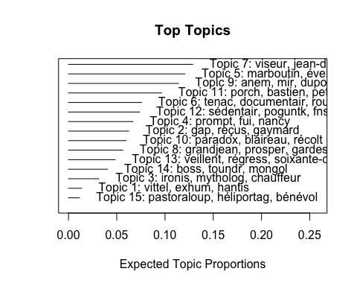

Les mots indicatifs pour topic listes

plot(poliblogPrevFit_15,type="labels",topics=c(7,5,9,11,6))

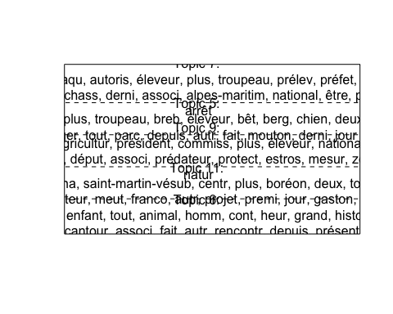

La différence dans le contenu d'un topic en fonction de la covariable contenu (ici le journal)

plot(poliblogPrevFit_15,type="perspectives",topics=7,main="topic 7")

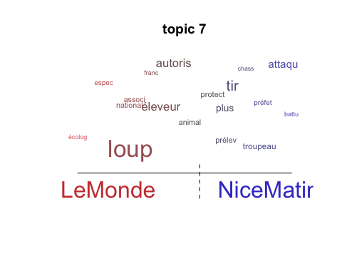

plot(poliblogPrevFit_15,type="perspectives",topics=5,main="topic 5")

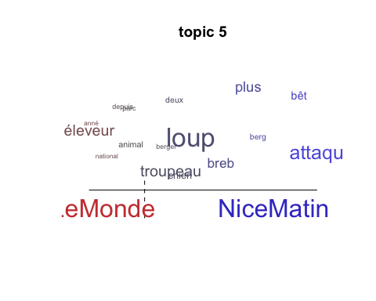

plot(poliblogPrevFit_15,type="perspectives",topics=9,main="topic 9")

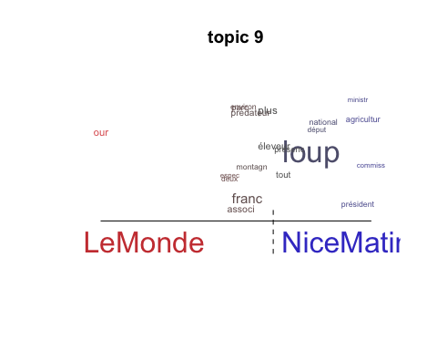

plot(poliblogPrevFit_15,type="perspectives",topics=11,main="topic 11")

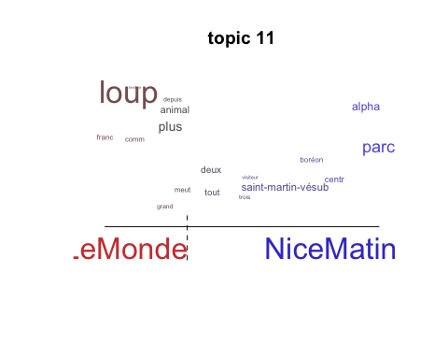

plot(poliblogPrevFit_15,type="perspectives",topics=6,main="topic 6")

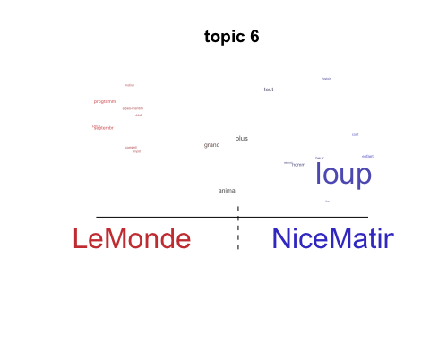

On regarde l'évolution temporelle de la proportion du corpus que le topic occupe (en rouge, Nice Matin ; en bleu, Le Monde):

for (i in c(7,5,9,11,6)){  
prep <- estimateEffect(c(i) ~ title * year, poliblogPrevFit_15,metadata = meta, uncertainty = "None")  
plot.estimateEffect(prep, covariate = "year", model = poliblogPrevFit_15,method = "continuous", xlab = "year", moderator = "title",moderator.value = "LeMonde", linecol = "blue", printlegend = F,main=paste("topic",i))  
plot.estimateEffect(prep, covariate = "year", model = poliblogPrevFit_15,method = "continuous", xlab = "year", moderator = "title",moderator.value = "NiceMatin", linecol = "red", add = T,printlegend = F)  
}

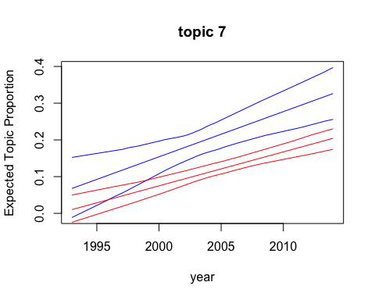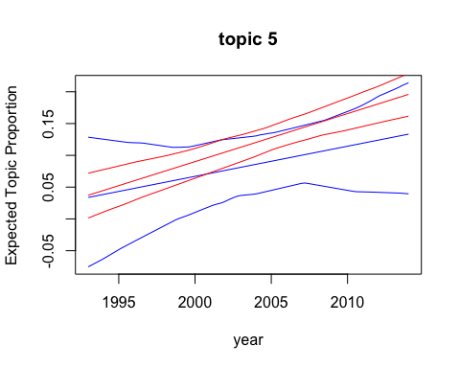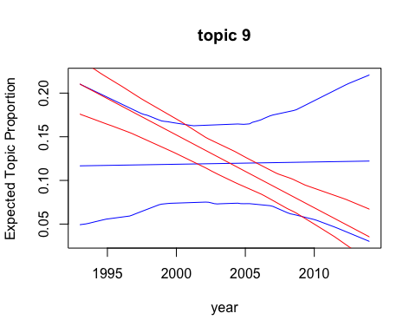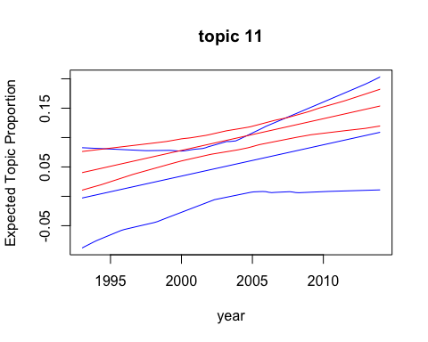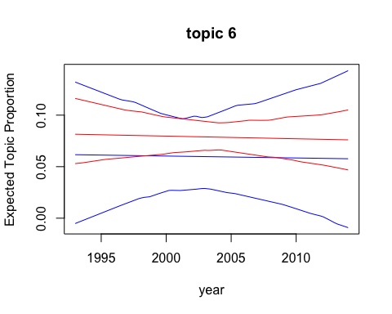

On regarde GRAPHICAL NETWORK DISPLAY of how closely related topics are to one another, (i.e., how likely they are to appear in the same document):

mod.out.corr<-topicCorr(poliblogPrevFit_15)  
plot.topicCorr(mod.out.corr)

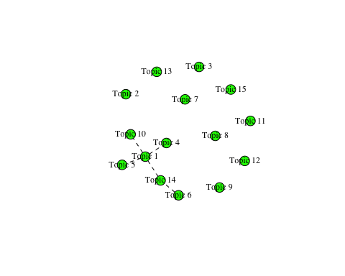

On détermine les topics les plus importants et on les interprète. Pour ce faire, on récupère les documents qui sont très corrélés avec le topic qui nous intéresse:

On transforme d'abord la base en un vecteur de caractères où chaque composante est un doc:

texts <- rep(NA,length(base))  
for (i in 1:length(base)){  
 temp <- as.character(lapply(base[i], as.character))  
 texts[i] <- temp  
}

On cherche et affiche les 5 documents les plus associés aux topics:

thoughts7<-findThoughts(poliblogPrevFit_15, texts=texts,n=5, topics=7)$docs[[1]]  
# pour améliorer la lisibilité, rajoute des séparateurs entre les 5 documents  
thoughts7 = gsub("c[:(:]","-------------------------------------------",thoughts7)  
write(thoughts7,'topic7.txt')  
thoughts5<-findThoughts(poliblogPrevFit_15, texts=texts,n=5, topics=5)$docs[[1]]  
# pour améliorer la lisibilité, rajoute des séparateurs entre les 5 documents  
thoughts5 = gsub("c[:(:]","-------------------------------------------",thoughts5)  
write(thoughts5,'topic5.txt')  
thoughts9<-findThoughts(poliblogPrevFit_15, texts=texts,n=5, topics=9)$docs[[1]]  
# pour améliorer la lisibilité, rajoute des séparateurs entre les 5 documents  
thoughts9 = gsub("c[:(:]","-------------------------------------------",thoughts9)  
write(thoughts9,'topic9.txt')  
thoughts11<-findThoughts(poliblogPrevFit_15, texts=texts,n=5, topics=11)$docs[[1]]  
# pour améliorer la lisibilité, rajoute des séparateurs entre les 5 documents  
thoughts11 = gsub("c[:(:]","-------------------------------------------",thoughts11)  
write(thoughts11,'topic11.txt')  
thoughts6<-findThoughts(poliblogPrevFit_15, texts=texts,n=5, topics=6)$docs[[1]]  
# pour améliorer la lisibilité, rajoute des séparateurs entre les 5 documents  
thoughts6 = gsub("c[:(:]","-------------------------------------------",thoughts6)  
write(thoughts6,'topic6.txt')