KECK-like AO system end-to-end simulations
pipeline coded into OOMAO
Olivier Beltramo-Martin, Carlos M. Correia

2017-04-25

1. Purpose

The Keck Ao Simulation Pipeline (KASP) is designed for providing a end-to-end simulations tools for the Keck adaptive optics system, in the prospects of performing PSF-reconstruction (PSF-R) for a segmented pupil of 10m class. The code is mainly supported by OOMAO (Object-Oriented Matlab Adaptive Optics) coded into Matlab [R. Conan 2014], that simulates the electric field propagation through the atmosphere, telescope and adaptive optics system. KASP allows to simulate any AO system in a SCAO/LGSAO/GLAO configuration so far, and will be extended to LTAO, especially in the context of PSF-R with Harmoni on the E-ELT.

2. Code architecture

OOMAO is object-oriented and invokes different Matlab classes (source, telescope, atmosphere, dm, wfs …) which are handled for propagating the wave-front through all the system. On top of that, KASP includes additional classes for simulating a AO loop from a parameter file only (as it's done with YAO on Yorick):
- systemSimulator class: instantiate all the AO system from the parameters file
- psfR class: PSF-R taking the system class as an input for reconstruction the PSF from the simulated telemetry
- psfStats class: tools for estimating the simulated/reconstructed PSF properties
- fourierModel class: calculation of AO errors PSDs and then the PSF from the system class using the Fourier description of the residual phase
- crowdedFields class: simulate a crowded field from a catalog [J. Ascenso 2015]
- quasiStellarObjects class: simulate QSO profile

The systemSimulator class carries all useful information about the system, telescope and atmosphere and is taken as an input for other class. KASP is now being upgraded for processing real Keck on-sky data and will allow to switch between simulation and on-sky data.

3. Keck-like PSF simulations
3.1. Atmosphere parameters

@500nm: r0=0.1243 (seeing of 0.83'')
L₀ is taken infinite

Altitude [km] | 0 | 4 | 8 | 16
Fraction [%] | 74.0 | 15.0 | 9.9 | 1.1
Wind speed [m/s] | 5 | 10 | 15 | 25
Wind direction [rd] | 0 | π/4 | π/2 | π

3.2. System parameters

#Parameters | Value | Unit
Science magnitude | 12 | mag
Science photometric band | K
PSF pixel scale | 9.81 | mas
Telescope diameter | 11.14 | m
Central obstruction | 0 | m
Pupil shape | circular
Pixels in pupil | 200 | pixel
LGS magnitude | 9.5 | mag
LGS height | 90 | km
LGS WFS #lenslets | 20
LGS WFS pixel/lenslet | 10 | pixels
LGS WFS platescale | 0.5 | λ/d
LGS WFS ron | 4 | e- rms/frame
LGS WFS light threshold | 0.6
LGS WFS throughput | 0.9
LGS WFS exposure Time | 2 | ms
TT magnitude | 12 | mag
TT photometric band | R
TT WFS pixels | 20 | pixels
TT WFS platescale | 0.5 | λ/D
TT WFS ron | 8 | e- rms/frame
TT WFS throughput | 0.93
TT WFS exposure time | 2 | ms
DM #actuator | 21
DM coupling factor | 0.15
LGS loop latency | 2 | ms
LGS loop gain | 0.5
TT loop latency | 2 | ms
TT loop gain | 0.3

3.3. PSF simulations in LGSAO mode

KASP simulates the AO correction in real-time, DM commands u_{TTR} and u_{TT} are recursively updated following an integrator law:

u_{TTR}(k) = u_{TTR}(k-1) – g_{TTR}*R_{TTR}*s_{LGS}(k-2)
u_{TT}(k) = u_{TT}(k-1) – g_{TT}*R_{TT}*(ps_{TT}*D/4)*s_{TT}(k-2),

with R_{TTR} and R_{TT} the command matrices for tweeter/tip-til mirrors and ps_{TT} the TT WFS pixelscale. See [R. Conan 2014] for more explanations on how OOMAO is working. LGSs are focused at 90km but following results do not include any sodium depth and extra fwhm of the LGS spot (options included into KASP). The tweeter command matrix is computed using a simple push-pull approach of the DM using a reference calibration source, a modal approach using Zernike modes is also implemented. In particular, symmetrical structures in the PSF at 10λ/D are bad filtered waffle modes using the zonal calibration method based on the poke matrix.

I've simulated a Keck-like system, over 10 s of temporal realization, with a central LGS plus on-axis NGS for measuring the tip-tilt, for a zenith angle= 0 and 35 deg. Simulations are providing a grid of PSF across a 20''x20'' field of view each 2'' location.
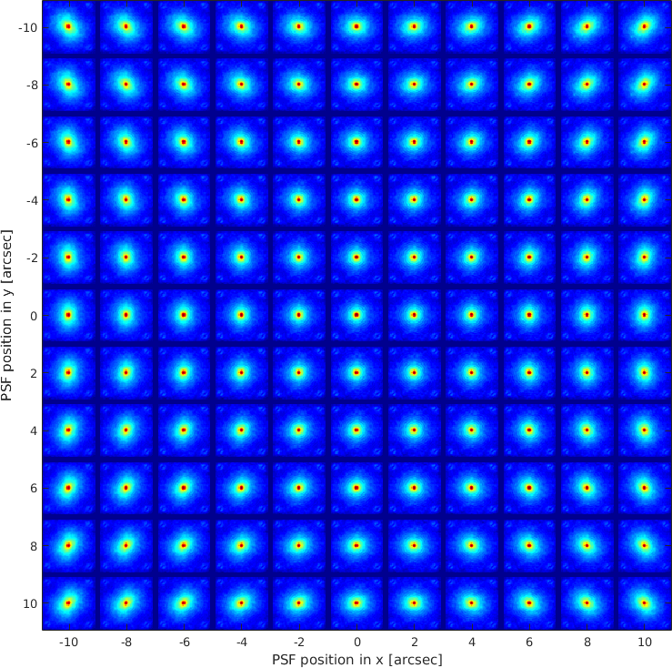
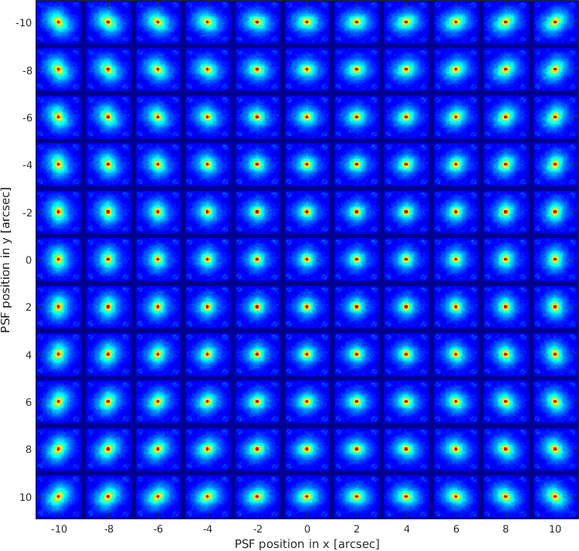

4.

Fig. 1: K-band PSFs simulated using KASP in LGSAO. Zenithal angle = 0 (left) and 35 deg (right).
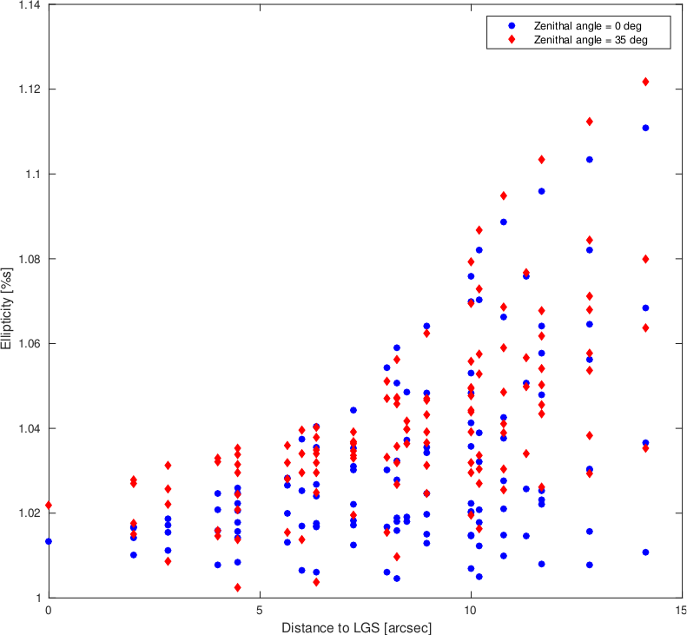
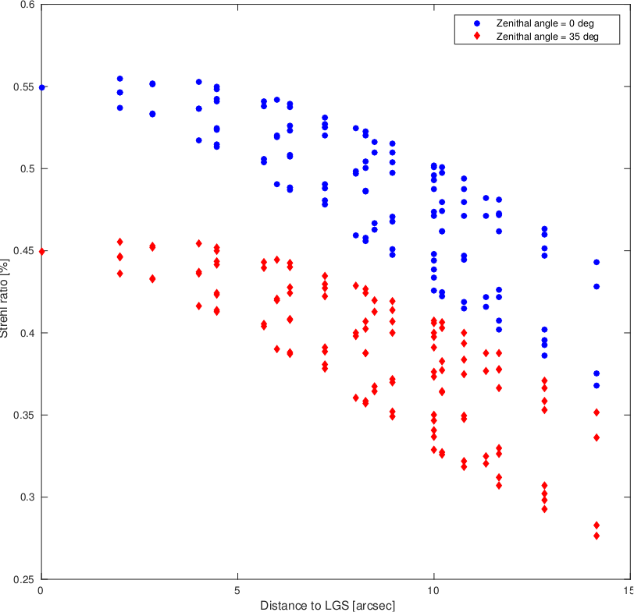

Fig. 2: K-band Strehl and Gaussian aspect ratio of PSF with radial distance to LGS.

Aspect ratios given in Fig 2 are derived from a bivariate Gaussian-model fitting over PSFs, and are increased by around 10% from center to 10” showing a quite strong impact of the anisoplanatism effects comparable to anisoplanatism model code provided by G. Witzel et al.

Strehl ratios are dropping down from 55%/46% at center to 42%/37% at 10” off-axis with a zenith angle respectively of 0 and 35 deg, which gives in median value a drop off evaluated to 0.83 and 0.86.

3.4. Anisoplanatism model
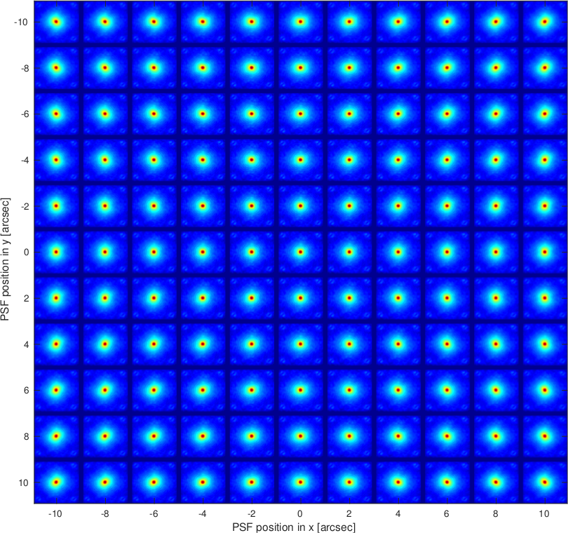
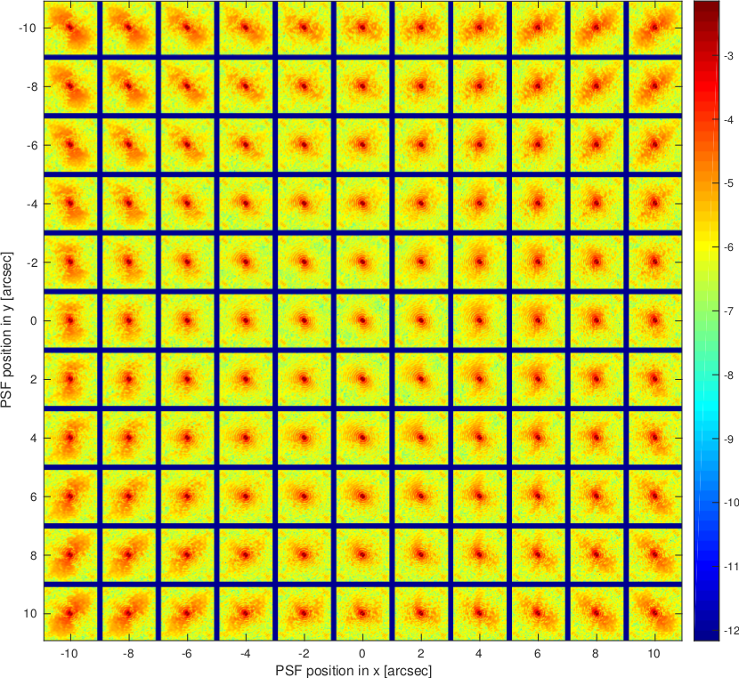
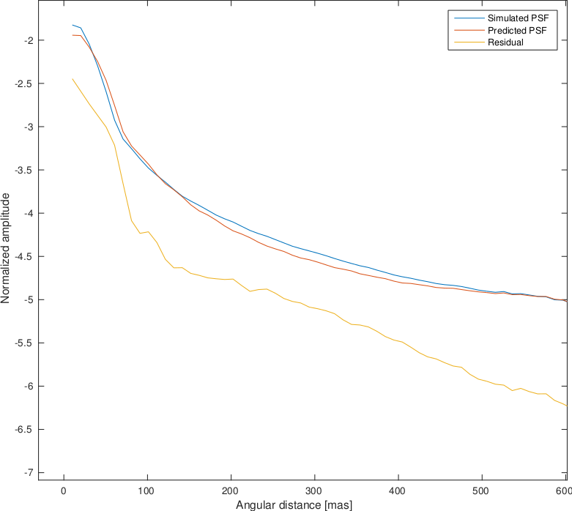
Top: Fig. 3: K-band PSFs predicted using the Flicker's anisoplanatism model and map of residual at zenith..

Left: Fig. 4: K-band upper-left corner PSFs profiles simulated using KASP and predicted using the Flicker's anisoplanatism model and residual. PSFare normalized to an unitary flux.

According to Fig. 3 and 4 The Flicker's model [Flicker2008] (Eq. 119) for anisoplanatism allows to partially reproduce the observed anisoplanatism, but reasons of model errors need to be deeper investigated (non-stationnarity for instance).

4. Notes
4.1. C_{n}²(h) profile to fraction values

In the context of the study on comparison of anisoplanatism in atmospheric modeling codes, Gunther has compared the impact of anisoplanatisms onto PSF shape and characteristics using the following C_{n}²(h) profile:

Altitude[km] | 0.5 | 1.0 | 2.0 | 4.0 | 8.0 | 16 | Seeing [''] | MASS | DIMM
C_{n}²(h) | 1..88e-21 | 3.39e-22 | 2.74e-21 | 7.14e-14 | 4.74e-14 | 5.41e-15 |  | 0.37 | 0.83

KASP requires the r₀ value and the strength fraction per layer. Firstly, I ignored the three first altitude layers whose strength is negligible in front of upper ones. I assume so the difference of seeing between MASS and DIMM comes from the ground layer, artificially located at 0 km in my simulation. The ground layer seeing is thus:

s₀ = (0.83^{5/3} – 0.37^{5/3})^{3/5} = 0.69''

The ground layer fraction is:
w₀ = 0.69^{5/3}/0.83^{5/3} = 74 %

The altitude layer fraction at 4, 8 and 16 are respectively:
w₄ = 7.14/12.421 * 26 = 15.0%
w₈ = 4.74/12.421*26 = 9.9%
w₁₆ = 0.541/12.421*26 = 1.1%

5. References

[R. Conan 2014]: R. Conan and C.M. Correia, “Object-oriented Matlab adaptive optics toolbox” in proceedings SPIE, vol. Adaptive Optics Systens IV, 9148, 2014.

[J. Ascenso 2015]: J. Ascenso, B. Neichel, M. Silva and T. Fusco, “PSF reconstruction for AO photometry and astrometry”, proceedings AO4ELT4, 2015.

[Flicker 2008]: R. Flicker, “PSF reconstruction for Keck AO Phase 1 Final Report”, internal report.

