FcNetwork

valid set: Average loss: 0.0041, Accuracy: 5099/6000 (85%)

valid set: Average loss: 0.0037, Accuracy: 5190/6000 (86%)

valid set: Average loss: 0.0036, Accuracy: 5214/6000 (87%)

valid set: Average loss: 0.0033, Accuracy: 5286/6000 (88%)

valid set: Average loss: 0.0032, Accuracy: 5280/6000 (88%)

valid set: Average loss: 0.0032, Accuracy: 5317/6000 (89%)

valid set: Average loss: 0.0031, Accuracy: 5320/6000 (89%)

valid set: Average loss: 0.0031, Accuracy: 5294/6000 (88%)

valid set: Average loss: 0.0030, Accuracy: 5351/6000 (89%)

valid set: Average loss: 0.0031, Accuracy: 5305/6000 (88%)

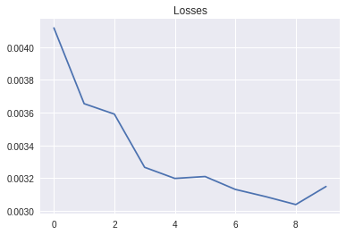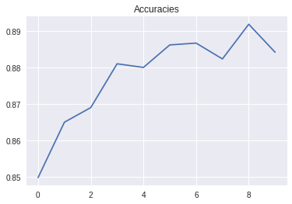

CNN_2_16_32

valid set: Average loss: 0.0036, Accuracy: 5210/6000 (87%)

valid set: Average loss: 0.0031, Accuracy: 5330/6000 (89%)

valid set: Average loss: 0.0030, Accuracy: 5333/6000 (89%)

valid set: Average loss: 0.0029, Accuracy: 5377/6000 (90%)

valid set: Average loss: 0.0029, Accuracy: 5363/6000 (89%)

valid set: Average loss: 0.0028, Accuracy: 5378/6000 (90%)

valid set: Average loss: 0.0029, Accuracy: 5356/6000 (89%)

valid set: Average loss: 0.0028, Accuracy: 5422/6000 (90%)

valid set: Average loss: 0.0026, Accuracy: 5434/6000 (91%)

valid set: Average loss: 0.0026, Accuracy: 5456/6000 (91%)

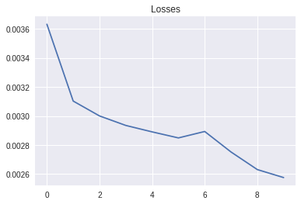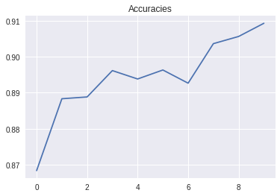

CNN_2_32_64

valid set: Average loss: 0.0036, Accuracy: 5196/6000 (87%)

valid set: Average loss: 0.0031, Accuracy: 5321/6000 (89%)

valid set: Average loss: 0.0029, Accuracy: 5393/6000 (90%)

valid set: Average loss: 0.0027, Accuracy: 5417/6000 (90%)

valid set: Average loss: 0.0026, Accuracy: 5444/6000 (91%)

valid set: Average loss: 0.0026, Accuracy: 5448/6000 (91%)

valid set: Average loss: 0.0026, Accuracy: 5403/6000 (90%)

valid set: Average loss: 0.0027, Accuracy: 5433/6000 (91%)

valid set: Average loss: 0.0025, Accuracy: 5475/6000 (91%)

valid set: Average loss: 0.0024, Accuracy: 5491/6000 (92%)

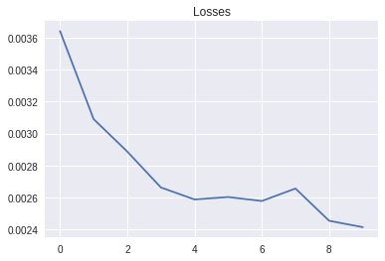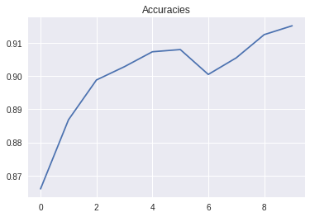

CNN_2_64_128

valid set: Average loss: 0.0035, Accuracy: 5247/6000 (87%)

valid set: Average loss: 0.0032, Accuracy: 5306/6000 (88%)

valid set: Average loss: 0.0029, Accuracy: 5362/6000 (89%)

valid set: Average loss: 0.0027, Accuracy: 5410/6000 (90%)

valid set: Average loss: 0.0029, Accuracy: 5373/6000 (90%)

valid set: Average loss: 0.0027, Accuracy: 5427/6000 (90%)

valid set: Average loss: 0.0026, Accuracy: 5438/6000 (91%)

valid set: Average loss: 0.0026, Accuracy: 5467/6000 (91%)

valid set: Average loss: 0.0025, Accuracy: 5464/6000 (91%)

valid set: Average loss: 0.0026, Accuracy: 5451/6000 (91%)

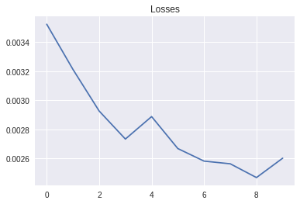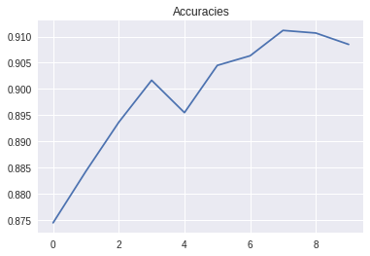

CNN_3_16_32_64

valid set: Average loss: 0.0034, Accuracy: 5254/6000 (88%)

valid set: Average loss: 0.0032, Accuracy: 5305/6000 (88%)

valid set: Average loss: 0.0028, Accuracy: 5381/6000 (90%)

valid set: Average loss: 0.0028, Accuracy: 5401/6000 (90%)

valid set: Average loss: 0.0028, Accuracy: 5371/6000 (90%)

valid set: Average loss: 0.0026, Accuracy: 5423/6000 (90%)

valid set: Average loss: 0.0025, Accuracy: 5459/6000 (91%)

valid set: Average loss: 0.0026, Accuracy: 5446/6000 (91%)

valid set: Average loss: 0.0025, Accuracy: 5460/6000 (91%)

valid set: Average loss: 0.0024, Accuracy: 5482/6000 (91%)

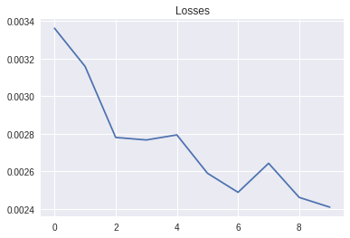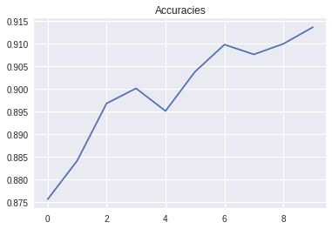

CNN_3_32_64_128

valid set: Average loss: 0.0033, Accuracy: 5280/6000 (88%)

valid set: Average loss: 0.0031, Accuracy: 5329/6000 (89%)

valid set: Average loss: 0.0028, Accuracy: 5379/6000 (90%)

valid set: Average loss: 0.0026, Accuracy: 5434/6000 (91%)

valid set: Average loss: 0.0025, Accuracy: 5461/6000 (91%)

valid set: Average loss: 0.0025, Accuracy: 5463/6000 (91%)

valid set: Average loss: 0.0025, Accuracy: 5471/6000 (91%)

valid set: Average loss: 0.0025, Accuracy: 5474/6000 (91%)

valid set: Average loss: 0.0023, Accuracy: 5508/6000 (92%)

valid set: Average loss: 0.0024, Accuracy: 5518/6000 (92%)

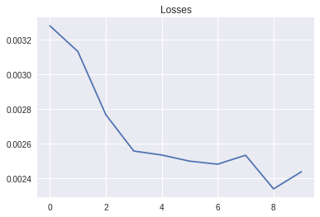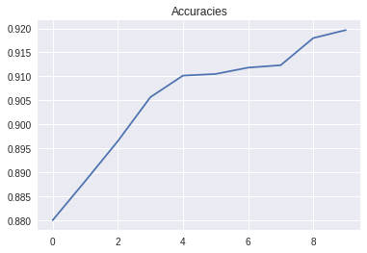

test set: Average loss: 0.0025, Accuracy: 9107/10000 (91%)