OLIVIER KOCH
246 Franklin Street, Cambridge MA 02139 USA  Cell: +1-617-447-7421 |  |  | koch@csail.mit.edu  http://people.csail.mit.edu/koch
OBJECTIVE | To obtain an academic research position in the fields of computer vision and robotics.
PROFILE | My research interests include computer vision, 2D/3D geometry and robotics. I am particularly interested in applications to mapping and navigation for robots and humans in unknown, unconstrained environments. I have experience and interest in both software and hardware engineering.
EDUCATION
Oct 2009 (expected) | Massachusetts Institute of Technology, Cambridge, MA, USA  Department of Electrical Engineering and Computer Science (EECS)  Computer Science and Artificial Intelligence Lab (CSAIL), PhD Candidate  Thesis Title: A Self-Calibrating Vision-based Method for Human-Oriented Navigation  Thesis Advisor: Seth Teller  Prof Seth Teller and I are developing a vision-based navigation assistant that helps humans navigate unexplored environments. The method is entirely non-metric and provides coarse guidance in a human-understandable way. It requires no camera calibration, does not constraint the number of cameras or their relative position on the rig and uses a novel method for correlating the user motion and motion of features on the images.
Feb 2007 | Massachusetts Institute of Technology, Cambridge, MA, USA  Department of Electrical Engineering and Computer Science (EECS)  Computer Science and Artificial Intelligence Lab (CSAIL), Master of Science - Cumulative GPA 4.6/5.0  Thesis Title: Wide-Area Egomotion from Omnidirectional Video and Coarse 3D Structure  Courses: Computer vision, Theory of Computation, Computer Graphics, Distributed Systems  The thesis project consisted in an egomotion estimation algorithm that takes as input a coarse 3D model of an environment, and an omnidirectional video sequence captured within the environment, and produces as output a reconstruction of the camera’s 6-DOF egomotion expressed in the coordinates of the input model. The principal novelty of our method is a robust matching algorithm that associates 2D edges from the video with 3D line segments from the input model.
1999 - 2002 | Ecole Nationale Superieure de Techniques Avancees, Paris, France  Diplome d’Ingenieur – Major: Operating systems/Parallel computing/Networks/Cryptography
1997 – 1999 | Classes Preparatoires aux Grandes Ecoles, MP*, Lycee Charlemagne, Paris, France  Intensive preparation to the concourse leading to the French engineering schools with focus on differential equations, linear algebra, geometry, analysis, statistics and physics.
WORK & RESEARCH EXPERIENCE
Jun - Oct 2007 | Institut National de Recherche en Informatique et Automatique (INRIA), France  Intern, Perception group - advisor Peter Sturm  - Developed new methods for 3D patch reconstruction from known structure-from-motion algorithms.  - Produced a ground-truth database of video sequences and camera paths in simulated environments.
Feb 2006 –  Nov 2007 | Massachusetts Institute of Technology, Cambridge, MA, USA  Team member, DARPA Urban Challenge 2007  - Developed an application for mission and map editing allowing live overlay of satellite images  - Initiated ideas for local laser-based navigation algorithms  - Assisted the team with infrastructure work and software testing
WORK & EXPERIENCE (continued)
Oct 2002 –  Oct 2004 | General Electric Healthcare, Buc, France  Software Engineer, X-Ray Imaging System Innova 4100 Digital Leader (DL) Team  - Designed and developed C++/CORBA applications for medical software in a strong team environment.  - Completed Six Sigma training (Green Belt certification) by decreasing DL startup time by 50%  - Managed the Environment, Health and Security program of the team ($10,000 budget)
Mar - Aug 2002 | Massachusetts Institute of Technology, Cambridge, MA, USA  Intern, Lab for Computer Science, Computer Graphics Group, The City Scanning Project – Seth Teller  - Mapped the plane sweep algorithm onto an heterogeneous cluster of IRIX machines (speedup 15)  - Assessed overall performance of the system and diagnosed computational bottlenecks.  - Assisted PhD student on camera calibration and epipolar geometry problems.
May – July 2001 | Université Jussieu, Paris, France  Intern, Laboratoire de Meteorologie Dynamique (LMD) – advisor Laurent Li  - Developed cluster analysis models for the Southern Hemisphere climate in Fortran 90
SELECT PUBLICATIONS
- Olivier Koch, Seth Teller, A Self-Calibrating, Vision-based Calibration Assistant, ECCV Workshop on Computer Vision Applications for the Visually Impaired, October 2008, Marseille, France.

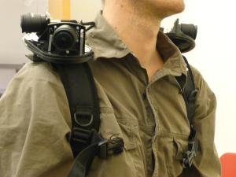 |  | We describe a body-worn sensor suite, environment representation, set of algorithms, and graphical-aural interface designed to provide human-centered guidance to a person moving through a complex space. The central idea underlying our approach is to model the environment as a graph of visually distinctive places (graph nodes) connected by path segments (graph edges). During exploration, our algorithm processes multiple video-rate inputs to identify visual features and construct the “place graph” representation of the traversed space. The system then provides visual and/or spoken guidance in user-centered terms to lead the user along existing or newly-synthesized paths. Our approach is novel in several respects: it requires no precise calibration of the cameras or multi-camera rig used; it generalizes to any number of cameras with any placement on the body; it learns the correlation between user motion and evolution of image features; it constructs the place graph automatically; and it provides only coarse (rather than precise metrical) guidance to the user.
- Olivier Koch, Seth Teller, Wide-Area Egomotion Estimation from Known 3D Structure, CVPR 2007, Minneapolis.
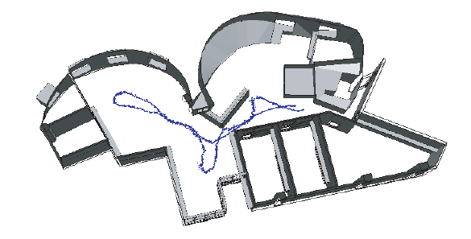 |  | This paper describes an egomotion estimation algorithm that takes as input a coarse 3D model of an environment, and an omnidirectional video sequence captured within the environment, and produces as output a reconstruction of the camera’s 6-DOF egomotion expressed in the coordinates of the input model. The principal novelty of our method is a robust matching algorithm that associates 2D edges from the video with 3D line segments from the input model. Our system handles 3-DOF and 6-DOF camera excursions of hundreds of meters within real, cluttered environments. It uses a novel prior visibility analysis to speed initialization and dramatically accelerate image-to-model matching. We demonstrate the method’s operation, and qualitatively and quantitatively evaluate its performance, on both synthetic and real image sequences.
- Olivier Koch and Seth Teller, The City Scanning Project: Validation and Parallel Algorithms, MIT LCS Technical Report, 2002
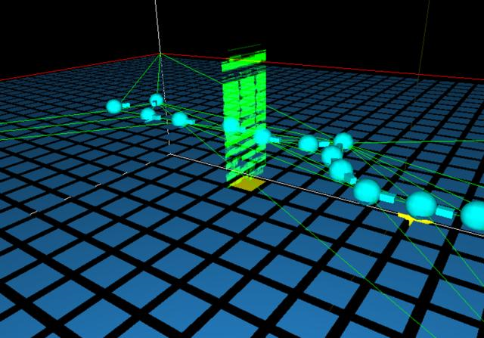 |  | The goal of this project was to map the most time-consuming step of the city scanning project (namely, the plane sweep algorithm) onto a cluster of 32 IRIX machines spread across the lab. I reached a speedup of 15 using a master-slave model programmed with the Message Passing Interface (MPI) library. In addition, I assessed the overall performance of the system and proposed solutions to solve the new computational bottlenecks. During the final weeks of my stay, I analyzed the bundle adjustment algorithm and assisted a PhD student in validating it.
TEACHING
- 6.01 Introduction to EECS 1, Teaching Assistant (Prof. L. Kaebling, T. Lozano-Perez), Spring 2008
An introduction to the main computer science concepts through robotics: software engineering, feedback and control, circuits, probability and planning. 300+ students! Very intensive class involving a lot of student-teacher interaction in labs.

- 6.092 Introduction to Software Engineering in Java, Instructor, January 2008 and 2009
A hands-on introductory class to Java over four weeks in January. Two instructors, 60 students.

SKILLS
Computers | Linux (Ubuntu), Windows (XP) – extended experience in C/C++/Java/Matlab/Perl/Python/bash scripting  Libraries: OpenGL, MPI, Glib, pthread, ImageMagick, OpenCV, IPP – Camera Calibration: Matlab, Easycalib – Embedded systems: Mini-ITX
Languages | French: native; English: fluent; German: renewable; Spanish: basic
LEADERSHIP
- Launched and developed the Energy Regatta at MIT, $10,000 budget, 2006-2008
- Directed the MIT Club Francophone, 400 members, 2006-2007
- Trained and supervised the MIT team at the X-HEC sailing regatta in France, 2006-2007.

