How to use MQTT-Spy with Orange Datavenue Live Objects

Table des matières

Prerequisites 1

Configure your MQTT-Spy to connect to Orange Live Objects: 2

Authentication: 3

(Optional) TLS security: 3

(Optional) HTTP Proxy: 4

Formatting incoming messages 4

(json+device only) Scripted publication 4

(Application only) Auto subscription 6

Logs 6

Resources 6

# Prerequisites

An account on <https://liveobjects.orange-business.com>, even a free *discover* one.

An API-Key generated on your account.

MQTT-Spy running: <https://github.com/olivm-fr/paho.mqtt-spy/releases>

Publication scripts from <https://github.com/olivm-fr/paho.mqtt-spy/tree/master/0-examples>

# Configure your MQTT-Spy to connect to Orange Live Objects:

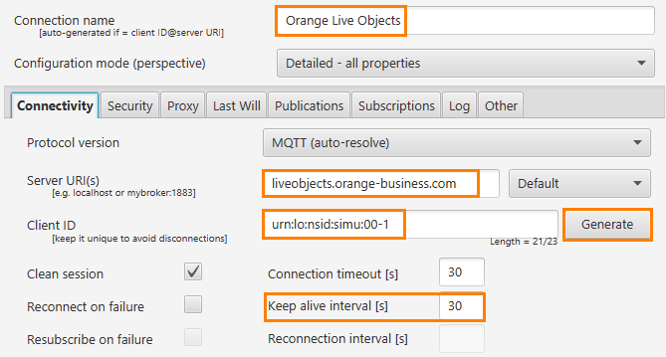

Client ID:

* As an application to act as a data consumer: click on “Generate”
* As a device publishing data and receiving commands/parameters/firmware, enter a device URN following the format urn:lo:nsid:<namespace>:<id>

NB :

* Protocol “Default” may be changed to “websockets” if MQTT protocol is filtered by your network infrastructure
* “Reconnect on failure” and “Resubscribe on failure” way be checked if relevant for you

# Authentication:

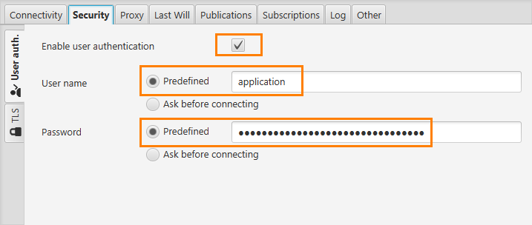

User name:

* “application” to act as a data consumer, subscribing to FiFos
* “connector” to act as an external connector (third-party backend or gateway)
* “json+device” to act as a device publishing data and receiving commands/parameters/firmware  
  

Password:

* For application: API-Key generated on your account with “application” rights profile
* For connector: API-Key generated on your account with “ext. connector” rights profile
* For json+device: API-Key generated on your account with “MQTT device” rights profile

# TLS security:

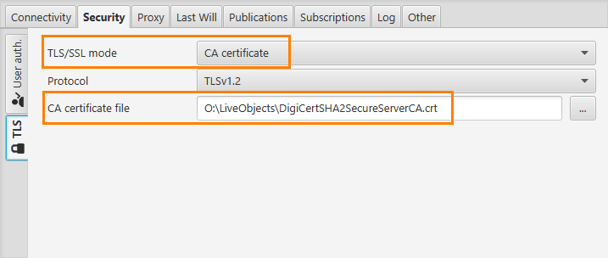

This is optional, but strongly recommended as it allows your key to remain secret.

The certificate can be found here: <https://dl.cacerts.digicert.com/DigiCertSHA2SecureServerCA.crt>

# (Optional) HTTP Proxy:

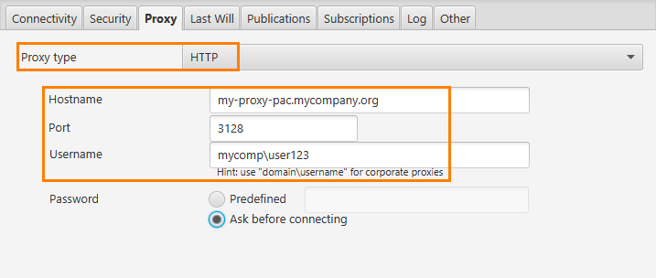

If your network provider has a proxy configured to reach the internet, you have to enter the information above. The proxy must allow the use of CONNECT verb. If the proxy filters on the protocol, you may prefer the WebSocket connection with or without TLS, see the previous chapters.

# Formatting incoming messages

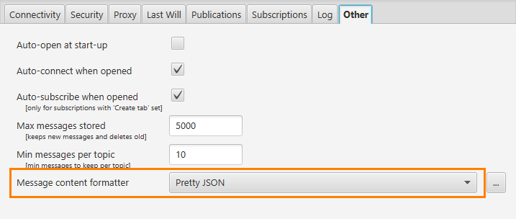

# (json+device or connector, only) Scripted publication

To simulate a device sending data frames at regular interval:

1. Open %USERPROFILE%\mqtt-spy via an explorer location bar, or via the *Windows-Menu >> Run* popup.  
   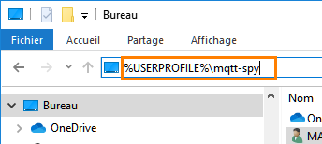 or 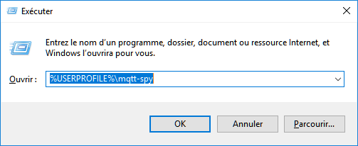
2. Place *.js files from <https://github.com/olivm-fr/paho.mqtt-spy/tree/master/0-examples> into that folder.  
   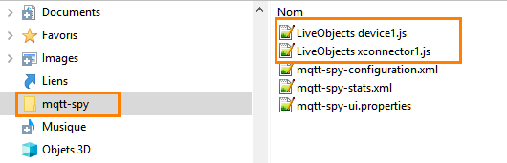
3. Open MQTT-Spy. Open a Live Objects connection.  
    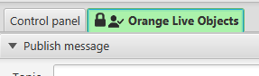
4. Open the “Scripted publications” pane  
   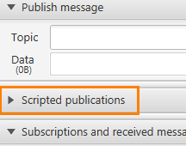
5. Right click on the script and choose “Start”.   
   NB: *do NOT* click on repeat, as the repetition is set in the script to have coherent data sets  
   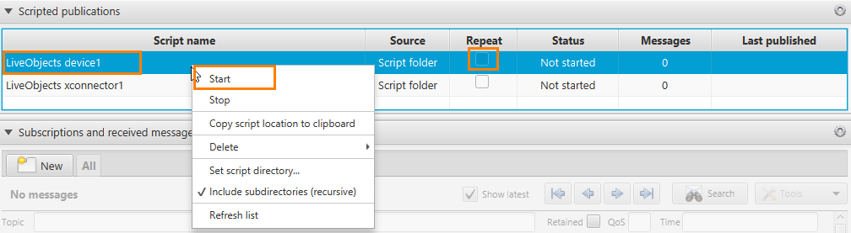
6. Number in Messages column will increase. You can check on Live Objects that messages have arrived  
   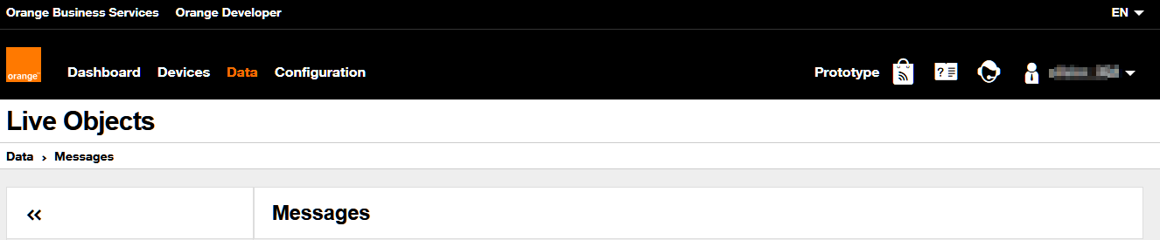  
   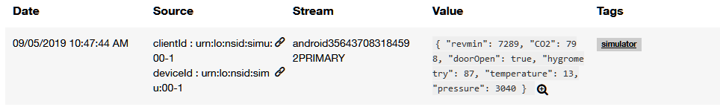
7. Stop the simulator:  
   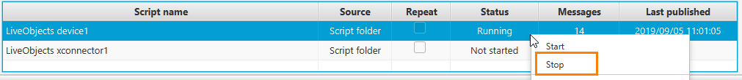

# (External connector only) Commands management

External-connector devices can receive commands. To do so, the MQTT client must subscribe to a specific topic connector/v1/requests/command. It should send an answer to commands, to acknowledge them.

Set the subscription as follows, using the full path to the script LiveObjects xconnector1-cmdack-auto.js given in the examples:

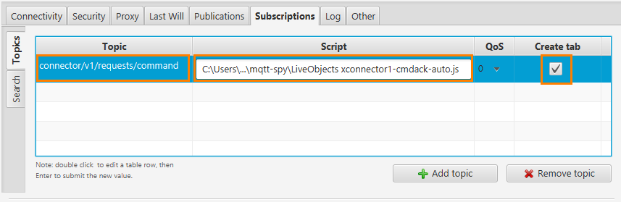

Set the option below, too:

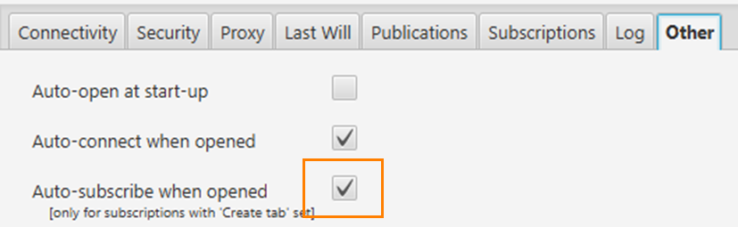

# (Application only) Auto subscription

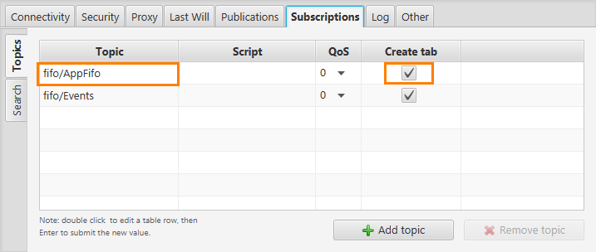

For applications only (do not define them for json+device), you can subscribe to FiFos automatically by defining them here. FiFos must pre-exist in your Live Objects account with the same names.

Set the option below, too:



# Logs

In case of issues, logs are available here : file mqtt-spy.log in an explorer opened in path %USERPROFILE%\AppData\Local\mqtt-spy\app

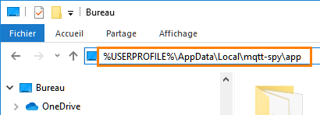 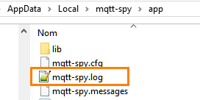

# Resources

Live Objects FAQ, user guide, etc: <https://liveobjects.orange-business.com/#/faq>

Live Objects APIs Swagger: <https://liveobjects.orange-business.com/swagger-ui/index.html>

Live Objects technical manual: <https://liveobjects.orange-business.com/doc/html/lo_manual_v2.html>