Coding Challenge 4

Olivia Brown

2025-02-27

Table of Contents

# Manuscript Link

[Link to manuscript](https://doi.org/10.1094/PDIS-06-21-1253-RE)

# Packages, Color Palette, and Data Prep

library(knitr)  
library(rmarkdown)  
library(pandoc)  
library(tinytex)  
library(ggplot2)  
library(ggpubr)  
  
#read in data  
mycotoxindata <- read.csv("MycotoxinData.csv", na.strings="na")  
  
#change treatment from chr to factor  
mycotoxindata$Treatment <- as.factor(mycotoxindata$Treatment)  
  
#reorder the levels using factor()  
mycotoxindata$Treatment <- factor(mycotoxindata$Treatment, levels = c("NTC", "Fg", "Fg + 37", "Fg + 40", "Fg + 70"))  
  
#add colorblind palette  
cbbPalette <- c("#000000", "#E69F00", "#56B4E9", "#009E73", "#F0E442",  
 "#0072B2", "#D55E00", "#CC79A7")

# GGPlots

#DON GGplot  
Q1Plot <- ggplot(mycotoxindata, aes(x = Treatment, y = DON, fill= Cultivar, color = Cultivar)) +   
 geom_boxplot(position = position_dodge()) +  
 geom_point(position = position_jitterdodge(0.09), alpha=0.6, shape = 21, colour = "black")+  
 xlab("") + ylab("DON (ppm)") +  
 scale_fill_manual(values = c("Ambassador" = "#0072B2", "Wheaton" = "#D55E00")) +   
 scale_color_manual(values = c("Ambassador" = "#0072B2", "Wheaton" = "#D55E00")) +  
 theme_classic()+  
 facet_wrap(~Cultivar)  
Q1Plot

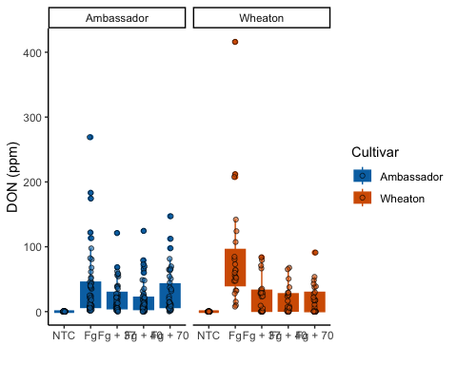

#X15ADON GGplot  
Q3Plot <- ggplot(mycotoxindata, aes(x = Treatment, y = X15ADON, fill= Cultivar, color = Cultivar)) +   
 geom_boxplot(position = position_dodge()) +  
 geom_point(position = position_jitterdodge(0.05), alpha=0.6, shape = 21, colour = "black")+  
 xlab("") + ylab("15ADON") +  
 scale_fill_manual(values = c("Ambassador" = "#0072B2", "Wheaton" = "#D55E00")) +   
 scale_color_manual(values = c("Ambassador" = "#0072B2", "Wheaton" = "#D55E00")) +  
 theme_classic()+  
 facet_wrap(~Cultivar)  
Q3Plot

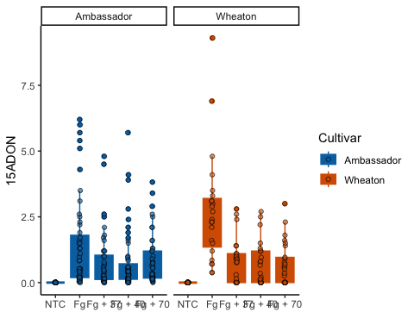

#Mass per Seed GGplot  
Q3Plot_PT2 <- ggplot(mycotoxindata, aes(x = Treatment, y = MassperSeed_mg, fill= Cultivar, color = Cultivar)) +   
 geom_boxplot(position = position_dodge()) +  
 geom_point(position = position_jitterdodge(0.05), alpha=0.6, shape = 21, colour = "black")+  
 xlab("") + ylab("Seed Mass (mg)") +  
 scale_fill_manual(values = c("Ambassador" = "#0072B2", "Wheaton" = "#D55E00")) +   
 scale_color_manual(values = c("Ambassador" = "#0072B2", "Wheaton" = "#D55E00")) +  
 theme_classic()+  
 facet_wrap(~Cultivar)  
Q3Plot_PT2

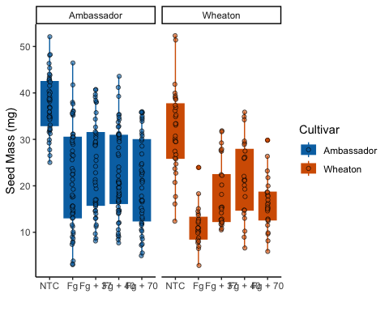

# DON T test

Q1Plot_TTEST <- Q1Plot+   
 geom_pwc(aes(group = Treatment), method = "t.test", label = "p.adj.format")  
Q1Plot_TTEST

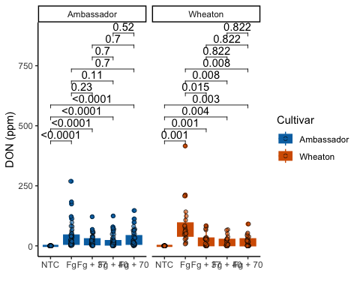

# X15ADON T test

Q3Plot_TTEST <- Q3Plot +  
 geom_pwc(aes(group = Treatment), method = "t.test", label = "p.adj.format")  
Q3Plot_TTEST

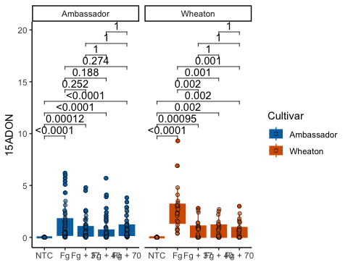

# Mass Per Seed T test

Q3Plot_PT2_TTEST <- Q3Plot_PT2 +  
 geom_pwc(aes(group = Treatment), method = "t.test", label = "p.adj.format")  
Q3Plot_PT2_TTEST

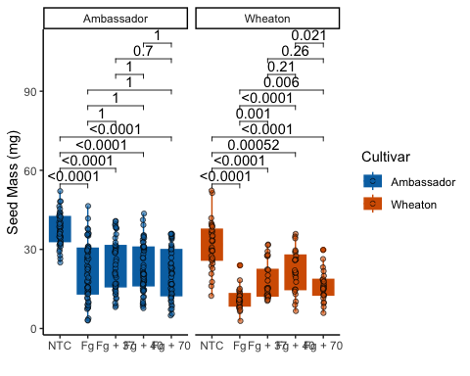

# Combine T Tests

figure2<- ggarrange(  
 Q1Plot_TTEST, Q3Plot_TTEST, Q3Plot_PT2_TTEST, labels = "AUTO", nrow = 1, ncol = 3, common.legend = T)  
figure2

