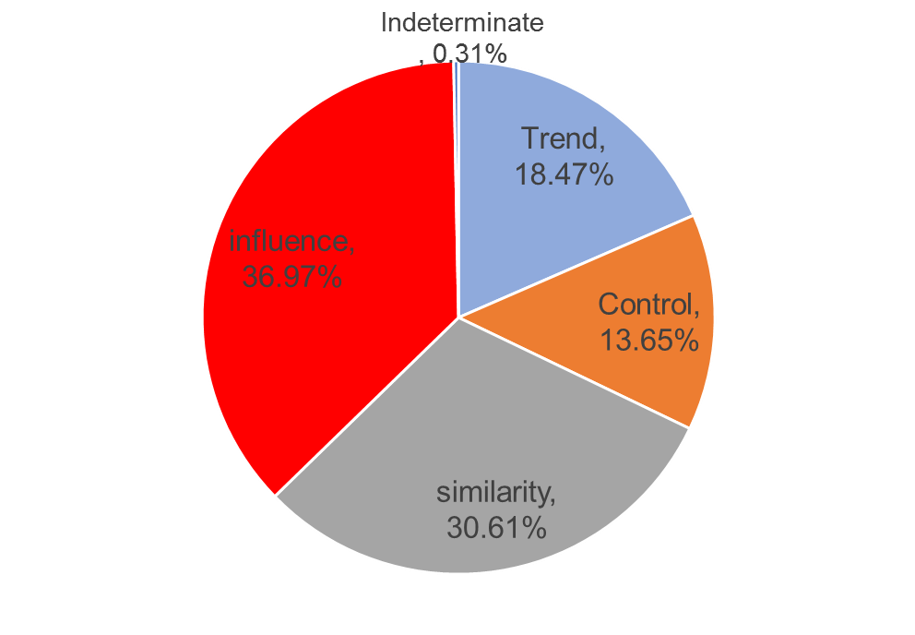
Trait-based selection and social influence.- We have begun to use the combined survey and dynamic network data to examine whether tie formation and dissolution mechanisms are governed either by a process of selection into certain relationships or influence (contagion). We have begun looking at a particularly salient behavioral trait in this population, namely alcohol (beer) consumption to examine whether there a contagion process (persons become drinkers if they attach to friends who drink) or a selection process (persons are more likely to become friends---and keep the tie---if they both share the same drinking behavior pattern. Preliminary results from stochastic actor based models (a type of dynamic network modelling based on agent-based simulations) using four waves of survey data (Fall 2011, Spring 2012, Summer 2012 and Fall 2012) suggest that in the case of beer consumption both selection and influence effects are in operation, with influence accounting for about 37% of dyadic similarity in drinking behavior, and selection accounting for about 31% (with other mechanisms “control” and inter-temporal correlations in behavior “trend” accounting for the rest). Ongoing (and very preliminary) work using political attitudes as the trait of interest reveal a different picture, with selection being overwhelmingly more important than influence in accounting for dyadic matching.

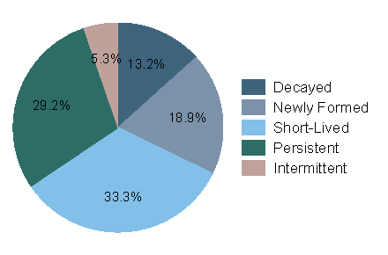
Personal Traits dynamic tie decay and formation processes.- We have also begun work trying to connect personal traits that vary across a slow time-scale (e.g. personality characteristics, such as extraversion, agreeableness, openness to new experience, conscientiousness, and neuroticism) collected at the first time period, with dynamics of tie formation, persistence and decay for the first 75 weeks of observation. We use an “observation window” method (see Miritello et al 2013, arXiv:1304.1979) to classify ties as new, short-lived, persistent or decayed. We find that in the first 75 weeks a majority of ties are either short lived or newly formed, close to a third are persistent and about 13% are observed in the first 15 weeks but are no longer observed after that. In addition, preliminary results support the hypothesis that personality characteristics are correlated with both the number and the rate at which persons form new ties and keep old ones. In particular, persons high in extraversion form a higher number of ties of all types, while persons classified as high in agreeableness have a higher rate of new tie formation, a lower rate of tie decay and a higher rate of tie persistence.

