Beyond Revealed Preferences: Cultural Socialization and the Stratification of Complex Musical Tastes

INTRODUCTION

BACKGROUND
Research on cultural consumption has overwhelmingly studied tastes, and to a lesser extent, knowledge, practices, meaning-making, etc. While these research agendas have mostly traveled along different–albeit sometimes parallel–tracks, recent theoretical advances have united them into the analysis of what Ma (2025) calls “complex tastes.” In this framework, valuations (conceptions of whether a cultural object or genre is generally regarded as worthy) are distinguished from preferences (personal likes and dislikes) and both from the active consumption of specific cultural forms.
The key to the argument is that complex tastes emerge because these three dimensions can come apart; people, inter alia, can like things they don’t deem worthy, consume things they don’t like, and regard as worthy things they don’t consume, up to the seven possible combinations of each binary (excluding the zero pole of non-consumption and non-liking of unworthy things). These configurations allow disjunctures in different types of taste. Much like the difference between stated and revealed preferences, individuals may overestimate or overstate their consumption of higher status cultural forms. Likewise, just as individuals provide explanations and justifications for their lowbrow consumption– they consume “ironically” or as a “guilty pleasure” (McCoy and Scarborough) – in complex tastes they may overclaim or underclaim how what they like vs. what they are consuming.
For instance, in a recent empirical piece, Ma (2026) revisits the question of gender differences in cultural tastes from the complex tastes perspective. Noting the puzzle of somewhat muted empirical findings in this regard, when we should expect strong gendering of tastes, Ma argues that this results from viewing tastes exclusively as preferences or consumption, rather than as complex tastes. Using a survey sample from Prolific Academic, Ma shows that once tastes are defined as complex tastes (counts of musical genres satisfying a specific combination of positive and negative valuation, preference, and consumption), structured gender differences emerge. Particularly, Ma finds that women are less likely than men to have “guilty pleasures” (consume and like genres that they evaluate as bad) and are also marginally less likely to engage in “distant consumption” (consume genres that they dislike and regard badly). Meanwhile, women are significantly more likely than men to engage in justified abstentions (not consume genres that they like but evaluate negatively), and are also more likely to engage in distance praise (evaluate positively genres that they neither prefer nor consume).

Rather than treating this as a binary construct –

The complex taste argument has implications for recent debates in the sociology of taste. In research on omnivorousness, for example, it is still unsettled if omnivorousness is best understood as rooted in practice, or instead rooted in presentation of self; when a high cultural capital respondent says they like Reggae or Jazz, do they mean they know anything about or consume it, or simply that they are the type of person who may be open to it? Peterson, for example, conceptualized it as rooted in thin practice and operationalized it as the difference between liking and loving. Recent work, however, argues that many of the elements in the omnivore’s complex taste portfolio are identity claims. Higher-cultural-capital respondents, for example, are more likely than lower-cultural-capital respondents to claim knowledge of fictitious historical figures, suggesting that it may be more dispositional.
At the same time, the complex taste argument brings familiar challenges in “measuring culture” (Mohr et al. 2020). For instance, a pure self-report approach, such as Ma’s (2026), is likely to underestimate the existence of complex tastes, and indeed, the majority of complex taste combinations in Ma’s (2026, figure 2) study displayed evidence of zero-inflation. The problem is that by constructing both preferences and consumption from self-reports, any such complex taste measure is likely to be subject to consistency bias (Podsakoff et al. 2003), which happens when survey respondents try to maintain logical or attitudinal consistency across questions. In the case of cultural tastes, for instance, respondents are likely to over-inflate consumption self-reports so they match their avowed preferences. In this paper, we aim to contribute to the challenge of measuring complex tastes by including a novel…

HYPOTHESES
H1A. In their self-reported liking, individuals underclaim how much they listen to songs from conventionally lowbrow genres.
H1B. In their self-reported liking, individuals overclaim how much they listen to highbrow genres.

H2. As cultural capital increases, overclaiming increases.

H3. As cultural capital increases, overclaiming particularly increases for conventionally highbrow genres.

METHODS AND DATA
As noted, the main goal of this study is to examine overclaiming in cultural consumption, conceptualized as a “complex taste,” specifically within the musical taste domain. In our measurement approach, overclaiming occurs when individuals report an affinity for a musical genre in the abstract, yet that genre is absent from the artists and tracks present in their recent listening repertoires. The hypothesis is that abstract survey questions regarding cultural preferences may capture aspirational identities, symbolic boundary claiming, or socially desirable affiliations rather than routine everyday consumption. By contrasting abstract genre ratings with playlist data, this analysis evaluates the social distribution and structural determinants of symbolic cultural claims.
To examine this phenomenon empirically, we harmonize survey responses mapping abstract genre evaluations to verified playlist consumption across twenty musical genres. We estimate Bayesian crossed random-effects multinomial logistic regression models (Bürkner 2017) that simultaneously account for clustering of repeated responses within respondents and variation across musical genres. This modeling strategy also allows us to specify genre-specific random slopes for selected variables, allowing us to test how cultural capital indicators shape distinct complex tastes across varying positions in the genre cultural hierarchy.

VARIABLES
The data preparation aligns self-reported recent listening streams with twenty standardized genre codes and matches them with twenty corresponding survey items gauging abstract genre liking. The resulting dataset combines behavioral measures of consumption, abstract evaluative ratings, and demographic indicators.

[...]

Abstract Genre Liking
Abstract genre liking was assessed through the survey item: “How much do you like listening to the following genres of music?” Respondents evaluated their affinity for twenty musical genres (including Classical, Jazz, Musicals/Showtunes, Opera, and Rap/Hip-hop) on a seven-point Likert scale ranging from 1 (“Very Much Dislike”) to 7 (“Very Much Like”). This is the standard approach to measure cultural taste using social surveys (Bryson 1996; Lizardo and Skiles 2016; Childress et al. 2021).

Concrete Listening Behavior
Concrete listening behavior was captured through a dedicated media player retrieval module. Respondents were first screened for their primary music listening platform and prompted regarding real-time access to their music libraries: “Do you currently have access to your iTunes?” (or Spotify / Winamp). For respondents with active player access, the survey provided specific instructions to open their media player application, sort their music library by “Plays” (play counts), and record the names of their top ten artists or bands, along with their associated play counts and genre tags. For respondents accessing music without play count logging or through general streaming, the survey asked them to enter the top ten musical artists currently in regular rotation in their everyday listening. The listed artists were subsequently classified into the corresponding twenty broad genre categories.

Complex Taste Indicators
We construct two binary indicators for each person-genre observation. Liking is assigned a value of 1 if the respondent evaluated their affinity for the genre at 5, 6, or 7 on the seven-point scale, and 0 otherwise. Listening is assigned a value of 1 if the genre appeared at least once among the respondent’s top ten reported playlist artists, and 0 otherwise. The wide survey records are subsequently reshaped into a long-format structure in which the unit of analysis is the person-genre dyad.
To evaluate overclaiming within a unified framework, we specify four mutually exclusive complex tastes for every person-genre dyad. The baseline complex taste, Neither, comprises instances where an individual neither likes nor listens to the genre. The Underclaiming (Listen Only) complex taste describes cases where an individual listens to an artist in that genre but does not express abstract liking, capturing unacknowledged or ambient consumption (Ma 2026). The Overclaiming (Like Only) complex taste denotes instances where an individual expresses abstract liking for a genre that is absent from their listening repertoire, indicating symbolic claim without behavioral enactment. Finally, the Consistent (Both) complex taste captures congruent active engagement, where reported liking is accompanied by documented listening.

Cultural Capital Indicators
Early cultural socialization is measured by childhood arts exposure, based on the survey item: “During your childhood, how frequently did your parents or guardians engage you with the arts?”, rated on a seven-point scale from 1 (“Not At All”) to 7 (“All The Time”). Educational attainment is derived from the survey prompt: “What is the highest degree or level of school you have completed?” The original seven response tiers (ranging from less than 9th grade to an advanced degree) are recoded into six analytical categories: Less than High School, High School Graduate, Some College, Associate’s Degree, Bachelor’s Degree, and Graduate Degree. Parental education is constructed as the household maximum of maternal and paternal educational attainment using the identical six-tier scale.

Other Socio-Demographic Variables
Respondent demographic controls incorporate age, gender, household income, and ethnoracial background. Respondent age is elicited via birth year (ranging from 1928 to 2000) and categorized into six generational groups: Under 30 (born 1989–2000), 30–39 (born 1979–1988), 40–49 (born 1969–1978), 50–59 (born 1959–1968), 60–69 (born 1949–1958), and 70 and Older (born 1928–1948), entered in each model as a single ordinal variable. Gender is asked with options for Female, Male, and Other, operationalized in the regression equations as a binary indicator for women. Household income is prompted through the question: “Please indicate the answer that includes your entire household income before taxes”, measured across twelve income brackets spanning from Less than $10,000, $10,000–$19,999, $20,000–$29,999, through subsequent $10,000 increments up to $150,000 or More. Ethnoracial identification (race5) collapses eight raw survey options (White, Black or African American, Native American, Pacific Islander, Hispanic/Latino, Asian, Middle Eastern, and Other) into five standardized categories: White (baseline), Black, Hispanic, Asian, and Other/Mixed. Finally, we adjust for streaming platform source, which is classified into four operational modes: Free Recall, iTunes, Spotify, and Winamp.

Statistical Modeling Strategy
All data processing, Bayesian estimation, statistical analyses, and data visualizations are implemented in the R statistical computing environment (version 4.5.3; R Core Team 2026). To accommodate the crossed hierarchical structure of the data (N = 1,574 respondents evaluated across J = 20 musical genres, yielding 24,457 dyads), we estimate Bayesian crossed random-effects multinomial logistic regressions using the brms package (version 2.23.0; Bürkner 2017; 2018) via the cmdstanr interface (Gabry et al. 2024) using CmdStan (version 2.39.0; Stan Development Team 2024; Carpenter et al. 2017).
Our analysis proceeds in four steps. 1) First, we estimate a model including only random intercepts and fixed effects for cultural capital and demographics and examine overall tendencies for certain genres to be overclaimed, underclaimed, or consistently engaged. 2) Second, we implement a Bayesian version of the Wald test to assess which fixed-effects covariates have the most predictive power, select the best predictor, and examine the overall fixed-effects estimates on the different complex taste configurations. 3) Third, we examine whether the effect of the best fixed-effects predictor varies across genre random effects by estimating random-slope models with decreasing constraints on the slopes. 4) Fourth, we select the best-fitting model from the previous step and examine the structure of the random effects to test whether high-cultural-capital individuals are more or less likely to overclaim with regard to certain genres, and to examine the characteristics of the genres that high-cultural-capital individuals are more likely to overclaim based on our model parameters.
In the baseline crossed random intercepts specification (Model 1), the linear predictor for respondent i evaluating genre j across active complex tastes s ∈ {ListenOnly, LikeOnly, Both} relative to the baseline reference state Neither is formulated as:

η_{ijs} = α_{s} + X_{i} β_{s} + u_{0is} + u_{0js} (1)

where α_{s} represents the state-specific intercept, X_{i} is the vector of respondent-level predictors with corresponding fixed-effect coefficient vector β_{s}, u_{0is} ~ N(0, σ_{id, s}²) represents the respondent random intercept capturing individual-level engagement propensities, and u_{0js} ~ N(0, σ_{genre, s}²) denotes the genre random intercept capturing baseline genre popularity. In this baseline specification, we assume the effects of all individual-level predictors—including childhood arts exposure—are homogeneous across genres.
To test whether the returns to cultural capital vary systematically across cultural genres, we extend the baseline model to the crossed random coefficients (random slopes) specification:

η_{ijs} = α_{s} + X_{i} β_{s} + u_{0is} + u_{0js} + u_{1js} · best_pred_{i} (2)

Where u_{1js} ~ N(0, σ²_{best, s}) is the genre-specific random slope allowing the effect of the best cultural capital predictor from the X_{i} matrix in equation (1) on state s to vary across musical genres. Weakly informative regularizing priors are assigned to all fixed effects (β ~ N(0, 1.5)), random-effects standard deviations (σ ~ Exponential(1)), and random-effects correlation matrices (Ω ~ LKJ(2)). All models are estimated using Hamiltonian Monte Carlo across four chains with 2,000 iterations each (1,000 warmup iterations and 1,000 post-warmup sampling iterations per chain).

Results

Step 1: Genre-Level Complex Tastes: Random Intercept Estimates
To examine baseline propensities for each complex taste across the twenty musical genres after adjusting for individual-level demographics, we evaluate the genre random intercepts ($u_{0j}$) from the baseline Bayesian crossed random intercepts model. In a multinomial logistic regression with reference baseline $Y=Neither$, each of the three logit equations models the log-odds of entering state $k∈\{LikeOnly,ListenOnly,Both\}$ relative to complete non-engagement:

$log\left(\frac{P(Y=k∣genre j)}{P(Y=Neither∣genre j)}\right)=α_{k}+u_{0j}^{(k)}+Xβ_{k}$ (3)

Because all three logit equations share the identical baseline denominator ($P(Neither)$), the raw genre random intercepts $u_{0j}^{(k)}$ are heavily structured by overall genre popularity or the volume of complete population non-engagement. For niche or highbrow genres where the vast majority of respondents neither listen nor like (such as Opera at 80.2% or Bluegrass at 63.0%), the large baseline denominator shifts the random intercepts for all three complex tastes simultaneously into negative territory. Conversely, for widely popular mainstream genres (such as Classic Rock at 12.1% Neither and Contemporary Pop at 17.9% Neither), the small non-engagement baseline elevates intercepts across all three states into positive values.
Empirically, raw genre random intercepts across all three states correlate with overall genre popularity ($P(Any Engagement)$) at $r>0.92$. Consequently, raw intercept rankings across states yield superficially similar hierarchies that primarily reflect genre mass appeal rather than distinct qualitative engagement styles. To isolate each genre’s qualitative tendency toward overclaiming, underclaiming, or consistent engagement, we correct the shared popularity effect by calculating within-genre centered random intercepts across posterior draws:

$Δu_{0j}^{(k)}=u_{0j}^{(k)}−{u‾}_{0j}, where {u‾}_{0j}=\frac{1}{3}\sum_{m∈\{LikeOnly,ListenOnly,Both\}}{}u_{0j}^{(m)}$ (5)

By subtracting the genre’s mean random intercept ${u‾}_{0j}$, the shared baseline volume cancels out. A positive deviation ($Δu_{0j}^{(k)}>0$) signifies that a genre exhibits a disproportionate excess tilt toward complex taste $k$ relative to its own baseline engagement level, whereas $Δu_{0j}^{(k)}<0$ indicates under-representation in that complex taste. A deviation is classified as directionally credible if at least 95% of its posterior probability density falls on one side of zero ($pd≥0.95$). Figure 1 shows the results.
[Figure 1 about here]
The corrected complex taste profiles suggest three distinct qualitative configurations across musical genres. In the symbolic overclaiming configuration, genres credibly tilted toward overclaiming include Bluegrass, Oldies, Musicals, Easy Listening, Jazz, Swing/Big Band, and Opera. Conditional on any engagement occurring, these styles are disproportionately liked in the abstract without corresponding playlist listening, which may reflect nostalgic affection (in the case of Oldies) or aspirational symbolic attachment (in the case of Opera, Jazz, and Musicals). In contrast, the consistent engagement configuration comprises genres credibly tilted toward Both, including Classic Rock, Country, Contemporary Rock, and Contemporary Pop. For these established “rock and pop” genres, reported liking is more likely to be corroborated by active listening repertoires. Finally, the underclaiming configuration includes styles credibly tilted toward Listen Only, such as Latin, Rap/Hip Hop, Heavy Metal, and Contemporary Pop. These genres show elevated rates of playlist playback without reported high liking, likely reflecting ambient listening, algorithmic playlist exposure, or unacknowledged consumption.

Step 2: Global Variable Importance: Bayesian Joint Wald Tests
In multinomial logistic regression, categorical and continuous predictors contribute multiple parameters across separate logit equations. Evaluating individual coefficients in isolation can obscure a construct’s overall explanatory contribution across the full system of complex tastes. To establish an overall hierarchy of predictor importance, we test the joint null hypothesis that all parameters associated with a given variable are simultaneously zero ($H_{0}:β_{k}=0$) across all three active engagement logits relative to the baseline state (Neither).
Accordingly, we compute the Bayesian Joint Wald statistic using the posterior parameter distributions from the baseline crossed random intercepts model (Model 1). Estimating omnibus test statistics from this baseline model provides a clean assessment of global predictor importance before introducing genre-level slope variation. The test statistic is evaluated from the posterior mean parameter vector ${β‾}_{k}=E[β_{k}∣D]$ and the posterior covariance matrix $Σ_{post,k}={Cov}_{post}(β_{k}∣D)$, calculated as the squared Mahalanobis distance from the null origin:

$W_{Bayes}={\bar{β}}_{k}^{⊤}Σ_{post,k}^{-1}{\bar{β}}_{k}$ (4)

Under asymptotic posterior normality, $W_{Bayes}$ follows a $χ^{2}$ distribution with degrees of freedom equal to the parameter count $K=dim(β_{k})$. Because the covariance matrix is derived directly from the hierarchical posterior draws, this test naturally incorporates uncertainty from both respondent- and genre-level clustering.
[Table 1 about here]

Best Predictor Analysis
As Table 1 shows, the multivariate Wald tests identify childhood arts exposure as by far the best predictor of complex tastes in music (χ² = 134.44, df = 3, p < 0.001). Streaming platform retrieval method ranks second (χ² = 40.10, df = 9, p < 0.001), reflecting differences in behavioral reporting precision across playlist platforms and recall modes. Ethnoracial identification (χ² = 18.48, df = 12, p = 0.102) and educational attainment (χ² = 18.31, df = 3, p < 0.001) follow in explanatory magnitude. In contrast, parental education (χ² = 3.12, df = 3, p = 0.373), household income (χ² = 2.31, df = 3, p = 0.510), and gender identification (χ² = 1.90, df = 3, p = 0.593) display comparatively modest joint contributions, indicating that the transmission of parental social advantage into complex musical consumption is largely mediated through direct cultural socialization in childhood.

Detailed Coefficient Estimates Across Complex Tastes
The Bayesian parameter estimate tables present posterior distributions across all three active complex tastes relative to the baseline reference category (Neither). Posterior means and medians characterize central tendency, while the posterior standard deviation quantifies estimation uncertainty in a manner analogous to classical standard errors. The 95% Credible Intervals (2.5% to 97.5% quantiles) delineate the parameter range containing 95% of the posterior mass. The Probability of Direction ($pd$) reports the proportion of posterior draws sharing the sign of the median estimate, indexing directional certainty, with values exceeding 97.5% approximating conventional significance thresholds.
[Table 2 about here]
[Table 3 about here]
[Table 4 about here]
The posterior estimates from the baseline random intercepts model indicate that childhood arts exposure is a strong, substantively significant positive predictor of overclaiming ($β‾=0.231$, 95% CrI: [0.188, 0.274], $pd=100\%$). While arts exposure also positively predicts consistent engagement ($β‾=0.141$, 95% CrI: [0.091, 0.191], $pd=100\%$), its substantive effect on overclaiming is markedly larger. In contrast, childhood arts exposure does not reliably predict underclaiming ($β‾=−0.014$, 95% CrI: [-0.062, 0.033], $pd=71.6\%$). Educational attainment exhibits a consistent positive association across all three active complex tastes relative to non-engagement ($β‾=0.070$, 95% CrI: [0.017, 0.124] for overclaiming; $β‾=0.092$, 95% CrI: [0.029, 0.154] for underclaiming; and $β‾=0.091$, 95% CrI: [0.026, 0.156] for consistent engagement), suggesting that the main effect of acquired cultural capital is simply to move people out of consistent non-engagement and toward any of the other three complex tastes considered here. In contrast, the credible intervals for parental education and household income include zero across all equations, demonstrating that the intergenerational transmission of socioeconomic advantage into complex musical consumption is largely mediated through direct cultural socialization rather than financial capital.

Visualizing the Effect of Arts Exposure on Complex Tastes
To illustrate the substantive effect size of cultural capital across complex tastes, we compute posterior expected probabilities across the seven levels of childhood arts exposure, holding demographic covariates constant at sample medians and reference modes. Specifically, counterfactual expectations are generated across all 4,000 post-warmup Hamiltonian Monte Carlo posterior parameter draws for an idealized reference respondent with median education (tier 3, Some College), median parental education, age cohort 30–39, gender identification as a man, median income bracket ($40,000–$49,999), White racial identification, and Free Recall platform reporting. Applying the multinomial softmax inverse-link transformation while integrating over the crossed random effects yields the full posterior predictive distribution of state probabilities $\hat{P}(complextaste=k∣child_arts = m)$ for each exposure level.
The resulting posterior distributions are visualized using half-eye plots, which combine continuous density estimation with discrete interval summaries. For each level of arts exposure, the curved upper slab displays the posterior probability density function, visualizing the exact shape, spread, and skewness of the expected probability distribution. The solid central point denotes the posterior median (50th percentile), representing the primary estimate of central tendency, while the single horizontal error bar delineates the 95% credible interval (spanning the 2.5th and 97.5th percentiles). This integrated visual format allows for simultaneous inspection of central tendency, parametric uncertainty, and distributional asymmetries across the four complex tastes.
[Figure 2 about here]
As we can see from Figure 2, as childhood arts socialization shifts from minimal (1) to extensive (7), the predicted probability of overclaiming increases from 19.4% (95% CrI: [13.4%, 27.0%]) to 45.7% (95% CrI: [33.7%, 57.6%]), representing an increase of over 26 percentage points over the range of the art exposure variable. Over the same interval, the predicted probability of consistent engagement increases modestly from 9.0% (95% CrI: [4.4%, 18.7%]) to 12.5% (95% CrI: [6.0%, 25.3%]), a much smaller substantive effect, while underclaiming declines from 11.1% to 6.0% and the probability of remaining unengaged (Neither) drops by more than half from 59.5% to 34.9%. As a result, respondents with low levels of exposure have a much higher probability of consistent non-engagement than overclaiming, while the reverse is true for respondents with high levels of arts exposure. These divergent trajectories suggest that early cultural exposure modestly enhances consistent engagement repertoires while substantially expanding respondents’ tendency to trade consistent non-engagement with any one genre for (over)claiming symbolic affinity for unlistened genres.

The Divergence of Omnivorousness and Cap Constraints
When respondents are allowed to rate 20 genres on a Likert scale but can list only up to 10 artists in regular rotation, it is reasonable to worry that a forced “ceiling effect” artifactually produces overclaiming among high-cultural-capital individuals. Specifically, if early socialization increases omnivorousness (the number of genres liked), high-cultural-capital respondents might simply run out of room in their top 10 artist slots, forcing them to mechanically overclaim on whatever genres didn’t make the cut. However, the data does not support this mechanical constraint argument. As Figure 3 shows, while childhood arts exposure sharply increases the volume of genres respondents like (from 5.7 genres at level 1, to 11.0 genres at level 7), their concrete behavioral listening footprint remains virtually flat (hovering between 3.4 and 3.8 genres on average).
[Figure 3 about here]
The median respondent clusters their top 10 most-played artists into 3 distinct genres, and fewer than 1.1% of respondents list artists spanning exactly 10 distinct genres. High-cultural-capital respondents are thus not running out of room, as they have ample “slack” to list artists from Opera or Classical music if they actively listened to them. Instead, they choose to allocate their 10 artists within the same few core popular genres (e.g., Rock or Pop) while leaving their highbrow, prestige tastes entirely in the abstract. Furthermore, if the effect were purely a random mathematical artifact of the 10-artist cap, we would expect high-cultural-capital individuals to drop genres from their top ten unsystematically, proportional to baseline popularity. Instead, as we will see later, the Bayesian Crossed Random Slopes model confirms that the overclaiming effect is highly structured and genre-specific: cultural capital drastically inflates overclaiming for high-prestige institutionalized genres (like Opera, Classical, Jazz, and Musicals) while having no effect whatsoever on genres like Country.

Genre-Specific Effects of Childhood Arts Exposure

Step 3: Bayesian Model Comparison
Having established that early arts exposure is the most consistent cultural capital predictor of complex tastes, and that it is tilted toward the overclaiming pole, we next determine the optimal hierarchical structure for modeling multinomial taste engagement across respondents (N = 1,574) and genres (J = 20), when the effect of cultural capital on complex tastes is allowed to vary across genres. To do so, we evaluate five competing crossed mixed-effects specifications.
The baseline specification, Model 1 (Crossed Random Intercepts), incorporates respondent random intercepts and genre random intercepts across all three non-baseline logit equations, assuming that the effect of childhood arts exposure is uniform across genres. This is the model on which the previous estimates discussed are based. Model 2 (Constrained Random Slopes — Like Only) tests whether genre-level heterogeneity in arts socialization is restricted strictly to symbolic overclaiming by specifying random slopes exclusively on the LikeOnly logit while maintaining random intercepts for ListenOnly and Both. Model 3 (Constrained Random Slopes — Under- and Overclaiming) permits genre-specific random slopes on both inconsistent complex tastes (ListenOnly and LikeOnly) while constraining Both to random intercepts. Model 4 (Constrained Random Slopes — Over- and Consistent Engagement) estimates genre-specific random slopes on both LikeOnly and Both while constraining ListenOnly to random intercepts. Finally, Model 5 (Full Crossed Random Slopes) freely estimates genre-level random slopes for childhood arts exposure alongside respondent-level random intercepts across all three logit equations. Table 2 shows the model fit results.
We compare these specifications using the Widely Applicable Information Criterion (WAIC) and expected log predictive density (elpd_{waic}). To facilitate interpretation, the comparison table breaks down the random-effects structure by explicitly indicating which of the three active complex taste equations—Underclaiming (Listen Only), Overclaiming (Like Only), or Consistent Engagement (Both)—incorporate genre-specific random slopes for childhood arts exposure (✓), with Neither serving as the baseline state. The Parameters column reports the total dimensionality of the estimated model, encompassing fixed regression coefficients, random-effect variance components, covariance parameters, and individual person- and genre-level random deviations. The expected log predictive density (elpd_{waic}) and its accompanying standard error estimate how accurately the fitted model predicts new, unseen observations on the log-probability scale, where higher (less negative) values reflect superior predictive ability. The Widely Applicable Information Criterion (WAIC) converts this predictive accuracy to the conventional deviance scale (WAIC = -2 × elpd_{waic}) while adjusting for effective model complexity, so lower values indicate a more favorable trade-off between fit and parsimony. Finally, ΔWAIC reports the relative difference in predictive error compared with the baseline random-intercepts specification, where negative values indicate improved out-of-sample performance.
The model comparison metrics show clear predictive gains as random slopes for cultural socialization are introduced and partitioned across complex tastes, suggesting that the cultural socialization effect on complex tastes differs across genres. Moving from the random-intercept baseline (Model 1) to Model 2, which allows random slopes only for overclaiming (LikeOnly), reduces WAIC by 93.5 points (WAIC=48,823.9). This substantial initial improvement confirms that early cultural capital induces overclaiming in ways that are not uniform across genres but vary systematically with the symbolic prestige of each musical style. Adding random slopes for underclaiming (ListenOnly) in Model 3 yields only a negligible incremental gain (WAIC=48,822.1, WAIC=−1.8 vs. Model 2), indicating that genre-level heterogeneity in cultural capital slopes is essentially absent for unacknowledged or ambient listening.
In contrast, Model 4—which specifies random slopes simultaneously on overclaiming (LikeOnly) and consistent consumption (Both) while constraining underclaiming (ListenOnly) to random intercepts—produces a dramatic leap in predictive accuracy (WAIC=48,735.1, WAIC=−182.3 relative to baseline, and WAIC=−88.8 relative to Model 2). This confirms that childhood arts socialization structures not only symbolic claiming but also consistent behavioral enactment across distinct musical styles. Finally, the fully unrestricted specification (Model 5) achieves the lowest overall deviance (WAIC=48,732.4, WAIC=−185.0 relative to Model 1), adding an incremental 2.7 WAIC points of predictive gain beyond Model 4. The comparison across these nested specifications demonstrates that early cultural capital operates decisively along two complex taste dimensions—Overclaiming (Like Only) and Consistent (Both)—while playing a negligible role in differentiating Underclaiming (Listen Only) across genres. Because Model 5 provides the most comprehensive specification and the best out-of-sample predictive performance, it serves as the primary basis for our final analytic steps.
To evaluate whether the influence of arts socialization differs across cultural genres, we examine the genre-specific posterior random coefficients extracted from the crossed random slopes model.
[Table 5 about here]

Step 4: Link Between Overclaiming Odds and Genre Characteristics

Bayesian Posterior Odds of Overclaiming
For each genre $j$, the total genre-specific effect of childhood arts exposure on the log-odds of overclaiming relative to non-engagement is defined as $β_{LikeOnly,j}={β‾}_{LikeOnly}+u_{1j,LikeOnly}$. We evaluate the multiplicative change in the odds of overclaiming across the full range of arts exposure ($Δ=6$) as ${OR}_{j}=exp(6⋅β_{LikeOnly,j})$. Figure 3 displays the posterior distributions using half-eye visualizations showing posterior medians alongside 66% and 95% credible intervals.
[Figure 4 about here]
The genre-specific distributions indicate marked stratification in responsiveness to cultural socialization. In the figure, genres are categorized into three levels by computing the odds ratio of liking the genre among respondents with a college education (or above) compared with those with a high school education or lower. The three categories are: Preferred genres favored disproportionately by college graduates (ratio $>1.25$, including Opera, Classical, Folk, Swing/Big Band, Musicals, Jazz, R&B/Blues, and Bluegrass); slightly preferred genres with moderate educational affinity (ratio between $1.0$ and $1.25$, including Reggae, Contemporary Pop, Latin, Easy Listening, Gospel, Contemporary Rock, and Oldies); and less preferred populist forms favored less by college graduates relative to high school graduates (ratio $<1.0$, including Classic Rock, New Age, Country, Heavy Metal, and Rap/Hip Hop).
As Figure 3 shows, traditional highbrow genres exhibit the largest increases in overclaiming odds as childhood arts exposure increases, with Opera displaying a 15.2-fold increase (95% CrI: [8.46, 28.25]) and Classical music displaying a 12.0-fold increase (95% CrI: [7.07, 20.18]). Cosmopolitan genres such as Jazz ($OR=7.23$), Latin ($OR=7.08$), Swing/Big Band ($OR=6.78$), Reggae ($OR=6.19$), Musicals ($OR=5.68$), and New Age ($OR=5.36$) show five- to seven-fold increases. In contrast, commercial and popular genres exhibit comparatively subdued overclaiming propensities for high-cultural capital individuals, with Country music representing the only genre whose 95% credible interval spans unity ($OR=1.07$, 95% CrI: [0.61, 1.82]).

Correlation Between Overclaiming Odds and Genre Characteristics
The negative link between genre popularity and the tendency of high-cultural capital respondents to overclaim them is clear in Figure 4. In that figure, we assess the structural relationship between baseline genre popularity and responsiveness to overclaiming by early cultural socialization by comparing the (uncorrected) genre random intercepts ($u_{0j}$) and random slopes ($u_{1j}$) for the overclaiming equation. As shown, the genre random intercepts and slopes display a strong inverse correlation ($r=−0.83$, Spearman $ρ=−0.82$). This negative association suggests that culturally legitimated genres with comparatively low baseline popularity (such as Opera and Classical) exhibit the steepest increases in overclaiming in response to early arts socialization. Conversely, widely popular genres (such as Contemporary Pop or Classic Rock) show near-flat slopes, suggesting that cultural capital is primarily mobilized when claiming affinity for comparatively exclusive or institutionalized cultural forms.
[Figure 5 about here]
[Figure 6 about here]
To more directly evaluate whether overclaiming propensity tracks the broader cultural hierarchy, we compare the genre-specific odds ratios against an objective measure of educational class prestige. We measure class prestige from respondents’ abstract evaluations as the College Preference Ratio, as defined earlier. As we can see, educational prestige correlates strongly with the Bayesian odds ratios of overclaiming ($r=0.79$, Spearman $ρ=0.70$). Evaluating this association across all 4,000 posterior Markov Chain Montecarlo (MCMC) draws yields a median Pearson correlation of $r=0.74$ (95% CrI: [0.60, 0.83]) and a median Spearman rank correlation of $ρ=0.65$ (95% CrI: [0.51, 0.77]). By comparison, the correlation between overclaiming propensity and the racial preference ratio (Black-to-White liking ratio) is weaker ($ρ=0.38$), suggesting that symbolic overclaiming is structured primarily along educational and class-based legitimation boundaries rather than ethnoracial taste divisions.

DISCUSSION
Netflix love is blind house of cards
Limitations: top 10 songs. Fuller data (such as book registry library data)

OTHER STUFF
Have data cleaned. Some first analysis steps done.

It’s only the top 10 songs, though; need to check whether there’s variation between people reporting actual listening vs. entering their top 10s.

Abstract liking versus concrete listening.

Bigger discrepancy for high-cultural capital people between abstract liking and concrete listening.

White respondents are more likely to overclaim.

Do a respondent-genre observation and have genre as a random effect.

Ground truth behavioral versus liking as self-presentation.

References
Podsakoff, Philip M., Scott B. MacKenzie, Jeong-Yeon Lee, and Nathan P. Podsakoff. 2003. "Common Method Biases in Behavioral Research: A Critical Review of the Literature and Recommended Remedies." *Journal of Applied Psychology* 88(5):879–903.
Podsakoff, Philip M., and Dennis W. Organ. 1986. "Self-Reports in Organizational Research: Problems and Prospects." *Journal of Management* 12(4):531–44.
Bürkner, Paul-Christian. 2017. “brms: An R Package for Bayesian Multilevel Models Using Stan.” Journal of Statistical Software 80 (1): 1–28. https://doi.org/10.18637/jss.v080.i01.
Bürkner, Paul-Christian. 2018. “Advanced Bayesian Multilevel Modeling with the R Package brms.” The R Journal 10 (1): 395–411. https://doi.org/10.32614/RJ-2018-017.
Carpenter, Bob, Andrew Gelman, Matthew D. Hoffman, et al. 2017. “Stan: A Probabilistic Programming Language.” Journal of Statistical Software 76 (1): 1–32. https://doi.org/10.18637/jss.v076.i01.
Gabry, Jonah, Rok Češnovar, Andrew Johnson, and Steve Bronder. 2024. cmdstanr: R Interface to ’CmdStan’. https://mc-stan.org/cmdstanr/.
R Core Team. 2026. R: A Language and Environment for Statistical Computing. R Foundation for Statistical Computing. https://www.R-project.org/.
Stan Development Team. 2024. CmdStan: The Command-Line Interface to Stan. https://mc-stan.org/users/interfaces/cmdstan.
[Table 1 about here]
Note. Multivariate Distance from Null Origin across All Engagement Logits (Baseline Random Intercepts Model).
[Table 2 about here]
Note. Posterior Estimates from Baseline Crossed Random Intercepts Model (Ref: Neither).
[Table 3 about here]
Note. Posterior Estimates from Baseline Crossed Random Intercepts Model (Ref: Neither).
[Table 4 about here]
Note. Posterior Estimates from Baseline Crossed Random Intercepts Model (Ref: Neither).
[Table 5 about here]
Note. Out-of-Sample Predictive Accuracy across Crossed Hierarchical Specifications (N = 24,457 person-genre dyads).
[Figure 1 about here]
[Figure 2 about here]
[Figure 3 about here]
[Figure 4 about here]
[Figure 5 about here]
[Figure 6 about here]
[Table 1 about here]
Note. Multivariate Distance from Null Origin across All Engagement Logits (Baseline Random Intercepts Model).
[Table 2 about here]
Note. Posterior Estimates from Baseline Crossed Random Intercepts Model (Ref: Neither).
[Table 3 about here]
Note. Posterior Estimates from Baseline Crossed Random Intercepts Model (Ref: Neither).
[Table 4 about here]
Note. Posterior Estimates from Baseline Crossed Random Intercepts Model (Ref: Neither).
[Table 5 about here]
Note. Out-of-Sample Predictive Accuracy across Crossed Hierarchical Specifications (N = 24,457 person-genre dyads).
[Figure 1 about here]
[Figure 2 about here]
[Figure 3 about here]
[Figure 4 about here]
[Figure 5 about here]
[Figure 6 about here]
Table 1
Joint Variable Importance (Bayesian Wald χ²)
Predictor | Bayesian Wald χ² | df | p
Childhood Arts Exposure | 134.44 | 3 | < 0.001
Platform (Streaming Source) | 40.10 | 9 | < 0.001
Race / Ethnicity | 18.48 | 12 | 0.102
Education | 18.31 | 3 | < 0.001
Age Category | 9.24 | 3 | 0.026
Parental Education | 3.12 | 3 | 0.373
Household Income | 2.31 | 3 | 0.510
Gender ID (Woman) | 1.90 | 3 | 0.593
Note. Multivariate Distance from Null Origin across All Engagement Logits (Baseline Random Intercepts Model).
Table 2
Predictors of Overclaiming (Like Only)
Predictor | Mean | Median | SD | 95% CrI Low | 95% CrI High | pd
Intercept | -1.612 | -1.612 | 0.246 | -2.096 | -1.123 | 1.000
Education | 0.070 | 0.070 | 0.027 | 0.017 | 0.124 | 0.993
Parental Education | -0.026 | -0.026 | 0.023 | -0.071 | 0.019 | 0.867
Childhood Arts Exposure | 0.231 | 0.231 | 0.022 | 0.188 | 0.274 | 1.000
Age Category | 0.068 | 0.068 | 0.023 | 0.022 | 0.112 | 0.996
Gender ID (Woman) | 0.030 | 0.030 | 0.069 | -0.106 | 0.165 | 0.667
Household Income | -0.002 | -0.001 | 0.011 | -0.023 | 0.020 | 0.557
Race: Black | 0.259 | 0.259 | 0.102 | 0.058 | 0.456 | 0.994
Race: Hispanic | 0.019 | 0.018 | 0.103 | -0.183 | 0.220 | 0.577
Race: Asian | 0.280 | 0.284 | 0.160 | -0.048 | 0.585 | 0.956
Race: Other/Mixed | 0.097 | 0.097 | 0.170 | -0.242 | 0.430 | 0.720
Platform: Spotify | 0.186 | 0.185 | 0.096 | -0.001 | 0.373 | 0.975
Platform: iTunes | 0.182 | 0.184 | 0.088 | 0.006 | 0.355 | 0.980
Platform: Winamp | 0.604 | 0.612 | 0.480 | -0.362 | 1.545 | 0.896
Note. Posterior Estimates from Baseline Crossed Random Intercepts Model (Ref: Neither).
Table 3
Predictors of Underclaiming (Listen Only)
Predictor | Mean | Median | SD | 95% CrI Low | 95% CrI High | pd
Intercept | -1.786 | -1.785 | 0.323 | -2.424 | -1.144 | 1.000
Education | 0.092 | 0.092 | 0.032 | 0.029 | 0.154 | 0.998
Parental Education | -0.028 | -0.029 | 0.027 | -0.081 | 0.022 | 0.855
Childhood Arts Exposure | -0.014 | -0.014 | 0.024 | -0.062 | 0.033 | 0.716
Age Category | -0.002 | -0.002 | 0.027 | -0.055 | 0.050 | 0.528
Gender ID (Woman) | 0.003 | 0.003 | 0.081 | -0.157 | 0.163 | 0.515
Household Income | -0.015 | -0.015 | 0.013 | -0.041 | 0.010 | 0.875
Race: Black | 0.076 | 0.077 | 0.121 | -0.162 | 0.313 | 0.740
Race: Hispanic | 0.224 | 0.220 | 0.120 | -0.005 | 0.462 | 0.972
Race: Asian | 0.416 | 0.421 | 0.188 | 0.049 | 0.776 | 0.988
Race: Other/Mixed | 0.066 | 0.067 | 0.196 | -0.313 | 0.453 | 0.632
Platform: Spotify | -0.375 | -0.376 | 0.113 | -0.598 | -0.155 | 1.000
Platform: iTunes | -0.489 | -0.490 | 0.106 | -0.696 | -0.281 | 1.000
Platform: Winamp | -0.298 | -0.293 | 0.593 | -1.508 | 0.827 | 0.689
Note. Posterior Estimates from Baseline Crossed Random Intercepts Model (Ref: Neither).
Table 4
Predictors of Consistent (Both)
Predictor | Mean | Median | SD | 95% CrI Low | 95% CrI High | pd
Intercept | -2.231 | -2.238 | 0.429 | -3.065 | -1.329 | 1.000
Education | 0.091 | 0.091 | 0.033 | 0.026 | 0.156 | 0.997
Parental Education | -0.035 | -0.034 | 0.027 | -0.090 | 0.019 | 0.896
Childhood Arts Exposure | 0.141 | 0.142 | 0.026 | 0.091 | 0.191 | 1.000
Age Category | -0.001 | -0.001 | 0.026 | -0.053 | 0.050 | 0.519
Gender ID (Woman) | 0.113 | 0.114 | 0.084 | -0.054 | 0.280 | 0.910
Household Income | 0.011 | 0.011 | 0.013 | -0.016 | 0.037 | 0.787
Race: Black | 0.117 | 0.118 | 0.123 | -0.126 | 0.353 | 0.830
Race: Hispanic | -0.099 | -0.100 | 0.126 | -0.346 | 0.156 | 0.785
Race: Asian | 0.245 | 0.247 | 0.190 | -0.132 | 0.612 | 0.902
Race: Other/Mixed | -0.007 | -0.004 | 0.206 | -0.408 | 0.384 | 0.510
Platform: Spotify | -0.098 | -0.095 | 0.114 | -0.332 | 0.115 | 0.806
Platform: iTunes | -0.171 | -0.171 | 0.105 | -0.372 | 0.034 | 0.950
Platform: Winamp | 0.711 | 0.707 | 0.534 | -0.350 | 1.738 | 0.908
Note. Posterior Estimates from Baseline Crossed Random Intercepts Model (Ref: Neither).
Table 5
Bayesian Mixed-Effects Model Fit Comparison
Model | Under | Over | Both | Par | WAIC  (SE) | ΔWAIC
1. Crossed Random Intercepts (Baseline) | — | — | — | 4,820 | 48,917.4  (230.4) | 0.0
2. Constrained Slopes (Like Only) | — | ✓ | — | 4,840 | 48,823.9  (229.6) | -93.5
3. Constrained Slopes (Under- & Overclaiming) | ✓ | ✓ | — | 4,860 | 48,822.1  (229.5) | -95.3
4. Constrained Slopes (Overclaiming & Consistent) | — | ✓ | ✓ | 4,860 | 48,735.1  (229.5) | -182.3
5. Full Crossed Random Slopes (Preferred) | ✓ | ✓ | ✓ | 4,880 | 48,732.4  (228.6) | -185.0
Note. Out-of-Sample Predictive Accuracy across Crossed Hierarchical Specifications (N = 24,457 person-genre dyads).
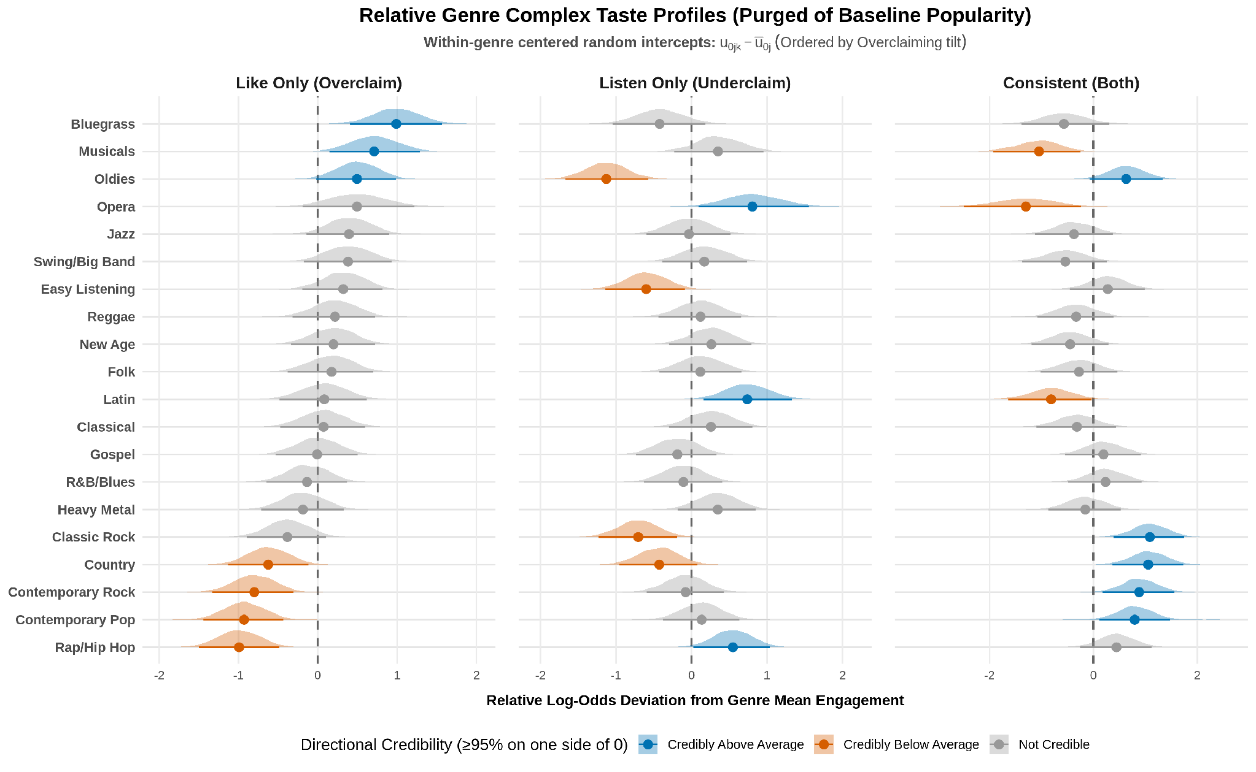
Figure 1. Relative Genre Engagement Profiles Purged of Baseline Popularity. Within-genre centered random intercepts showing log-odds deviations across complex taste configurations relative to genre mean engagement.
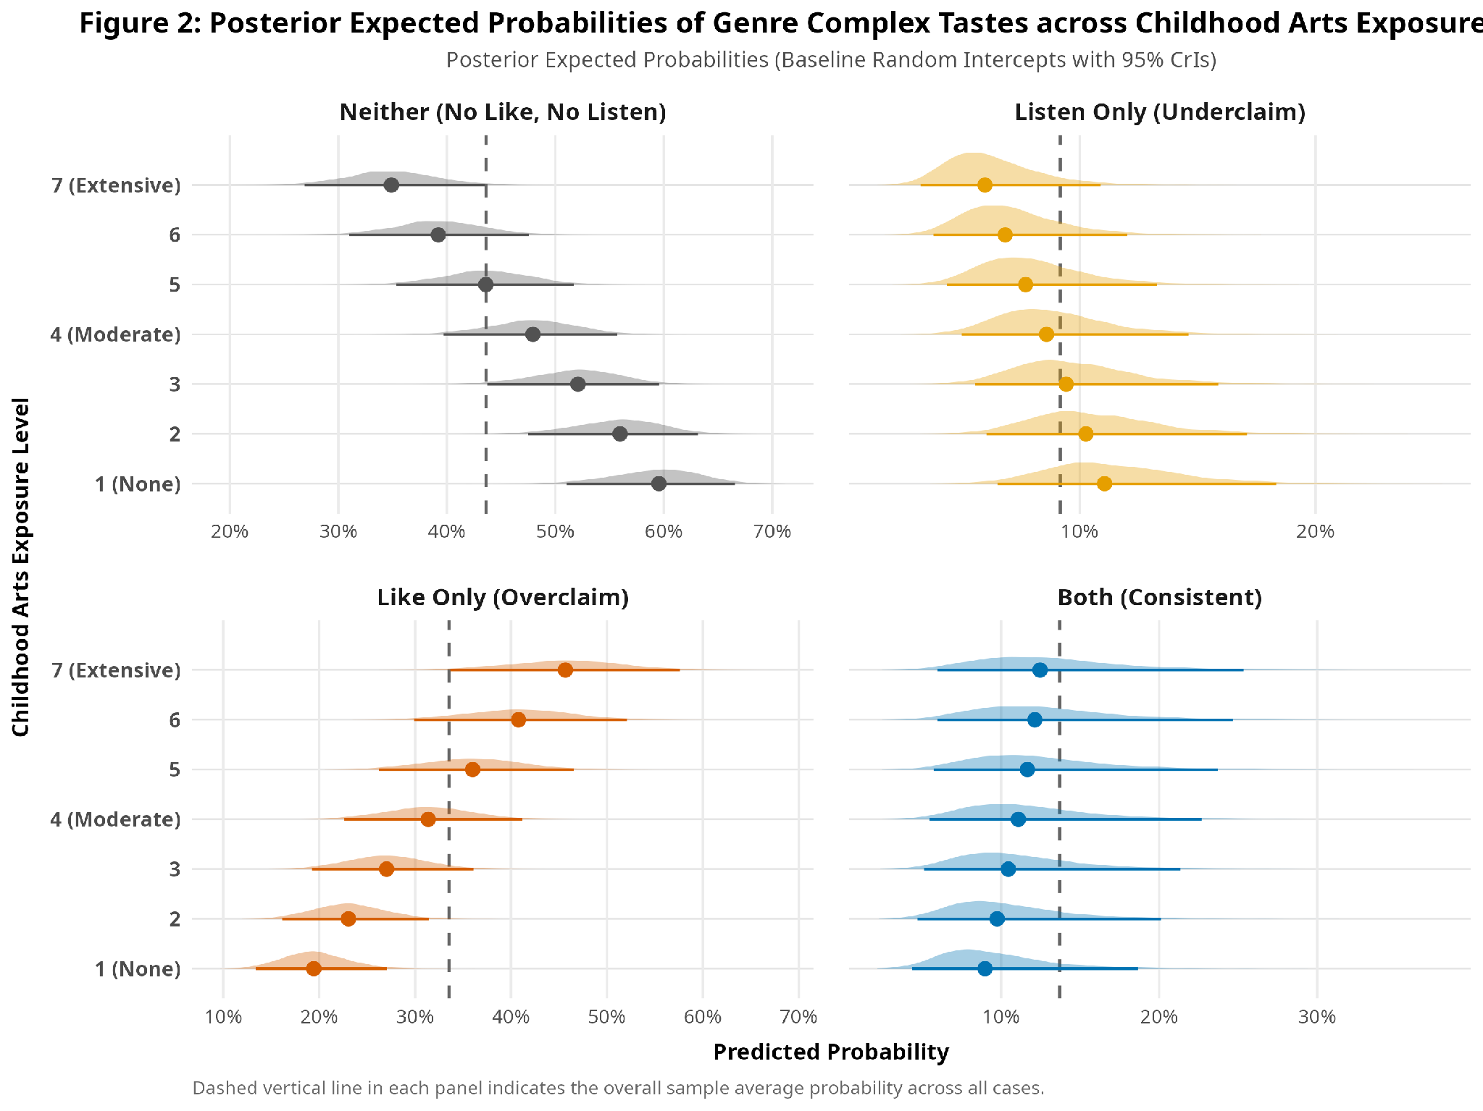
Figure 2. Posterior Expected Probabilities of Genre Complex Tastes across Childhood Arts Exposure Levels. Expected probabilities for each complex taste state computed across the childhood arts exposure scale using the Bayesian crossed random slopes model.
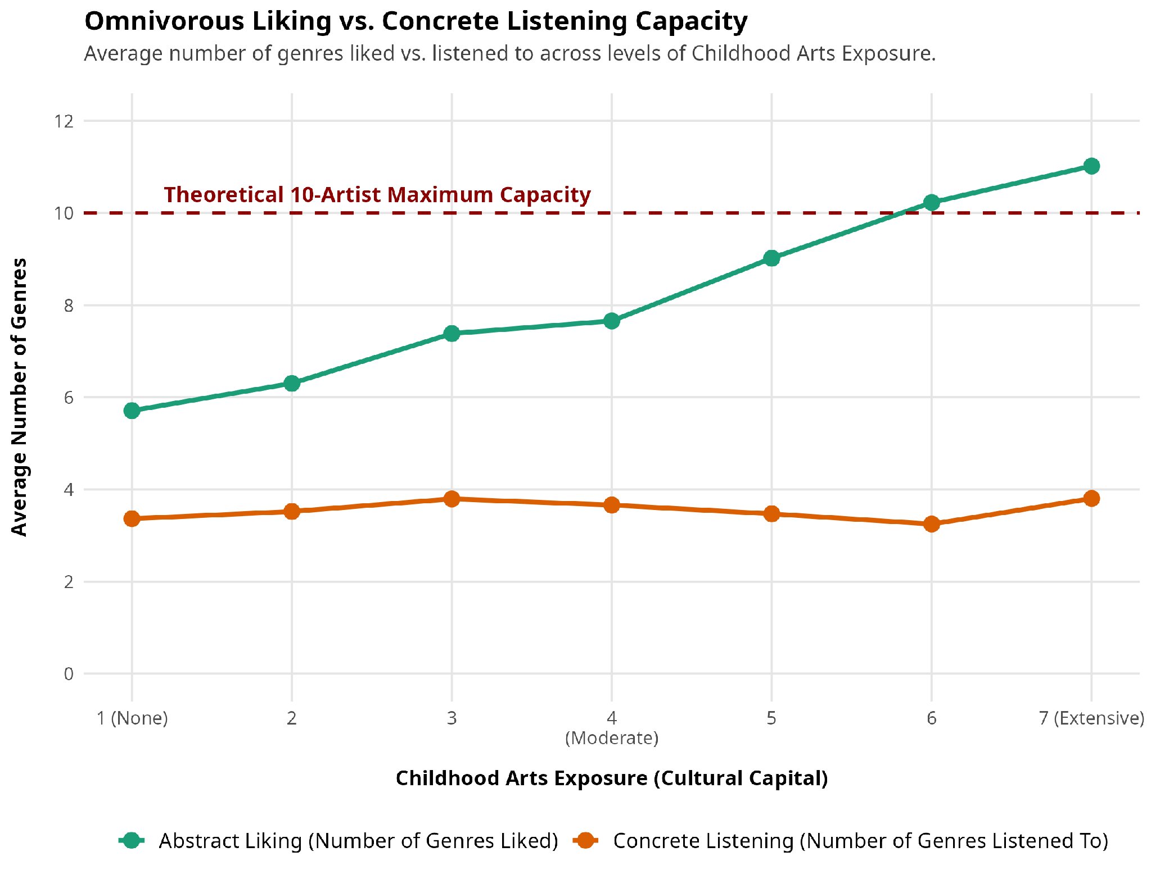
Figure 3. Divergence Between Stated Preferences and Concrete Listening Repertoires Across Levels of Cultural Socialization.
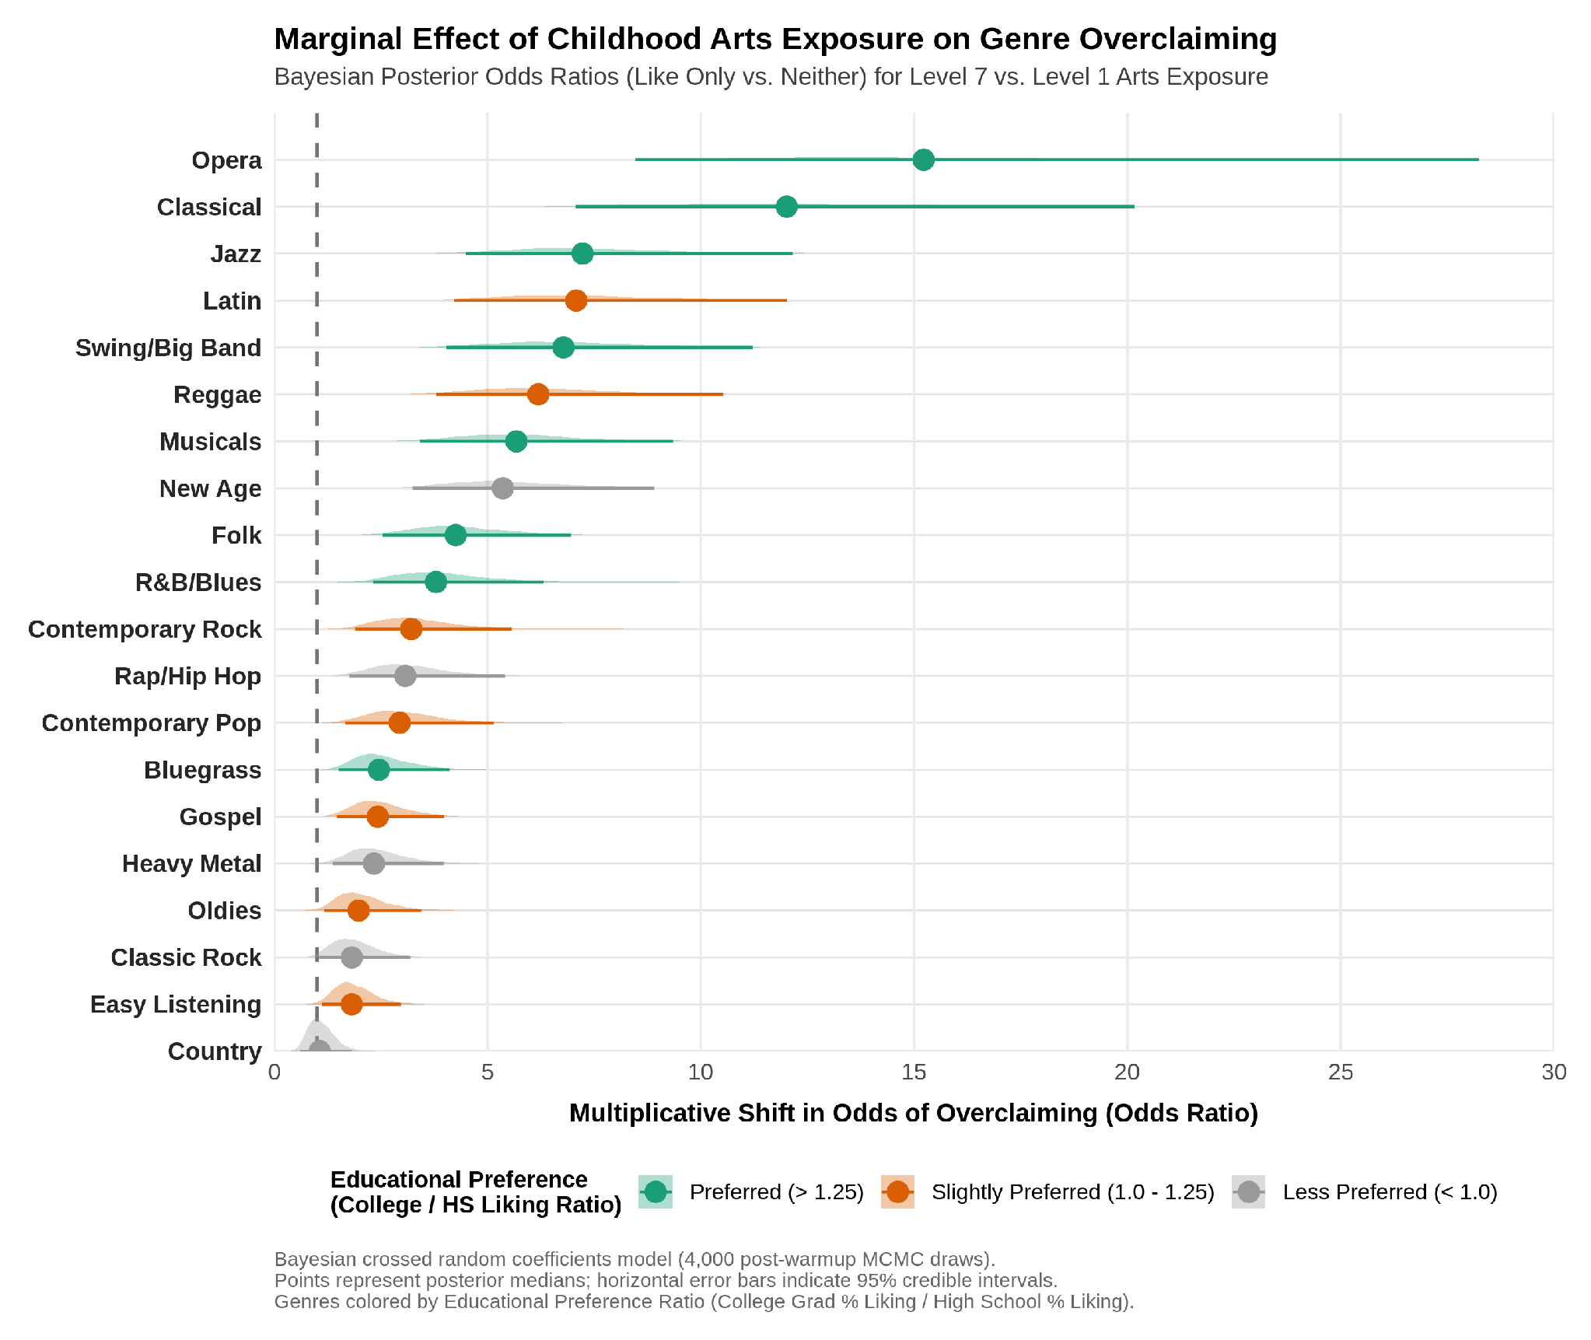
Figure 4. Genre-Specific Marginal Effects of Childhood Arts Exposure on Symbolic Overclaiming. Bayesian posterior odds ratios evaluating the shift in overclaiming odds for extensive versus absent childhood arts exposure across twenty musical genres.
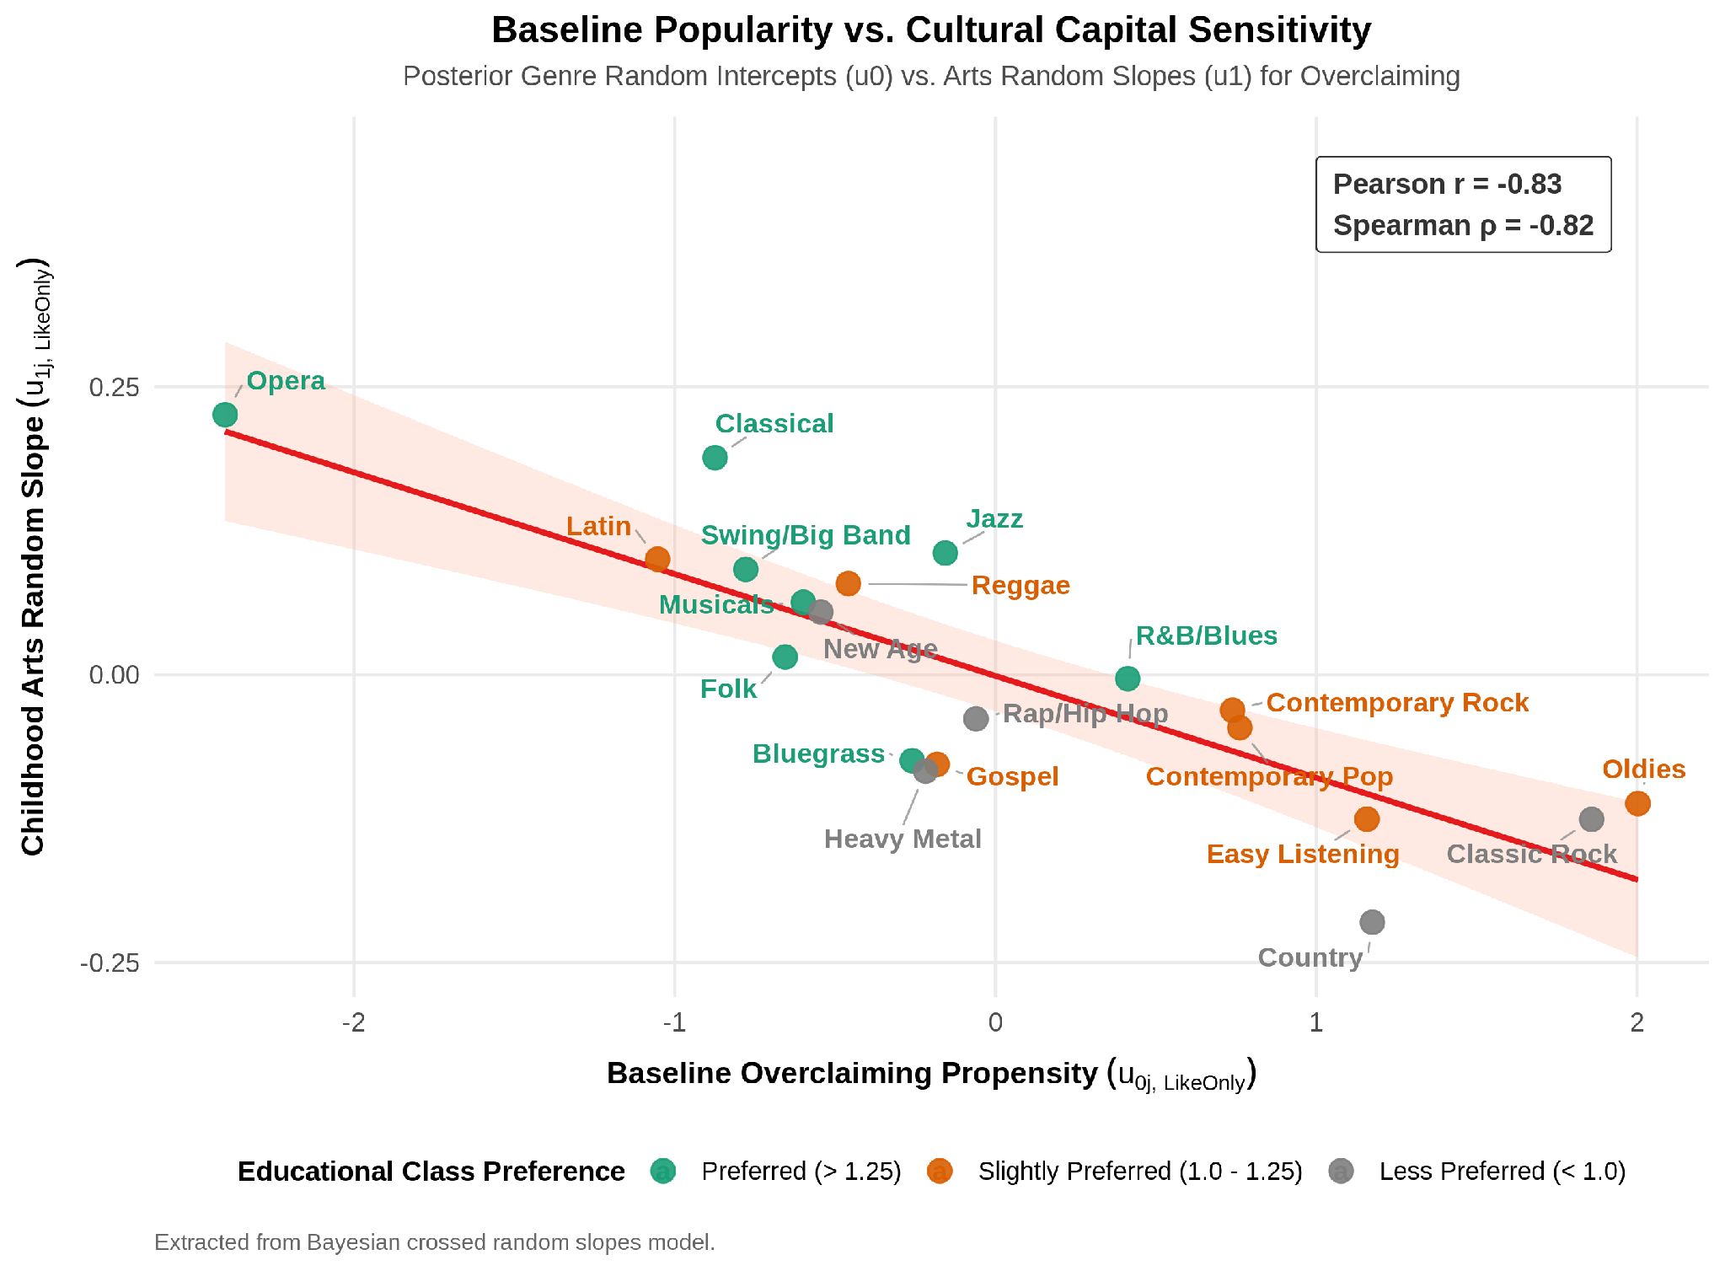
Figure 5. Structural Bivariate Association between Baseline Overclaiming Propensity and Cultural Capital Sensitivity. Scatterplot of posterior genre random intercepts against childhood arts exposure random slopes for the overclaiming equation.
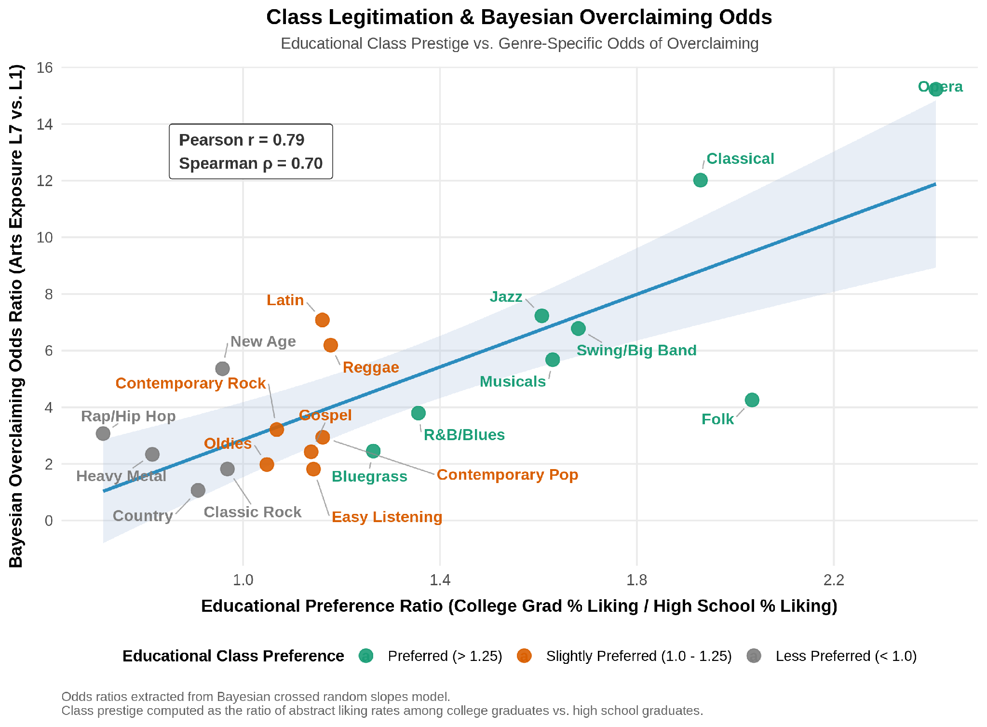
Figure 6. Class Legitimation and Bayesian Overclaiming Odds Ratios across Educational Prestige. Relationship between educational class prestige and genre-specific Bayesian odds ratios of overclaiming.

