Cross-Domain 2D Consensus Analysis
Analysis Report
By plotting the Location Intercept (x-axis: overall liking, or “chef-ness” for cuisine) against the Disc Parameter (y-axis: level of consensus vs. polarization), we can identify fascinating patterns in how cultural tastes are structured across domains.
Across all four domains, a recurring theme emerges: niche or “safe” categories tend to generate high consensus (agreement), while categories tied to strong cultural identities, fandoms, or extreme aesthetics drive massive polarization.

1. Cuisine Authenticity (Professional vs. Domestic)
Unlike the other domains, Cuisine’s x-axis measures whether a food is best prepared by a “Traditional Elder” (left) vs. a “Professional Chef” (right).
- The Polarized Extremes: French cuisine (x = 3.06) is viewed as the most “Professional” cuisine by far, but it is deeply polarized (y = -0.98). Conversely, Italian (x = -0.70) and Mexican (x = -1.33) lean domestic/elder, but are the most highly polarized in the dataset (y = -1.10). This indicates fierce cultural disagreement about how these globally ubiquitous foods should be produced.
- The High-Consensus Middle: Cuisines like Ethiopian, Pakistani, and Lebanese sit near the middle of the x-axis but feature the highest consensus (y ≈ 0.50). Because they are less universally ubiquitous in the US context, respondents agree more uniformly on their production norms.
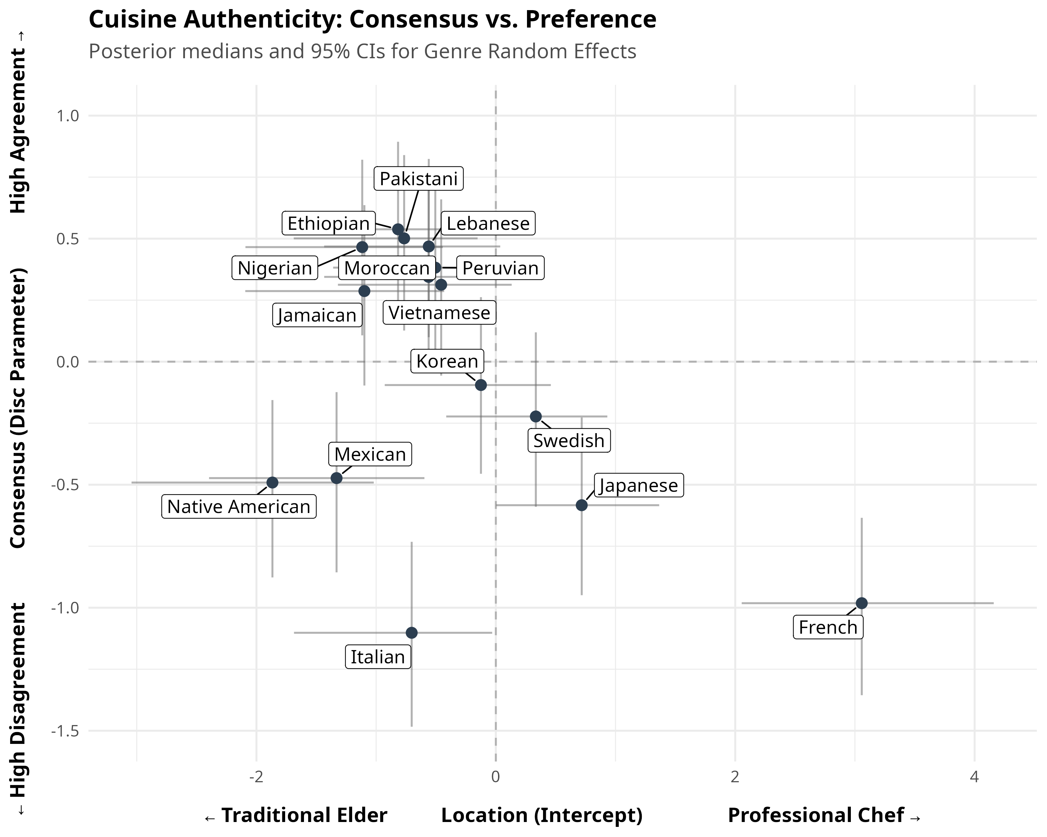
Cuisine 2D Consensus Plot

2. Music Taste (Like vs. Dislike)
- The Identity Polarizers: Rap (x = -1.66) and Heavy Metal (x = -3.07) are the most intensely polarizing genres in the entire project (y = -1.26 and -1.25, respectively). These are high-passion, identity-driven genres where listeners are strictly divided into “love it” or “hate it” camps.
- The “Safe” Consensus: Bluegrass, Folk, and Swing generate the highest consensus. They are mildly disliked on average, but almost everyone agrees on them—likely because they are non-offensive heritage genres that don’t trigger intense aesthetic tribalism.
- The Classic Rock Anomaly: Classic Rock is uniquely fascinating; it is the most universally liked genre (x = +4.63) but is still highly polarized (y = -0.62). This implies a floor effect: almost nobody hates it, but the variance between “it’s okay” and “it’s the greatest music ever” is massive.
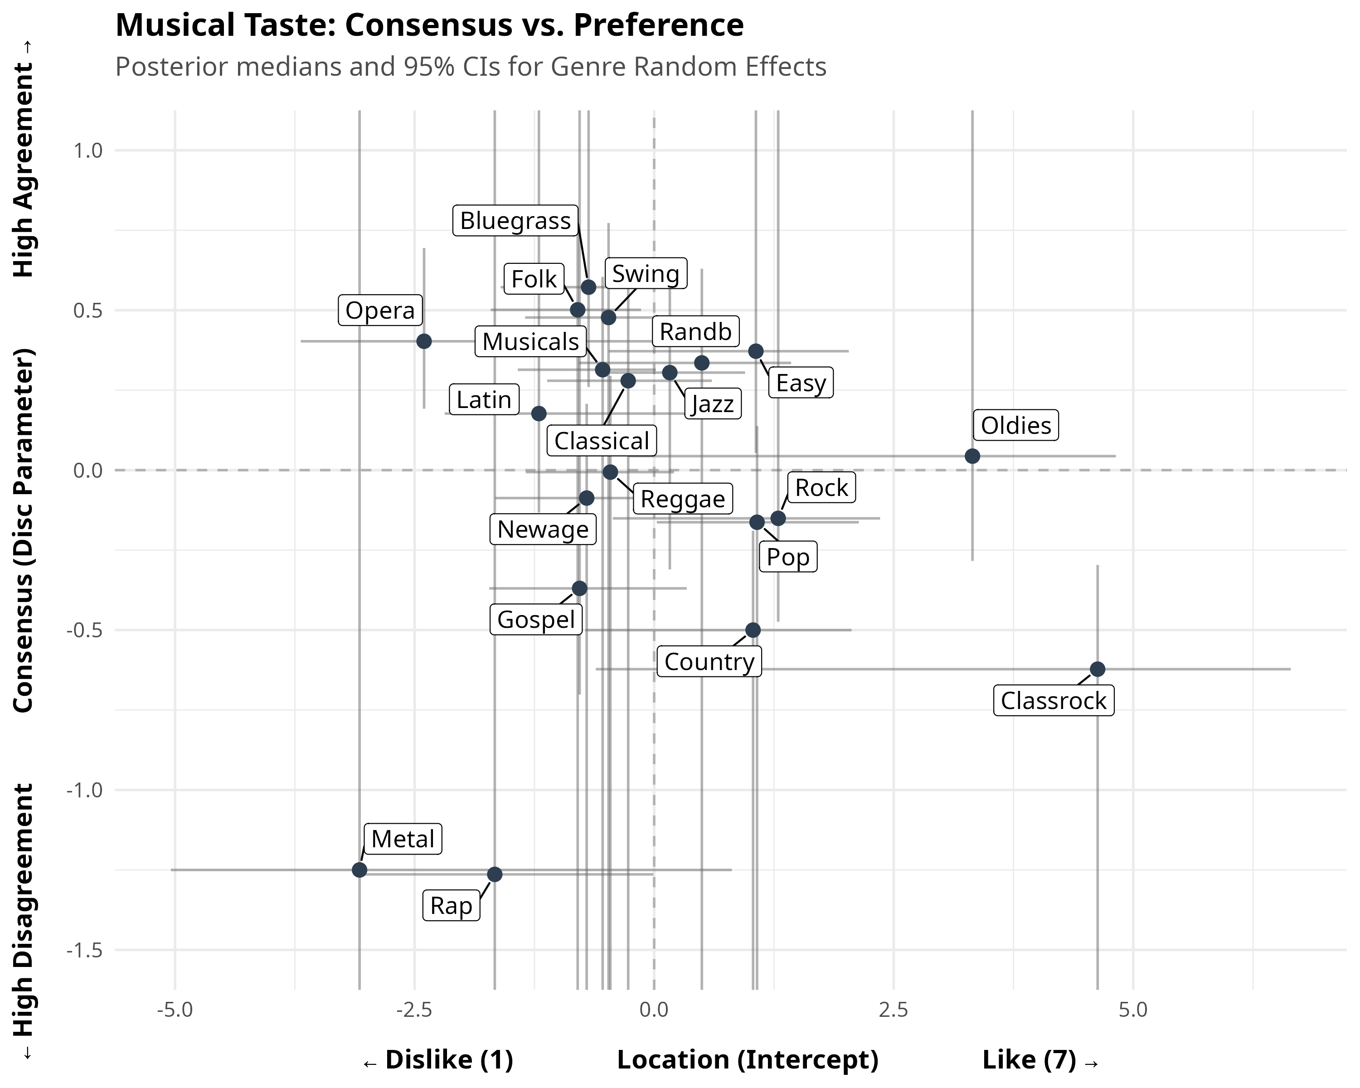
Music 2D Consensus Plot

3. Television Taste
- Broad Appeal = Consensus: TV shows the clearest relationship between broad-market appeal and consensus. Mainstream genres like Action and Drama are both highly liked and enjoy high consensus.
- The Fandom Effect: The most polarized TV genres are Horror (y = -0.80), Sports (y = -0.67), and Sci-Fi (y = -0.54). Much like Rap and Metal in music, these genres rely on dedicated, fanatic audiences while actively alienating viewers outside the fandom.
- Mundane Consensus: Genres like Game Shows and Talk Shows are mildly disliked but boast very high consensus. They are the background noise of television, generating uniform, mild distaste rather than passionate hatred.
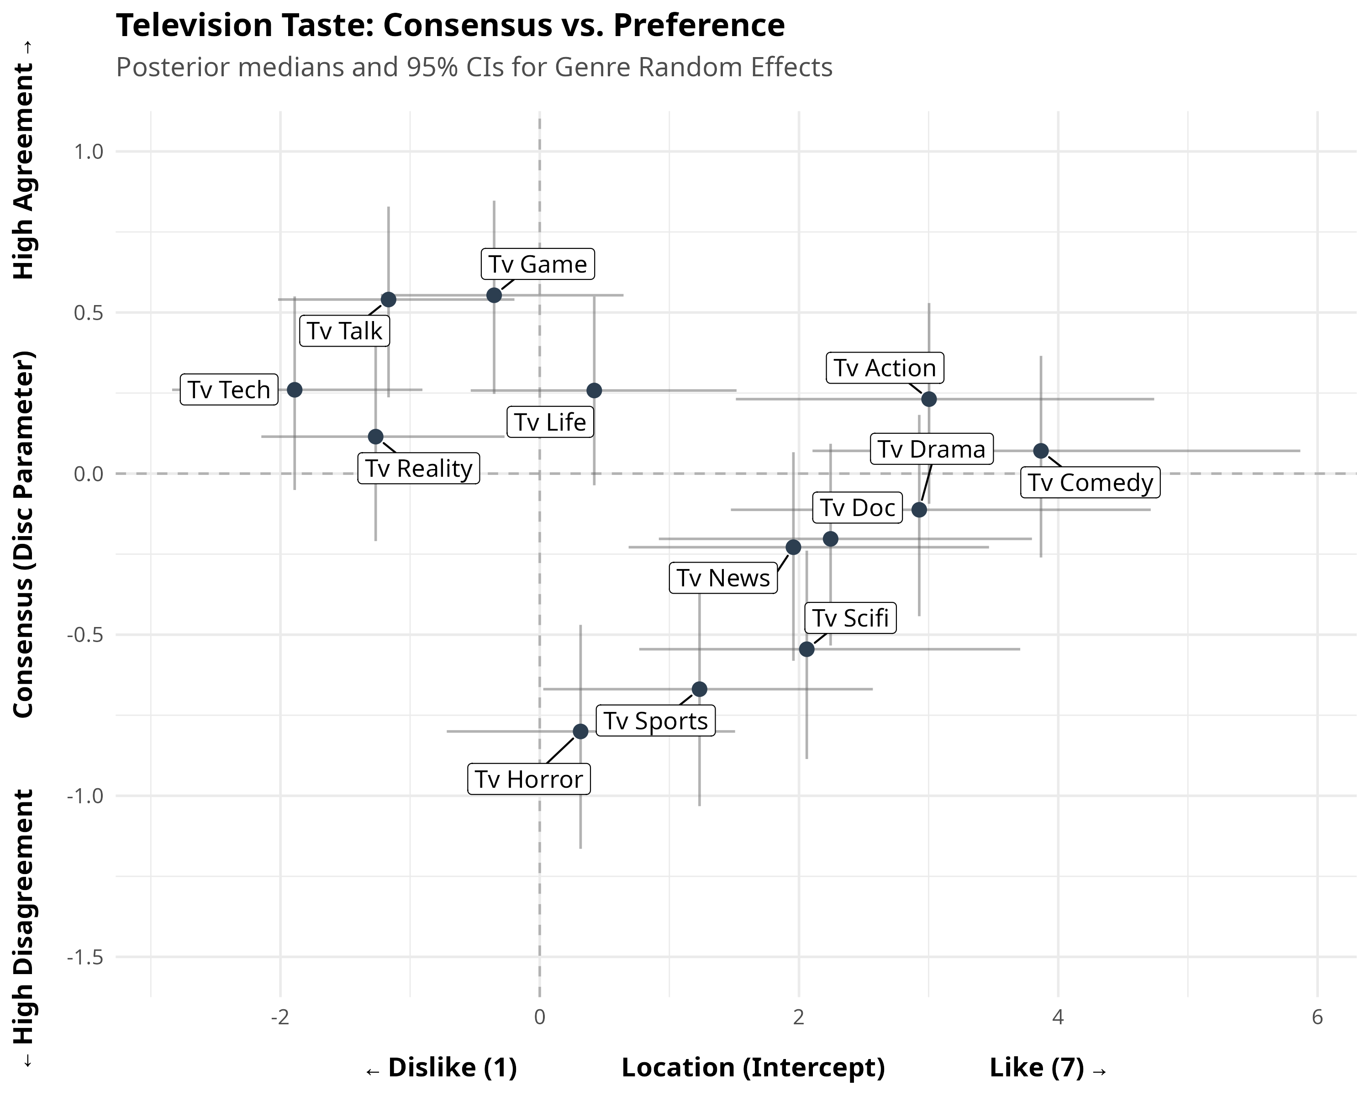
TV 2D Consensus Plot

4. Movie Taste
- The Polarized Auteur Genres: Horror again proves to be deeply polarizing (y = -0.64), alongside Musicals (y = -0.26) and Romance. These genres require a specific aesthetic buy-in from the viewer that fractures audiences.
- The Blockbuster Consensus: Movie audiences agree strongly on Action, Drama, and Crime (y > 0.30), which also happen to be highly liked. These represent the standard narrative backbone of Hollywood, producing highly uniform, agreeable audience reactions.
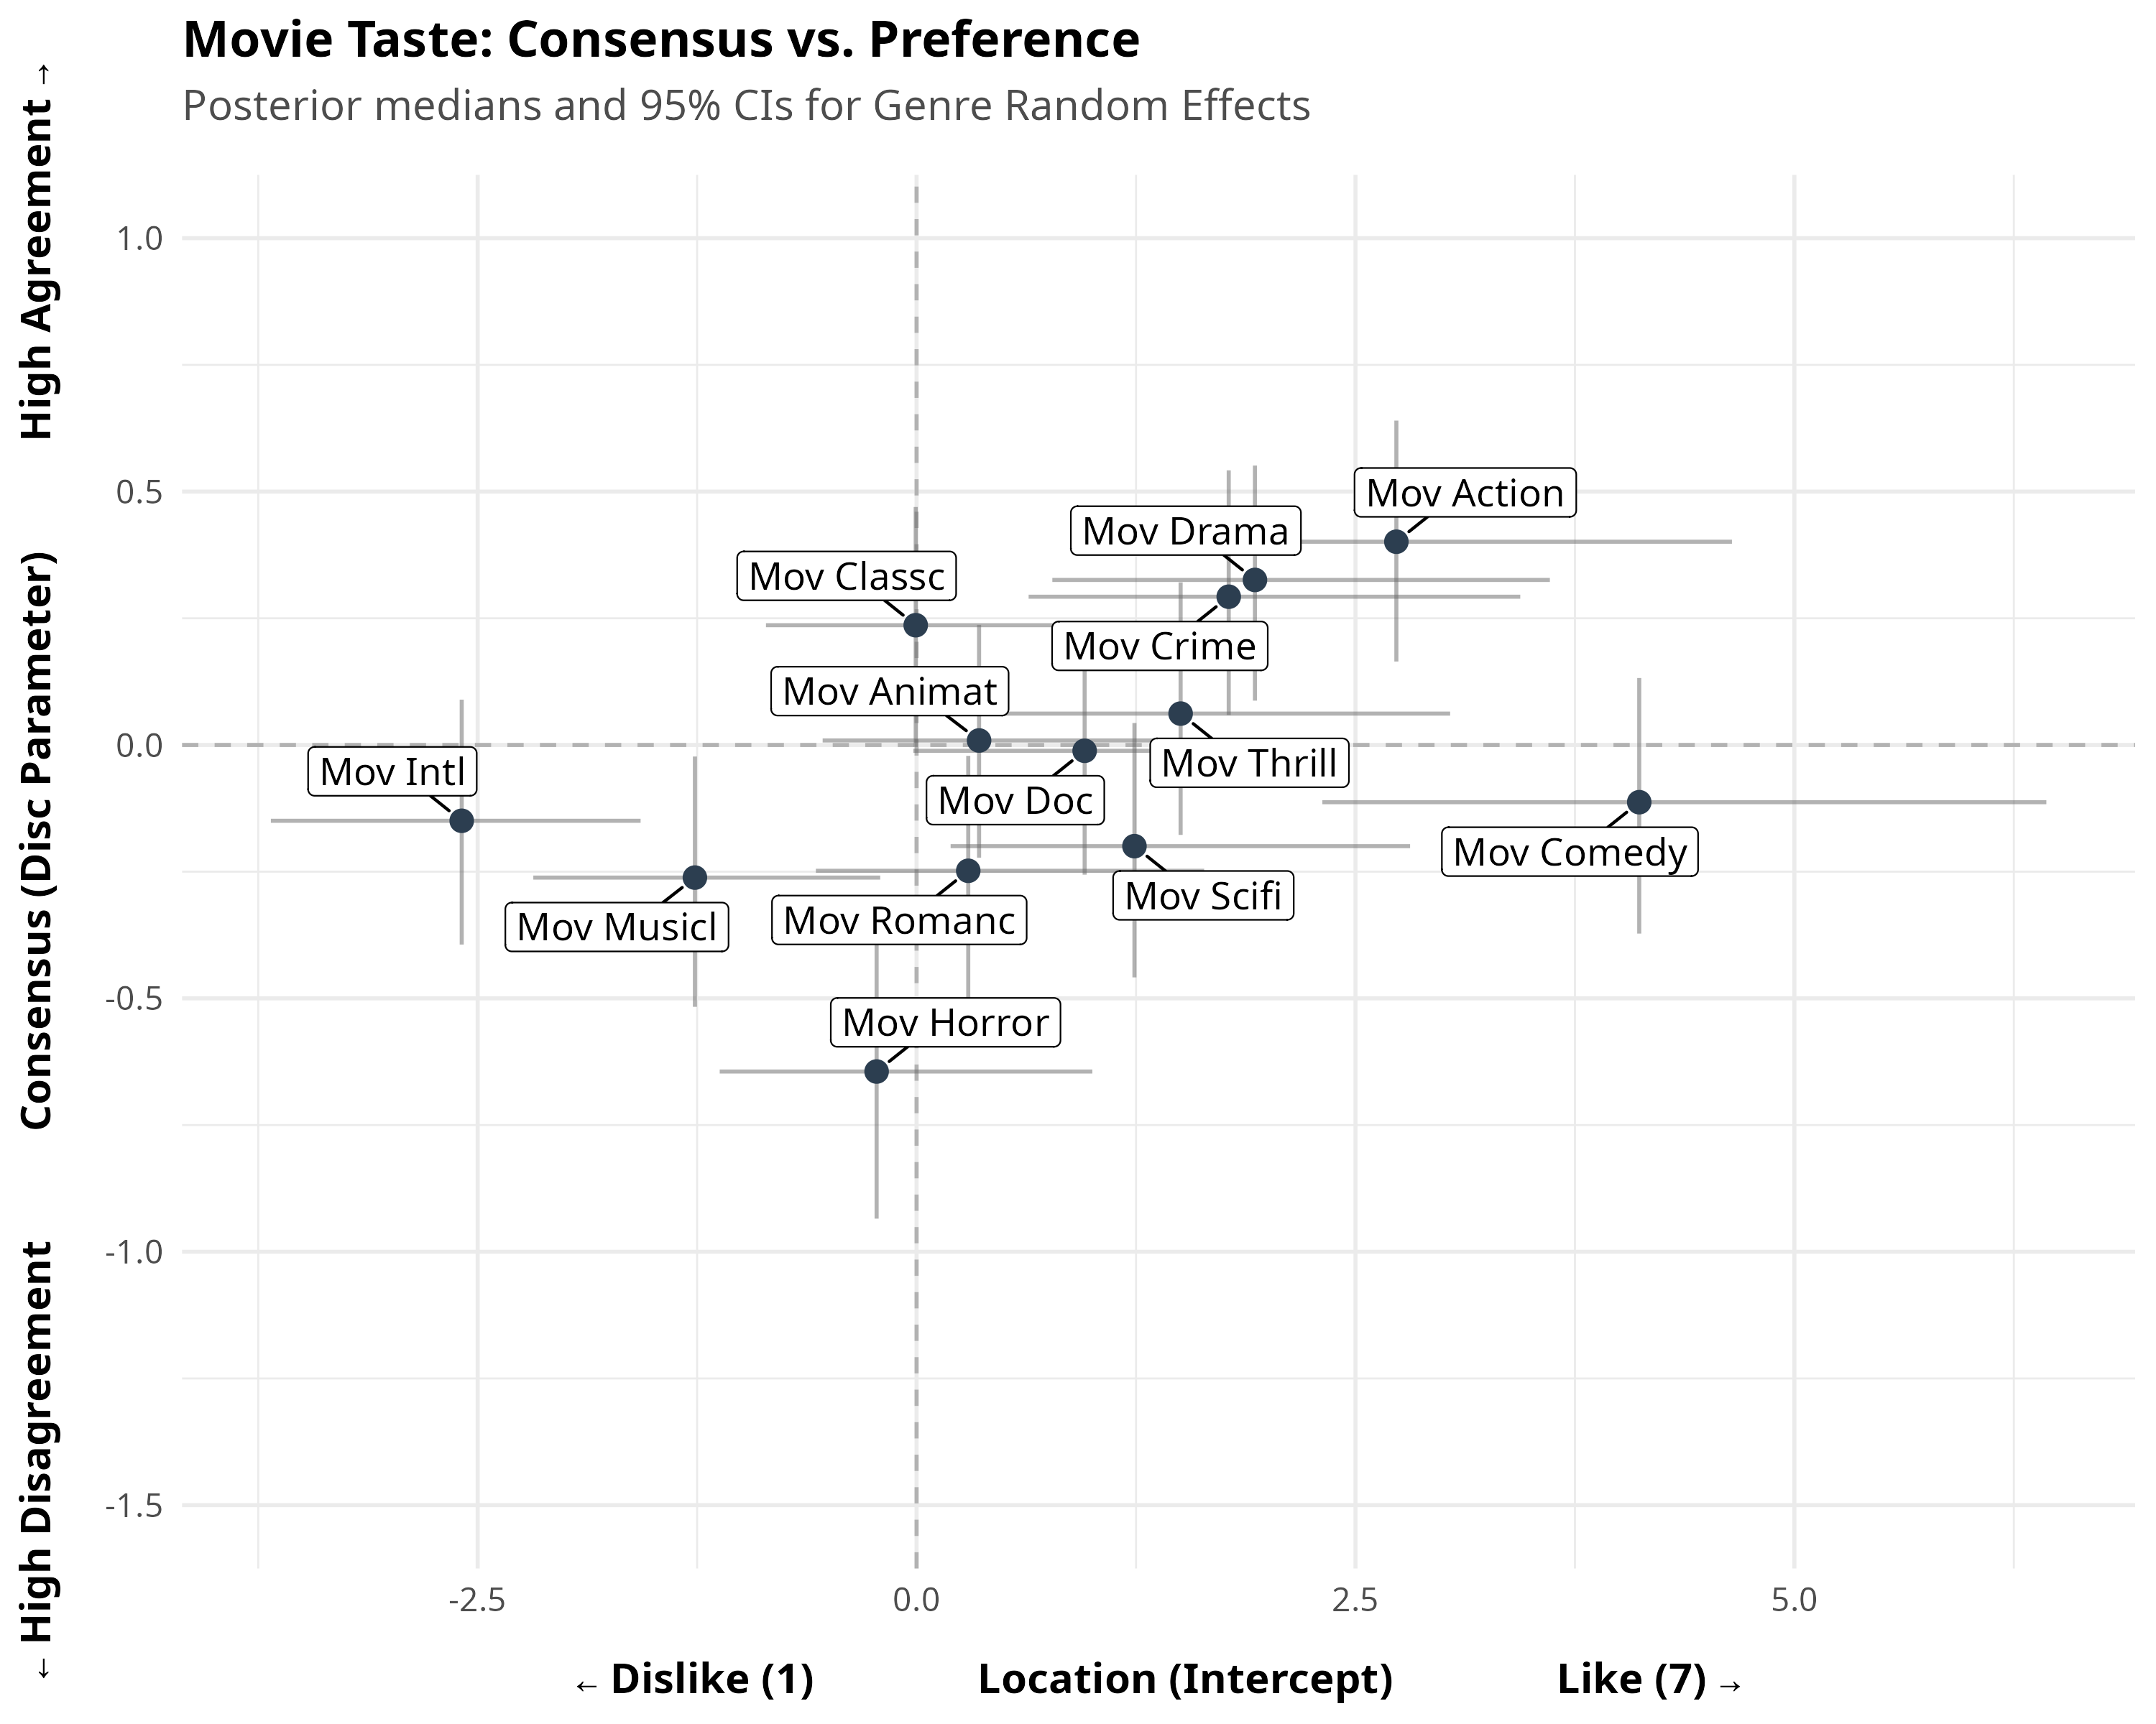
Movie 2D Consensus Plot

Summary
When looking at the plots side-by-side, Music and Cuisine exhibit much deeper vertical variance (polarization) than TV and Movies. People disagree far more vehemently about what music they identify with and how their food should be cooked than they do about what to watch on a screen. Screens drive consensus; food and music drive cultural tribalism.

