Omar Lizardo’s Academic Website - Homework I: Graph Theory

[Omar Lizardo’s Academic Website](../index.html)

* [Work](../pubs.html)
* [Blog](../blog.html)
* Teaching
  + [Social Networks (111) Textbook](https://olizardo.github.io/networks-textbook/)
  + [Classical Social Theory Lecture Notes](https://olizardo.github.io/classical-sociological-theory-notes/)
  + [SOCIOL 208B (Spring 2022)](../syllabi/SOCIOL208b-spring22.html)
  + [SOCIOL 204 (Sociological Theorizing)](../syllabi/SOCIOL204.html)
  + [SOCIOL 245 (Cultural Sociology)](../syllabi/SOCIOL245.html)
  + [SOCIOL 111 (Social Networks)](../syllabi/SOCIOL111.html)
* [Vita](../vita.pdf)
* [Bio](../bio.html)
* [Email](mailto:olizardo@soc.ucla.edu)

## On this page

* Vertex and edge sets
* Node Neighborhoods
* Node Degree
* Subgraphs

[View source](https://github.com/olizardo/mysite/blob/main/soc-111-homeworks/homework1-answered.qmd)

# Homework I: Graph Theory

## Vertex and edge sets

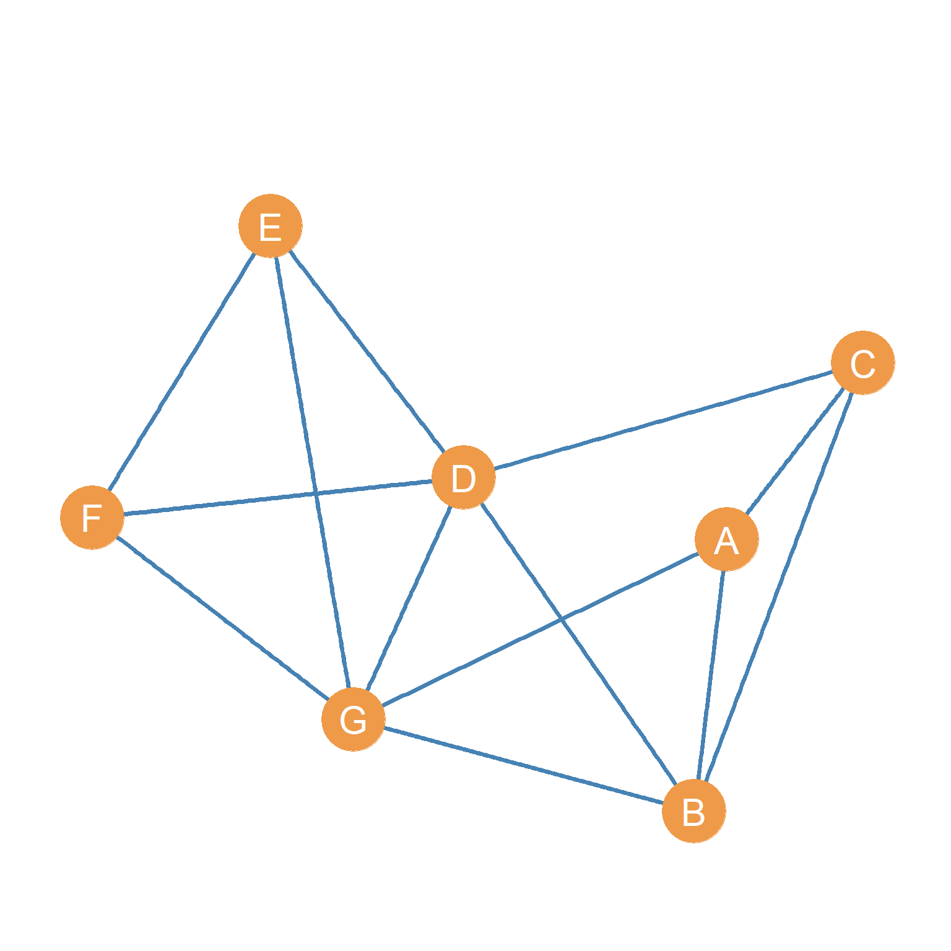

Figure 1: A simple graph.

Consider the graph shown in Figure 1:

1. Write down the **vertex set** of the graph:  
   A, B, C, D, E, F, G, H  
   VA, VB, VC, VD, VE, VF, VG, VH
2. Write down the **edge set** of the graph:

|  |  |  |  |  |  |  |  |  |  |  |  |  |  |  |  |
| --- | --- | --- | --- | --- | --- | --- | --- | --- | --- | --- | --- | --- | --- | --- | --- |
| AB | AC | BC | BD | CD | DE | DF | EF | AG | BG | DG | EG | FG | AH | CH | EH |

## Node Neighborhoods

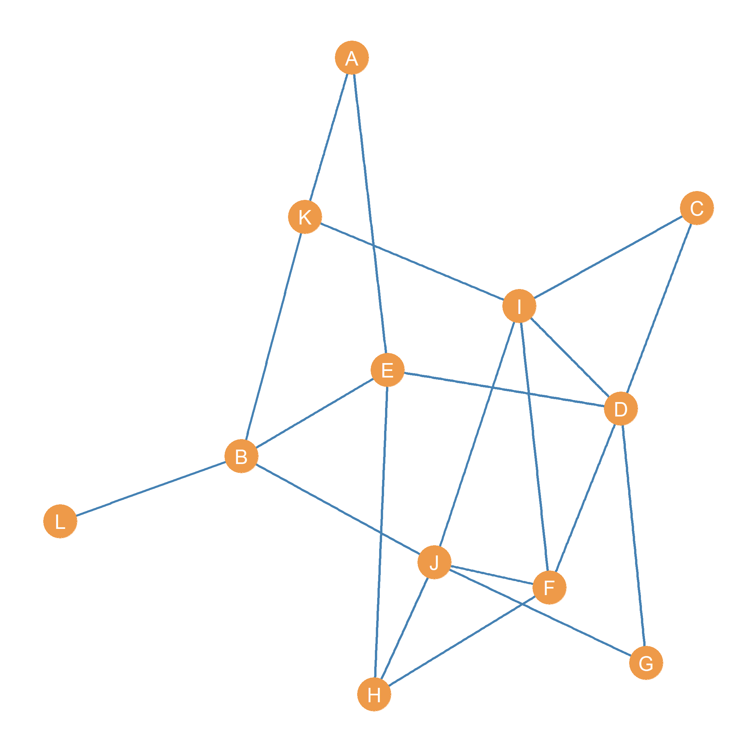

Figure 2: Another simple graph.

Consider the graph shown in Figure 2:

1. Write down the **neighborhood** of node *D*  
   C, E, F, G, I
2. Write down the **neighborhood** of node *K*  
   A, B, I
3. What is the **intersection** of the neighborhoods of nodes *D* and *I*?  
   C, F
4. What is the **intersection** of the neighborhoods of nodes *E* and *F*?  
   D, H
5. What is the **union** of the neighborhoods of nodes *H* and *J*?  
   A, B, D, H, I, J

## Node Degree

Consider the graph shown in Figure 2:

1. What is the **degree** of node *B*?  
   4
2. What is(are) the node(s) with the largest **degree**?  
   5
3. What is(are) the node(s) with the smallest **degree**?  
   1

## Subgraphs

1. Go back to Figure 1. Draw the **node-deleted** subgraph of this graph that *excludes* nodes *D* and *G*

