Omar Lizardo’s Academic Website - Homework I: Graph Theory

[Omar Lizardo’s Academic Website](../index.html)

* [Work](../pubs.html)
* [Blog](../blog.html)
* Teaching
  + [Social Networks (111) Textbook](https://olizardo.github.io/networks-textbook/)
  + [SOCIOL 111 (Social Networks Undergraduate Class)](../syllabi/SOCIOL111.html)
  + [SOCIOL 204 (Topics in Sociological Theorizing Reading List)](../syllabi/SOCIOL204.html)
  + [SOCIOL 204 (Topics in Sociological Theorizing Spring 2025)](../syllabi/SOCIOL204-sp25.html)
  + [SOCIOL 208A & 208B (Computational Social Networks Sequence)](https://olizardo.github.io/SOCIOL208/)
  + [SOCIOL 245 (Cultural Sociology)](../syllabi/SOCIOL245.html)
* [Vita](../vita.pdf)
* [Bio](../bio.html)
* [Email](mailto:olizardo@soc.ucla.edu)

## On this page

* Vertex and edge sets
* Node Neighborhoods
* Graph Metrics
* Subgraphs

[View source](https://github.com/olizardo/mysite/blob/main/soc-111-homeworks/homework1.qmd)

# Homework I: Graph Theory

## Vertex and edge sets

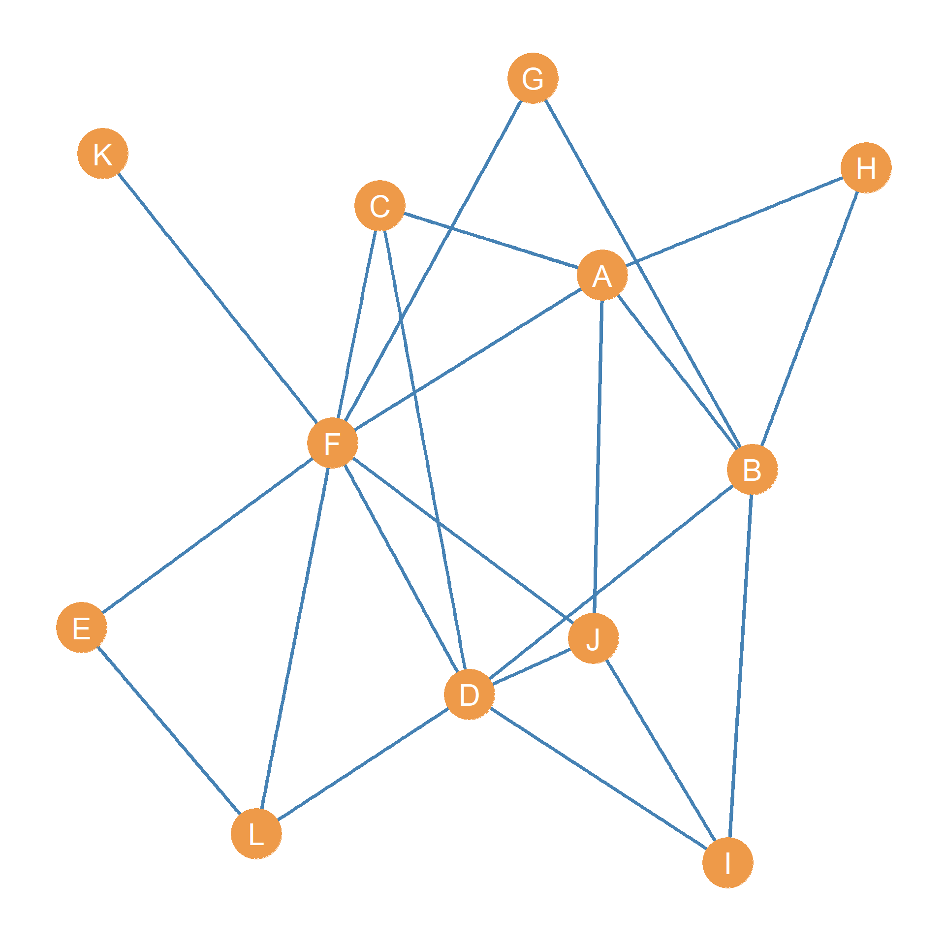

Figure 1: A simple graph.

Consider the graph shown in Figure 1:

1. Write down the **vertex set** of the graph:
2. Write down the **edge set** of the graph:

## Node Neighborhoods

1. Write down the **neighborhood** of node **F**
2. Write down the **neighborhood** of node **J**
3. What is the **intersection** of the neighborhoods of nodes **F** and **J**?
4. What is the **intersection** of the neighborhoods of nodes **A** and **F**?
5. What is the **union** of the neighborhoods of nodes **H** and **J**?

## Graph Metrics

1. What is the **order** of the graph?
2. What is the **size** of the graph?
3. Write down the graph’s **degree sequence**:
4. Write down the graph’s **maximum Degree**:
5. Write down the graph’s **minimum degree**:
6. What is the graph’s **degree range**?
7. What is the graph’s **sum of degrees**?
8. What is the graph’s **average degree**?
9. What is the graph’s **maximum size**?
10. Compute the **density** of the graph:

## Subgraphs

1. Go back to Figure 1. Draw the **node-deleted** subgraph of this graph that *excludes* nodes *D*, *F*, and *J*
2. List the **isolate** nodes in the node-deleted subgraph you obtained in the previous step.