# Homework II: Directed Graphs

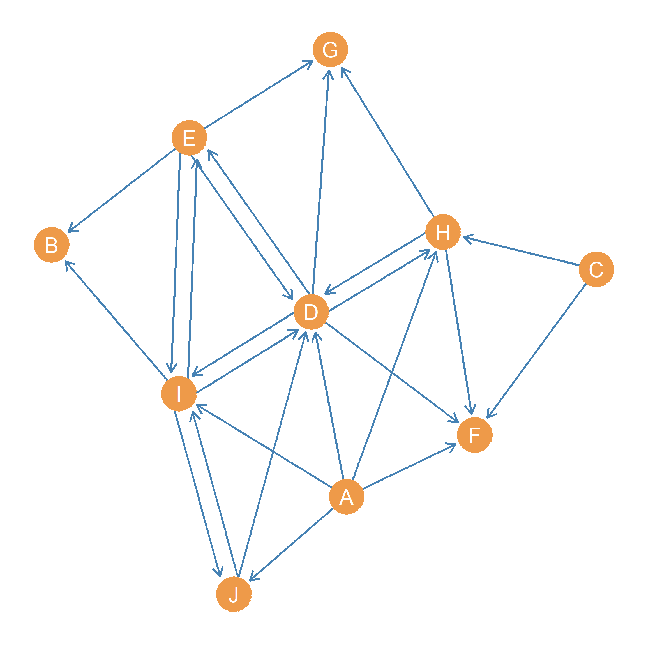

Figure 1: A directed graph.

Consider the graph shown in Figure 1:

1. Write down the **edge set** of the graph:
2. Who are the **out-neighbors** of node *A*?
3. Who are the **in-neighbors** of node *D*?
4. What is the **intersection** of the **out-neighborhoods** of nodes *D* and *A*?
5. What is the **intersection** of the **in-neighborhoods** of nodes *D* and *F*?
6. What is the **union** of the **out-neighborhoods** of nodes *E* and *A*?
7. What is the **union** of the **in-neighborhoods** of nodes *D* and *F*?
8. What is the **out-degree** of node *E*?
9. What is the **in-degree** of node *D*?
10. What is(are) the node(s) with the largest **out-degree**?
11. What is(are) the node(s) with the largest **in-degree**?
12. What is(are) the node(s) with the smallest **out-degree**?
13. What is(are) the node(s) with the smallest **in-degree**?
14. Which is(are) the **receiver node(s)** in the graph?
15. Which is(are) the **transmitter node(s)** in the graph?
16. Write down the set of **mutual dyads** in the graph:
17. What type of **dyad** is formed by the subgraph containing nodes *C* and *F*?
18. What type of **dyad** is formed by the subgraph containing nodes *B* and *C*?
19. What type of **dyad** is formed by the subgraph containing nodes *E* and *I*?
20. How many **mutual dyads** are there in the graph?