# Homework III: Graph Metrics

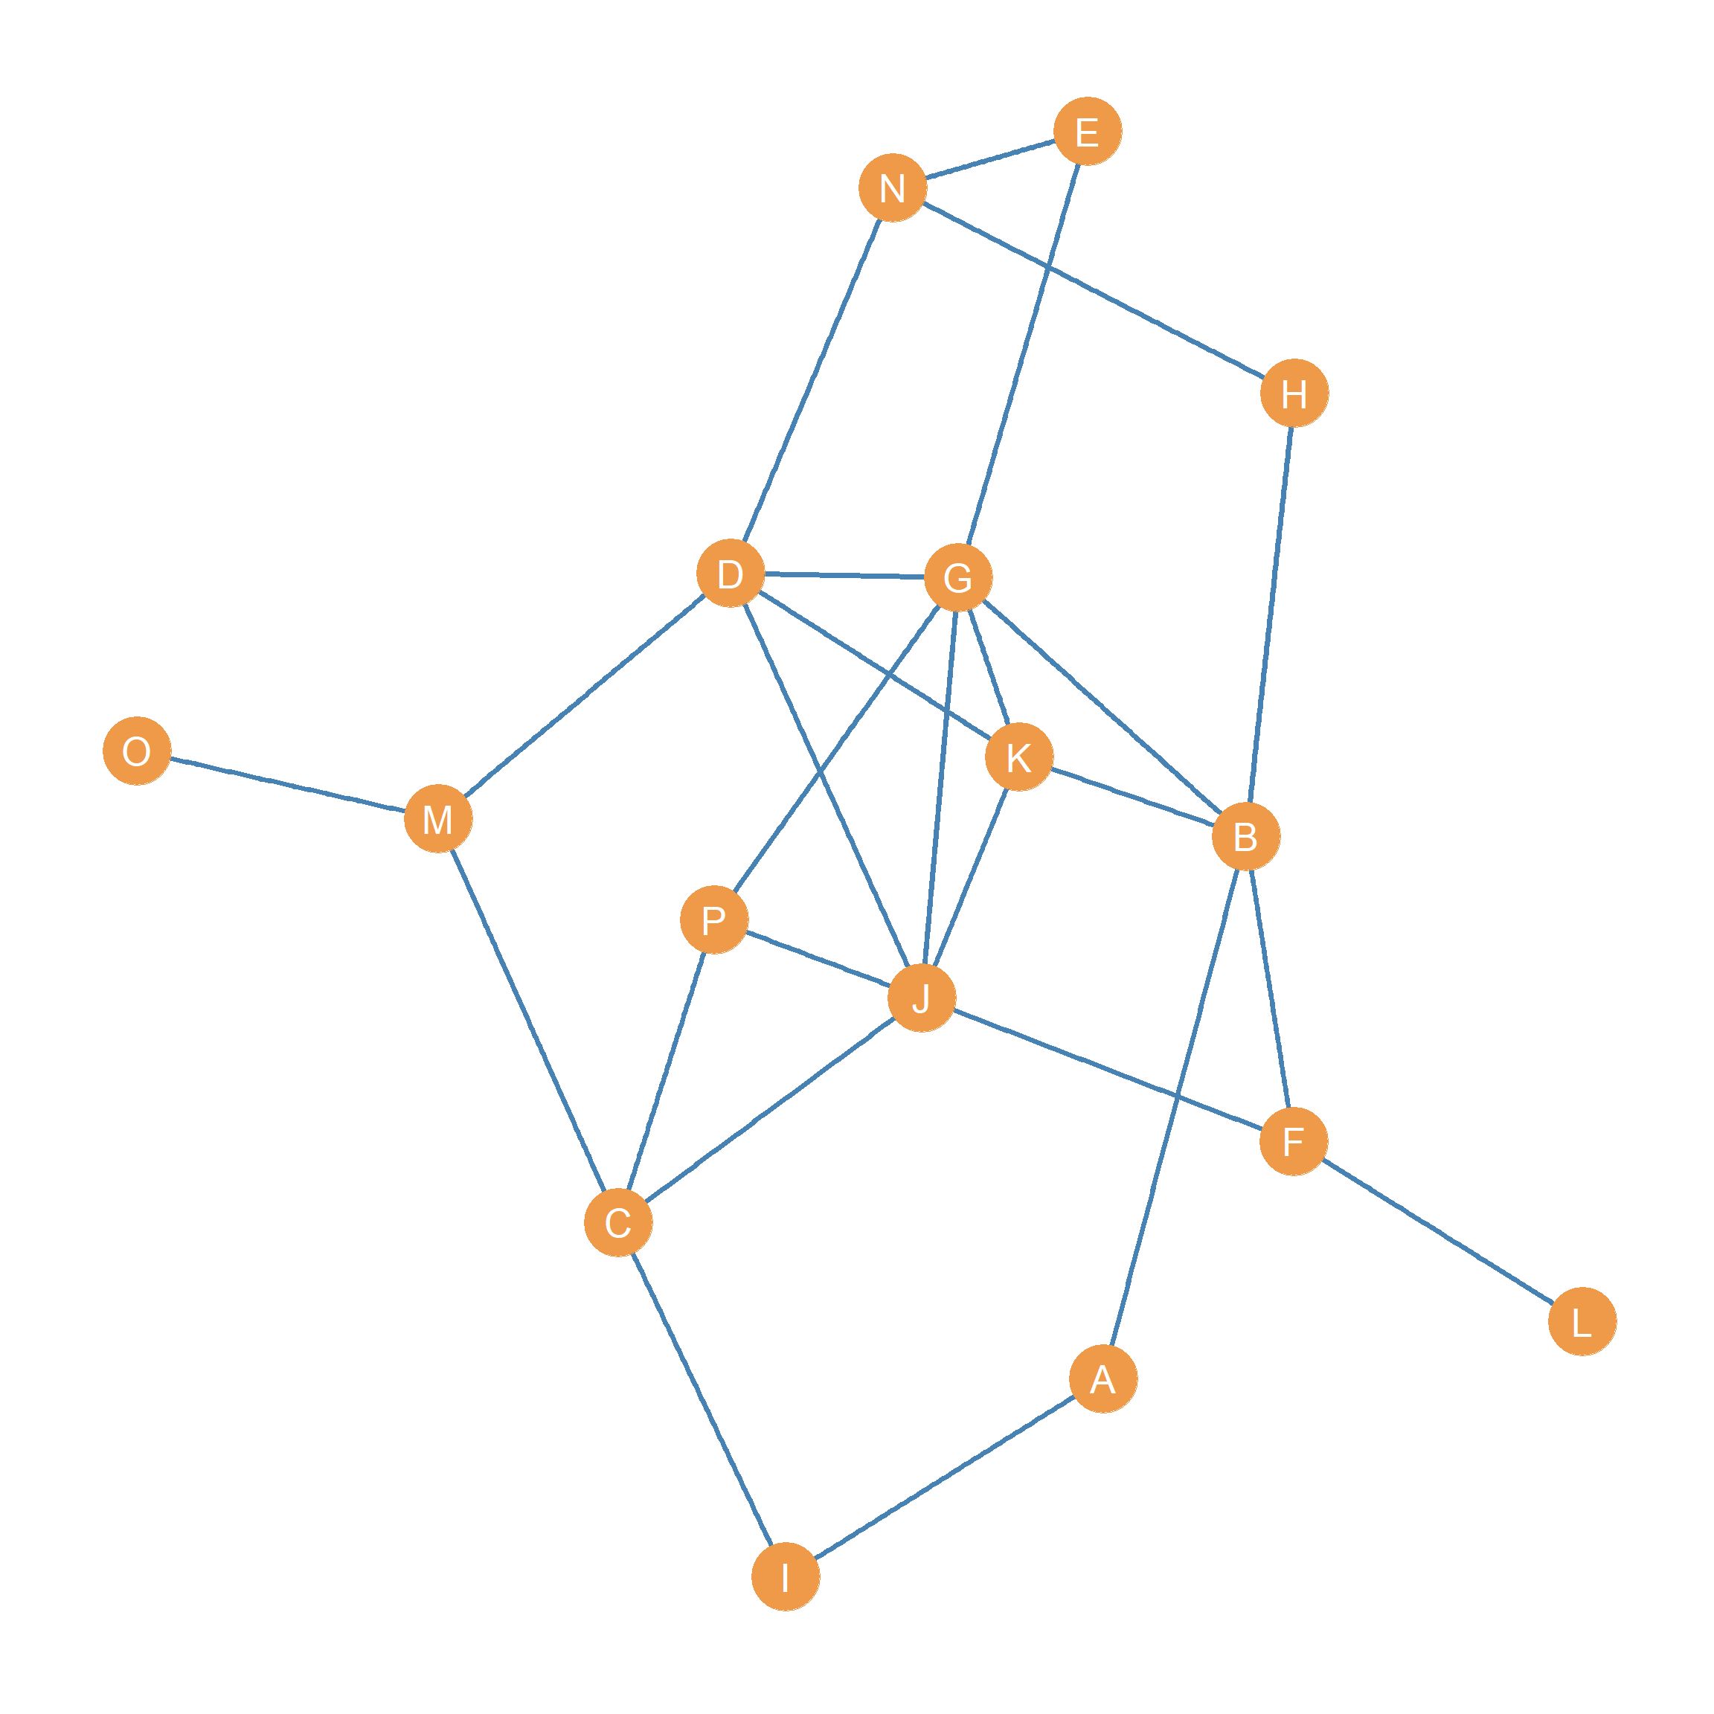

Figure 1: An undirected graph.

Consider the graph shown in Figure 1:

1. What is the **order** of the graph?
2. Write down the graph’s **degree sequence**:
3. What is the graph’s **degree range**?
4. What is the graph’s **sum of degrees**?
5. What is the **size** of the graph?
6. What is the graph’s **average degree**?
7. What is the graph’s **maximum size**?
8. Compute the **density** of the graph:

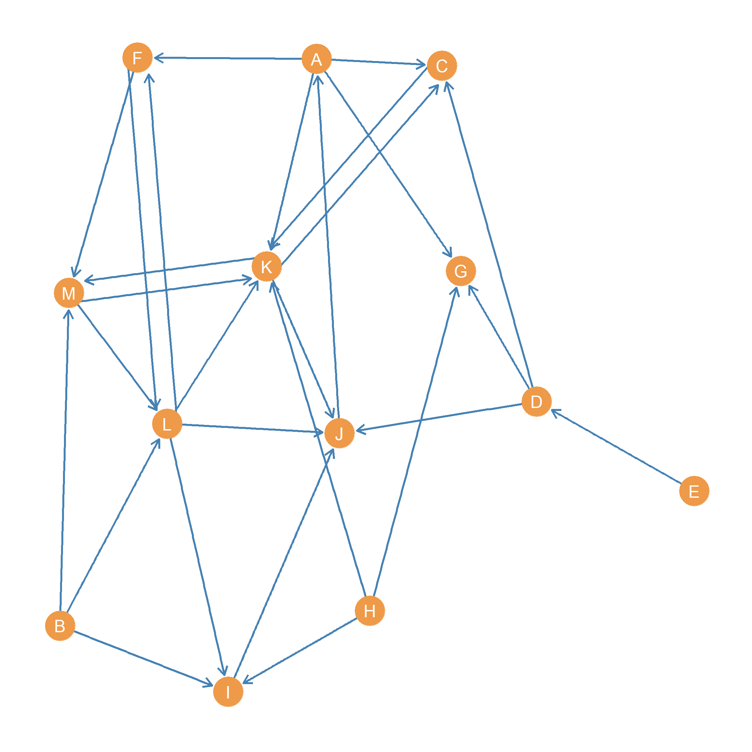

Figure 2: A directed graph.

Consider the graph shown in Figure 2:

1. What is the graph’s **out-degree sequence**?
2. What is the graph’s **in-degree sequence**?
3. What is the graph’s **out-degree range**?
4. What is the graph’s **in-degree range**?
5. What is the graph’s **sum of degrees**?
6. What is the **size** of the graph?
7. What is the graph’s **maximum size**?
8. Compute the **density** of the graph: