# Homework IV: Indirect Connections and Matrices

## Indirect Connections

Consider the graph shown in Figure 1:

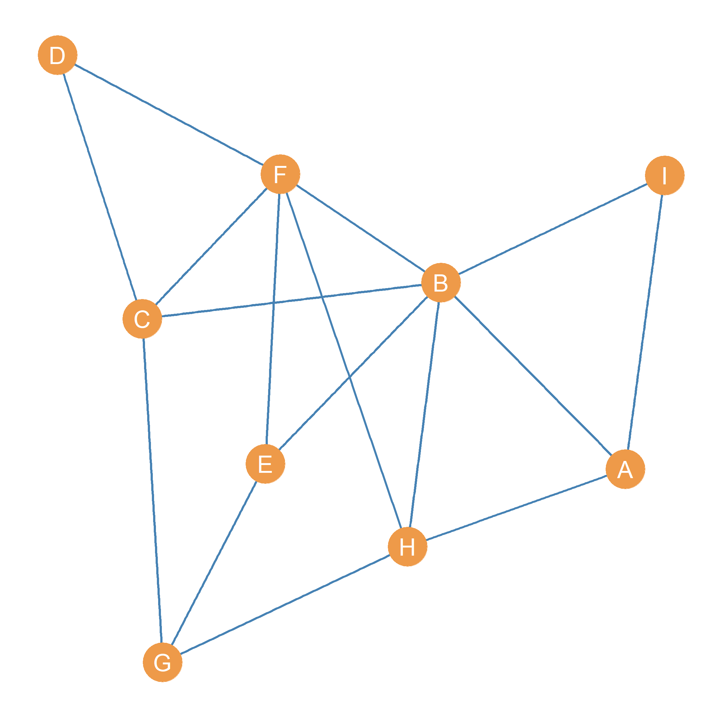

Figure 1: An undirected graph.

1. Write down *all* the **paths** of length four (l = 4) connecting node *G* and node *F*:
2. Write down *all* the **paths** of length two (l = 2) featuring node *B* as the **inner node**:
3. Write down all the **shortest paths** connecting nodes *G* and *I*:
4. Write down one **cycle** of length six that starts and ends with node *C*:

## Directed Paths

Consider the graph shown in Figure 2:

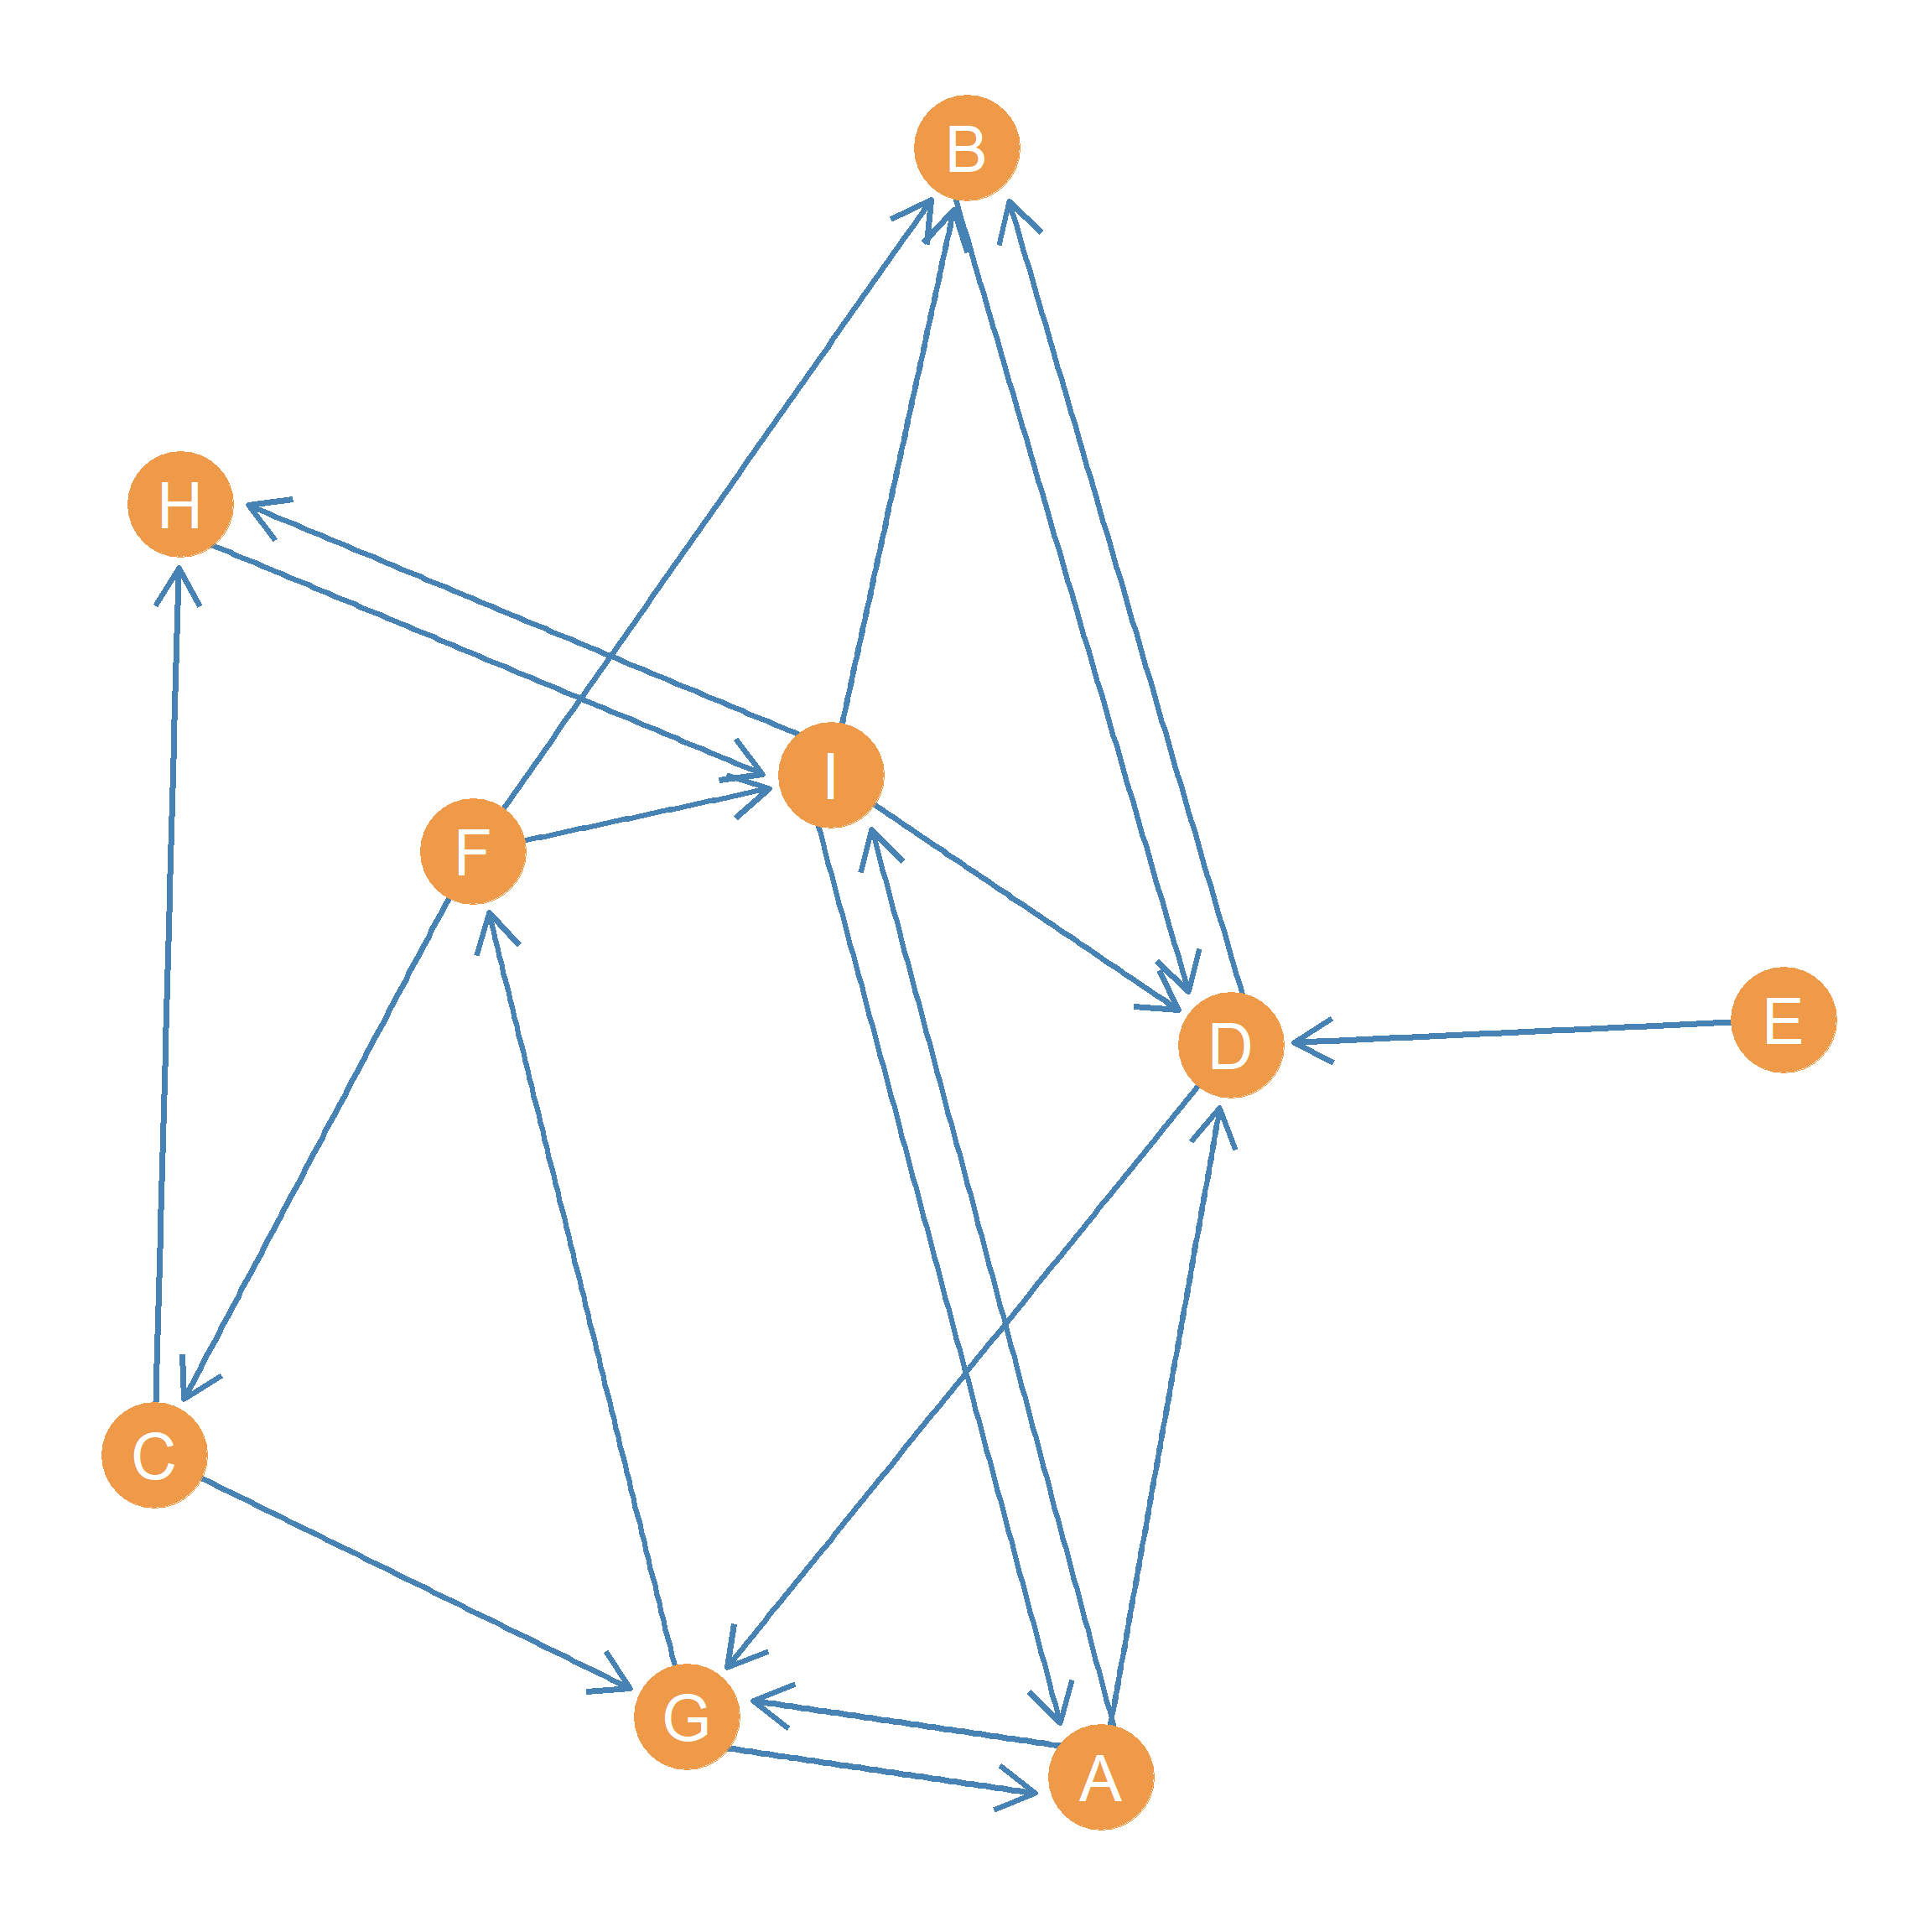

Figure 2: A directed graph.

1. Write down *all* the **directed path(s)** going *from* node *G* *to* node *B*:
2. What is the length of the **shortest directed path(s)** connecting going *from* node *A* *to* node *C*?
3. If *B* wanted to send a message to *H* in the most efficient way, how many intermediaries would *B* have to use?
4. Write down a directed **cycle** of length five (l = 5) starts and ends with node *D*:

## Matrices

* In the matrix below, write down the cell entries for the **adjacency matrix** corresponding to the graph shown in Figure 2:

|  |  |  |  |  |  |  |  |  |  |
| --- | --- | --- | --- | --- | --- | --- | --- | --- | --- |
|  | A | B | C | D | E | F | G | H | I |
| A | ---- |  |  |  |  |  |  |  |  |
| B |  | ---- |  |  |  |  |  |  |  |
| C |  |  | ---- |  |  |  |  |  |  |
| D |  |  |  | ---- |  |  |  |  |  |
| E |  |  |  |  | ---- |  |  |  |  |
| F |  |  |  |  |  | ---- |  |  |  |
| G |  |  |  |  |  |  | ---- |  |  |
| H |  |  |  |  |  |  |  | ---- |  |
| I |  |  |  |  |  |  |  |  | ---- |

* In the matrix below, write down the cell entries for the **reachability matrix** corresponding to the graph shown in Figure 2:

|  |  |  |  |  |  |  |  |  |  |
| --- | --- | --- | --- | --- | --- | --- | --- | --- | --- |
|  | A | B | C | D | E | F | G | H | I |
| A | ---- |  |  |  |  |  |  |  |  |
| B |  | ---- |  |  |  |  |  |  |  |
| C |  |  | ---- |  |  |  |  |  |  |
| D |  |  |  | ---- |  |  |  |  |  |
| E |  |  |  |  | ---- |  |  |  |  |
| F |  |  |  |  |  | ---- |  |  |  |
| G |  |  |  |  |  |  | ---- |  |  |
| H |  |  |  |  |  |  |  | ---- |  |
| I |  |  |  |  |  |  |  |  | ---- |

* In the matrix below, write down the cell entries **geodesic distance matrix** corresponding to the graph shown in Figure 1:

|  |  |  |  |  |  |  |  |  |  |
| --- | --- | --- | --- | --- | --- | --- | --- | --- | --- |
|  | A | B | C | D | E | F | G | H | I |
| A | ---- |  |  |  |  |  |  |  |  |
| B |  | ---- |  |  |  |  |  |  |  |
| C |  |  | ---- |  |  |  |  |  |  |
| D |  |  |  | ---- |  |  |  |  |  |
| E |  |  |  |  | ---- |  |  |  |  |
| F |  |  |  |  |  | ---- |  |  |  |
| G |  |  |  |  |  |  | ---- |  |  |
| H |  |  |  |  |  |  |  | ---- |  |
| I |  |  |  |  |  |  |  |  | ---- |

What is the **diameter** of the graph shown in Figure 1?