# Homework V: Affiliation Networks

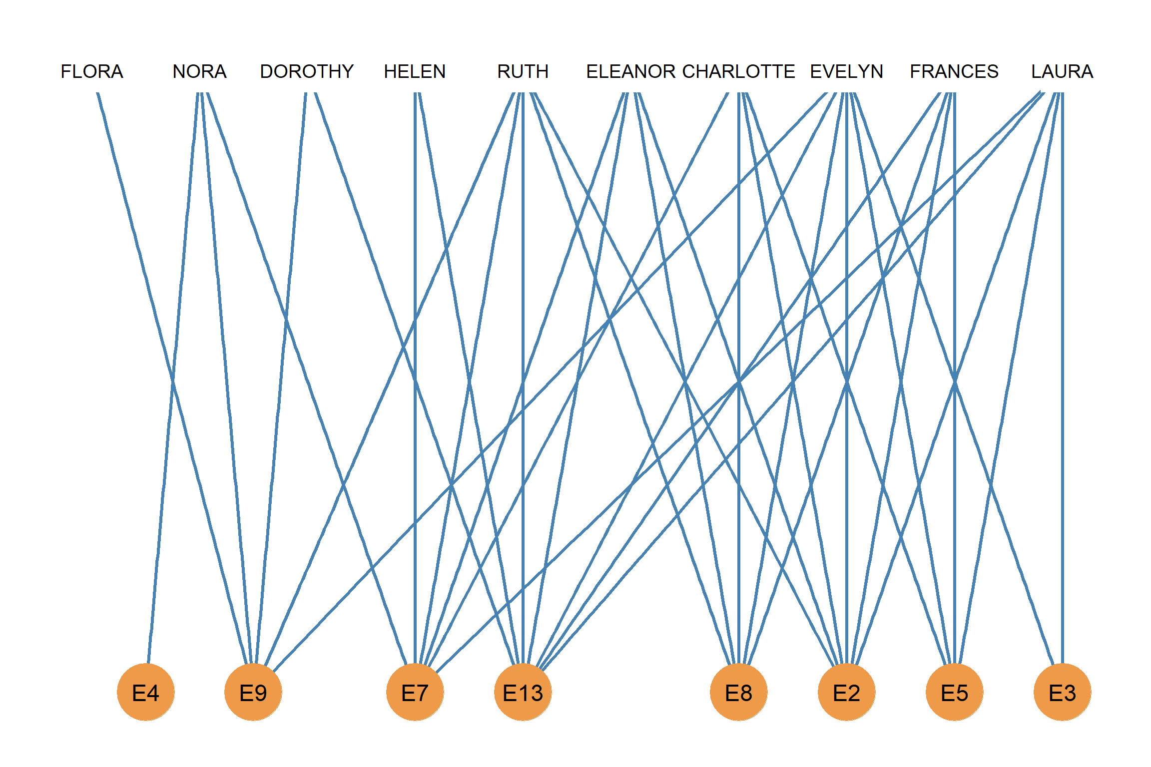

Figure 1: Southern women bipartite graph.

The Figure above shows the **bipartite graph** corresponding to (part of) the *Southern Women Events Data* a classic social network data set collected in the 1930s by the sociologist Allison Davis and collaborators and included in book [*Deep South*](https://www.amazon.com/Deep-South-Anthropological-Southern-Classics/dp/1570038155). The graph represents observed attendance at 8 social events by 10 Southern “high society” women from the South.

* Write down the **affiliation matrix** corresponding to the Southern women network bipartite graph.

|  |  |  |  |  |  |  |  |  |
| --- | --- | --- | --- | --- | --- | --- | --- | --- |
|  | E9 | E7 | E13 | E2 | E8 | E5 | E3 | E4 |
| RUTH |  |  |  |  |  |  |  |  |
| FRANCES |  |  |  |  |  |  |  |  |
| EVELYN |  |  |  |  |  |  |  |  |
| LAURA |  |  |  |  |  |  |  |  |
| NORA |  |  |  |  |  |  |  |  |
| ELEANOR |  |  |  |  |  |  |  |  |
| FLORA |  |  |  |  |  |  |  |  |
| DOROTHY |  |  |  |  |  |  |  |  |
| CHARLOTTE |  |  |  |  |  |  |  |  |
| HELEN |  |  |  |  |  |  |  |  |

1. Which women attend the most events?
2. Which women attend the least events?
3. What is the average number of events attended by the women?
4. Which are the largest event(s)?
5. Which are the smallest event(s)?
6. What is the average event size?

* Write down the *transpose* of the **affiliation matrix** corresponding to the Southern women network bipartite graph.

|  |  |  |  |  |  |  |  |  |  |  |
| --- | --- | --- | --- | --- | --- | --- | --- | --- | --- | --- |
|  | RUT. | FRA. | EVE. | LAU. | NOR. | ELE. | FLO. | DOR. | CHA. | HEL. |
| E9 |  |  |  |  |  |  |  |  |  |  |
| E7 |  |  |  |  |  |  |  |  |  |  |
| E13 |  |  |  |  |  |  |  |  |  |  |
| E2 |  |  |  |  |  |  |  |  |  |  |
| E8 |  |  |  |  |  |  |  |  |  |  |
| E5 |  |  |  |  |  |  |  |  |  |  |
| E3 |  |  |  |  |  |  |  |  |  |  |
| E4 |  |  |  |  |  |  |  |  |  |  |

Using the information in the previous tables and what you know about **matrix multiplication**:

* Write down the entries corresponding to the **co-membership matrix** of the Southern women.

|  |  |  |  |  |  |  |  |  |  |  |
| --- | --- | --- | --- | --- | --- | --- | --- | --- | --- | --- |
|  | RUT. | FRA. | EVE. | LAU. | NOR. | ELE. | FLO. | DOR. | CHA. | HEL. |
| RUT. |  |  |  |  |  |  |  |  |  |  |
| FRA. |  |  |  |  |  |  |  |  |  |  |
| EVE. |  |  |  |  |  |  |  |  |  |  |
| LAU. |  |  |  |  |  |  |  |  |  |  |
| NOR. |  |  |  |  |  |  |  |  |  |  |
| ELE. |  |  |  |  |  |  |  |  |  |  |
| FLO. |  |  |  |  |  |  |  |  |  |  |
| DOR. |  |  |  |  |  |  |  |  |  |  |
| CHA. |  |  |  |  |  |  |  |  |  |  |
| HEL. |  |  |  |  |  |  |  |  |  |  |

* Write down the entries corresponding to the **group overlap matrix** of the Southern women.

|  |  |  |  |  |  |  |  |  |
| --- | --- | --- | --- | --- | --- | --- | --- | --- |
|  | E9 | E7 | E13 | E2 | E8 | E5 | E3 | E4 |
| E9 |  |  |  |  |  |  |  |  |
| E7 |  |  |  |  |  |  |  |  |
| E13 |  |  |  |  |  |  |  |  |
| E2 |  |  |  |  |  |  |  |  |
| E8 |  |  |  |  |  |  |  |  |
| E5 |  |  |  |  |  |  |  |  |
| E3 |  |  |  |  |  |  |  |  |
| E4 |  |  |  |  |  |  |  |  |