# Homework VI: Ego-Network Metrics

|  |
| --- |
| (a) Ego to alter ties.    (b) Alter to alter ties. |

Figure 1: Ego Network ties in a hypothetical ego-network.

* Consider Figure 1(a). This shows the **ego-to-alter** ties in a hypothetical ego-network.
* Consider Figure 1(b). This shows the **alter-to-alter** ties in the hypothetical ego-network shown in Figure 1(a).

1. What is the **size** of ego’s network?
2. What is ego’s clustering coefficient?

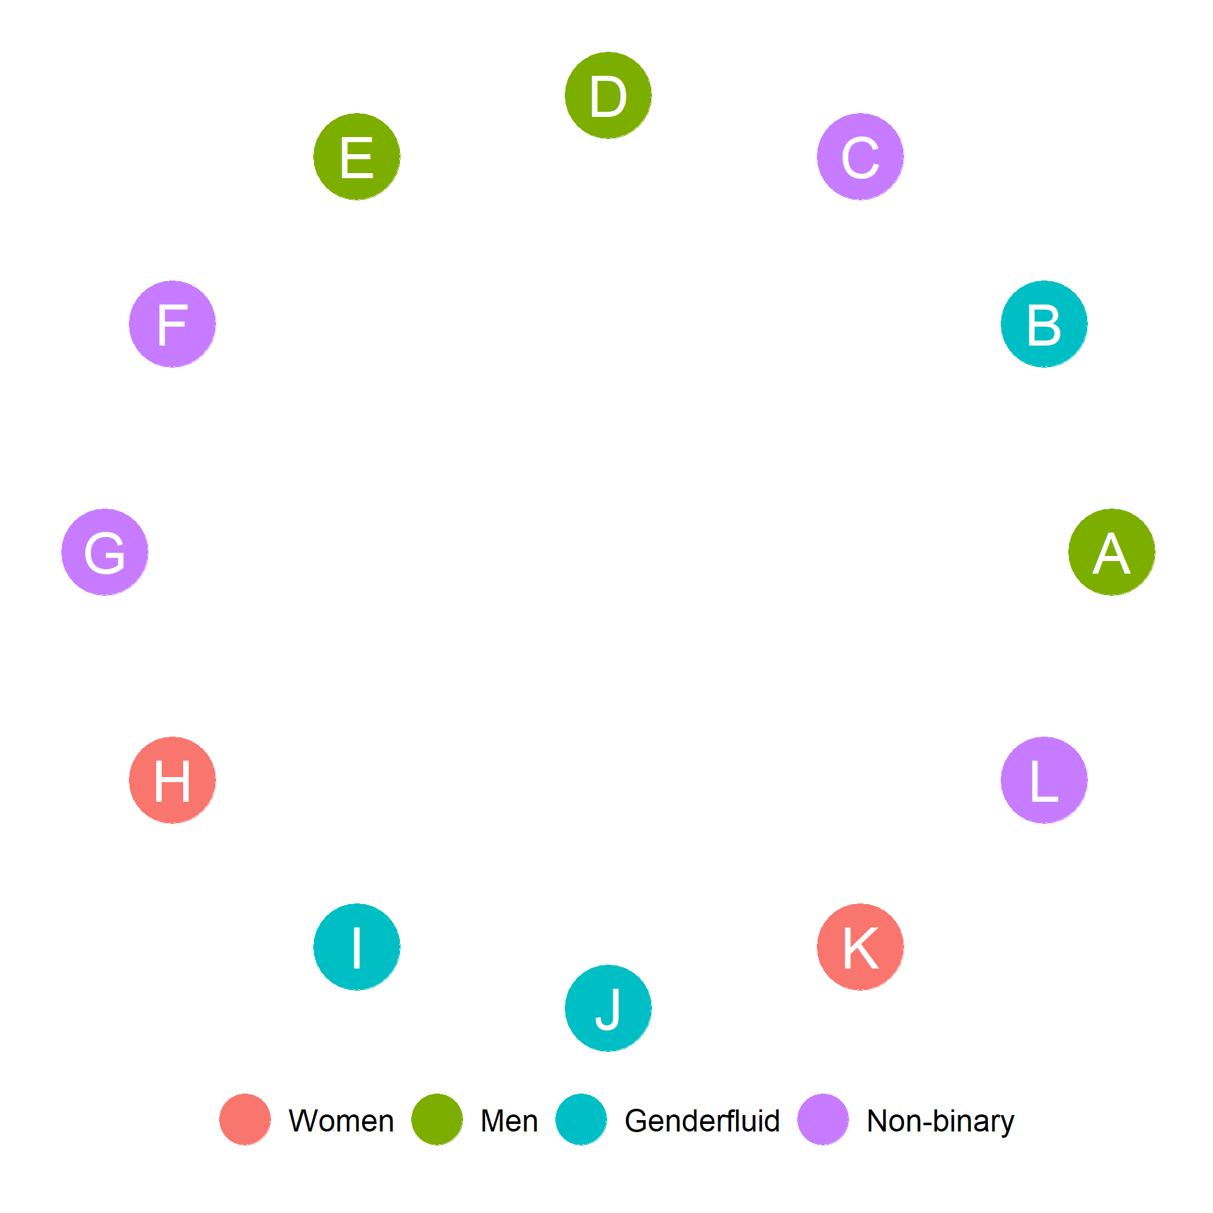

Figure 2: Gender identification of alters.

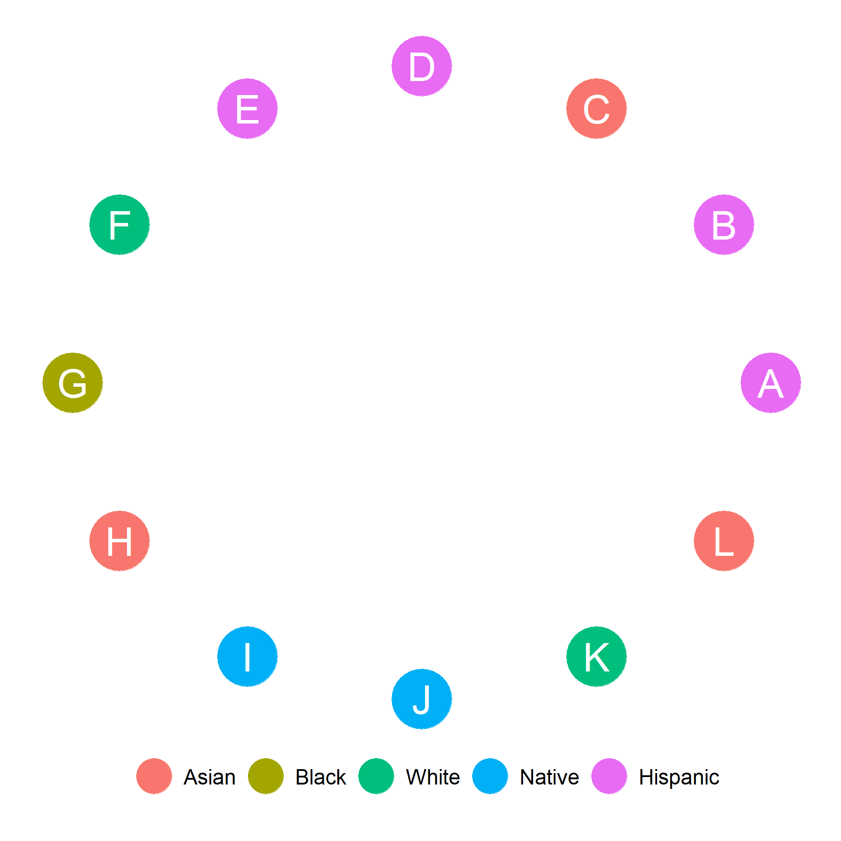

Figure 3: Ethnoracial identification of alters.

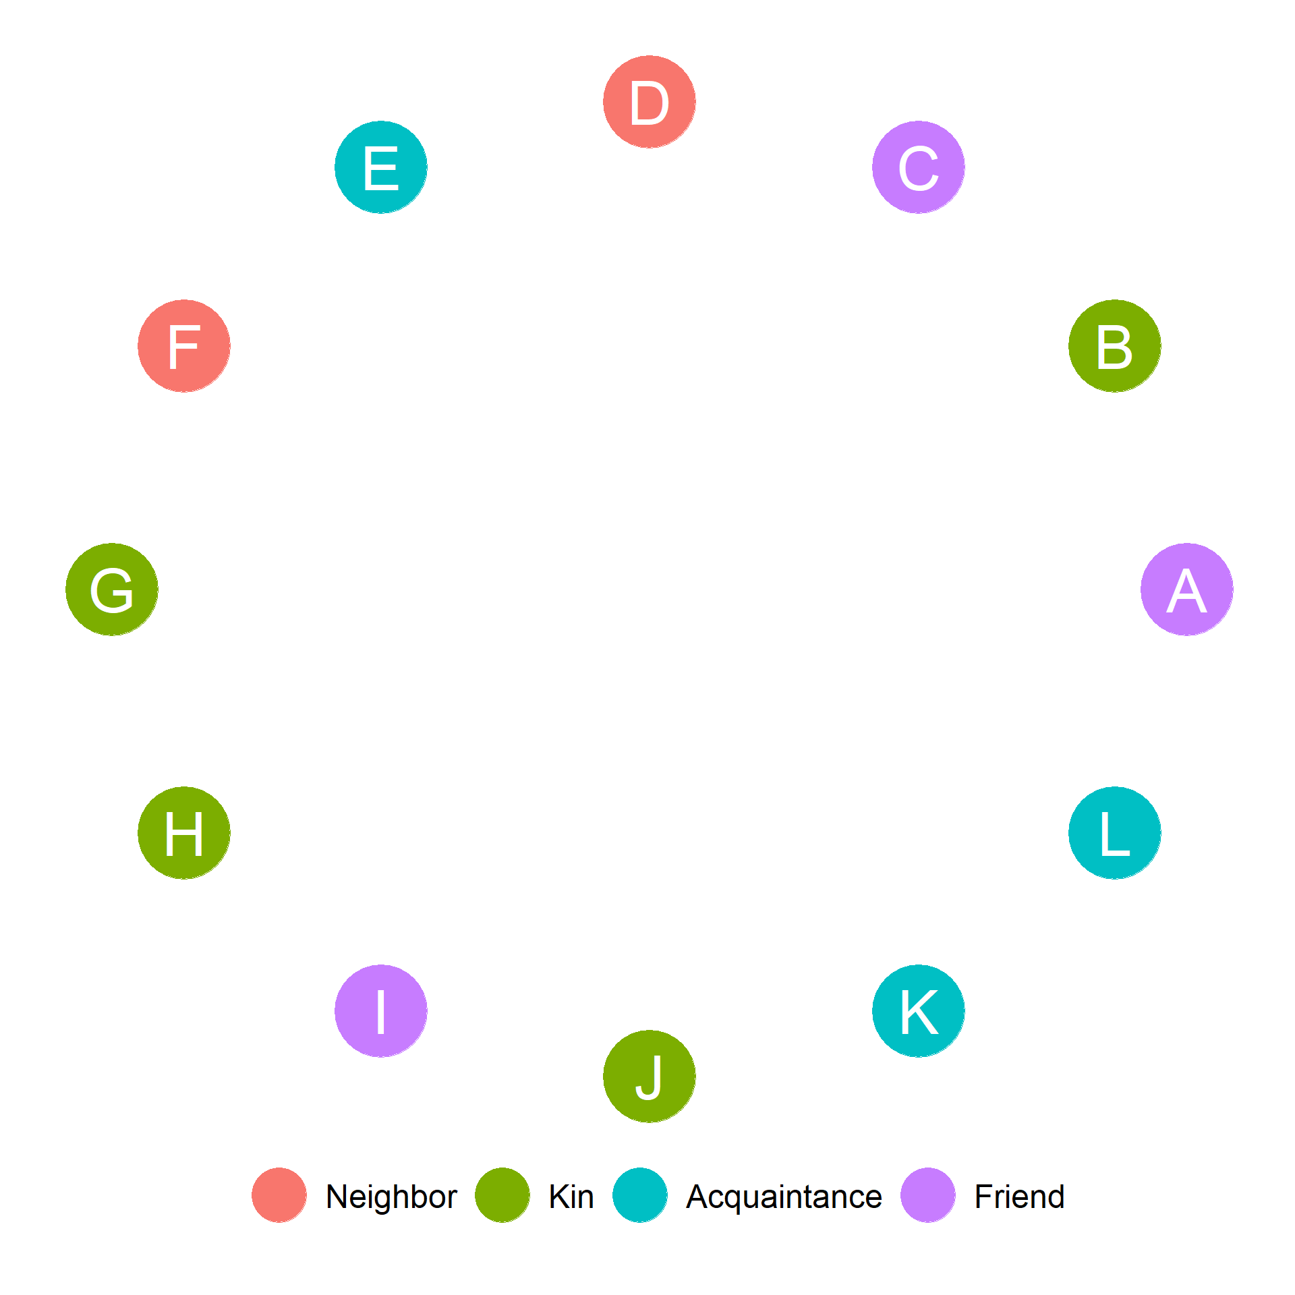

Figure 4: Role relations of alters with Ego.

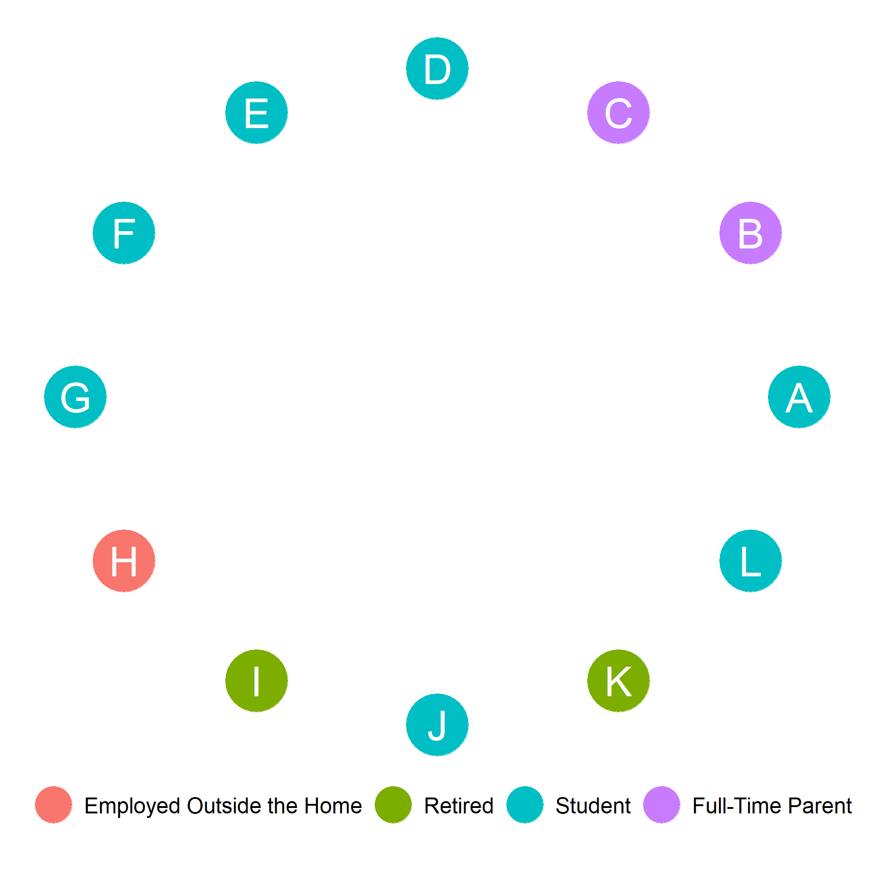

Figure 5: Employment status of alters.

Figure 2-Figure 5 show some sociodemographic and role-relational characteristics of alters in ego’s network. Ego is a *UCLA student who identifies as Hispanic and as a Man*. Using this information:

1. Compute Ego’s **homophily** with respect to gender identity.
2. Compute Ego’s **homophily** with respect to Ethnoracial identification.
3. Compute the **proportion** kin in Ego’s network.
4. Compute the **proportion** non-Hispanic in Ego’s network.
5. Compute the **proportion** of individuals employed outside the home in Ego’s network.
6. Compute the **diversity** of Ego’s Network with respect to ethnoracial identity.
7. Compute the **diversity** of Ego’s Network with respect to employment status.
8. Compute the **diversity** of Ego’s Network with respect to gender identity.
9. Compute the **proportion** of fellow students in Ego’s network.
10. Does ego have a stronger **same-group preference** with respect to race than with respect to gender? (Yes/No)
11. Is the **diversity** of ego’s network larger when it comes to race than when it comes to employment status (Yes/No)
12. What is the **proportion** of ego’s network composed of kin who are also full-time parents?
13. Compute the **proportion** of people who identify as Men or Women in ego’s network.
14. Draw the **subgraph** of Ego’s alter-to-alter ties that is only composed of students