# Homework VII: Subgroups

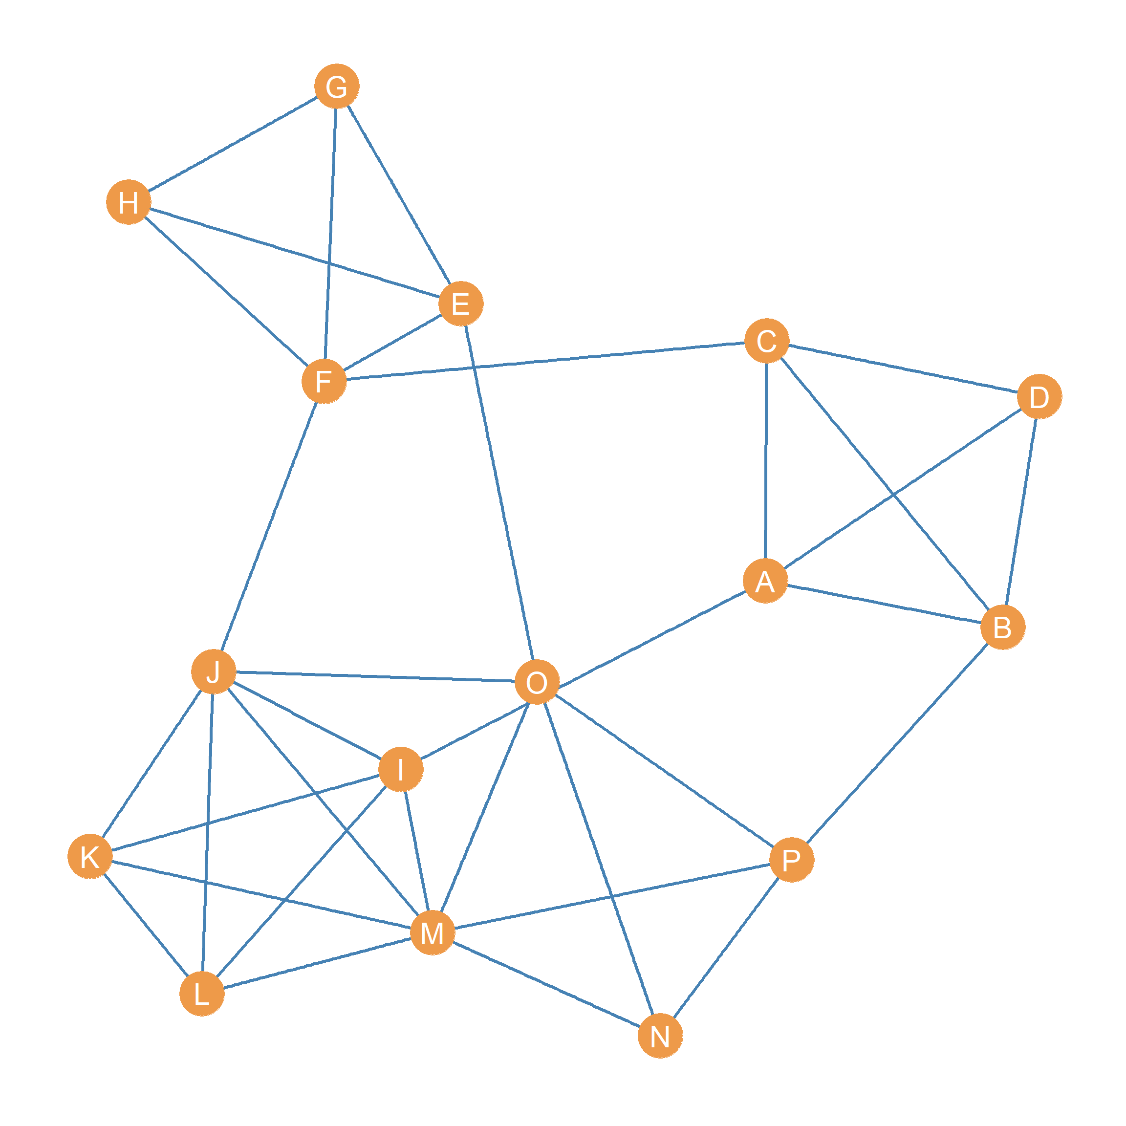

An undirected graph.

1. List the nodes in all the **cliques** of *size four* in the graph.
2. How many **cliques** of *size four* does node *M* belong to?
3. List the edges would have to be added to the graph to make nodes {A, C, F, J, O} into a clique of size 5:
4. Write down a set of *two* nodes that if removed would disconnect the graph:
5. Write down a set of *three* edges that if removed would disconnect the graph:
6. List the nodes in two 2-cliques in the graph:
7. List the nodes in one 3-clique in the graph:
8. Imagine we removed the edges {FJ, FC, EO, AO, BP}. How many components would the resulting graph have?
9. List the nodes in the *five cliques of size four* nested inside the clique of size five.
10. List the nodes in the *four cliques of size three* nested inside one of the cliques of size four.