# Homework VIII: Graph Connectivity and Structural Similarity

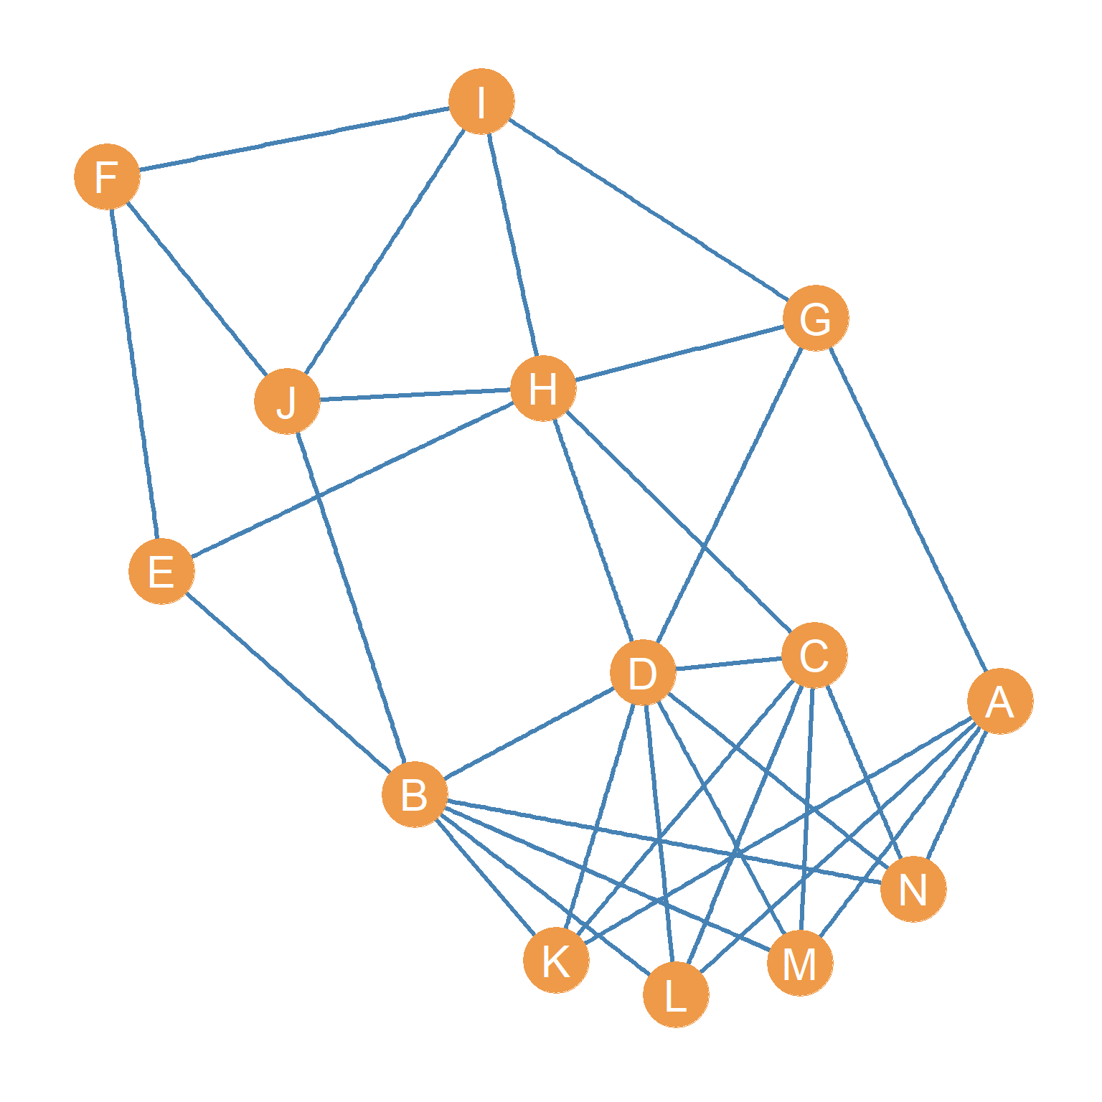

Figure 1: An undirected graph.

In the matrix below, write down the cell entries for the **adjacency matrix** corresponding to the graph shown in Figure 1:

|  |  |  |  |  |  |  |  |  |  |  |  |  |  |  |
| --- | --- | --- | --- | --- | --- | --- | --- | --- | --- | --- | --- | --- | --- | --- |
|  | A | B | C | D | E | F | G | H | I | J | K | L | M | N |
| A | ---- |  |  |  |  |  |  |  |  |  |  |  |  |  |
| B |  | ---- |  |  |  |  |  |  |  |  |  |  |  |  |
| C |  |  | ---- |  |  |  |  |  |  |  |  |  |  |  |
| D |  |  |  | ---- |  |  |  |  |  |  |  |  |  |  |
| E |  |  |  |  | ---- |  |  |  |  |  |  |  |  |  |
| F |  |  |  |  |  | ---- |  |  |  |  |  |  |  |  |
| G |  |  |  |  |  |  | ---- |  |  |  |  |  |  |  |
| H |  |  |  |  |  |  |  | ---- |  |  |  |  |  |  |
| I |  |  |  |  |  |  |  |  | ---- |  |  |  |  |  |
| J |  |  |  |  |  |  |  |  |  | ---- |  |  |  |  |
| K |  |  |  |  |  |  |  |  |  |  | ---- |  |  |  |
| L |  |  |  |  |  |  |  |  |  |  |  | ---- |  |  |
| M |  |  |  |  |  |  |  |  |  |  |  |  | ---- |  |
| N |  |  |  |  |  |  |  |  |  |  |  |  |  | ---- |

Using the information from the previous matrix, in the matrix below, write down the cell entries for the **structural similarity matrix** corresponding to the graph shown in Figure 1 using the **Euclidean Distance**:

|  |  |  |  |  |  |  |  |  |  |  |  |  |  |  |
| --- | --- | --- | --- | --- | --- | --- | --- | --- | --- | --- | --- | --- | --- | --- |
|  | A | B | C | D | E | F | G | H | I | J | K | L | M | N |
| A | ---- |  |  |  |  |  |  |  |  |  |  |  |  |  |
| B |  | ---- |  |  |  |  |  |  |  |  |  |  |  |  |
| C |  |  | ---- |  |  |  |  |  |  |  |  |  |  |  |
| D |  |  |  | ---- |  |  |  |  |  |  |  |  |  |  |
| E |  |  |  |  | ---- |  |  |  |  |  |  |  |  |  |
| F |  |  |  |  |  | ---- |  |  |  |  |  |  |  |  |
| G |  |  |  |  |  |  | ---- |  |  |  |  |  |  |  |
| H |  |  |  |  |  |  |  | ---- |  |  |  |  |  |  |
| I |  |  |  |  |  |  |  |  | ---- |  |  |  |  |  |
| J |  |  |  |  |  |  |  |  |  | ---- |  |  |  |  |
| K |  |  |  |  |  |  |  |  |  |  | ---- |  |  |  |
| L |  |  |  |  |  |  |  |  |  |  |  | ---- |  |  |
| M |  |  |  |  |  |  |  |  |  |  |  |  | ---- |  |
| N |  |  |  |  |  |  |  |  |  |  |  |  |  | ---- |

1. Using the Information in the previous matrix, write down the set of nodes that are **structurally equivalent** (e.g., connected to the same set of neighbors) in the graph shown in Figure 1.
2. Out of the nodes that are not structurally equivalent, which pairs of nodes have the highest **structural similarity** in the graph shown in Figure 1?
3. Using the **Jaccard Similarity** metric, compute the structural similarity between nodes *B* and *D* in the graph shown in Figure 1.
4. Using the **Dice Similarity** metric, compute the structural similarity between nodes *C* and *D* in the graph shown in Figure 1.
5. Using the **Cosine Similarity** metric, compute the structural similarity between nodes *A* and *C* in the graph shown in Figure 1.
6. Write down a **node cut set** for the graph shown in Figure 1.
7. Write down an **edge cut set** for the graph shown in Figure 1.
8. What is the **k-connectivity** of the graph?
9. What is the **edge connectivity** of the graph?
10. What is the **pairwise k-connectivity** between nodes *E* and *G*?