S18 SOCI 111: Social Networks
Homework 1
DUE: 4/19/18; 110 points

Instructions: These problems give you an opportunity to use the concepts and techniques we’ve learned so far to analyze some real and toy social systems. They also test your understanding of basic definitions and procedures. Think of them like exercises; they help build your network muscles! I encourage you to work in groups (of no more than 5), but each student should prepare her or his own solution, along with a note crediting other members of the working group. Please make sure you truly understand a solution, and please: DO NOT COPY SOLUTIONS. We will figure it out.
In general, you should show your work rather than just writing down a number. This makes it easier for us to see that you know what you are doing, and easier for you to see when you’ve made a trivial mistake. On the other hand, don’t just throw everything vaguely relevant at the wall and hope that something sticks. You need to be judicious!
Please turn in a hard copy of your solutions to the TA at the beginning of class. Your solution should be neat and legible: you can type it up or write it out by hand, but we aren’t going to engage in decipherment here.
Degree Distributions and Eulerian Paths
- Consider a graph G with the following property: it has 2 nodes of degree 1; 4 nodes of degree 2; and 1 node of degree 4. Recall that the degree of a node is the number of neighbors it has. The degree distribution of a network shows the fraction of nodes in the network that have degree 0, degree 1, degree 2, degree 3, etc. The degree distribution is usually plotted with degree on the x-axis (starting at zero and counting up) and fraction of nodes having degree k on the y-axis. Plot the degree distribution for this network. Hint: Ask yourself how many nodes in this network have 0 neighbors? How many have 1 neighbor? How many have 2 neighbors? Etc. (5 points)

- Now draw a possible graph G with this degree count. There are a couple of different graphs that satisfy the degree count in Q1. Make sure your graph is connected. (5 points)

- Without looking at your graph, I know that it is possible to find a path on your graph that crosses every edge, and crosses each edge only once (Note: this is technically called an “Eulerian path.”) By deleting a single edge from your graph (while keeping your graph connected), you can make it impossible to find a path that crosses every edge, and crosses each edge only once. What edge do you delete? And why are you sure this will make an Eulerian path impossible? (5 points)

Fun with adjacency matrices!

- Consider the following network:

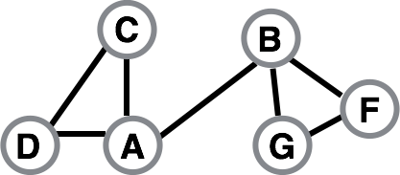

Write out the corresponding adjacency matrix (5 points)

- Consider the following adjacency matrix. Is this network directed or undirected? How do you know (without drawing the network)? (5 points)

A B C D E F
$$\left[\begin{matrix}0 & 1 & 0 & 0 & 0 & 0 \\ 1 & 0 & 1 & 0 & 1 & 0 \\ 0 & 0 & 0 & 1 & 1 & 0 \\ 0 & 0 & 1 & 0 & 0 & 0 \\ 0 & 0 & 0 & 0 & 0 & 1 \\ 0 & 1 & 0 & 0 & 0 & 0\end{matrix}\right]$$

- Now draw the network corresponding to the adjacency matrix in Q5. (5 points)

- The in-degree of a node is the number of other nodes that point to it; hence the in-degree of B is 2. The out-degree of a node is the number of other nodes that it points to; hence the out-degree of B is 3. Write down the in- and out-degrees of all the other nodes in the network. (5 points)

- Now we will explore some interesting properties of the adjacency matrix. What happens when you add up all the entries in a given row (e.g., what happens when you add up all the entries in the first/top row, row A)? What happens when you add up all the entries in a given column (e.g., what happens when you add up all the entries in the first/left-most column, column A)? Compare these answers to your answers in Question 7. Do you notice anything interesting? Conjecture (i.e., guess) what might be happening. (5 points)

- Write down the formula for the maximum number of edges in an undirected network with n nodes. How would you change this to express the maximum number of edges in a directed network with n nodes? Explain your reasoning. (5 points)

Weak ties and strong science

Q10-Q16 concern the following network of scientists. Each link represents a collaboration:

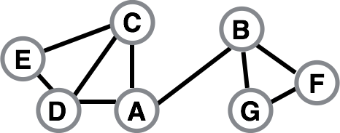

- What is the distance between Scientist D and Scientist F? Show a breadth first-search that demonstrates this. You only need to show the layers required to reach scientist F. (5 points)

The distance from D to F is 3 (2 points for distance; 3 points for BFS—they do not need to show ties internal to a layer)

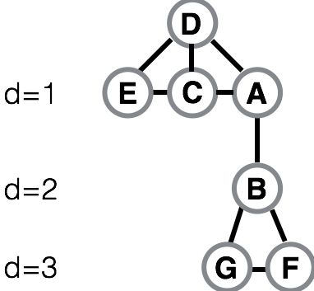

- What is the clustering coefficient of node A? Please show your work. (5 points)

- Name two edges that you would expect to form because of triadic closure. Justify your answer. (4 points)

- Explain, in your own words, three reasons why triadic closure occurs. Give an example for each. (6 points)

- A node X is a “gatekeeper” if, for some other two nodes Y and Z, every path from Y to Z passes through X. Is node B a gatekeeper? Explain why or why not. (2 points)

- A node X is a “local gatekeeper” if there are two neighbors of X, say Y and Z, that are not connected by an edge. Is node G a local gatekeeper? Explain why or why not. Hint: See Figure 2.14 on page 40. (3 points)
- What advantage might it give someone to be a gatekeeper (or a local gatekeeper)? (5 points)
Extreme Erdős
- As you know, I have an Erdős number of 4. Is it possible for me to get a lower Erdős number? If so, how would I go about doing it? If not, why not? Make sure to explain your answer. (5 points)

- Sadly, Paul Erdős died in 1996. What will happen to the average Erdős number in the long run? By the year 2096, would the average Erdős number be larger or smaller than the average Erdős number today? (5 points)

For Q19 – Q24 let’s return to this graph of scientists
- Call nodes A, C, D, E “Group 1” and nodes B, G, F “Group 2.” How many edges between Group 1 and Group 2 are possible, in theory? How many actually exist? (5 points)

- Scientist A currently participates in a bridge, spanning a structural hole. What advantages might Scientist A accrue from her position? (5 points)

- Scientist A finds out from Scientist D that Scientist E is trying to form a tie to Scientist G. Why might Scientist A want to prevent that tie from forming? (5 points)

- Imagine that Scientist E collaborates with Scientist G. What is the span of the new edge E-G? Is this edge a local bridge? Explain your answer. (5 points)

- If all of the nodes in this network satisfy the strong triadic closure principle and the edge D-A is a strong tie, what must be true of the edge A-B? Explain your answer. Interpret your result in the context of scientific collaborations (5 points)

