S18 SOC 111: Social Networks
FINAL: out of 127 points
DATE: 6/13/18

Instructions: Please write your answers in a blue book. Your answers should be neat and legible; we aren’t going to engage in decipherment here. Partial credit is available on most questions, so it’s in your best interest to attempt every question and to write out your solution in reasonable detail. I would recommend that you read the entire exam before you begin. It is 8 pages long, and includes extra credit on the last page. Start with the questions you are sure about! And keep an eye on the time; you will need to pace yourself carefully. Avoid getting bogged down! GOOD LUCK!

Q1-Q3 concern the following network:
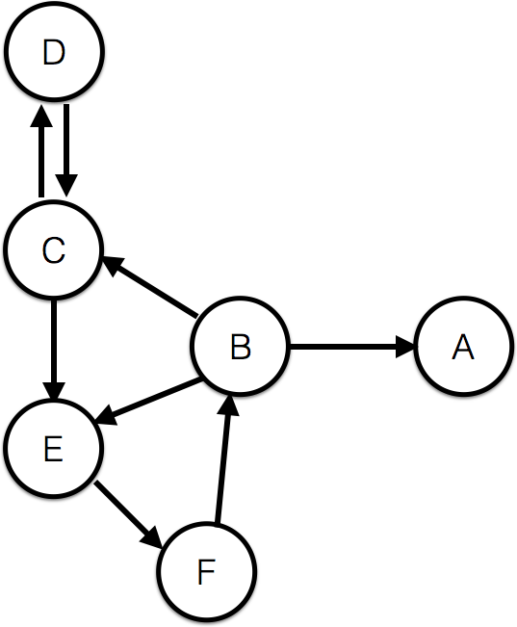

- Write down the adjacency matrix for this network. (5 points)

A B C D E F
$$\left[\begin{matrix}0 & 0 & 0 & 0 & 0 & 0 \\ 1 & 0 & 1 & 0 & 1 & 0 \\ 0 & 0 & 0 & 1 & 1 & 0 \\ 0 & 0 & 1 & 0 & 0 & 0 \\ 0 & 0 & 0 & 0 & 0 & 1 \\ 0 & 1 & 0 & 0 & 0 & 0\end{matrix}\right]$$

Note that the adjacency matrix is asymmetric, as this is a directed network with some un-reciprocated ties. The students might also put the letter labels along the rows as well.
[grading notes: -1 for each error in the matrix]

- Which nodes are in the largest strongly connected component of this graph? Explain your answer. (5 points)
The nodes in the largest strongly connected component are B, C, D, E, F.
[3 points; -1 for each missing node]

Recall that all of the nodes in a strongly connected component must be reachable from every other node in the SCC via a directed path. It is possible for each of these nodes to reach every other node along a directed path. [2 points for some version of this; must mention directed path to receive full credit]

- There are six nodes in this network. What is the maximum number of edges possible in this network? NOTE THAT IT IS DIRECTED. Please show your work (i.e., include the formula you use to calculate the answer). (5 points)

This graph has 6 nodes. Let $N$be the number of nodes, so here $N=6$. Because this is a directed network, we don’t have to divide by two in the formula for the maximum number of edges. The maximum number of edges is therefore:

$$N\left(N-1\right)=6\left(6-1\right)=6×5= 30$$

[2 points for correct answer; 3 points for correct formula]

Q4-Q6 concern the following graph: 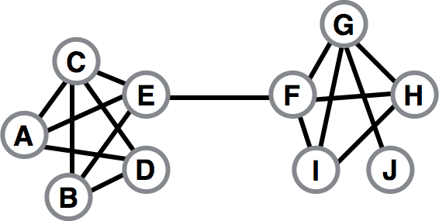

- What is the clustering coefficient of node F? Make sure to show your calculations. (5 points)

Recall that the clustering coefficient is “number of ties between neighbors of F” divided by “number of potential ties between neighbors of F.” Node F has 4 neighbors (its degree is 4). It therefore has 6 pairs of potential neighbors $=\frac{k(k-1)}{2}= \frac{4(4-1)}{2}=\frac{12}{2}=6$. Of those 6 pairs, 3 actually exist (G-H; H-I; I-G). Therefore, its clustering coefficient is 1/2.
[2 points for correct answer; 3 points for correct formula]

- If all of the nodes in this network satisfy the strong triadic closure principle and the edge C-E is a strong tie, what must be true of the edge E-F? Explain your answer.
(5 points)
The edge E-F must be a weak tie.
[2 points]
Because all nodes satisfy strong triadic closure, Edge E-F being a strong tie would require that an edge exist connecting C to F. But we do not observe this tie. Hence E-C must be a weak tie.
[3 points]

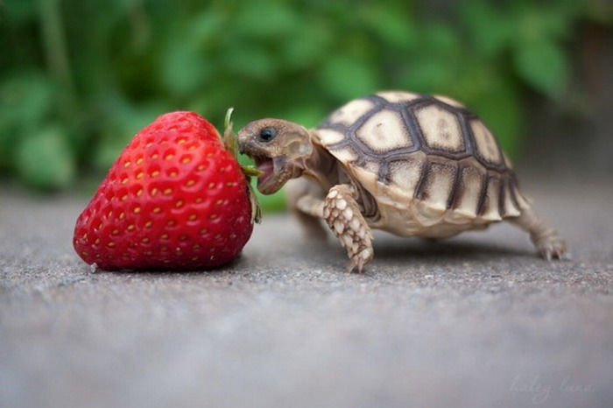

- Imagine that you are node E.
  - You need to ask one of your friends for a favor (e.g., to take care of your beloved pet turtle Tiny while you are on vacation). Who would you rather ask: node C or node F? Explain your answer. (5 points)

[grading note: 2 points for correct answer; 3 points for explanation. The explanation should make reference to the embeddedness of the tie to node C (or the number of mutual friends); based on this, the explanation may refer to the role of the mutual friends in monitoring, evidence for greater trust, shared expectations, mutual obligation, etc., as opposed to the tie to node F, which is not embedded. As before, they do not have to discuss ALL of these things. They do not have to mention Coleman by name.]

Node C is a much better choice to take care of your beloved turtle! The tie with node C is quite embedded; they have two mutual friends. This suggests a high level of trust among these friends. This trust facilitates the exchange of favors, and a strong sense of mutual obligation and shared expectations. Because of the highly embedded nature of his tie to Node C, Node E is more likely to feel comfortable putting Node C in charge of Tiny. He’s more likely to find out if Node C doesn’t take good care of Tiny, and is more likely to know if Node C has done a good job with other friends’ animals in the past. It’s also true that Node C is more likely to feel obligated to do Node E a favor. The mutual friends would also sanction Node C if she were irresponsible or neglectful. As opposed to the tie with Node C, which likely participates in high levels of Coleman-style closure capital, the tie with Node F is entirely dis-embedded (no mutual friends) giving no chance for monitoring and lower levels of shared trust, mutual obligation, etc.
  - Now imagine you are looking for a new job (it’s expensive to feed Tiny these fine strawberries). Which friend is likely to be the best source of novel information? Again, explain your answer. (5 points)

[grading note: 2 points for correct answer; 3 points for explanation. Need to explain why the other friends have old information and Node F has novel information to receive full credit]
The best source of information is likely to be Node F. Your other friends (C,A,B) likely have many common acquaintances and hence access to the same information. They are likely to know only about opportunities that you already know about. Node F, however, belongs to a different “chunk” of the social network, and is likely to have independent, fresh, and distinct information—including leads on exciting job opportunities! This was demonstrated by Granovetter in his “strength of weak ties” study. [they do not need to mention Granovetter explicitly]

 vs. 

- Bum bum ba-da dum dum! (That is supposed to be the Game of Thrones theme music). Consider two actors from Game of Thrones: Peter Dinklage (Tyrion Lannister, left), who has been in many movies/TV shows, and Maisie Williams (Arya Stark, right) who has been in few. Which do you think is larger: The average “Dinklage-number” or the average “Williams-number,” where both are defined like the Bacon number or the Erdős number? Explain your answer—making sure to explain how to calculate a “Dinklage-number” and a “Williams-number.” (5 points)

Remember the definition of a Bacon number. Define two actors as “connected” if they appear together in the same movie/TV show. The Bacon number for an actor X is the smallest number of such connections required to get from that actor to Kevin Bacon. Now define the Dinklage number as the smallest number of such connections required to get from a given actor to Peter Dinklage, and the Williams number as the smallest number of such connections required to get from a given actor to Maisie Williams.

[3 points for this]

The average Dinklage number and average Williams number are merely computed by averaging the Dinklage number and the Williams number over all other actors. Because Peter Dinklage has appeared in many movies, he has many paths into the networks of all actors. This will tend reduce the average Dinklage number, as there are more actors with Dinklage number 1, hence more actors with Dinklage number 2, etc. Because Maisie Williams has appeared in few movies, she has a smaller number of immediate connections in IMBD. This makes the paths to other actors longer, on average. There are fewer actors with Williams number 1, hence fewer with Williams number 2, etc. This will tend to make the average Williams number larger. In particular, the average Williams number is likely to be larger than the average Dinklage number (in fact, it is).

[2 points for this]

- What are the three mechanisms that can generate homophily? List them and give a brief explanation for each (5 points)
[grading note: 2 points for first mechanism; 2 points for second mechanism; 1 point for third mechanism. If a mechanism is named/stated but not described, only give 1 point. They do not need to apply the mechanism to an example in describing it, but they certainly may]

The three possible mechanisms are: direct selection (selection on the observed homophilous characteristic); homophily on a correlated, often unobserved, trait (sometimes called indirect selection or latent homophily); and social influence. In direct selection, people choose friends on the basis of the homophilous characteristic in question (e.g., people selecting their friends on the basis of race, gender, bow-tie wearing, obesity status, etc., in networks that show homophily on those traits). In homophily on an “unobserved” trait [latent homophily], people choose friends because of latent factors that are correlated with the observed homophilous traits (e.g., people becoming friends with others in their neighborhood, when the neighborhood is racially or economically homogeneous or located near many fast-food restaurants [the last in the case of obesity]; etc.). In social influence, people modify their behaviors to bring them into alignment with the behaviors of their friends.

HERE ARE SOME POSSIBLE APPLICATIONS/EXAMPLES:
In the first case (direct selection), Candy Kingdom citizens would explicitly choose to become friends with each other on the basis of whether they support KOO or Bubblegum. In the case of latent homophily, citizens might be homophilous on some other trait that is correlated with political preference. For example, imagine that most of the citizens who support KOO come from the southern part of the Candy Kingdom, while most of the citizens who support Bubblegum come from the northern part. Citizens might be homophilous on geographic origin, but this could also generate homophily on their political preferences. In the case of social influence, citizens change their political preference to be more similar (i.e., through the influence of) their friends; so those who are friends with KOO supporters become KOO supporters, while those who are friends with Bubblegum supporters tend to become Bubblegum supporters.

Consider the following affiliation graph connecting sociologists to areas of study:

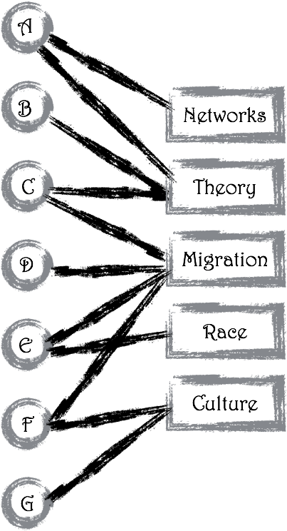

- Draw the corresponding projected graph on the nodes A, B, C, D, E, F, G.
(5 points)

Q10-Q12 concern the following game:
Erving and Dorothy are playing the popular online roleplaying game World of Warcraft. Players advance in the game by accumulating experience points. Erving and Dorothy have heard that a powerful monster, the Elder Bruin, will appear if you do an Eight Clap in the center of Westwood Forest. If they fight the Elder Bruin together, they will win and will each get 10 experience points (a payoff of 10 each). After a little preparation, they walk together to the center of the forest, and do the Eight Clap. But in the seconds before the Elder Bruin appears, both notice that many weaker monsters (Trojan Warriors) are wandering around nearby. Erving and Dorothy realize that they could just run away and fight those monsters instead of fighting the approaching Elder Bruin. With seconds to choose, each must independently decide to stay and fight the Elder Bruin or run off to fight the weaker monsters. If Erving sticks to the plan but Dorothy runs off to fight the weaker monsters, Erving will be unable to beat the Elder Bruin alone and will receive 0 experience points. Dorothy, by contrast, will receive 6 experience points for killing the weaker monsters. The same is true if Dorothy sticks to the plan and Erving doesn’t: 0 for Dorothy and 6 for Erving. If they both run away to fight the weaker monsters, the Elder Bruin won’t chase them, and they will each get 6 experience points for killing the weak monsters. To summarize: if both fight the Elder Bruin, both get a payoff of 10; if one fights the Elder Bruin but the other runs away to fight the weak monsters, the one fighting the Elder Bruin gets a payoff of 0 and the one fighting weak monsters gets a payoff of 6; if both fight the weak monsters, both get a payoff of 6. Assume both players only care about experience points.

- Draw the payoff matrix for this game. (5 points)
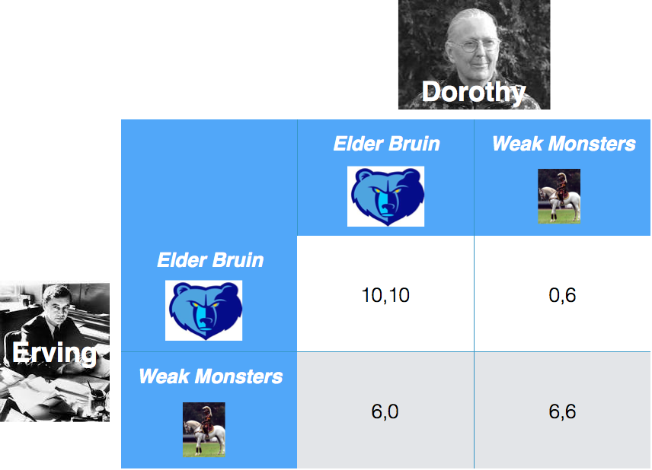
- Does this game have any pure-strategy Nash equilibria? If so, find them. Explain your answer by checking all possible outcomes. (5 points)
[1 point for each NE identified. 3 points for explanation, which accumulate by 1 points per cell explained (up to 5)]

Let the strategy “Fight Elder Bruin” be represented EB and the strategy “Fight Weak Monsters” be represented as WM. Then there are two pure-strategy equilibria: (EB, EB) and (WM, WM). Recall that in a Nash equilibrium, each player’s strategy is the best response to the other player’s strategy. In other words, neither player can do better by unilaterally changing strategy. In (EB,EB), if either Erving or Dorothy changes strategy from EB to WM, s/he gets a payoff of 6, which is strictly less than the payoff of 10 that s/he would have received in the equilibrium. In (WM,WM), if either Erving or Dorothy changes strategy from WM to EB, s/he gets a payoff of 0, which is less than the payoff of 6 that s/he gets in the equilibrium. Hence neither has an incentive to shift strategies in these outcomes, making them both Nash Equilibria.

Finally, we must consider (WM,EB) and (EB,WM). In (WM,EB), if Erving changes strategy to EB, he gets a payoff of 10, greater than the 6 he currently gets. So he has an incentive to unilaterally shift strategy, which is enough to show this outcome is not a NE. Similarly, if Dorothy changes strategy from EB to WM, she gets a payoff of 6, greater than the 0 he currently gets. So she also has an incentive to unilaterally shift strategy.

In (EB,WM), if Erving changes strategy to WM, he gets a payoff of 6, greater than the 0 he currently gets. So he has an incentive to unilaterally shift strategy, which is enough to show this outcome is not a NE. Similarly, if Dorothy changes strategy from WM to EB, she gets a payoff of 10, greater than the 6s he currently gets. So she also has an incentive to unilaterally shift strategy.

- Which outcome is socially optimal? Briefly explain how you determined this.
(2 points)

The socially optimal outcome is (EB,EB). In this outcome, the total payoff is 10+10 = 20. This is the largest total payoff across outcomes; for (EB,WM) and (WM,EB), the total is 6, and for (WM,WM) it is 12.

Consider the following outcome for a network-exchange theory experiment:

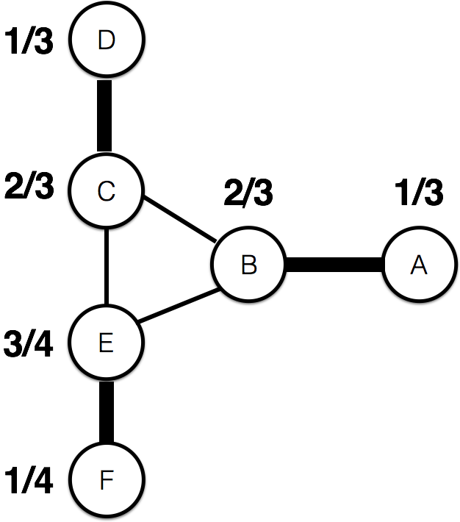

Bold lines represent the matching (who exchanges with whom), while the numbers give the values.

- Is this outcome stable? Explain your answer. (5 points)

We check whether the outcome is stable by checking that none of edges excluded from the matching is an instability. Recall that an instability is an edge not in the matching for which the values at either end add up to less than 1. If they did, the nodes at either end of the edge could disrupt the outcome by exchanging with each other, and they would be better off by dividing the value of the edge (=1). Here, 2/3 + 2/3 = 4/3 > 1 for B-C and
2/3 + 3/4 = 17/12 > 1 for C-E and B-E. These edges represent all the potential instabilities; because none of them is an instability, the outcome is stable.

[2 points for saying not stable; 3 points for explanation. They don’t have to go through the fraction addition to get full credit]

- Is this outcome balanced? Explain your answer and show your work. (5 points)
This outcome is balanced. [1 point for this]

Now we must show that the outcome is balanced. To save time, note that C-D and B-A are in some sense “the same.” In both cases, D and A have no other option and are exploitable. B and C are connected to each other (as potential outside options) and to E.

So, we only need to check C-D and E-F; in checking C-D, we also check B-A.

To check that the outcome is balanced, we must verify that the values at either end of each edge in the matching correspond to the Nash bargaining solution, where the outside options are given by the largest value the node in question could obtain by stealing another node from its current partner.

Considering C and D, we see that C has an outside option of 1/3 (from B) and will accept nothing less. D has an outside option of 0 (and hence has a floor of 0). The surplus is 1 – 1/3 = 2/3. In the Nash bargaining solution, the surplus is divided equally between the two nodes, which have used all the leverage of their outside options in setting their minimum values. Surplus/2 = 1/3, so D should get 0 + 1/3 = 1/3 and C should get 1/3 + 1/3 = 2/3. This is exactly what we have in the outcome for C-D. The same analysis holds for A-B.

[2 points for NBS analysis of C-D or A-B]

Considering E and F, we see that E has an outside option of 1/3 (from B) and will accept nothing less. F has an outside option of 0 (and hence has a floor of 0). The surplus is 1 – 1/3 = 2/3. In the Nash bargaining solution, the surplus is divided equally between the two nodes, which have used all the leverage of their outside options in setting their minimum values. Surplus/2 = 1/3, so E should get 1/3 + 1/3 = 2/3 and F should get 0 + 1/3 = 1/3. This is NOT what we have as the outcome for E-F. Hence the overall outcome is not balanced.

[2 points for NBS analysis of E-F]
Note, incidentally, that we can SEE the outcome is not balanced. There is no structural reason for E to be more powerful than B or C. [if they make some observation along these lines but don’t do the calculations, they can get 2 of the 4 possible points]

[Ok, TECHNICALLY, all they have to do is E-F. If they do that, do it correctly, and clearly state that this shows it is not balanced, they get the full 4 points for explanation]

- Explain, in two or three sentences, why search engines must keep the details of their ranking algorithms a secret. (5 points)
Because considerable commercial value is tied up with the rank of webpages on search engine results, website owners have a strong incentive to optimize this rank (this is an example of reactivity). If the details of ranking algorithms were known, then websites would try to maximize their rank using that information, swamping any signal of the relevance of the website to a query. Ranking results would be contaminated by such efforts to “game” the system—yet the value of search engines rests on the objectivity of rankings. This objectivity would be undermined by such gaming or cheating of the ranking algorithm.
[3 points for analysis of one side, 2 points for analysis of the other]

Q16-Q17 concern the following scenario:
Jake has disappeared. 80% of the time, this means he’s gone to visit his girlfriend, Lady Rainicorn. 20% of the time, however, this means he’s been kidnapped by the Ice King. So we know that $Pr\left(safe\right)= 0.80$ and $Pr\left(danger\right)= 0.20$. When Jake visits Lady Rainicorn (and is hence safe), he only forgets to bring his viola 10% of the time: $Pr\left(left viola|safe\right)= 0.10$. When the Ice King kidnaps Jake (so Jake is in danger), the Ice King almost always forgets to steal the viola, so $Pr\left(left viola|danger\right)= 0.90$.

- What is the probability that Jake’s viola is still there when he’s gone missing, i.e., what is $Pr\left(left viola\right)$? (5 points)

Jake’s viola can be left behind in two ways: either Jake is with Lady Rainicorn and forgot it (Jake is safe AND left viola), or Jake was kidnapped and the Ice King didn’t think to steal the viola (Jake is in danger AND left viola). So:
$$Pr\left(left viola\right)=Pr\left(danger\right)×Pr\left(left viola|danger\right)+Pr\left(safe\right)×Pr\left(left viola|safe\right)=0.20×0.90+0.80×0.10=0.26$$[technically, if they get the correct value, they should get full points; if they have the full formula but do not substitute the correct numbers, 4 points for the full formula]
- Suppose that Finn discovers Jake’s viola on the couch. What is the probability that Jake is in danger given this discovery, i.e., what is $Pr\left(danger|left viola\right)$?
(5 points)
Setting this up:
$$Pr\left(danger|left viola\right)=\frac{Pr\left(danger\right)×Pr\left(left viola|danger\right)}{Pr\left(left viola\right)}$$
[3 points for this part]

We know $Pr\left(danger\right)=0.20$ and that $Pr\left(left viola|danger\right)=0.90$. We calculated $Pr\left(left viola\right)$ in Q17. Putting this all together,

$$Pr\left(danger|left viola\right)=\frac{0.20×0.90}{0.26}=0.6923$$
[2 points for these substitutions]

So it is quite likely that Jake is in danger (note that $Pr\left(danger\right)$ increased from 0.2 to 0.6923 – a factor of ~3.5. [technically, if they get the correct value, they should get full points; I’ve put partial credit signposts above]
Q18-Q19 concern the following scenario:
You are running a focus group on an ad campaign for a new energy drink called Slurm. All twenty participants are seated around a conference table. You decide to go around the table and ask each participant what he or she thinks of the ad. The first participant, Scruffy, says he loves it. The second participant, Zoidberg, says he loves it, too. The third participant, Leela, says she is also in favor of Slurm’s campaign (i.e., she loves it).


- What will the other 17 participants say? Assume that each will say that they like the ad if the majority of independent signals suggest that the ad is Good (3 points)

We are in an information cascade. All subsequent participants will say that they love the ad. [That’s it. They don’t need to explain anything further]

- Is it possible to infer Scruffy’s private signal from his behavior? How about Zoidberg’s? Leela’s? If so, state what the private signal is; if not, say why not (7 points)

Yes, it is possible to infer Scruffy’s signal: it is a “High” signal, suggesting to Scruffy that Slurm’s campaign is Good (hence his choice to Adopt).
[2 points]

It is also possible to infer Zoidberg’s: it is a “High” signal, too (if it had been low, Zoidberg would have Rejected the campaign).
[2 points]

It is not possible to infer Leela’s private signal. If it had been High, she would have said the campaign is Good (she knows Scruffy and Zoidberg’s signals from their behavior, plus her private High signal). However, if her private signal had been Low, she would have said the campaign is Good, anyway (Scruffy and Zoidberg’s inferred High signals outweigh her single Low signal).
[3 points]

Consider the following dynamical rule for joining a protest against the King of OOO:
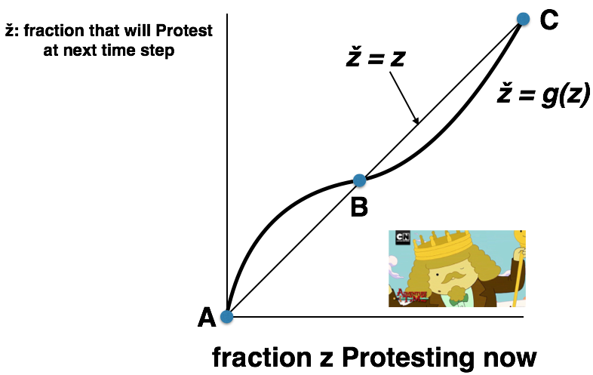

- A, B, and C are equilibrium points.
  - Are they stable or unstable? Explain how you know. (5 points)
A is stable; B is unstable; C is stable. [2 points, 1 for each up to 2]

Here’s how you know. Between A and B, g(z) > z. That means the fraction that will protest at the next time step is greater than the fraction currently protesting. Hence, between A and B the fraction protesting will grow. Between B and C, g(z) < z. That means the fraction that will protest at the next time step is LESS than the fraction currently protesting. Hence between B and C the fraction protesting will decrease.
[2 points for some discussion like this]

So, if the fraction protesting goes a bit above A, it keeps growing (to B). Hence A is unstable.
If the fraction protesting goes a bit BELOW B, it grows back to B. If it goes a bit ABOVE B, it decreases back to B. Hence B is stable.

If the fraction protesting goes a bit BELOW C, it decreases all the way down to B. Hence C is unstable.
[1 point]
  - If we start with a fraction z₀ = 0 of the Candy People population protesting, what is likely to happen in the long run? Remember that there is always a little “noise,” e.g., someone might spontaneously start protesting. (5 points)
In the long run, a little noise will push this fraction above A (z₀ = 0). Because A is unstable [they might also specify because g(z) > z between A and B] the fraction protesting will keep growing until it hits B, which is stable.

[3 points for saying it will end up at B; 2 points for some explanation]

- Consider the network depicted below; each node starts with the behavior B.
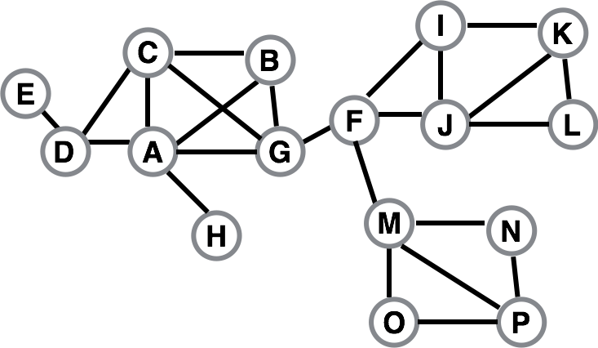
Now suppose that nodes F and A both adopt the new behavior A. Each other node has a threshold of q = 1/3 for switching to behavior A. The behavior A will NOT spread through the whole network. Find a cluster of density greater than 1 – q = 2/3 that blocks behavior A from spreading to all nodes, starting from F and A, at threshold q. Make sure to calculate its density. (5 points)
We know that the complete cascade must have been thwarted by a cluster of density greater than 1 – q = 2/3. M, N, O, P is such a cluster. Let’s check. M has four neighbors (F, N, O, P). Three of four are in the set {M, N, O, P}. N has two neighbors (M, P), both of which are in the set {M, N, O, P}. O also has two neighbors (M, P, both of which are in the set {M, N, O, P}. Finally, P has three neighbors (M, N, O) all of which are in the set {M, N, O, P}. {M, N, O, P } thus forms a cluster of density 3/4: for every node in {M, N, O, P} a fraction of 3/4 (or more) of its neighbors are in the cluster.
[2 points for M, N, O, P; 3 points for calculating cluster density.]
- Suppose that you work for an agricultural company. You have been tasked with testing a new hybrid seed product, to see how well it sells. You first market the product in State X, where farmers have extensive experience growing hybrid seed. Adoption is very rapid, with over half the farmers using your new hybrid seed product after only 6 months. Your company now plans to expand to State Y. Your boss wants to send an initial shipment of hybrid seed as large as the amount that sold in State X in the first 6 months. It’s important that you not overestimate, as the seed will go bad after about 6 months if it isn’t planted. Before signing off on the order, you suggest a trip to State Y to determine whether farmers have planted hybrid seed before. Explain why. (5 points).

In State X, farming with hybrid seed is well-established and hence legitimate. [This is the main thing to say]. Hybrid seed is more than just legitimate and compatible with existing farming practices, however; prior experience with hybrid seed also reduces the perceived risk and complexity of planting a new hybrid seed product. As research on the diffusion of innovation shows, all of these features make it easy for the innovation (in this case, new hybrid seed) to spread. As Rossman argues, high legitimacy makes it possible for adoption to proceed via constant hazard: as long as someone is aware of the innovation, s/he has a constant probability of adopting it, regardless of the number of other adopters. This is why adoption was so rapid in State X; everyone made individual adoption decisions, paying no attention to the behavior of others, so they just needed to become aware of the new hybrid seed product. Evidently, given that more than half the farmers adopted in just six months, the probability of adoption was quite high.
[2 points for some discussion of legitimacy, past experience, and rapid adoption/constant hazard. They don’t need to use the term constant hazard.]

If farmers in State Y have planted hybrid seed before, we might expect a similar uptake (perhaps not quite as aggressive, depending on the extent of their experience – note that State X had “extensive” experience with hybrid seed). If farmers in State Y have no prior experience with hybrid seed, however, the challenge is steep; it’s not just the new hybrid seed product that must diffuse, but the very practice of farming with hybrid seed. In this case the new hybrid seed product seems riskier, more complicated, and is less legitimate/compatible with existing beliefs and practices. Hence the hybrid seed will spread with much greater difficulty; farmers will look to their neighbors and network alters for guidance in adopting this new farming practice (corresponding to an endogenous hazard). It is thus incredibly unlikely that you will see the same large adoption as in State X in the first six months; much more likely will be an “s-shaped” adoption curve, with relatively few adoptions in the first months. Your boss’s plan would thus lead to a huge amount of wasted seed; hence, your trip is very reasonable!

[3 points for some discussion of how lack of legitimacy, past experience, etc. leads to “network-y” adoption/endogenous hazard. They don’t need to use the term endogenous hazard.]

(Side note: When the probability of adoption depends on the number who have already adopted, the initial probability of adoption is usually quite low.)

- When you look at the Facebook page of a public figure (for example, our University of California colleague Robert Reich), it currently tells you how many other people have Liked that Public page. While many Public pages don’t receive too many Likes, some become SUPER popular and receive many Likes (FYI, Robert Reich’s has over 2.5 MILLION Likes). Now imagine that Facebook did NOT tell you how many other people Liked the Public page. Would this make super popular Public pages MORE likely or LESS likely. Why? Make sure to explain your answer. (5 points)
The proposed change would make super popular Public pages LESS likely. [2 points]

The current Facebook policy makes information about the choices of others available and salient, by revealing how many other users have Liked a Public page. This information facilitates a rich-gets-richer/preferential attachment dynamic, driven by the imitation of the choices of others (students might mention Salganik, Dodds, and Watts’ Music Lab experiment, but they don’t have to). This dynamic would lead to power-law-like (or at least broad) distributions, and thus makes super popular Public pages more likely. If Facebook changed policy, it would make it much harder for people to imitate the choices of others (they wouldn’t know what those choices were), eliminating or at least super-attenuating the rich-gets-richer dynamic (students might mention De-metricator, but don’t have to). The elimination of this dynamic would thus make super popular Public pages LESS likely.
[3 points; must make some mention of rich-gets-richer/preferential attachment/imitating the choices of others leading to highly unequal outcomes/independent choices leading to more normally distributed outcomes/etc. ]
- Which scenario is more likely to increase inequality: (1) A fancy new app for job hunting is introduced to the social network at Bruin State University. The network of students is relatively well-mixed (non-homophilous) on traits like financial capital, familial background/social status, etc. Users of the app end up with starting salaries up to 15% higher than those who do not use the app! The app is somewhat costly, and can be challenging for new users. (2) The same app spreads through the social network in Auldskuul University, which is homophilous by family background and financial capital (so students from wealthier families tend to be friends exclusively with each other, and likewise for students from more modest families). As before, users of the app end up with starting salaries up to 15% higher than those who do not use the app. The app is somewhat costly, and can be challenging for new users. In three or four sentences, explain which scenario is more likely to increase inequality. (5 points)

Scenario 2 will increase inequality
[2 points for correct answer].

Here we have a practice (the app) that increases the well-being of adopters, but is expensive and challenging to use. This means that advantaged individuals are more likely to adopt. This also means that having friends who have already adopted the innovation is likely to be important in adoption. In the first case (Scenario 1), the social network is NOT homophilous on traits that promote adoption of the practice (in this case, financial capital and family background); this means that the app is less likely to spread asymmetrically to highly advantaged individuals, as likely adopters are not typically friends with likely adopters. [The students don’t have to say this, but the most likely pattern would be for more advantaged students to be early adopters, and for their friendship with less advantaged students to push those students over the threshold so they adopt, too]. In the second case (Scenario 2), the social network is homophilous on traits that increase the probability of adoption, so that likely adopters are friends with other likely adopters. This means that the beneficial practice will spread much more rapidly among already advantaged individuals, making them even better off.
[3 points for explanation; should discuss role of differences between the networks in spread of app amongst only advantaged or advantaged and disadvantaged]

EXTRA CREDIT 1. In your own words, name and briefly explain two properties of an innovation that can affect how easily it diffuses. Give an example of each property.
(5 points)

There are four options: complexity, observability, trialability, compatibility.

[3 for first, 2 for second; if they just say the name, it’s worth 1 point]

Complexity is pretty straightforward: the more complex an innovation is, the harder it will be for it to spread (because it seems riskier, harder to learn about, master, and apply, etc. – it has higher startup cost). For example, it has been possible for at least 1.5 decades to store information remotely and access it through the Internet. Dropbox made remote storage (technically, cloud storage) much less complex, integrating it completely with the file system, and has been widely adopted as a consequence.

Observability refers to how easy it is to tell that others in your social network/neighborhood/etc. have adopted the innovation. The less observable an innovation is, the harder it is for it to spread. For example, birth control technologies are not highly observable; this complicates their diffusion, as it is harder to assess the number of others who have adopted (suggesting that the innovation might be safe, sensible, etc.)

Trialability refers to how easy or difficult it is to “test” an innovation at low cost before adopting. Tattooing is obviously NOT trialable; by contrast, hybrid seed corn is quite trialable – farmers can plant a portion of their field with hybrid seed and test it out before adopting whole hog.

Compatibility refers to how well the innovation integrates with existing practices, behaviors, norms, beliefs, etc. It is closely related to Rossman’s concept of legitimacy. Hybrid seed corn had a hard time diffusing in areas that had never used it before, because it required planting practices that were completely different from those used in the past. Hybrid sorghum diffused quite easily in areas that had previous exposure to hybrid seed corn, because farming practices had changed to be compatible with hybrid seed. On this front, you might also mention the “r” versus “s” adoption curves; legitimate/compatible technologies are adopted with constant hazard, i.e., the probability of adoption is independent of the number of other adopters, leading to an
r-shaped adoption curve (as a function of time). Less compatible technologies are adopted with endogenous hazard, i.e., the probability of adoption depends on the number of other adopters, leading to an s-shaped adoption curve (as a function of time). This isn’t necessary for a discussion of compatibility, but it’s a nice addition.
EXTRA CREDIT 2. Be creative! On a separate page of your Blue Book, draw a picture, write a poem, or share a quote that is relevant to SOC 111. It doesn’t have to be amazing or anything; I just want to give you an opportunity to express yourself and your creativity. (5 points)
As long as they put something here, they get five points for free.

