S18 SOCI 111: Social Networks
Homework 2
DUE: 5/3/18
100 POINTS

Instructions: As before, these problems give you an opportunity to use the concepts and techniques we’ve learned in class to analyze interesting social systems. They also test your understanding of basic definitions and procedures. Think of them like exercises; they are here to build your network muscles! I encourage you to work in groups (of no more than 5), but each student should prepare her or his own solution, along with a note crediting other members of the working group. Please make sure you truly understand a solution, and please: DO NOT COPY SOLUTIONS. We will figure it out.
Please turn in a hard copy of your solutions to the TA at the beginning of class. Your solution should be neat and legible: you can type it up or write it out by hand, but we aren’t going to engage in decipherment here.
Capital idea!
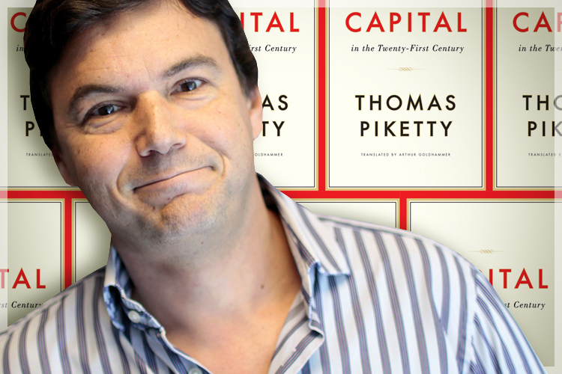
- Let’s talk capital! In your own words, define each of the four kinds of capital discussed in class (financial, physical, human, and social). Give a concrete (real-world) example of each. (8 points)

- Lada has just become a lead data scientist at Facebook. In order to move to Facebook headquarters, in Menlo Park, CA, Lada needs to borrow someone’s van. She has two friends who own vans: Scott and Tom. Tom and Lada have no mutual friends, while Scott and Lada have five. Who is more likely to lend Lada his van? Explain your answer. (5 points)

- Coleman-style social capital is sometimes described as a “public good” and hence suffers from a “free-rider” problem. In two or three sentences, explain what this means. To make the explanation concrete, illustrate it with a real-world example.
(5 points)

Sticking together?
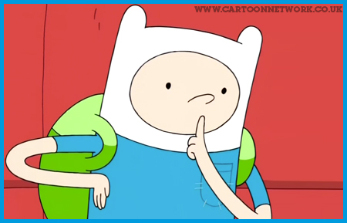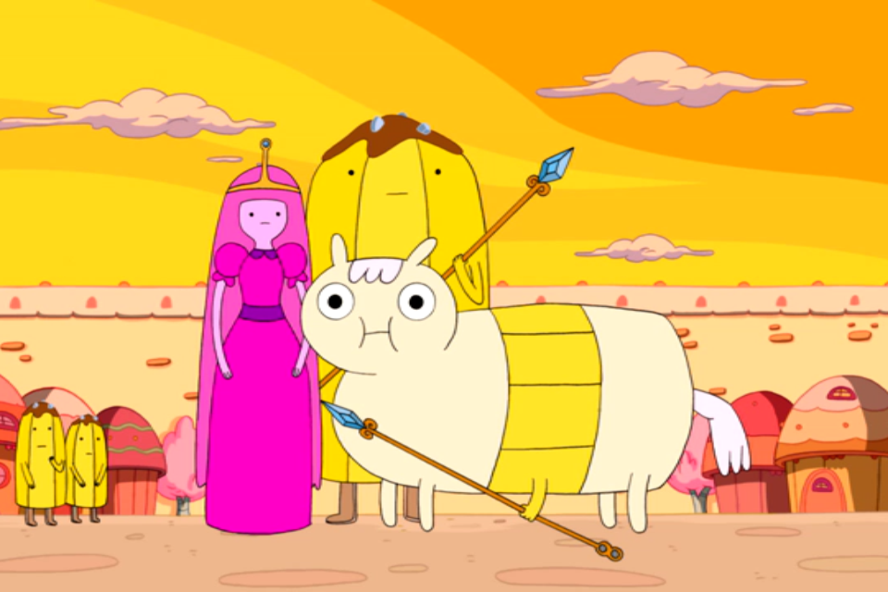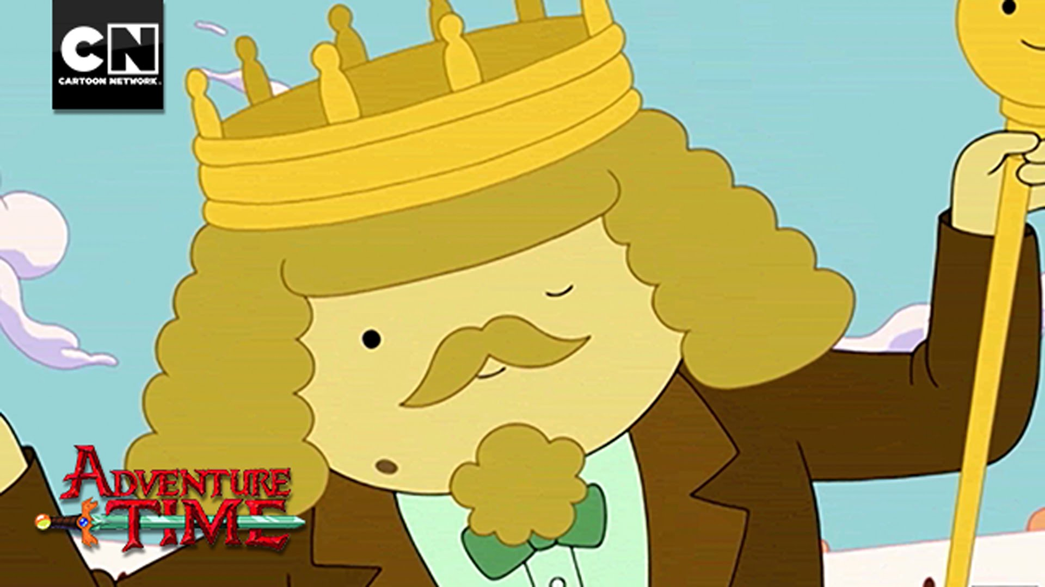

- Suppose that 4000 of the citizens in the Candy Kingdom are loyal to the Real King of Ooo (hereafter KOO) and 6000 are loyal to Princess Bubblegum. If friendships between citizens are formed at random, what fraction of friendships would you expect to connect a KOO loyalist to a Bubblegum loyalist? Explain your answer. (5 points)

- Now here’s what we actually find: Of 100,000 friendships between these citizens, 70,000 of them connect a KOO loyalist and a Bubblegum loyalist. Is there evidence for homophily? Why or why not? Do you think this is realistic? (5 points)

- Assume that we find evidence for homophily in this network—i.e., citizens who support KOO tend to be friends with each other, and citizens who are loyal to Princess Bubblegum tend to be friends with each other. Briefly describe three possible mechanisms that could generate this homophily and explain how they would work.
(5 points)

- What kind of data would you need to decide between possible explanations? Explain your answer. (5 points)

Getting closure

- Consider three students at Bruin State University: Lada, Bernardo, and Mark. These students are not friends with each other, currently. Lada and Bernardo are both members of the computer club. Lada and Mark are both members of the math team. Lada and Mark are also both members of the Sociology Undergraduate Association. Mark and Bernardo have no activities in common. Which two students are most likely to become friends? Which two students are least likely? Explain your answer. (5 points)

- What kind of closure process is described in the previous question? Explain your answer. (2 points)

- Suppose that Lada has two close confidants: her mentor, Professor Huberman, and her sister. Professor Huberman and Lada’s sister aren’t close friends; in fact, they don’t know each other at all! This structure seems to be a “forbidden triad” (and Lada violates Strong Triadic Closure). Drawing on Mario Small’s recent work, explain why we might expect to see a “forbidden triad” in this situation. (5 points)

You really need to focus up!
Consider the following affiliation graph connecting people (left) to various fan communities (foci):

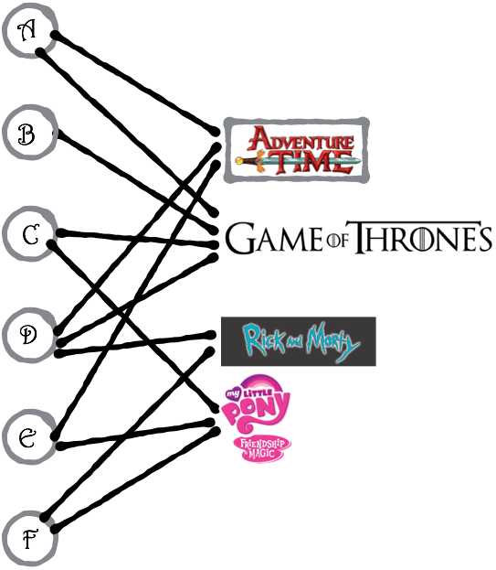

- The projected graph of an affiliation network connects two individuals when they share the same focus. Draw the projected graph for this affiliation network, joining two people when they like watching the same show. The nodes of the projected graph should be the six individuals on the left; edges should join any two individuals who watch the same show. (5 points)

Given a network showing pairs of people who share activities, we can try to reconstruct an affiliation network consistent with this information. Suppose that you are trying to infer the structure of a bipartite affiliation network, and you have obtained by indirect observation the projected network on the set of people, in which an edge joins each pair of people who share a focus. This projected network is shown below.
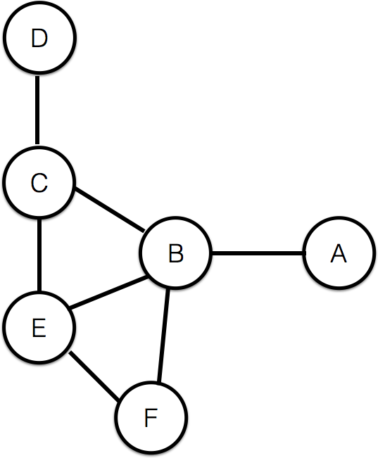

- Draw two different affiliation networks—on the same set of people, but with different foci—such that the projected graphs derived from these affiliation networks are identical to the projected graph above. Don’t just change the name of the foci; you have to change the pattern of connections from people to foci (but remember, the projected graph must stay the same). What does this tell you about projected graphs versus the full affiliation networks? (6 points)

Revenge of closure

- In your own words, describe the difference between triadic closure, focal closure, and membership closure. Give an example of each one. Feel free to draw a picture for each (though you aren’t required to do so). (6 points)

Schelling Model

- Consider the world from the Parable of the Polygons (go to: http://ncase.me/polygons/ and start playing around). Let there be an equal number of squares and triangles, with the board 20% empty. Now assume that our agents want to move if <10% of their neighbors are like them. What level of segregation emerges, when the system settles down? How does the level of segregation change, as you increase the preference to have neighbors of the same type (e.g., change the threshold at which agents will move)? What happens eventually, as you reach very high discriminatory preference (e.g., the agents will move if <90% of their neighbors are like them)? Do you think this will change as you increase or decrease the amount of empty space? HINT: You can actually test all of these ideas out on the Parable of the Polygons website!
(8 points)

Summer Movies
Q15-Q16 concern the following game:

Rick and Morty are trying to decide what movie to see. Rick would prefer to see the new action blockbuster hit, Two Brothers. Morty would prefer to see the dark comedy Mrs. Sullivan. Despite having a preference for different movies, they would rather see a movie together than alone. If they both see Two Brothers, Rick will get a payoff of 4 and Morty will get a payoff of 3. If they both see Mrs. Sullivan, Rick will get a payoff of 3 and Morty will get a payoff of 4. If Rick sees Two Brothers and Morty sees Mrs. Sullivan, they will each get a payoff of 2 (they are seeing their preferred movie, but they are sad to be seeing it alone). If Rick sees Mrs. Sullivan and Morty sees Two Brothers, they will each get a payoff of 0 (not only are they going to the movies alone; they aren’t interested in the movies they are seeing).

- Draw the payoff matrix for this game. (5 points)

- Find any pure-strategy Nash equilibria in this game. Explain your answer—make sure you consider each combination of strategies. (10 points)

I wish I was a little bit taller

- You are walking on campus one day with a friend when you come across a dusty bottle on the ground. You try to take the cork out, but it won’t budge. You ask your friend to help, and together—with you holding the bottle, and your friend pulling on the cork—you get it open. Lo and behold, a genie emerges! He says, “It’s your lucky day! For freeing me, you get three wishes. Unfortunately, there are two of you, so I’m afraid someone is going to end up with more wishes.” The genie points to you. “Since you are holding the bottle, I’ll let you decide. Either you can have two wishes, and your friend can have one; or you can have one wish, and your friend can have two. Here’s the catch: your friend has to accept the offer. If your friend rejects the offer, then neither of you gets any wishes.” To think about this game, fill out the following game tree:
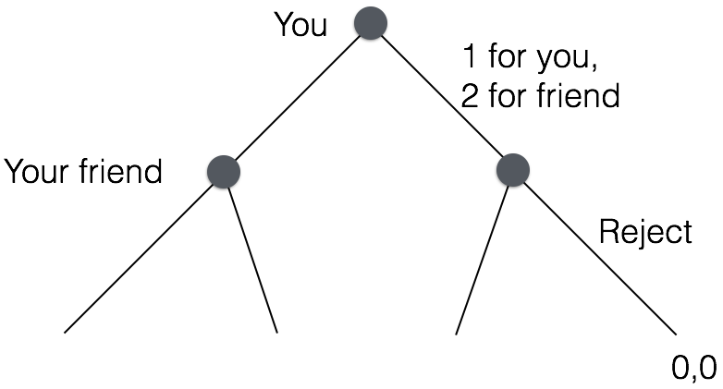
The first node represents your choice; each outgoing branch is labeled with which strategy you chose. The second layer of nodes represents your friend’s choice; again, each branch is labeled with the option chosen by your friend. At the bottom are the payoffs. So, if you offer your friend two wishes, keeping one for yourself, and your friend rejects that offer, you each get zero wishes (0 for you, 0 for friend). Once you complete the game tree, ask yourself: What is the rational move for your friend (i.e., the one that maximizes wishes)? What, then, is the rational move for you? What if you had to split 100 wishes? What would this same analysis suggest? How realistic do you think this game theoretic analysis is? Make sure to explain your answers. (10 points)

