S18 SOCI 111: Social Networks
Homework 3 – 75 points total
DUE: 5/29/18 – note extended deadline!!!

Instructions: As before, these problems give you an opportunity to use the concepts and techniques we’ve learned in class to analyze interesting social systems. This time I’ve leaned more toward interesting conceptual puzzles rather than brute calculations. I encourage you to work in groups (of no more than 5), but each student should prepare her or his own solution, along with a note crediting other members of the working group. Please make sure you truly understand a solution, and please: DO NOT COPY SOLUTIONS. We will figure it out. This includes copying solutions from earlier years.
Please turn in a hard copy of your solutions to the TA at the beginning of class. Your solution should be neat and legible: you can type it up or write it out by hand, but we aren’t going to engage in decipherment here.
- Suppose a network exchange theory experiment is run on the graph depicted below using the one-exchange rule. Say which node or nodes you would expect to make the most money (i.e., receive the most favorable exchanges) and why.
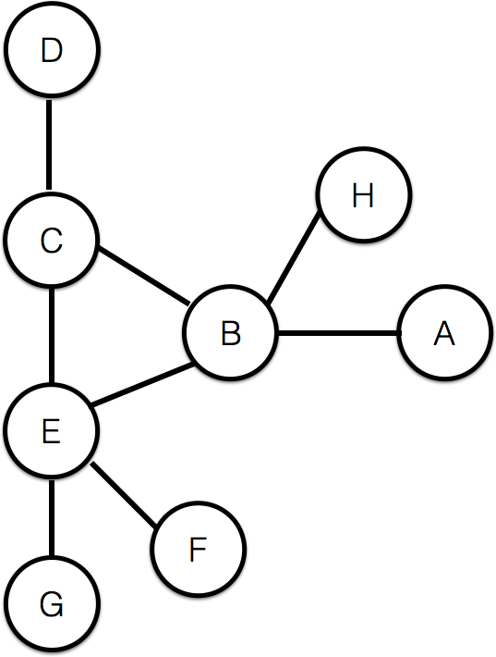
Also, do you think the advantage experienced by the most powerful nodes in this graph will be more similar to the advantage experienced by the most powerful node on a 3-node path, or more similar to the advantage experienced by the most powerful node on a 4-node path? Give a brief (1-3 sentence) explanation for each of your answers. (You do not need to give actual numbers for the amounts of money the nodes would receive)
(10 points)

Now consider the following outcome on a slightly different network:

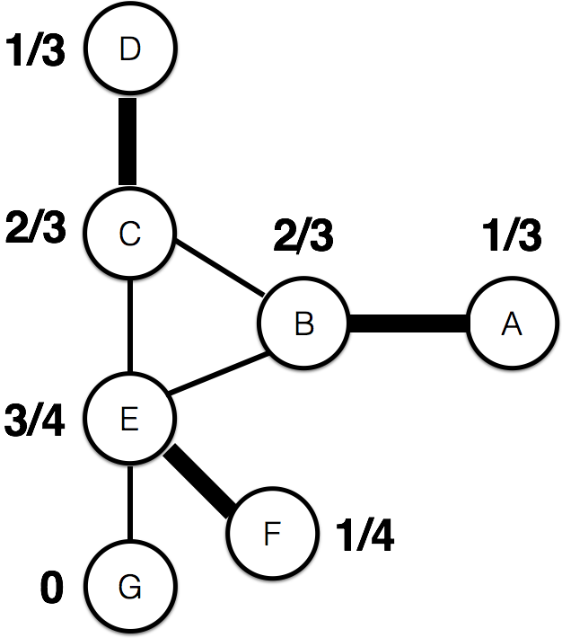
Bold lines represent the matching (who exchanges with whom), while the numbers give the values.
- Is this outcome stable? Explain your answer. (5 points)
- This outcome is not balanced. Explain how you know (without checking). Now show how you could change the outcome to be balanced, and demonstrate that this new outcome is balanced. Show your work. (10 points)

Now consider the following outcome for a network-exchange theory experiment:

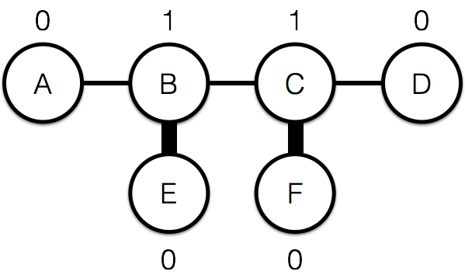

- If you performed the experiment with UCLA undergraduates, would you expect to see these precise values? Why or why not? (5 points)

- Imagine that a team of sociologists at Bruin State University finds that experimental subjects contribute more in a public goods game if you tell them that their contributions will be publicly disclosed. A competing team at Southern Trojan University finds that subjects contribute more in the same setup (i.e., a public goods game) if you tell them that their friends already contributed. Each team claims to have discovered a different, “universal” human social behavior. The sociologists at Bruin State University performed ten experiments: in the US, China, Sweden, Egypt, and India, as well as five small-scale societies. Each of these experiments by the Bruin State sociologists had 100 subjects; each found the same result. The sociologists from Southern Trojan University had many more subjects—ten thousand of them—all of whom are students at Southern Trojan University. Which study provides better evidence for “universal” human behavior? Explain why. (5 points)

- Describe an example of a graph where adding a single edge can increase the size of the largest strongly connected component by at least 1,000 nodes. Clearly, you don’t need to draw the full graph; rather, you should describe it in words. You may find it helpful to draw a schematic picture as well. (5 points)

- Josephina Bruin runs a website called “Bruin Bytes,” which delivers delicious snacks to students working late at night. But her site doesn’t even show up on the first page of search results for Google queries like “late night food UCLA.” She looks into search engine optimization and receives proposals from two companies. The first company says that she needs to optimize her Authority score, which they can do for her by creating several pages with high Hub scores that link to Josephina’s site. The second company says that she needs to increase her PageRank by linking to the websites of other popular restaurants, which they will help her do for a modest fee. Josephina knows that Google uses both PageRank and Hubs & Authorities to rank search results. The first company asks for a lot more money, but Josephina chooses it anyway. When her business partner, who has not taken SOC 111, asks her why, she says that the second company’s approach definitely would not have worked, while the first company’s approach made sense. Explain her decision: why the second company’s approach won’t work, and why the first company’s approach could. (5 points)

Q8-Q9 concern the following scenario:
The neuroscientists Christof Koch and Giulio Tononi believe that we’ll be able to build a consciousness detector in the near future. Currently, scientists believe that humans, many mammals and birds, and octopuses are all conscious in some form—but certainly not plants, robots, or computers. Suppose that 20% of all robots in the future eventually become conscious. This means that
$Pr\left(conscious\right)= 0.20$ and $Pr\left(not conscious\right)= 0.80$.
The consciousness detector is a reliable but imperfect signal of whether something is conscious. If an entity is conscious, the detector will give a positive read 95% of the time: $Pr\left(positive|conscious\right)= 0.95$. However, it will sometimes give a positive read even when an entity is not conscious: $Pr\left(positive|not conscious\right)= 0.10$.

- What is the probability that the consciousness detector will give a positive read when applied to a future robot, i.e., what is $Pr\left(positive\right)$? (5 points)
- Suppose that we test a robot and get a positive read. What is the probability that the robot is conscious, i.e., what is$Pr\left(conscious | positive\right)$? Based on this result, do you think it would be ethical to turn the robot off? (5 points)
- [Note: this is based on a true story!] It’s graduation day! To the thrilling tune of Elgar’s Pomp and Circumstance, Professor Foster crosses Wilson plaza and takes the stage. When he turns around, he is greeted with a surprising sight!
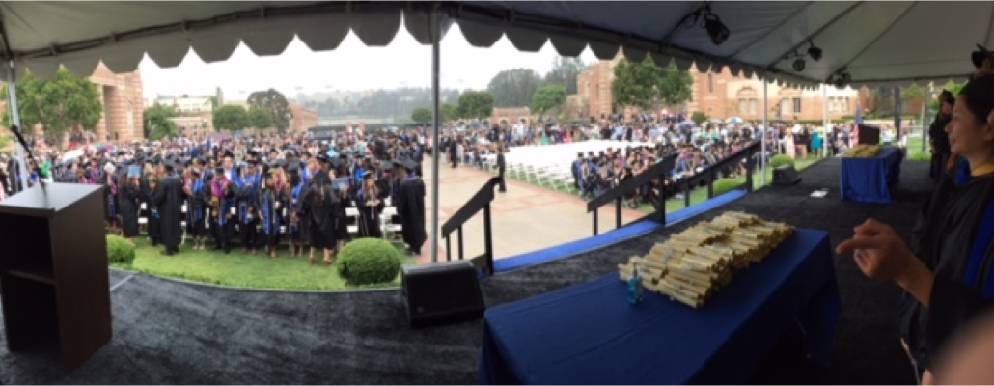
Half of the students (to his left) are standing up, and half of the students (to his right) are sitting down. Using information cascades, briefly explain how this might have happened. You may assume that students can observe the decision of anyone ahead of them on their side but do not look at the other side. Include an explanation of the total independent information available to the students as they decide whether to sit or stand. You may also assume that they are not influenced by what the professors are doing—though I hope in general you are somewhat influenced by us (5 points)
- In this problem we will explore the power of expertise and ignorance in creating and destroying information cascades. Let’s keep the same setup as in lecture and Chapter 16; ordinarily, individuals can see the behaviors but not the private signals of all previous individuals. Each individual receives a private signal (“High” or “Low”) and must decide whether to Accept or Reject the technology, belief, behavior, practice, etc., in question. To be concrete, let’s assume we are talking about a technology—say, a new virtual assistant. Individuals want to Accept Good technology and Reject Bad technology. Good technologies are more likely to generate High private signals; Bad technologies are more likely to generate Low private signals. Finally, suppose we have two types of individuals: Ordinary and Expert. Ordinary people have no special knowledge, and so they only get one private signal. Experts have special knowledge relevant to the decision, and so they get two private signals (they always get the same signal – two High or two Low). Assume that everyone knows who is an Expert and who is Ordinary. Everyone also knows that an Expert gets two private signals, while an Ordinary person gets only one.

Imagine that Person 1 is an Expert and Person 2 is Ordinary. Person 1 receives two Low signals and Rejects. Person 2 receives a High signal.

  - What can Person 2 infer about Person 1’s private signals? (3 points)
  - What should Person 2 do? Explain your answer. (3 points)
.
Now imagine that Person 3, 4, 5, etc. arrive and make their decisions in sequence. These people are all Ordinary.
  - Explain why an information cascade will occur. (3 points)

Now imagine that after some number of Ordinary people (say 50), another Expert arrives as Person 51. She receives two High signals.

  - What will Person 51 (the Expert) do? Explain your answer, and the consequences for the information cascade. (3 points)

  - Can an information cascade occur despite multiple Experts acting sequentially? Imagine that Persons 1, 2, and 3 are all Experts. See if you can find a scenario in which an information cascade will nonetheless occur. (3 points)

