S18 SOCI 111: Social Networks
Homework 4
DUE: 6/7/18
80 points total

Instructions: As before, these problems give you an opportunity to use the concepts and techniques we’ve learned in class to analyze interesting social systems. Once again, I’ve leaned more toward interesting conceptual puzzles rather than brute calculations. I encourage you to work in groups (of no more than 5), but each student should prepare her or his own solution, along with a note crediting other members of the working group. Please make sure you truly understand a solution, and please: DO NOT COPY SOLUTIONS. We will figure it out. This includes copying solutions from earlier years.
Please turn in a hard copy of your solutions to your TA at the beginning of class. Your solutions should be neat and legible: you can type them up or write them out by hand, but we aren’t going to engage in decipherment here.
- Why is it sometimes rational to imitate the behavior of others? Briefly describe two reasons, and give an example of each. (5 points)
Two rational reasons for imitating the behavior of others are: information effects and direct benefit effects. In the case of information effects, you imitate the behavior of others because their behavior has revealed information about the state of the world (e.g., that a product is Good or Bad, that a practice is a Good Idea or a Bad Idea, etc.). Notably, you receive no additional benefit for doing what other people are doing. If I see many folks eating the same type of sandwich and decide to buy it, it is because I think it must be a good sandwich (information); I derive no greater pleasure from the sandwich because five other people ate the same (type of) sandwich. With direct benefit effects, you imitate the behavior of others because aligning your behavior with the behavior of others has direct positive benefits for you (without mediation through information). This chiefly arises in situations when the benefits of some practice, product, or behavior are a function of the number or fraction of people who have adopted the practice, product, or behavior. So, if many of my friends have joined Google +, that directly increases the benefit to me of joining Google + (I have more people to talk to). I benefit directly from aligning my behavior with that of my friends, instead of, say, joining some other social networking platform.
[3 points for first reason, 2 points for second reason; -1 if they don’t give example; if reason is only stated, give one point]
You are the first UCLA graduate to run for President of the United States. Congratulations! You need to pick a running mate, so you form a committee to interview potential Vice-Presidential candidates. The committee narrows your options down to Candidate A and Candidate B; they invite the two Candidates in for intense interviews. Everyone on the committee was interested in making the best possible choice, but after the interviews it was clear that members of the committee had different ideas about which of the two candidates was the best choice. When the committee met to make the final decision they decided to go around the room and ask each person on the committee to announce which of the two Candidates they believed to be the best choice. The head of the committee reports back to you that everyone on the committee said that Candidate B seemed to be the best choice. Impressed by the unanimous decision, you call Candidate B to see for yourself. Although you have mixed feelings after your phone conversation, you decide to go with Candidate B anyway. After a month of campaigning with Candidate B, it is clear that you should have chosen Candidate A.

- How could it be that the committee members unanimously supported Candidate B, even though you were quite sure that before the committee meeting some members supported Candidate A? Explain what has happened, and how your training in social networks could have prevented this catastrophe (5 points)

An information cascade has occurred. The first person to speak in the meeting already supported Candidate B, based on her prior opinion/private information, and hence spoke in favor of Candidate B. The second person to speak in the meeting also supported Candidate B already (again, based on his prior opinion); he spoke in favor of Candidate B as well. Now everyone else in the meeting has two pieces of independent information: Person 1 and Person 2 have both revealed their private information, and both pieces of private information support Candidate B. We do not know what the third person to speak originally thought. Her private information may have supported Candidate A, or Candidate B. Let’s say she went into the meeting thinking that Candidate A was better. She now has three independent pieces of information: two favoring Candidate B (from Person 1 and Person 2) and one favoring Candidate A (her own information). Because the majority of independent signals supports Candidate B, it would be rational for Person 3 to support Candidate B as well, regardless of her private information. Hence Person 3 will speak in favor of Candidate B. This analysis extends to all subsequent speakers in the meeting: any of them with private information in favor of Candidate A will discount it and support Candidate B, leading to a unanimous decision in favor of Candidate B. Indeed, even YOU had some private information favoring Candidate A (remember your mixed feelings after talking to Candidate B), which you discounted in favor of the group’s decision.

[3 points for this exposition; they don’t need to do the detailed scenario, but they need to talk about how the first few people spoke and how this affected the decisions of subsequent movers]

As a student of social networks, you could have anticipated this catastrophe and demanded that the committee meeting not use the “go around the room and state your preference” approach. That decision-making procedure is fundamentally flawed and vulnerable to information cascades. Because they stated their opinions sequentially, the members of the committee were put in a position where they could rationally discount private information to follow the crowd (in addition, there may have been “social” pressure to conform once the cascade started). The simplest procedure would be for everyone to write down his or her opinion on a sheet of paper and go with the majority. Let’s say, however, that your team prized consensus, so that a straight up & down secret ballot would not work. Then the following procedure might work: have every member of the committee write down their evaluation on a sheet of paper; then have all of the members simultaneously reveal their preference. Following this initial information step, have each member of the committee explain why s/he supports Candidate A or B. Then follow this with a deliberative discussion, aiming at consensus. If the majority originally supported Candidate A, it should be relatively easy to persuade the others. Even if Candidate B were supported by a majority at first, this process would stand a greater chance of leading to consensus around A, as the problems with B may have come out in deliberation.

[2 points for this]

- You are in charge of marketing a new smartphone app, SeeFood, that allows users to share pictures of food with each other. Uptake of the app will obey the following dynamical rule: 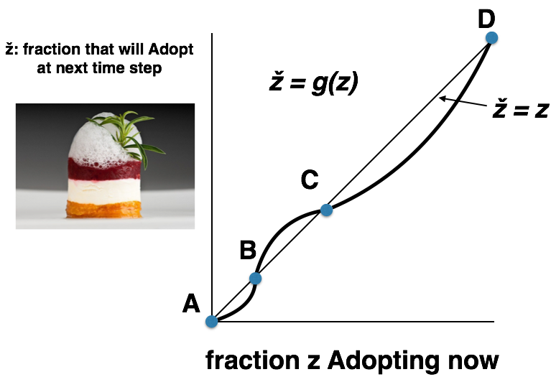

- If you spend $50,000 on marketing, you can get a fraction z’ of the population to Adopt the app at time 0. This fraction z’ is between B and C—just above B, in fact. If you spend $300,000 you can get a fraction z’’ of the population to Adopt at time 0 (mostly by giving the App away). This fraction z’’ is close to D. Your intern argues that you should spend the $300,000, as it will get you close to total adoption. If adoption settles at fraction A, your company will make $0 in revenue; at fraction B, your company will make $100,000 in revenue; at fraction C, your company will make $200,000 in revenue; and at fraction D, your company will make $500,000 in revenue. Is your intern right? If not, what should you do? In all cases, you need to subtract the cost of your campaign from the revenue. Be sure to explain your reasoning. (10 points)
Your intern is wrong.
[2 points]

Note that fractions A, B, C, and D are all equilibria: z = g(z).
If you follow the intern’s suggestion and spend $300,000 (mostly by giving away the App), you end up with z’’ Adopting at time 0. This fraction z’’ is close to but less than D. However, between C and D, g(z) < z. This means that the fraction that Adopts at the next time step is less than the fraction now Adopting. In other words, we will decay down from “close to D” all the way to C.
[3 points for this analysis]

Now consider the other option. If you spend $50,000 on marketing, you’ll end up with z’ Adopting at time 0. This fraction is between B and C (just above B). Note, however, that g(z) > z between B and C. Thus the fraction that Adopts at the next time step will be greater than the fraction now Adopting, until you reach stable equilibrium C. (C is stable because g(z) > z below C and g(z) < z above C, so you return to C from small perturbations).
[3 points for this analysis]

Thus both strategies lead to a final adopting fraction of C, which produces revenue of $200,000. If you follow the intern’s approach, you have a net loss ($200,000 - $300,000 = -$100,000) while the other strategy leads to a profit of $150,000 (= $200,000 - $50,000). You should follow the other strategy.
[2 points for this]

Consider our model of the diffusion of a new behavior through a social network. Recall that to define this model, we have a network, a behavior B that everyone starts with, and a threshold q for switching to a new behavior A. Any node will switch to A if at least a fraction q of its neighbors have adopted A. If exactly q of its neighbors have adopted A, we assume it adopts A, too.

Consider the network depicted below; each node starts with the behavior B.
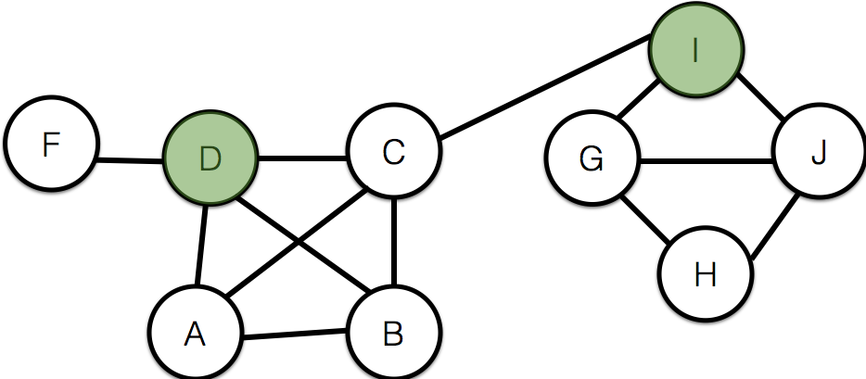

- Now suppose that the two shaded nodes (D and I) both adopt the new behavior A, and each other node has a threshold of q = 1/2 for switching to behavior A.

- If other nodes follow the threshold rule for choosing behaviors, which nodes will eventually switch to the new behavior A? You do not have to explain your answer. (5 points)
One possible history of the system is as follows: The behavior first spreads to F (1 of 1 neighbors adopting) and C (2 of 4 neighbors adopting). Then it spreads to B (2 of 3 neighbors adopting) and A (2 of 3 neighbors adopting). It will never spread to G, H, or J. So: it will spread from D and I to A, B, C, and F.

- Find a cluster of density greater than 1 – q = 1/2 that blocks behavior A from spreading to all nodes, starting from D and I, at threshold q. (5 points)
We know that the complete cascade must have been thwarted by a cluster of density greater than 1 – q = 1/2. G, H, and J is a good candidate (in fact, it must be such a cluster). Let’s check. H has two neighbors (G and J). Both are in the set {G,H,J}. G has three neighbors: H,I,J; two of the three are in the set {G,H,J}. J also has three neighbors: G,H,I; two of the three are in the set {G,H,J}. Thus {G,H,J} forms a cluster of density 2/3: for every node in {G,H,J} a fraction of 2/3 (or more) of its neighbors are in the cluster.
- A group of 20 students living on the third and fourth floors of a college dorm like to play online games. When a new game appears on campus, each of these students needs to decide whether to join, by registering, creating a player account, and taking a few other steps necessary in order to start playing.

When a student evaluates whether to join a new online game, she bases her decision on how many of her friends in this group are involved in the game as well. (Not all pairs of people in this 20-person group are friends, and it is more important whether your friends are playing than whether many people in the group overall are playing.)

To make the story concrete, let’s suppose that each game goes through the following “life cycle” within this group of students:
(a) The game has some initial players in the group, who have discovered it and are already involved in it.
(b) Each other student outside this set of initial players is willing to join the game if at least half of her friends in the group are playing it.
(c) Rule (b) is applied repeatedly over time, as in our model from Chapter 19 for the diffusion of a new behavior through a social network.
Suppose that in this group of 20 students, 10 live on the third floor of the dorm and 10 live on the fourth floor. Suppose that each student in this group has two friends on their own floor, and one friend on the other floor. Now, a new game appears, and five students all living on the fourth floor each begin playing it.

HINT: Draw a picture of a social network that satisfies the above description – this might help you work through the possible answers.

The question is: if the other students use the rule above to evaluate whether to join the game, will this new game eventually be adopted by all 20 students in the group? There are three possible answers to this question: yes, no, or there is not information in the set-up of the question to be able to tell. Say which answer you think is correct, and explain. (10 points)
As you might have guessed from the question immediately preceding (Q5), this is a question about the diffusion of an innovation. Clusters will be extremely important in determining whether the innovation is adopted by all 20 students.

The two essential pieces of information are: a) the threshold for the spread of the innovation; and b) the overall organization of the social network. The threshold is easy to read off from the question: each student is willing to join the game if at least half of her friends are playing it. This means the threshold q = 1/2. We also immediately know that the innovation will NOT spread through the entire network if we can find a cluster of density greater than 1-q, i.e., of density greater than 1/2 outside the initial set of adopters.

[3 points for

Can we find such a cluster? Recall that a cluster of density p is a set of nodes such that for each node in the cluster, a fraction p or more of the node’s neighbors are also in the cluster. Note that “each student in this group has two friends on her own floor, and one friend on the other floor.” In other words, each student has three friends, and two of those friends are on the same floor. That means that for students on the fourth floor, 2/3 of their friends are on the fourth floor; similarly, for students on the third floor, 2/3 of their friends are on the third floor. The students on the third floor constitute a cluster of density 2/3; it is a set of nodes (students) such that for each student in the cluster, a fraction 2/3 of her neighbors are also in the cluster. The game starts on the fourth floor, and we see immediately that there is indeed a set of nodes outside this initial set with density greater than 1/2: the third floor. Each student on the third floor has only one of her three friends on the fourth floor; it is thus impossible for any third floor student to have greater than half of her friends play the game, even if the game spreads through the entire fourth floor (which there is no guarantee it will, depending on how the initial 5 are positioned in the network). Because no third floor student will ever have her threshold met, the game will never spread to the third floor. Thus we know for certain that the game will not be adopted by all 20 students.

As suggested, a cartoon might make this easier:

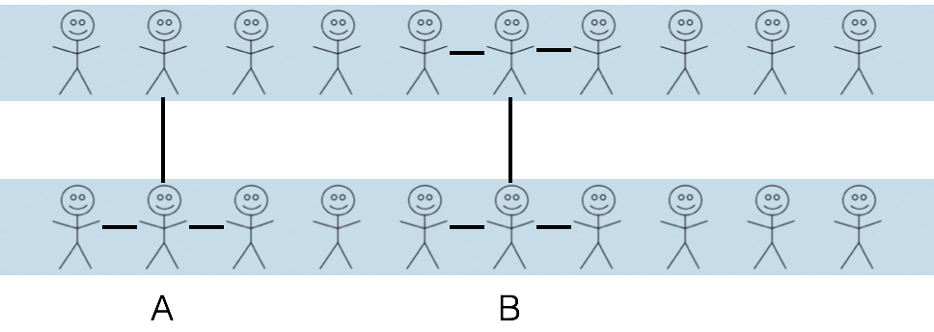

Here we see that anyone on floor three (e.g., A an B) has at most ONE neighbor out of three on the fourth floor. Even if everyone on the fourth floor has adopted, no one on the third floor will ever have > 1/2 of neighbors adopting.

Recall that the threshold q in our diffusion models can be derived from a coordination game. In the original version we studied, the (A,A) equilibrium gives payoff a to both players and the (B,B) equilibrium gives payoff b. Now let’s modify this basic model in two ways. First, suppose that we have two different types of nodes: Workers and Bosses. Workers only play with Bosses; Workers never play with Workers, and Bosses never play with Bosses. Now imagine that currently, both Workers and Bosses play strategy Unequal, in which they divide the total value produced by employment unequally, so that the Worker gets payoff u_{W} and the Boss gets payoff u_{B}, which is greater than u_{W}. Now imagine another strategy Equal is introduced, in which Workers and Bosses divide the total value equally, so that the Worker and the Boss both get the same payoff e. Now e is greater than u_{W} so in any specific interaction the Workers would prefer strategy Equal; on the other hand, e is less than u_{B} so the Bosses would prefer strategy Unequal. Workers and Bosses have to play the same strategy in every interaction (in other words, you can’t be Unequal in some interactions and Equal in others); as in the earlier model, if a Worker and a Boss play a different strategy (e.g., the Worker plays Equal and the Boss players Unequal) the payoff to each is 0. Note: these next two questions seem tricky, but you are doing some serious, cutting-edge stuff here. And you can solve them by following the threshold derivation in class closely. You may also find it helpful to put in concrete numbers for the different payoffs, though you should answer using the general payoffs.
- Imagine a Worker who currently plays Unequal and who interacts with d Bosses. What fraction of those Bosses would have to play Equal before the Worker would switch? Write down this threshold as a function of e and u_{W}. Imagine that the Worker’s payoff when he plays Unequal becomes very small; what does that do to the threshold? Do you think that makes it easier or harder for the system to switch over to sharing Equal value? You might think about how this relates to Marx and Engels’ famous statement that “[the] proletarians have nothing to lose but their chains.” (10 points)

First, why is this a cool question? It is based on a model from Sam Bowles’ graduate textbook, Microeconomics, which I taught in my graduate seminar on formal models of social structures [he explicitly makes the analogy with the Communist Manifesto]. I realized as I was teaching my graduate class that this model was very similar to the coordination game models of thresholds that we had studied, and thought it would be cool for you to see that you can get at some of the key intuitions about institutions that distribute value more and less equally with some pretty straightforward methods we learned in SOC 111.
Let’s first draw the payoff matrix for the coordination game between workers and bosses:
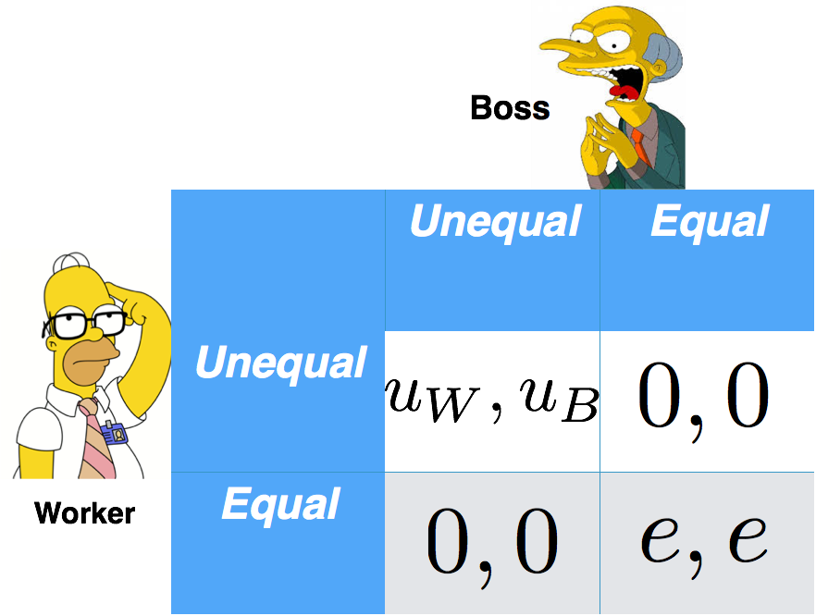
[they don’t need to draw this]
Note that payoffs only come when Worker and Boss coordinate on strategy. Now we want to figure out what fraction of a Worker’s Bosses must play Equal before a Worker will shift from Unequal to Equal. Our focal Worker has d Bosses. A fraction p of its Bosses play E; a fraction 1-p play U. The Worker will switch to E if the payoff from doing so is greater than (or equal to) the payoff from playing U. Hence the condition is:
$$Payoff E≥ Payoff U$$
We can write the payoff of E as the sum of the payoff from playing E against Bosses who play E and the payoff from playing E against Bosses who play U:
$$Payoff E=\left[\#Bosses who play E\right]*\left[payoff to Worker of E,E\right]+\left[\#Bosses who play U\right]*\left[payoff to Worker from E,U\right]=\left[\#Bosses who play E\right]*\left[e\right] +\left[\#Bosses who play U\right]*0$$
and likewise for U:
$$Payoff U=\left[\#Bosses who play E\right]*\left[payoff to Worker of U,E\right]+\left[\#Bosses who play U\right]*\left[payoff to Worker from U,U\right]=\left[\#Bosses who play E\right]*0 +\left[\#Bosses who play U\right]*u_{W}$$

[2 points for getting to this point]
Substituting pd for the # of Bosses who play E and (1-p)d for the # of Bosses who play U:
$$pde+≥\left(1-p\right)du_{W}$$
[2 points for getting to this point]
We divide both sides by d and multiply out over the parentheses:
$$pe+≥u_{W}-pu_{W}$$
And isolate the p:
$$pe+pu_{W}≥u_{W}$$
Finally, factoring out p and dividing by $e+u_{W}$
$$p≥\frac{u_{W}}{e+u_{W}}$$
[3 points for getting to this point]
Now imagine that the Worker’s payoff from playing Unequal, i.e., $u_{W}$, becomes very small. For the sake of argument, imagine it goes to zero. You can see that
$$p≥\frac{u_{W}}{e+u_{W}}$$
goes to zero as well. This implies that as $u_{W}$ gets small the threshold decreases (heading toward zero). So if $u_{W}$ is very small, we expect the threshold to be very small. What this means is that only a small fraction of Bosses have to offer the Equal contract before the Worker will shift.
[2 points for this]
In other words, it makes it easier for the system to switch to an institution that shares Equal value. In this scenario, the proletarians literally have almost nothing to lose (the payoff from Unequal is very tiny) and so they are more likely to switch.
[1 point for this]
[Extra credit] Imagine a Boss who currently plays Unequal and who interacts with d Workers. What fraction of those Workers would have to play Equal before the Boss would switch? Write down this threshold as a function of e and u_{B}. If the Boss’s payoff when he plays Unequal is very large, what does that do to the threshold? Do you think that makes it easier or harder for the system to switch over to sharing Equal value?
(5 points)
Note that, as before, payoffs only come when Worker and Boss coordinate on strategy. Now we want to figure out what fraction of a Boss’s Workers must play Equal before the Boss will shift from Unequal to Equal. Our focal Boss has d Workers. A fraction p of its Workers play E; a fraction 1-p play U. The Boss will switch to E if the payoff from doing so is greater than (or equal to) the payoff from playing U. Hence the condition is:
$$Payoff E≥ Payoff U$$
We can write the payoff of E as the sum of the payoff from playing E against Workers who play E and the payoff from playing E against Workers who play U. Remember that Workers are the Row players, and Bosses are Column players:
$$Payoff E=\left[\#Workers who play E\right]*\left[payoff to Boss of E,E\right]+\left[\#Workers who play U\right]*\left[payoff to Boss from U,E\right]=\left[\#Workers who play E\right]*e +\left[\#Workers who play U\right]*0$$
and likewise for U:
$$Payoff U =\left[\#Workers who play E\right]*\left[payoff to Boss of E,U\right]+\left[\#Workers who play U\right]*\left[payoff to Boss from U,U\right]$$
$=\left[\#Workers who play E\right]*0 +\left[\#Workers who play U\right]*u_{B}$
Substituting pd for the # of Workers who play E and (1-p)d for the # of Workers who play U:
$$pde+≥\left(1-p\right)du_{B}$$
[2 points]
We divide both sides by d and multiply out over the parentheses:
$$pe+≥u_{B}-pu_{B}$$
And isolate the p:
$$pe+pu_{B}≥u_{B}$$
Finally, factoring out p and dividing by $e+u_{B}$
$$p≥\frac{u_{B}}{e+u_{B}}$$
[1 points]
Now imagine that the Boss’s payoff from playing Unequal, i.e., $u_{B}$, becomes very large. You can see that
$$p≥\frac{u_{B}}{e+u_{B}}$$
increases as $u_{B}$ grows; to see this, note that once $u_{B}≫e$ we essentially have $u_{B}$ divided by$u_{B}$ so p converges to 1.
[1 point for saying threshold goes up]
What this means is that the Boss will be very resistant to switching; only if practically all workers play Equal will the Boss shift and offer the Equal contract, because he gets so much value out of the Workers who play Unequal. This obviously makes it harder for the system to switch over to sharing Equal value.
[1 point for this]

- In your own words, name and briefly explain four properties of an innovation that can affect how easily it diffuses. Give an example of each property. (10 points)
There are four options: complexity, observability, trialability, compatibility.

[3 for first, 3 for second, 2 for third, 2 for fourth; if they forget an explanation, -1 on the points for that sub-answer]

Complexity is pretty straightforward: the more complex an innovation is, the harder it will be for it to spread (because it seems riskier, harder to learn about, master, and apply, etc. – it has higher startup cost). For example, it has been possible for at least 1.5 decades to store information remotely and access it through the Internet. Dropbox made remote storage (technically, cloud storage) much less complex, integrating it completely with the file system, and has been widely adopted as a consequence.

Observability refers to how easy it is to tell that others in your social network/neighborhood/etc. have adopted the innovation. The less observable an innovation is, the harder it is for it to spread. For example, birth control technologies are not highly observable; this complicates their diffusion, as it is harder to assess the number of others who have adopted (suggesting that the innovation might be safe, sensible, etc.)

Trialability refers to how easy or difficult it is to “test” an innovation at low cost before adopting. Tattooing is obviously NOT trialable; by contrast, hybrid seed corn is quite trialable – farmers can plant a portion of their field with hybrid seed and test it out before adopting whole hog.

Compatibility refers to how well the innovation integrates with existing practices, behaviors, norms, beliefs, etc. It is closely related to Rossman’s concept of legitimacy. Hybrid seed corn had a hard time diffusing in areas that had never used it before, because it required planting practices that were completely different from those used in the past. Hybrid sorghum diffused quite easily in areas that had previous exposure to hybrid seed corn, because farming practices had changed to be compatible with hybrid seed. On this front, you might also mention the “r” versus “s” adoption curves; legitimate/compatible technologies are adopted with constant hazard, i.e., the probability of adoption is independent of the number of other adopters, leading to an
r-shaped adoption curve (as a function of time). Less compatible technologies are adopted with endogenous hazard, i.e., the probability of adoption depends on the number of other adopters, leading to an s-shaped adoption curve (as a function of time). This isn’t necessary for a discussion of compatibility, but it’s a nice addition.
- You have been put in charge of a child immunization program for rubella, covering two different countries. Neither country has rubella vaccination at the moment. In country A, vaccination for other diseases is a well-established practice. In country B, vaccination for any disease is completely unknown. In which country is the practice of rubella vaccination likely to spread more easily? What do you think the adoption curves will look like in the two countries? (You can draw them if you like). Briefly explain your answer. (10 points)
The practice of rubella vaccination will spread more easily in country A.
[1 point]

In country A, the practice of vaccination in general is well-established and hence legitimate. This also reduces the perceived risk and complexity of rubella vaccination. All of these traits make the innovation diffuse more easily. As Rossman argues, high legitimacy makes it possible for adoption to proceed via constant hazard: as long as someone is aware of the innovation, s/he has a constant probability of adopting it, regardless of the number or fraction of other adopters. This leads to an “r” shaped adoption curve, with a rapid initial increase in the fraction of the population adopting.
[2 points for first one]
In country B, more than the rubella vaccination needs to spread; the very practice of vaccination as a legitimate thing to do must spread as well. Here the innovation seems riskier, more complicated, and is less legitimate/compatible with existing beliefs and practices. Hence rubella vaccination will spread more slowly, with an endogenous hazard: the probability of adoption depends on the fraction of other folks who have adopted. When that fraction is small, the probability is small, and hence the rate of adoption is slow. As more folks adopt, the probability increases and the rate of adoption increases; eventually, adoption will slow down as most of the relevant folks have adopted. This corresponds to an “s-shaped” adoption curve.
[2 points for second one]
[grading note: they don’t need to use the TERMS constant and endogenous hazard, but they do need to describe the basic idea]

- Imagine two sandwich shops across the street from one another. At Simon’s Sandwich Shoppe, they sell ye olde timey British Sandwiches. At HändBrød they sell super-modern sandwiches “inspired by the sea” or “based on Seamus Heaney’s Beowulf” (see picture in Q3 above, Immortalized by SeeFood™). Both shops are equally popular. However, at Simon’s Sandwich shop, customers order by picking from a simple list – no other information besides the name of the sandwich and its ingredients. At HändBrød, there is a HändBrød “leaderboard” showing how many people have bought each sandwich. In which shop would you expect to see a single sandwich account for a substantial fraction of purchases each day (i.e., be super-popular)? Briefly explain your answer. (10 points)

You would expect to see a super-popular sandwich at HändBrød.

[3 points for this]

One of the chief mechanisms for generating extreme inequality in popularity (including super-popular items) is a rich-gets-richer dynamic driven by the imitation of the choices of others. HändBrød makes information about the choices of others available and salient, thus facilitating a rich-gets-richer/preferential attachment dynamic (the students might mention Salganik, Dodds, and Watts’ Music Lab experiment).

[4 points for some discussion of rich-gets-richer, imitating choices of others, etc.]
Simon’s Sandwich Shoppe provides no information about the choices of other sandwich eaters, so it is hard to see how a rich-gets-richer dynamic could operate there; customers are more likely to make choices independently.

[3 points for this part]

