Figures
Figure 1: Increase in Likelihood of Being ‘Very Proud’ Post-9/11 (Odds Ratios) 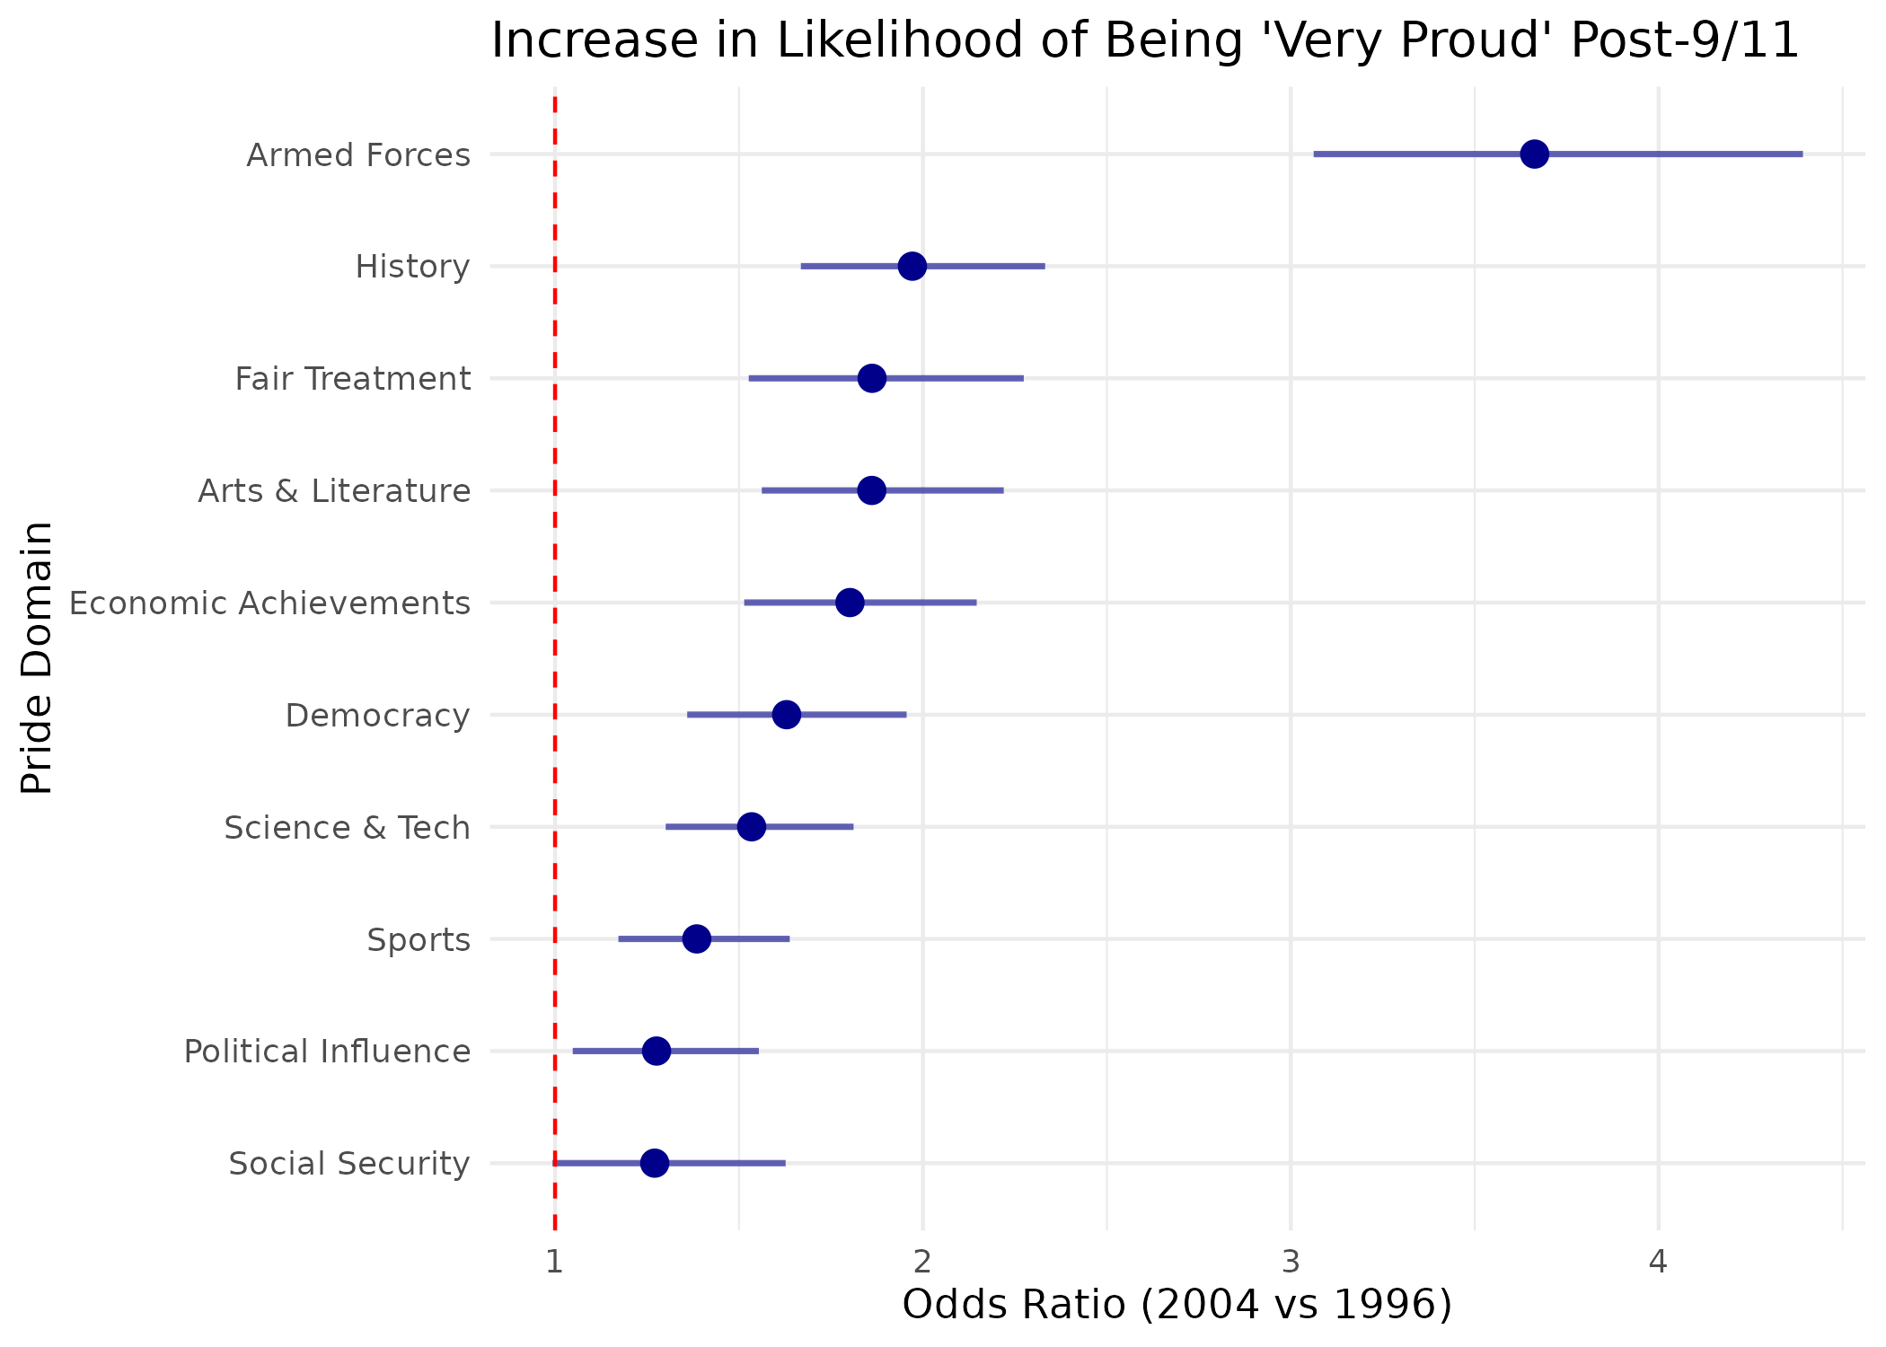
Figure 2: Distribution of U.S. Pride Scale Scores (1996 vs. 2004) 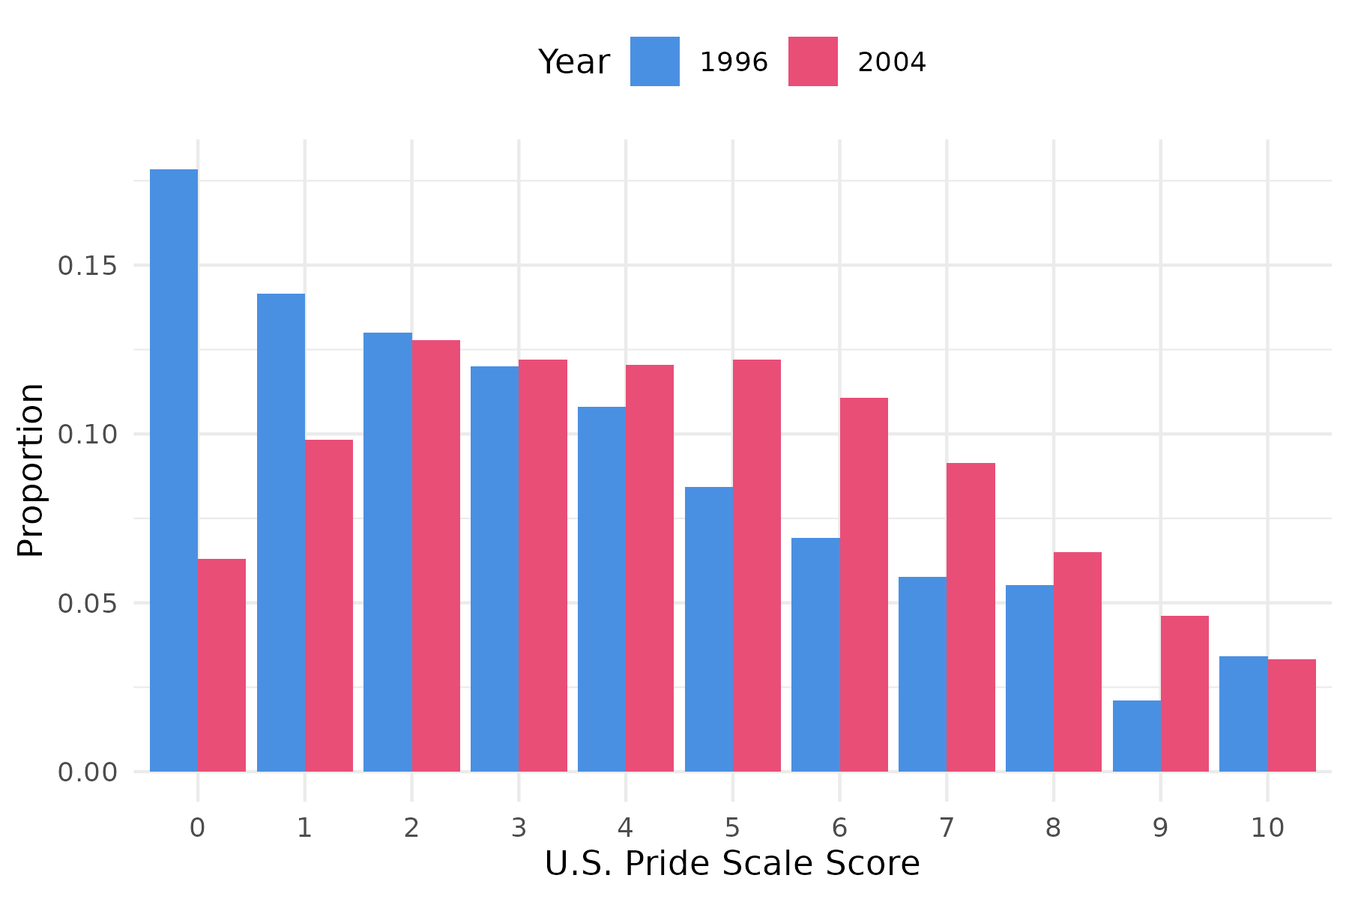
Figure 3: Predicted U.S. Pride Score across Education Levels by Year 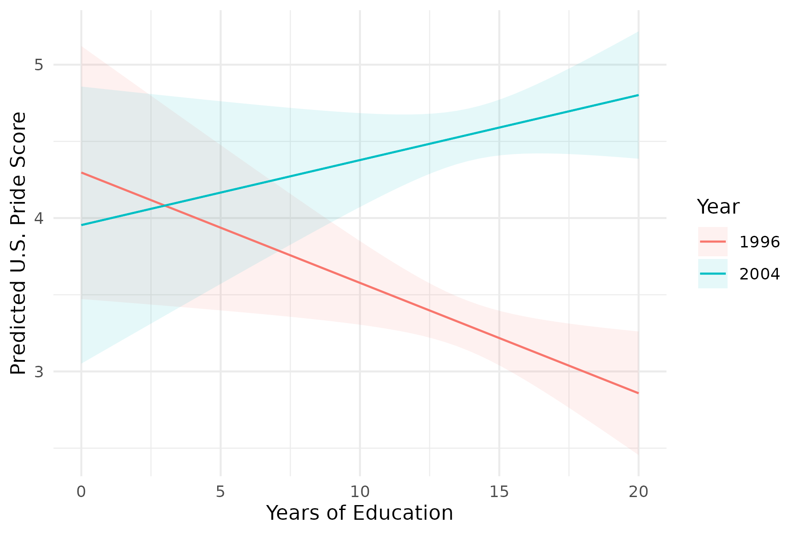
Figure 4: Effect of Specific Association Memberships on U.S. Pride (Controlling for Cohort) 