Introduction
Which groups are more likely to experience increased feelings of national pride after experiencing a threat to the nation? In this paper, I use survey data on a representative sample of Americans collected before and after the events of 9/11 to shed light on this question. This “natural experiment” allows me to adjudicate between competing hypotheses regarding the socio-demographic distribution of feelings of national pride following a threat to the nation.
Theories in the tradition of the “authoritarian personality” (Adorno et al. 1950) and the modern political science of the personality correlates of political ideology (John T. Jost et al. 2007, 2017; John T. Jost, Nosek, and Gosling 2008) conceive of national pride as reflecting a form of “irrational patriotism,” driven by fundamentally ingrained motivational and affective factors that differ across people. These theories predict that members of low-status groups will be much more likely to experience renewed feelings of national pride after experiencing a threat to the nation. From this perspective, a threat to the nation is seen as endangering the “ontological security” (Giddens 1984) of persons whose lives are characterized by routine and alienating work, who are disengaged from established institutions, or who have been left behind by recent structural changes to the economy and rapid cultural shifts in dominant values (Wuthnow 2019).
Theories of attachment to collectivities as a nested group (Lawler 1992; Mueller and Lawler 1999), on the other hand, point to a different dynamic and lead to a clearly divergent empirical implication. According to the choice-process approach, individuals are more likely to experience affective attachment to a larger group within which other groups that they belong to are nested (such as the nation), only to the extent that they are able to in fact experience freedom and autonomy in their everyday dealings, and to the extent that this autonomy and freedom is attributed to membership both in the more proximate groups that they are part of, and to the larger unit within which these groups are nested.
These two propositions suggest that, given that high status individuals are more likely to be in structural positions that afford autonomy and self-direction (Kohn and Schooler 1969, 1978; Kohn 1977), and given that they are more likely to belong to “nested-subgroups," such as voluntary associations (Bell and Force 1956; Freeman, Novak, and Reeder 1957; Janoski and Wilson 1996; Knoke 1986; McPherson 1981; Scott 1957; Tomeh 1973; Dederichs 2024), within which feelings of attachment to super-ordinate collectivities can be fostered and made salient, the choice-process theory predicts that it will be high-status individuals who will be more likely to experience renewed feelings of national pride following a threat to the nation.
In this paper,

Where Does National Pride Come From? Two Approaches

The Needs-Based and irrational patriotism Models
Standard approaches in social psychology geared toward explaining individual differences in affective attachment to nations as collectivities usually point to factors associated with the emotional needs that such feelings of national pride meet (John T. Jost et al. 2007). Thus, classic studies of the authoritarian personality noted how persons who scored high on authoritarianism scales were also prone to express “irrational” feelings of pride and “blind” attachment to the nation conceived as a solidary collectivity (Adorno et al. 1950; Pettigrew 1999). Excessive attachment to national groups is usually regarded as pathological and as leading to various suboptimal societal outcomes, such as support for authoritarian or charismatic leaders and less support for democratic or inclusive institutions (Santos and Jost 2024).
If feelings of national pride are an expression of either authoritarianism or irrational patriotism, then we should find it overrepresented among those groups marked by the socio-demographic characteristics typically associated with these cognitive and affective orientations. The bulk of the research suggests this refers to low-status, low-education groups, typically alienated from mainstream institutions and disempowered in their everyday interactions (Collins 1986; John T. Jost 2017; John T. Jost et al. 2003). This implies that post-9/11 increases in national affective attachment in the U.S. should be concentrated among lower-status groups, who may be more likely to react to epistemic and existential threats to the status quo by becoming affectively attached to the nation, thereby increasing their belief in the propriety and desirability of existing systems.

Lawler’s Choice-Process Theory and Nested Attachments
In contrast to needs-based and irrational patriotism views, Edward Lawler’s (1992) choice-process theory posits a different mechanism. According to the theory, people value individuality, freedom, and self-efficacy, and they engage in structured action within concrete social contexts, primarily nested subgroups, to enact those values. In this way, groups provide individuals with a “context of choice” within which successful purposive action occurs. Positive emotions stemming from the sense of autonomy and control afforded by the group trigger an attribution process that leads people to become affectively attached to those groups and, by implication, to any larger group within which those groups are nested.
From this perspective, national “groups”–closer to “imagined communities” in Anderson’s (1991) sense—will be the object of strong positive affective attachments to the extent that they are perceived as responsible for giving the person a sense of autonomy, freedom, and a structured “menu” of choices. The central point is that emotions produced in choice processes help account for actors’ affective attachments to multiple, nested collectivities of which they are members. Under normal circumstances in individualistic societies like the United States, a proximal rule prevails: local groups tend to elicit stronger feelings of attachment than more distal groups within which they are nested (e.g., cities, states, the U.S. as a whole). However, when the individual is embedded in nested groups that allow for the transfer of positive affect from smaller to larger collectivities, the nation can become the beneficiary of this affective attachment if attribution rules shift.

The Theoretical Status of 9/11: A Shift in Attribution Rules
From both the need-based and irrational patriotism perspectives, 9/11 is seen as an external “shock” that increases ingroup-outgroup differentiation, leads to processes of self-categorization, and results in more intense feelings of affective attachment to the collectivity, particularly among those with presumably the largest psychological needs (e.g., to justify the system, need for order and cognitive closure, and so forth). From the choice-process perspective, on the other hand, 9/11 can be seen as a shock to the cultural rules that govern the attribution of responsibility for the positive feelings engendered by the choice process. In the immediate post-9/11 period, we should expect a weakening of the proximal rule and the emergence of a distal rule. Under a distal responsibility regime, the nation becomes more salient as the ultimate source of opportunities for choice, freedom of expression, and autonomy.
This sense of saliency should be stronger for individuals embedded in nested subgroups. Therefore, efficacious action in structured social arenas and embeddedness in nested subgroups should be positively connected to affective attachment to the national collectivity when the proximal rule is weakened. Consequently, post-9/11 increases in national affective attachment should be concentrated among high-SES individuals, who are more likely to engage in high autonomy everyday behavior and more likely to belong to multiple nested subgroups.

Data and Variables
To adjudicate between these empirical implications, I rely on data from the 1996 and 2004 waves of the General Social Survey (GSS). These two waves, collected before and after the events of September 11, 2001, include a special module on attitudes toward the United States, providing an ideal natural experiment to assess shifts in national attachment.

Dependent Variables
Two primary dependent variables are analyzed: a U.S. Pride scale and a Nationalism scale. The U.S. Pride scale is an additive index constructed from ten questions asking respondents how proud they are of America across various domains. The prompt asks, “How proud are you of America in each of the following...” followed by domains such as the way democracy works, its political influence, economic achievements, social security system, scientific and technological achievements, sports, arts and literature, armed forces, history, and fair treatment of groups. Response categories are “Very proud,” “Somewhat proud,” “Not very proud,” and “Not proud at all.” Each item was dichotomized so that “Very proud” equals 1 and all other responses equal 0, yielding an additive scale from 0 to 10 (Cronbach’s $α=0.80$).
The Nationalism scale captures agreement with statements asserting American superiority and blind loyalty (Schatz, Staub, and Lavine 1999). It is computed as the mean of four items: (1) “I would rather be a citizen of America than of any other country in the world,” (2) “The world would be a better place if people from other countries were more like the Americans,” (3) “Generally speaking, America is a better country than most other countries,” and (4) “People should support their country even if the country is in the wrong.” Responses were recorded on a 5-point Likert scale ranging from “Strongly agree” (1) to “Strongly disagree” (5). The items were reverse-coded prior to averaging so that higher values indicate stronger nationalism (Cronbach’s $α=0.64$).

Independent Variables
The primary independent variables of interest are education and embeddedness in nested subgroups (voluntary associations). Education is measured continuously as the highest year of school completed (ranging from 0 to 20).
To evaluate nested subgroup embeddedness, I use data on voluntary association memberships available in the 2004 wave. Respondents were asked whether they belonged to any of 15 different types of groups (e.g., fraternal, service, veterans, political, labor union, sports, youth, school, hobby, school fraternity/sorority, nationality, farm, literary/art, professional, and church-affiliated groups). Each membership type is represented as a binary indicator (1 = Yes, 0 = No). I also calculate the total number of memberships per respondent to capture overall associational embeddedness.

Control Variables
All models include statistical controls for birth cohort (centered at 1955). The 2004 cross-sectional models additionally control for gender, race, and geographic region. While political ideology is theoretically relevant, it cannot be included in the main models due to a severe data availability issue: in the 2004 GSS wave, the questions assessing political ideology and the module assessing national attachment were administered on mutually exclusive ballots, resulting in no respondents having data for both variables in that year. We therefore exclude it from our primary analyses to allow for the 1996-2004 comparison. However, Appendix A presents supplementary models adjusting for political ideology restricted to the 1996 subsample for which this data is available.

Results

The Period Effect on Pride Items
An initial examination of the binary items comprising the U.S. Pride scale confirms a substantial period effect between 1996 and 2004. Survey-weighted logistic regressions indicate that the likelihood of respondents reporting being “very proud” of the United States significantly increased across nearly all measured domains (see Figure 1). Not surprisingly, pride in America’s armed forces is an outlier, but we can also observe notable increases in pride for U.S. history, fair treatment of all groups, arts and literature, and economic achievements post-9/11. These universal shifts across items mean that the overall distribution of the U.S. Pride scale shifted markedly upward in 2004 compared to 1996 (see Figure 2).
[Insert Figure 1 about here]
[Insert Figure 2 about here]

Nationalism and Irrational Patriotism
The irrational patriotism perspective predicts that 9/11 should have driven an increase in nationalism, particularly among lower-status and less-educated groups. However, our baseline and interaction models assessing the Nationalism scale yield a different picture. While baseline nationalism was indeed higher among older individuals with lower levels of educational attainment in 1996 (John T. Jost et al. 2003), the interaction between education and the survey year on the Nationalism scale is neither statistically nor substantively significant. The need-based and irrational patriotism hypotheses fail to fully capture the changing dynamics of national attachment after 9/11, as the anticipated surge in blindly patriotic nationalism among the dispossessed did not neatly materialize as the primary driver of the 9/11 effect (Table 1).
[Insert Table 1 about here]

Education and the 9/11 Effect
Turning to the U.S. Pride scale under the Choice-Process framework, we compare the effects of education across the two periods. OLS models reveal a striking reversal. As shown in the first model of Table 2, in 1996, education was negatively associated with national pride, supporting the hypothesis that low-status individuals are more likely to feel such pride. However, as we can see in the second model in the same table, the coefficient estimate in 2004 is positive (though not significant at conventional levels). A pooled model that formally tests the interaction between education and the survey year shows a significant positive interaction term, suggesting that national pride increased at a faster rate among higher-educated individuals after 9/11.
This shift directly supports the choice-process prediction: individuals with greater structural autonomy experienced the most dramatic increase in their national attachment patterns under the new distal attribution regime. Figure 3 plots the predicted marginal effects of education on the U.S. Pride Scale score, clearly demonstrating the positive slope of education in 2004 in clear contrast to the corresponding negative slope in 1996, opening up a substantial gap between high-education individuals observed in 2004 versus similarly educated individuals observed eight years before. Meanwhile, individuals with low levels of education display similar, statistically indistinguishable, and relatively high levels of national pride in both periods.
[Insert Table 2 about here]
[Insert Figure 3 about here]

Nested Membership and National Attachment
Following the choice-process framework, we assess how voluntary association membership acts as a nested grouping structure that correlates with attachment to the nation using the 2004 sample. As shown in Table [tab:full2004], the overall volume of voluntary memberships is a statistically significant, positive predictor of national pride, regardless of whether it is measured as a categorical variable or a continuous count. And this effect is robust to the inclusion of various controls, most notably nationalist sentiment, which is presumably the primary channel through which political ideology (e.g., conservatism) affects feelings of national pride.
However, a crucial dynamic emerges when disaggregating organizational memberships. According to choice-process theory, affective attachment to the nation requires that the proximate group be cognitively nested within the national structure. Our results confirm this: while the total number of memberships has a positive effect, specific groups that are inherently linked to the national fabric—such as Veterans Groups, Political Clubs, and Fraternal Organizations—foster autonomy that is easily attributed to the larger national collective, resulting in the most substantial increases in U.S. pride. As illustrated in Figure 4, these specific nested groups strongly drive the positive relationship between associational embeddedness and national attachment.
[Insert Table 3 about here]
[Insert Figure 4 about here]

Discussion and Conclusion

Summary of Main Results
This study set out to determine which socio-demographic groups were most likely to experience increased feelings of national pride following a threat to the nation, using the events of 9/11 as a natural experiment. First, while overall levels of national pride increased significantly across nearly all domains post-9/11, the often-theorized surge in blindly patriotic “nationalism” (reflecting a belief in American superiority and uncritical loyalty) was not heavily stratified by socioeconomic status. Although older individuals and those with lower baseline education exhibited higher absolute levels of nationalism, the rate of change in nationalism post-9/11 did not differ significantly by educational attainment.
Second, and in striking contrast, the structural predictors of the affective U.S. Pride scale shifted dramatically. In 1996, education was negatively associated with national pride, aligning with standard expectations that the highly educated display less overt attachment to the nation. However, by 2004, the effect of education on pride had reversed. Highly educated individuals experienced the steepest and most significant increases in national attachment, fundamentally re-ordering the demographic profile of American national pride.
Third, in the post-9/11 period, embeddedness in voluntary associations proved to be a powerful predictor of this affective attachment. While the total volume of memberships was positively associated with national pride, disaggregating these groups revealed a more specific dynamic. It was specifically embeddedness in groups cognitively linked to the national structure—such as veterans’ organizations, political clubs, and fraternal societies—that most powerfully drove the positive relationship between associational life and national pride.

Theoretical Implications
These findings directly challenge and help to adjudicate between two divergent theoretical perspectives on the nature of national attachment. Standard psychological perspectives on nationalism fall short in predicting which individuals were more likely to experience national pride in this new period. Needs-based approaches and theories of “irrational patriotism” or authoritarianism predict that those with the most dire needs for belongingness and system justification (typically lower-status, less-educated, and structurally marginalized groups) should experience the most intense increases in their attachment. Our results show that this is definitively not the case.
Instead, the results are more consistent with Lawler’s (1992) choice-process approach. Post-9/11, it was precisely those individuals more likely to experience structural autonomy in their day-to-day behavior—the highly educated—who increased their attachment to the national collectivity. In this framework, the events of 9/11 acted as a cultural shock that temporarily shifted attribution rules from a “local” (proximal) to a “national” (distal) orientation. Efficacious action and positive affect generated in structured, local contexts could suddenly be attributed to the nation as the ultimate guarantor of those freedoms. Furthermore, the strong effect of specific nested groups accounts for exactly how this positive affect generated in local, structured contexts is transferred to the super-ordinate collectivity.
An important analytical distinction must therefore be maintained between class-based expression rules and internal feeling rules. While lower-status individuals may have been more likely to express national pride in highly visible ways (e.g., via bumper stickers or overt patriotic displays), they were paradoxically less likely as a group to experience a proportional increase in affective attachment. High-status individuals embedded in nested groups were actually more likely to feel increased national pride after 9/11, even if they were less likely to outwardly express it in stereotypical ways. By shifting our theoretical lens to the choice process, we can better understand the structural and affective foundations of modern patriotism.

Limitations and Future Research
While this study leverages a unique historical juncture to evaluate macro-level shifts in attachment, several limitations in the current effort present opportunities for future research. First, the analysis relies on pooled cross-sectional data from the GSS. Because we observe different, independent samples in 1996 and 2004, we cannot track true within-individual changes in national pride. Future research should engage with longitudinal panel data to observe intra-individual shifts in attribution rules and affective attachments following national crises. Tracking the same individuals would allow researchers to make more robust causal claims about how an individual’s pre-crisis structural position conditions their post-crisis emotional response.
Second, data availability constraints prevented the inclusion of political ideology in the primary 2004 models. Although supplementary models on the 1996 subsample demonstrated that the baseline structural effects of education remain robust after adjusting for conservative ideology, and the results in 2004 remain robust to the inclusion of nationalist sentiments (the main mechanism via which political ideology presumably operates), future investigations should leverage datasets in which a more direct adjustment for political ideology is feasible. This would allow researchers to ask novel questions about the independent and interacting roles of political conservatism and structural autonomy over time, exploring whether the choice-process mechanism operates differently across partisan divides.
Finally, this study relies on educational attainment and voluntary association counts as proxy measures for the structural affordance of autonomy and self-direction. Future studies could address these theoretical mechanisms more directly using different methods. For instance, researchers could directly measure occupational autonomy and subjective self-efficacy via survey instruments, or experimentally manipulate the salience of the distal attribution rule in a laboratory setting. Furthermore, exploring whether other types of national threats—such as economic depressions, severe domestic political polarization, or global pandemics—trigger a similar distal attribution rule, or instead cause a retrenchment into local, proximal attachments, remains an exciting frontier for the sociology of emotions and political sociology.

Supplementary Models with Political Ideology (1996 Only)
Because the 2004 GSS administered the political ideology and national attachment modules on mutually exclusive survey ballots, it is impossible to adjust for political ideology in pooled models or models using the 2004 sample. However, given the theoretical relevance of conservative political ideology to national attachment, we present our core models predicting the Nationalism and U.S. Pride scales here restricted to the 1996 subsample of respondents who provided valid responses for both political ideology and the dependent variables.
[Insert Table A1 about here]
[Insert Table A2 about here]

Descriptive Statistics
[Insert Descriptive Statistics Table about here]

References
Adorno, Theodor W, Betty Aron, Else Frenkel-Brunswik, Daniel J Levinson, William Morrow, Maria Hertz Levinson, and R Nevitt Sanford. 1950. The Authoritarian Personality. Harper. books.google.com › booksbooks.google.com › books.
Anderson, Benedict. 1991. “Imagined Communities. 1983. Rev. Ed.”
Bell, Wendell, and Maryanne T Force. 1956. “Social Structure and Participation in Different Types of Formal Associations.” Social Forces 34: 345–50.
Collins, Randall. 1986. Weberian Sociological Theory. Cambridge University Press.
Dederichs, Kasimir. 2024. “Join to Connect? Voluntary Involvement, Social Capital, and Socioeconomic Inequalities.” Social Networks 76: 42–50. https://doi.org/10.1016/j.socnet.2023.07.004.
Freeman, Howard E, Edwin Novak, and Leo G Reeder. 1957. “Correlates of Membership in Voluntary Associations.” American Sociological Review 22: 528–33.
Giddens, Anthony. 1984. The Constitution of Society: Outline of the Theory of Structuration. Polity Press.
Hogg, Michael A, and Deborah I Terry. 2000. “Social Identity and Self-Categorization Processes in Organizational Contexts.” Academy of Management Review. Academy of Management 25 (1): 121–40. https://doi.org/10.5465/amr.2000.2791606.
Janoski, Thomas, and John Wilson. 1996. “Pathways to Voluntarism: Family Socialization and Status Transmission Models.” Social Forces 74: 271–92.
Jost, John T. 2017. “Working Class Conservatism: A System Justification Perspective.” Current Opinion in Psychology 18: 73–78. https://doi.org/10.1016/j.copsyc.2017.08.020.
Jost, John T., Melanie Langer, Vivienne Badaan, Flávio Azevedo, Edgardo Etchezahar, Joaquin Ungaretti, and Erin P. Hennes. 2017. “Ideology and the Limits of Self-Interest: System Justification Motivation and Conservative Advantages in Mass Politics.” Translational Issues in Psychological Science 3 (3): e1–26. https://doi.org/10.1037/tps0000127.
Jost, John T., Jaime L. Napier, Hulda Thorisdottir, Samuel D. Gosling, Tibor P. Palfai, and Brian Ostafin. 2007. “Are Needs to Manage Uncertainty and Threat Associated with Political Conservatism or Ideological Extremity?” Personality and Social Psychology Bulletin 33 (7): 989–1007. https://doi.org/10.1177/0146167207301028.
Jost, John T., Brian A. Nosek, and Samuel D. Gosling. 2008. “Ideology: Its Resurgence in Social, Personality, and Political Psychology.” Perspectives on Psychological Science 3 (2): 126–36. https://doi.org/10.1111/j.1745-6916.2008.00070.x.
Jost, John T., Brett W. Pelham, Oliver Sheldon, and Bilian Ni Sullivan. 2003. “Social Inequality and the Reduction of Ideological Dissonance on Behalf of the System: Evidence of Enhanced System Justification Among the Disadvantaged.” European Journal of Social Psychology 33 (1): 13–36. https://doi.org/10.1002/ejsp.127.
Knoke, David. 1986. “Associations and Interest Groups.” Annual Review of Sociology 12: 1–21.
Kohn, Melvin L. 1977. Class and Conformity: A Study in Values, with a Reassessment, 1977. University of Chicago Press. http://books.google.com/books/about/Class_and_Conformity.html?hl=&id=FPRUXUxy3xAC.
Kohn, Melvin L, and Carmi Schooler. 1969. “Class, Occupation, and Orientation.” American Sociological Review 34: 659–78.
———. 1978. “The Reciprocal Effects of the Substantive Complexity of Work and Intellectual Flexibility: A Longitudinal Assessment.” American Journal of Sociology 84 (1): 24–52. https://doi.org/10.1086/226739.
Lawler, Edward J. 1992. “Affective Attachments to Nested Groups: A Choice-Process Theory.” American Sociological Review 57 (3): 327. https://doi.org/10.2307/2096239.
McPherson, J Miller. 1981. “A Dynamic Model of Voluntary Affiliation.” Social Forces 59: 705–28.
Mueller, Charles W, and Edward J Lawler. 1999. “Commitment to Nested Organizational Units: Some Basic Principles and Preliminary Findings.” Social Psychology Quarterly 62: 325–46.
Pettigrew, Thomas F. 1999. “Placing Authoritarianism in Social Context.” Politics, Groups, and the Individual 8 (5).
Santos, Débora de Oliveira, and John T. Jost. 2024. “Liberal-Conservative Asymmetries in Anti-Democratic Tendencies Are Partly Explained by Psychological Differences in a Nationally Representative u.s. Sample.” Communications Psychology 2 (1): 61. https://doi.org/10.1038/s44271-024-00096-3.
Schatz, Robert T, Ervin Staub, and Howard Lavine. 1999. “On the Varieties of National Attachment: Blind Versus Constructive Patriotism.” Political Psychology 20 (1): 151–74.
Scott, John C. 1957. “Membership and Participation in Voluntary Associations.” American Sociological Review 22: 315–26.
Tomeh, Aida K. 1973. “Formal Voluntary Organizations: Participation, Correlates, and Interrelationships.” Sociological Inquiry 43: 89–122.
Wuthnow, Robert. 2019. “The Left Behind, Decline and Rage in Small-Town America,” 159–64. https://doi.org/10.1515/9780691195155-008.
ewpage
Table 1: Predictors of Nationalism Scale (1996 vs 2004)
 | Base Change | Educ Interaction
Education (Years) |  | -0.053***
 |  | (0.007)
Birth Cohort | -0.010*** | -0.009***
 | (0.001) | (0.001)
Year: 2004 | 0.134*** | 0.190
 | (0.028) | (0.135)
Education × Year 2004 |  | -0.003
 |  | (0.010)
Intercept | 22.352*** | 21.858***
 | (1.645) | (1.607)
Num.Obs. | 2558 | 2555
R2 | 0.050 | 0.096
R2 Adj. | 0.049 | 0.094
AIC | 5630.1 | 5500.9
BIC | 5653.5 | 5535.9
Log.Lik. | -2811.070 | -2744.434
F | 67.404 | 67.571
RMSE | 0.70 | 0.67
- p < 0.1, * p < 0.05, ** p < 0.01, *** p < 0.001

Table 2: Effects of Education on U.S. Pride Scale (1996 vs 2004)
 | 1996 | 2004 | Pooled Interaction
Education (Years) | -0.066* | 0.040 | -0.072*
 | (0.030) | (0.032) | (0.030)
Birth Cohort | -0.047*** | -0.028*** | -0.038***
 | (0.005) | (0.005) | (0.004)
Year: 2004 |  |  | -0.343
 |  |  | (0.624)
Education × Year 2004 |  |  | 0.114**
 |  |  | (0.044)
Intercept | 96.569*** | 59.411*** | 79.100***
 | (10.017) | (10.314) | (7.183)
Num.Obs. | 1066 | 975 | 2041
R2 | 0.081 | 0.030 | 0.084
R2 Adj. | 0.080 | 0.028 | 0.083
AIC | 5239.6 | 4778.3 | 10021.1
BIC | 5259.4 | 4797.8 | 10054.8
Log.Lik. | -2615.781 | -2385.153 | -5004.531
RMSE | 2.73 | 2.60 | 2.67
- p < 0.1, * p < 0.05, ** p < 0.01, *** p < 0.001

Table 3: Predictors of U.S. Pride (2004 sample only)
 | Demographics | Mem (Cat) | Mem (Count) | Full (+ Nat)
Education (Years) | 0.017 | -0.010 | -0.007 | 0.059+
 | (0.032) | (0.033) | (0.033) | (0.032)
Birth Cohort | -0.025*** | -0.024*** | -0.024*** | -0.016**
 | (0.005) | (0.005) | (0.005) | (0.005)
Female | -0.706*** | -0.677*** | -0.679*** | -0.583***
 | (0.167) | (0.167) | (0.167) | (0.160)
Race: Black | -1.331*** | -1.355*** | -1.373*** | -1.165***
 | (0.260) | (0.260) | (0.261) | (0.250)
Race: Other | -0.087 | -0.036 | -0.060 | -0.064
 | (0.339) | (0.339) | (0.339) | (0.324)
Region: South | 0.256 | 0.250 | 0.252 | 0.146
 | (0.177) | (0.177) | (0.177) | (0.170)
Nationalist Scale |  |  |  | 1.164***
 |  |  |  | (0.122)
Total Memberships (Count) |  |  | 0.115* | 0.112**
 |  |  | (0.045) | (0.043)
Memberships: 1-2 |  | 0.406*
 |  | (0.199)
Memberships: 3+ |  | 0.680**
 |  | (0.221)
Intercept | 53.833*** | 51.190*** | 51.826*** | 31.206**
 | (10.188) | (10.200) | (10.204) | (9.992)
Num.Obs. | 975 | 974 | 974 | 974
R2 | 0.071 | 0.081 | 0.077 | 0.157
R2 Adj. | 0.066 | 0.073 | 0.071 | 0.150
AIC | 4743.7 | 4735.3 | 4736.6 | 4650.3
BIC | 4782.8 | 4784.1 | 4780.5 | 4699.1
Log.Lik. | -2363.873 | -2357.626 | -2359.299 | -2315.136
RMSE | 2.56 | 2.55 | 2.55 | 2.41
- p < 0.1, * p < 0.05, ** p < 0.01, *** p < 0.001

Table A1: Predictors of Nationalism Scale (1996 Subsample with Ideology)
 | Base Change | With Educ
Education (Years) |  | -0.053***
 |  | (0.007)
Birth Cohort | -0.010*** | -0.009***
 | (0.001) | (0.001)
Political Ideology (Conservative) | 0.178*** | 0.196***
 | (0.048) | (0.047)
Intercept | 23.425*** | 22.082***
 | (2.279) | (2.237)
Num.Obs. | 1281 | 1279
R2 | 0.069 | 0.113
R2 Adj. | 0.068 | 0.111
AIC | 2750.2 | 2687.3
BIC | 2770.8 | 2713.0
Log.Lik. | -1371.109 | -1338.640
F | 47.653
RMSE | 0.68 | 0.66
- p < 0.1, * p < 0.05, ** p < 0.01, *** p < 0.001

Table A2: Effects of Education on U.S. Pride Scale (1996 Subsample with Ideology)
 | 1996
Education (Years) | -0.063*
 | (0.031)
Birth Cohort | -0.046***
 | (0.005)
Political Ideology (Conservative) | 0.687***
 | (0.207)
Intercept | 94.622***
 | (10.124)
Num.Obs. | 1029
R2 | 0.094
R2 Adj. | 0.092
AIC | 5033.7
BIC | 5058.4
Log.Lik. | -2511.842
RMSE | 2.70
- p < 0.1, * p < 0.05, ** p < 0.01, *** p < 0.001
ewpage

Figures
Figure 1: Increase in Likelihood of Being ‘Very Proud’ Post-9/11 (Odds Ratios) 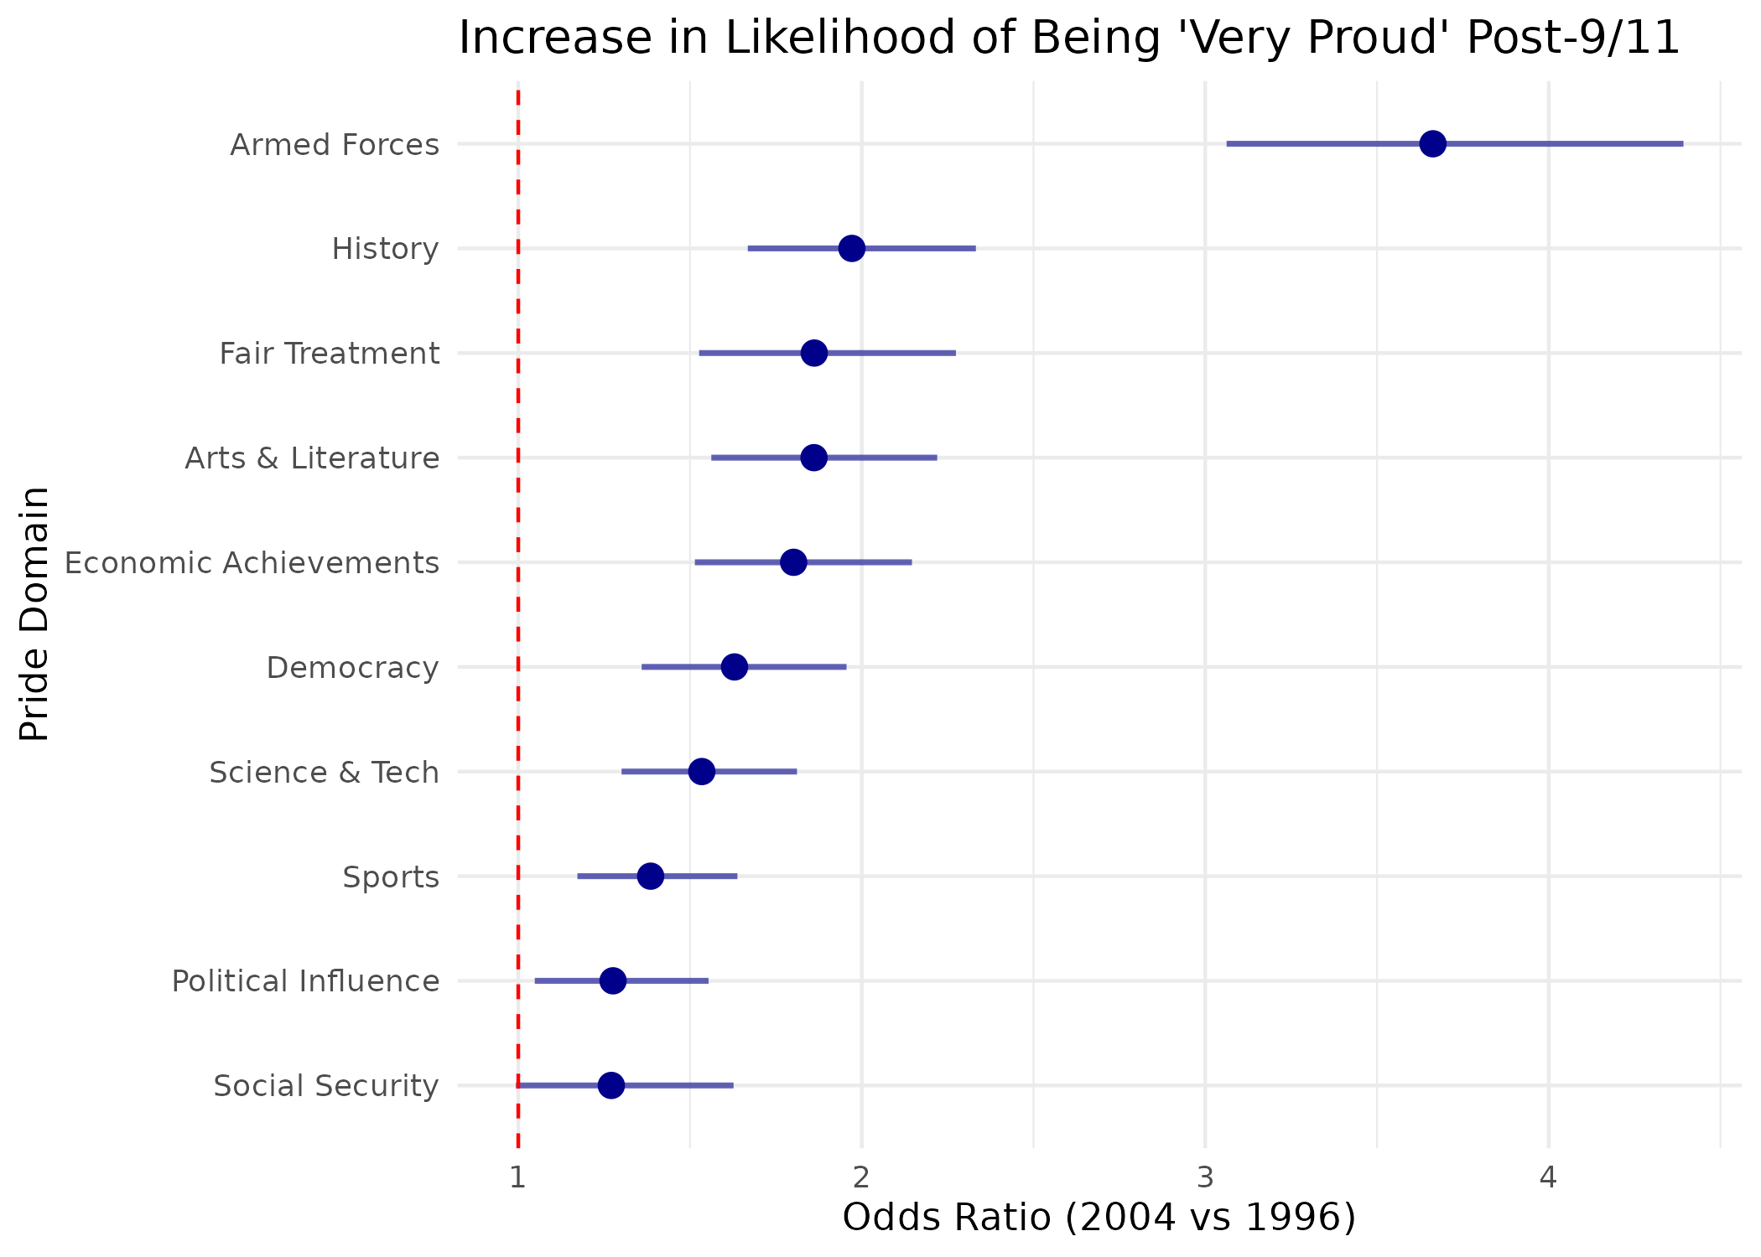
Figure 2: Distribution of U.S. Pride Scale Scores (1996 vs. 2004) 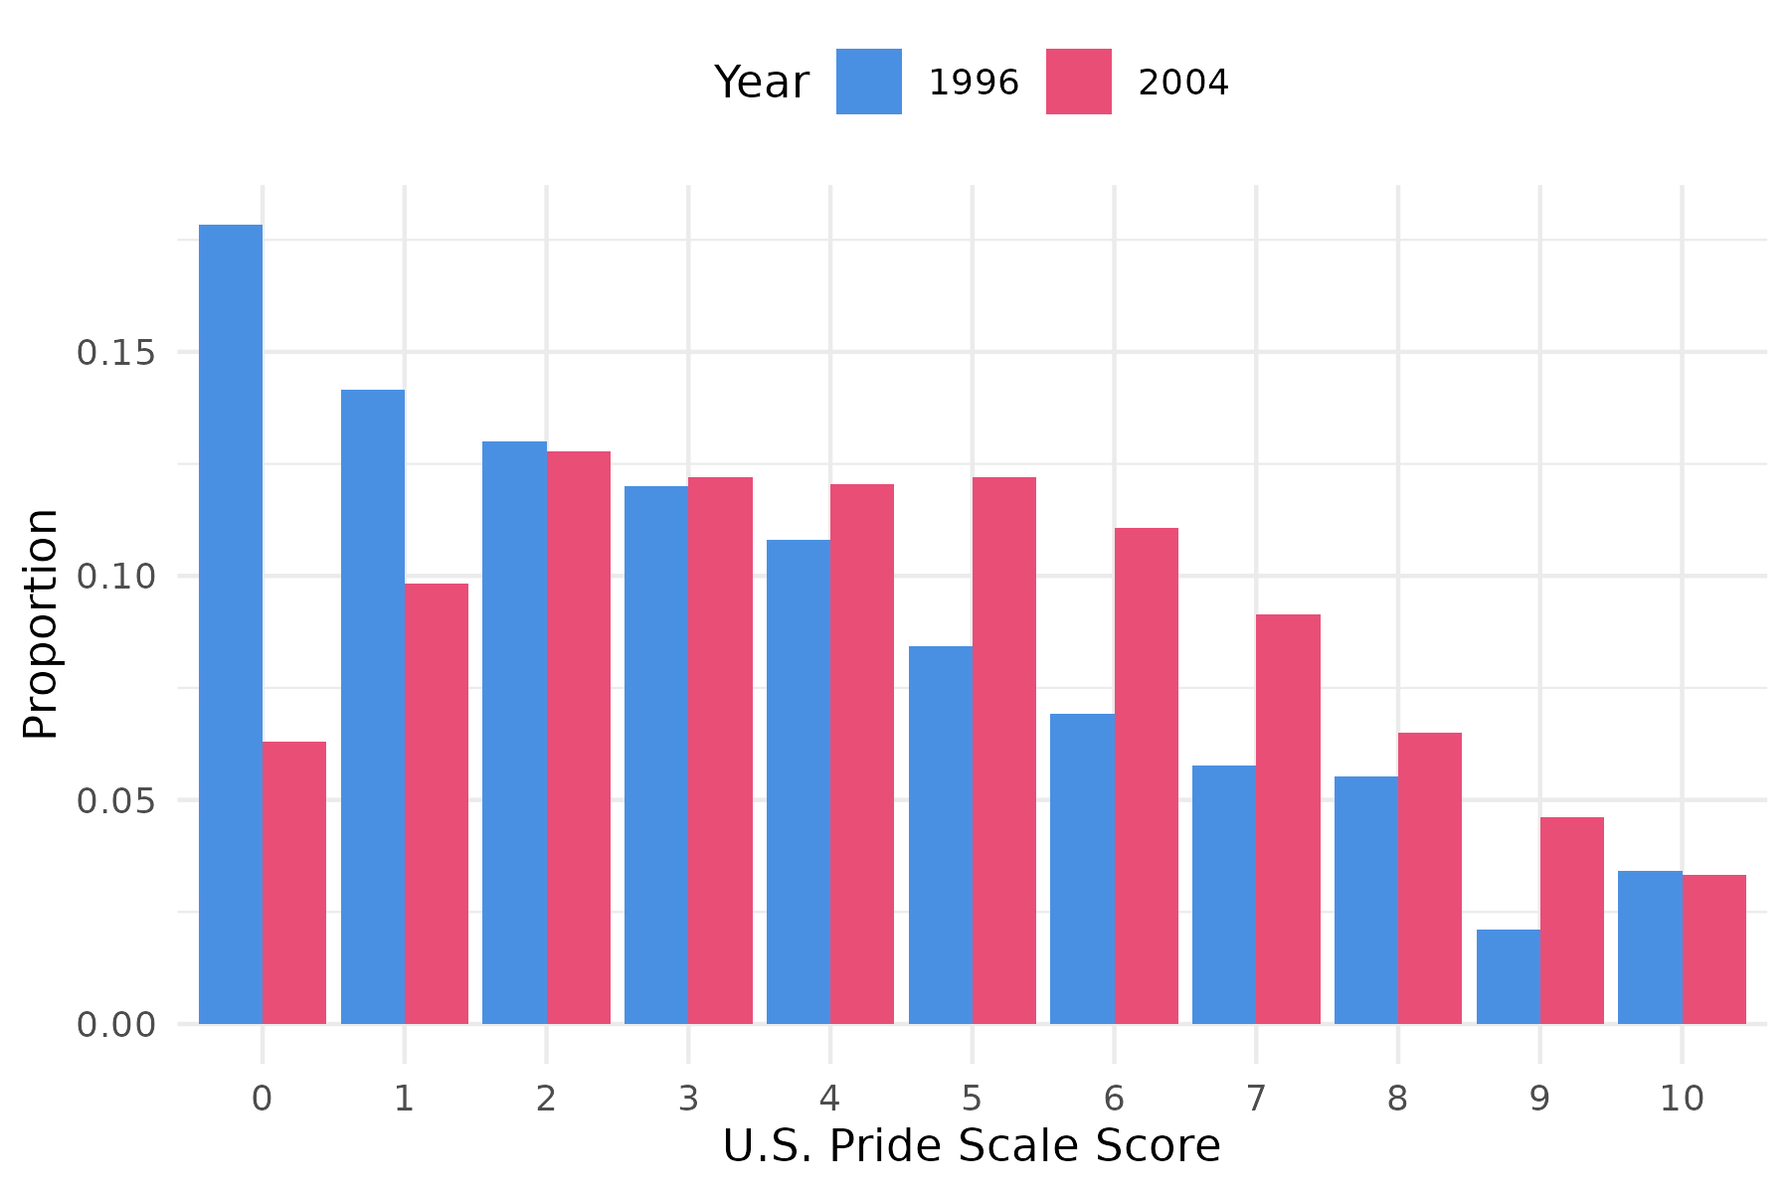
Figure 3: Predicted U.S. Pride Score across Education Levels by Year 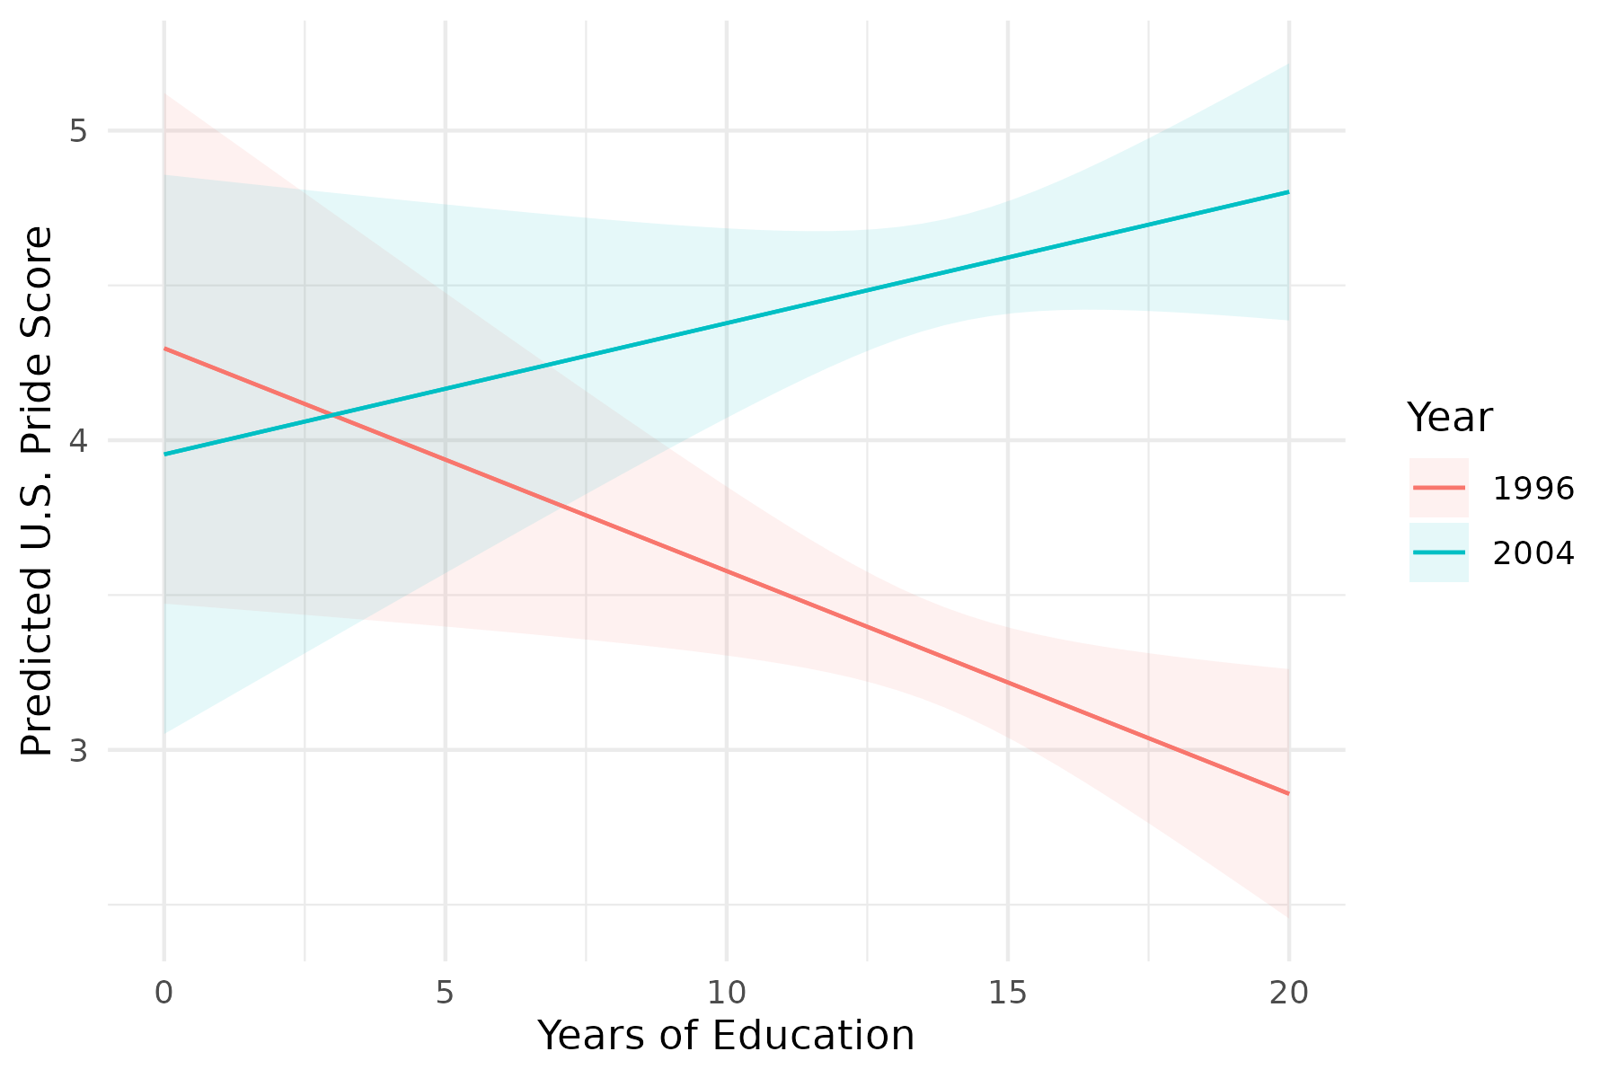
Figure 4: Effect of Specific Association Memberships on U.S. Pride (Controlling for Cohort) 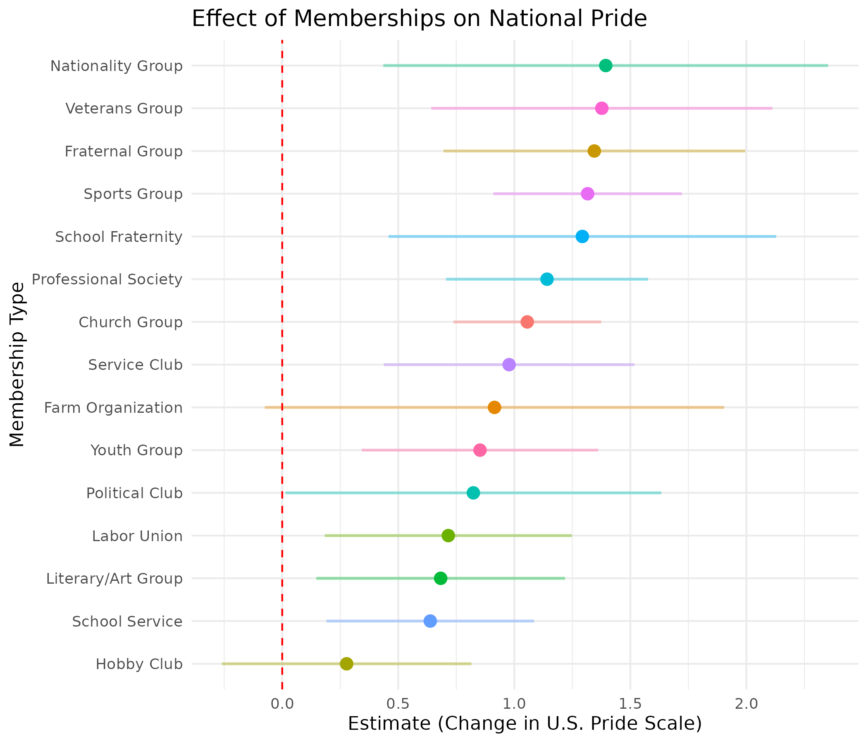

Social Identity Theory and Self-Categorization Theory can also be considered “need-based” theories (Hogg and Terry 2000). In these frameworks, the self-enhancement motive leads individuals to become affectively attached to prestigious national collectivities. Individuals become attached to national groups in the very same way that they become attached to any other group—if the group is perceived as meeting emotional needs for self-esteem, prestige, and a sense of efficacy and belonging.

