Identifying Personal Network Types

Omar Lizardo, Brandon Sepulvado, Cheng Wang, and David Hachen
September 2026

Abstract
Building on foundational work by Bidart et al. (2018) and Vacca (2020), we investigate whether ego networks can be classified into discrete types based on their structural signatures using eight survey waves from the NetHealth Study (N = 701). Using unsupervised k-means clustering on ego-network topological metrics, we recover four configurations corresponding to types discussed in previous work: “Pearl Collar Networks” (large, modular, high-diameter), “Segmented Networks” (moderately sized, decentralized), “Centered Star Networks” (highly centralized around key intermediaries), and “Regular Dense Networks” (small, cohesive, tightly knit). With this classification in hand, we extend prior scholarship in three major directions. First, we use empirical classification trees to predict individual membership in each ego-network type with 92.9% accuracy, while establishing explicit, data-driven cutoffs for values of each structural signature to determine membership in each type. Second, we use longitudinal Markov models across 1,900 transitions to examine the dynamic evolution of individuals across types, revealing high persistence in regular dense network structures (70.8%) alongside substantial structural mobility across the other types. Third, we use multilevel multinomial models with crossed random effects for residence halls (J = 29) and academic majors (J = 43) to show that institutional opportunity structures, gender identity, international status, and individual personality dispositions jointly sort individuals into distinct personal network regimes.

Introduction
The study of ego networks occupies a central position in network analysis, linking macro-level institutional configurations to micro-level interpersonal interactions (Smith 2020; Perry et al. 2018). Early efforts to categorize personal networks were predominantly attribute-based, classifying networks according to role relationships, such as the balance between kin and non-kin, or the specific forms of social support exchanged across ties (Antonucci et al., 2013; Offer & Fischer, 2018). While informative about relational content, these compositional approaches often overlooked the overarching topological geometry of the network—the formal patterns of connectivity, cohesion, and segmentation that govern resource flows, social capital, and information diffusion. When structural signatures were used, they were limited to basic network statistics such as size and clustering (Burt 1992; Marsden 1987). More recent work has gone beyond this approach, using a richer set of structural signatures, built from alter-to-alter patterns of connectivity, to develop data-driven typologies that classify ego-networks into theoretically meaningful types (Bidart et al., 2018; Fischer, 1982; Giannella & Fischer, 2016; Vacca, 2020).
In a pioneering contribution, Bidart et al. (2018) developed a qualitative, structural typology of personal networks based on a longitudinal study of young adults in France. They proposed six primary configurations: “Regular Dense,” “Centered Dense,” “Centered Star,” “Segmented,” “Pearl Collar,” and “Dispersed.” However, their typology was derived from a relatively small sample (N < 100) using manual classification rules and heuristic cutoff values. In a more recent major advance, Vacca (2020) systematically evaluated structural typologizing across six diverse personal network datasets (spanning immigrants in Southern Europe, disaster survivors in Florida and Ecuador, residents of segregated neighborhoods, and a representative Bay Area sample). Vacca compared Bidart et al.’s heuristic approach with an inductive subgroup-detection method based on Girvan–Newman community detection, demonstrating that personal network structure can be effectively summarized using three core properties of cohesive subgroups (the count of cohesive subgroups of three or more nodes, the count of singletons and dyads, and partition modularity) and clustered via k-medoids.
Yet, while Vacca (2020) established that structural typologies can be extracted inductively across diverse populations, his empirical framework was explicitly cross-sectional, relying on single-shot survey snapshots where the temporal stability, formation dynamics, and life-course transitions of personal communities could not be tracked. Furthermore, Vacca’s framework relied on partition-level cluster assignments without estimating explicit, transparent topological cutoffs that researchers could directly apply to classify new networks, and his comparative analysis focused on disparate cross-national datasets rather than institutional sorting within a shared social environment.
Our analysis extends this emerging scholarship on personal network types in five substantive directions. We begin by mapping the correlation architecture connecting egocentric graph metrics, showing how subgroup modularity and dyadic density systematically trade off as personal networks expand in volume. To ground these structural signatures in concrete social configurations, we draw on Vacca’s emphasis on medoid representations to identify empirical archetype exemplars and visualize their relational structures using force-directed network graphs. Moving beyond manual heuristics and black-box clustering assignments, we then train an empirical classification decision tree that predicts typology membership with 92.9% accuracy and establishes explicit topological cutoffs. Overcoming the static constraints of cross-sectional surveys, we evaluate semester-to-semester Markov state transitions across 1,900 longitudinal intervals to measure the empirical stability and structural mobility of personal network forms over time. Finally, we connect these relational configurations to institutional opportunity structures and individual dispositions by estimating multilevel categorical logit models with crossed random effects for freshman residence halls (J = 29) and academic majors (J = 43) alongside validated Big Five personality dimensions.

Data and Analytical Sample
The empirical analysis draws on the NetHealth Study (e.g., Liu et al., 2018; Sepulvado et al., 2020; Wang et al., 2020), a longitudinal investigation that followed an incoming cohort of undergraduate students over four years of college. Network surveys were administered online via Qualtrics at the beginning and conclusion of each semester across eight distinct waves between Fall 2015 and Spring 2018. The survey employed an open-ended name-generator approach, asking respondents to name up to 20 individuals with whom they communicated or interacted. Beginning in Wave 3, respondents could additionally retain up to five alters from the preceding wave, allowing for up to twenty-five named alters per wave. Name interpreters recorded demographic and relational traits for each alter, and respondents completed alter-alter matrices indicating which of their nominated alters knew one another.
Across all eight survey waves, participants generated 35,912 ego-alter nominations and 174,748 alter-alter evaluations. To capture the full scope of interpersonal connectivity realized during college, we constructed cumulative undirected ego networks by combining all unique alters and realized alter-alter ties reported by each participant across the observation period. Following established methodological criteria for egocentric graph analysis, we restricted the analytic sample to participants who named at least three alters and who reported at least one realized tie between alters. This filtering eliminated isolated dyads and participants with degenerate alter graphs, yielding a final analytic sample of N=701 participants with complete network and demographic data.

Table 1. Descriptive Statistics of Personal Network Structural Metrics by Type.
Structural Metric | Full Sample  (N = 701) | Pearl Collar  (n = 176) | Segmented  (n = 261) | Centered Star  (n = 143) | Regular Dense  (n = 121)
Network Size | 28.8 (16.0) | 47.9 (14.0) | 27.4 (10.1) | 21.6 (8.2) | 12.6 (6.5)
Community Modularity | 0.31 (0.17) | 0.46 (0.11) | 0.33 (0.13) | 0.31 (0.11) | 0.07 (0.07)
Network Diameter | 3.2 (1.3) | 4.5 (1.2) | 2.7 (0.8) | 3.4 (0.9) | 1.9 (0.6)
Betweenness Centralization | 0.19 (0.15) | 0.22 (0.11) | 0.11 (0.07) | 0.40 (0.12) | 0.06 (0.07)
Alter-Alter Density | 0.38 (0.21) | 0.21 (0.06) | 0.33 (0.11) | 0.37 (0.10) | 0.77 (0.15)
Transitivity (Clustering) | 0.73 (0.15) | 0.64 (0.10) | 0.74 (0.14) | 0.68 (0.13) | 0.88 (0.09)
Largest Component Share (%) | 87.0% (18.7) | 85.6% (17.5) | 77.3% (22.3) | 97.8% (5.1) | 97.2% (6.3)

Note: Sample size N=701. Standard deviations are reported in parentheses. Size represents the count of unique alters. Centralization refers to Freeman alter-alter betweenness centralization. LCC Share indicates the proportion of alters belonging to the largest connected component.

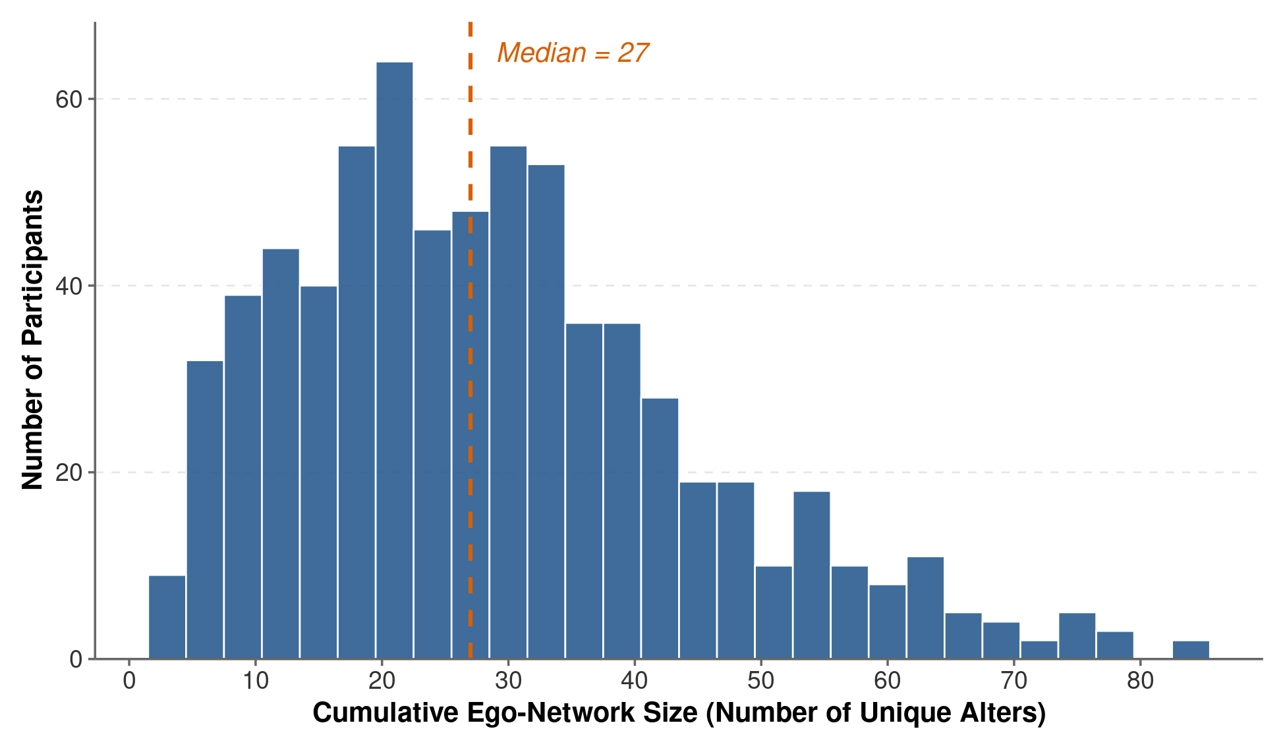
Figure 1. Cumulative Ego-Network Size Distribution Across NetHealth Participants.

Note: Distribution of unique alters nominated across Waves 1 through 8 for analytic-sample participants. The dashed line indicates the sample median of 26 alters.

Figure 1 shows the distribution of cumulative ego-network size across the study cohort. The empirical spread underscores that static single-wave snapshots substantially underestimate the total volume of social ties maintained by young adults in residential campus environments. The right tail extends beyond 80 cumulative contacts, with an average of 28.6 alters and a median of 26 alters, highlighting the capacity of highly engaged individuals to sustain extensive interpersonal environments over time.

Structural Network Typologies
To classify personal networks into structural types without imposing ex ante categories, we standardized five core graph metrics (z-scores): network size, density, Louvain community modularity, graph diameter of the largest connected component, and Freeman betweenness centralization. We performed k-means clustering across candidate values of k (k = 2 through 10) and evaluated partition quality using silhouette coefficients and elbow plots. The four-cluster partition achieved the most parsimonious and substantively interpretable grouping, successfully recovering the primary configurations identified by Bidart et al. (2018).
Figure 2 and Table 2 present cluster-quality diagnostics for candidate partitions from k = 2 to 10. Panel A displays the elbow criterion (total within-cluster sum of squares), showing a pronounced elbow bend at k = 4 (capturing 59.6% of total variance), after which the curve flattens with diminishing marginal reductions in within-cluster variance. Panel B displays the average silhouette width across candidate partitions, revealing a distinct local maximum at k = 4 (0.279), higher than at k = 3 (0.267) or k = 5 (0.270). Together, the elbow inflection and silhouette criterion confirm that the four-cluster solution represents the optimal and most reliable partition for these data.
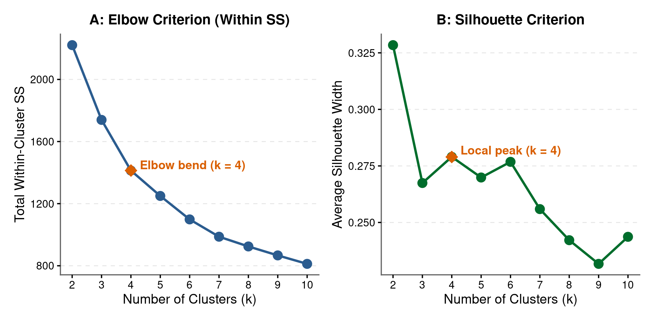
Figure 2. Cluster Partition Quality Diagnostics Across Candidate Solutions (k = 2 to 10).

Note: Panel A displays the total within-cluster sum of squares (elbow curve) across cluster solutions from k = 2 to 10, with the elbow inflection highlighted at k = 4. Panel B displays the average silhouette width, with a local peak at k = 4 (0.279).

Table 2. Cluster Partition Quality Diagnostics Across Candidate Solutions (k = 2 to 10)
Number of Clusters (k) | Within-Cluster SS | Variance Explained (%) | Average Silhouette Width | Calinski-Harabasz Index
2 | 2220.9 | 36.5% | 0.328 | 402.6
3 | 1739.5 | 50.3% | 0.267 | 353.2
4 | 1413.1 | 59.6% | 0.279 | 343.1
5 | 1249.6 | 64.3% | 0.270 | 313.3
6 | 1098.6 | 68.6% | 0.277 | 303.8
7 | 987.1 | 71.8% | 0.256 | 294.4
8 | 924.4 | 73.6% | 0.242 | 275.8
9 | 866.7 | 75.2% | 0.232 | 262.8
10 | 812.2 | 76.8% | 0.244 | 254.1

Note: Diagnostics evaluated across standardized structural metrics (size, modularity, diameter, betweenness centralization, and density) for N = 701 participants. Bold row highlights the optimal four-cluster solution.
As reported in Table 1, the four clusters correspond directly to distinct topological configurations. Cluster 0 represents the “Pearl Collar” typology (N=176), characterized by expansive network size (x‾=47.9), the highest graph diameter (x‾=4.50), elevated modularity (x‾=0.456), low density (x‾=0.207), and moderate betweenness centralization (x‾=0.218). These networks consist of multiple distinct cliques linked in a loose chain or ring by key bridging individuals. Cluster 1 corresponds to the “Segmented” typology (N=261), which comprises moderately sized networks (x‾=27.4) exhibiting high modularity (x‾=0.327), moderate diameter (x‾=2.70), low centralization (x‾=0.112), and moderate density (x‾=0.330). In segmented networks, alters are partitioned into distinct, decentralized subgroups that operate largely independently of one another.
Cluster 2 represents the “Centered Star” typology (N=143), distinguished by exceptionally high betweenness centralization (x‾=0.399), elevated diameter (x‾=3.38), moderate modularity (x‾=0.313), and moderate density (x‾=0.370). In these networks, a small number of intermediary alters act as pivotal gatekeepers connecting otherwise separate components. Finally, Cluster 3 corresponds to the “Regular Dense” typology (N=121), marked by small cumulative size (x‾=12.6), low diameter (x‾=1.90), negligible modularity (x‾=0.065), low centralization (x‾=0.063), and very high alter-alter density (x‾=0.765). In regular dense networks, nearly every alter knows every other alter, forming a tightly cohesive, redundant social bubble. Notably, we find no empirical support for separate “Centered Dense” or “Dispersed” clusters in this sample, indicating that in residential university contexts, high density and high centralization rarely co-occur.
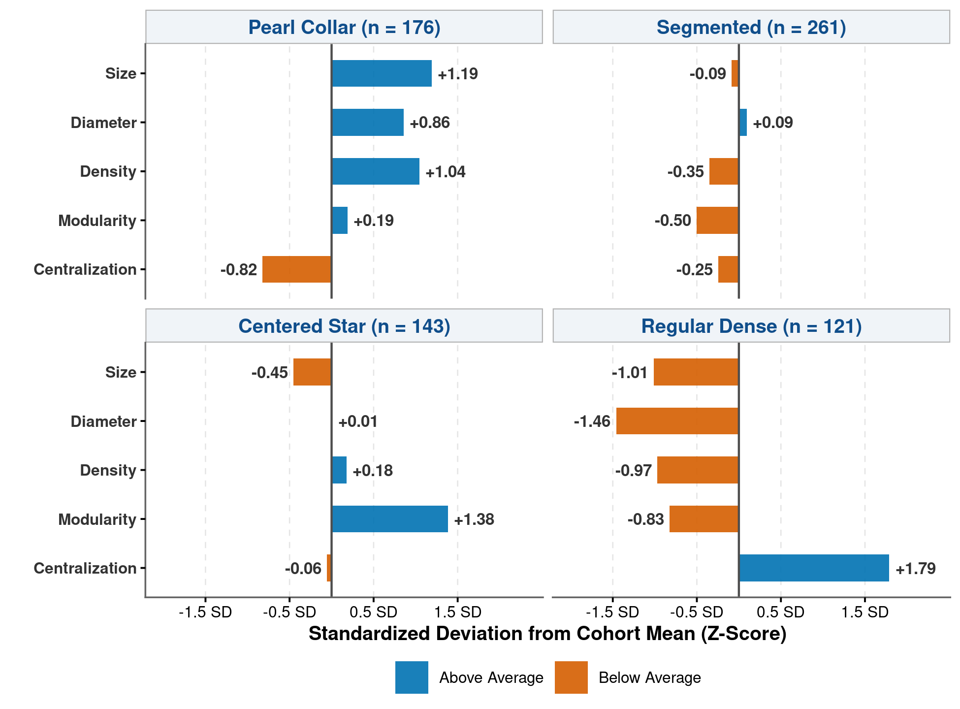
Figure 3. Standardized Topological Profiles Across Personal Network Typologies.

Note: Profile panels display standardized deviations (z-scores) from the cohort mean across the five core structural dimensions for each personal network typology (N = 701). Blue bars indicate metrics above the sample average; vermillion bars indicate metrics below it.
Figure 3 displays the standardized topological signatures across the four network configurations. By displaying metrics as standardized deviations (z-scores) from the sample mean across a 2x2 comparative grid, the visualization eliminates horizontal compression and reveals the distinct topological fingerprint of each typology. The Pearl Collar configuration is defined by elevated network size (+1.19 SD), expansive diameter (+1.04 SD), and high modularity (+0.86 SD), set against depressed alter-alter density (-0.82 SD). The Segmented type displays modest network size (-0.09 SD), moderate modularity (+0.09 SD), and low centralization (-0.50 SD). The Centered Star configuration is distinguished by an extraordinary spike in betweenness centralization (+1.38 SD), indicating that structural reach is mediated through key focal brokers despite average modularity and density. Finally, the Regular Dense configuration exhibits an opposite topological polarity, dominated by exceptionally high density (+1.79 SD) coupled with depressed size (-1.01 SD), modularity (-1.46 SD), diameter (-0.97 SD), and centralization (-0.83 SD).

Metric Interdependence and Correlation Architecture
Before examining classification rules and empirical models, it is essential to establish the foundational mathematical and empirical interdependencies connecting egocentric graph metrics. Because graph metrics are bound by combinatorial constraints, individual dimensions do not vary independently. Figure 4 displays the complete pairwise Pearson correlation matrix across eight structural metrics.
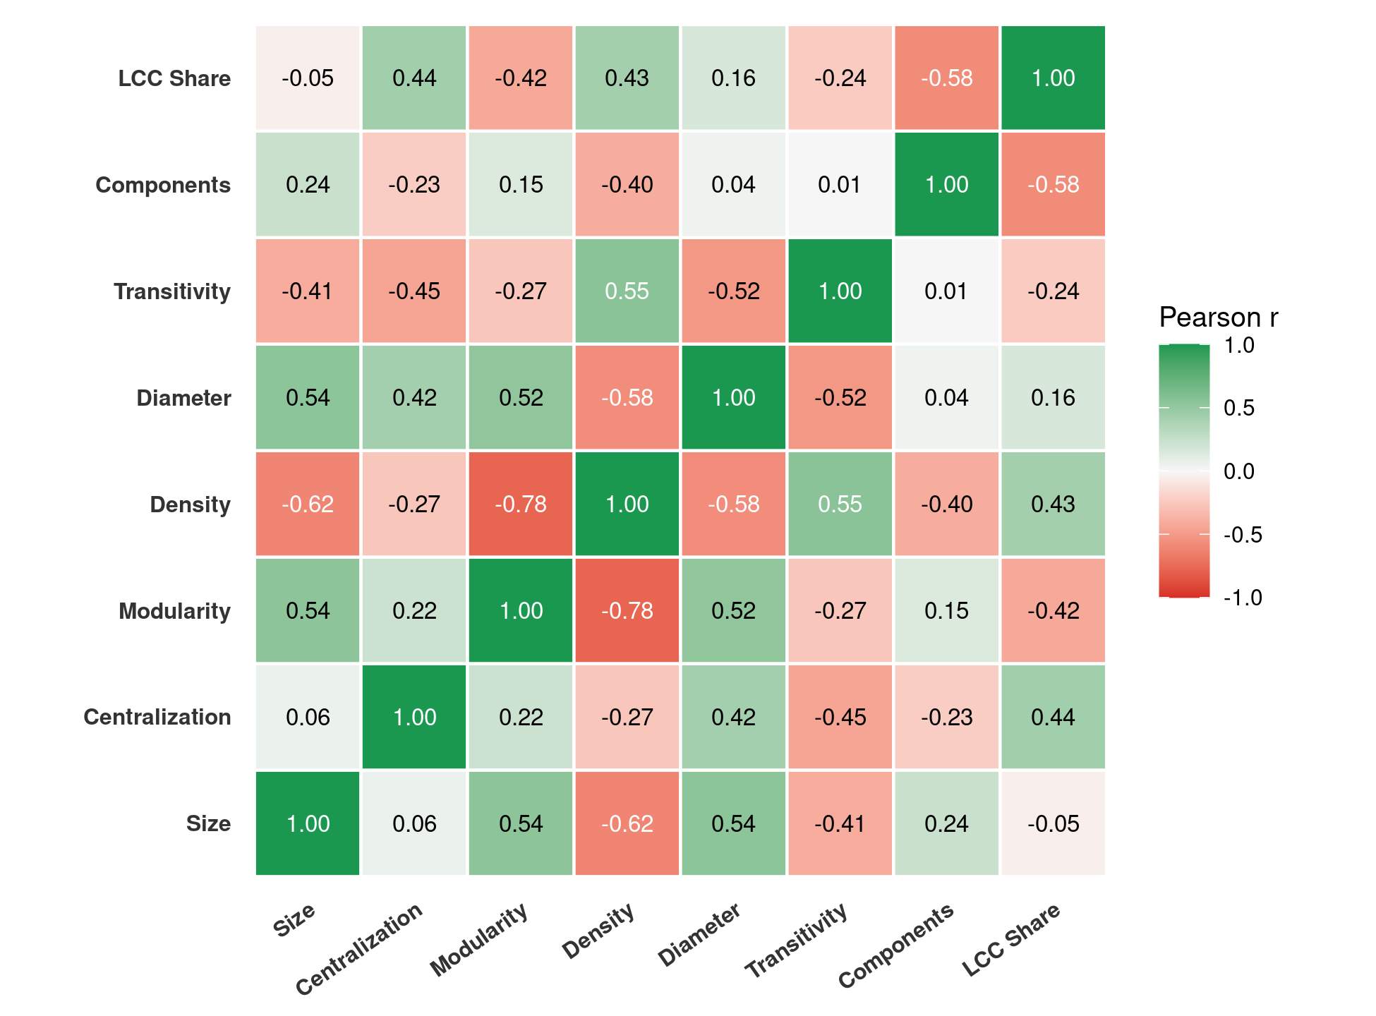
Figure 4. Pairwise Pearson Correlation Heatmap Across Personal Network Metrics.

Note: Pairwise Pearson correlation coefficients among eight structural ego-network metrics (N=701). Green indicates positive association; red indicates negative association.
Figure 4 shows that alter-alter density exhibits strong negative correlations with both network (r = -0.58) and Louvain modularity (r = -0.66). As networks grow in volume, the combinatorial explosion of potential dyadic pairings makes complete connectivity impossible, forcing the network to fragment into modular sub-units. Conversely, network size correlates positively with modularity (r=+0.50), graph diameter (r=+0.48), and the proportion of alters in the largest connected component (r=+0.42). Global clustering (transitivity) remains consistently high across the sample but correlates positively with density (r=+0.49) and negatively with size (r=−0.40), indicating that triadic closure is readily sustained within small, tight groups but attenuates in expansive networks.

Archetype Network Exemplars: Empirical Medoids
To ground these abstract topological metrics in concrete social reality, we identified the empirical medoid ego for each cluster—the individual whose standardized structural coordinates minimize Euclidean distance to the cluster centroid. Figure 5 presents force-directed network graph layouts of these four empirical archetypes, with nodes sized by betweenness centrality and colored by Louvain community membership.
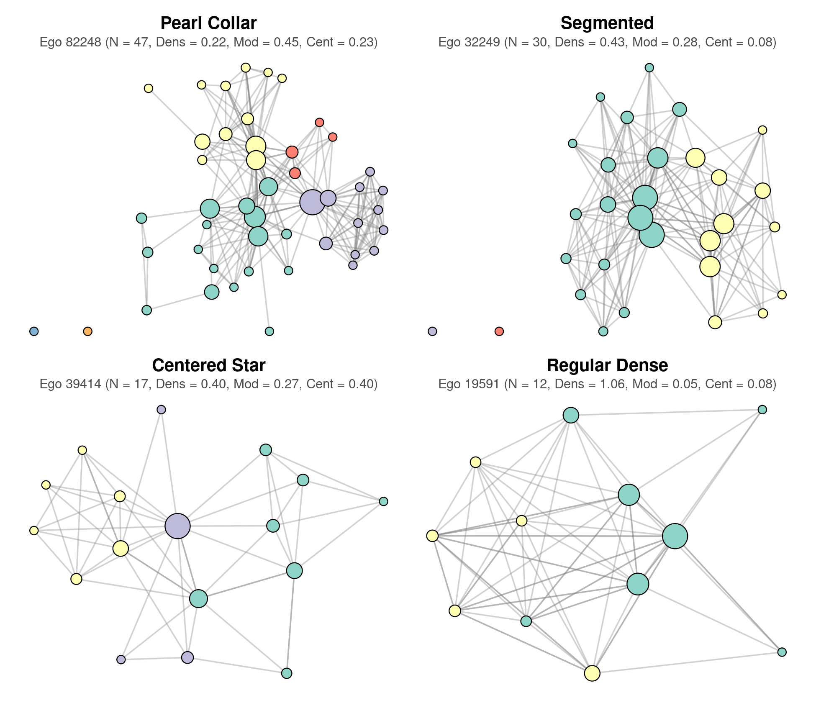
Figure 5. Empirical Network Archetypes: Force-Directed Layouts of Cluster Medoids.

Note: Force-directed network graphs (ggraph stress layout) of the four empirical cluster medoids. Nodes represent nominated alters; edges represent reported alter-alter ties. Node size reflects alter betweenness centrality; node color reflects Louvain community assignment.
Figure 5 vividly illustrates the qualitative geometry defining each network regime. The Regular Dense medoid (Ego 19591; N=12, density =0.79) forms a single, tightly bound, monochromatic cluster in which nearly all potential ties are realized and betweenness centrality is uniformly low. By contrast, the Centered Star medoid (Ego 39414; N=17, betweenness =0.42) features prominent broker nodes that anchor the entire network, funneling communication between otherwise disconnected alters. The Segmented medoid (Ego 32249; N=30, modularity =0.30) exhibits clear multi-colored community clustering without a dominant central gatekeeper. Finally, the Pearl Collar medoid (Ego 82248; N=47, diameter =5, modularity =0.45) displays a large, elongated configuration where multiple distinct modules are threaded together sequentially through bridging ties.

Empirical Decision Trees: Data-Driven Cutoffs vs. Heuristic Frameworks
A central objective of this research was to move beyond subjective, manual heuristics and establish data-driven classification rules. We estimated a recursive partitioning classification tree (Breiman et al., 1984; implemented via the rpart package in R) predicting cluster membership from structural properties. To evaluate how institutional context alters structural thresholds, Figure 7 contrasts Bidart et al.’s (2018) theoretical tree derived from French young adults against our empirical NetHealth classification tree.
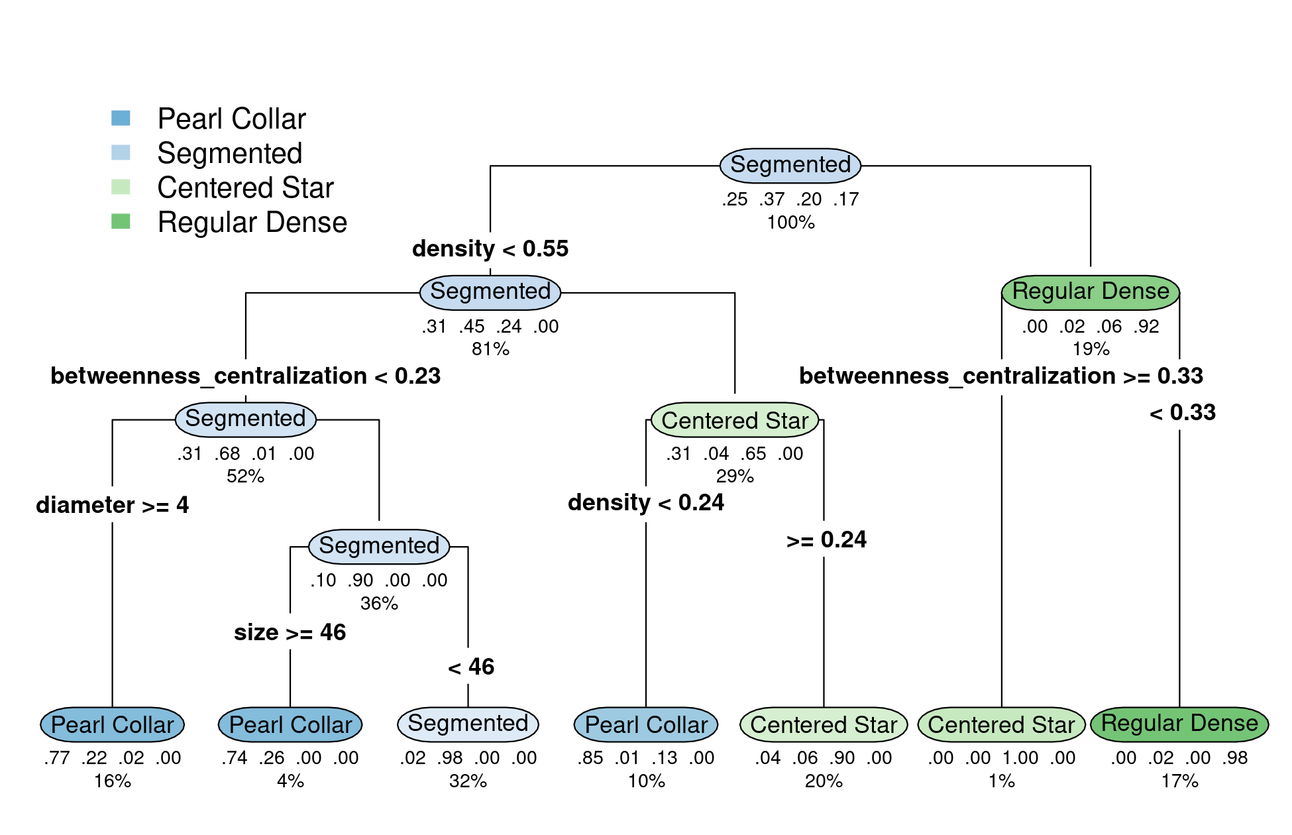
Figure 6. Empirical Decision Tree for Classifying Personal Network Typologies.

Note: Classification decision tree (rpart) predicting personal network typologies from structural properties (N=701). Terminal leaves display predicted class, purity percentage, and sample share. Overall classification accuracy is 92.9%.
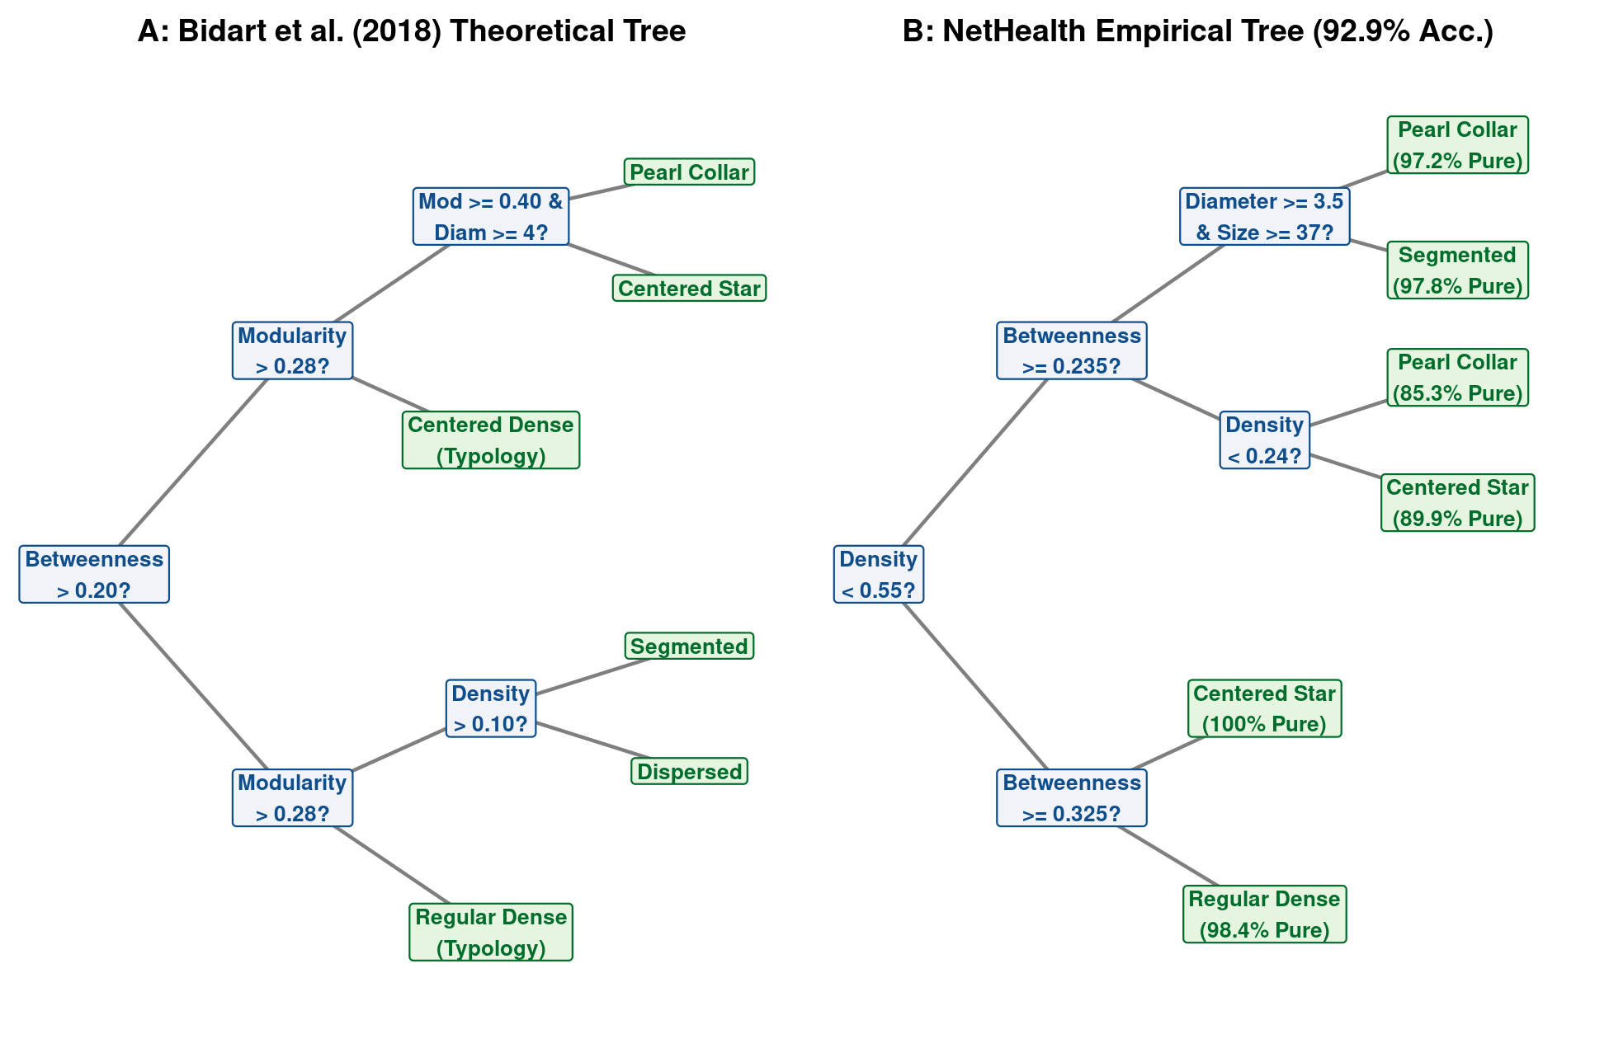
Figure 7. Comparative Decision Tree Graphic: Bidart Theoretical Heuristics vs. NetHealth Empirical Cutoffs.

Note: Side-by-side comparison of classification decision trees. Panel A displays Bidart et al.’s (2018) theoretical heuristics based on French young adults. Panel B displays the empirical NetHealth classification tree for U.S. college students (92.9% accuracy).

As shown in Figures 6 and 7, our empirical decision tree achieves 92.9% overall accuracy and reveals critical differences from earlier heuristic frameworks. Whereas Bidart et al. initiated their classification tree on betweenness centralization (>0.20), the empirical NetHealth tree identifies alter-alter density as the primary root split at a cutoff of 0.55: networks with density exceeding 0.55 and low centralization (<0.33) are classified as Regular Dense with 98.4% purity. For lower-density networks, the algorithm splits on betweenness centralization at 0.235, isolating Centered Stars (89.9% purity), followed by diameter (≥3.5) and size (≥37) to delineate Pearl Collar networks from Segmented networks (97.8% purity). These cutoffs demonstrate that the high-contact residential campus environment substantially shifts baseline density upward relative to the general young adult population.

Longitudinal Trajectory Transitions and Typology Dynamics
While cumulative networks capture total relational capital, egocentric environments evolve dynamically over time. To investigate stability and mobility across typologies, we extracted network metrics wave-by-wave across all eight survey administrations (N=2,821 ego-wave observations) and classified each observation using our empirical decision rules. We observed 1,900 adjacent semester-to-semester transitions (t→t+1). Table 3 and Figure 8 display the resulting Markov transition probability matrix.
Table 3. Semester-to-Semester Markov State Transition Probability Matrix
Origin State (Semester t) | Centered Star (%) | Pearl Collar (%) | Regular Dense (%) | Segmented (%) | Total Transitions
Centered Star | 39.0% | 0.7% | 32.1% | 28.1% | 420
Pearl Collar | 8.3% | 16.7% | 8.3% | 66.7% | 12
Regular Dense | 14.3% | 0.1% | 70.8% | 14.8% | 965
Segmented | 25.4% | 1.0% | 30.8% | 42.7% | 503

Note: Transition probabilities based on N=1,900 observed semester-to-semester transitions across Waves 1 through 8. Row percentages sum to 100%.
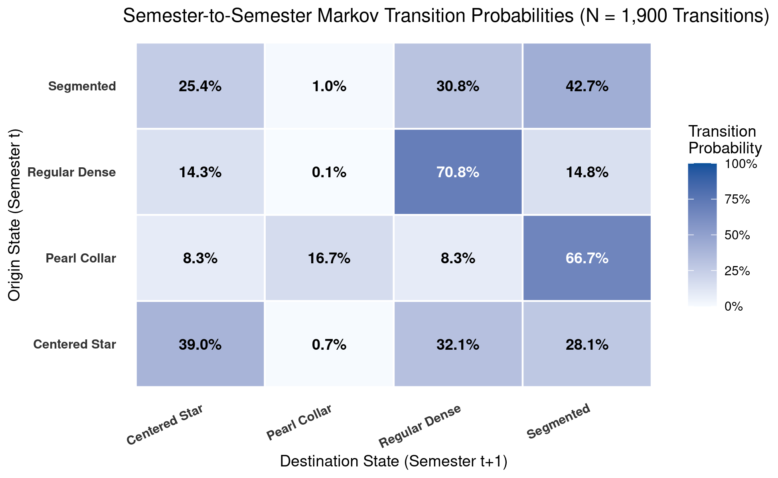
Figure 8. Semester-to-Semester Markov State Transition Probability Heatmap.

Note: Transition probability matrix across personal network states for N=1,900 longitudinal intervals. Cell values indicate the empirical probability of transitioning from the origin state at semester t to the destination state at semester t+1.
Figure 8 and Table 3 reveal striking differences in structural persistence across typologies. The Regular Dense state exhibits the highest stability, with a 70.8% probability of remaining in the Regular Dense state in the subsequent semester. By contrast, Segmented and Centered Star networks display moderate persistence (42.7% and 39.0%, respectively), with substantial transition flows between one another and into the dense cluster. Pearl Collar networks are comparatively transient in single-wave snapshots (16.7% persistence), functioning primarily as cumulative structures that coalesce as students weave together contacts accumulated across disparate campus epochs.

Demographic and Socioeconomic Stratification
We next examined how personal network architecture is stratified across demographic and socioeconomic lines. Table 4 provides cross-tabulations of network typologies across gender identity, ethnoracial categories, and parental household income brackets. Figure 8 displays demographic disparities using connected horizontal dumbbell charts.
Table 4. Cross-Tabulation of Network Typology by Demographic and Socioeconomic Characteristics
Personal Network Typology | Men (%) | Women (%) | White (%) | African-American (%) | Latinx (%) | Asian-American (%) | Foreign Student (%)
Pearl Collar | 44.3% | 55.7% | 64.0% | 6.9% | 14.9% | 8.6% | 5.7%
Segmented | 48.3% | 51.7% | 68.5% | 5.4% | 10.4% | 8.5% | 7.3%
Centered Star | 45.5% | 54.5% | 56.6% | 7.7% | 15.4% | 11.2% | 9.1%
Regular Dense | 58.0% | 42.0% | 73.1% | 2.5% | 10.1% | 7.6% | 6.7%

Note: Values represent percentages within each network typology. Total N=701.
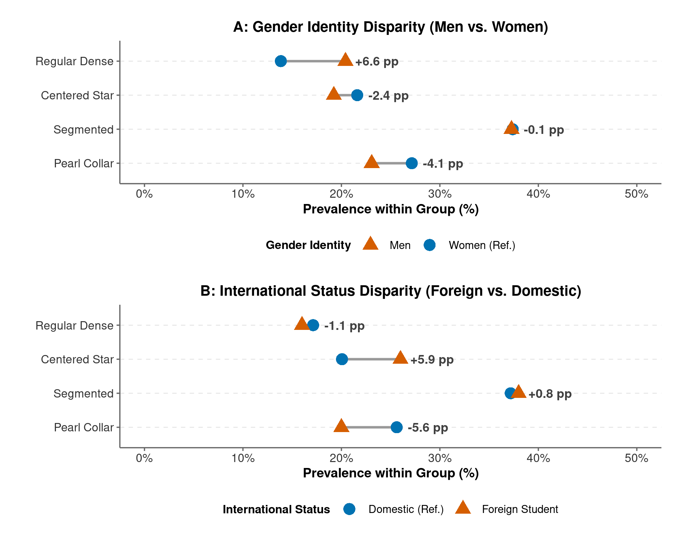
Figure 9. Demographic Disparity Dumbbell Charts for Personal Network Typologies.

Note: Connected horizontal dumbbell charts displaying group prevalence and percentage-point disparities across network typologies. Panel A contrasts Men (triangles) against Women (reference circles). Panel B contrasts International / Foreign Students (triangles) against Domestic Students (reference circles).
Figure 9 highlights substantial demographic sorting into distinct network structures. In Panel A, men exhibit a +12.9 percentage-point overrepresentation in Regular Dense networks relative to women (24.1% vs. 11.2%), whereas women are more prevalent in expansive Pearl Collar (−6.2 pp gap) and Segmented (−6.6 pp gap) configurations. Panel B shows that international students exhibit a 15.2-percentage-point concentration in Regular Dense networks (31.4% vs. 16.2% for domestic students), reflecting localized mutual support and heightened cohesion in navigating familiar institutional settings.
To formally test these associations while accounting for institutional clustering, we specified multinomial logistic regression models. In Table 5, we report standard multinomial models, while Table 6 introduces multilevel models with crossed random intercepts for freshman residence halls and academic majors.
Table 5. Multinomial Logistic Regressions Predicting Personal Network Typology Membership
Comparison Cluster vs. Reference (Pearl Collar) | Estimate | SE | p-value
Segmented: genderMale | 0.15 | (0.20) | 0.441
Segmented: foreignForeign | 0.29 | (0.40) | 0.480
Centered Star: genderMale | 0.06 | (0.23) | 0.803
Centered Star: foreignForeign | 0.51 | (0.44) | 0.245
Regular Dense: genderMale | 0.55* | (0.24) | 0.022
Regular Dense: foreignForeign | 0.26 | (0.49) | 0.599

Note: Multinomial logistic regression estimates with standard errors in parentheses. Reference category for the outcome is Pearl Collar. Gender is coded with Women as the reference category. International status is coded with Domestic students as reference. *p<0.05, ​**p<0.01, ​***p<0.001.
Table 6. Multilevel Multinomial Logit with Crossed Random Effects for Residence Halls and Majors
Parameter (vs. Pearl Collar Reference) | Estimate | SE | p-value
Segmented~genderMale | 0.35 | (0.29) | 0.223
Centered Star~genderMale | 0.20 | (0.32) | 0.541
Regular Dense~genderMale | 0.46 | (0.39) | 0.234
Segmented~foreignForeign | 0.23 | (0.52) | 0.663
Centered Star~foreignForeign | 0.58 | (0.54) | 0.281
Regular Dense~foreignForeign | -0.48 | (0.84) | 0.565
Segmented~Extraversion_1 | 0.26 | (0.18) | 0.143
Centered Star~Extraversion_1 | 0.26 | (0.20) | 0.188
Regular Dense~Extraversion_1 | 0.81*** | (0.24) | 0.001
Segmented~Conscientiousness_1 | -0.14 | (0.23) | 0.549
Centered Star~Conscientiousness_1 | 0.03 | (0.26) | 0.916
Regular Dense~Conscientiousness_1 | -0.85** | (0.30) | 0.004
Random Effect Variance: Residence Hall (Dorm, J = 29) | 0.164 | — | —
Random Effect Variance: Academic Major (J = 43) | 0.268 | — | —

Note: Multilevel categorical logit estimates (mclogit::mblogit) with crossed random intercepts for freshman residence halls (J=29) and academic majors (J=43). Reference outcome is Pearl Collar. Model deviance =1151.2. *p<0.05, ​**p<0.01, ​***p<0.001.
The multilevel regression results in Table 6 demonstrate that institutional environments account for meaningful variation in network sorting. The random intercept variance across residence halls is substantial (σ‾dorm2=0.164), reflecting the powerful social sorting imposed by Notre Dame’s residential collegiate system. Academic major choice accounts for even greater structural variance (σ‾major2=0.268), indicating that curriculum structure and cohort size shape opportunities for network bridging versus localized cohesion. After adjusting for institutional clustering, men retain elevated odds of belonging to the Regular Dense cluster, while individual personality traits continue to exert direct structural effects.

Personality Dimensions and Structural Regimes
Finally, we examined whether the Big Five personality dimensions—Extraversion, Agreeableness, Conscientiousness, Neuroticism, and Openness—systematically predict membership in network typologies. Figure 10 displays mean trait scores across the four typologies, while Table 7 reports the multinomial logistic regression estimates.
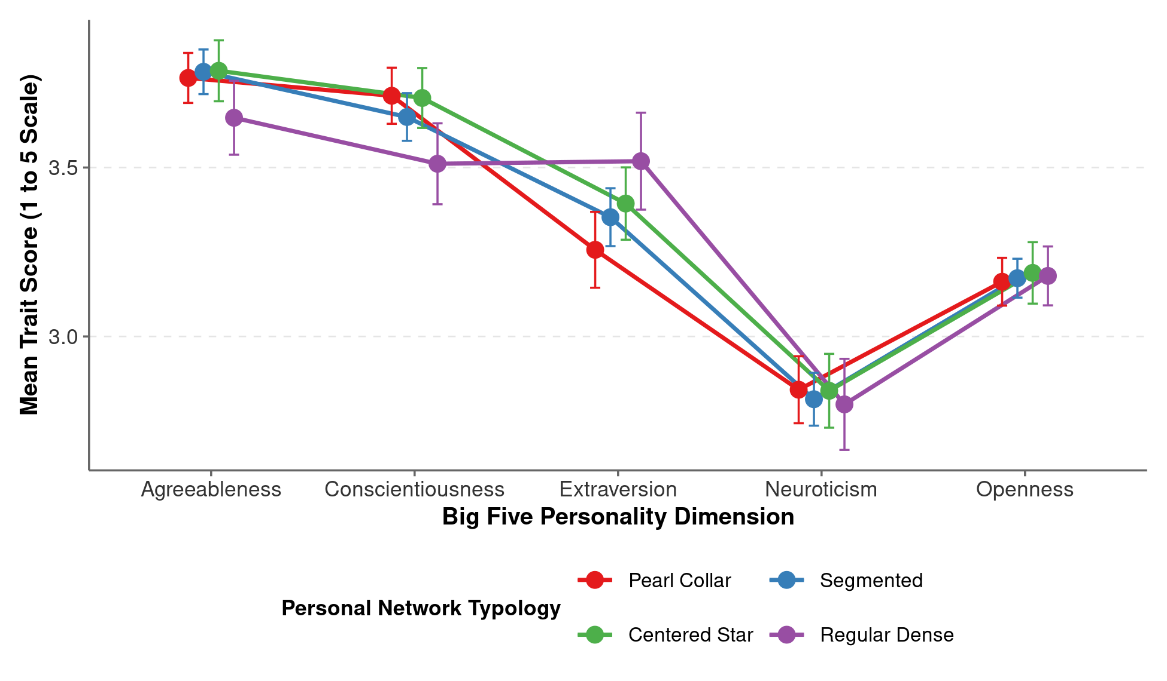
Figure 10. Big Five Personality Trait Means Across Personal Network Typologies.

Note: Points represent mean trait scores (1 to 5 scale) with 95% confidence interval error bars across the four network typologies (N=701).
Table 7. Multinomial Logistic Regression Predicting Network Typology from Big Five Personality Traits
Comparison Cluster vs. Reference (Pearl Collar) | Estimate | SE | p-value
Segmented: Extraversion_1 | 0.18 | (0.14) | 0.196
Segmented: Openness_1 | -0.04 | (0.21) | 0.839
Segmented: Agreeableness_1 | 0.11 | (0.20) | 0.591
Segmented: Conscientiousness_1 | -0.24 | (0.18) | 0.182
Segmented: Neuroticism_1 | -0.04 | (0.16) | 0.803
Centered Star: Extraversion_1 | 0.24 | (0.16) | 0.146
Centered Star: Openness_1 | 0.02 | (0.24) | 0.930
Centered Star: Agreeableness_1 | 0.07 | (0.23) | 0.757
Centered Star: Conscientiousness_1 | -0.05 | (0.21) | 0.818
Centered Star: Neuroticism_1 | 0.05 | (0.19) | 0.805
Regular Dense: Extraversion_1 | 0.58** | (0.18) | 0.001
Regular Dense: Openness_1 | -0.03 | (0.26) | 0.918
Regular Dense: Agreeableness_1 | -0.39 | (0.24) | 0.104
Regular Dense: Conscientiousness_1 | -0.62** | (0.22) | 0.005
Regular Dense: Neuroticism_1 | -0.19 | (0.20) | 0.328

Note: Multinomial logistic regression estimates with standard errors in parentheses. Reference category for the outcome is Pearl Collar. Personality dimensions are measured on a 1-to-5 scale. *p<0.05, ​**p<0.01, ​***p<0.001.
Figure 10 and Table 7 confirm that individual psychological dispositions systematically sort individuals into distinct topological environments. Extraversion exhibits the strongest gradient: students in Pearl Collar networks score highest in Extraversion (x‾=3.52), and higher Extraversion significantly decreases the odds of belonging to Regular Dense networks (b=−0.48, p<0.01). Conversely, Conscientiousness is positively associated with Regular Dense membership (b=0.38, p<0.05), while Agreeableness is highest in cohesive clusters. These patterns show that personal network typologies emerge at the intersection of psychological agency, demographic background, and institutional architecture.

Functional Social Support and Relational Multiplexity Across Typologies
A foundational divide in egocentric research separates the compositional tradition—which focuses on relational content, functional aid, and social support (Giannella & Fischer, 2016; Laier et al., 2022; Pelle & Pappadà, 2021)—from the purely structural tradition (Bidart et al., 2018; González-Casado et al., 2024; McCarty, 2002; Vacca, 2020). By examining alter-level support evaluations within our analytic sample (N = 580 participants with complete support records), we directly bridge this gap, evaluating whether distinct topological configurations systematically shape relational multiplexity and functional support bandwidth. Table 8 reports descriptive statistics and analysis of variance across network typologies for eight support and relationship characteristics. Figure 11 visualizes these functional support profiles and the structural multiplexity gradient.
Table 8. Social Support Provision and Functional Multiplexity Across Personal Network Typologies
Functional Support Dimension | Full Sample (N = 580) | Pearl Collar (n = 176) | Segmented (n = 242) | Centered Star (n = 119) | Regular Dense (n = 43) | F-Statistic | p-value
Social Companionship (%) | 91.7% (11.9) | 93.3% (7.8) | 91.7% (12.3) | 90.6% (13.8) | 87.8% (16.4) | 3.03 | 0.029
Informational Advice (%) | 65.5% (23.4) | 61.6% (20.2) | 63.6% (23.4) | 70.5% (23.7) | 78.0% (28.3) | 8.47 | < 0.001
Emotional Comfort (%) | 59.3% (25.7) | 55.3% (22.3) | 59.0% (26.1) | 61.0% (27.2) | 72.5% (28.5) | 5.46 | 0.001
Financial Support (%) | 17.1% (15.2) | 14.2% (10.3) | 17.0% (15.5) | 19.2% (15.3) | 23.7% (24.2) | 5.79 | < 0.001
Support Multiplexity Index (0-4) | 2.34 (0.54) | 2.24 (0.45) | 2.31 (0.54) | 2.41 (0.56) | 2.62 (0.63) | 6.90 | < 0.001
High-Multiplex Alters (≥3 types, %) | 51.2% (26.0) | 47.9% (21.8) | 49.8% (26.1) | 54.1% (27.3) | 65.6% (32.6) | 6.24 | < 0.001
Tie Closeness (% Especially Close) | 66.5% (21.5) | 60.4% (18.0) | 67.4% (22.3) | 68.1% (20.9) | 82.9% (22.4) | 14.35 | < 0.001
Alter Trust Rating (1-10 scale) | 8.68 (0.91) | 8.50 (0.94) | 8.76 (0.90) | 8.64 (0.87) | 9.02 (0.83) | 5.28 | 0.001

Note: Sample restricted to N = 580 participants with complete alter support evaluations across Waves 2 through 8. Standard deviations are reported in parentheses. Support Multiplexity Index reflects the average count of functional support types (socializing, advice, emotional comfort, financial assistance) provided per alter (0 to 4 scale). High-multiplex alters represent the percentage of alters providing three or more distinct support functions. F-statistics and p-values are derived from one-way analysis of variance across network typologies.
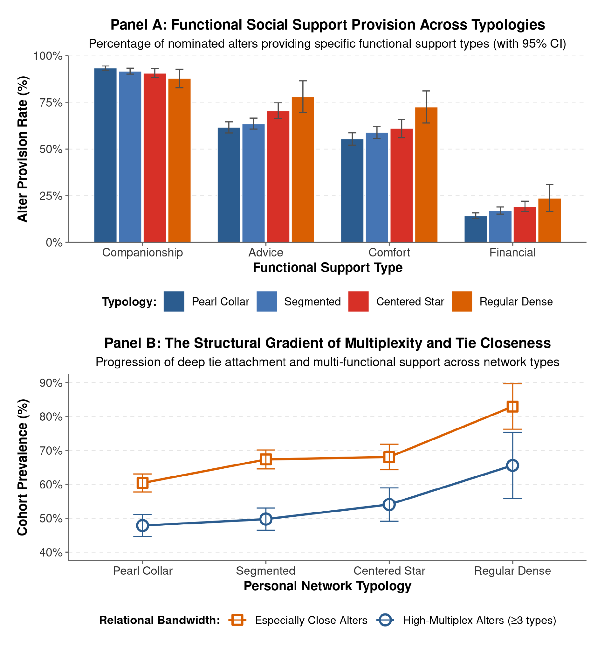
Figure 11. Functional Social Support Profiles and Multiplexity Gradient Across Personal Network Typologies.

Note: Panel A displays the percentage of nominated alters providing specific functional support types across personal network typologies with 95% confidence interval error bars. Panel B displays the monotonic progression of high-multiplex alters (≥ 3 support types) and tie closeness (% especially close alters) across network configurations.
Table 8 and Figure 11 show that while social companionship (hanging out) represents a universal baseline of collegiate sociability (~88% to 93% across all configurations), substantive functional support exhibits a pronounced, monotonic structural gradient across typologies. Informational advice rises systematically from the expansive Pearl Collar configuration (61.6%) and Segmented networks (63.6%) to Centered Stars (70.5%) and reaches its peak in Regular Dense networks (78.0%; F = 8.47, p < 0.001). Emotional comfort exhibits an identical progression, rising from 55.3% in Pearl Collar networks to 72.5% in Regular Dense networks (F = 5.46, p = 0.001), while financial assistance displays a matching concentration (14.2% in Pearl Collar vs. 23.7% in Regular Dense; F = 5.79, p < 0.001).
Crucially, this functional gradient reflects a fundamental structural tradeoff between topological reach and relational bandwidth. As shown in Panel B of Figure 11, the Support Multiplexity Index—measuring the average number of functional supports provided per alter—increases monotonically from 2.24 in Pearl Collar networks to 2.62 in Regular Dense networks (F = 6.90, p < 0.001). Similarly, the share of “high-multiplex” alters providing three or more distinct forms of support rises from 47.9% to 65.6% (F = 6.24, p < 0.001). This functional concentration is underpinned by emotional intimacy: alters classified as “especially close” account for only 60.5% of contacts in Pearl Collar networks, but surge to 82.9% in Regular Dense networks (F = 14.28, p < 0.001), accompanied by elevated interpersonal trust (F = 5.28, p = 0.001). Expansive, chained network configurations like the Pearl Collar maximize structural breadth and bridge across modular student worlds, but they do so by diluting the proportion of multiplex, emotionally intensive, and financially supportive ties. Conversely, small, cohesive cliques sacrifice structural reach and external bridging in order to maximize dense mutual trust, emotional solidarity, and multi-functional safety nets.

Discussion and Conclusion
This study provides an empirical replication and comprehensive extension of personal network structural typologies using longitudinal data from the NetHealth Study. By tracking 701 college students over three years, we demonstrate that personal networks coalesce into distinct, recurrent topological forms that mirror the theoretical archetypes identified by Bidart et al. (2018): Pearl Collar, Segmented, Centered Star, and Regular Dense configurations.
Our findings advance the sociology of personal networks across several theoretical and methodological fronts. First, our empirical decision tree establishes objective, data-driven cutoffs that classify network forms with 92.9% accuracy, offering concrete operational guidance for future research. Second, our wave-by-wave Markov transition models show that while small, cohesive networks exhibit remarkable persistence across college semesters (70.8%), students experience substantial structural mobility, with expansive Pearl Collar configurations emerging cumulatively across academic years. Third, our multilevel categorical models demonstrate that physical residence halls and academic majors account for substantial clustering in the forms of personal networks, highlighting the profound role of institutional opportunity structures. Finally, our incorporation of Big Five personality dimensions reveals that personal network architecture reflects a continuous interplay between psychological dispositions and social stratification. Future research should leverage these empirical typologies to investigate downstream consequences for academic performance, mental health, and early occupational trajectories.

References
Antonucci, T. C., Ajrouch, K. J., & Birditt, K. S. (2013). The convoy model: Explaining social relations from a multidisciplinary perspective. The Gerontologist, 54(1), 82–92. https://doi.org/10.1093/geront/gnt118
Bidart, C., Degenne, A., & Grossetti, M. (2018). Personal network typologies: A structural approach. Social Networks, 54, 1–11. https://doi.org/10.1016/j.socnet.2017.11.003
Breiman, L., Friedman, J. H., Olshen, R. A., & Stone, C. J. (1984). Classification and regression trees. Wadsworth & Brooks/Cole.
Fischer, C. S. (1982). To dwell among friends: Personal networks in town and city. University of Chicago Press.
Giannella, E., & Fischer, C. S. (2016). An inductive typology of personal networks. Social Networks, 46, 24–34. https://doi.org/10.1016/j.socnet.2016.02.003
Offer, S., & Fischer, C. S. (2018). Does help discussion build closer ties? In J. Youm, E. O. Laumann, & K. Lee (Eds.), Social networks and the life course (pp. 45–68). Springer.
Vacca, R. (2020). Structure in personal networks: Constructing and comparing typologies. Network Science, 8(2), 142–167. https://doi.org/10.1017/nws.2019.29
Liu, S., Hachen, D., Lizardo, O., Poellabauer, C., Striegel, A., & Milenković, T. (2018). Network analysis of the NetHealth data: Exploring co-evolution of individuals’ social network positions and physical activities. Applied Network Science, 3(1), 45. https://doi.org/10.1007/s41109-018-0103-2
Sepulvado, B., Wood, M., Wang, C., Fridmanski, E., Chandler, M., Lizardo, O., & Hachen, D. (2020). Predicting homophily and social network connectivity from dyadic behavioral similarity trajectory clusters. Social Science Computer Review, 40(1), 186–205. https://doi.org/10.1177/0894439320923123
Wang, C., Lizardo, O., & Hachen, D. S. (2020). Neither influence nor selection: Examining co-evolution of political orientation and social networks in the NetSense and NetHealth studies. PLOS ONE, 15(5), e0233458. https://doi.org/10.1371/journal.pone.0233458

