Learning Julia

A Guide to Julia resources

Important Links:
- GitHub CLI

Package development tutorial

Julia and GitHub
Julia packages are maintained in GitHub.
Any Julia project must be represented in a corresponding GitHub repository.
You can develop a Julia package on a GitHub repository under your private GitHub account.
Once you are happy with it, you may want your package “ABC.jl” to become accessible to any other Julia developer in the usual way that is: “pkg> add ABC” .
For this to happen you will have to send a Git pull request to the mainainers of the Julia METADATA.jl package.
In the above link, Chris Rackauckas explained how you can create the directory structure of a new project using the generate function of the PkgDev package. All that is now obsolete, as the preferred way of starting a new Julia project is to follow the documentation made available in the PkgTemplates.jl Julia project.
The PkgTemplates.jl project is meant to be the ultimate solution to the problem of routinely create Julia packages in a reproducible way. However, there is a lack of up-to-date tutorials on the actual use of this remarkable tool. As a result, only experts with CI tools and Julia Pkg can really benefit from the available documentation.
Lobianco Concise Tutorial
This tutorial is apparently rather old, since most of the material stored in the GitHub repository has not been updated after 2020. Moreover, it does not assume using the PkgTemplates.jl approach to create packages. Given that, it may still be the best source for a novice to get an understanding of the basic architecture underlying Julia package development, so that perhaps one can acquire a sufficient background to then be able to understand how everything could be done in a better, i.e. a more standardised, way by leveraging the PkgTemplates stuff.

Understanding modules
Let follow Lobianco’s Concise Tutorial section about Understanding modules:
“The main objective of modules is to provide separate namespaces for global names in Julia”.
The following note clarifies an important point about the import and using Julia statements:
Note: using and import, when they are followed with either Main.x or .x, look for a module already loaded and bring it and its exported objects into scope (for import only those explicitly specified). Otherwise, they do a completely different job: they expects a package, and the package system lookups the correct version of the module x embedded inside package x, it loads it, and it bring it and its exported objects into scope (again, for import x only those explicitly specified).

Developing a Julia package
Let follow Lobianco’s Concise Tutorial section about Developing Julia packages:
“A package is nothing else that a collection of one or more hierarchically connected modules (at least one with the same name of the package acting on top of the hierarchy) logically connected to provide a given functionality, enriched with metadata that make the discovery, usage and interconnection of modules much simpler. Hence, before developing a package, be sure you fully understand how modules behave in Julia, as described in the previous section.”
Here we follow Lobianco and use the name MyAwesomePackage to indicate the name of a new Julia package that we want to create. In the process we normally go through a few steps, namely
- Step 1: Using the Julia Pkg generate function one creates a skeleton of the MyAwesomePackage package, under a temporary folder with the same name.
- Step 2: Using the Julia Pkg activate and Pkg add functions one makes the initial declaration of external packages upon which the MyAwesomePackage depends.
A limited amount of code could also be created under the src/ and test/ subfolders.
- Step 3: One create a GitHub repository named MyAwesomePackage.jl (note the .jl suffix, dictated by Julia conventions). The initial content of this repository will be normally limited to the following files:
  - README.md
  - LICENSE
  - .gitignore
- Step 4: Using the Git CLI, the content locally generated under MyAwesomePackage/ is merged with content pulled from the GitHub repository MyAwesomePackage.jl and the result is finally pushed onto the branch main of that (remote) repository.
- Step 5: From this point onward, the local content under MyAwesomePackage/ is of no use, and development continues using a local clone of the remote MyAwesomePackage.jl repo.
Before starting a detailed demonstration of each one of the above steps, it is useful to fix some environment variables which make it easier to develop scripts that automate some of these steps.

JULIA_PKG_DEVDIR
This environment variable controls where a Julia package is locally made available (i.e. stored) for development. Here we assume that this variable is set in the .bashrc file of Julia developers to contain the path of a folder storing local clones of Julia GitHub projects.

JULIA_TMP_DEVDIR
By our (not Julia’s) convention this environment variable controls the path of a folder under which a Julia developer wants to temporarily store the initial skeletons of Julia packages created by the Julia Pkg generate function. We assume this variable to be also set in the .bashrc file.

Step 1 – Create the package skeleton
marcello@X570:~$ cd $JULIA_TMP_DEVDIR
marcello@X570:/tmp$ julia -q
(@v1.8) pkg> generate MyAwesomePackage
Generating project MyAwesomePackage:
MyAwesomePackage/Project.toml
MyAwesomePackage/src/MyAwesomePackage.jl
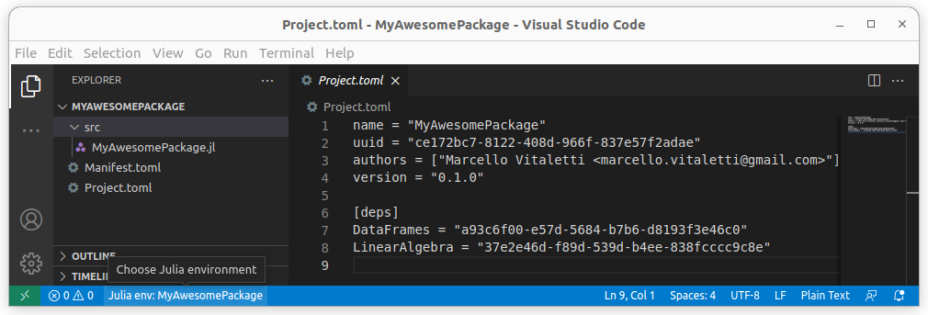

Step 2 – Complete the initial structure
(@v1.8) pkg> activate /tmp/MyAwesomePackage
Activating project at `/tmp/MyAwesomePackage`
(MyAwesomePackage) pkg> add LinearAlgebra DataFrames
Updating registry at `~/.julia/registries/General.toml`
Resolving package versions...
Updating `/tmp/MyAwesomePackage/Manifest.toml`
[34da2185] + Compat v4.5.0
[a8cc5b0e] + Crayons v4.1.1
[9a962f9c] + DataAPI v1.14.0
[a93c6f00] + DataFrames v1.4.4
[864edb3b] + DataStructures v0.18.13
[e2d170a0] + DataValueInterfaces v1.0.0

.. .. .. .. .. .. .. .. .. .. .. .. .. .. .. .. ..

[3fa0cd96] + REPL
[9a3f8284] + Random
[ea8e919c] + SHA v0.7.0
[9e88b42a] + Serialization
[6462fe0b] + Sockets
[2f01184e] + SparseArrays
[10745b16] + Statistics
[8dfed614] + Test
[cf7118a7] + UUIDs
[4ec0a83e] + Unicode
[e66e0078] + CompilerSupportLibraries_jll v0.5.2+0
[4536629a] + OpenBLAS_jll v0.3.20+0
[8e850b90] + libblastrampoline_jll v5.1.1+0
Precompiling project...
1 dependency successfully precompiled in 0 seconds. 23 already precompiled.
The Manifest.toml file now lists the UUID and version of about 45 package dependencies.
From the message in output, we take note that the DataFrames version is v1.4.4
Going back to our new Project.toml file, the two packages have been added to the [deps] section. We now want to specify the version of the third-party packages our MyAwesomePackage works with, and in particular, if we want to register it in the official Julia registry, we need to specify an upper version. We can do that by adding to Project.toml a new [compat] section where we write down DataFrames = "1.4, 1.5", that is we allow MyAwesomePackage to work with any DataFrames in the v1.4.x or v1.5.x series. In other words, we assume that the functionality that our package depends from has been introduced in v1.4.0 and that it will be still available in the v1.5.x series.
We also add julia = "1.8.2" assuming that our package works only with Julia >= v1.8.2 within the v1.x serie.
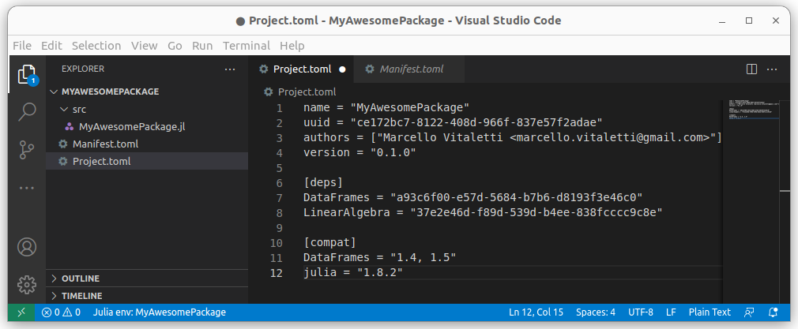

Step 3 – Create the GitHub repository
First, we create the repository in GitHub, considering a package name that follows the Julia's package naming guidelines and, by custom, calling the repository by the package name followed by the ".jl" prefix. For example, in this tutorial we chose MyAwesomePackage as the package name, hence the name of the corresponding GitHub repository must be MyAwesomePackage.jl.
Don't forget to add a README file (so we can immediately clone the repository) and choose Julia as the .gitignore template (see this screen image).
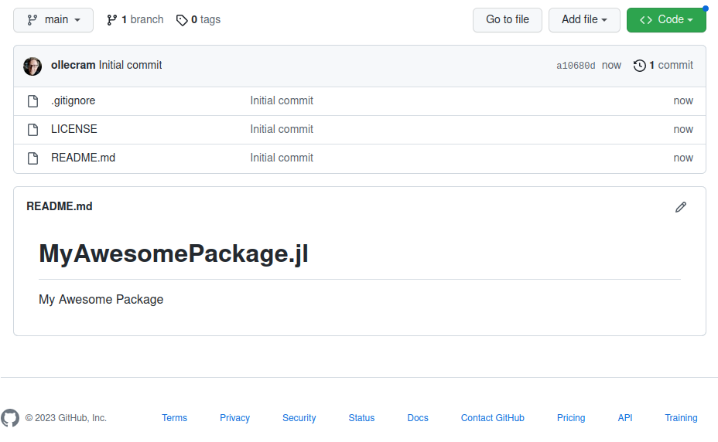

Step 4 – Merge locally and Push to GitHub
The following table lists the commands to be issued locally to merge the Julia project files created by the @pkg> generate command with the files stored in the newly created GitHub project
cd $JULIA_TMP_DEVDIR/MyAwesomePackage | Make the skeleton folder the working directory
git init -b main | Create the .git/ subfolder.  -b main causes the main branch to be given the same name as that of the main branch on GitHub
git add . | All files previously created by @pkg> generate are now staged (locally made known) to Git
git commit -a -m “<message>” | Commit all staged files
git remote add origin <URL> | Provide URL of the GitHub remote repository using the SSH form  git@github.com:ollecram/<package>.jl.git  where <package> = MyAwesomePackage
git config pull.rebase false | This is critical to avoid Git complaining on the next command about bringing two divergent branches together
git pull origin main --no-edit  --allow-unrelated-histories | This pulls from GitHub the README.md, LICENSE and .gitignore files
git status | Output should be as follows:  On branch main  nothing to commit, working tree clean
git push --set-upstream origin main | …  To github.com:ollecram/MyAwesomePackage.jl.git  …  Branch ‘main’ set up to track remote branch ‘main’

The bash script initJuliaPackage.sh should be created under /usr/local/bin to accept a single argument (the name of the Julia package) and performs all of the above commands.

The initJuliaPackage.sh bash script
A complete implementation of initJuliaPackage.sh is reproduced in the following text box.

The following screen shows the actual output produced by the initJuliaPackage.sh script.
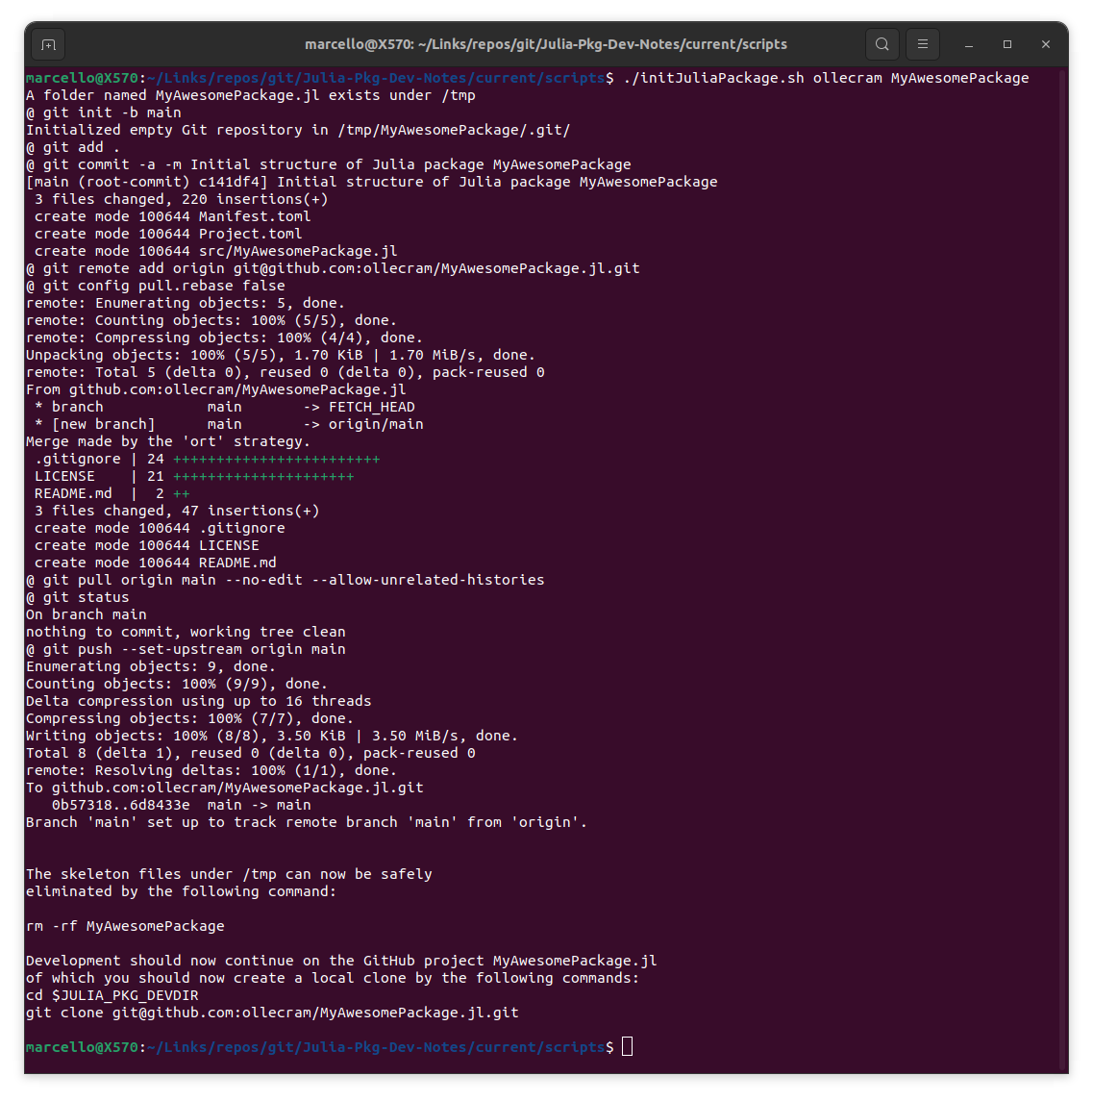

Step 5 – Continue normal Dev/Test/Doc

Creating the package and implementing tests

The repository doesn't yet contain the minimum set of information that allows it to be downloaded as a "Julia package", hence we will first generate a basic package structure locally, using the Julia tool generate. We will then commit and link this git repository with the remote GitHub repository we just made, push the basic package structure to GitHub and, at that point, we can download it again as a Julia Package and continue its development.
Let assume the shell variable JULIA_PKG_DEVDIR contains the path in the local filesystem where we keep local clones of GitHub repositories. This is the directory where we want the new package to appear as a subfolder. We then open a shell, cd to this path and start the Julia REPL:
marcello@X570:/$ cd $JULIA_PKG_DEVDIR
marcello@X570:~/Links/repos/git$ julia -q
julia>
We now use the Julia Pkg functions to generate our package structure locally:
(@v1.8) pkg> generate MyAwesomePackage
Generating project MyAwesomePackage:
MyAwesomePackage/Project.toml
MyAwesomePackage/src/MyAwesomePackage.jl

This command created a new folder MyAwesomePackage whose src subfolder includes the file MyAwesomePackage.jl, a “Hello World” version of our awesome package. Most importantly, it includes the Project.toml file. For now, the latter includes:
- the name of the package;
- the author name and email;
- the unique id that has been assigned to the new package (this is a code that depends from stuff like the MAC address, the exact time, the process id, etc...) and
- the initial version of the package. Check that the author and initial version are ok for you (for example, Lobianco prefers to start a package with version 0.0.1 rather that 0.1.0).
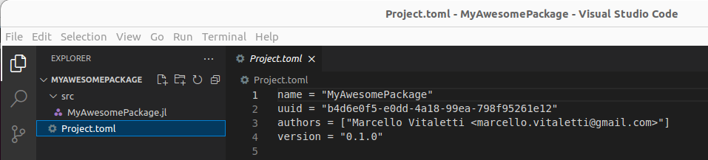
Project.toml will also hold the dependencies that our package will require. So, for example, let’s assume that MyAwesomePackage depends from the packages LinearAlgebra (a standard lib package) and DataFrames (a popular third-party package to work with tabular data , aka “dataframes”).
We first need to “activate” the MyAwesomePackage folder with the Pkg activate command.

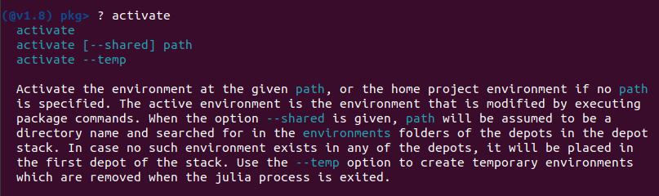
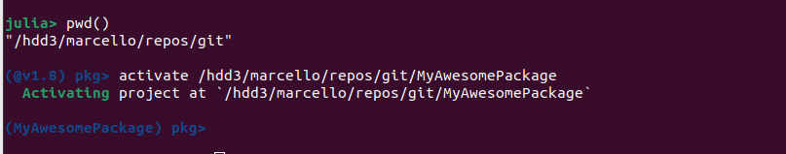
Note how the prompt string of the Pkg environment changed to (MyAwesomePackage) after the activate command. We can now add the two packages:
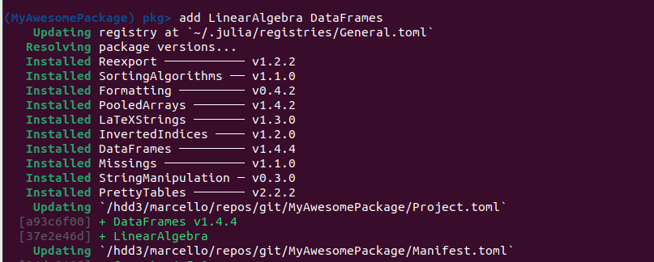
Here is the updated version of Project.toml
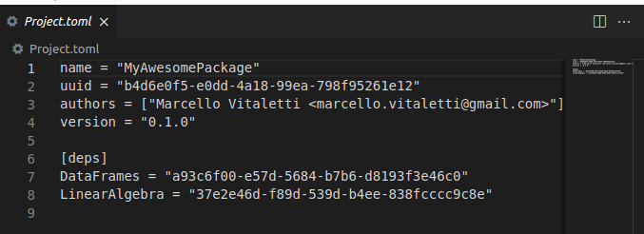

The Manifest.toml file now lists the UUID and version of about 45 package dependencies.
From the message in output, we take note that the DataFrames version is v1.4.4
Going back to our new Project.toml file, the two packages have been added to the [deps] section. We now want to specify the version of the third-party packages our MyAwesomePackage works with, and in particular, if we want to register it in the official Julia registry, we need to specify an upper version. We can do that by adding to Project.toml a new [compat] section where we write down DataFrames = "1.4, 1.5", that is we allow MyAwesomePackage to work with any DataFrames in the v1.4.x or v1.5.x series. In other words, we assume that the functionality that our package depends from has been introduced in v1.4.0 and that it will be still available in the v1.5.x series.
We also add julia = "1.8.2" assuming that our package works only with Julia >= v1.8.2 within the v1.x serie.
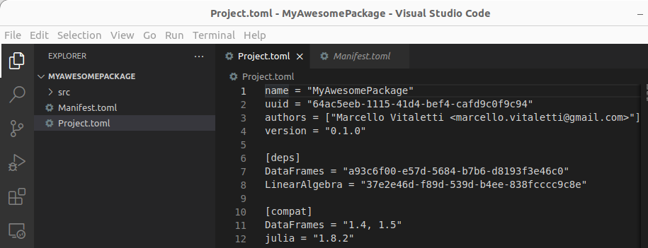
Our new package is now ready to be linked with the repository we created in GitHub. While in this tutorial we will use a terminal, you can just use the github web interface to copy the files generate has produced to your Git repository.
Let leave Julia for now, go to the local package folder with a terminal and run the Git init command to initialize the project repository
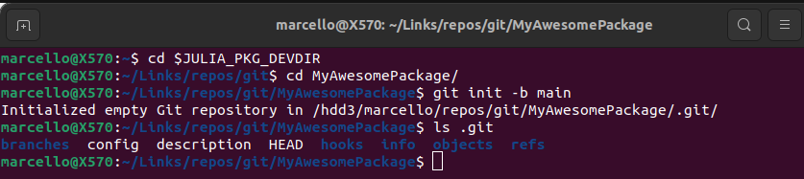
The following Git commands locally merge the files created by generate with the few files (LICENSE, README.md and .gitignore) created on GitHub for the MyAwesomePackage project, then finally push the merged project to the repote GitHub repository.

Sequence of commands to complete project initialization

# !/bin/bash

# A. Check that a package was created by Pkg.generate
if [ -d "$JULIA_PKG_DEVDIR/$1" ]

then

echo A folder named "$1.jl" exists under $JULIA_PKG_DEVDIR

else

echo ERROR: A folder named "$1.jl" DOES NOT exist under $JULIA_PKG_DEVDIR

exit

fi

# B. Save the current working directory

cwd=$(pwd)

# 1.

cd "$JULIA_PKG_DEVDIR/$1"

# 2.

git init -b main

# 3.

git add .

# 4.

git commit -a -m \"Initial structure of Julia package $1\"

# 5.

SSH_URL="github.com:ollecram/$1.jl.git"

git remote add origin $SSH_URL

# 6.

git pull.rebase false

# 7.

git pull origin main –no-edit --allow-unrelated-histories

# 8.

git status

# 9.

git push --set-upstream origin main

# C. Restore the current working directory

cd $cwd

Documenting our package
Let follow Lobianco’s Documenting our package.

Understanding Modules
I recommend reviewing the way Julia modules work by reading the corresponding section of Lobianco's Understanding modules. In particular, the following note from Lobianco’s clarifies an important point about the import and using Julia statements:
Note: using and import, when they are followed with either Main.x or .x, look for a module already loaded and bring it and its exported objects into scope (for import only those explicitly specified). Otherwise, they do a completely different job: they expects a package, and the package system lookups the correct version of the module x embedded inside package x, it loads it, and it bring it and its exported objects into scope (again, for import x only those explicitly specified).

Alternatively, one could use the more advanced approach supported by the Julia PkgTemplates.jl project.
See an explanation of JULIA_PKG_DEVDIR in the documentation of the Pkg develop function.
Reminder: the GitHub project associated to Julia MyAwesomePackage is named MyAwesomePackage.jl
The HTTPS form would cause the Git CLI to issue an authentication prompt, but then authentication would fail anyway, because GitHub has abolished HTTPS authentication in this context.
This option avoids prompting the user for a message to be attached to the associated merge operation
Type “]” to switch from the Julia REPL to the Pkg environment. Type the Backward key to switch back to REPL.
Note the option “-b main” in the git init command. This is needed because the Git default for the repository main branch is “master” while GitHub’s own default is “main” and that is the name in the newly created repo!

