Music Melody Heuristic Method
MMHM

What a Music Melody is

A music melody (MM) is a sequence of n notes, with n typically a small number ranging from a minimum of 2 to a maximum of about 10. Notes in a melody are not required to have all the same duration, but a large fraction of beautiful melodies whose notes do not all have the same duration would likely not loose their character entirely if notes are all played with a constant duration.
Another reasonable assumption is that a constant translation of pitch (up or down) applied to all notes of a melody would not change the essence of the sensory experience in most individuals (except perhaps those rare people endowed by nature of the so-called abolute pitch).
Consequently, for the purposes of this software any two melodies are considered the SAME melody if one can be obtained from the other by applying a uniform translation of pitch.
Neglecting the difference between black and white keys on a piano keyboard, we have thus a palette of about 7 octaves, each octave including 12 distinct notes. In this palette, the pitch difference betwen each note and its two neighboring notes is 1 semi-tone.
Given the frequency (pitch) of a piano key , and the twelfth root of 2, the immediately preceding key’s note has frequency / while the immediately following key produces a note whose frequency is times .
Here we adopt the very general perspective that a melody of N+1 notes is completely specified by the N numbers indicating the distance in semi-tones between one note and the next.
Once these N numbers are given, the melody notes are obtained by choosing one of them at will.
Let assume distances in semitones be allowed to vary in the [-m:+m] range, where m is a positive integer. This implies that the distance in semi-tones between two consecutive notes can take 2m+1 distinct values. Once N and m are specified, simple combinatorial calculations give us the total number Z of distinct melodies, namely (2m+1) raised to the power N.
Example: N = 10, m=5 give Z = 11¹⁰ that is, approximately, 26 billions!
How could one hope to identify beautiful melodies by searching for them in such a vast sea?
That is the theme of the next section.

Making sense of melody search in that vast sea
There are a number of reflections that can help one’s search of beautiful melodies within the billions of possible sequences of admitted pitch distances. In order to keep the language clear, we use the term “interval” to indicate the number of semitones which separates one note from the next one or from the previous one.
A melody of N+1 notes is then fully characterized by its N intervals, that is: N integer numbers. Each one of these numbers is constrained to be chosen from a set of Admissible Pitch Distances (APD). In most cases, the APD is determined by a relatively small integer m as it will include the 2m+1 integers which belong to the set of all integers within [-m, +m].
Let the APD set be specified and let M be its cardinality .
Example: Taking as APD the set of all integers within [-m, +m] we have M = 2m+1.
In this example, the APD set includes the number zero, which must be the case unless one wants to exclude melodies where the same note is consecutevely repeated one or more times!
Assume to have performed n independent random extractions from the APD set, and to have put this sequence of values in a vector v. It will become clear in the following that one very much needs some meaningful indicators qualifying the “character” (or “structure” if you like) of any such sequence of integers (the intervals), in the hope that some correlation could be established (perhaps in a probabilistic sense) between the structure of a melody and values of a corresponding set of indicators.
The “rotation” of a melody (sequence of N pitch variations) can be visualized by imagining the N values printed on a ribbon of length L that is wrapped around a cylinder whose circumference is exactly equal to L. Hence the first integer on the ribbon will touch the last one. After choosing the sense of rotation (e.g. clock-wise) one can start the melody at any place.
This is a crucial point for all that follows: we are going to treat all the N, possibly distinct sequences of N pitch variations resulting from arbitrarily choosing the starting point, as
equivalent representatives of a melody class.
The next most useful concept is the identification of a whole melody class by an integer. This number we call the melody class Id (MC-Id). The MC-Id of a melody class and the cardinality M of the associated APD set are necessary and sufficient to uniquely determine a specific member (melody) of the melody class. The other members of the melody class are obtained by “rotation” from this one. All this is enabled by the method one uses to associate a melody class to an integer.

Identifying melody classes by a unique integer
Given M the cardinality of the melody APD set, and V a 1-dimensional array of length M, let members of the APD set be stored in some arbitrary, yet specified order in the array V.
Concrete example: APD={-3, -2, -1, 0, 1, 2, 3}; M=7; V = [-3, -2, -1, 0, 1, 2, 3]; N=5.
A representative R of a melody class fitting the above specification could be identified by a sequence of N=5 values taken from the 1-dimensional array V, like for exmple:
R = [2, -1, 0, 1, -3] (where each element is a member of the APD set). An equivalent, more convenient way to choose an identifier R* of a melody class is to replace each value in R by the corresponding offset of that value in the array V (of length M) whereby, in this example,
R* = [5, 2, 3, 4, 0]. Defined in this way, R* does not depend directly on the actual APD values.
One key observation about the elements of the above array R* is that the sequence of its elements can be interpreted as the representation of an integer number in base M, were M = length(V) is the cardinality of the APD set. The whole sequence (hence the corresponding melody class) can thus be uniquely identified by that integer value, that we denote as I_{M}.
Building on the above example, the sequence R* = [5, 2, 3, 4, 0] is interpreted as representing
I₇ = 5*7⁰ + 2*7¹ + 3*7² + 4*7³ + 0*7⁴ = 5 + 2*7 + 3*49 + 4*343 + 0*2401 = 3939
By decoding the individual digits representing that number in base M, one immediately recovers the vector uniquely associated to that particular sequence of APD’s, namely : [5, 2, 3, 4, 0].
Another key observation is that a k-steps rotation of the sequence of elements in the vector V does not necessarily produce a distinct integer value corresponding to the same melody class. Indeed, the cardinality of the set of all possible rotations of a melody class very much depends on the structure of the melody. Here we give two examples with M=7 and N=5
- Example 1: R* = [6, 2, 3, 4, 5] : k-steps rotations with k in {1, 2, 3, 4} yield distinct melodies:
    - [2, 3, 4, 5, 6]; [3, 4, 5, 6, 2]; [4, 5, 6, 2, 3]; [5, 6, 2, 3, 4] .
- Example 2: R* = [2, 2, 2, 2, 2] : This melody structure is clearly rotation invariant, hence the associate melody class includes only one member, represented by the number 2801.
Let compute the MC-Id (integer identifying a whole class) for classes in the above two examples. Starting from the list of N indices defining an arbitrary member of the class, one generates all other members of the class by rotation of the list. Interpreting each list as the reversed representation of an integer in base M, the class MC-Id is just the minimum of these N integers. Therefore
Ex 1: MC-Id = 3*7⁰ + 4*7¹ + 5*7² + 6*7³ + 2*7⁴ = 3 + 4*7 + 5*49 + 6*343 + 2*2401 = 7136
Ex 2: MC-Id = 2*7⁰ + 2*7¹ + 2*7² + 2*7³ + 2*7⁴ = 2 + 2*7 + 2*49 + 2*343 + 2*2401 = 5602

Sampling methods for detecting nice melodies in the vast sea
Our next goal is to device a strategy for sampling the potentially vast sea of melodies.
Even delimiting the search to melodies associated with a given pair (M, N) of parameters, we may still be presented with an enormous number of possibilities.
In the previous section we learned two facts:
- Melody structure, defined by the R* vector, determines the cardinality of a melody class;
- There is a one-to-one mapping between melody classes and positive integers (plus zero) whose representation in base M requires up to N digits.
Fact b. suggests that a uniform random sampling of integers in the range [0, M^{N} - 1] would implement an unbiased exploration of the set of melody classes. In details: once an integer n is sampled, one first determines the melody class which that integer is a member of. The class itself is identified by the minimum integer which is obtained by cyclic rotations of the digits of the integer n in base M.
The analysis conducted so far about melody classes and their representation by integers in the range [0, M^{N} - 1] , implies that the observed relative frequency of class hits in a uniform random sampling of integers in that range, must be directly proportional to the ratio of their cardinalities.
In details: Let choose integers M, N and K ≥ 10, where M and N define the set of melody classes as explained above. Let K * M^{N} = R_{{M,N,K}} be the number of sampled integers, so that, on average, each melody class should receive K random extractions. , i.e. integers in the range [0, M^{N} - 1] .
Checking this obvious prediction by a numerical experiment seems to be a very sensible first step in validating the correctness of any software implementation. This is explained in details in
APPENDIX 1 -- Pearson’s chi-squared test statistic (with PYTHON code examples)
Since all the existing code for this project has been implemented in Julia until now, I searched for a Julia equivalent of Python libraries Numpy and PyTorch that could run on my GPU as well.
The search was very encouraging: see GPU computing in Julia (YouTube) by Jamie Mair
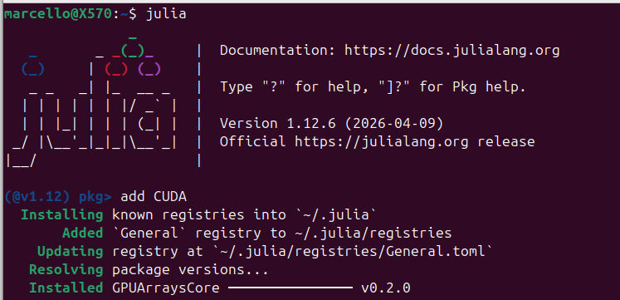
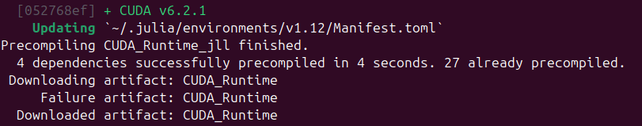
…..
…..
…..
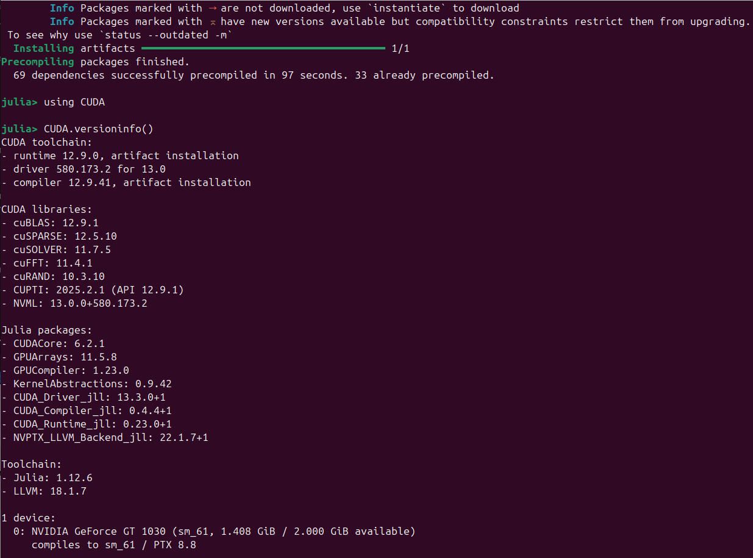
- Package [61eb1bfa] + GPUCompiler v1.23.0 have new versions available but compatibility constraints restrict them from upgrading.
To see why use `status --outdated -m`
- Package [d1e2174e] + CUDA_Compiler_jll v0.4.4+1 was not downloaded,
use `instantiate` to download
- julia> CUDA.versioninfo()
Prints the exhaustive set of data seen in the above snapshot, including the available GPU
In my case: 0: NVIDIA GeForce GT 1030 (sm_61, 1.408 GiB / 2.000 GiB available)

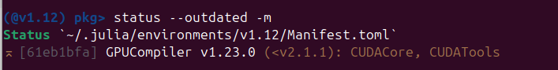
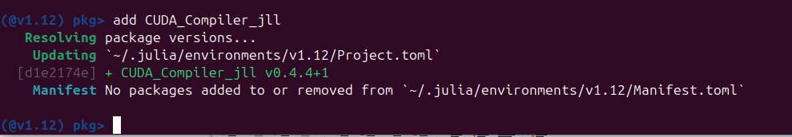
In order to run Pearson Chi-square tests I asked for and obtained the following AI advice:

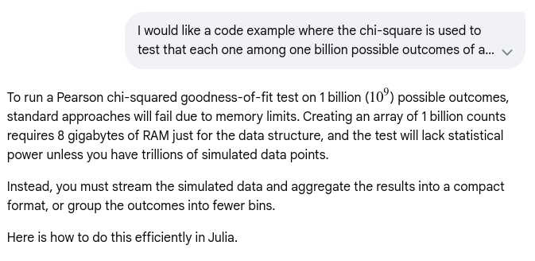
Il codice è stato salvato all’interno del repository GitHub Melody.jl, under
docs/resources/Chi-Square_test_with_Julia.jl

Early experiments appear to show a marked disuniformity of hits density across melody classes suggesting that distinct melody classes have different probability to occur in a uniform random sampling of all classes. In turn, this fact suggests to investigate a possible correlation between hits density and structural properties of a melody class such as the following 4 integers :
- Cardinality (number of class members);
- Algebraic sum of pitch distances (ASPD);
- Sum of absolute pitch distances (SAPD);
- The difference (SAPD – ASPD).

Numerical experiments
The first numerical experiment is based on the above choice of APD={-3, -2, -1, 0, 1, 2, 3}, M=7,
V = [-3, -2, -1, 0, 1, 2, 3] and N=5.
Integers in the range [0, 6x7⁰ + 6x7¹ + 6x7² + 6x7³ + 6x7⁴] = [0, 6x2801] = [0, 16806] = [0, 7⁵-1] are thus all valid representatives of some melody class with the stated constraints.
In this case, the set of all possible melody identifiers includes 7⁵ (16807) elements. With each one of these integer numbers we can do the following:
- Rotate the sequence of its digits in base M to find the minimum integer value MC-Id, which we adopt as the unique identifier of the corresponding melody class;
- Map each MC-Id to the structural properties of the class (the above 4 integers);
- Define the likelyhood of a class, as the fraction of total hits and try to establish its correlation with the 4 structural properties. Ideally, one would hope to be able to fit the measured likelyhood with some (polynomial?) function of the 4 structural variables.
- Try to correlate qualitative features of the shape of the likelyhood interpolating function and the musical appeal of the corresponding melody.
In order to tackle the last step of the above program, one will need software tools by which the melody can be put in a playable format, like e.g. MIDI or MuseSCore.

Appendices

APPENDIX 1 - Pearson’s chi-squared test statistic

Q: I am tasked to statistically validate the hypothesis that the K possible outcomes of a repeatable experiment all have the same probability. K equals 2 billions. I can easily simulate in software 10 times K experiments (simulated in Python code) so that each possible outcome receives 10 hits on average. What Python statistical package can help me assess the hypothesys?

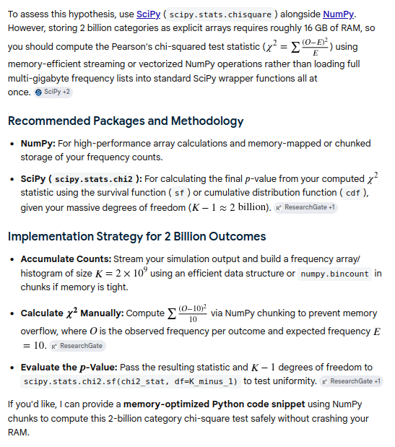

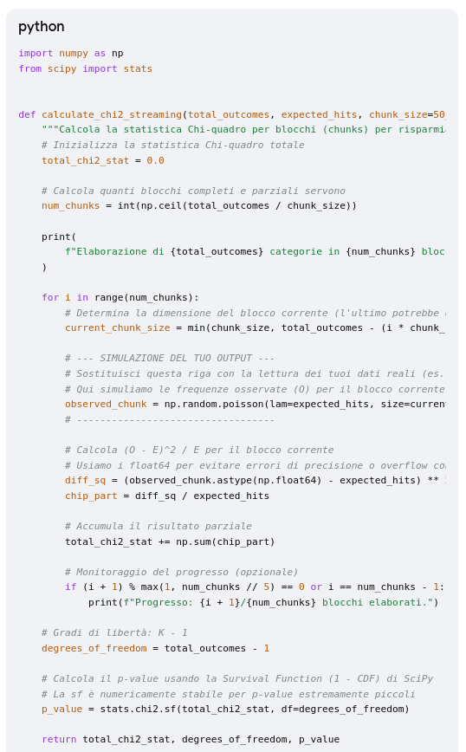

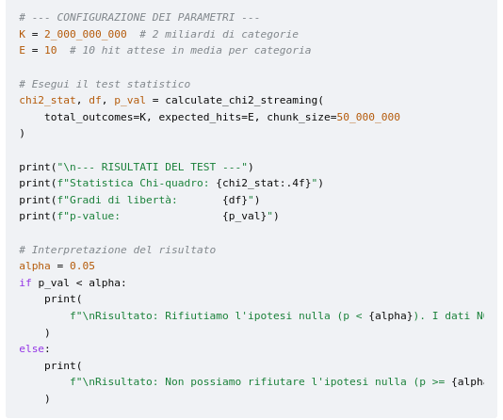

Il codice qui mostrato, è stato salvato all’interno del repository GitHub Melody.jl, under
docs/resources/AI_Pearsons_chi-square-test_for_melody-classes.py

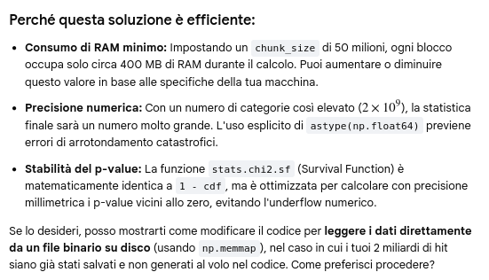
Si desidero sapere come come modificare il codice per leggere i dati direttamente da un file binario su disco (usando np.memmap), nel caso in cui i miei 2 miliardi di hit siano già stati salvati e non generati al volo nel codice
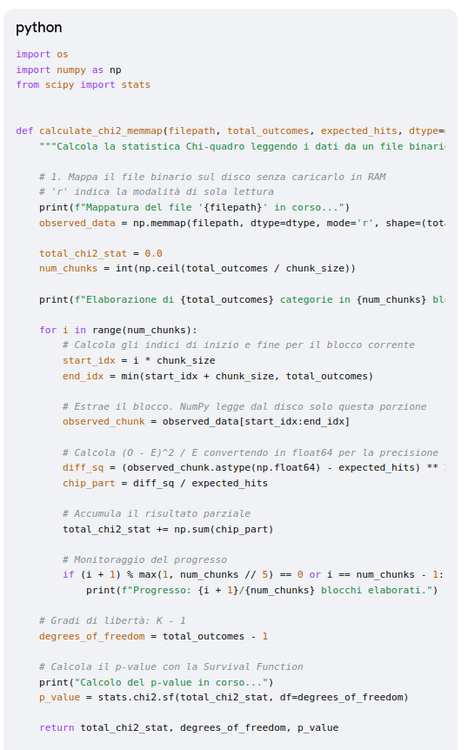

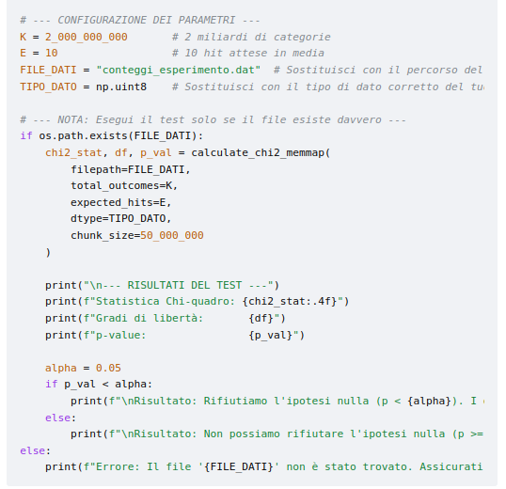
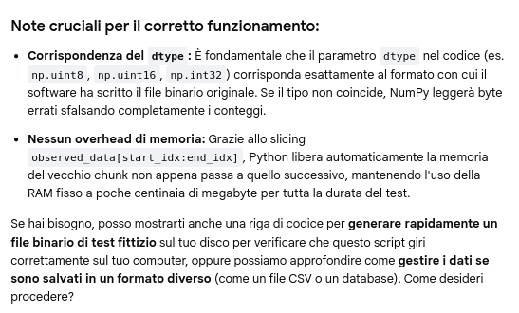

Polynomial in 3 variables fitting melody class data
DA RIVEDERE COMPLETAMENTE ALLA LUCE DEI RISULTATI della SEZ PRECEDENTE!
Our next step is to find an interpolating polynomial in 3 integer variables (cardinality, ASPD, SAPD) taking as its value in R the relative frequency of sampling associated to the independent variables. Following are some instructions on how the polynomial coefficients can be determined.
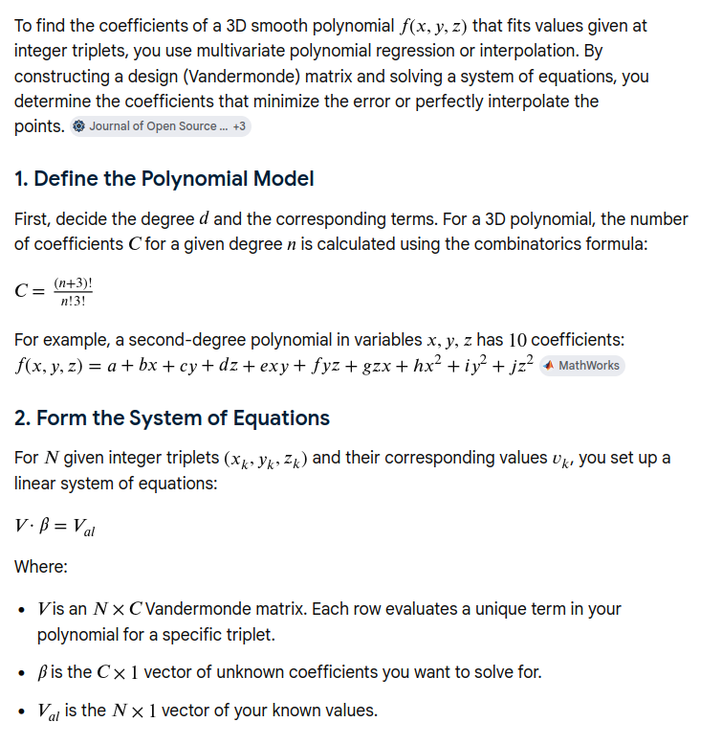

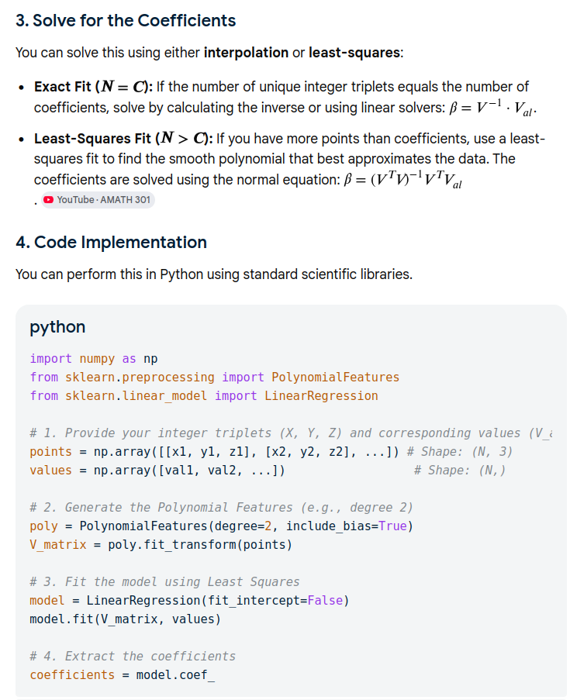

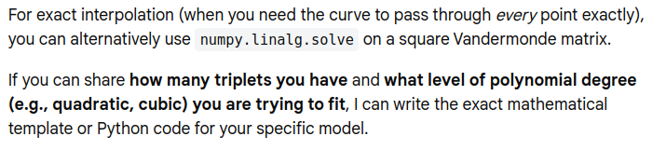

For example, if N is even the number of notes is odd, so you may want to pick the central note at will.
- One might want to forbid melodies containing consecutive repetitions of the same note. This would be simply specified by eliminating the zero (0) from the set of allowed pitch distances between consecutive notes.
There must be no constraint in the software to force the APD to be of the [-m, +m] type: The APD integers can be just be given explicitely as an unordered array of integers. However, giving the APD some structure may be helpful in that it could make it easier to interpret results, especially in the testing phase of the software.
In this context, the term "structure" refers to any property of a sequence of intervals (integers) that most musicians would recognize as the primary factor determining whether the corresponding listening experience is enjoyed or rejected..
In practice, we see no use for arbitrariness in the ordering of these integers in the array V, hence for the sake of clarity we opt for having them sorted in increasing order, whereby V[1] V[2] … V[N].
Note that length(V) = 7 = M as it should be!
The N values ​​do not necessarily have to be distinct from one another, but a number included twice would have twice the probability of being included in a randomly generated sequence.
Yes, we also find it more convenient to actually have the lowest power (0) of M (7) multiply the first digit, hence in reverse order with respect to the usual convention of representing a number in base M.
As a consequence, the cardinality of a melody class with N intervals cannot exceed N – 1.
Naturally, any class member would also work, but in the following we will stick to the minimum.

