LESSON  PLAN | DATE: Feb.1, 2016
LESSON  PLAN | TIME: 10:00-10:40 | CLASS: Kindergarten
LESSON  PLAN | DURATION: 30-40 minutes | SCHOOL: Cedar Park Elementary
Pre-school competencies:  Developmental Domains | COMPETENCY 1 • TO PERFORM SENSORIMOTOR ACTIONS EFFECTIVELY IN DIFFERENT CONTEXTS  Students will move about, explore their space and manipulate various objects when creating various patterns during several of the activities.  COMPETENCY 3 • TO INTERACT HARMONIOUSLY WITH OTHERS: Students will interact harmoniously with others by helping their peers in need and accomplishing tasks in groups. They will apply conflict-resolution process with help from the teacher.  COMPETENCY 4 • TO COMMUNICATE USING THE RESOURCES OF LANGUAGE When prompted, students will be able to explain verbally the choice for their patterns. They will be able to explain what composting is when prompted.  COMPETENCY 5 • TO CONSTRUCT HIS/HER UNDERSTANDING OF THE WORLD Students will use what they learned in class about composting and their prior experiences to exercise thinking in a variety of contexts. They will attempt to describe their leanings to each other and to the teacher verbally and in future projects.  COMPETENCY 6 • TO COMPLETE AN ACTIVITY OR PROJECT Students will persevere in completing the pattern activities. They will discover strategies to help create patterns.
Cross Curricular Competencies
  Intellectual Competency: to use information, to solve problems, to exercise critical judgment, to use creativity.
  Competency and key feature: To construct his/her understanding of the world: shows interest and curiosity in math by experimenting using materials, making connections to real life, observes, expresses what they know, describes and applies learning.
Broad Areas of learning
  Environmental Awareness and Consumer Rights and Responsibilities
  To encourage students to develop an active relationship with their environment while maintaining a critical attitude towards exploitation of the environment, technological development and consumer goods.
  Students will understand what is compostable and what is not. Based on this separation of groups, they will then be able to create patterns.
OBJECTIVES  (CURRICULUM DOMAIN) | Students will learn about what garbage from their lunch and recess snacks is what is compostable. Students will learn how to make two different groups (compostable and non -compostable). After learning about the differences between these two groups, students will be able to identify what a pattern is and predict what should come next in patterns. Students will be able to create an ABAB pattern.
GROUP SIZE & MATERIALS | -Entire class  -60 red buttons and 60 blue buttons  -An apple, a water bottle, sandwich crust, a wrapper, an orange peel, and a juice box.  -Rocks, buttons, twigs of different lengths, leaves of different colors and sizes (for the math centre).  -Students’ lunches  -White board  -Blue marker  -Red marker  -Green marker  -Black marker  -Cut out numbers ( hree sets of 1 and 2’s)

PROFESSIONAL COMPETENCIES:

1. To act as professional inheritor, critic and interpreter of knowledge or culture when teaching students.
I will connect children’s experiences with patterns they see in everyday life to the context of AB patterns in math.

2. To communicate clearly in the language of instruction, both orally and in writing, using correct grammar, in various contexts related to teaching.
I will pace my oral explanations in appropriate fashion as well as articulate new vocabulary clearly. I will give accurate and understandable definition of composting.

3. To develop teaching/learning situations that are appropriate to the students concerned and the subject content with a view to developing the competencies targeted in the programs of study
I will provide multiple opportunities for students to work a lone, in pairs, in small groups or in large groups (the whole class) as well as various pattern activities to create appropriate and “real-world” learning situations. For example, the composting bin versus the trashcan is scenario that they may have to face on a daily basis that promotes environmental well being and responsibility.

4. To pilot teaching/learning situations that are appropriate to the students concerned and to the subject content with a view to developing the competencies targeted in the programs of study.
I will provide students with the resources they need to take part in the learning situations and learning centre. I will guide students in choosing, and understanding the information provided. I will support them in understand the elements of a problem situation or the requirements of a task or project. I will create conditions in which students can engage in meaningful problem situations, tasks or projects, based on their cognitive, emotional and social characteristics.

5. To evaluate student progress in learning the subject content and mastering the related competencies. I will gather information as students are engage in a learning situation in order to identify their strengths and areas of improvement and to review and adapt my teaching accordingly to help them progress. For example, I will be formative assessing throughout the activities. I will design a personal evaluation competency to keep track of their progress (checklist for each student) as they rotate into the math centre. I will take this opportunity to work with them one-on-one to create an AB pattern using coloured buttons, rocks, sticks etc.
6. To plan, organize and supervise a class in such a way as to promote students' learning and social development. I will use whole group, small group and individual activities to implements an efficient system for running regular classroom activities. During whole-group activities, I will keep my students engaged and learning. During small group activities, I will circulate around the room to provide modelling and guiding questions. During the one-on-one math centre activity, other students will be at various centres. They will be familiar with the routine by then.

TIME | LESSON
0-3  (3 minutes)  3-8  (5 minutes)  8-13  (5  min.)  13-18  (5 min)  .  18-23  (5 min)  23-28  (5 min.)  28-30  (2 min)  30-40  (10 minutes) | - Introduction: Tell the students that they will be learning about patterns today. Gather their conceptions. Tell students that a pattern is a design that repeats.  “Today for math we will be learning about patterns. Can someone tell me what they think a pattern is?”  They share their ideas/respond.  “Patterns are things, like objects, or designs that repeat. I’ll sing you a song and invite you to sing along in a bit to help us remember what patterns are. Just listen: Patterns are something that repeats, that repeats, that repeats. Patterns are something that repeats over and over. Now you join!”  They sing along.  “You can use numbers to show patterns. I’m going to teach you a new verse:  An example of a pattern that repeats that repeats that repeats, an example of a pattern that repeats is 1,2,1,2,1,2.”  Demo this on the board. Draw it on the board or use magnet numbers.  “You can use colours to show patterns. An example of a pattern that repeats that repeats that repeats, an example of a pattern that repeats is blue green blue green blue green”  They sing.  “Can someone come up here and show me the same type of pattern but using the colors Red and Blue?”  Student comes up.  You can use letters to show patterns. An example of a pattern that repeats that repeats that repeats, an example of a pattern that repeats is A.B,A,B,AB”  Students sing along.  Development: Explicitly teach by bringing a boy and a girl and a boy and a girl to the front of the class. Show the students that this is a pattern called AB (repeat).  “The “A” letter can represent a girl in the patterns and the “B” letter can represent the boy in the pattern. As a class challenge, let’s get the whole class, all the boys and girls to make an AB pattern. What should we do first?  Discussion and plan with students. And accomplish the task. Take a picture for their portfolio. Once task completely say something like:  Nice work, team! I really like how you worked together, communicated well, took turns, and remembered the AB pattern.  Now explicitly teach the following: Now we are going to take what we learned and apply this to the real world.  “Has anyone ever heard of the word “compost” before? What is “composting”?  Gather their responses. Tell them your definition:  “Composting is a way of helping the environment. We take the leftovers from your meals (like the crust from your sandwich, the banana peel from your snack, the carrot that you might have dropped on the floor) and turn it into valuable food for your garden. This reduces how much trash goes into the trash bin and then how much trash ends up in the garbage landfills. Here’s a picture of what can go in the compost bin (Photo A)!  Show them a picture of a landfill (Photo B). Then show them your compost bin (Photo C). Explain that some schools have different bins for different things (Photo D). See Appendix for photos. Explain that today you will be focusing on compost.  “This is our compost bin that helps break down or decompose organic solid wastes like an apple core. But first, we have to figure out what goes into the garbage bin, trash and what goes into our organic bin. As a group, let’s separate things into compost (A) and non-compost (B). Where do you think the apple belongs?”  Continue this line of questioning for each item until groups are formed. Say something like:  “Now that we have our two groups, A group and B group, let’s make our AB pattern!”  Model to the group, ABABAB or compost, non-compost, compost, non-compost, compost, and non-compost.  CLOSURE /TRANSITION:  Let them try. Now it’s your turn to try. Because it’s snack time, go get your lunches. We will use what we have in our lunch boxes to create more AB patterns. Ask them to share organic and in-organic materials. A lone or in groups of 2-3, allow them each to create their own AB patterns. Have them present them to the class on a voluntary basis.  Evaluation:  - Did the children enjoy and understand the information you were presenting to them about the difference between compost and non-compost?  - Did all the children participate in singing the pattern song?  - Did children come up with their own examples of patterns for the song?  - Were the children able to recite the repeated chant without teacher support?  - Could the children remember the name of the pattern they learned (AB pattern)? How much support was needed?  - Were children able to remember how to make an AB pattern on their own at the math centre? How much prompting or support was needed? (See activities below)

TIME | ACTIVITY
What’s next? (Development/Extensions) Math Centre will have different coloured buttons, different sizes of rocks, and lengths of sticks and thicknesses of sticks to encourage them to practice the AB pattern. There will be an AB pattern card reminding them of how the pattern goes. Other cards like and AAB card (AABAABAAB) and ABC (ABCABCABC) cards will be on the table for them to explore and try.

Prompting needed: Place students in small groups of 2-3. Give groups 2 different colors of buttons. Tell them to work together to make an AB pattern. Walk around the class and discuss the patterns. Say something like: “I want you to separate the blue buttons from the red buttons and make a blue and red pattern.”

Possible concerns: Maybe a student is gender or going through a gender change or does not identify with the gender assigned to them at birth. In this case, randomly pass out 2 types of stickers. As students to place them on their forehead in order to complete the original “boy, girl” AB pattern activity in the earlier stage of the lesson plan.

Follow up activities:
-Read books about recycling and or composting. Refer back to photo D.
-Have a guest from the Montreal recycling Centre visit.
-Have an architect come visit to help students realize that patterns are around us everyday.
-Visit the Canadian Centre for Architecture with the class
-Create more complex patterns with the entire class.
-Ask students everyday to come up with their own pattern project. Ask them to go home and choose a topic or object that can fit on and be glued to a Bristol board. For example, candy wrappers or spaghetti noodles, or rocks, or sticky notes, and have them create their own pattern at home and bring it in and present it to the class. Ask the parents to help them with the hot glue gun gluing. After a few weeks, video-tape the children presenting their patterns and why they chose that material/ object. Consider using this as a portfolio piece.

APPENDIX

Photo A: What goes in the compost bin? 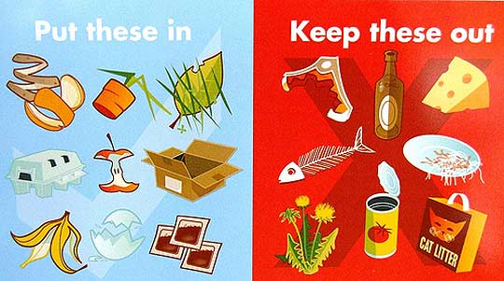
https://kirbykrew.files.wordpress.com/2014/05/putinleaveout.jpg


Photo B: Landfill
https://swilson37.files.wordpress.com/2010/08/landfill.jpg

Photo C: Compost Bin
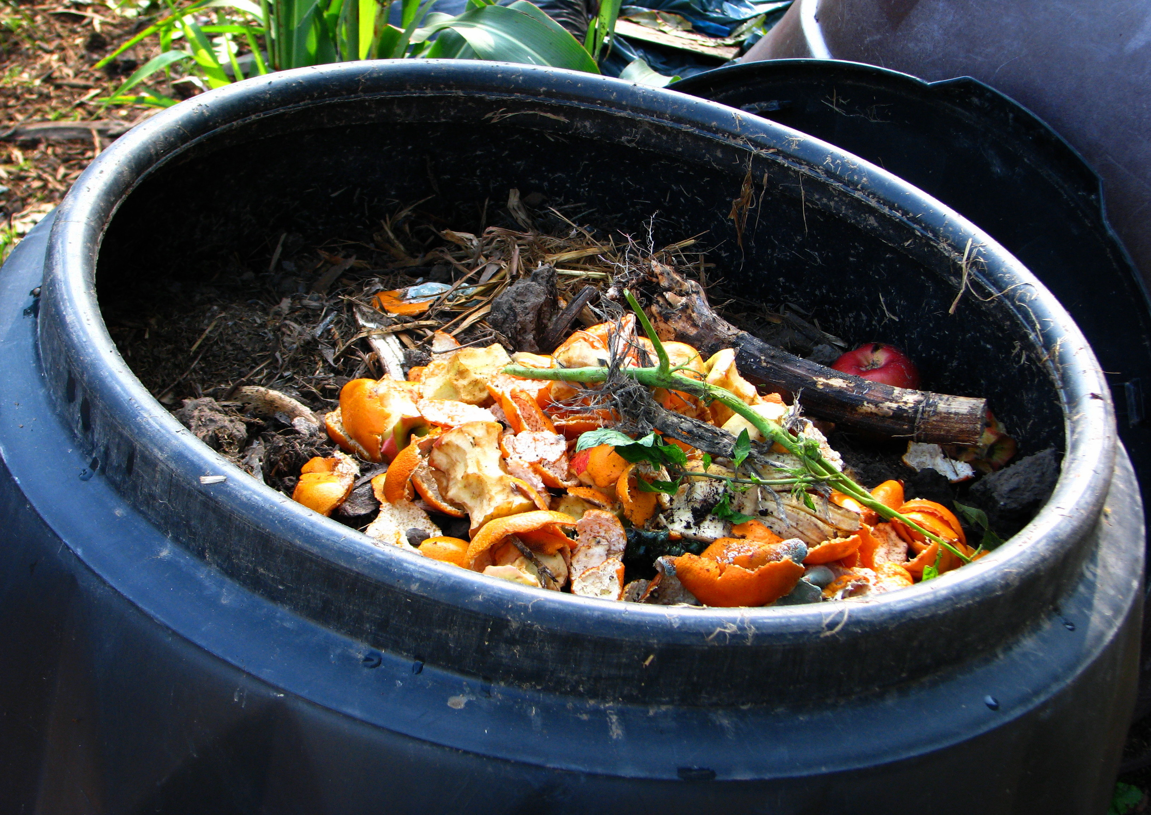

https://southgippsland.files.wordpress.com/2008/05/fosterprimary_159.jpg

Photo D: Compost, Recycle, and Trash
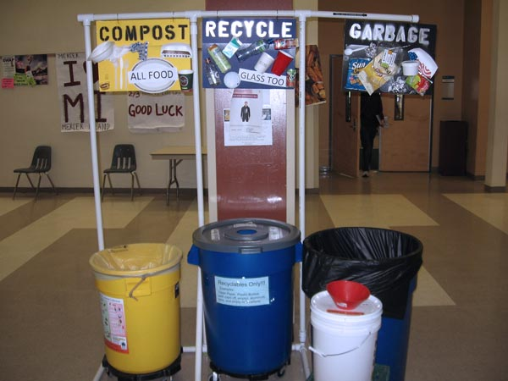
https://your.kingcounty.gov/solidwaste/greenschools/images/MIHS-recycling-station-large.jpg

