
Programme Name | Undergraduate Computing Suite
Module Title | Object-Oriented Programming
Module Code | MCOMD2BRP
Module Start Date | Sept 2018
Module Level | 5 | Assessment Type(s) | Programming Assignment: Assignment 2
Word Length / Duration (equivalent | 2,000 | % contribution to module mark | 50%
Hand out Date | 3 Dec 2018 | Submission Location | Blackboard Assignment Dropbox and Turnitin
Submission Date | 7 Jan 2019 | Feedback Date | With Results

Overview
In this task you are required to create an Object-Oriented Program using the C# language to meet the specification outlined below. Some design and reflection on your work will also be required.

Specification
Sarre Running Sports is located on the campus of the University of Sarre next to the running track and requires a Stock Management and Point of Sale System. The following UML Class Diagram represents part of the system design.

The shop stocks a number of items for sale – sports clothing, running shoes and other accessories (Bags, Nutrition and Watches). Each item for sale has a name, price, current stock level and a level at which items should be re-ordered. Each item comes from one supplier, but a supplier can provide many products. Customers make purchases of items and the sale date and sale price is recorded for each item.

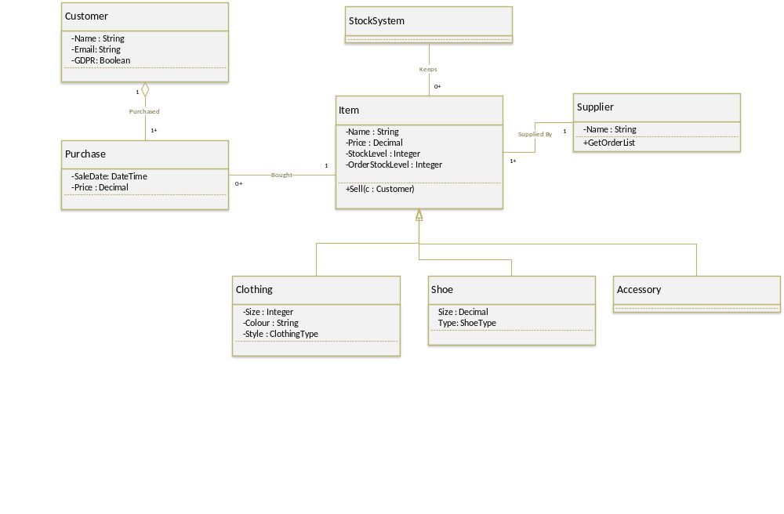
Clothing items have their size, colour and style recorded. Styles are shorts, capris, leggings, vests, tops and jackets.

Shoes items have size and shoe type. Shoe types are racer, stability, neutral, trail and track.

For accessories: Bags have a capacity, nutrition has a quantity and type (carbs, protein) and watches are simple, heart rate, GPS, or GPSandHeartRate.

The system is required to do the following tasks
- Add a new item to the inventory (list of items sold)
- Add a new supplier
- Get a list of items requiring restock by from a given supplier
- Sell an item to a new customer
- Sell and item to an existing customer
- Get a list of all purchases by a customer

A database system (e.g. Access or SQLite) must not be used, and there is no need for the data to be kept after the program is closed down.

Tasks

Task 1 – Investigation into the enum keyword (10%)
A typical question at interview would be to discuss the usage of a particular C# keyword. Write a short, referenced, description of how the enum keyword can be used to create a new data type. Make use of a simple example to show how these could be used within the problem scenario of this assessment.
Submission: A brief report submitted onto Turnitin

Task 2- Implementing the solution in C# (70%)
Your task is to create an Object-Oriented implementation of the required system in C#. The UML class diagram in the scenario is only partially complete and you will find it useful to complete it before you start to program. You should look particularly at where you allocate responsibilities in the classes to meet the requirements.

For this exercise, your system should be able to cope with a relatively large number of items, customers and purchases, but a smaller number of suppliers.

Submission: A zip of the whole project solution submitted on Blackboard.

Task 3 – Discussion on Interfaces (20%)
Discuss how you could have used interfaces in the C# language in your OO model. To answer this question describe briefly what an interface in OO using appropriate references, before demonstrating an example usage of this technique. Ensure that you talk about the benefits and drawbacks of using interfaces in this particular scenario.
Submission: A report outlines discussion to TurnitIn.

Task 4 – Bonus Task – Writing a Unit Test
Write a set of automatic tests that check the working of ONE of the classes. Ensure that there are sufficient tests to check that the functionality of the class works well.
These marks can increase your overall mark in the Task 2, but cannot increase it higher than maximum marks.
Submission: An NUnit test suite as part of the zip submission for Task 1.

Undergraduate Computing Suite
MCOMD2BRP Object-Oriented Programming
201819
Assignment 2

Feedback Sheet

Student Name:

Area | Max Max | Mark Awarded
Task 1: Investigation of enum | 10
Task 2: Implementation | 70
Task 3: Discussion of Interfaces | 20
Task 3: Bonus Task  - NUnit  - Selection of Tests | 5  5
Total | 100

Final Grade:

Comments

Appendix A – Mark Scheme

The below tables indicate what would typify a particular grading area. The marker will review the work with these in mind. However, a section that is strong in some area, even though it doesn’t cover all areas may well score in the next level up, while one which shows a weakness may score in a level below even if it may at first to achieve all the elements.

Task 1: enum investigation (10%)
Grade | Typified By
0-3 | No, or weak report on enum with only one usage shown that is not useful to this scenario. Lacks references.  If presented at an interview, would not promote the candidate successfully to the company.
4-6 | Basic report on enum – at least one usage of use in this scenario. Some references, but not strong or not written up well using Harvard References. If presented at an interview would be an adequate answer and would not put the organisation off employing the candidate.
7-10 | Good report, clearly written with good clear referencing– good example of how it can be used in this scenario. If presented at an interview would put the candidate in a good light for employment.

Task 2 Implementation (70%)

Requirements Met (15%)
Grade | Typified By
0-6 | Can perform one or two of the basic tasks
7-11 | Can perform a reasonable proportion of the tasks including at least one reporting task, or more of the tasks with errors
12-15 | Can perform all of the tasks, with no errors

Good OO Model and Implementation (35%)
Grade | Typified By
0-13 | No use of OO or very basic use of OO – with Objects used as data stores – with limited responsibilities, and only simple accessors and mutators to attributes. Implementation issues.
14-21 | Basic use of OO. Basic classes used, basic responsibilities given to classes, not just accessors and mutators. Implementation issues may be present. Classes may not be fully complete
22-28 | Good use of OO. Specified classes all implemented. At least one other class implemented to improve solution. Responsibilities appropriately allocated and distributed.
29-35 | Very good use of OO to solve the issue with appropriate responsibilities implemented. Few, if any problems with an implementation. Additional classes used well to make solution easier to develop. Inheritance, overriding, overloading all demonstrated in the solution in at least one place to good effect. Interfaces may be used appropriately for highest marks.

Simple and efficient algorithms/processing code (10%)
Grade | Typified By
0-3 | No code or no algorithmic code present.
4-6 | Basic algorithms to perform tasks, but overly complex, contain errors or inefficient
7-10 | Good use of algorithms to solve tasks. Minor or no errors in algorithms

Good Coding Standards (5%)
Grade | Typified By
0-1 | Poor coding standards and lack of consistency throughout.
2-3 | Basic coding standards apparent. May have some inconsistency
4-5 | Good coding standard readily apparent. No inconsistency.

Good User interface (5%)
Grade | Typified By
0-1 | Program does not compile or Poor user interface that is impossible to use without training
2-3 | Basic GUI or Console interface that works, but lacks finesse by for example lack of error handling, poor alignment of information/ components etc.
4-5 | Good UI that fits purpose and shows nice design elements

Task 2 Discussion on use of Interfaces (20%)

Discussion (15%)
Grade | Typified By
0-6 | No, or very weak discussion of OO Interfaces
7-11 | A basic discussion of what an interface is or how it could be used in the given scenario. No code snippets or benefits or drawbacks discussed.
12-15 | A good description of interfaces, with an example that would be very relevant to the scenario. Benefits and drawbacks of the interface discussed with appropriate code snippets examples (remember you don’t have to implement this stuff!)

References (5%)
Grade | Typified By
0-1 | No references
2-3 | Basic references to online sources, not the most appropriate. Not necessarily proper Harvard format.
4-5 | Mix of highly appropriate online and Library sources, presented well in Harvard format.

Task 3 – Bonus Task

NUnit Creation (5%)
Grade | Typified By
0-1 | Not attempted
2-3 | NUnit in project, but does not link appropriately into project
4-5 | NUnit present in project and tests run automatically

Selection of Tests (5%)
Grade | Typified By
0-1 | No, or non-useful tests
2-3 | A small number of tests that do simple checking of attributes/properties are set correctly (checks on the state of the object), or even smaller number of checks that methods operate appropriately
4-5 | Moderate number of test that test at least one method in detail as well as some checks on attributes/properties.

