

**Enterprise Web Software Development**

**(Individual Report)**

**Assessor name:** **Ho Nguyen Phu Bao**

**Group member name:**

* **Nguyen Minh Man (GCS18090)**
* **Dang Quoc Anh**
* **Chau Minh Duy (GCS185565)**

**Author:**

* **Nguyen Minh Man**

**Assignment due:** **November, 15th, 2021**

**Assignment submitted:** **November, 15th, 2021**

Contents

**1.** **Team member** 1

**2.** **Introduction** 2

3. Evalutaion 2

3.1 Product evaluation 2

3.1.1 Product highlight 2

3.1.2 What further can be done 2

3.2 Process evaluation 3

3.3 Team evaluation 3

**3.4** **My evaluation for each team member** 4

**3.5** **Self evaluation** 7

4 Conclusion 8

1. **Team member**

|  |  |  |
| --- | --- | --- |
| **Website system collecting ideas for improvemen**t | | |
| **Members** | Nguyen Minh Man | Frontend developer, Support Backend, Tester |
| Dang Quoc Anh | Frontend developer, Backend Developer, Database Designer. |
| Chau Minh Duy | BA, Support Frontend, support Backend, Scrum master. |
| **Tutor** | Ho Nguyen Phu Bao | |
| **Trello** | <https://trello.com/webenterpriseresit/home> | |
| **Group Repository** | <https://github.com/ollylll97lll/WebEnterprise1640> | |

1. **Introduction**

The coursework's purpose is to teach students how to operate as a team, and it is based on the agile scrum framework's working style. The project required us to create a website for a huge university that would be used to collect ideas from their staffs for the university improvement.

Our team must follow the scrum structure in order to meet the topic's needs. As a result, a Scrum Master, product owner, database engineer, web designer, programmer, and tester are all required. The product owner will serve as our educator, and the remaining duties will be distributed among team members. However, because our team consists of only three people, we will be filling various responsibilities at the same time.

Because of the weekly meeting minutes, user stories, and sprint backlogs, the scrum team collaborated successfully to produce an efficient and high-quality solution on schedule. The responsibilities and roles of each team member have been addressed in the team report, therefore in this individual report I will simply discuss some of the product's main pages, product review, and evaluating the members' performance.

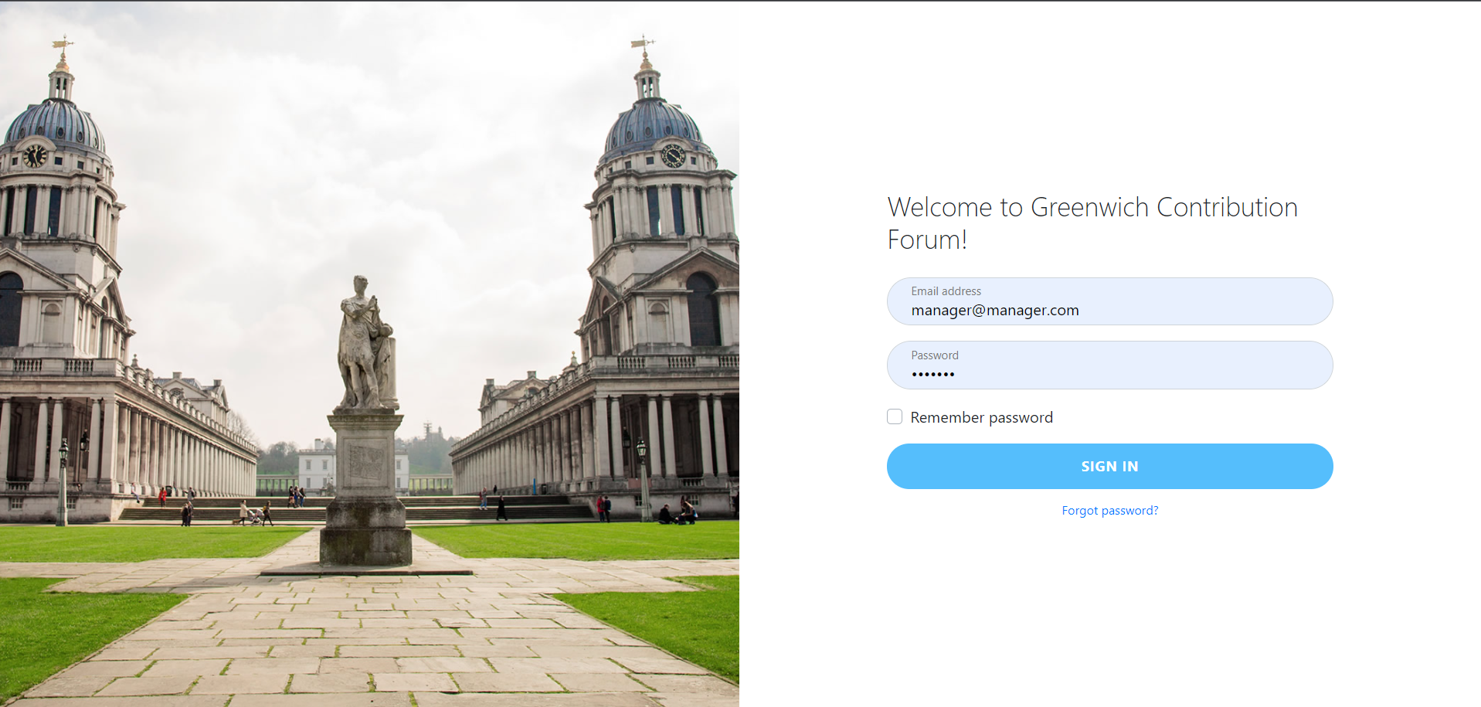

Figure 1: Login Page

1. **Evalutaion** 
   1. **Product evaluation**

The product is finished with the way the users want, the requirements they set are basically fulfilled in this project. My team members and I have met the essential need of users, which is to create a system to collect opinions from staffs.

We use ReactJS to create the user interface, MongoDb is the database we use to store information locally. Since we use Scrum in this project, the meetings take place with a dense layer, which limits the errors that arise while completing the system.

When a request is made from the Frontend, the frontend passes the request to the backend to process the request. Then the data will be transmitted to the Frontend to display to the user. Of course, the API cannot be missing in this process.

Git repository: <https://github.com/ollylll97lll/WebEnterprise1640/tree/dev>

* + 1. **Product highlight**
* Privacy

Since information technology is becoming more sophisticated, a rising number of individuals using it on a daily basis. Information security is critical, so when designing the system, we must ensure that each user's password is not detected. More specifically, we have encrypted each user's password, which will subsequently be saved in the database. This protects personal information while also ensuring openness in the post-approval process.

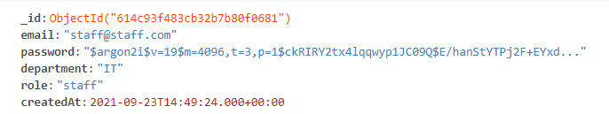

Figure 2: Passwords is encrypted for increased durability.

* Responsive

Responsive is an indispensable concept when building any system in the present time. Therefore, building a responsive website is a plus point in attracting users.

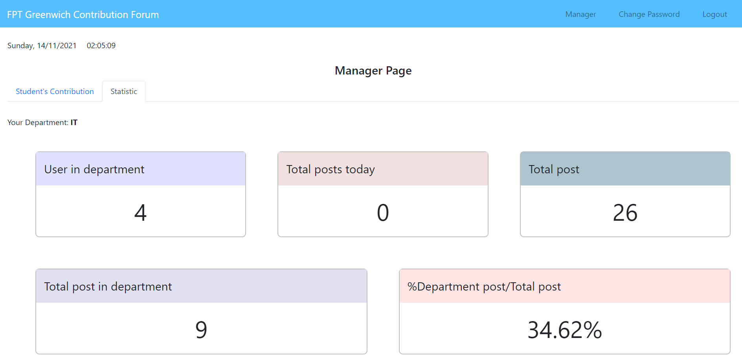

Figure 3: Manager Page Without Responsive

* 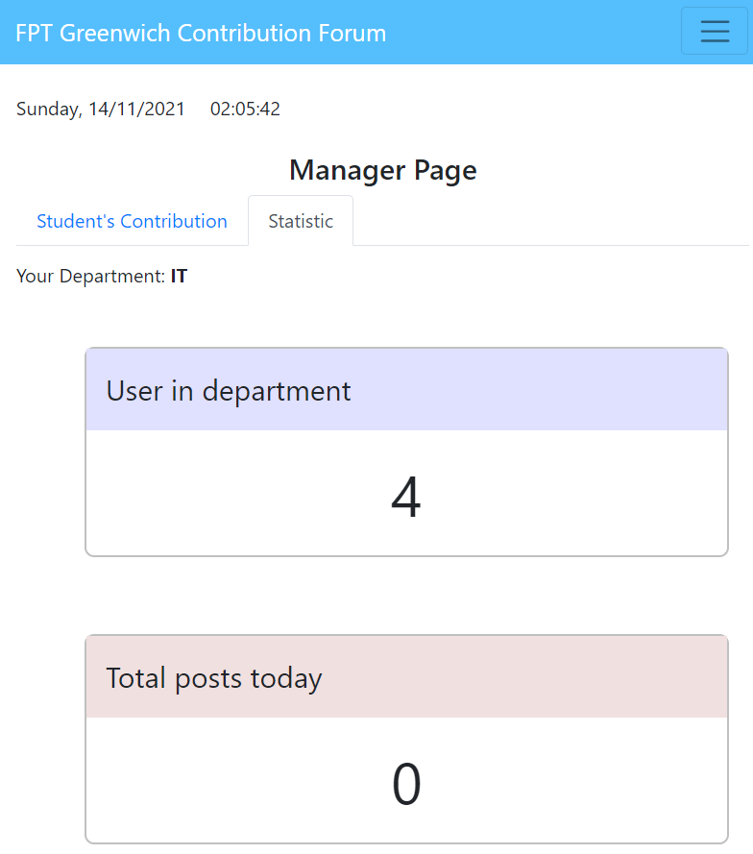

Figure 4: Manager Page With Responsive

* + 1. **What further can be done**

Create Application

In addition to creating an interface that is compatible with all devices, I believe that developing a dedicated app for it would attract more people. As more people use smartphones, there will be a greater demand to use downloaded programs rather than going to the internet.

Our team's time to perfect a website is limited, thus developing an application is now out of the question. However, if we have more time or the product is in use, we will continue to develop it by establishing an application for it.

- Publish system

Our items are still being sold locally due to a lack of time and the inability to purchase required services as a result of the difficult pandemic. We can only work from home, so purchasing an internet server or domain name is out of the question. Perhaps it is because the cost is prohibitively expensive and we will not be able to sustain it for an extended period of time, therefore we opted to operate it locally.

However, if I want this product to improve, I believe that in the future, I and my team members will contribute and develop it more. We will begin purchasing internet servers and domain names so that users may more easily utilize and understand the website.

* 1. **Process evaluation**

The system is perfected because we apply Scrum in the working process, this helps our team save time, reduce minor errors when working alone. Because when applying this method, meetings will take place continuously with a dense frequency.

Theoretically, the Scrum team should have at least 5 members to be able to divide the roles among themselves. However, my team only has 3 members so division will be very difficult because one person may have to take on 2 to 3 roles at the same time. Our team uses many platforms to communicate with each other such as Discord, Messenger, Zalo, MS Team. In which Discord is the place where we mainly communicate, all images and draft comments are sent to Discord. MSteam is the place where we use to synthesize the most accurate images for group reporting.

Each week the group has a meeting at the weekend to summarize the work that each member has done in the past week and the questions they have encountered. However, because our group is very small, the meetings take place with more frequency, most of them are 2-3 days a meeting. Due to frequent meetings, Scrum Master has an excel sheet to summarize the contents of those short meetings.

The URL to the file containing each person's to-do list for the week is provided below.

<https://docs.google.com/spreadsheets/d/1BCnfiYHxFY1qnWg5YKhqOJHHUNf37qkvkScRPvBWhMg/edit#gid=0>

Thanks to this recording, we have saved a lot of time, as well as more frequent meetings, helping members to make less mistakes during the product development process. Finally, our team has completed the basic requirements that users have given.

* 1. **Team evaluation**

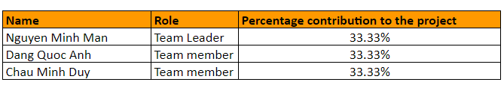

This is a common assessment sheet that all team members have met and evaluated together.

|  |  |  |  |
| --- | --- | --- | --- |
| **Name** | **Factor** | **Average rating** | **Comments** |
| Nguyen Minh Man | Attendance: **9**  Timekeeping: **10**  Initiative: **8**  Communication: **9**  Collaboration:**8**  Focus:**9**  Commitment:**9** | **8.6** | As a team leader and master of sprint 2.He demonstrated that he was a dedicated worker by continually urging everyone to work to the best of their abilities. Furthermore, at meetings, he is always the one who makes the final choice, demonstrating that he is a trustworthy person in both decisions and work. |
| Dang Quoc Anh | Attendance:**9**  Timekeeping:**10**  Initiative:**8**  Communication:**8**  Collaboration:**9**  Focus:**9**  Commitment:**9** | **8.6** | He is the one who divides and takes choices in sprint 3, which is mostly the team's task. To be able to assign duties effectively, he must be highly understanding of his team members, from credentials to spare time. Furthermore, if there are difficulties with the code, he is always the one to provide solutions and assist other members in meetings. |
| Chau Minh Duy | Attendance:**9**  Timekeeping:**10**  Initiative:**8**  Communication:**8**  Collaboration:**9**  Focus:**9**  Commitment:9 | **8.6** | As the person in charge of dividing the work in sprint 1, he was always required to provide the team with a variety of answers. Because sprint 1 included a significant amount of frontend and backend design for the product, it is clear that he is extremely educated about creating diagrams as well as comprehending the primary needs of the given issue. In meetings, he always delivers directives as well as acceptable group solutions. |

* 1. **My evaluation for each team member**

This is a scorecard that I built to assess my team members' attitudes and work while working on the project. In the review part below, I will also rank and score myself.

Team leader: Nguyen Minh Man

|  |  |  |  |  |  |  |
| --- | --- | --- | --- | --- | --- | --- |
| **Rate on a scale of 1 to 5 according to the contribution of each team member (Low = 1, high = 5)** | **1** | **2** | **3** | **4** | **5** | **Comments** |
| Show a commit for the project. |  |  |  |  | x |  |
| Communicate issues clearly, solving problems when necessary |  |  |  | x |  | Always make the final decision for developer team |
| Always complete the committed work on time, if the work cannot be completed due to technical reasons, the best alternative solution will be provided. |  |  |  | x |  | Timely submission is 85% |
| Communication between members. |  |  |  | x |  |  |
| Make effective use of project tools where applicable, i.e. status reports, project schedules, project archives. |  |  |  | x |  | Schedule developer team meetings. |
| Discuss and inform about possible or certain risks encountered in the process of working |  |  |  | x |  |  |
| Conduct an urgent meeting if there is a change in the project with team members, have control over the meeting |  |  |  |  | x | Control the developer meetings. |
| Give feedback and suggestions to complete the project |  |  |  | x |  |  |
| Have good knowledge of project related products and services. |  |  |  | x |  |  |
| Make final decisions in meetings |  |  |  |  | x | Make the final decision of developer meetings. |
| Get the job done professionally |  |  |  |  | x |  |

Team member: Dang Quoc Anh

|  |  |  |  |  |  |  |
| --- | --- | --- | --- | --- | --- | --- |
| **Rate on a scale of 1 to 5 according to the contribution of each team member (Low = 1, high = 5)** | **1** | **2** | **3** | **4** | **5** | **Comments** |
| Show a commit for the project. |  |  |  |  | x |  |
| Communicate issues clearly, solving problems when necessary |  |  |  | x |  |  |
| Always complete the committed work on time, if the work cannot be completed due to technical reasons, the best alternative solution will be provided. |  |  |  | x |  | Timely submission is 95% |
| Communication between members. |  |  |  | x |  |  |
| Make effective use of project tools where applicable, i.e. status reports, project schedules, project archives. |  |  |  | x |  |  |
| Discuss and inform about possible or certain risks encountered in the process of working |  |  |  | x |  |  |
| Conduct an urgent meeting if there is a change in the project with team members, have control over the meeting |  |  |  | x |  |  |
| Give feedback and suggestions to complete the project |  |  |  | x |  |  |
| Have good knowledge of project related products and services. |  |  |  |  | x | Have a good knowlegde as backend. |
| Make final decisions in meetings |  |  |  | x |  |  |
| Get the job done professionally |  |  |  |  | x | Coding very clean. |

Team member: Chau Minh Duy

|  |  |  |  |  |  |  |
| --- | --- | --- | --- | --- | --- | --- |
| **Rate on a scale of 1 to 5 according to the contribution of each team member (Low = 1, high = 5)** | **1** | **2** | **3** | **4** | **5** | **Comments** |
| Show a commit for the project. |  |  |  | x |  |  |
| Communicate issues clearly, solving problems when necessary |  |  |  | x |  |  |
| Always complete the committed work on time, if the work cannot be completed due to technical reasons, the best alternative solution will be provided. |  |  |  |  | x | Timely submission is 85% |
| Communication between members. |  |  |  | x |  | Commnucation very well between members. |
| Make effective use of project tools where applicable, i.e. status reports, project schedules, project archives. |  |  |  | x |  | Host 80% meettings. |
| Discuss and inform about possible or certain risks encountered in the process of working |  |  |  |  | x | Always discuss about risk when doing the system. |
| Conduct an urgent meeting if there is a change in the project with team members, have control over the meeting |  |  |  | x |  |  |
| Give feedback and suggestions to complete the project |  |  |  | x |  |  |
| Have good knowledge of project related products and services. |  |  |  | x |  |  |
| Make final decisions in meetings |  |  |  | x |  | Make fincal decision of 80% mettings. |
| Get the job done professionally |  |  |  |  | x |  |

* 1. **Self evaluation**

Since my team doesn ot have enough people to divide all the work, the members will have to work harder and be more active than other groups. As a team leader of developer team, I have to lead the team and make important decisions. However, my team does not let my role as leader be a pressure, they divide the work among themselves, help and respect each other so I will only make the final decision of developer team. My roles are Fronend Developer, support Backend and tester.

I am the person who receives the tasks directly from the BA of the team then I will further divide the work for each member of the developer team. Since our team has completed an internship at FPT, working in frontend is very easy for all members. Therefore, the process of making frontend is shortened. In addition, I also have the role of support for the backend, because I have had contact with the backend before, so I am confident that I can support the backend in the best way.

Finally there is Tester, this role is very important in all projects, since I am the team leader, I will take over this role. After completing any small part of the project, I will run it to see if there are errors and then take notes to give to the developer. After the product was completed, I tested it many times, and even made a Test Case table for members to follow.

In each meeting I am always the one who has to make decisions for the developer team , but the team members did not make it difficult for me because they always offer many different options. So I just have to choose between the options.

Overall, my contribution is just enough for the team to complete this project. Through this project I have gained more experience in leading a project team, in the future if there are more projects I think I am confident enough to take on the role of team leader again

1. **Conclusion**

This report is given to evaluate the team's overall product, as well as other members and the work that the members have done in the process of perfecting the product.During the implementation phase, we followed the Scrum working guideline of holding weekly meetings and recording the sessions in an excel file, which allowed us to perfect the product in a short period of time, The school has set a time limit.

Because of applying the scrum framework in this project, everything went very smoothly and easily. In this personal report of mine, I mentioned some main pages of the project, in addition to some highlights of the project, where the project can develop in the near future.

Next in the report is the process of making this product, followed by the evaluation of each member. The first part consisted of a review board where the entire team convened and tested each member at the same time. The rest is where I rate myself and other team members.

The last part is my personal review, I have outlined some limitations while working on the project as well as some highlights. In addition, I also list the jobs that I have undertaken while working on this project.

The challenge for me and our team on this project was to adopt Scrum, which was a huge hindrance for me and the other team members at first. But then everyone worked hard and perfected the product very well.

This is the first major product I've worked on as a team, so some minor bugs cannot be avoided. But in general all the basic requirements have been fulfilled.