***Requirement Definition Document***

***Assignment 1– SDP LAB (CS3036)***

***Territory wise Social Media Observer***

*Third Year – Semester II, Module VI*

*Division D - Bachelor of Technology – Computer Engineering*

**Bract’s Vishwakarma Institute Technology**

***PUNE – 411037***



*Prepared by:*

|  |  |  |
| --- | --- | --- |
| ***Name*** | ***Roll No*** | ***GR Number*** |
| Sumit Shengokar | D-54 | 1710705 |
| Digvijay Sonvane | D-64 | 1710220 |
| Swaraj Sonvane | D-65 | 1710764 |
| Shruti Vasave | D-76 | 1710060 |

*Approved by:*

|  |  |  |
| --- | --- | --- |
| ***Name*** | ***Signature*** | ***Date*** |
| Prof. Mahesh Dube |  | 2020 |

***Table of Contents***

[***1.***    ***Context***](https://docs.google.com/document/d/1ubz1U6dDGnvIs_GdcyO1D1RmiPw876hngnjlGNJNnZc/edit#heading=h.35nkun2)

[***2.***    ***Problems***](https://docs.google.com/document/d/1ubz1U6dDGnvIs_GdcyO1D1RmiPw876hngnjlGNJNnZc/edit#heading=h.1ksv4uv)

[***3.***    ***Solutions***](https://docs.google.com/document/d/1ubz1U6dDGnvIs_GdcyO1D1RmiPw876hngnjlGNJNnZc/edit#heading=h.44sinio)

[***4.***    ***Benefits***](https://docs.google.com/document/d/1ubz1U6dDGnvIs_GdcyO1D1RmiPw876hngnjlGNJNnZc/edit#heading=h.2jxsxqh)

[***5.***    ***Concept Diagram***](https://docs.google.com/document/d/1ubz1U6dDGnvIs_GdcyO1D1RmiPw876hngnjlGNJNnZc/edit#heading=h.z337ya)

1. **Context**

Social media websites have emerged as one of the platforms to raise users' opinions. Opinion of people matters a lot to analyse how the propagation of information impacts the lives of people and in which format information is shared matters a lot.

    Territory wise social media observer is a system which helps in analysing the statistics of different file formats or file types which are shared by users on social media sites. File formats like images, articles, videos, GIFs etc are shared on social media platforms like Facebook, twitter, Tumblr, etc. A topic becomes trending on social media if more and more users are contributing and giving judgements on a topic. Analysing data is important as to determine recent trends, campaigns running on social media with the help of which we can spread awareness and to provide feedback using it and also to modify those sites accordingly.

    Territory wise social media observer application is important to understand the type of files and data shared on social media and to understand the intent behind it. The intention is to gain wider perception of how data is shared on social media and in which formats? And how it differs in different territories in India. And on specific occasion and festivals how the trend differs and also the type of files shared on social media.

1. **Problems**

    The challenging part about social media is the difficulty in collecting and tracking the qualitative data such as text, images and videos as it continues to generate valuable information as the organization grows. The system shall be able to track and collect the data by using tools available to generate user understandable analysis report.

    The system shall be able to determine the effectiveness of social media activities in a particular location to understand the effect on different areas like politics, NGO’s, entertainment and also on the people belonging to that location. System should be measuring the impact of social media.

    The system shall analyse what characterizes the digital social media during festival time in quantitative matters like which file format is being shared most on social media. Also, what difference does social media contribution make in festival seasons and what things does social media do for social participants?

    Data analysis visualization must be the key aspect of the system. Visual representation of data whereby information that has been abstracted in some schematic form with the goal of communicating information clearly and effectively through graphical means. Showing the magnitude of data (particularly in different file formats) involved must be able to leverage social media marketers to drive business objectives.

1. **Solution**

The system will provide an interface to register the user in which the user will provide login credentials such as name, mobile number and email address. System will then validate user login by determining whether the input given by the user is valid or not. System will then authenticate the user.

System will take the territory as input and then system will provide all the trending and recent topics of that particular region. System will be using APIs provided by twitter which helps in getting the top trending tweets and searches of the region.

System will then visualize all the data or tweets and will show statistics about the data formats that are articles or text, images and videos and will provide a detailed report about it. System will visualize the data in the form of bar-graphs, pie-charts and others. System will make use of the python numpy and Pandas library to show it.

System will provide search functionality. Users will be able to search for hashtags or keywords which are used in social media. System will search about the given hashtag and will provide users with top searches. System will be using the Twitter Search API which gives top search results on twitter.

System will also take user id as input and will provide all the tweets and information of the user

Like location, Number of tweets, likes, retweets and friends of users. System will be using tweepy

API to access the data of user from social media

1. **Benefits**

Once this system is sophistically developed and is deployed it will give us following

benefits:

1. Identify a crisis on time and treat it properly before it becomes giant.
2. Markets can be monitored with the help of sentiment analysis
3. Can easily help marketers connect with their most important customers and understand what’s being said at specific events
4. Governments and corporations can develop strategies to influence the votes/market

1. **Concept Diagram**

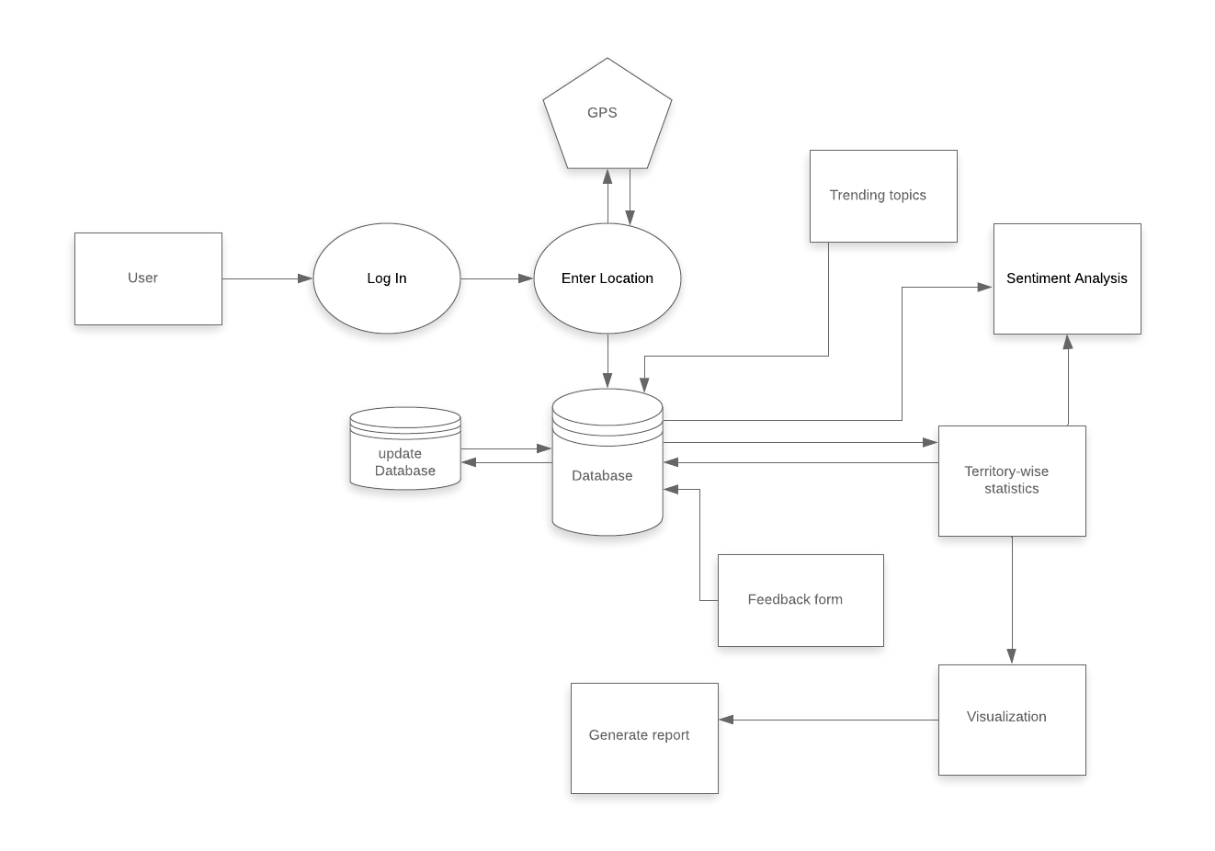

***System Requirement Specification***

***Assignment 2***

Department of Computer Engineering

**BRACT’S Vishwakarma Institute Technology**

***PUNE – 411 037***



*Prepared by:*

|  |  |  |
| --- | --- | --- |
| ***Name*** | ***Roll No*** | ***GR Number*** |
| Sumit Shengokar | D-54 | 1710705 |
| Digvijay Sonvane | D-64 | 1710220 |
| Swaraj Sonvane | D-65 | 1710764 |
| Shruti Vasave | D-76 | 1710060 |

*Approved by:*

|  |  |  |
| --- | --- | --- |
| ***Name*** | ***Signature*** | ***Date*** |
| Prof. Mahesh Dube |  | 2020 |

***Table of Contents***

|  |
| --- |
| **TITL** |
| 1. **Introduction** |
| 1. Purpose |
| • Scope |
| • Abbreviations, Definitions & Acronyms |
| • References |
| • Overview |
| • **Overall Description** |
| * 1. Problem Statement |
| • Product Perspective |
| • Product Position Statement |
| • Software Interfaces |
| • Hardware Interfaces |
| • User Interfaces |
| • Product Functions |
| • Constraints |
| • Assumptions & Dependencies |
| 1. **Specific Requirements** |
| 1. Product Hierarchy |
| • Logical Databases |
| • Non-functional Requirements |

***1.Introduction***

A System Requirement Specification document as a link between the technical aspects and the consumer of the system. It therefore is a collection of requirements that includes the specification and the representation as well. It will cover the overall description, specific requirements and other miscellaneous information about the same.

This software requirement specification document of “Territory wise social media observer” does the same by describing the functioning of the system. Territory wise social media Observer analyses the tweets based on location or territory as the importance of this system revolves around its ability to take into consideration the location and generate analysis and solutions accordingly. This ability helps in recognizing different trends and to reach the local users of specific locations. This also helps in analysing data patterns and formats that are being shared on social media, it also visualizes the data to help us understand the analysis. Territory wise social media observer helps in analysing the statistics of different file formats or file types which are shared by users on social media sites.

*1.1. Purpose*

This document gives insight into analysis of social media data and requirements for determining the operating characteristics of Territory wise Social Media Observer. It gives an overview of how the Territory wise social media observer is designed and developed to operate.

The purpose of this document is to provide details about the system product to the developer and to the customer. This document gives a detailed description about the system, its features, functionalities, and specifications of the system. It describes different problem statements involved in the system, the product perspective for the intention of the target audience system for whom the system is being developed. Different hardware and software specifications that will be required for the system to be built.

For the developers this document will provide the specific requirements. This will help the developer in the development of the system. Product hierarchy will guide the developer to know the exact goals of the system followed by their objectives of each goal. Process given below the objectives will guide the developer to know how to achieve the goals while the development of the system. For the customer the document provides product functions. It gives the details of the functionalities of the product. This document would give the overall description of each and every function which the customer intends to use.

    The purpose of the SRS document is to provide a detailed overview of our system’s goals and objectives. It also states the processes required to complete the objectives. This document lists out different types of user interfaces, different constraints and different assumptions and their dependencies that are important for the implementation of the system. It states the logical databases which will be used by the system. This document will make the developer to further design the use cases and the sequence diagrams. This document will be used by both the developer and the software during the software development life cycle period.

*1.2. Scope*

           User has to first login into the system to use it in which the user has to register his name, email with password. The system will provide an interface to the user in which he has to enter location or territory name. The system then will provide detailed information and statistics about the data file formats which have been shared in that particular locality. The system will also show the visualization of data or statistics of particular territory which the user entered.

        After the user login, users can access the recent data or tweets which the worldwide users are talking about. Users can also access the tweets about the trending topics worldwide or in particular regions. The system will fetch the top trending tweets or data from twitter through API and provide it to users.

        The system will provide the data or tweets about the hashtags or keywords which users want to access. System with the help of API’s will get the data or tweets from twitter and will provide it on the user interface.

        The system will also be able to access users' tweets using his screen name. User has to enter his screen name or user id after which system will be able to access his tweets as well as friends.

        System will also be able to determine the number of retweets of a user as well as total likes to his or her posts.

        System will also be able to provide tweets or data from specific locations using the standard geo-location API in which the system filters the location based on users demand and will provide the tweets of particular locality. Standard API provides access to 1% of all tweets as only a very small percentage of tweets have geographical data associated with them.

        System will do visualization of tweets by storing the data or tweets in a csv or json file using numpy and pandas libraries. In file each column of tweet , likes , retweets will be stored and will be accessed based on user need.

*1.3.* *Definitions Acronyms and Abbreviations*

           While describing the software requirement specification for this system the document uses the following acronyms and their meaning or descriptions are given in the table below.

|  |  |
| --- | --- |
| ***Term or acronym*** | ***Description*** |
| **SRS** | A software requirements specification (SRS) is a document that captures a complete description about how the system is expected to perform. |
| **API** | Application programming interface (API) is a communication protocol to simplify implementation and maintenance of software. |
| **JSON** | JavaScript Object Notation is an open-standard file format or data interchange format that uses human-readable text to transmit data objects consisting of attribute–value pairs |
| **Numpy** | Numpy is a general-purpose array processing library which uses a large amount of mathematical functions to operate. |
| **Pandas** | pandas is a software library written for the Python programming language for data manipulation and analysis. |

*1.4.* *References*

                    While analysing the requirements of our system, these following were referred:

[1]    Track tweets from geographic location. Available from: <https://www.bmc.com/blogs/track-tweets-location/>

[2]    Mining twitter data for sentiment analysis of events. Available from <https://towardsdatascience.com>

[3]    Twitter’s API.   Available from <https://computer.howstuffworks.com>

*1.5.* *Overview*

    This document is a condensed summary of a Social media monitor that will provide territory-wise analytics. It deals with the analysis of user opinions and the trends associated with them on social media platforms.  It also deals with the problem of tracking, processing qualitative data, its classification and analysis. This document shows how the Territory-wise Social Media Observer tackles these problems and provides robust solutions.

Along with technical aspects like hardware and software requirements, the     documents enlists the functionalities of the system. It is a succinct representation of interfaces, both hardware and software. It provides insight into the goals, objectives along with the constraints, assumptions and dependencies. It also talks about logical databases and other various non-functional requirements of the system.

***Problem Statement***

|  |  |
| --- | --- |
| **The problem** | Social networking is significantly impacting an individual's life ensuring efficient communication. Social media analysis is a cumulative process of following steps involved -   * Data discovery * Data collection * Pre-processing * Preparation * Analysis * Visualization |
| **Affects** | * Citizens * Organizations * Government Policies * Marketing |
| **The Impact** | * Spot seasonal changes and distinguish them from real problem * Organising Marketing strategy efficiently * Impact on factors like society, environment, human rights * Increase in research on social diverse and audiences |
| **Successful Solution** | An efficient system that will provide the user -   * About the social trends details before becoming influencer * The results of social media activities which can also have a positive impact on enhancing your social media. * To provide information of regional analysis to implant public awareness * To provide abstractive and schematic form with the goal of communicating information clearly and effectively through graphical means. |

**2.4.1 SOFTWARE INTERFACES**

|  |  |
| --- | --- |
| ***Name*** | ***Details*** |
| **Operating System** | * Name:    Windows, Linux, DOS * Purpose: Manages device hardware and software resources by providing a firmware between the two. |
| **Front End** | * Name: HTML, CSS, BOOTSTRAP * Version number: HTML5, CSS3, BOOTSTRAP 4 * Source: Open Source * Purpose: To provide user interface with the application. |
| **Back End Connector** | * Name: Twitter API * Source: Authorized developer for twitter * Purpose: To allow accessing of data from twitter API for authorized users. |
| **Back End** | * Name: Django framework * Database: Db sqlite * Source: Open source * Purpose: To create and store databases and connect the backend with the front end . |
| **Runtime Environment** | * Name: Web Browsers (as a Host ) * Source: Web URL * Purpose: Provides an environment to modify and analyse on local servers. |

2.5  User Interfaces

|  |  |
| --- | --- |
| ***Type*** | ***Purpose*** |
| User Registration | This form will take the inputs from the user to create a new user for the system . It will also update the database with the new user details. |
| Search Bar | This will have a text as input. This page will provide results of analysis in the form of user understandable graphs. |
| Change Location | This button  will provide the option to change your current location of an area chosen for analysis to user desired . |
| Log In and Log Out | This form will provide users to log into or log out their account. |
| Analysis report | This page of the system will provide the report of analysis of a territory and also the comparison among different territories . |
| Home | This page of the system will provide all the details of the site working. Site details like programmer, contact details ,site navigation and terms and conditions . |
| User Feedback Form | At last when the journey ends this form will allow the user to provide the feedback regarding the System Assistance. |

2.6. Product Functions

**1.**     **Goal 1 – Register new User**

The system shall create profile of new users. The system shall ask users to provide their details. Users shall give their name, username, email and password. Password entered by user should not be same as username and password should be strong, it should contain both small, big letters and digits. System shall then add the new entry into the database.

**Objective 1 – collect details**

The system shall ask user for their name, email and password to register. System shall also ask user to create a unique username to access functionalities. The system shall be able to track user activities for safe use.

**Process 1 - Take user inputs**

The system shall provide user interface to enter his name, email, username and password. The system shall not be able to provide user personal information to other users, hence storage is done in encryption manner for user safety.

**Process 2 – Validate user**

The system shall then send the validation one-time password or link to confirm his identity as security is important. After confirming his identity user shall be then able to access application.

**Objective 2 –** Authenticate user login

The system accepts user information before accessing system functionalities. The system requests user login credentials for login. After entering user details system shall validate the login input.

**Process 1:** Request User Details.

The system shall provide interface to enter user details like username and password. The system shall wait for the user to enter the details. The system shall provide the student with the button to submit the details.

**Process 2:** Validate Student Details.

The system shall send details to the system database for validation. The system shall check the username. The system shall then cross-check with system encrypted password with the user entered password. The system displays success message after successful validation.

**2.**     **Goal 2 – Keyword or Hashtag search**

The System will take keyword or hashtag as input. System shall also provide an input bar to enter the count of tweets users want to fetch. After that System will provide top searches on interface.

**Objective 1 – accept valid details**

The system in order to make sentiment analysis of the social media data, should collect data. For this the user will enter the keyword in the search bar, the system will start giving all the social media top tweets. Input should be valid and meaningful otherwise it may not show output.

**Process 1:** Accept hashtag or keyword name

In this process the system will provide the user interface to enter the keyword name or hashtag to access its data or tweets. System will provide top and recent tweets from the input area provided by the user.

**Process 2:** Call API

After entering the input, the system with the help of API will collect data from social media. ***Search*** ***API*** will help in fetching the keyword wise data which will comprise of tweets, images and videos.

**Objective 2** – Get Json file

System will be able to access in-depth tweet information with the help of a JSON file provided on the user interface.

**Process 1:** Take hashtag or keyword as input

System shall also be able to give detailed information about recently fetched tweets of keywords or hashtag given by users. After fetching the data from social media, the system shall also be able to tell the number of likes, retweets, followers, text-background, text-colour, font etc. and many more about the all fetched tweets.

**Process 2:** Provide table report

System shall be able to show all the useful information of tweets in table format and will tell about likes, shares or retweets of the tweet.

**3.**     **Goal 3 – *Retrieve Trending Information***

The system must retrieve the reason for the heavy use of social media in a territory. The system will then analyse the details of the usage and will return a search result to understand more about the incident happening in the particular area.

**Objective 1** – Trends of particular region

After entering the territory, the system will provide the top trending and hot topics in the particular region. System will also keep track of occasion and festival on the particular day.

**Process 1:** Select territory

To get the top trends in Particular territory, System will accept the territory as input, System will display all the trending topics of territory.

**Process 2:** Analyse Trending Details

After accepting territory, System will give statistics about top trending topics of regions and will visualize all the topics in the form of pie-chart and bar-graphs.

**Objective 2 –** Occasion or Festival detail

The System shall provide an interface to provide the details about a special occasion or festival which is trending on social media.

**Process 1:** Trending topics information

System will provide top trending topics of particular region to the user. System will also display the information about trending topics to the user and will provide details of it.

**Process 2:** Accept Social media ID

System will accept the social media ID of user and will display the tweets or images or videos tweeted by user, System will also provide detailed report about it.

**4.**     **Goal 4 – *Output and Analysis report***

The system must give visual analysis report to user obtained by performing analysis of each tweets stored in system database. System must provide user with options for choosing which type of analysis report they wish to see.

**Objective 1** – Visualization of  Analysis report

After analyzing  social media system will show analysis report to user in the form of graphical diagrams for comparisons use of bar graphs and histogram,for showing sentiments pie charts etc.

**Process 1:** Use data related to social media stored in system database

To perform analysis system will use social media database in our system. Preprocessing of the data will happen to get the most important metadata needed for analysis.

**Process 2:** Make visual report

After separating metadata, System will use this data to plot graphs which are self explanatory as well as serves different purposes like comparisons and sentiments.

**Objective 2 –** Increasing Awareness of using Social media

The System shall help user to understand different trends in social media also help user to generate revenues through ads and sales.Encouraging user for community envolvement  for making meaningful connection and help society.

**Process 1:** Trending topics on social media

System will provide top trending topics of particular region to the user. System will also provide user analysis report comparisons in different regions to understand trends on social media.

**Process 2:** Visualization of growth in social media

Analysis report will show different aspects of social media over regions in the graphical format. Report will contain different statistical measures to get proper overview of social media.

**5.**     **Goal 5 – *Sentiment Analysis on tweets***

The system shall provide an interface to perform sentiment analysis twitter data and sorting it into sentiments positive, negative or neutral.

**Objective 1*-*** ***Data gathering and preparing***

System shall gather current data or historical data based on user demand. Current tweets are useful to track keywords or hashtags in real-time.

Process 1: Gather data using twitter API

System shall use Twitter streaming API to connect to twitter data stream  and gather tweets in real-time . Twitter filter will allow user to track tweets with specific keyword, mention or hash-tag.

Process 2:  Data preparing

System shall be able to pre-process the data as data gather from twitter is unstructured. System shall remove noisy data like removing all types of emojis, special characters and extra blank spaces. System shall also be able to remove duplicate tweets or too shorter tweets.

**Objective 2** – ***Creating Sentiment Analysis Model***

System shall already train the sentiment analysis model and then user can try sentiment analysis on pre-trained model.

Process 1: Importing twitter data

System shall ask user to import the tweets in real time or to upload csv file of data from user to perform sentiment analysis on twitter data.

Process 2: Tag data to train classifier

System shall ask user to tag tweet as positive, negative or neutral. After tagging the first tweets, the model will start making its own predictions and user can correct them if answer is not correct.

**6.**       **Goal 6 – *Get feedback***

System shall be able to ask user about his experience about application and suggestions to improve it.

**Objective 1** : ***Customer Survey form***

System shall ask user to fill the customer survey form provided by system to help the developer about problems and experience face by user.

Process 1: Fill details

System shall ask user about recommendation of application to different user, rating of application from five stars.

Process 2: Give suggestions and grievances

System shall ask user to write in the text box about suggestions for developers for application and also about their grievances to solve it in future.

**Objective 2**: ***Chat with developer***

System shall give an option to user to directly chat with the developer of system and put-forward his grievances.

Process 1: Using API

System shall make use of API to perform communication between

User and developer.

Process 2: Que and Ans session

System shall provide user with series of question to put-forward his grievances and suggestions and shall also ask about communication with developer.

Constraints

1. Data collection through the API of twitter at real time.
2. Tweepy API for twitter provides their users with only upto 100 tweets and  such a small data fetching everytime to make enough data to train on a machine learning model is a time consuming task.
3. Training and Visualization on real time data would take time to get the result.

**1.3        ASSUMPTIONS & DEPENDENCIES**

1. The computer system on which software is installed is assumed to have an uninterrupted power supply. In case the crashes due to power failure, the system will not be accessible until the power is restored.
2. Users have accounts on the social media platforms that the System caters to.
3. Users have a sufficient amount of data to generate analytics.
4. The internet service is available in order to make use of the system
5. The system will not be available when the system is being upgraded for installing the new OS, a new version of the System itself.
6. ***Overall Description***
   1. ***Problem Statement***

|  |  |
| --- | --- |
| **The problem** | Social networking is significantly impacting to individual’s life ensuring efficient communication. Social media analysis is a cumulative process of following steps involved -   * Data discovery * Data collection * Pre-processing * Preparation * Analysis * Visualization |
| **Affects** | * Citizens * Organizations * Government Policies * Marketing |
| **The Impact** | * Spot seasonal changes and distinguish them from real problem * Organising Marketing strategy efficiently * Impact on factors like society, environment, human rights * Increase in research on social diverse and audiences |
| **Successful Solution** | An efficient system that will provide the user -   * About the social trends details before becoming influencer * The results of social media activities which can also have a positive impact on enhancing your social media. * To provide information of regional analysis to implant public awareness * To provide abstractive and schematic form with the goal of communicating information clearly and effectively through graphical means. |

* 1. ***Product Perspective***

Territory wise Social Media Observer is designed to observe the trends and emerging opinions on social media platforms. The product intends to build a system that will improve the statistical analysis of various file formats/types. It will collect data shared globally and attempt to put it into a local perspective. Territory wise Social Media Observer attempts at providing the users an edge in the identifying opinions. From a marketing and branding outlook, marketers will be able to understand the views of their customers and will be able to strategize accordingly. The visualizations will provide an at-a-glance overview and identify major views. Alternatively, in-depth and detailed analytics will help identify the subtle-er ones. Additionally, the tool of sentiment analysis coupled with the product will provide an added insight.

* 1. ***Product Position Statement***

|  |  |
| --- | --- |
| For | * Marketers * Branding Executives * Governments * Public Relations departments of corporations |
| The (Product) | * Territory-wise Social Media Observer |
| That | * Allows the user to register using his/her social media credentials and location information * Allows access to the tweets about trending topics worldwide or in particular region * Provides detailed information and statistics about the data file formats which have been shared in that particular locality * Shows the visualization of data or statistics of particular territory which the user has entered |
| Our Product | * Will identify a crisis on time and treat it properly before it becomes giant Will allow tracking of vehicle * Will monitor markets with sentiment analysis * Will enable marketers connect with their most important customers and understand what’s being said at specific events * Will enable corporations to develop strategies to influence the market |

1. **DEVELOPER SPECIFIC REQUIREMENTS**
   1. PRODUCT HIERARCHY

* 1. Software System Attributes
     1. *Reliability*
  2. The system validates the user id and password before accessing the features of the system .
  3. The system server side will validate OTP for authentication.
  4. The System will be robust.
  5. Real time results will be provided according to user query search on location.
  6. Details getting updated using GeoCode API in real time, the reliability is very high.
     1. *Security*

        Software security assurance is a process that helps design and implement [software](https://en.wikipedia.org/wiki/Software) that protects the [data](https://en.wikipedia.org/wiki/Data_(computing)) and [resources](https://en.wikipedia.org/wiki/Resource_(computer_science)) contained in and controlled by that software. Software is itself a resource and thus must be afforded appropriate [security](https://en.wikipedia.org/wiki/Security#Types)

1. System would require the user to login with an email address or user name.
2. Users will not get logged in if they try to use unauthorised email address or user name.
3. Django provides a local security check before filling information in form.
4. Database operations can only be done by Admin so users are not allowed to access databases directly.

* + 1. *Correctness*

        A SRS is correct if and only if every requirement represents something required of the system by the end user or stake-holder, i.e., every requirement in the SRS contributes to the satisfaction of some need, and all needs are considered in the specification.

1. All the requirements of this system have only originated from nothing other than end-user’s/stake-holder’s/customer’s needs and all the needs are taken care of through the functionality of this system.
2. Hence we conclude that this System Requirement Specification is correct.
   * 1. *Consistency*

        A SRS is consistent if and only if no subset of individual requirements stated therein is in conflict with the requirements of the other subset.

1. None of the requirements of this system is in conflict with the other requirements.
2. The main requirements of this system are: a) User Management, b) Runtime training and testing & c)Fetching tweets from specific location.
3. As per the analysis of these functionalities done in section 2.8 above, we clearly see that they do not contradict each other and hence it can be said that this system is consistent.

* + 1. *Availability*

Availability is the ratio of time a system or component is functional to the total time it is required or expected to function.

1. There is API available to fetch tweets and analyse them at same time.
2. If the connection is lost due to some reason, then there is function which will store the tweets into json format till next session resumes.

***Use Cases***

***Assignment 4***

***Territory wise Social Media Observer***

*Third Year – Semester II, Module VI*

*Division D - Bachelor of Technology – Computer Engineering*

**Bract’s Vishwakarma Institute Technology**

***PUNE – 411037***



*Prepared by:*

|  |  |  |
| --- | --- | --- |
| ***Name*** | ***Roll No*** | ***GR Number*** |
| Sumit Shengokar | D-54 | 1710705 |
| Digvijay Sonvane | D-64 | 1710220 |
| Swaraj Sonvane | D-65 | 1710764 |
| Shruti Vasave | D-76 | 1710060 |

*Approved by:*

|  |  |  |
| --- | --- | --- |
| ***Name*** | ***Signature*** | ***Date*** |
| Prof. Mahesh Dube |  | 2020 |

***Use Cases***

***Assignment 4***

***Territory wise Social Media Observer***

*Third Year – Semester II, Module VI*

*Division D - Bachelor of Technology – Computer Engineering*

**Bract’s Vishwakarma Institute Technology**

***PUNE – 411037***



*Prepared by:*

|  |  |  |
| --- | --- | --- |
| ***Name*** | ***Roll No*** | ***GR Number*** |
| Sumit Shengokar | D-54 | 1710705 |
| Digvijay Sonvane | D-64 | 1710220 |
| Swaraj Sonvane | D-65 | 1710764 |
| Shruti Vasave | D-76 | 1710060 |

*Approved by:*

|  |  |  |
| --- | --- | --- |
| ***Name*** | ***Signature*** | ***Date*** |
| Prof. Mahesh Dube |  | 2020 |

**USE CASE 1 – LOGIN_ACTIVITY**

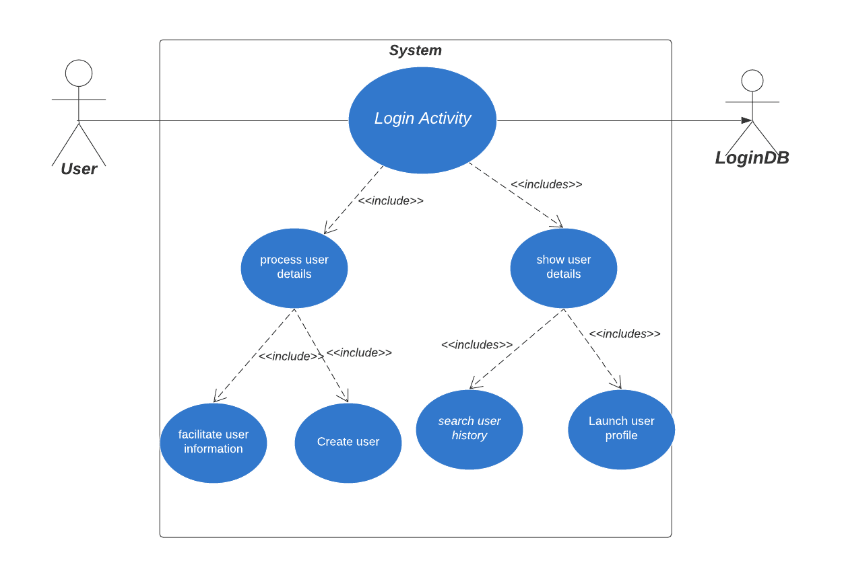

|  |  |  |
| --- | --- | --- |
| **USE CASE #1** | **Login_Activity** | |
| **Goal** | Facilitation of complete User  profile creation and giving access to  analysis process . | |
| **Purpose** | Creation of new User profile | |
| **Preconditions** | User should have valid email-id in order to create a new profile. | |
| **Success Condition** | Successful creation of new User  profile. | |
| **Failed Condition** | Already existing User profile. | |
| **Post Conditions** | After  successful registration of profile into the system, User can access the system | |
| **Primary Actors** | User | |
| **Secondary Actors** | User Database | |
| **Trigger** | information  regarding user profile  , feedback process initiation | |
|  |  | |
| **DESCRIPTION** | **Steps** | **Basic Course of Action** |
|  | 1 | User requests new profile creation. |
|  | 2 | System provides a new profile creation page. |
|  | 3 | System indicates mandatory fields in the form. |
|  | 4 | User submits profile details and accepts profile details. |
|  | 5 | System generates User profile credentials using entered details. |
|  | 6 | System displays profile creation confirmation message. |
|  | 7 | User wants to access system by providing personal credentials |
|  | 8 | System provides user sign-in form. |
|  | 9 | System accepts credentials. |
|  | 10 | System checks account’s validity with stored database parameters. |
|  | 11 | System displays a successful login message. |
|  | 12 | System launches user control panel . |
|  | 13 | System processes user profile and collect history if there exists |
|  | 14 | User requests to analyse user provided territory  . |
|  |  |  |
| **DESCRIPTION** | **Steps** | **Alternate Course of Action** |
|  | 1 | User requests account password reset. |
|  | 2 | System provides account reset form and asks user to enter registered email address. |
|  | 3 | System checks whether an account has been registered using the email address. |
|  | 4 | System displays user account details. |
|  | 5 | System generates password hints. |
|  | 6 | System provides a reset-method selection panel. |
|  | 7 | User selects reset-method from the selection panel. |
|  | 8 | System generates the default password and communicates it to the user by using the method selected. |
|  | 9 | System updates user account password. |
|  | 10 | System displays password reset confirmation. |
|  | 11 | User wants to access system by providing personal credentials |
|  | 12 | System provides user sign-in form. |
|  | 13 | User submits credentials . |
|  | 14 | System checks for validity of reports. |
|  | 15 | System saves changed password details in Login db. |
|  |  |  |
| **DESCRIPTION** | **Steps** | **Error Scenario** |
|  | 1 | Verify account credentials. |
|  | 2 | Validate account details. |
|  | 3 | Profile information should not be blank. |
|  | 4 | Report content extraction failed. |
|  | 5 | Non-existing user account. |

|  |  |  |
| --- | --- | --- |
| **USE CASE #1.1** | Process user Details | |
| ***Goal*** | Create a user profile inorder to provide counselling. | |
| ***Purpose*** | 1.      New  User Profile  2.      Update usert profile. | |
| ***Preconditions*** | Users should know the valid authentication parameters (username, password) and have a valid contact number. | |
| ***Success Condition*** | Successful Created a user profile. | |
| ***Failed Condition*** | Failed to create a user profile. | |
| ***Post Conditions*** | user will be able to access the system after only validation of user authentication parameters. | |
| ***Primary Actors*** | user | |
| ***Secondary Actors*** | **User Database** | |
| ***Trigger*** | Verify Primary Details | |
| ***DESCRIPTION*** | **Step** | ***Basic Course of Action*** |
|  | 1 | User wants to access the system. |
|  | 2 | Search for the login webpage and  load it on the screen. |
|  | 3 | Registration form is searched for new User registration. |
|  | 4 | The registration form will be displayed for creation of a user profile as a user if the user account is not already existing. |
|  | 5 | Login page will be loaded if the user account already exists. |
|  | 6 | User enter basic information needed in the registration form. |
|  | 7 | The data is validated and if the data is correct then the data will be saved in the database. |
|  | 8 | If no username  clashes with the entered username then registration is processed further. |
|  | 9 | System Loads two form on the screen:  Login and Sign Up |
|  | 10 | Login page is loaded if the user's account already exist. |
|  | 11 | User enters login username and password. |
|  | 12 | Login records are fetched from the user  database. |
|  | 13 | The entered details are checked whether they are present in fetched login records. |
|  | 14 | System access is provided to the user by logging him in the system. |
|  | 15 | Users select Login after sign Up is completed. |
| ***DESCRIPTION*** | **Step** | ***Alternate Course of Action*** |
|  | 1 | Allow users to modify details entered during the Registration Form. |
|  | 2 | System searches for alternate signup or login page. |
|  | 3 | Alternate registration page is loaded. |
|  | 4 | All available alternate registration or login options are searched. |
|  | 5 | Available options are displayed to the user. |
|  | 6 | User enter the login details in the login page for alternate accounts. |
|  | 7 | Login details are forwarded to the alternate account server and they are checked for correctness. |
|  | 8 | If registration is successful then user details are retrieved from the alternate account. |
|  | 9 | Registration form is opened having details of the user prefilled in it. |
|  | 10 | User modify any details if necessary and submit the registration form. |
|  | 11 | User chooses a username and password for his new account. |
| ***DESCRIPTION*** | **Step** | ***Error Scenario*** |
|  | 1 | Invalid username and password. |
|  | 2 | The registration is incomplete. |
|  | 3 | Alternate accounts could not be connected. |
|  | 4 | User account is unavailable. |

|  |  |  |
| --- | --- | --- |
| **USE CASE #1.2** | **Show User Details** | |
| ***Goal*** | The System shall allow the users to update their information such as name,home address,upload documents and other information. | |
| ***Purpose*** | System allows students to update user information,enter studentId and password and click the submit button. | |
| ***Primary Actors*** | User | |
| ***Secondary Actors*** | User Database | |
| ***Preconditions*** | The system shall be connected to the database. | |
| ***Post Conditions*** | User  has successfully updated the information | |
| ***DESCRIPTION*** | ***Step*** | ***Basic Course of Action*** |
|  | 1 | User opens the application. |
|  | 2 | System provides login id. |
|  | 3 | System fetches the database of the user. |
|  | 4 | Current student information is displayed. |
|  | 5 | User enters changes on change student details . |
|  | 6 | Changes are validated on the web server. |
|  | 7 | A Confirmation webpage is sent to the user. |
| ***DESCRIPTION*** | ***Step*** | ***Alternate Course of Action*** |
|  | 1 | System accepts the details of students. |
|  | 2 | System reviews the details of students |
|  | 3 | Change the details in the database locations. |
|  | 3 | System processes on the information taken into the system. |
|  | 4 | User changes are noted. |
|  | 5 | Database is updated in case new documents are added. |
|  | 6 | Changes in the database must be verified. |
|  | 7 | User acknowledge the success message of changes. |
| ***DESCRIPTION*** | ***Step*** | ***Error Scenario*** |
|  | 1 | Poor connectivity can lead to User  details unchanged. |

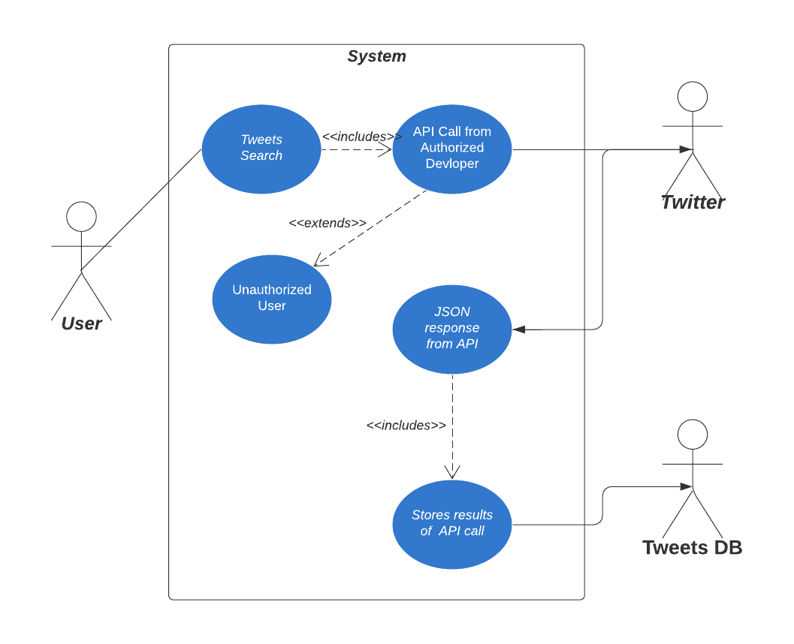

|  |  |  |
| --- | --- | --- |
| **USE CASE #2** | **Get tweets using API call** | |
| **Goal** | Fetching tweets by using API call  provided user input | |
| **Purpose** | Collecting tweets data through API call for performing analysis over these tweets . | |
| **Preconditions** | user profile must be created.  Given input must exist on maps and must have respective GeoCode. | |
| **Success Condition** | System makes API call and fetch tweets . | |
| **Failed Condition** | Given input does not exist on Google GeoCode.. | |
| **Post Conditions** | After successfully calling Twitter API store results in database . | |
| **Primary Actors** | User | |
| **Secondary Actors** | Tweets DB | |
| **Trigger** | Input given in search  bar will trigger API call  . | |
|  |  | |
| **DESCRIPTION** | **Step** | **Basic Course of Action** |
|  | 1 | User requests to view tweets in a territory. |
|  | 2 | System provides an interface to accept user given input. |
|  | 3 | System makes API call to fetch tweets . |
|  | 4 | API will make http request to Twitter. |
|  | 5 | Twitter will give http response to API call . |
|  | 6 | System will store results fetched into databse. |
|  | 7 |  |
|  | 8 | Show the saved database in history section |
|  | 9 | System maintains the user profile. |
|  | 10 | System displays the user profile. |
|  | 11 | User requests to view user profile. |
|  | 12 | System processes user profile. |
|  | 13 | User requests to view history details list. |
|  | 14 | System provides an interface to display history of the user . |
|  |  |  |
| **DESCRIPTION** | **Step** | **Alternate Course of Action** |
|  | 1 | User requests to view information related to the fruit |
|  | 2 | System provides an interface to view the information . |
|  | 4 | User requests to modify a particular dataset. |
|  | 5 | System provides feedback page . |
|  | 6 | Ask user about the feedback in written format . |
|  | 7 | Save the written feedback in database. |
|  | 8 | Send notification of successfully saving the feedback . |
|  | 9 | System sends a confirmation message after modification. |
|  |  |  |
| **DESCRIPTION** | **Step** | **Error Scenario** |
|  | 1 | Data communication failure. |
|  | 2 | Non- existing user profile. |

|  |  |  |
| --- | --- | --- |
| **USE CASE #2.1** | **Authenticate user details** | |
| ***Goal*** | The System shall verify  a user profile. | |
| ***Purpose*** | To enable the student to access the system | |
| ***Primary Actors*** | User | |
| ***Secondary Actors*** | User Database | |
| ***Preconditions*** | The system shall be connected to the database. | |
| ***Post Conditions*** | The system shall authenticate the User profile and User can view their counselling report. | |
| ***DESCRIPTION*** | ***Step*** | ***Basic Course of Action*** |
|  | 1 | User opens the application. |
|  | 2 | System provides login id. |
|  | 3 | User selects the registration form provided by the system if not register |
|  | 4 | User enters username and password. |
|  | 5 | System accepts the information that the User feeds. |
|  | 6 | Check for the availability of the User Name and it is not conflicting with other User. |
|  | 7 | System checks if the Password is entered in the format required. |
|  | 8 | Create the User profile into the system. |
|  | 9 | Validate the User by checking the correct information entered. |
|  | 10 | System creates server connection. |
|  | 11 | System sends the validation error if occurred. |
|  | 12 | System sends confirmation messages to the User’s email. |
| ***DESCRIPTION*** | ***Step*** | ***Alternate Course of Action*** |
|  | 1 | System asks the user to login. |
|  | 2 | User enters the mobile number. |
|  | 3 | OTP is generated randomly to verify the user. |
|  | 3 | OTP is sent to the registered mobile number. |
|  | 4 | OTP is verified if inserted correctly. |
|  | 5 | System compares the OTP entered by the user with the one sent by the system. |
|  | 6 | Students can access the system if OTP entered is valid. |
|  | 7 | Student acknowledges the success message. |
| ***DESCRIPTION*** | ***Step*** | ***Error Scenario*** |
|  | 1 | OTP entered is invalid. |

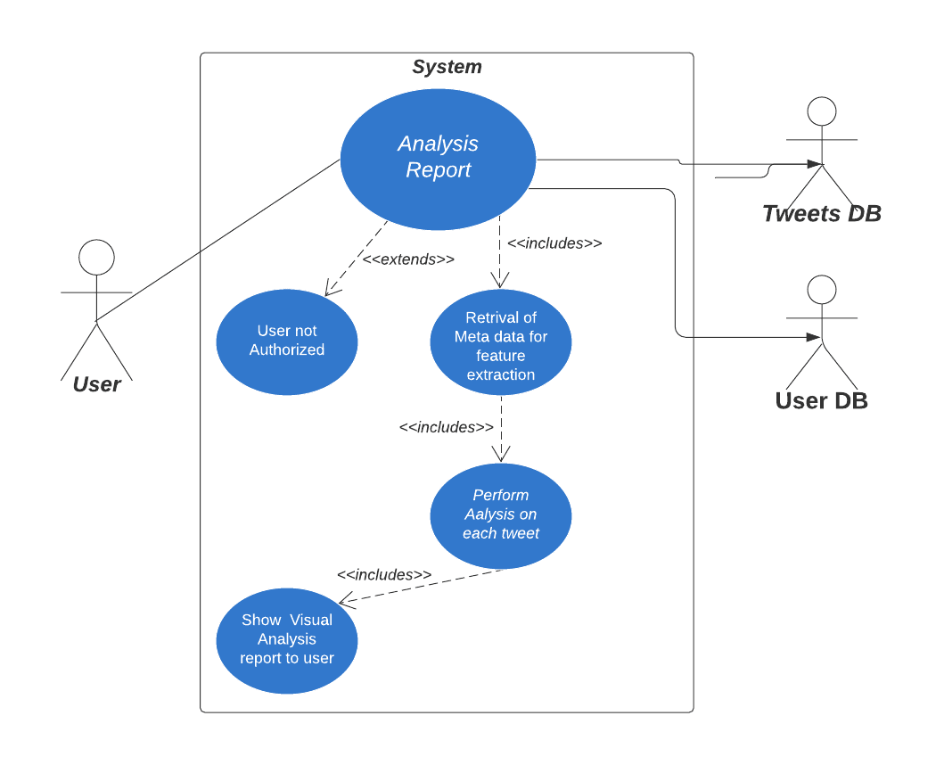

|  |  |  |
| --- | --- | --- |
| **USE CASE #3** | **Provide analysis report related to social media in territory** | |
| **Goal** | Analyze social media trends in user provided location | |
| **Purpose** | Analysis of social media depending upon the input territory provided by the user. | |
| **Preconditions** | user profile must be created.  Input in the form of text must be given .. | |
| **Success Condition** | System gives the analysis report in form of graphical visualization to user. | |
| **Failed Condition** | Dataset is not properly trained and the prediction goes wrong . | |
| **Post Conditions** | After providing  input system should analyse dataset and give analysis report. | |
| **Primary Actors** | User | |
| **Secondary Actors** | UserDB, TweetDB | |
|  |  | |
| **DESCRIPTION** | **Step** | **Basic Course of Action** |
|  | 1 | User request to view analysis over user provided territory. |
|  | 2 | System provides an interface to accept user provided input. |
|  | 3 | System makes API call to twitter API . |
|  | 4 | Twitter gives database in the form of json . |
|  | 5 | System stores this database into local machine.. |
|  | 6 | System preprocess data to remove redundancy. |
|  | 7 | System fetches important data from stores database. |
|  | 8 | System analyse this database. |
|  | 9 | System applies statistical formulae to visualize analysis. |
|  | 10 | System checks user profile |
|  | 11 | System gives analysis report to user. |
| **DESCRIPTION** | **Step** | **Alternate Course of Action** |
|  | 1 | User requests to view information related to territory. |
|  | 2 | System provides an interface to view the information . |
|  | 4 | User requests to modify a particular dataset. |
|  | 5 | System provides feedback page . |
|  | 6 | Ask user about the feedback in written format . |
|  | 7 | Save the written feedback in database . |
|  | 8 | Send notification of successfully saving the feedback . |
|  | 9 | System sends a confirmation message after modification. |
|  |  |  |
| **DESCRIPTION** | **Step** | **Error Scenario** |
|  | 1 | Data communication failure. |
|  | 2 | Non- existing user profile. |

Assignment 3 please edit - digvijay

BPD

Goal 1 bpd

Login User

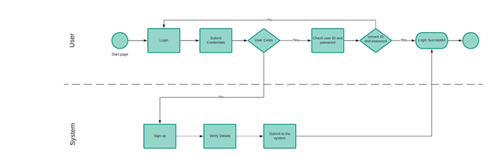

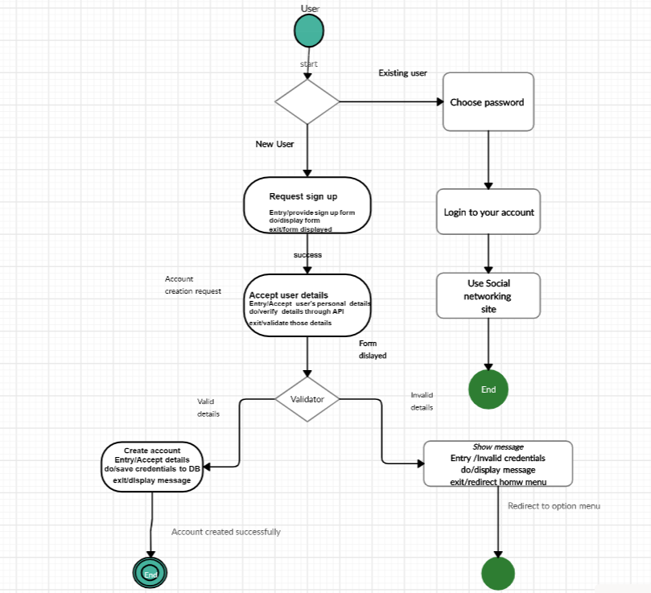

**Sequence Diagrams**

*Assignment 5– SDP LAB (CS3036)*

***Territory wise Social Media Observer***

*Third Year – Semester II, Module VI*

*Division D - Bachelor of Technology – Computer Engineering*

**Bract’s Vishwakarma Institute Technology**

***PUNE – 411037***



*Prepared by:*

|  |  |  |
| --- | --- | --- |
| ***Name*** | ***Roll No*** | ***GR Number*** |
| Sumit Shengokar | D-54 | 1710705 |
| Digvijay Sonvane | D-64 | 1710220 |
| Swaraj Sonvane | D-65 | 1710764 |
| Shruti Vasave | D-76 | 1710060 |

*Approved by:*

|  |  |  |
| --- | --- | --- |
| ***Name*** | ***Signature*** | ***Date*** |
| Prof. Mahesh Dube |  | 2020 |

## Introduction

Sequence diagram is the most common kind of [interaction diagram](http://www.uml-diagrams.org/uml-25-diagrams.html#interaction-diagram), which focuses on the [message](http://www.uml-diagrams.org/sequence-diagrams.html#message) interchange between a number of [lifelines](http://www.uml-diagrams.org/sequence-diagrams.html#lifeline).

Sequence diagram describes an interaction by focusing on the sequence of messages that are exchanged, along with their corresponding occurrence specifications on the lifelines.

The following nodes and edges are typically drawn in a UML sequence diagram: [lifeline](http://www.uml-diagrams.org/sequence-diagrams.html#lifeline), [execution specification](http://www.uml-diagrams.org/sequence-diagrams.html#execution), [message](http://www.uml-diagrams.org/sequence-diagrams.html#message), [combined fragment](http://www.uml-diagrams.org/sequence-diagrams-combined-fragment.html), [interaction use](http://www.uml-diagrams.org/sequence-diagrams.html#interaction-use), [state invariant](http://www.uml-diagrams.org/sequence-diagrams.html#state-invariant), continuation, [destruction occurrence](http://www.uml-diagrams.org/sequence-diagrams.html#destruction-occurrence-seq).

## UML Sequence Diagram Terminology

Following diagram illustrates all the terminology used in UML sequence diagram.

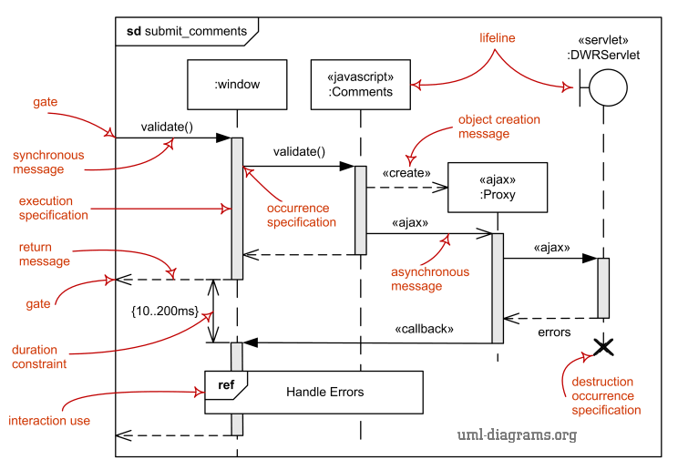

## Identifying Components of Sequence Diagram

## Lifeline

Lifeline is a [named element](http://www.uml-diagrams.org/uml-core.html#named-element) which represents an individual participant in the interaction. While [parts](http://www.uml-diagrams.org/composite-structure-diagrams.html#part) and structural features may have multiplicity greater than 1, lifelines represent only one interacting entity.

A lifeline is shown using a symbol that consists of a rectangle forming its "head" followed by a vertical line (which may be dashed) that represents the lifetime of the participant. The lifeline head has a shape that is based on the [classifier](http://www.uml-diagrams.org/classifier.html) for the part that this lifeline represents. Usually the head is a white rectangle containing name of class.

Examples:

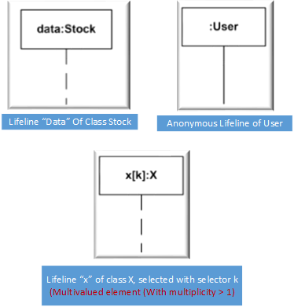

## Message

Message is a [named element](http://www.uml-diagrams.org/uml-core.html#named-element) that defines one specific kind of communication between [lifelines](http://www.uml-diagrams.org/sequence-diagrams.html#lifeline) of an interaction. The message specifies not only the kind of communication, but also the sender and the receiver. Sender and receiver are normally two occurrence specifications (points at the ends of messages).

A message reflects either an [operation](http://www.uml-diagrams.org/class-diagrams.html#operation) call and start of execution or a sending and reception of a [signal](http://www.uml-diagrams.org/common-behaviors.html#signal).

When a message represents an operation call, the arguments of the message are the arguments of the operation. When a message represents a signal, the arguments of the message are the attributes of the signal.

Depending on the type of [action](http://www.uml-diagrams.org/activity-diagrams-actions.html) that was used to generate the message, message could be one of:

1. [Synchronous call](http://www.uml-diagrams.org/sequence-diagrams.html#synchronous-call)
2. [Asynchronous call](http://www.uml-diagrams.org/sequence-diagrams.html#asynchronous-call)
3. [C](http://www.uml-diagrams.org/sequence-diagrams.html#create)reate, Delete, Reply Messages

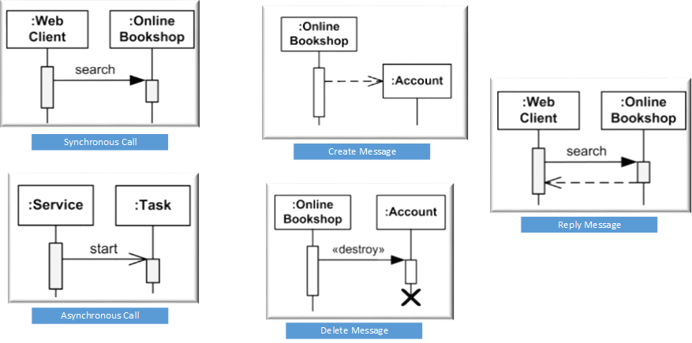

## 1.4. Actual Sequence Diagram

This section describes the various sequence diagrams for Territory wise Social Media Monitor

## 1.4.1 Sequence diagram – Registration of new user

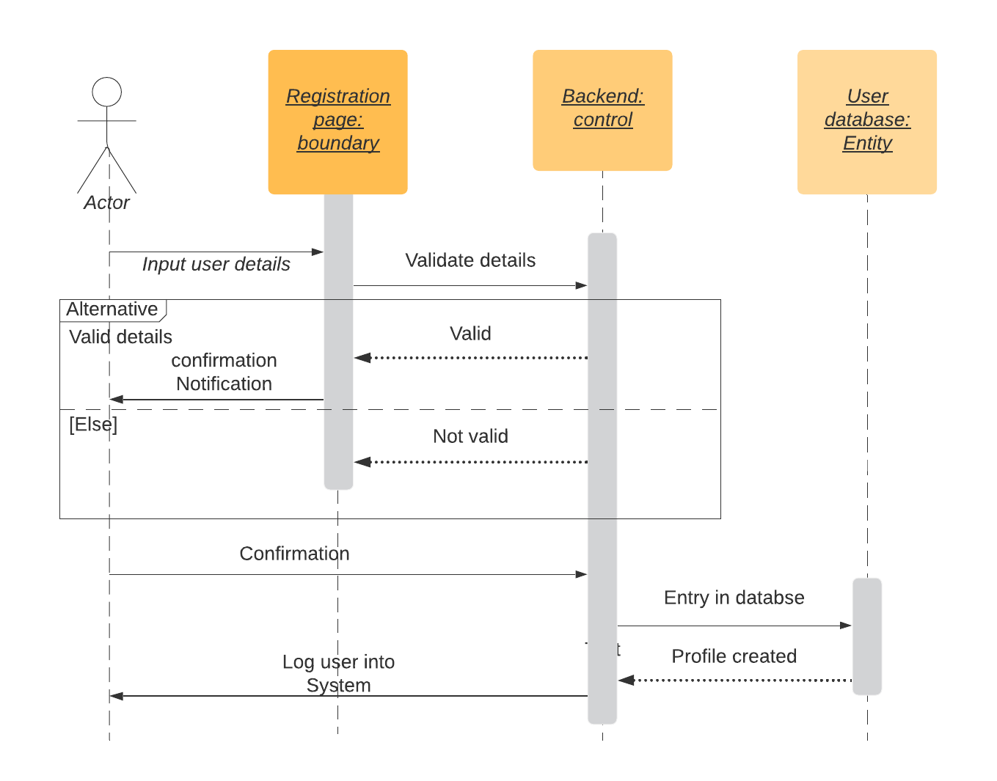

## 1. 4.2 Sequence diagram – Authentication

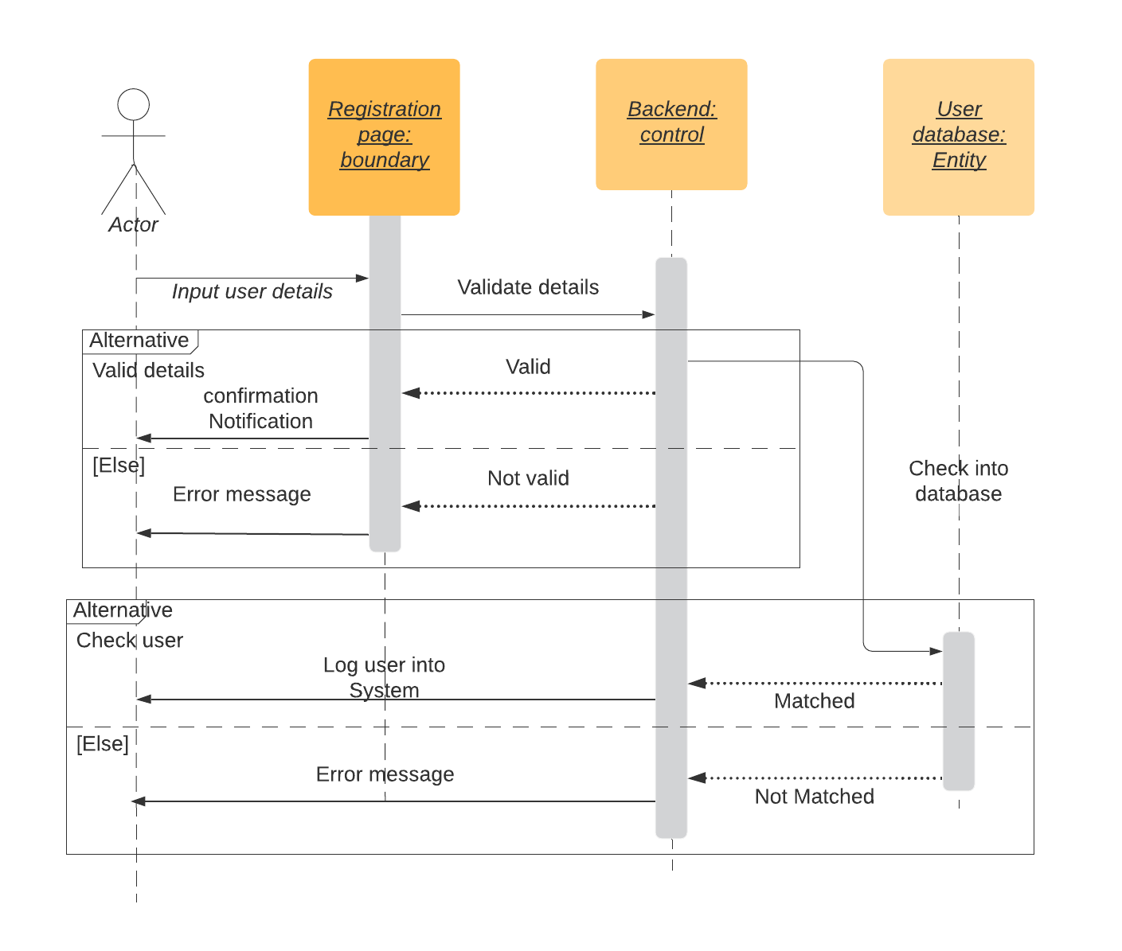

## 1. 4.3. Sequence diagram – Search Keyword or Hashtag

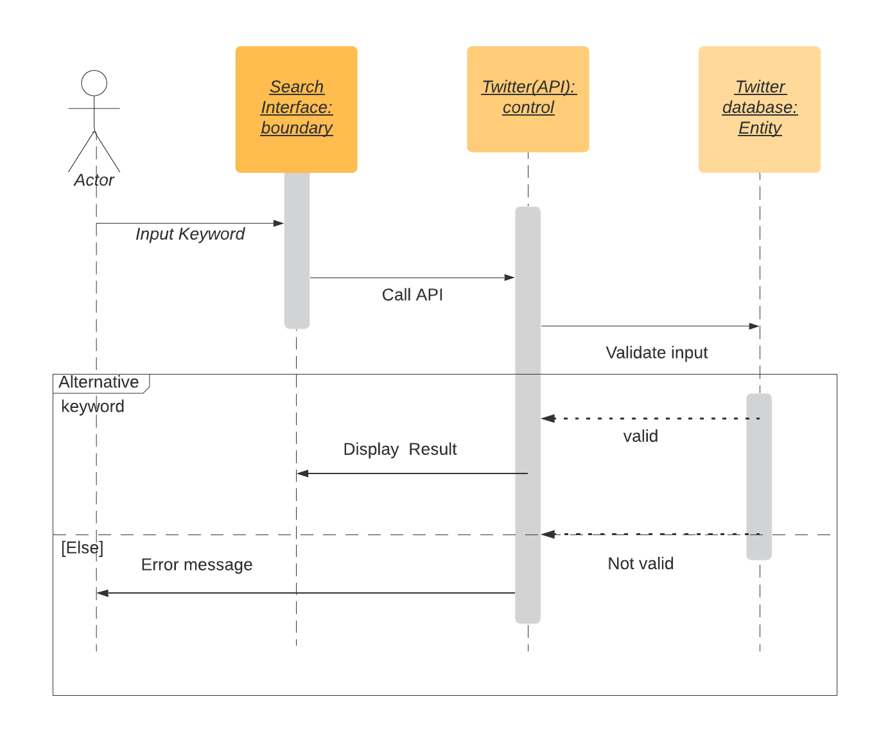

## 1. 4.4. Sequence diagram – Get JSON File

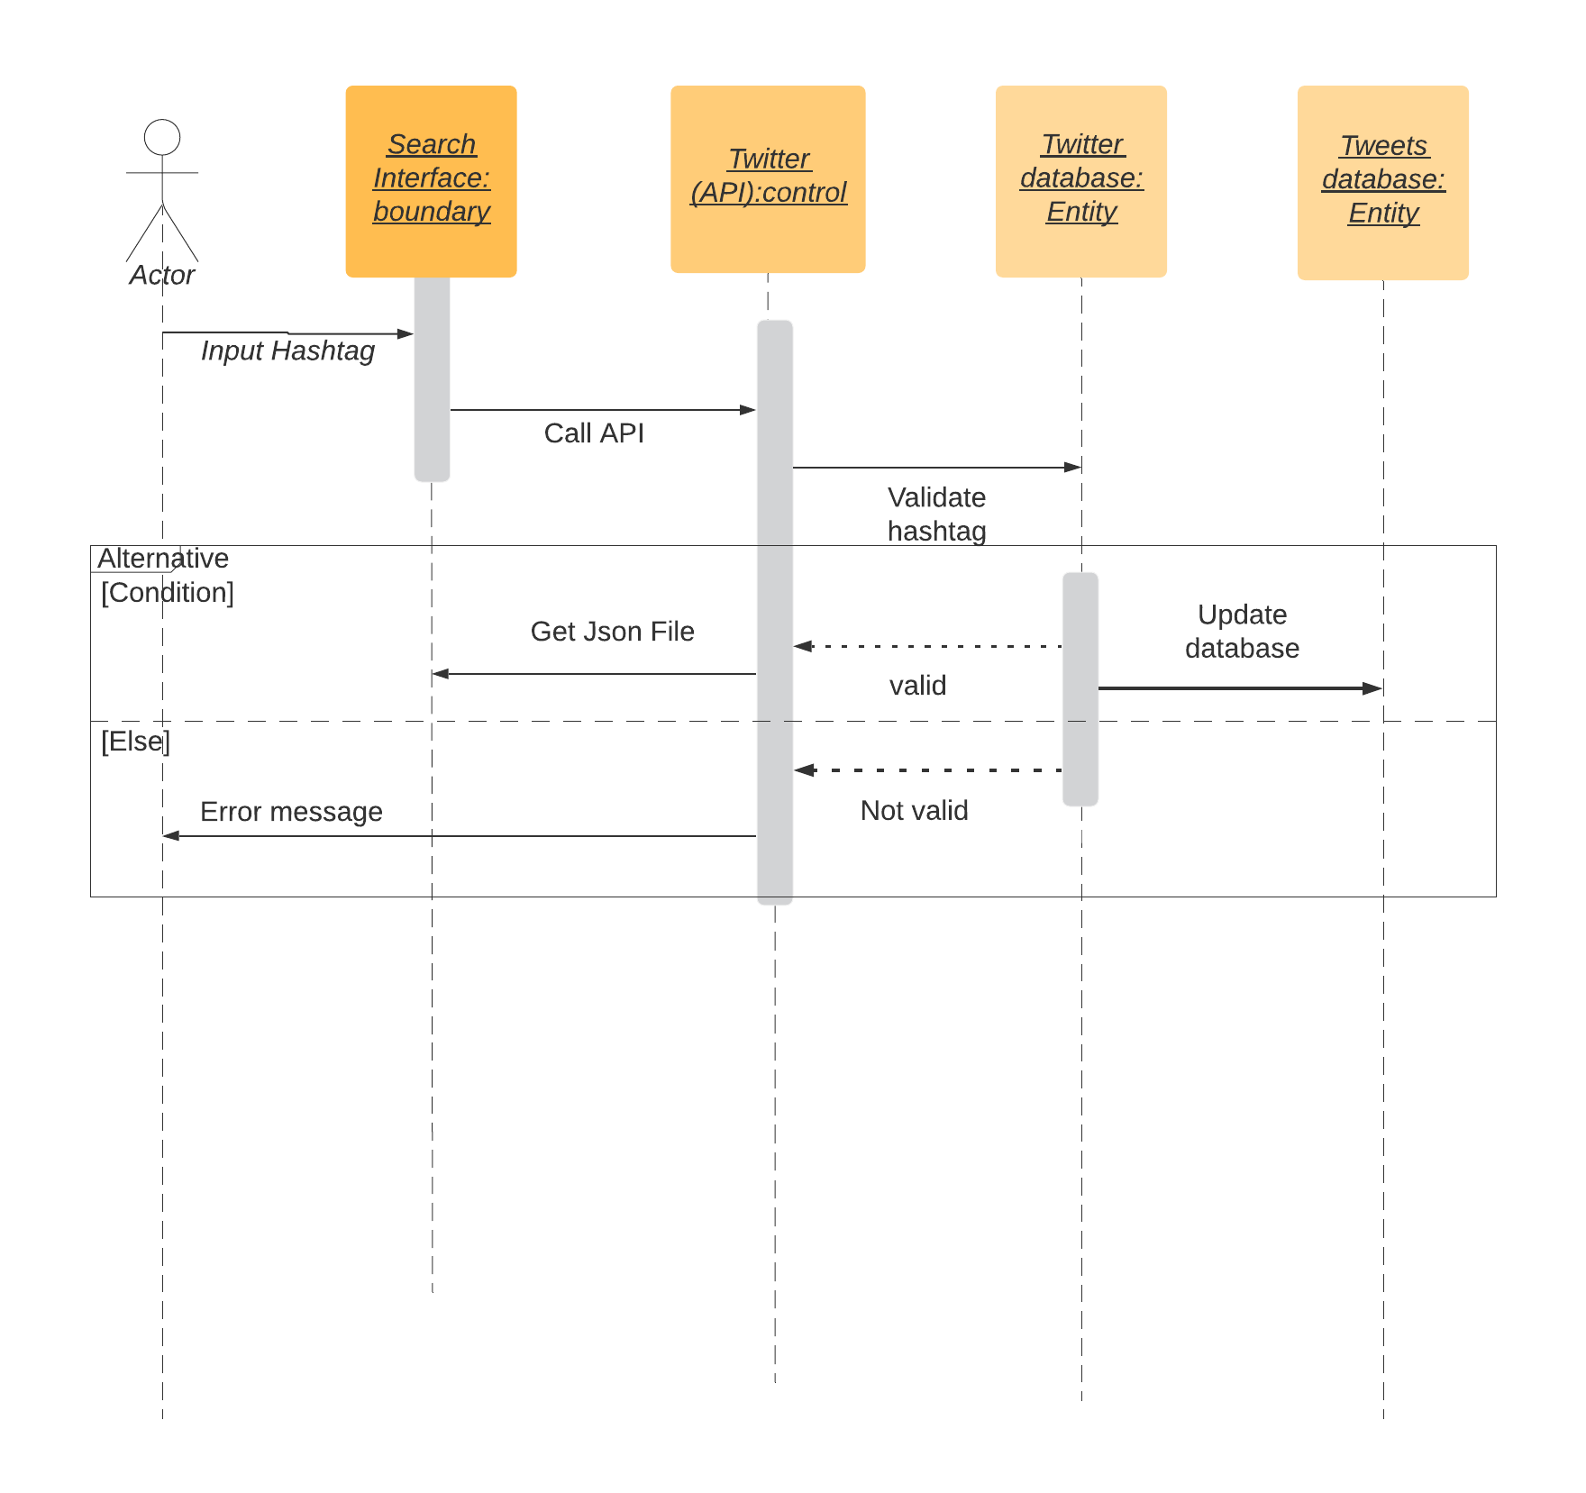

## 1.4. 5. Sequence diagram – Display Trends and give information about occasions

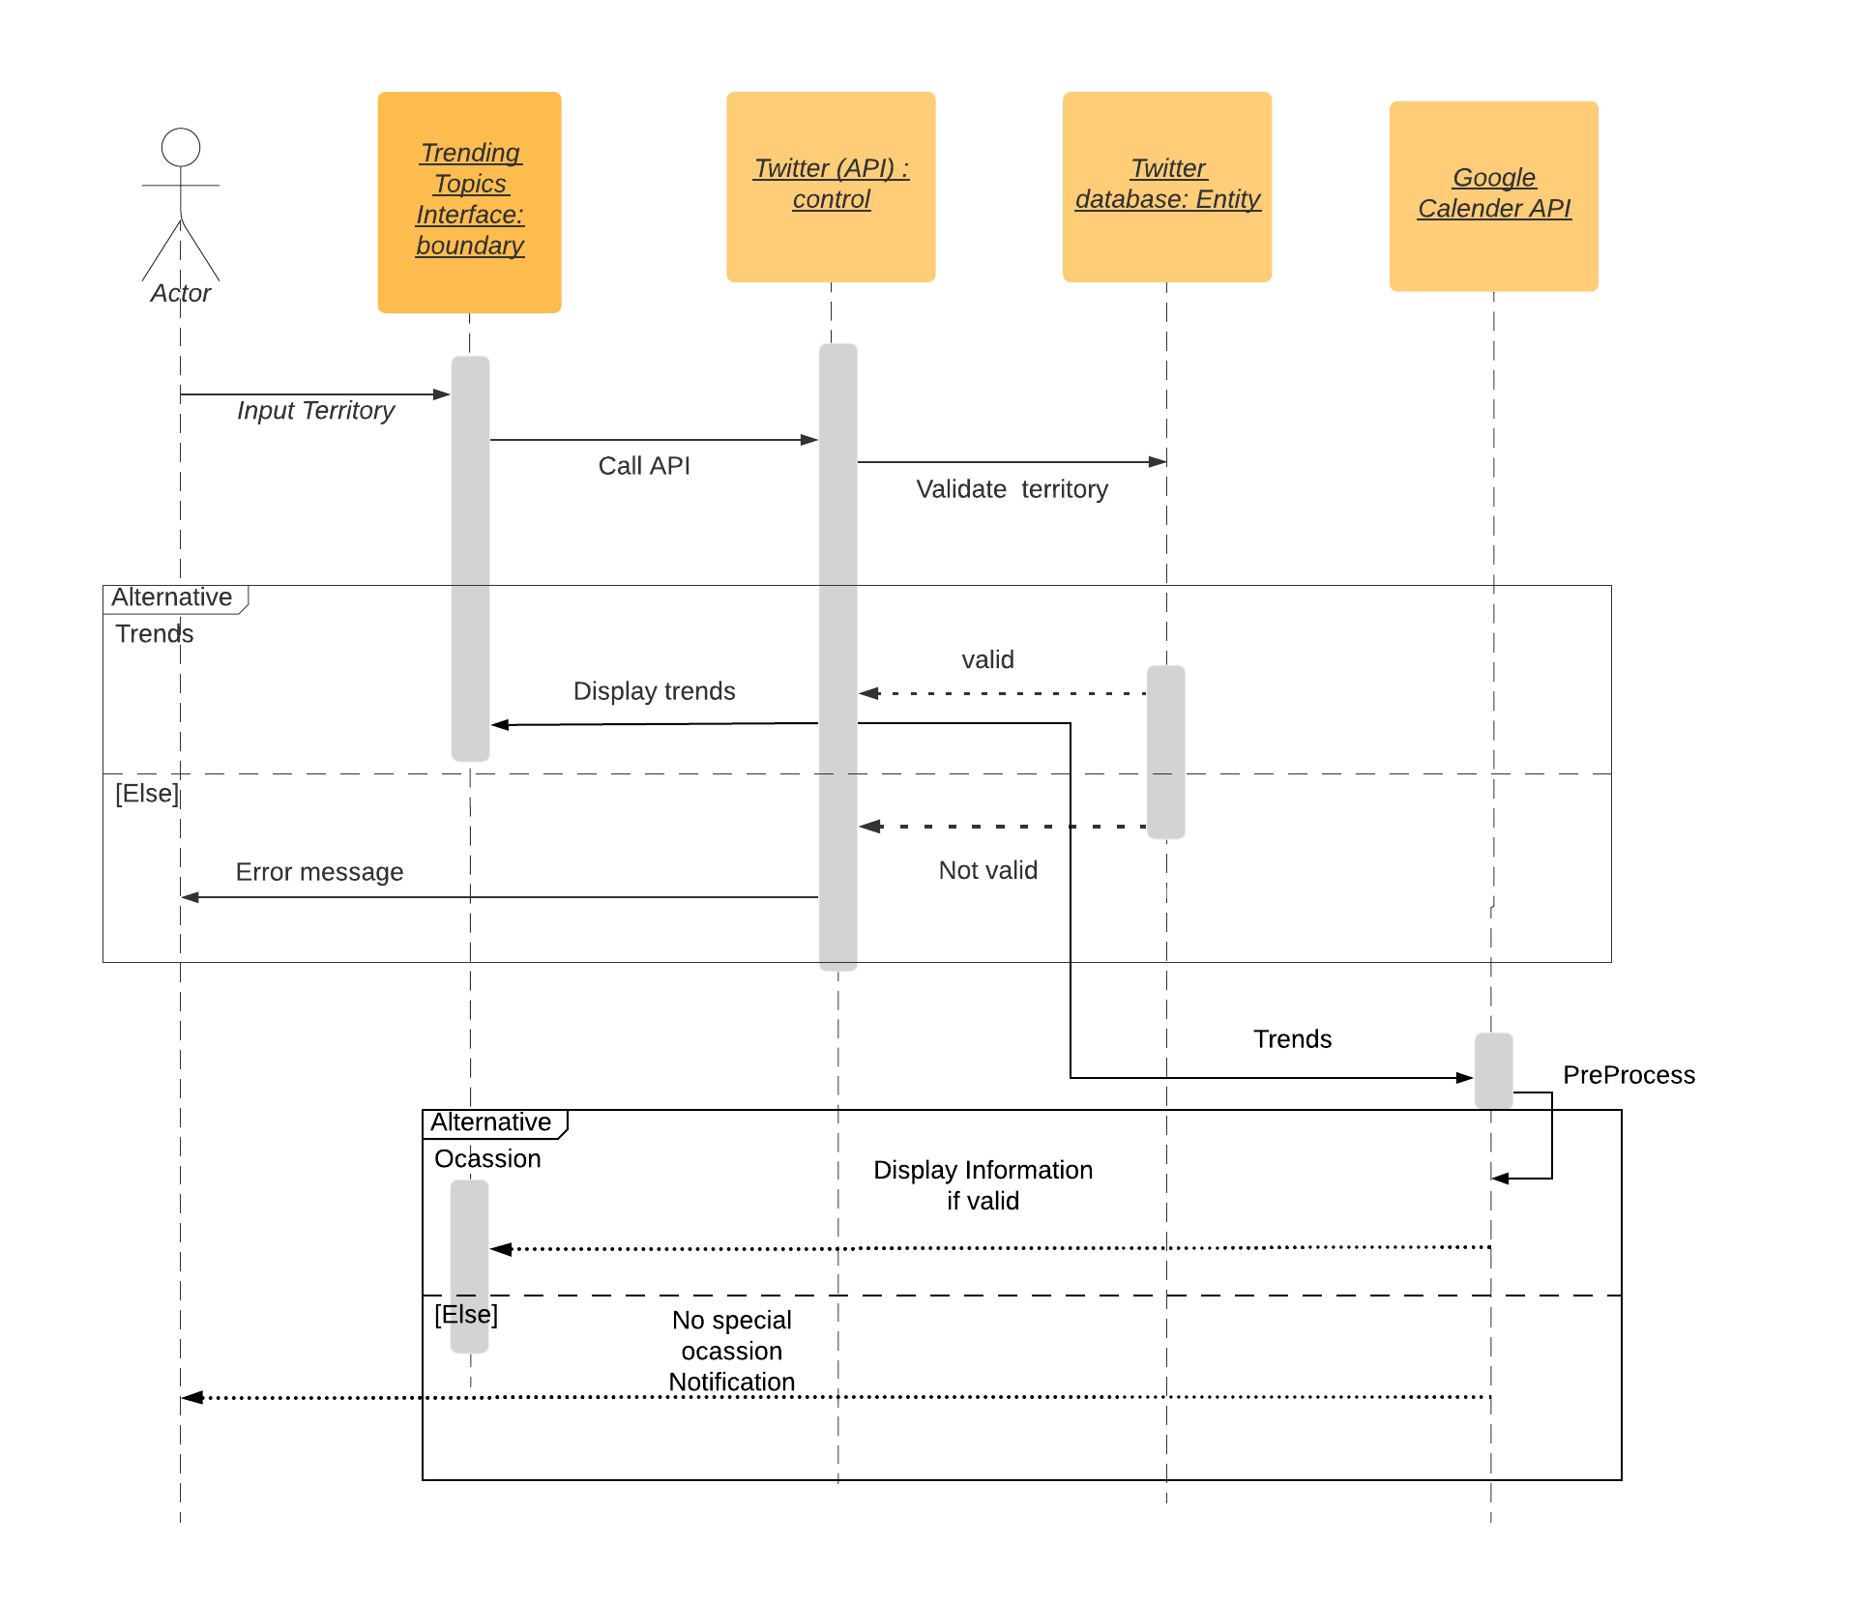

## 1. 4. 6. Sequence diagram – Semantic analysis of tweet

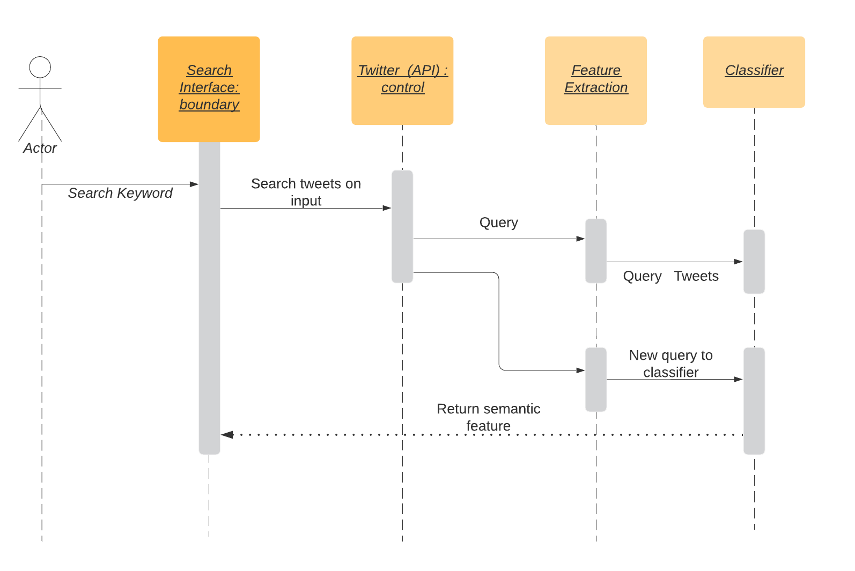

## 1.4.7. Sequence diagram – Feedback form

