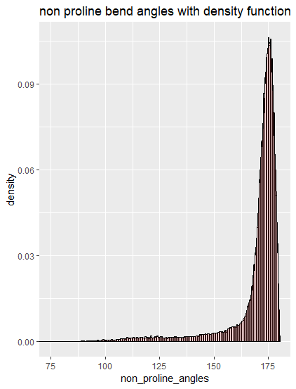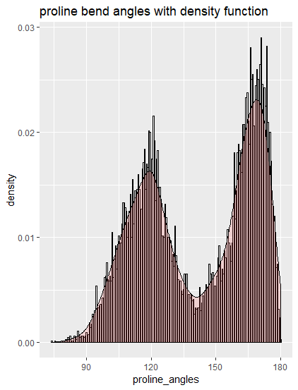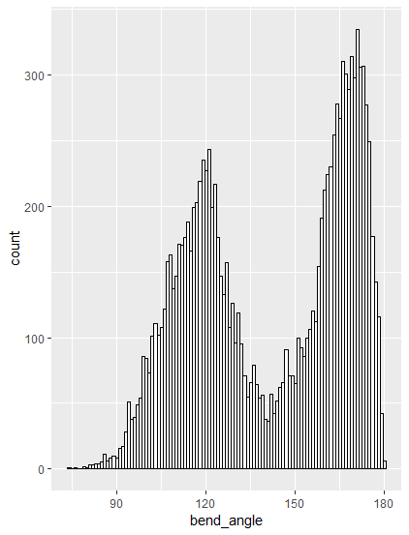Proline distribution

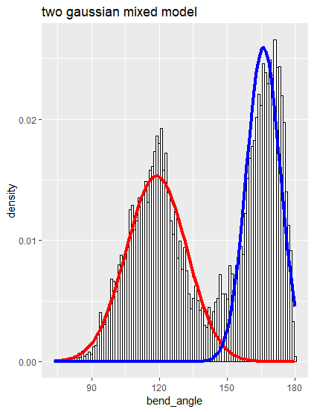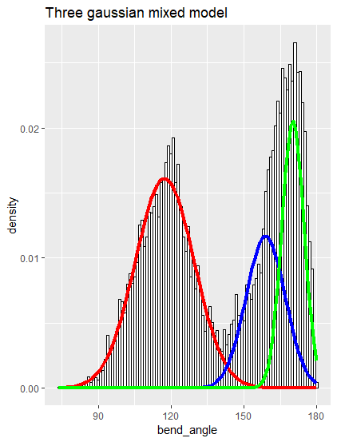

Two gaussian mixed model summary

summary of normalmixEM object:

comp 1 comp 2

lambda 0.513047 0.486953

mu 118.760184 165.911344

sigma 13.361777 7.496641

loglik at estimate: -55214.06

Three gaussian mixed model summary

summary of normalmixEM object:

comp 1 comp 2 comp 3

lambda 0.488383 0.235265 0.276352

mu 117.372331 158.892785 170.130773

sigma 12.093170 8.046908 4.571051

loglik at estimate: -54886.06

Non_proline_mixed data

Mixed Gaussian models

Using the mixtools lib of Rstudio

> summary(mixmdl5)

summary of normalmixEM object:

comp 1 comp 2 comp 3 comp 4

lambda 0.121627 0.348915 0.137006 0.257386

mu 105.394632 120.310702 152.508081 165.525593

sigma 8.860215 9.327625 8.255457 4.834483

comp 5

lambda 0.135066

mu 173.433693

sigma 2.809390

loglik at estimate: -54765.21

> summary(mixmdl6)

summary of normalmixEM object:

comp 1 comp 2 comp 3 comp 4

lambda 0.345859 0.0347281 0.0968758 0.261146

mu 113.198115 120.3979735 128.2984111 165.531030

sigma 10.700150 2.4589437 7.9685104 4.801175

comp 5 comp 6

lambda 0.125648 0.135744

mu 152.714002 173.443537

sigma 7.406503 2.807370

loglik at estimate: -54748.64