Parish-Hub: A Web-Based Services Management System

______________

A Thesis Presented to
The Faculty of the College of Computing and Information Sciences
BOHOL ISLAND STATE UNIVERSITY
Balilihan Campus
Magsija, Balilihan, Bohol

______________

In Partial Fulfillment
of the Requirements for the Degree
Bachelor of Science in Information Technology

Lynn Therese | A. | Bayo
Syke | H. | Amoguis
Gabriel | C. | Gumapac

September 2026
Chapter 2
PRESENTATION OF THE PRESENT AND PROPOSED SYSTEM
A. PRESENT SYSTEM
System Narrative
The current parish service management process of Our Lady of Mt. Carmel Parish in Del Carmen Norte, Balilihan, Bohol is mainly conducted through face-to-face transactions and manual recordkeeping. Parishioners who need church services such as Mass intentions, baptism, wedding, funeral or burial services, blessings, and other religious services are required to personally visit the parish office. They inquire about the available services, requirements, schedules, and corresponding fees. The parish secretary provides the necessary information and explains the requirements and procedures that the parishioner needs to follow.
Before a service can be processed, the parishioner is required to prepare and submit the necessary documents and information. The parish secretary checks the submitted requirements and records the request using paper forms, notebooks, logbooks, or other physical files. The secretary also provides instructions regarding incomplete requirements and informs the parishioner of the applicable schedule and procedures. For parishioners who are no longer residing in Balilihan but still need to request parish services, they may still need to personally visit or coordinate with the parish office to complete their transactions.
For services that require the approval of the parish priest, the secretary forwards the request and submitted requirements to the priest for review. The parish priest checks the completeness of the requirements and determines whether the requested service and schedule are acceptable. The priest also checks the availability of schedules for services such as baptism, wedding, funeral or burial Mass, confirmation, blessing, and other religious activities. The request is then approved or rejected based on the parish requirements and schedule availability. If requirements are incomplete, the parishioner is informed and is required to provide the missing documents or information.
Once the service is approved and payment is required, the parishioner proceeds to the designated cashier or treasurer. The payment is received and manually recorded in a receipt book, logbook, or other financial records. The cashier or treasurer issues a receipt as proof of payment and records the payment details for monitoring and reporting purposes. After the payment is completed, the concerned parish personnel are informed so that the service request can proceed according to the approved schedule.
The parish secretary is responsible for maintaining and organizing the records of parishioners, service requests, requirements, schedules, and other related information. These records are mainly stored in physical documents, notebooks, logbooks, and files. When information is needed, parish personnel manually search through the available records. Updates to requests, schedules, and payments are also recorded manually by the responsible personnel.

Constraints
The present system has several challenges that affect the efficiency of parish service management. Since transactions are mainly conducted personally at the parish office, parishioners need to spend time and transportation costs when making inquiries, submitting requirements, following up on requests, or confirming schedules. This may be inconvenient, especially for parishioners who live far from the parish or are currently residing outside Balilihan.
The use of paper-based forms, notebooks, and logbooks also makes record management more difficult. Records may become misplaced, damaged, incomplete, or difficult to retrieve when they are needed. Manually searching for previous records can take additional time, particularly when the parish has a large number of parishioners and service transactions.
Another constraint is the possibility of scheduling conflicts. Since schedules and service requests are managed manually, there is a possibility that overlapping schedules or changes may not be immediately identified or properly communicated to all concerned personnel. Changes in the availability of the parish priest, church facilities, or other parish activities may also affect previously arranged schedules.
The manual recording of payments and financial transactions can also make monitoring and reporting more time-consuming. The cashier or treasurer needs to manually calculate, record, verify, and summarize transactions. Errors in computation or recording may occur and may require additional time to review and correct.
Communication between parishioners and parish personnel is also limited by the current process. Parishioners usually need to personally visit the parish office or directly communicate with parish personnel to ask about requirements, schedules, request status, and other concerns. This may result in delays when parish personnel are unavailable or when parishioners cannot immediately visit the parish office.
Overall, the present system relies heavily on physical visits, manual processing, paper-based records, and direct communication. These limitations can result in longer processing times, difficulty in retrieving records, possible scheduling conflicts, and challenges in monitoring service requests and financial transactions.

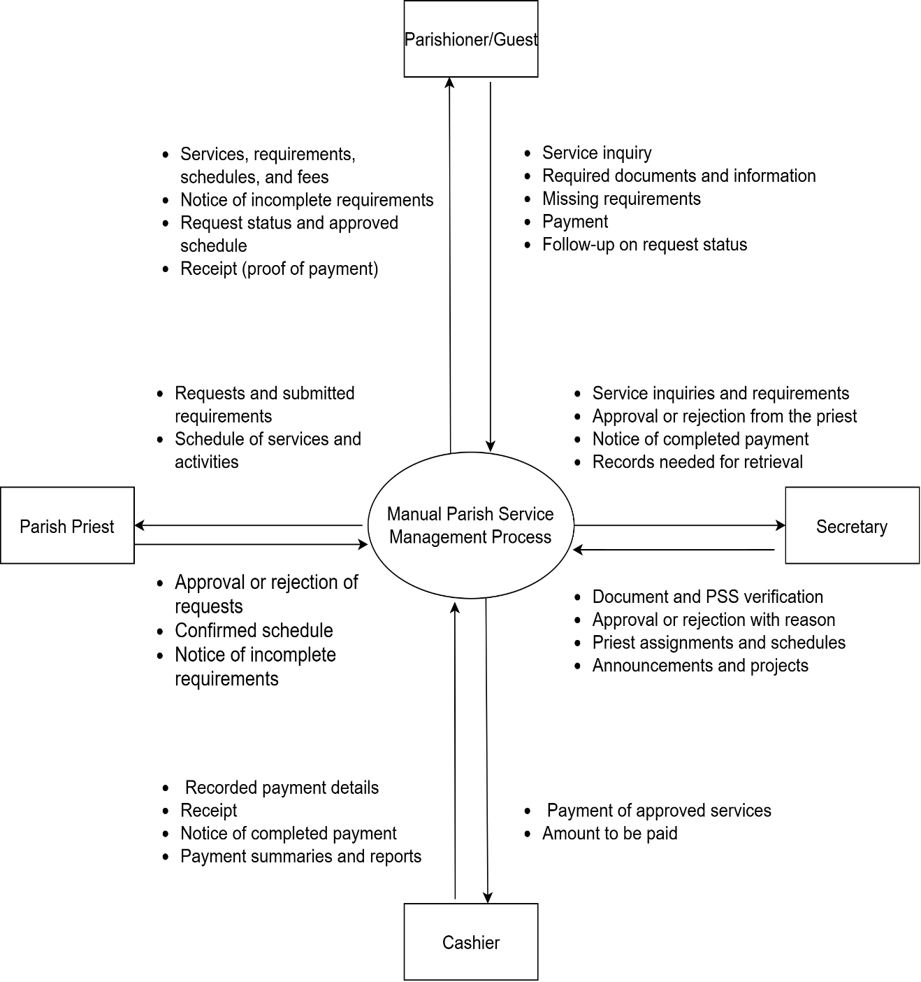

Figure 17: Context Diagram of the Present System

Event List
1. Parishioner Inquires About Parish Services
2. Parishioner Submits Requirements and Request
3. Secretary Forwards the Request to the Parish Priest
4. Parish Priest Reviews and Approves or Rejects the Request
5. Parishioner Is Informed of the Request Status or Missing Requirements
6. Parishioner Pays for the Approved Service
7. Cashier Issues a Receipt and Informs Parish Personnel
8. Secretary Maintains and Updates Parish Records
9. Parish Personnel Retrieve Records
Event List Diagram
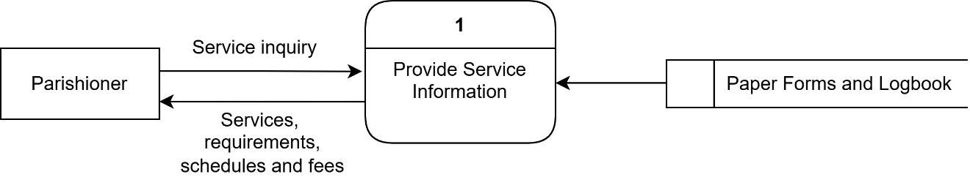
Figure 1. Parishioner Inquires About Parish Services
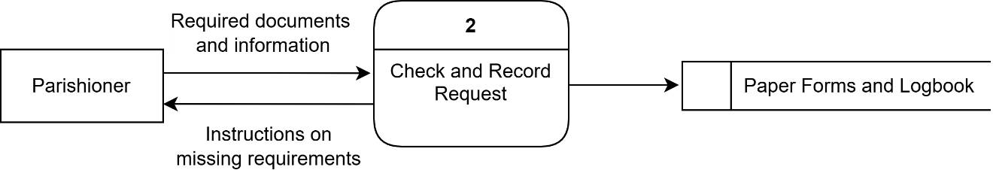
Figure 2. Parishioner Submits Requirements and Request
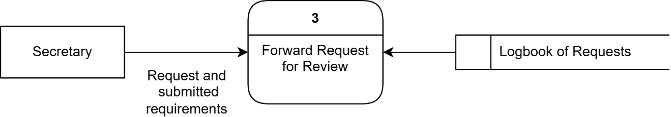
Figure 3. Secretary Forwards the Request to the Parish Priest
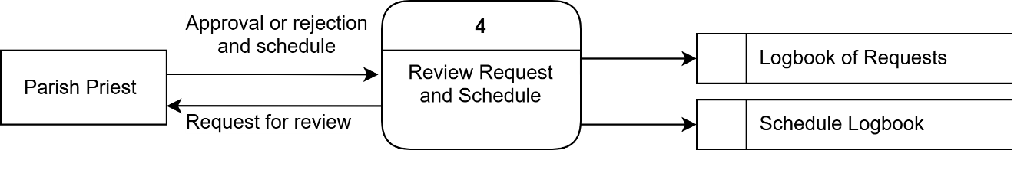
Figure 4. Parish Priest Reviews and Approves or Rejects the Request
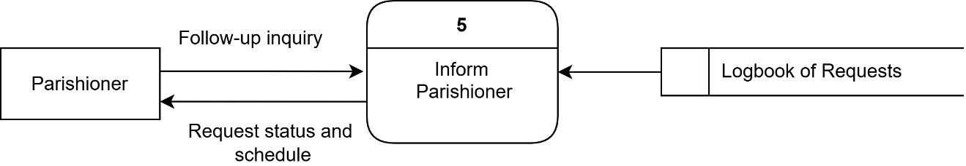
Figure 5. Parishioner Is Informed of the Request Status or Missing Requirements
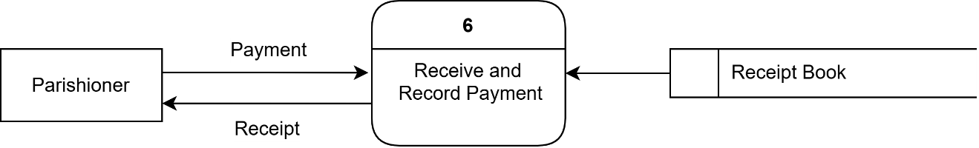
Figure 6. Parishioner Pays for the Approved Service

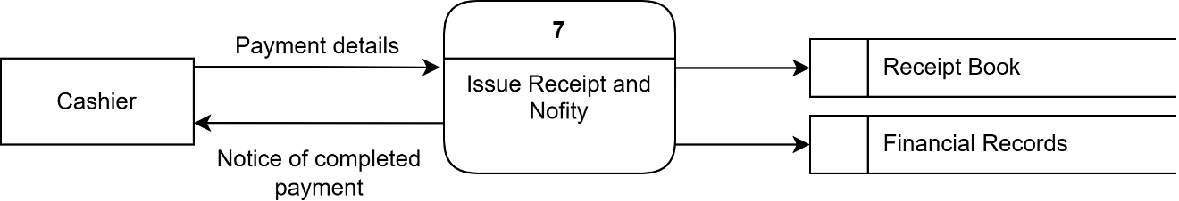
Figure 7. Cashier Issues a Receipt and Informs Parish Personnel
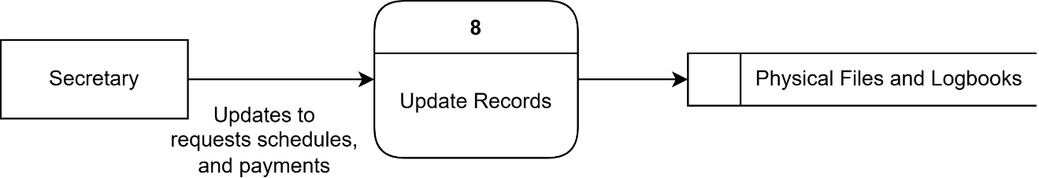
Figure 8. Secretary Maintains and Updates Parish Records
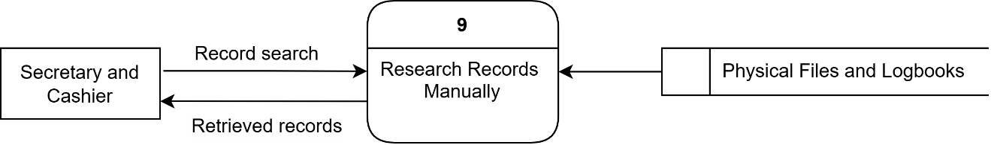
Figure 9. Parish Personnel Retrieve Records

B. PROPOSED SYSTEM
System Rules
The proposed ParishHub: A Web-Based Service Management System operates as a web-based system accessible to visitors and guests, registered parishioners, the secretary, the cashier, the parish priest as administrator, and assigned priests. Each user is given access only to the pages and functions of his or her role. Visitors may access the public pages to view the parish’s announcements, the Mass intentions offered for the day, the available services and their requirements and fees, the parish calendar, and information about the parish. A visitor may also communicate with the parish chatbot for frequently asked questions.
A parishioner who wishes to use the system creates an account by providing his or her last name, first name, optional middle name, email address, password, 11-digit mobile number starting with 09, birthdate, gender, and address, and by agreeing to the terms of use. All required fields must be completed and the password must contain at least eight characters before the account can be created. New accounts are always given the Parishioner role, and only the administrator can create accounts for parish staff. After registration, the parishioner may log in and access the parishioner dashboard, which shows upcoming appointments, recent announcements, and notifications.
To request a parish service, the parishioner opens the Services page, reads the requirements and fees of the service, and clicks Book Now. For baptism and wedding, the parishioner chooses either a Regular schedule, which shows only the fixed dates and times configured by the parish, such as the 1st and 3rd Saturday of the month for baptism, or a Special schedule, which allows a preferred date and time. For funeral Masses, the parishioner chooses between Misa sa Lubong and Misa sa Haya ug Misa sa Sementeryo and provides the date of death, since a funeral Mass may only be scheduled after the nine-day mourning period and is fixed at 1:00 PM. House blessings are scheduled by selecting a date and time on the calendar and providing the contact number and location of the blessing. The parishioner may also choose a preferred priest from the list of available priests for the selected date and time.
Before a booking is saved, the system validates the selected schedule against the parish’s scheduling rules. Bookings are not accepted on Monday afternoons and all day Tuesday, which are the office’s days off, on dates blocked on the parish calendar, at times already occupied by a scheduled Mass, in a Regular slot already taken by another request, or with a priest who is inactive, marked unavailable, or already booked at the same date and time. Confirmation and First Communion are not booked directly by parishioners because their dates depend on the availability of the Bishop and are set by the secretary.
Services with requirements display the documents that must be submitted. For a wedding, the couple uploads their baptismal and confirmation certificates and the sponsors’ baptismal certificate and fills out the Matrimony Application Form, the Katin-awan sa Kasal, and the Cluster Clearance for Wedding Sponsors. For a baptism, the parishioner uploads the child’s certificate of live birth and the sponsors’ baptismal certificate and fills out the Katin-awan sa Bunyag and the Cluster Clearance for Baptismal Sponsors. For a funeral Mass, the death certificate is uploaded and the Katin-awan sa Lubong is filled out. The system automatically generates the filled-out forms in the parish’s official format, saves a copy for the secretary’s checking, and allows the parishioner to download and print them for the required signatures. A request cannot be submitted when a required document is missing or invalid, and only PDF, JPG, and PNG files within the allowed size are accepted.
For baptism, wedding, and funeral Masses, the parishioner also indicates whether he or she is a PSS giver and, for baptism and wedding, the number of sponsors. The fee of these services is computed by the system from the parish’s fee rules based on the service, the schedule type (Regular or Special), the PSS classification, the priest’s stipend, and the number of additional sponsors beyond those included in the fee. The secretary verifies the PSS classification before payment can be made, and the computed fee is saved with the request so that it does not change after verification.
After a request is submitted, it is recorded with a Pending status and the secretary is notified. The secretary opens the request, views the uploaded documents and generated forms, and approves or rejects each document. A rejected document must have a reason, and the parishioner may only upload a replacement for the rejected document. The secretary approves the request only when all documents have been verified; otherwise, the secretary may reject the request with a reason that is shown to the parishioner. The secretary may also assign or change the priest and reschedule the request, subject to the same scheduling and priest availability rules. The parishioner is notified at each change of status.
Mass intentions follow a simple process. The parishioner selects the Mass date and the type of intention (for the living, for the dead, thanksgiving, healing, or birthday), provides the name of the offeror and the name of the person for whom the Mass intention is being offered, and may include an optional message. Mass intentions may be offered at the 6:00 AM Daily Mass from Monday to Saturday and at the 6:00 AM, 9:00 AM, or 4:00 PM Mass on Sundays. No documents are required, and no priest is selected. There is no fixed fee for Mass intentions; however, a voluntary offering greater than ₱0.00 (need pag data or 0 jud?)is required to submit an intention. Once the cashier confirms the payment, the intention is automatically approved and displayed on the Mass Intentions page, where it can be printed and read during the Mass.
Once a request is approved, the parishioner may proceed to payment. Payments may be made online through PayMongo, which supports GCash, Maya, and credit or debit cards, or in cash at the parish office. An online payment is counted only after PayMongo confirms that it was successful, after which the payment is verified and an official receipt is generated automatically. Cash payments are recorded and confirmed by the cashier, who may also record walk-in payments for an approved request. A request can only have one active payment, and a failed or cancelled payment may be repeated. When a payment is verified, the request’s status becomes Payment Verified and the official receipt with a unique receipt number becomes available to the parishioner.
After payment, the secretary confirms the appointment and marks it as Completed after the service has taken place. A parishioner may cancel his or her own appointment with a reason before it is confirmed. An approved appointment that remains unpaid when its scheduled date has passed is automatically cancelled by the system. The appointment statuses therefore follow the order Pending, Approved or Rejected, Payment Verified, Confirmed, and Completed, with Cancelled as an alternative status.
Parishioners and guests may also donate to the parish through the Donate button when donations are enabled by the secretary. The donor provides an optional name and email address, the amount, the purpose of the donation (General Donation, Church Maintenance, Charity, or Mass/Parish Activities), an optional ongoing project to support, and an optional message, then pays online or in cash. The cashier and administrator may also record walk-in donations. Donations are reflected in the cashier’s transaction records, in the progress of the parish’s ongoing projects, and in a weekly announcement thanking the donors.
Guests who do not have an account may still browse the services, book a service, submit a Mass intention, or donate by providing their full name, mobile number, and optional email address. The system gives the guest a reference code, which can be entered in the Check Status page to view the status of the request, replace a rejected document, and pay for an approved request.
The secretary maintains the information that supports scheduling. This includes the parish services and their fees and requirements, the Regular schedules of each service, the list of priests and their portal logins, the dates and times when a priest is unavailable, the parish calendar of events and blocked dates, and the locations used for parish events. The secretary also publishes announcements with an optional image, category, and display period, manages the parish’s ongoing projects, views and updates parishioner records, and generates weekly, monthly, and yearly reports of appointments and services.
The cashier monitors all payments in the Service payments, filters them by date, payment method, and status, views their details and receipts, and confirms pending payments. The cashier generates daily, weekly, monthly, and yearly financial reports that show the total income, the collections per service type, and donations, and these may be printed or exported. The parish priest, as administrator, has access to the dashboard of the entire system, manages staff accounts and their roles, monitors appointments, Mass intentions, payments, and donations, generates financial reports, and reviews the activity logs, which may be filtered by date.
All significant actions, such as logins, approvals, rejections, payments, and changes to records, are recorded in the activity logs together with the user, the module, the date and time, and the IP address. Passwords are stored as encrypted hashes, every form submission is protected against cross-site request forgery, and pages are protected by role-based access control so that users can only access the functions of their own roles.

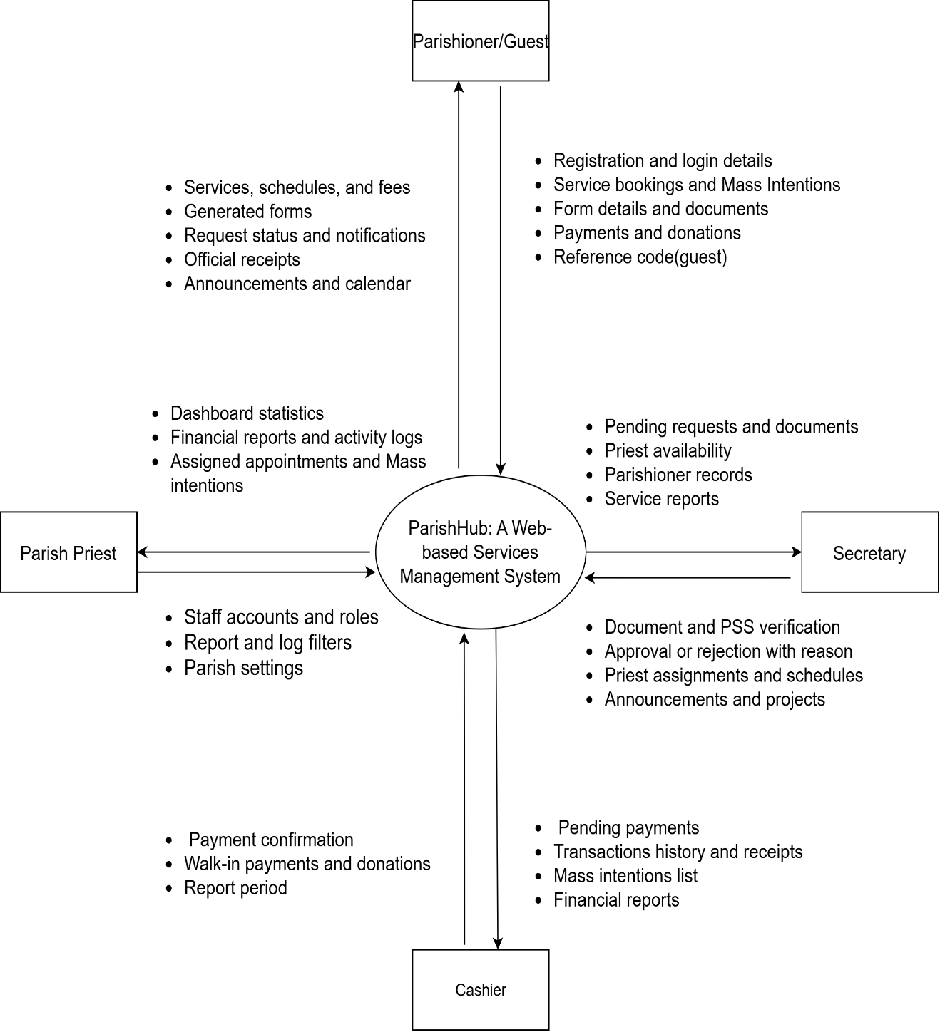

Figure 10. Context Diagram of the Proposed System

Event List
1. Account Registration
2. User Login and Role-Based Access
3. Viewing Services and Requirements
4. Booking a Parish Service
5. Submitting a Mass Intention
6. Generating Parish Forms
7. Uploading Required Documents
8. Reviewing Documents and PSS Classification
9. Approving or Rejecting Requests
10. Assigning Priests and Managing Unavailability
11. Processing Payments
12. Confirming Payments and Issuing Receipts
13. Confirming and Completing Appointments
14. Donating to the Parish
15. Checking Request Status
16. Managing Calendar, Schedules, and Locations
17. Publishing Announcements and Projects
18. Asking the Parish Chatbot
19. Generating Reports
20. Managing Users and Roles
21. Viewing Activity Logs
22. Viewing Priest Schedule and Mass Intentions
Event List Diagram
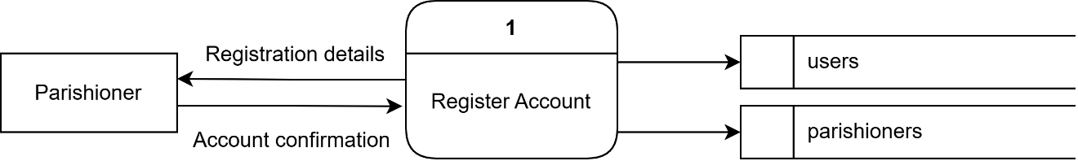
Figure 11. Account Registration
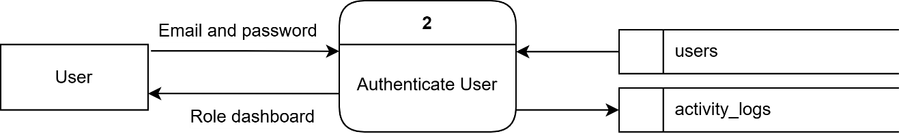
Figure 12. User Login and Role-Based Access
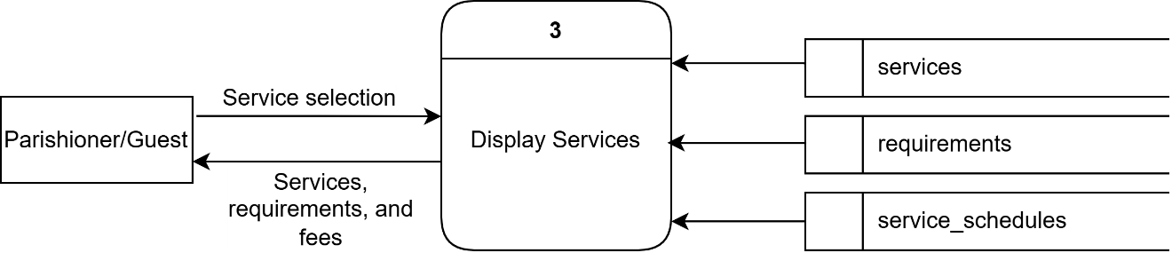
Figure 13. Viewing Services and Requirements
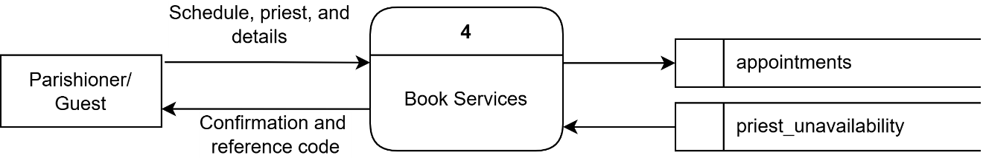
Figure 14. Booking a Parish Service
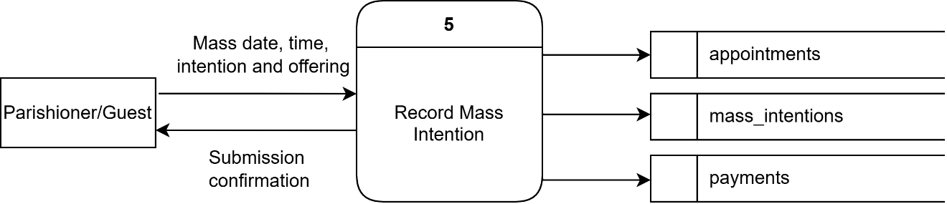
Figure 15. Submitting a Mass Intention

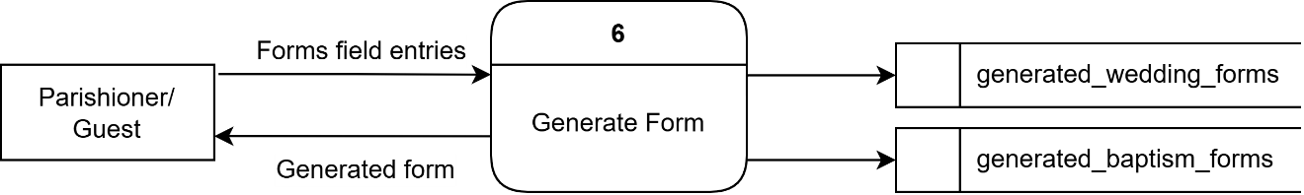
Figure 16. Generating Parish Forms
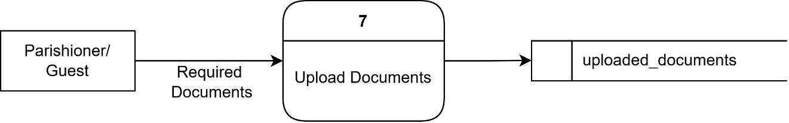
Figure 17. Uploading Required Documents
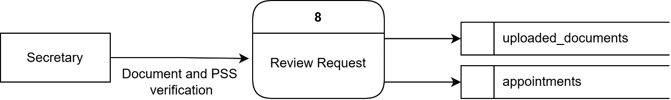
Figure 18. Reviewing Documents and PSS Classification
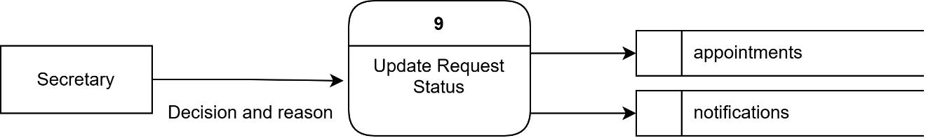
Figure 19. Approving or Rejecting Requests
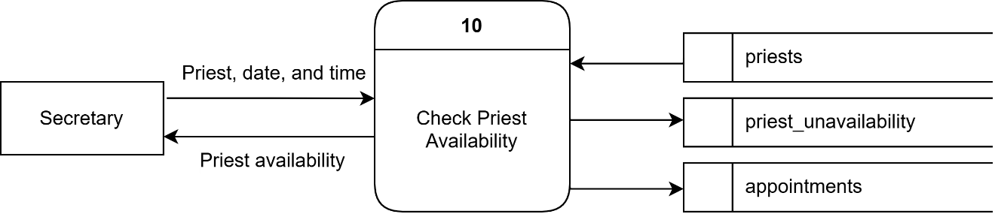
Figure 20. Assigning Priests and Managing Unavailability
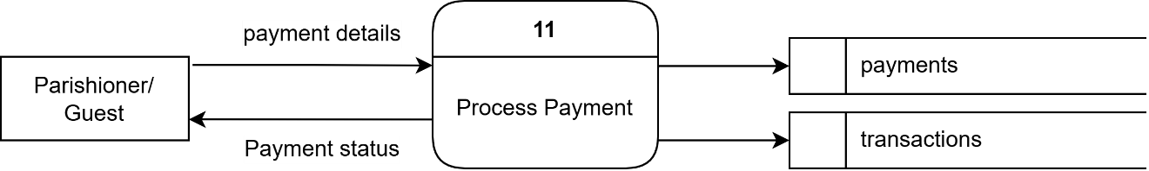
Figure 21. Processing Payments
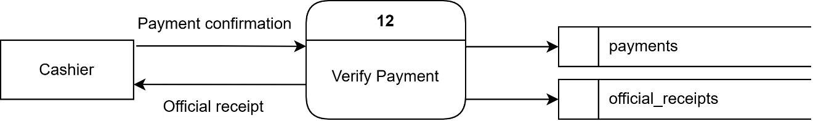
Figure 22. Confirming Payments and Issuing Receipts
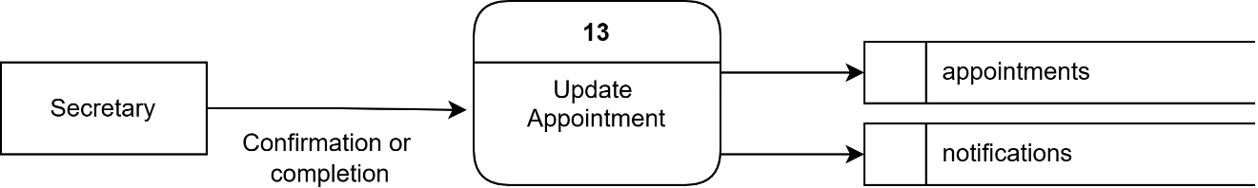
Figure 23. Confirming and Completing Appointments
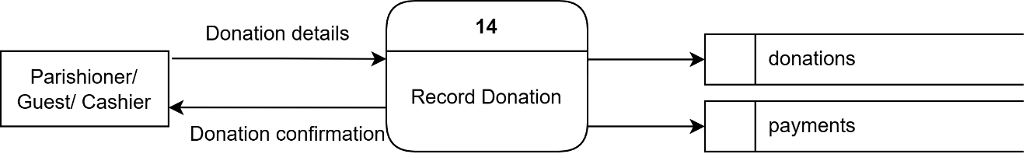
Figure 24. Donating to the Parish
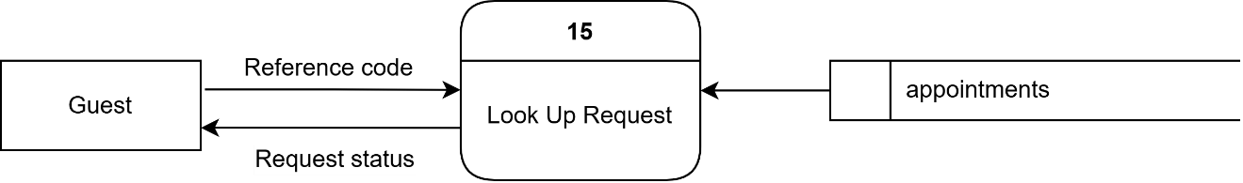
Figure 25. Checking Request Status
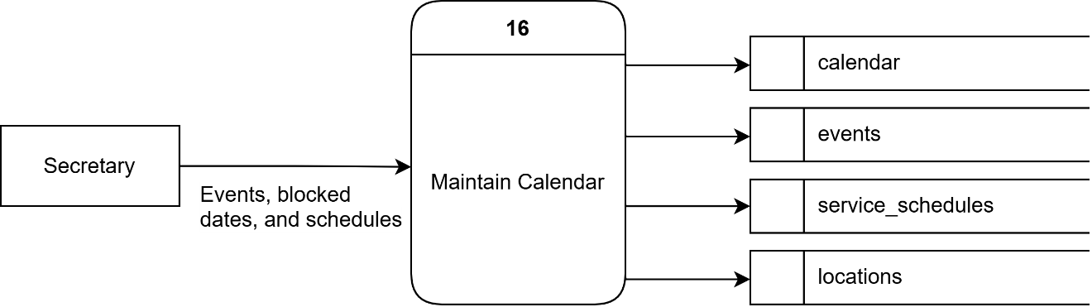
Figure 26. Managing Calendar, Schedules, and Locations

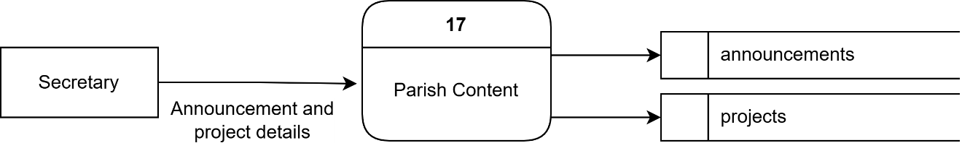
Figure 27. Publishing Announcements and Projects
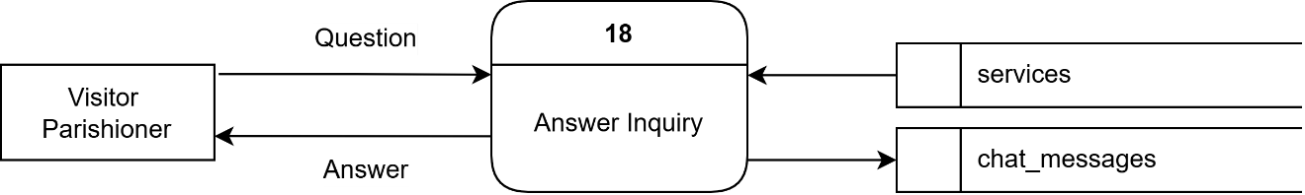
Figure 28. Asking the Parish Chatbot
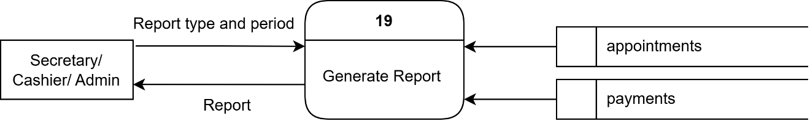
Figure 29. Generating Reports
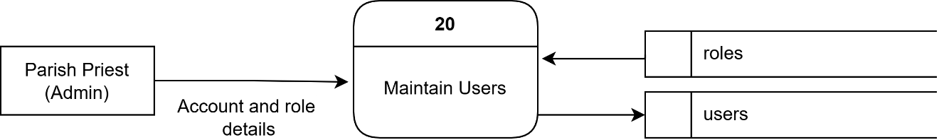
Figure 30. Managing Users and Roles
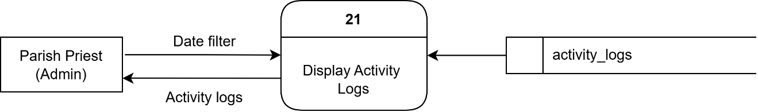
Figure 31. Viewing Activity Logs
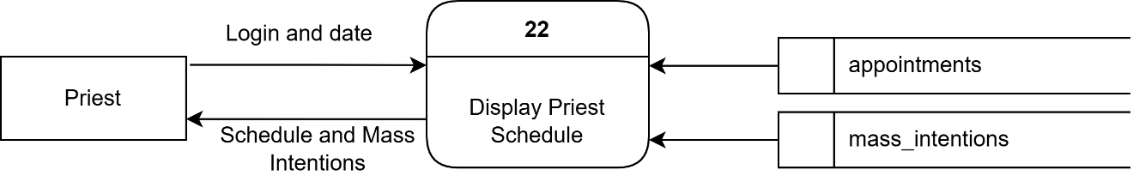
Figure 32. Viewing Priest Schedule and Mass Intentions

Process Specification
1. Home Page Process
Begin
Display parish banner, Latest Announcements, Today’s Mass Intentions, and Sacraments & Offerings
If Visitor selects "Get Started"
Redirect to Registration Page
End If
If Visitor selects "Sign In"
Redirect to Login Page
End If
If Visitor selects an announcement
Display announcement details in a modal
End If
If Visitor opens the chatbot
Perform Chatbot Process
End If
End
2. Login Process
Begin
Display Login Form
User enters Email Address and Password
Click "Sign In"
If credentials are valid
If account status is not active
Display "Your account is not active. Please contact the parish office."
Else
Record login in Activity Logs
If role is Admin
Redirect to Admin Dashboard
Else If role is Secretary
Redirect to Secretary Dashboard
Else If role is Cashier
Redirect to Cashier Dashboard
Else If role is Priest
Redirect to Priest Dashboard
Else
Redirect to Parishioner Dashboard
End If
End If
Else
Display "Incorrect email or password. Please try again."
End If
End
3. Registration Process
Begin
Display Registration Form
Parishioner enters Last Name, First Name, Middle Name (optional), Email Address, Password, Confirm Password, Phone Number, Birthdate, Gender, and Address
Click "Create Account"
If any required field is empty
Display the error message under the empty field
Else If email format is invalid
Display "Invalid email address format."
Else If password is less than 8 characters
Display "Password must be at least 8 characters."
Else If passwords do not match
Display "Passwords do not match. Please re-enter them."
Else If phone number is not 11 digits starting with 09
Display "Phone number must be exactly 11 digits starting with 09."
Else If email already exists
Display "An account with that email already exists."
Else
Save account with the Parishioner role
Display "Account created" confirmation
Redirect to Login Page
End If
End
4. Services Browsing Process
Begin
Display list of active services with description, requirements, and fee
If User clicks "Book Now"
If service is Mass Intention
Perform Mass Intention Process
Else
Perform Service Booking Process
End If
End If
If User clicks "Donate Now" and donations are enabled
Perform Donation Process
End If
End
5. Service Booking Process
Begin
Display Booking Modal for the selected service
If User is a guest
User enters Full Name, Phone Number, and Email (optional)
End If
If service is Baptism or Wedding
User selects "Regular" or "Special" schedule
If "Regular"
Display calendar with only the available Regular dates
Else
User selects preferred date and time
End If
User selects PSS classification and enters the number of sponsors
Else If service is Funeral
User selects Misa sa Lubong or Misa sa Haya ug Misa sa Sementeryo
User enters Date of Death
System sets the time to 1:00 PM
Else If service is House Blessing
User selects date and time and enters Contact Number and Location
End If
System displays available priests for the date and time
User selects preferred priest (optional)
User fills out the generated forms and uploads required documents
Click "Submit Request"
If date is on Monday afternoon or Tuesday
Display "The parish office is closed every Monday afternoon and all day Tuesday (staff day off). Please choose another date."
Else If date is blocked, slot is taken, or time is during a scheduled Mass
Display schedule conflict message
Else If selected priest is unavailable
Display priest unavailability message
Else If a required document is missing or invalid
Display document validation message
Else
Save appointment with Pending status, documents, and generated forms
Notify the Secretary
If User is a guest
Display Reference Code
End If
Display "Request submitted" confirmation
End If
End
6. Mass Intention Process
Begin
Display Mass Intention Form
User selects Preferred Date
System displays the Mass times for the date
User selects Mass time, Intention Type, and enters Offerer Name, Intention For, and Message (optional)
User enters Offering Amount
If time is not an official Mass time for the date
Display Mass time message
Else If amount is not greater than ₱0.00
Display "Payment is required before submitting a Mass Intention. Please enter a valid amount."
Else
Save Mass Intention
Perform Payment Process
If payment is confirmed
Set status to Approved automatically
Add the intention to the Mass Intentions list
End If
End If
End
7. Generate Wedding and Baptism Forms Process
Begin
Display required form fields (Matrimony Application, Katin-awan, Cluster Clearance)
User enters the form details
Click "Generate Form"
If required fields are incomplete or invalid
Display validation message under the field
Else
System fills the parish template with the entered details
Save the generated form for the Secretary’s checking
Display the generated form with Download and Print options
End If
End
8. Payment Process
Begin
If appointment status is Approved
Display amount to pay
If PSS classification is pending verification
Display "The parish office must verify the PSS classification before payment can be submitted."
Else
User selects "Pay Online" or "Pay in Cash"
If "Pay Online"
Create PayMongo checkout session
Redirect to PayMongo (GCash, Maya, or Card)
If PayMongo confirms payment
Set payment to Verified
Generate Official Receipt
Set appointment status to Payment Verified
Else
Mark payment as failed or cancelled
End If
Else
Record pending cash payment for the Cashier
End If
End If
End If
End
9. Donation Process
Begin
Display Donation Form
User enters Donor Name (optional), Email (optional), and Amount
User selects Purpose, Ongoing Project (optional), and Payment Method
Click "Donate Now"
If amount is not greater than zero
Display "Please enter a valid donation amount (more than zero)."
Else
Save donation
Perform Payment Process
Display donation confirmation
End If
End
10. Check Status Process
Begin
Display Reference Code input
Guest enters Reference Code
Click "Check Status"
If Reference Code is found
Display service, schedule, status, documents, and payment
If a document is rejected
Allow guest to replace the document
End If
If status is Approved and unpaid
Display "Pay Now" button
End If
Else
Display "No request found" message
End If
End
11. My Appointments Process
Begin
Display list of appointments sorted newest first (Upcoming and History)
If Parishioner selects "View"
Display appointment details, documents, payment, and receipt
End If
If status is Approved
Display "Proceed to Payment" button
End If
If a document is rejected
Allow upload of a replacement document
End If
If Parishioner clicks "Cancel" and status is not yet Confirmed
Ask for cancellation reason and confirmation
Set status to Cancelled
End If
End
12. Chatbot Process
Begin
Display chat window
User types a question or selects a suggested topic
System matches the question to a known topic
If topic is found
Retrieve answer from parish services, schedules, priests, and settings
Else
Display default reply with the parish contact details
End If
Save the exchange to chat messages
End
13. Appointment Review Process (Secretary)
Begin
Display list of appointments filtered by status
Secretary selects "Review"
Display request details, documents, generated forms, and priest availability
For each document
If document is valid
Mark document as Approved
Else
Enter rejection reason
Mark document as Rejected and notify parishioner
End If
End For
If PSS classification is pending
Secretary verifies PSS or Non-PSS
System computes and saves the fee
End If
If Secretary clicks "Approve"
If all documents are approved
Set status to Approved and notify parishioner
Else
Display "Verify all required documents first" message
End If
Else If Secretary clicks "Reject"
Enter reason for rejection
Set status to Rejected and notify parishioner
End If
End
14. Assign Priest and Reschedule Process
Begin
Secretary selects a priest or a new date and time
System checks schedule rules and priest availability
If no conflict
Save changes
Notify parishioner
Else
Display conflict message
End If
End
15. Confirm and Complete Appointment Process
Begin
If status is Payment Verified
Secretary clicks "Confirm"
Set status to Confirmed and notify parishioner
End If
If status is Confirmed and service date has passed
Secretary clicks "Mark as Completed"
Set status to Completed
End If
End
16. Priest Unavailability Process
Begin
Display list of priest unavailability
Secretary selects Priest, Date, Start Time and End Time (optional), Repeat Until (optional), and Reason
Click "Save"
If date is in the past
Display "Please choose a valid date that is today or later."
Else If end time is not later than start time
Display "The end time must be later than the start time."
Else If priest is already booked within the period
Display "Cannot mark this priest unavailable ... Reschedule or reassign that appointment first."
Else
Save unavailability
End If
End
17. Regular Schedules Process
Begin
Display Regular schedules per service
Secretary selects Service, Weekday, Occurrence (e.g., 1st, 3rd, or every week), and Time
Click "Add Schedule"
If the same schedule already exists
Display "That service already has the same regular schedule configured."
Else
Save schedule
End If
If Secretary clicks "Edit" or "Delete"
Ask for confirmation
Update or remove schedule
End If
End
18. Calendar and Locations Process
Begin
Display parish calendar with events, blocked dates, and appointments
If Secretary clicks a date
Display "Add Event" and "Block Date" forms
End If
If Secretary adds an event
Secretary enters Title, Description, Date, Time, Location, and Priest
Save event
End If
If Secretary blocks a date
Secretary enters Title and Notes
Save blocked date
End If
If Secretary manages locations
Add, edit, or deactivate a location with its category
End If
End
19. Announcements and Projects Process
Begin
Display list of announcements
Secretary enters Title, Content, Category, Image (optional), and Display Period
Click "Publish"
If title or content is empty
Display required field message
Else
Save and publish announcement
End If
If Secretary manages ongoing projects
Enter Project Name, Description, and Target Amount
Save project and display donation progress
End If
End
20. Parishioner Management Process
Begin
Display list of parishioners
Staff searches or filters parishioners
If Staff selects "View"
Display profile details, appointments, and donations
End If
If Staff updates account details or status
Save changes
Record in Activity Logs
End If
End
21. Payment Confirmation Process (Cashier)
Begin
Display Transaction History filtered by date, payment method, and status
Cashier selects "View"
Display payment details and proof
If payment is valid
Cashier clicks "Confirm Payment"
Set payment to Verified
Generate Official Receipt (OR-YYYY-000000)
Set appointment status to Payment Verified and notify parishioner
End If
If Cashier records a walk-in payment
Enter Appointment Number and Amount
If appointment is not awaiting payment
Display "Appointment is not awaiting payment" message
Else
Save and verify payment
End If
End If
End
22. Mass Intentions List Process
Begin
Display confirmed Mass intentions grouped by date and Mass time
User selects a date
If User clicks "Print"
Display printable list for reading during the Mass
End If
End
23. Financial Reports Process
Begin
User selects report type (Daily, Weekly, Monthly, or Yearly) and period
System retrieves verified payments and donations
Display total income, collections per service type, payment methods, and donations
If User clicks "Print" or "Export"
Generate printable report
End If
End
24. Service Reports Process (Secretary)
Begin
Secretary selects report period (Weekly, Monthly, or Yearly)
System retrieves appointments by service and status
Display services and appointment summary
If Secretary clicks "Print"
Generate printable report
End If
End
25. Users and Roles Process (Administrator)
Begin
Display list of staff accounts
If Admin clicks "Add User"
Admin enters name, email, password, and role
If email already exists
Display "Failed to create user (email may already exist)."
Else
Save user
End If
End If
If Admin changes a role or status
Ask for confirmation
Save changes and record in Activity Logs
End If
End
26. Activity Logs Process
Begin
Display activity logs grouped by date
Admin selects date range
Display user, action, module, IP address, and time of each log
End
27. Settings and Profile Process
Begin
Display profile details
User edits name, email, contact number, or profile photo
If details are invalid
Display validation message
Else
Save profile
End If
If User changes password
If current password is incorrect
Display "Current password is incorrect."
Else If new passwords do not match or are less than 8 characters
Display password error message
Else
Save new password
End If
End If
End
28. Priest Portal Process
Begin
Display priest dashboard with assigned upcoming appointments
If Priest opens Parish Calendar
Display events and assigned appointments
End If
If Priest opens Mass Intentions
Display Mass intentions per date and Mass time
End If
End
29. Notification Process
Begin
When a request, document, or payment status changes
Create notification for the parishioner
Display unread count on the bell icon
If Parishioner opens Notifications
Display notifications and mark them as read
End If
End
30. Automatic Cancellation Process
Begin
For each Approved appointment without a verified payment
If the appointment date has passed
Set status to Cancelled
Notify parishioner
End If
End For
End
31. Logout Process
Begin
User clicks "Logout"
Display "Are you sure you want to log out?"
If User confirms
End session
Redirect to Login Page
End If
End

Figure 33. Program Hierarchy (Public / Guest)

Figure 34. Program Hierarchy (Parishioner)

Figure 35. Program Hierarchy (Secretary)

Figure 36. Program Hierarchy (Cashier)

Figure 37. Program Hierarchy (Administrator / Parish Priest)

Figure 38. Program Hierarchy (Priest)
Database Design
The following tables present the database structure of ParishHub: A Web-Based Service Management System and describe the information stored and managed by each table. The database is implemented in PostgreSQL through Supabase.
Table 1. Roles: This table contains the user roles of the system.
Field name | Data type | Description
role_id | serial | Unique identifier of each role.
role_name | varchar | Name of the role (Parishioner, Secretary, Cashier, Admin, Priest).
description | varchar | Short description of the role.
created_at | timestampz | Date and time the role was created.

Table 2. Permissions: This table contains the permission keys that may be granted to roles.
Field Name | Data Type | Description
permission_id | serial | Unique identifier of each permission.
permission_key | varchar | Unique key of the permission.
description | varchar | Description of the permission.

Table 3. Role_permissions: This table links roles to their permissions.
Field Name | Data Type | Description
role_id | int | Identifier of the role.
permission_id | int | Identifier of the permission granted to the role.

Table 4. Users: This table contains the account information of all users of the system.
Field Name | Data Type | Description
user_id | serial | Unique identifier of each user.
role_id | int | Identifier of the user’s role.
firstname | varchar | First name of the user.
lastname | varchar | Last name of the user.
middlename | varchar | Middle name of the user (optional).
email | varchar | Unique email address used for logging in.
password | varchar | Encrypted (hashed) password of the user.
phone | varchar | Mobile number of the user.
address | varchar | Address of the user.
birthdate | date | Birthdate of the user.
gender | enum | Gender of the user (Male or Female).
profile_photo | varchar | File path of the profile photo.
status | enum | Account status (active, inactive, or suspended).
email_verified_at | timestamptz | Date and time the email was verified.
remember_token | varchar | Token used for remembering the login session.
created_at | timestamptz | Date and time the account was created.
updated_at | timestamptz | Date and time the account was last updated.
Table 5. Parishioners: This table contains the additional details of parishioner accounts.
Field Name | Data Type | Description
parishioner_id | serial | Unique identifier of each parishioner.
user_id | int | Identifier of the parishioner’s user account.
baptism_date | date | Date of baptism of the parishioner.
confirmation_date | date | Date of confirmation of the parishioner.
marital_status | enum | Marital status (Single, Married, Widowed, or Separated).
occupation | varchar | Occupation of the parishioner.
emergency_contact_name | varchar | Name of the emergency contact person.
emergency_contact_number | varchar | Number of the emergency contact person.

Table 6. Priests: This table contains the records of the priests of the parish.
Field Name | Data Type | Description
priest_id | serial | Unique identifier of each priest.
user_id | int | Identifier of the priest’s portal account, if any.
full_name | varchar | Full name of the priest.
title | varchar | Title of the priest (e.g., Rev. Fr.).
contact_number | varchar | Contact number of the priest.
email | varchar | Email address of the priest.
status | enum | Status of the priest (active, on_leave, or inactive).
created_at | timestamptz | Date and time the record was created.

Table 7. Priest_unavailability: This table contains the dates and times when a priest is not available.
Field Name | Data Type | Description
unavailability_id | serial | Unique identifier of each record.
priest_id | int | Identifier of the priest.
unavailable_date | date | Date when the priest is unavailable.
start_time | time | Start of the unavailable period (blank for whole day).
end_time | time | End of the unavailable period (blank for whole day).
reason | varchar | Reason for the unavailability.
created_by | int | User who recorded the unavailability.
created_at | timestamptz | Date and time the record was created.

Table 8. Services: This table contains the parish services offered in the system.
Field Name | Data Type | Description
service_id | serial | Unique identifier of each service.
service_name | varchar | Name of the service.
category | enum | Category of the service (Mass Intention, Wedding, Baptism, Funeral, Blessing, Confirmation, First Communion, Donation).
description | text | Description of the service.
fee | numeric | Default fee of the service.
requirements | text | Requirements of the service.
duration_minutes | int | Estimated duration of the service.
is_active | boolean | Indicates whether the service can be booked.
created_at | timestamptz | Date and time the service was created.
updated_at | timestamptz | Date and time the service was last updated.

Table 9. Requirements: This table contains the individual requirements of each service.
Field Name | Data Type | Description
requirement_id | serial | Unique identifier of each requirement.
service_id | int | Identifier of the service.
requirement_name | varchar | Name of the required document.
is_mandatory | boolean | Indicates whether the requirement is mandatory.

Table 10. Service_schedules: This table contains the Regular schedules of the services.
Field Name | Data Type | Description
schedule_id | serial | Unique identifier of each schedule.
service_id | int | Identifier of the service.
weekday | smallint | Day of the week (0 = Sunday to 6 = Saturday).
occurrence | smallint | Occurrence of the weekday in the month (1st to 5th; blank for every week).
slot_time | time | Fixed time of the schedule.
is_active | boolean | Indicates whether the schedule is active.
created_by | int | User who created the schedule.
created_at | timestamptz | Date and time the schedule was created.

Table 11. Service_fee_rules: This table contains the fee rules used to compute the fees of baptism, wedding, and funeral Masses.
Field Name | Data Type | Description
fee_rule_id | serial | Unique identifier of each fee rule.
service_category | varchar | Service category covered by the rule.
schedule_type | varchar | Schedule type (Regular, Special, or Any).
pss_classification | varchar | PSS classification (pss or non_pss).
base_fee | numeric | Base fee of the service.
priest_stipend | numeric | Stipend for the priest.
included_sponsors | int | Number of sponsors included in the fee.
additional_sponsor_fee | numeric | Fee for each additional sponsor.

Table 12. Appointment_status: This table contains the possible statuses of an appointment.
Field Name | Data Type | Description
status_id | serial | Unique identifier of each status.
status_name | varchar | Name of the status (Pending, Approved, Rejected, Payment Verified, Confirmed, Completed, Cancelled).

Table 13. Appointments: This table contains the service requests and appointments of parishioners and guests.
Field Name | Data Type | Description
appointment_id | serial | Unique identifier of each appointment.
parishioner_id | int | Identifier of the parishioner who made the request.
service_id | int | Identifier of the requested service.
priest_id | int | Identifier of the assigned priest.
appointment_date | date | Scheduled date of the service.
appointment_time | time | Scheduled time of the service.
status_id | int | Current status of the appointment.
remarks | text | Additional remarks of the requester.
approved_by | int | User who approved the request.
approved_at | timestamptz | Date and time of approval.
confirmed_by | int | User who confirmed the appointment.
confirmed_at | timestamptz | Date and time of confirmation.
cancelled_reason | varchar | Reason for cancellation.
rejection_reason | varchar | Reason for rejection.
date_of_death | date | Date of death (funeral Masses only).
schedule_type | varchar | Schedule type (Regular or Special).
pss_claim | varchar | PSS classification claimed by the requester.
pss_classification | varchar | PSS classification verified by the secretary.
pss_verified_by | int | User who verified the PSS classification.
pss_verified_at | timestamp | Date and time of PSS verification.
sponsor_count | int | Number of baptismal sponsors.
wedding_sponsor_count | int | Number of wedding sponsors.
fee_snapshot | jsonb | Saved computation of the service fee.
requirements_snapshot | jsonb | Saved list of requirements at the time of booking.
guest_name | varchar | Name of the guest requester.
guest_email | varchar | Email of the guest requester.
guest_phone | varchar | Mobile number of the guest requester.
guest_reference | varchar | Unique reference code given to the guest.
contact_phone | varchar | Contact number for the service (e.g., house blessing).
location_address | text | Location of the service (e.g., house blessing).
created_at | timestamptz | Date and time the request was submitted.
updated_at | timestamptz | Date and time the request was last updated.

Table 14. Mass_intentions: This table contains the details of Mass intentions.
Field Name | Data Type | Description
intention_id | serial | Unique identifier of each Mass intention.
appointment_id | int | Identifier of the related appointment.
intention_type | enum | Type of intention (Living, Dead, Thanksgiving, Healing, Birthday).
offerer_name | varchar | Name of the person offering the Mass.
intention_for | varchar | Person or intention prayed for.
message | text | Optional message to be read.

Table 15. Donations: This table contains the details of donations to the parish.
Field Name | Data Type | Description
donation_id | serial | Unique identifier of each donation.
appointment_id | int | Identifier of the related transaction record.
project_id | int | Identifier of the supported ongoing project.
donor_name | varchar(150) | Name of the donor (optional).
donor_email | varchar(150) | Email of the donor (optional).
purpose | varchar(50) | Purpose of the donation.
message | text | Optional message of the donor.

Table 16. Projects: This table contains the ongoing projects of the parish.
Field Name | Data Type | Description
project_id | serial | Unique identifier of each project.
project_name | varchar | Name of the project.
description | text | Description of the project.
target_amount | numeric | Target amount of the project.
is_active | boolean | Indicates whether the project is ongoing.
created_by | int | User who created the project.
created_at | timestamptz | Date and time the project was created.

Table 17. Uploaded_documents: This table contains the documents uploaded or generated for a request.
Field Name | Data Type | Description
document_id | serial | Unique identifier of each document.
appointment_id | int | Identifier of the related appointment.
draft_id | bigint | Identifier of the related wedding draft.
baptism_draft_id | bigint | Identifier of the related baptism draft.
requirement_id | int | Identifier of the related requirement.
requirement_label | varchar | Name of the requirement the file satisfies.
file_name | varchar | Original name of the file.
file_path | varchar | Storage path of the file.
file_type | varchar | Type of the file.
document_source | varchar | Source of the document (uploaded or generated).
generated_form_type | varchar | Type of generated form, if any.
review_status | varchar | Review status (pending, approved, or rejected).
rejection_reason | text | Reason the document was rejected.
reviewed_by | int | User who reviewed the document.
reviewed_at | timestamptz | Date and time of review.
superseded_by | int | Replacement document of a rejected file.
verified | boolean | Indicates whether the document is verified.
uploaded_at | timestamptz | Date and time of upload.

Table 18. Generated_wedding_forms: This table contains the wedding forms filled out and generated by the system.
Field Name | Data Type | Description
generated_form_id | serial | Unique identifier of each generated form.
appointment_id | int | Identifier of the related appointment.
draft_id | bigint | Identifier of the related wedding draft.
form_type | varchar | Type of form (matrimony application, cluster clearance, wedding sponsor clearance).
form_data | jsonb | Field values entered in the form.
document_id | int | Identifier of the generated document file.
status | varchar | Status of the form (draft, generated, pending_review, approved, rejected).
created_at | timestamptz | Date and time the form was created.
updated_at | timestamptz | Date and time the form was last updated.
Table 19. Generated_baptism_forms: This table contains the baptism forms filled out and generated by the system.
Field Name | Data Type | Description
generated_form_id | bigserial | Unique identifier of each generated form.
appointment_id | int | Identifier of the related appointment.
draft_id | bigint | Identifier of the related baptism draft.
form_type | varchar | Type of form (Katin-awan sa Bunyag or Cluster Clearance for Baptismal Sponsor).
form_data | jsonb | Field values entered in the form.
document_id | int | Identifier of the generated document file.
status | varchar | Status of the form.
created_at | timestamptz | Date and time the form was created.
updated_at | timestamptz | Date and time the form was last updated.

Table 20. Wedding_booking_drafts: This table temporarily stores wedding bookings while forms and documents are being completed.
Field Name | Data Type | Description
draft_id | bigserial | Unique identifier of each draft.
parishioner_id | int | Identifier of the parishioner (blank for guests).
guest_access_token_hash | char | Hashed access token of the guest.
guest_name / guest_email / guest_phone | varchar | Contact details of the guest.
service_id | int | Identifier of the service.
priest_id | int | Identifier of the selected priest.
appointment_date / appointment_time | date / time | Selected schedule.
schedule_type | varchar | Regular or Special schedule.
pss_claim | varchar | Claimed PSS classification.
sponsor_count / wedding_sponsor_count | int | Number of sponsors.
remarks | text | Remarks of the requester.
status | varchar | Status of the draft (draft, finalized, expired, abandoned).
expires_at | timestamptz | Expiration of the draft (24 hours).
finalized_appointment_id | int | Appointment created from the draft.
created_at / updated_at | timestamptz | Date and time created and updated.

Table 21. Baptism_booking_drafts: This table temporarily stores baptism bookings while forms and documents are being completed.
Field Name | Data Type | Description
draft_id | bigserial | Unique identifier of each draft.
parishioner_id | int | Identifier of the parishioner (blank for guests).
guest_access_token_hash | char | Hashed access token of the guest.
guest_name / guest_email / guest_phone | varchar | Contact details of the guest.
service_id | int | Identifier of the service.
priest_id | int | Identifier of the selected priest.
appointment_date / appointment_time | date / time | Selected schedule.
schedule_type | varchar | Regular or Special schedule.
pss_claim | varchar | Claimed PSS classification.
sponsor_count | int | Number of sponsors.
status | varchar | Status of the draft.
expires_at | timestamptz | Expiration of the draft (24 hours).
finalized_appointment_id | int | Appointment created from the draft.
created_at / updated_at | timestamptz | Date and time created and updated.

Table 22. Calendar: This table contains the dates marked on the parish calendar, including blocked dates.
Field Name | Data Type | Description
calendar_id | serial | Unique identifier of each calendar date.
title | varchar | Title of the date entry.
calendar_date | date | Date of the entry.
is_blocked | boolean | Indicates whether bookings are blocked on the date.
notes | varchar | Notes about the date.
created_by | int | User who created the entry.
created_at | timestamptz | Date and time the entry was created.

Table 23. Locations: This table contains the locations used for parish events.
Field Name | Data Type | Description
location_id | serial | Unique identifier of each location.
name | varchar | Name of the location.
location_category | varchar | Category (barangay, school, chapel, or other).
notes | varchar | Notes about the location.
is_active | boolean | Indicates whether the location is active.
created_at | timestamptz | Date and time the location was created.

Table 24. Events: This table contains the parish events displayed on the calendar.
Field Name | Data Type | Description
event_id | serial | Unique identifier of each event.
calendar_id | int | Identifier of the related calendar date.
title | varchar(150) | Title of the event.
description | text | Description of the event.
event_date | date | Date of the event.
event_time | time | Time of the event.
location | varchar(150) | Location text of the event.
location_id | int | Identifier of the managed location.
priest_id | int | Identifier of the assigned priest.
created_by | int | User who created the event.
created_at | timestamptz | Date and time the event was created.

Table 25. Announcements: This table contains the announcements published by the parish.
Field Name | Data Type | Description
announcement_id | serial | Unique identifier of each announcement.
title | varchar(200) | Title of the announcement.
content | text | Content of the announcement.
image | varchar(255) | Image of the announcement.
posted_by | int | User who posted the announcement.
is_pinned | boolean | Indicates whether the announcement is pinned.
category | varchar(30) | Category of the announcement.
status | enum | Status (draft, published, or archived).
start_date / end_date | date | Display period of the announcement.
duration_type | varchar(20) | Type of display period (specific date, month, year, custom range).
created_at / updated_at | timestamptz | Date and time created and updated.

Table 26. Payment_methods: This table contains the accepted payment methods.
Field Name | Data Type | Description
method_id | serial | Unique identifier of each method.
method_name | varchar | Name of the method (Cash, GCash, Maya, Bank Transfer, Card, PayPal, PayMongo).

Table 27. Payments: This table contains the payments made for appointments, Mass intentions, and donations.
Field Name | Data Type | Description
payment_id | serial | Unique identifier of each payment.
appointment_id | int | Identifier of the related appointment.
reference_number | varchar(100) | Reference number of the payment.
amount | numeric | Amount paid.
method_id | int | Identifier of the payment method.
payment_status | enum | Status (pending, verified, failed, refunded, cancelled).
payment_date | timestamptz | Date and time of payment.
verified_by | int | Cashier who verified the payment.
verified_at | timestamptz | Date and time of verification.
proof_of_payment | varchar | File path of the proof of payment.
created_at | timestamptz | Date and time the record was created.

Table 28. Transactions: This table contains the online payment gateway records.
Field Name | Data Type | Description
transaction_id | serial | Unique identifier of each transaction.
payment_id | int | Identifier of the related payment.
gateway | varchar | Payment gateway used (PayMongo).
gateway_transaction_id | varchar | Checkout session identifier from the gateway.
status | varchar | Status returned by the gateway.
raw_response | text | Response received from the gateway.
created_at | timestamptz | Date and time the record was created.

Table 29. Official_receipts: This table contains the official receipts issued for verified payments.
Field Name | Data Type | Description
receipt_id | serial | Unique identifier of each receipt.
payment_id | int | Identifier of the related payment.
receipt_number | varchar(50) | Unique receipt number (OR-YYYY-000000).
issued_by | int | Cashier who issued the receipt (blank if verified by PayMongo).
issue_date | timestamptz | Date and time the receipt was issued.
pdf_path | varchar(255) | File path of the receipt.

Table 30. Notifications
This table contains the notifications sent to users.
Field Name | Data Type | Description
notification_id | serial | Unique identifier of each notification.
user_id | int | Recipient of the notification.
type | enum | Channel of the notification (email, sms, website).
category | enum | Category (appointment, payment, announcement, system).
title | varchar(150) | Title of the notification.
message | text | Message of the notification.
is_read | boolean | Indicates whether the notification was read.
created_at | timestamptz | Date and time the notification was created.

Table 31. Chat_messages
This table contains the conversations with the parish chatbot.
Field Name | Data Type | Description
message_id | serial | Unique identifier of each message.
user_id | int | User who sent the message (blank for visitors).
session_id | varchar(100) | Chat session identifier.
sender | enum | Sender of the message (user or bot).
message | text | Content of the message.
intent | varchar(100) | Detected topic of the message.
created_at | timestamptz | Date and time the message was sent.

Table 32. Activity_logs
This table contains the audit trail of the actions performed in the system.
Field Name | Data Type | Description
log_id | serial | Unique identifier of each log.
user_id | int | User who performed the action.
action | varchar(150) | Description of the action.
module | varchar(100) | Module where the action was performed.
ip_address | varchar(45) | IP address of the user.
user_agent | varchar(255) | Browser information of the user.
created_at | timestamptz | Date and time of the action.

Table 33. Reports
This table contains the records of generated reports.
Field Name | Data Type | Description
report_id | serial | Unique identifier of each report.
report_type | varchar(100) | Type of the report.
generated_by | int | User who generated the report.
date_from / date_to | date | Period covered by the report.
file_path | varchar(255) | File path of the report.
created_at | timestamptz | Date and time the report was generated.

Table 34. Settings
This table contains the parish and system settings.
Field Name | Data Type | Description
setting_key | varchar(100) | Unique name of the setting.
setting_value | text | Value of the setting.
updated_at | timestamptz | Date and time the setting was last updated.

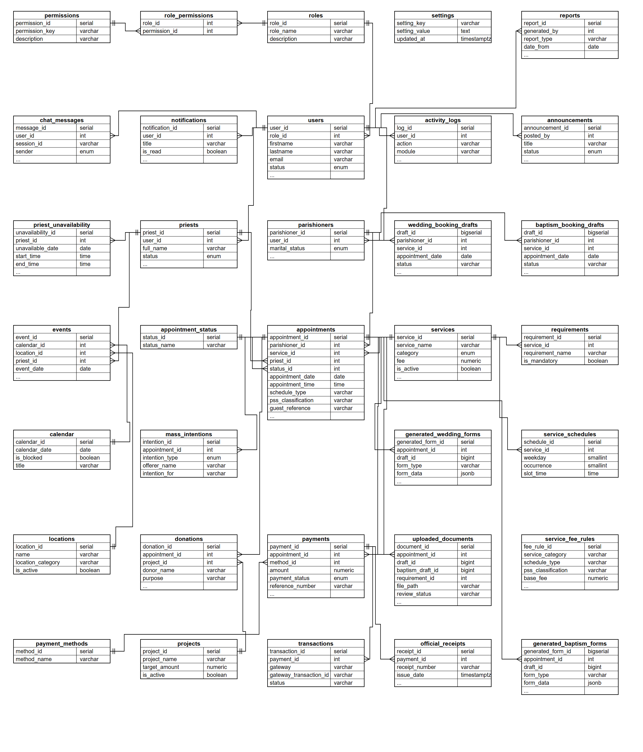

Figure 39. Database Schema
Test Data/Cases
Test Case 1: Login
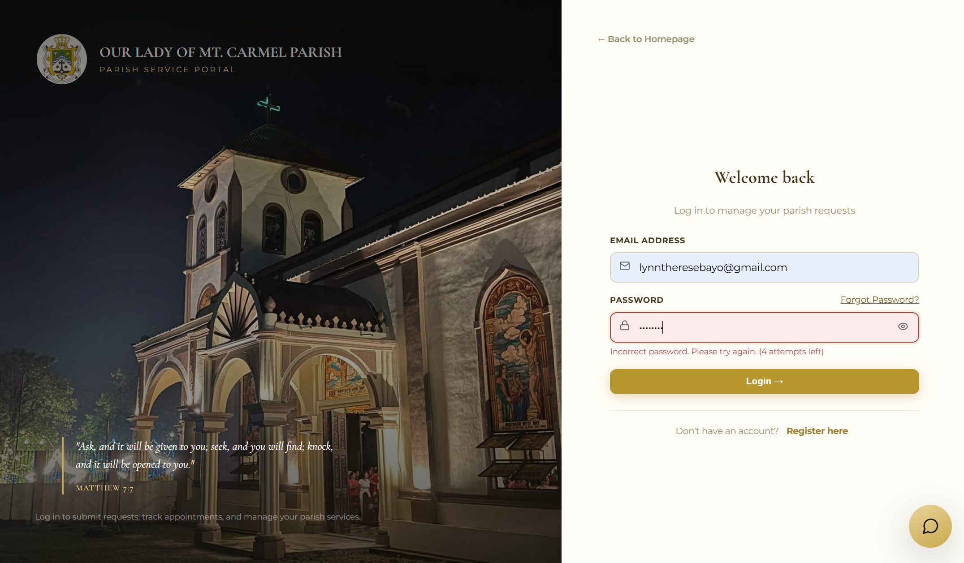
Preview 1: Invalid Login
INPUT: Registered email with an incorrect password
PROCESS: The system checks the entered email address and password against the stored account.
OUTPUT: Incorrect email or password. Please try again.

Test Case 2: Registration
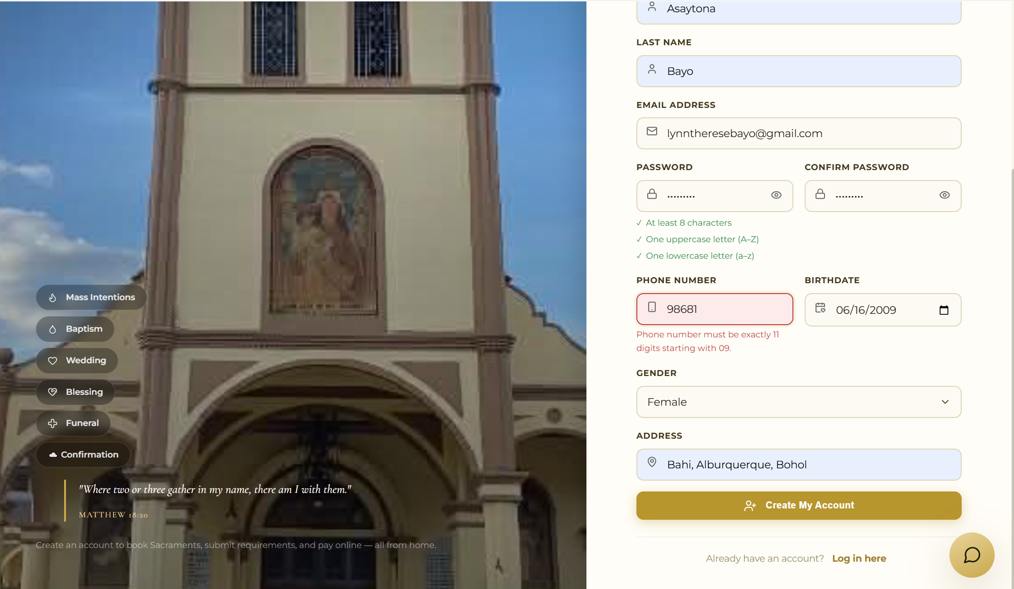
Preview 2: Invalid Phone Number on Registration
INPUT: Phone number “0912345” (less than 11 digits)
PROCESS: The system verifies that the phone number contains exactly 11 digits and starts with 09.
OUTPUT: Phone number must be exactly 11 digits starting with 09.

Test Case 3: Booking
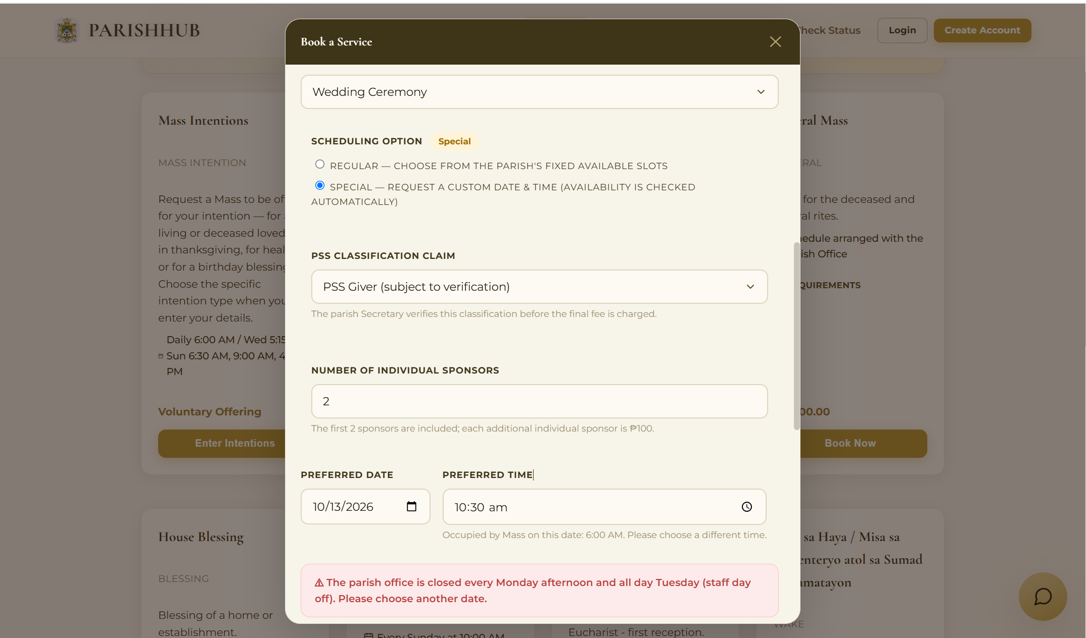
Preview 3: Booking on the Staff Day Off
INPUT: Special schedule on a Tuesday
PROCESS: The system checks the selected date and time against the office days off.
OUTPUT: The parish office is closed every Monday afternoon and all day Tuesday (staff day off). Please choose another date.

Test Case 4: Document Upload
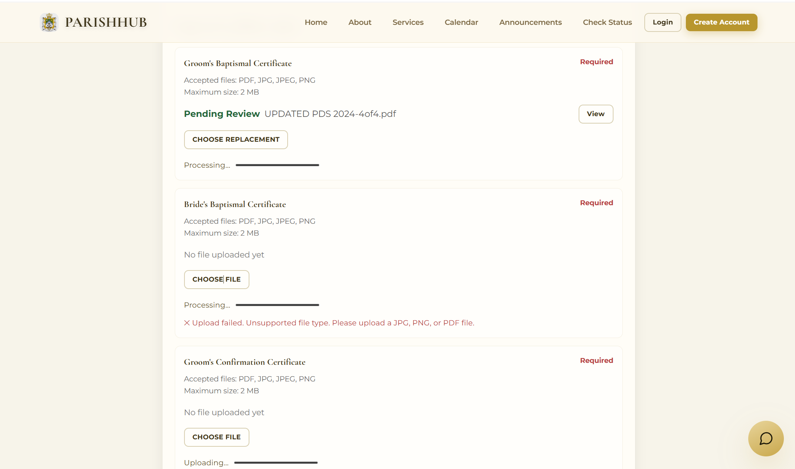
Preview 4: Unsupported File Type
INPUT: Word document (bride baptismal certificate.docx)
Valid file (bride baptismal certificate.pdf)
PROCESS: The system checks the file type of the uploaded document.
OUTPUT: Upload failed. Unsupported file type. Please upload a JPG, PNG, or PDF file.

Test Case 5: Service Booking
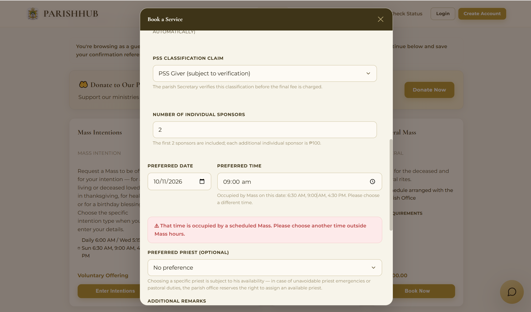
Preview 5: Booking During a Scheduled Mass
INPUT: Special wedding on a Sunday at 9:00 AM
PROCESS: The system checks whether the selected time is already occupied by a scheduled Mass.
OUTPUT: That time is occupied by a scheduled Mass. Please choose another time outside Mass hours.

Test Case 6: Funeral Mass Booking
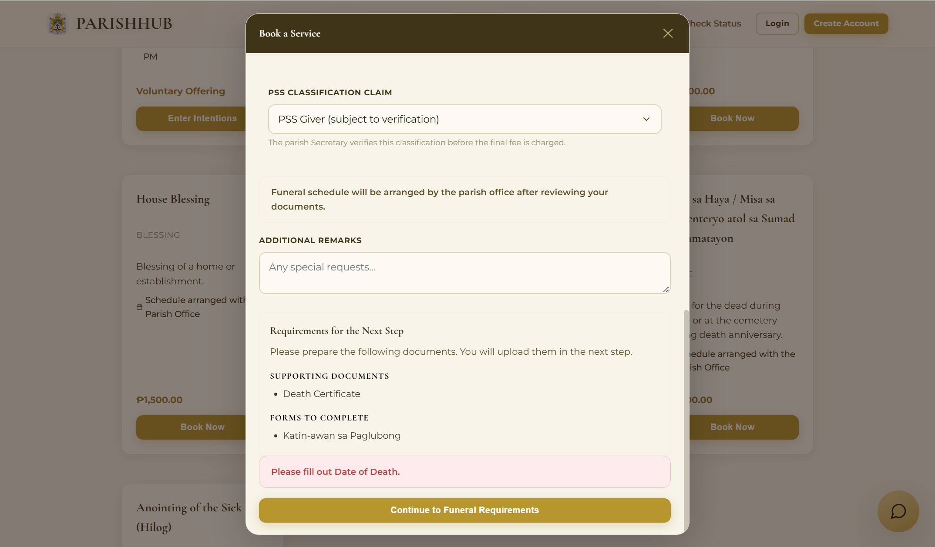
Preview 6: Missing Date of Death
INPUT: No date of death entered
PROCESS: The system requires the date of death to compute the nine-day mourning period.
OUTPUT: Please fill out Date of Death.

Test Case 7: Priest Management
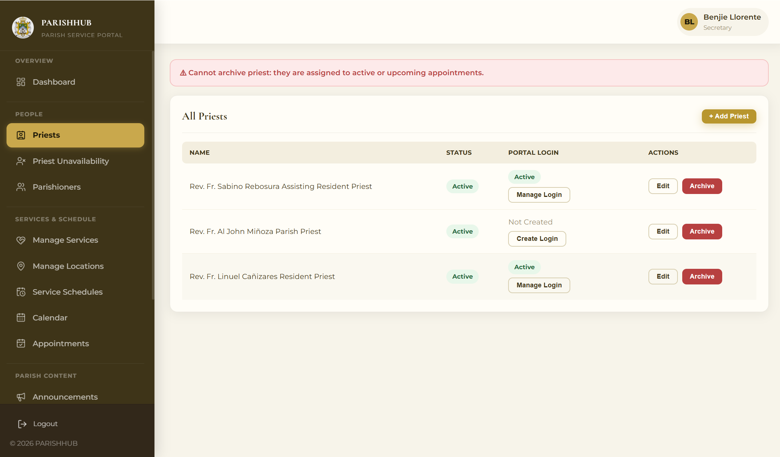
Preview 7: Archiving an Assigned Priest
INPUT: Archiving a priest who has upcoming appointments
PROCESS: The system checks whether the priest is assigned to active or upcoming appointments.
OUTPUT: Cannot remove priest: they are assigned to active or upcoming appointments.

Test Case 8: Document Upload
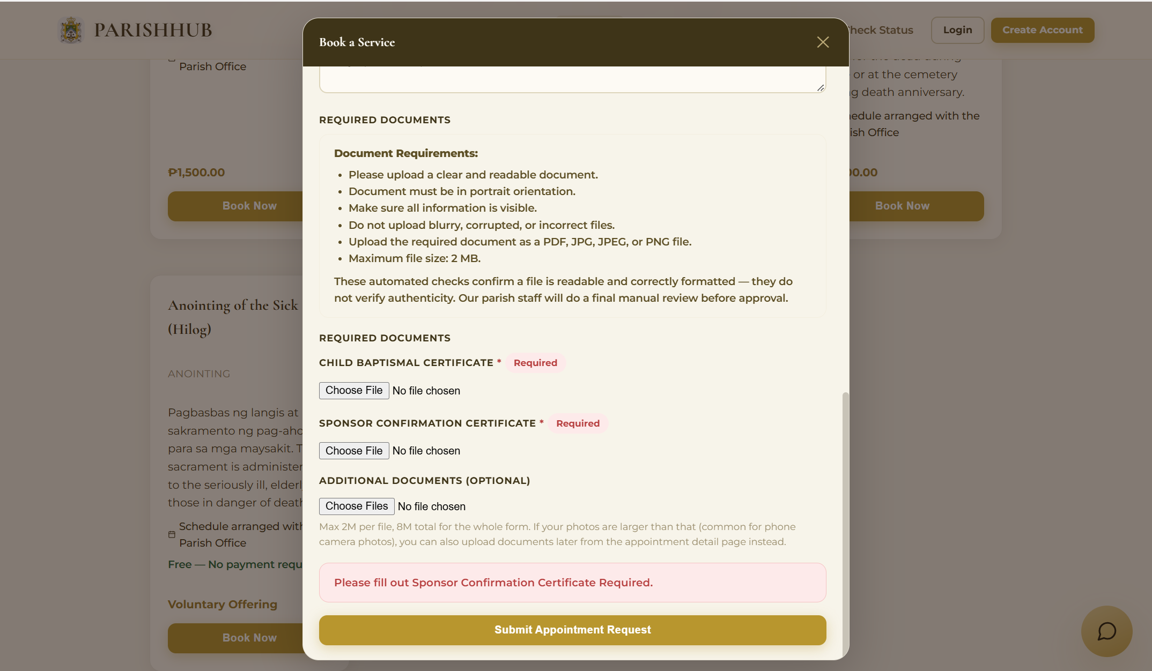
Preview 8: Missing Required Document
INPUT: No file selected for the Child’s Baptismal Certificate
PROCESS: The system checks that every required document of the service has an uploaded file.
OUTPUT: This document is required. Please choose a file to upload.

Test Case 9: Mass Intention Offering
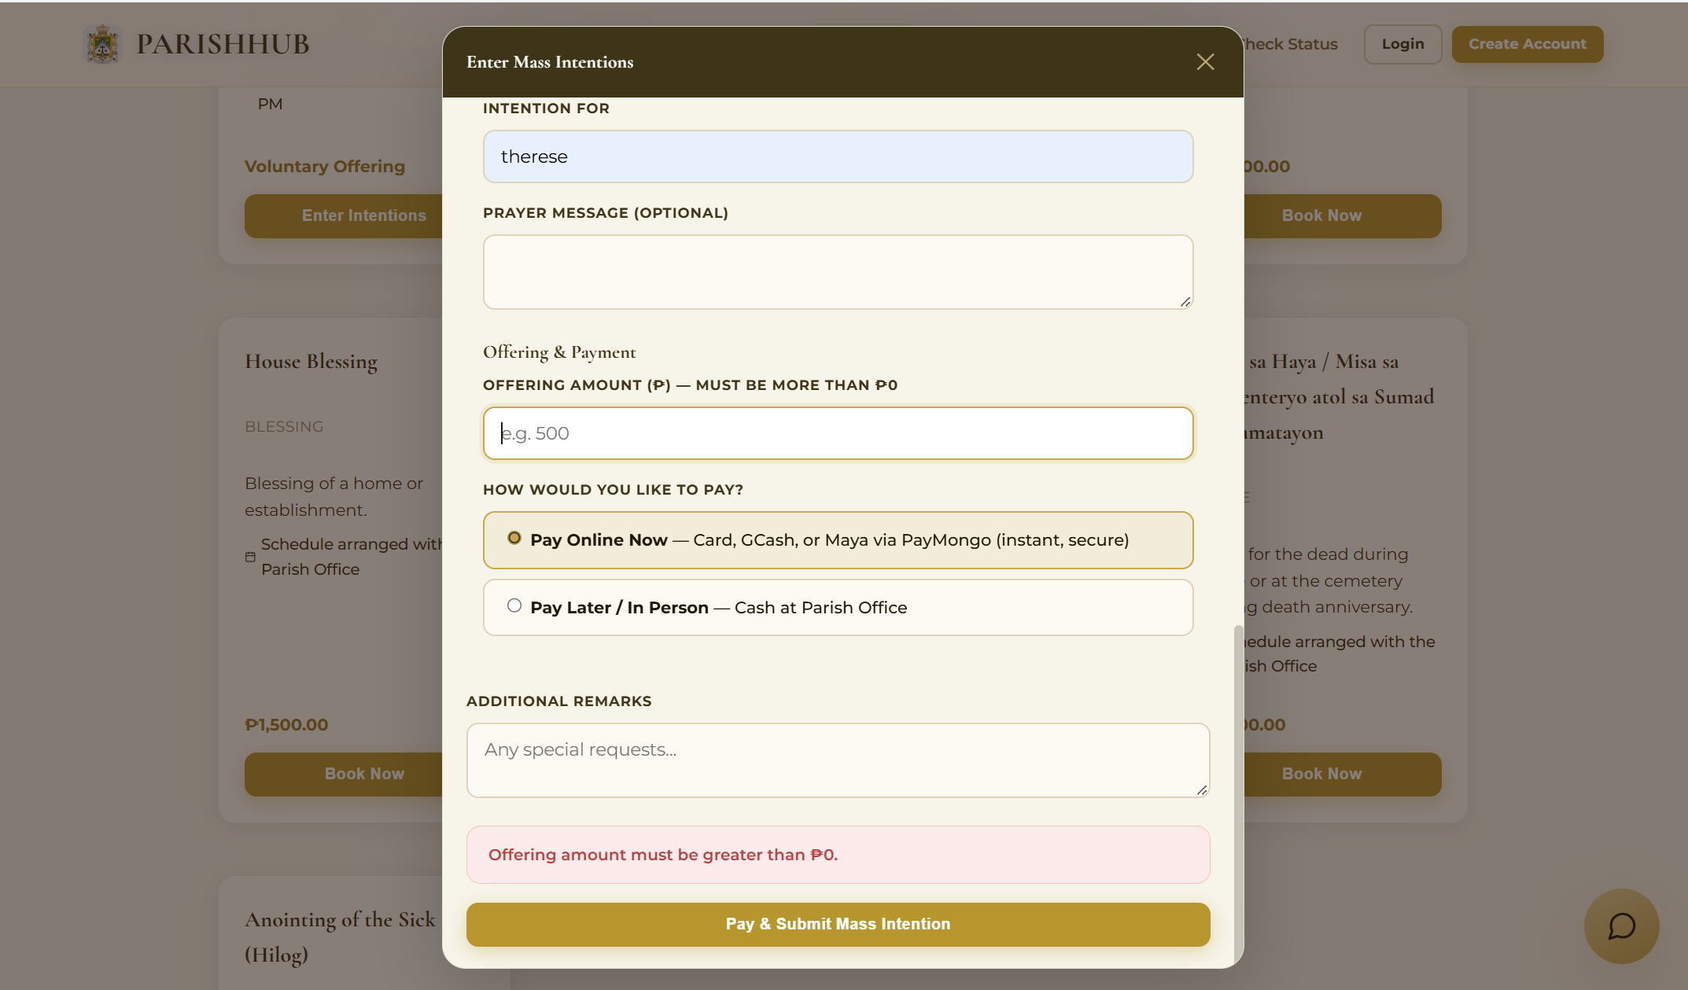
Preview 9: Zero Mass Intention Offering
INPUT: Offering amount of ₱0.00
No offering amount entered
PROCESS: The system verifies that the offering is greater than zero before the intention is submitted.
OUTPUT: Offering amount must be greater than ₱0.

Test Case 10: Change Password
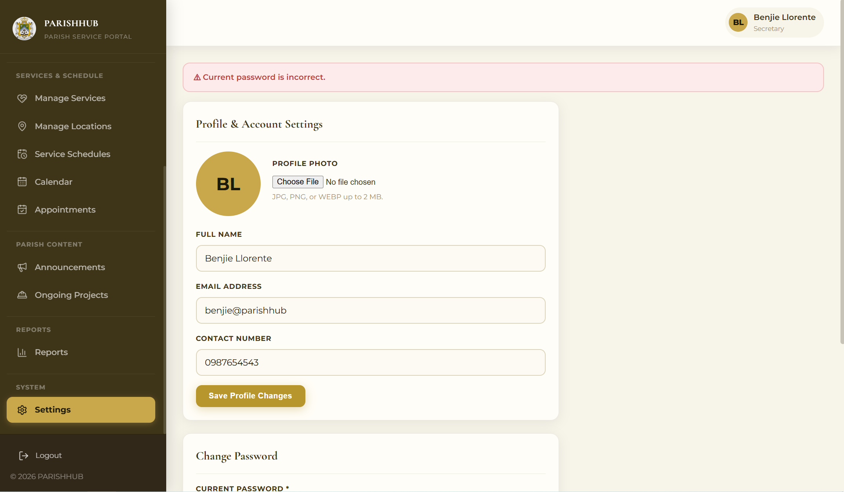
Preview 10: Incorrect Current Password
INPUT: Wrong current password
New password: Parish@2027
PROCESS: The system verifies the current password before saving the new password.
OUTPUT: Current password is incorrect.

Revision of the System
First Revision
- Migrate the database to Supabase (PostgreSQL) and deploy the system online
- Redesign the login and registration pages and add input validation
- Use the parish logo and the parish photo on the website
Second Revision
- Integrate Paymongo for Gcash, Maya, and card payments
- Allow guests to book services and donate without an account and add the Check Status page
Third Revision
- Separate the full name into last name, first name, and middle name and strengthen form validation
- Compute baptism, wedding, and funeral fees based on the scheduled type, PSS classification, and number of sponsors.
- Add generated wedding and baptism forms (Matrimony Application, Katin-awan, and Cluster Clearance) and store documents in Supabase Storage

Technical Requirements
Hardware, software, and peopleware are three essential requirements needed for the implementation of ParishHub: A Web-Based Service Management System. These components must work together effectively to ensure the system’s stability, efficiency, and long-term usability for managing parish services.
Hardware Specification
Hardware refers to the physical components of the computer system and mobile devices used to access and operate ParishHub. Since ParishHub is a purely web-based system hosted in the cloud, computers, laptops, tablets, or mobile phones may be used to access its functions, including booking services, paying, monitoring requests, and generating reports. The parish staff and parishioners may use similar hardware specifications because the system’s database and backend services are cloud-based, requiring users only to have a device capable of running a modern web browser. To ensure smooth and efficient performance, the following client specifications are recommended:
- Random Access Memory (RAM): Minimum of 4GB
- Processor: 1.5 GHz dual-core processor or higher
- Storage: At least 32 GB of internal storage for the operating system and browser.
- Display: 6-inch touchscreen display or higher (mobile) or 13-inch display with 1366 x 768 resolution (desktop/laptop).
- Printer: Any printer for printing official receipts, generated forms, Mass intentions, and reports (parish office)
- Connectivity: Minimum of 5 Mbps broadband or stable 4G/LTE mobile data connection.
Software Requirements
Software refers to the set of instructions that enables the computer to process, store, and retrieve data effectively. ParishHub requires both system software to operate efficiently.
Operating System
Because ParishHub is a web-based system, it can run on any modern operating system equipped with a supported web browser, such as Windows, macOS, and Linux and desktops and laptops, and Android and iOS for mobile devices. The system uses a responsive design so that it can be used comfortably on mobile phones.
Application Program: PHP, HTML, CSS and JavaScript
ParishHub uses PHP 8 as its server-side programming language, which handles the pages, business rules, scheduling validation, fee computations, and database transactions. HTML and CSS are used to build the responsive user interface, while JavaScript together with the FullCalendar library, provides the interactive calendars, booking modals, and instant form validation. The system integrates the Paymongo API for online payments through Gcash, Maya, and cards, and it’s packaged with Docker and hosted on the Render cloud platform.
Database: Supabase with PostgreSQL
ParishHub uses Supabase with PostgreSQL as its cloud-based database. It stores and manages the system’s data, including user accounts, service requests, schedules, Mass intentions, payments, receipts, donations, and activity logs. Supabase Storage is used to keep the uploaded documents and generated forms. Supabase was selected because it offers a secure and reliable cloud environment with encrypted connections, automatic backups, and scalable storage.
Web Browser
A modern web browser such as Google Chrome, Microsoft Edge, Mozilla Firefox, or Safari, with JavaScript enabled, is required to access the system.
Peopleware
Peopleware refers to the individuals who use and manage ParishHub, and its effectiveness depends on their proper use of the application. The Parish Priest, as administrator, oversees the system, manages staff accounts, and monitors reports and activity logs. The Secretary manages service requests, documents, schedules, priests, the calendar, announcements, and parishioner records. The Cashier confirms payments, issues official receipts, records donations, and prepares financial reports. The Priests view their assigned schedules and Mass intentions. The Parishioners and guests use the system to request services, submit Mass intentions, pay, donate, and monitor their requests. The Researchers or Developers maintain, improve, and update the system to ensure its efficient, secure, and reliable operation. Proper orientation and familiarity with the system are essential to maximize its functionality.
Cost-Benefit Analysis
The cost-benefit analysis compares the existing manual process with the proposed ParishHub system to determine whether the development is financially advantageous. Since the existing process mainly requires paper forms, logbooks, and the time of the parish staff, the analysis focuses on the operational costs required to maintain the proposed web-based system and the benefits it provides to the parish.
At present, parish service requests, schedules, and payments are handled through personal visits, paper forms, and logbooks. Although this process does not require significant operating expenses, it requires additional time and effort from both the parish staff and the parishioners due to the absence of a centralized system. To address these limitations, the development of ParishHub is proposed. The web-based system requires operational resources such as a domain name and cloud hosting. The estimated annual operating costs of the proposed system are presented in the following table.

Table 35. Proposed System Annual Operating Cost
ITEM | DURATION | PRICE | AMOUNT
A. Domain
Domain Name | 1 Year | ₱700.00 | ₱700.00
B. Web Hosting
Render Web Service (Starter) | 12 Months | ₱400.00 | ₱4,800.00
Total Proposed Annual Operating Cost |  |  | ₱5,500.00

Benefits
The proposed ParishHub provides a more efficient and organized approach to managing parish services by replacing manual recording with a centralized web-based platform. The system allows the parish staff to manage service requests, schedules, priests, payments, and records in one place, while enabling parishioners to request services and monitor their status online. This improves the accuracy of records, speeds up transactions, and supports better monitoring of parish operations.
Tangible Benefits
The ParishHub system provides tangible benefits by reducing manual work and improving operational efficiency. Service requests, parishioner information, Mass intentions, and payment transactions are stored digitally in the PostgreSQL database, allowing the staff to quickly retrieve information and generate reports without manually searching through logbooks. Forms are filled out online and generated automatically, which reduces paperwork and repeated visits to the parish office. Automatic fee computation, official receipts, and financial reports also reduce errors in collections and save time in preparing reports.
Intangible Benefits
ParishHub also provides intangible benefits to the parish staff and parishioners by improving service quality through an organized, reliable, and user-friendly platform. Parishioners can conveniently request services at any time, receive notifications, and see the status of their requests, providing greater transparency and convenience. The scheduling rules prevent conflicts in the schedules of the priests and the church, while secure authentication, role-based access, and activity logs help protect parishioner information in accordance with the Data Privacy Act. These improvements enhance the parish’s image and support better decision-making through timely and accurate records.
Interface Design
The screen layout of ParishHub is designed to be simple, clear, and user-friendly, allowing parishioners and parish staff to easily navigate and manage parish services.

Object ID: Home Page
Object Description: The public landing page of the parish
A. GENERAL DESCRIPTION
This displays the parish banner, the latest announcements, the Mass intentions offered for the day, and the available sacraments and offerings, with links to sign in or get started.
B. SCREEN LAYOUT
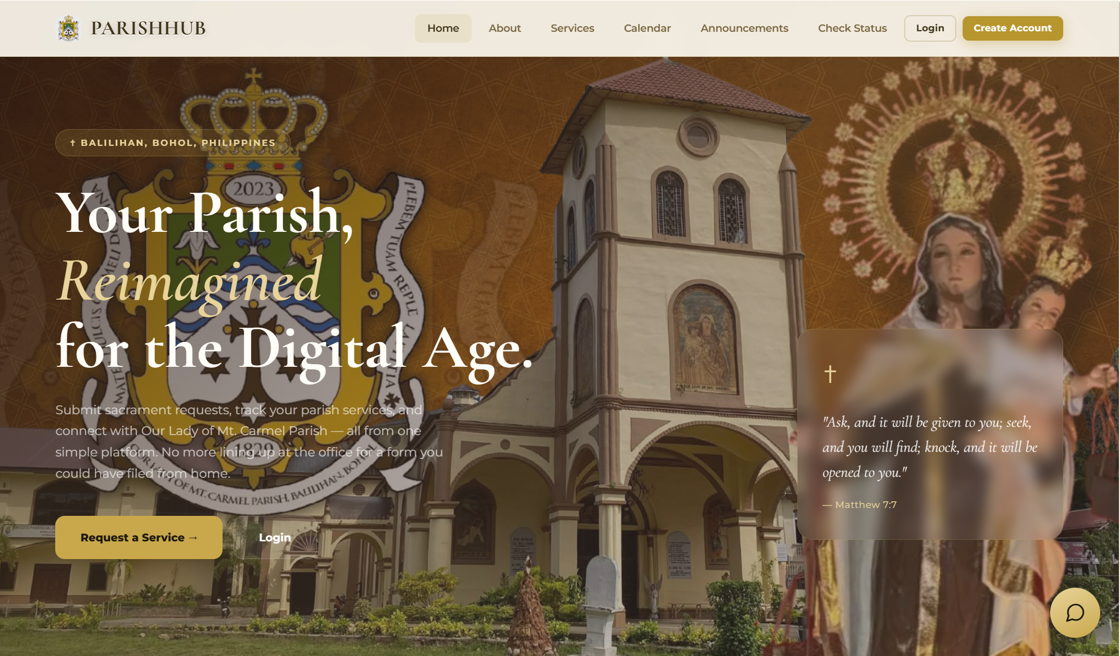
Preview 4: Home Page

Object ID: Check Status Page
Object Description: Public page for monitoring guest request using a reference code.
A. GENERAL DESCRIPTION
This allows guests to view the status, schedule, documents, and payment of a request submitted without an account, replace rejected documents, and pay approved requests.
B. SCREEN LAYOUT
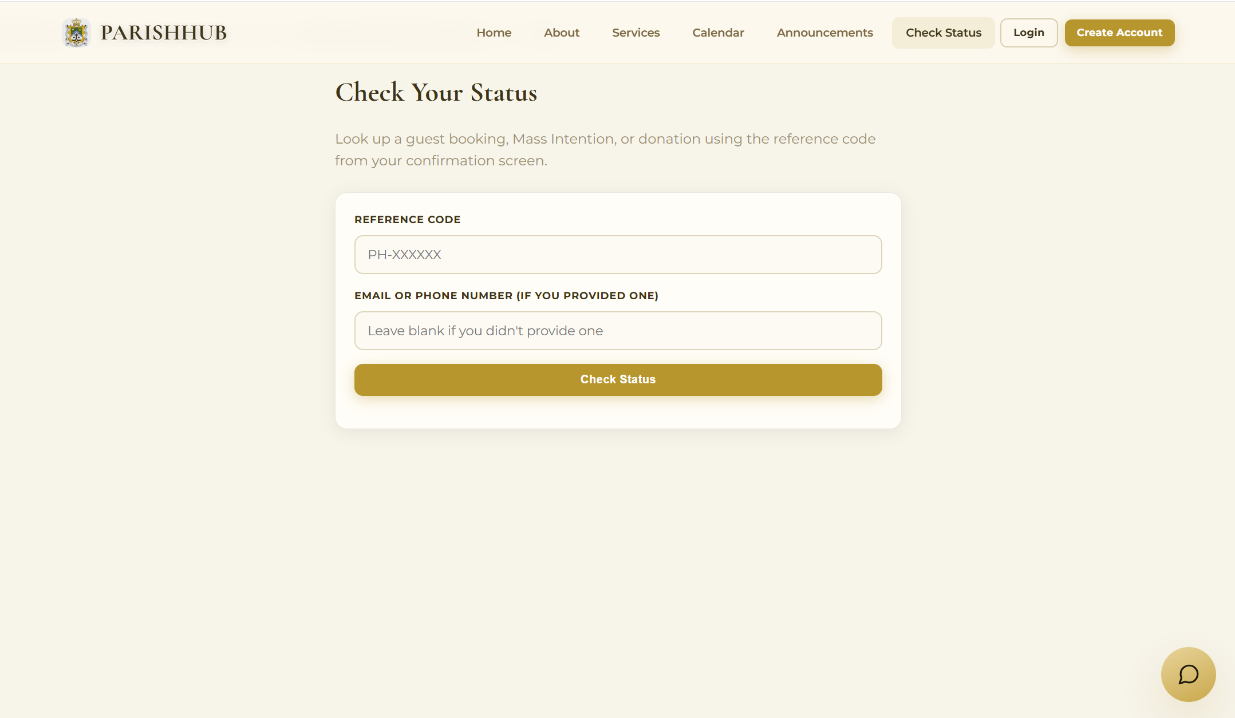
Preview 5: Check Status Page
Object ID: Login Page
Object Description: Main entry screen for user authentication.
A. GENERAL DESCRIPTION
This serves as the login screen where registered users enter their email address and password to access the dashboard of their role.
B. SCREEN LAYOUT
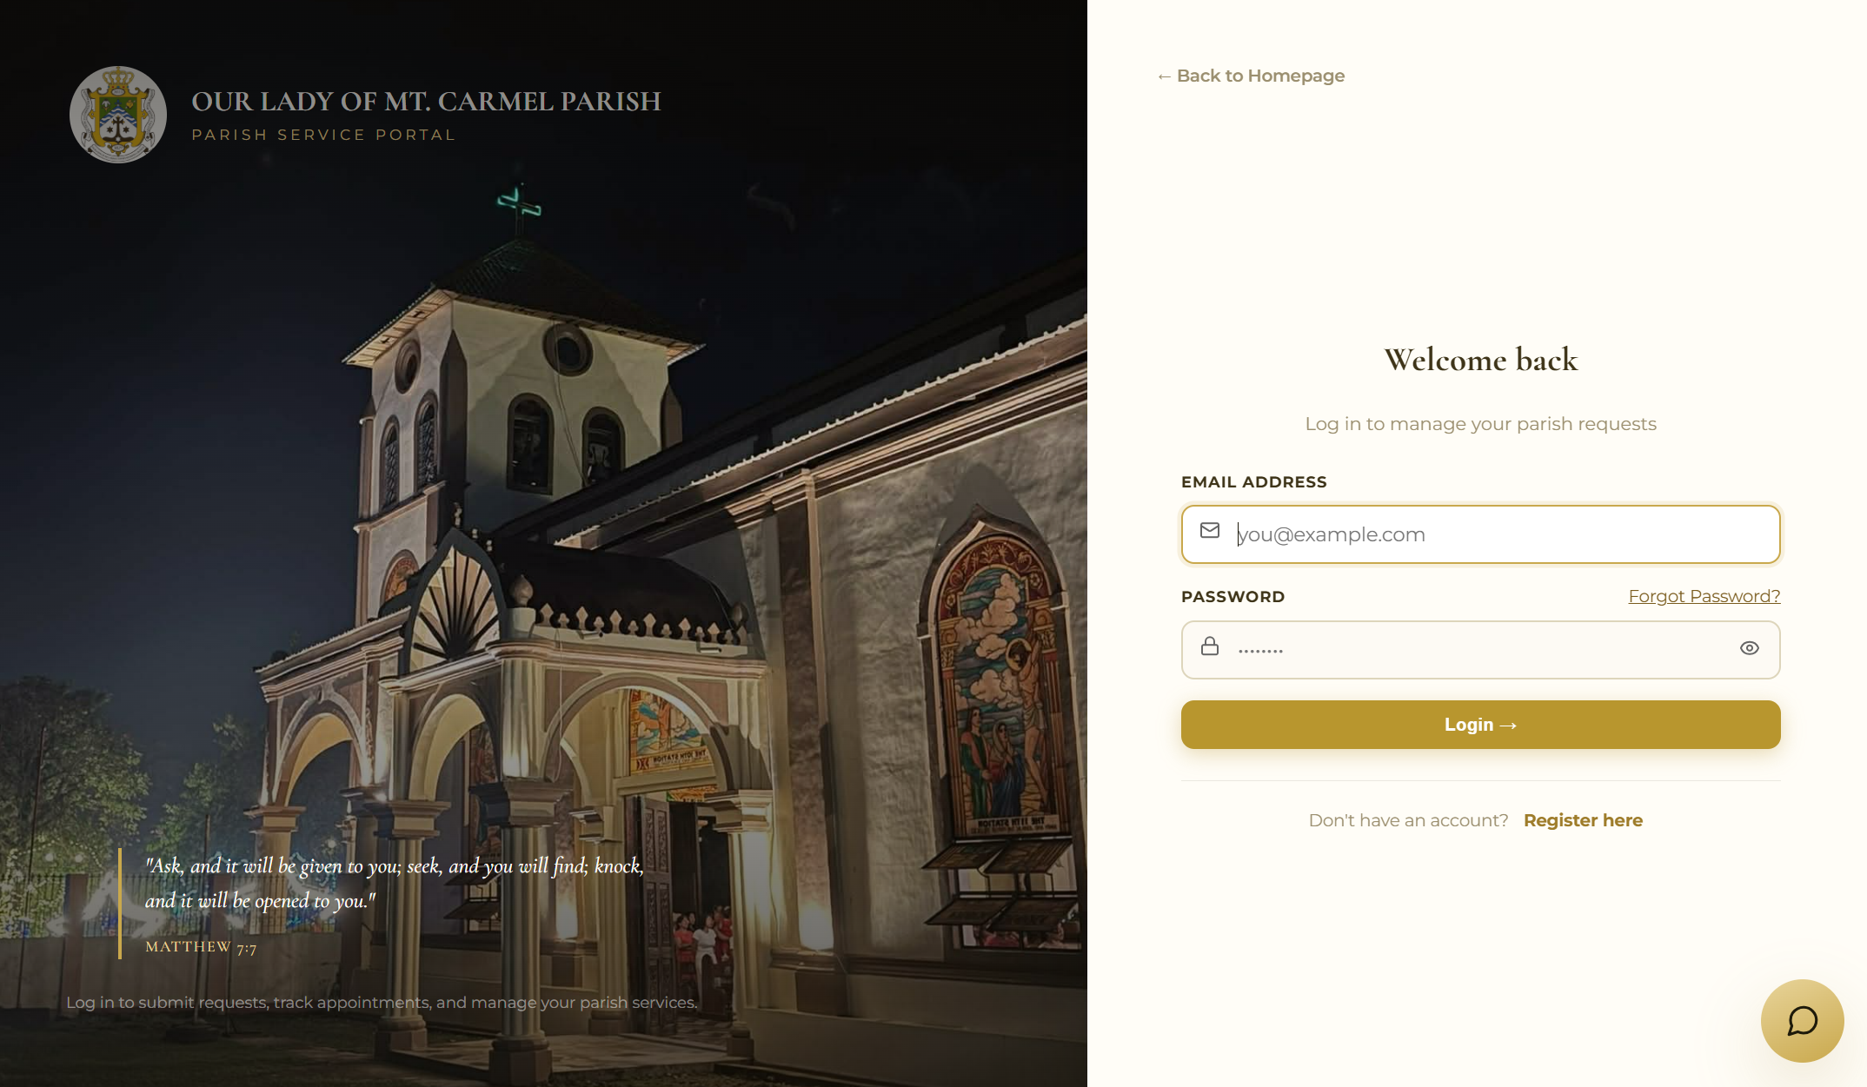
Preview 6: Login Page

Object ID: Registration Page
Object Description: Form for creating a parishioner account.
A. GENERAL DESCRIPTION
This allows parishioners to create an account by entering their personal information, contact details, and password, with validation messages for incomplete or invalid fields.
B. SCREEN LAYOUT
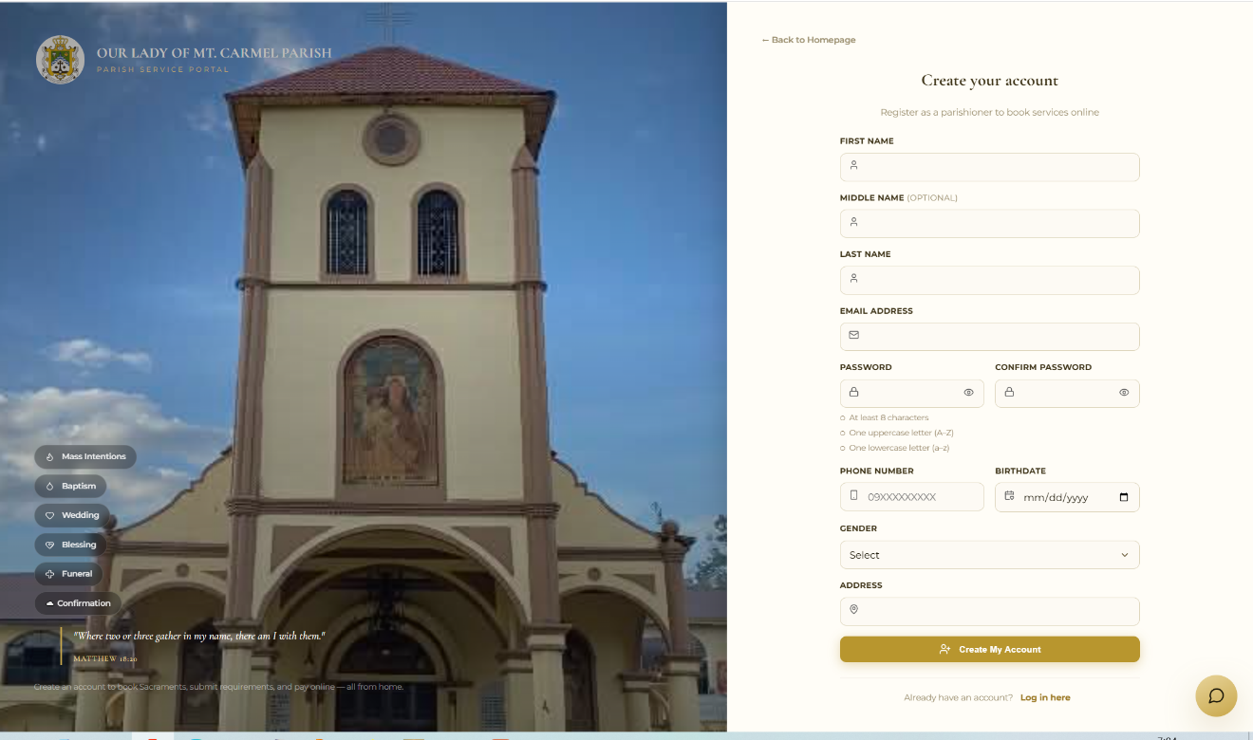
Preview 7: Registration Page

Object ID: Parishioner Dashboard
Object Description: Main Dashboard of the parishioner.
A. GENERAL DESCRIPTION
This provides parishioners with an overview of their upcoming appointments, recent announcements, and notifications.
B. SCREEN LAYOUT
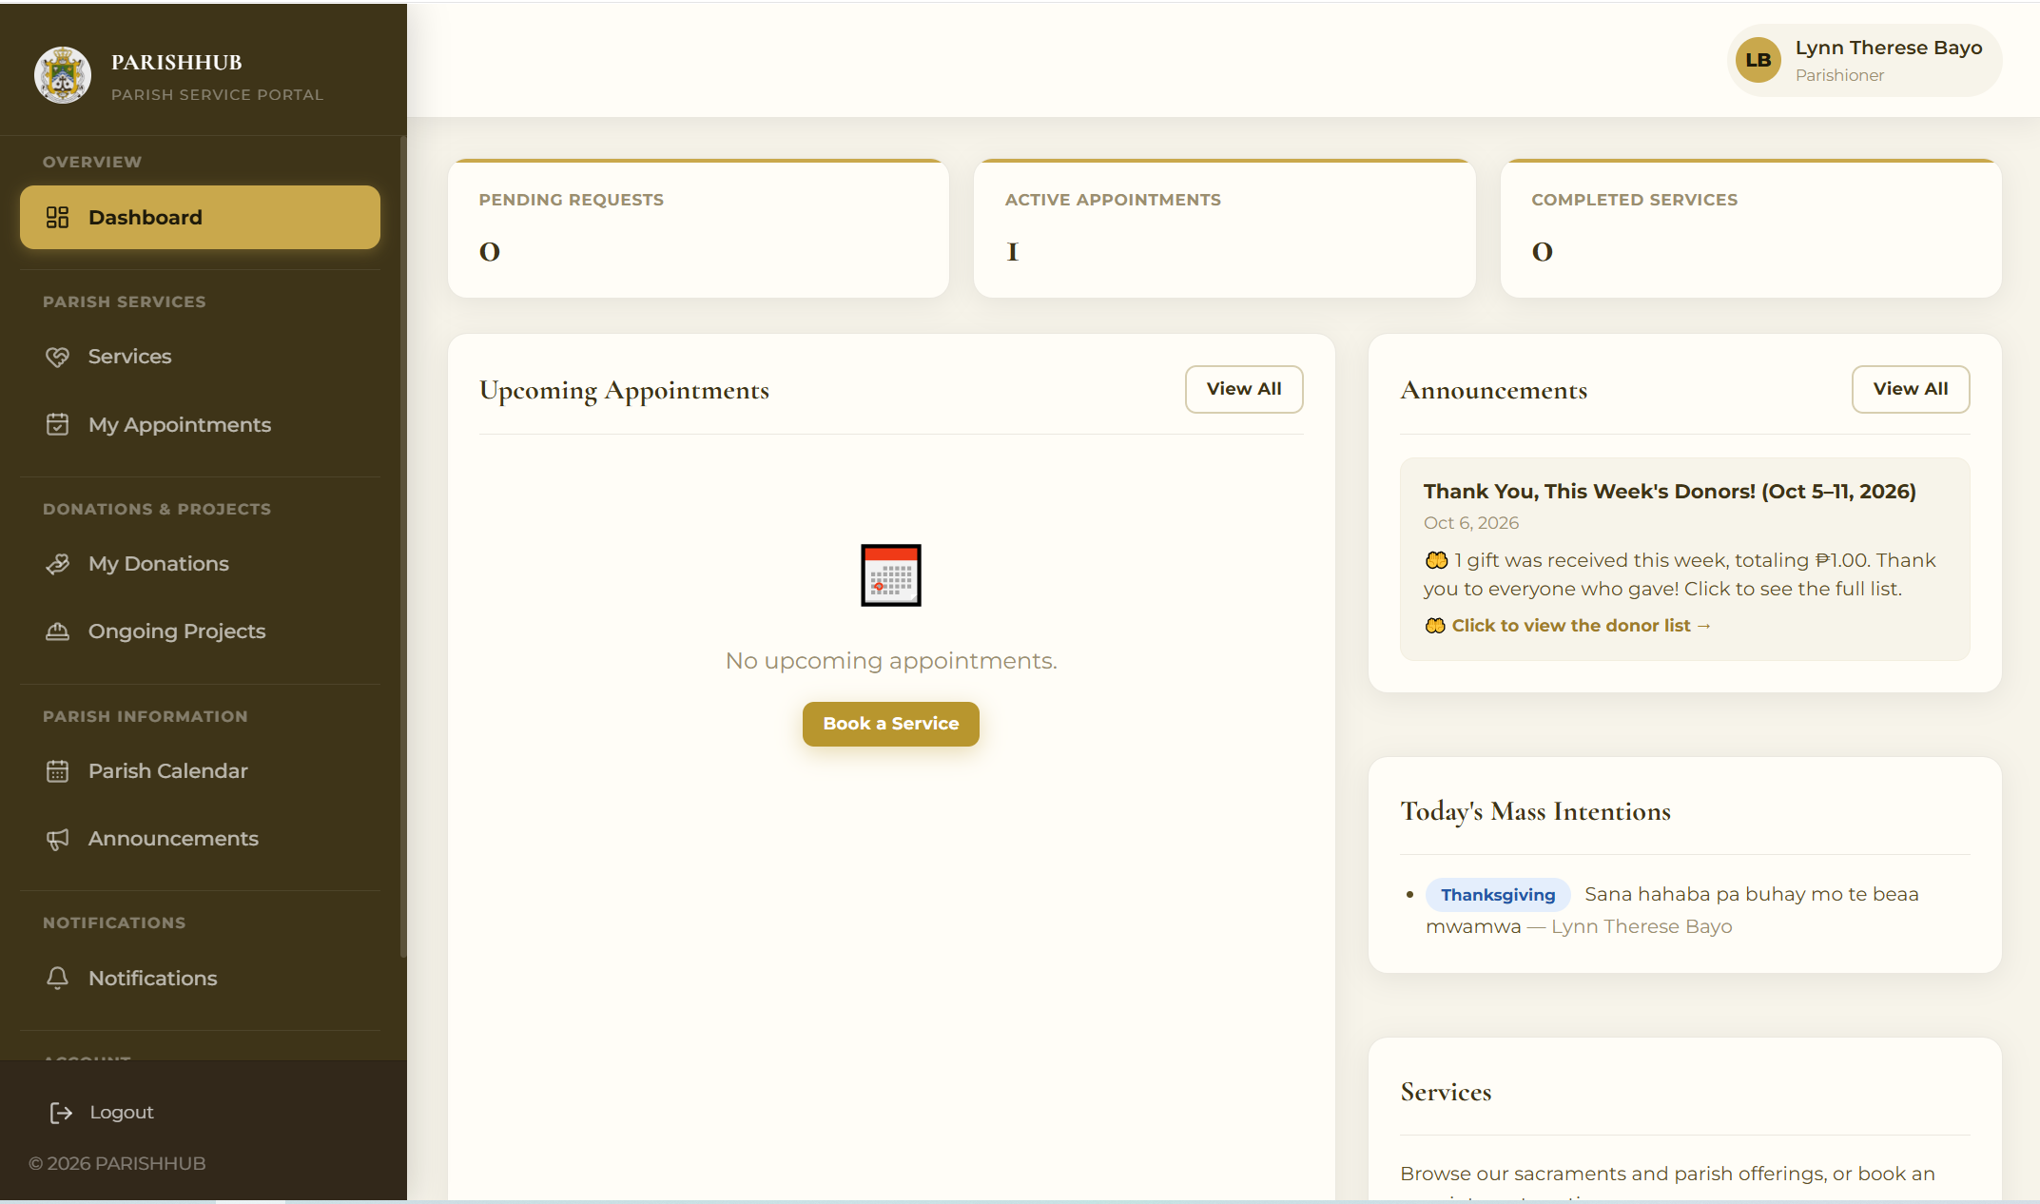
Preview 8: Parishioner Dashboard

Object ID: Service and Booking Page
Object Description: List of parish services and the booking form.
A. GENERAL DESCRIPTION
This displays the services with their requirements and fees and opens a booking modal where the parishioner selects the schedule and priest, fills out the generated forms, and uploads the required documents.
B. SCREEN LAYOUT
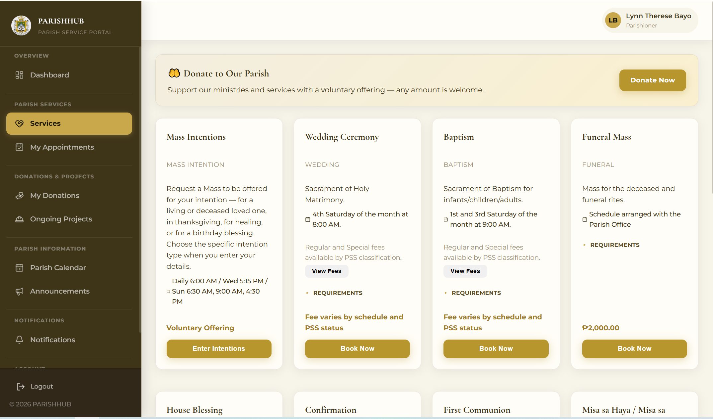
Preview 9: Services and Booking Page

Object ID: Mass Intention Form
Object Description: Form submitting Mass intentions.
A. GENERAL DESCRIPTION
This allows parishioners and guests to choose the date and Mass time, enter the intention details, and pay the voluntary offering.
B. SCREEN LAYOUT
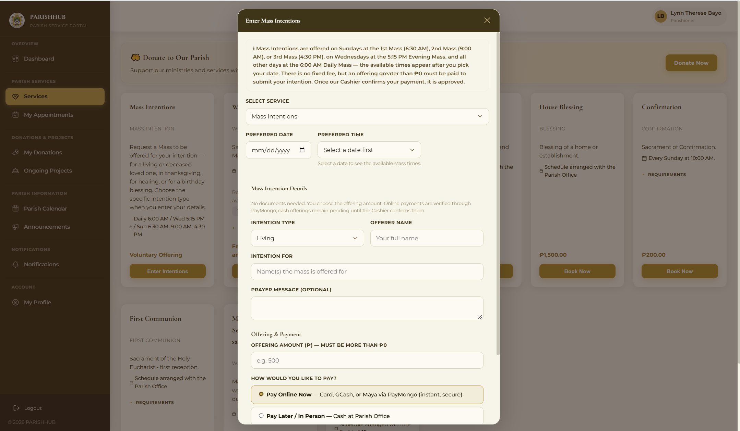
Preview 10: Mass Intention Form

Object ID: My Appointment Page
Object Description: List of the parishioner’s request.
A. GENERAL DESCRIPTION
This displays the parishioner’s upcoming and past requests with their status and allows viewing details, proceeding to payment, replacing rejected documents, cancelling, and viewing receipts.
B. SCREEN LAYOUT
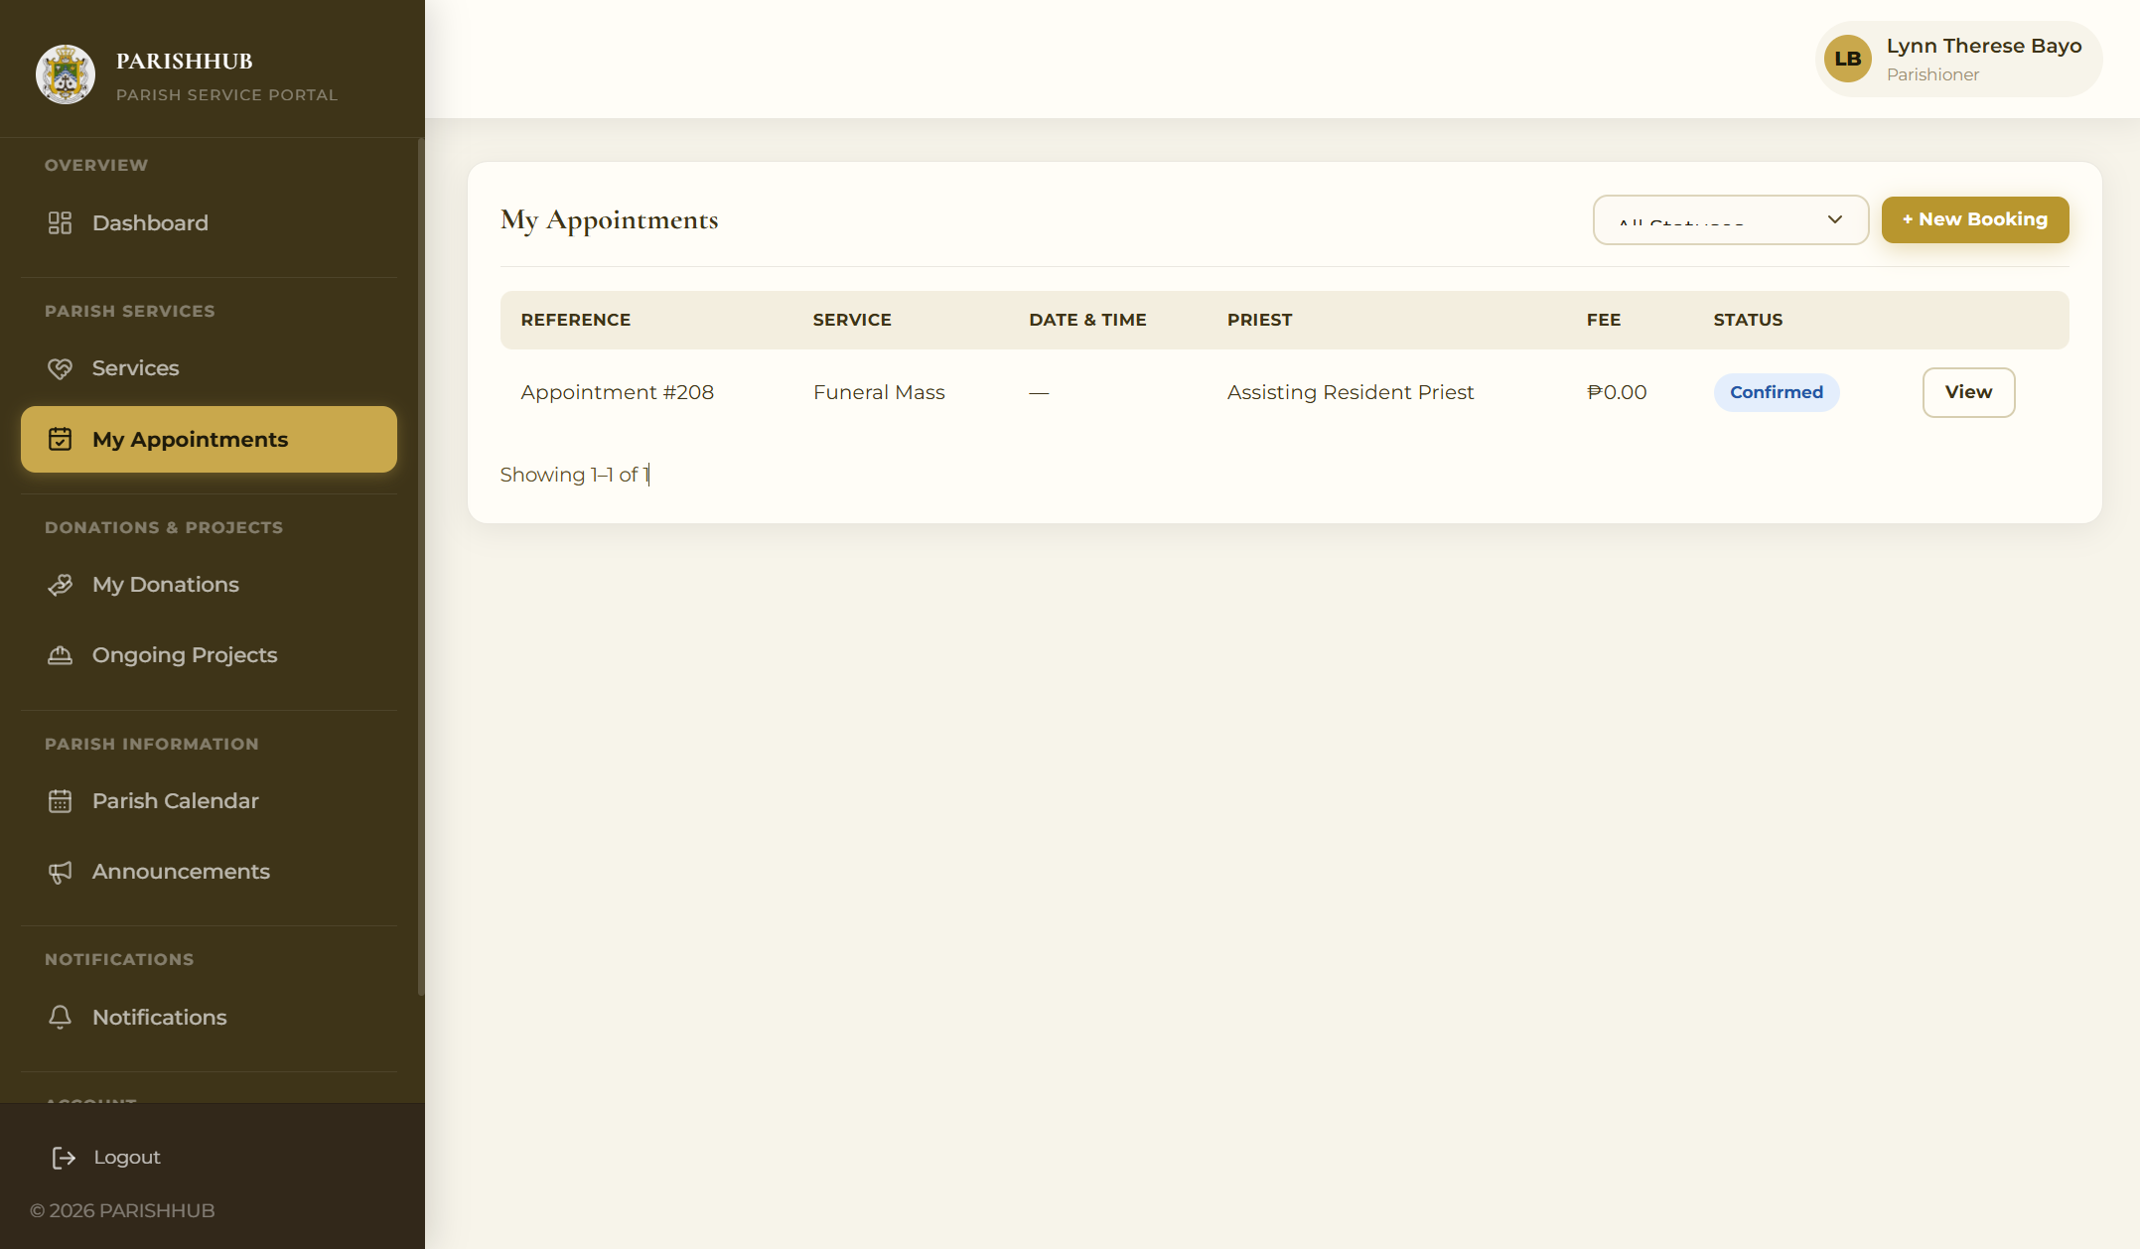
Preview 11: My Appointments Page

Object ID: Donation Form
Object Description: Form for donating the parish.
A. GENERAL DESCRIPTION
This allows parishioners and guests to donate by entering the amount, purpose, optional project, and payment method.
B. SCREEN LAYOUT
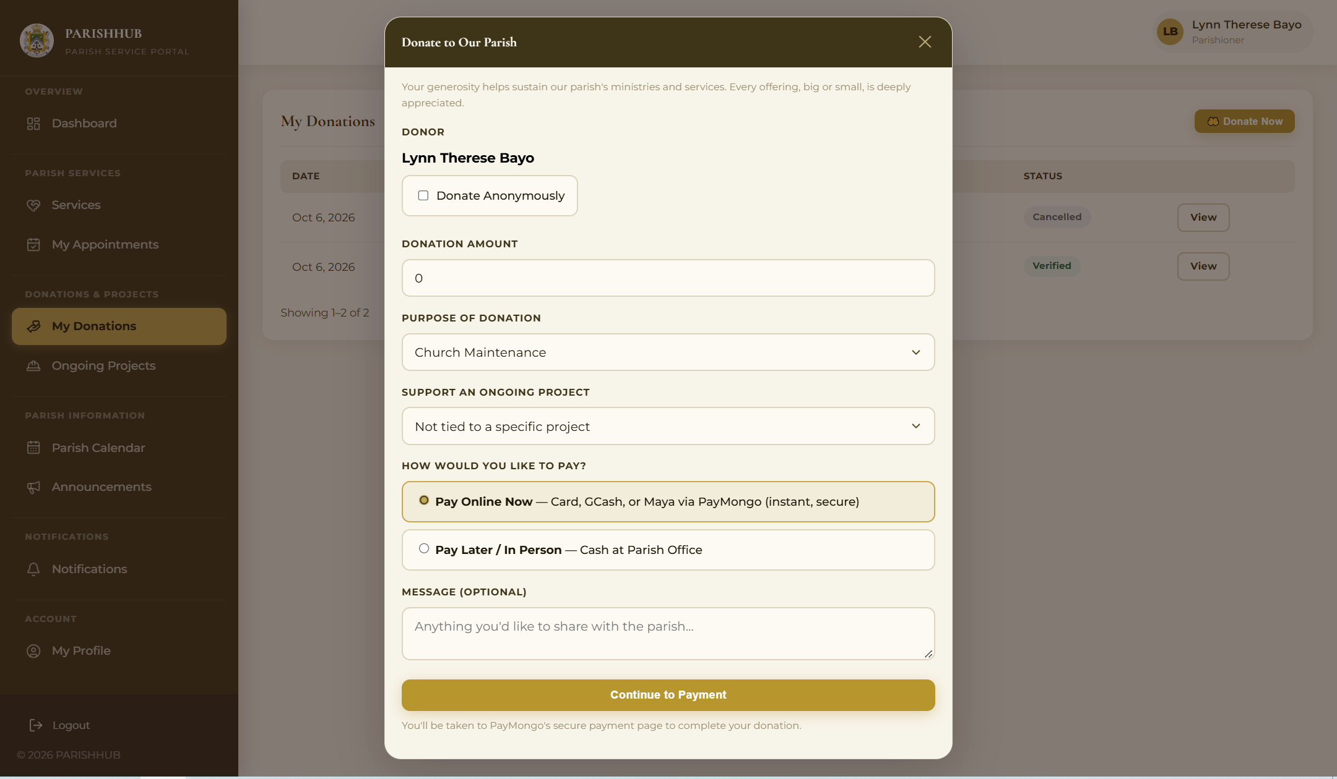
Preview 12: Donation Form

Object ID: Secretary Dashboard
Object Description: Main Dashboard of the secretary
A. GENERAL DESCRIPTION
This displays the number of pending, today’s, and this week’s requests and the most recent service requests.
B. SCREEN LAYOUT
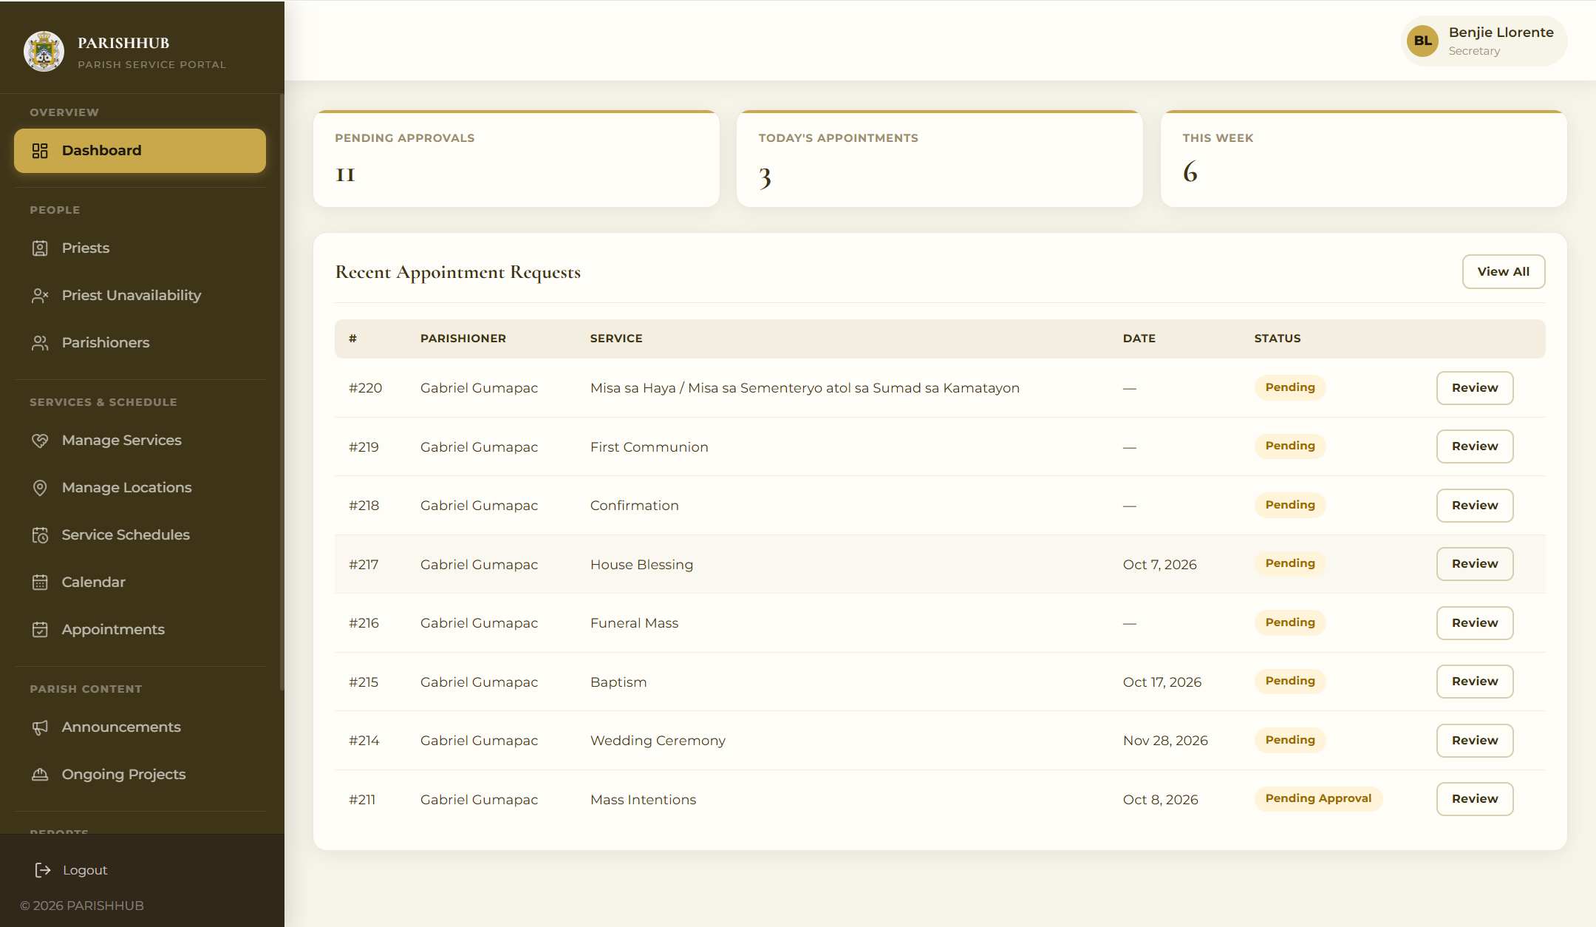
Preview 13: Secretary Dashboard

Object ID: Appointment Review Page
Object Description: Secretary tool for reviewing service requests.
A. GENERAL DESCRIPTION
This allows the secretary to view the request details, verify or reject each document, verify the PSS classification, check priest availability, approve or reject the request, assign a priest, and reschedule.
B. SCREEN LAYOUT
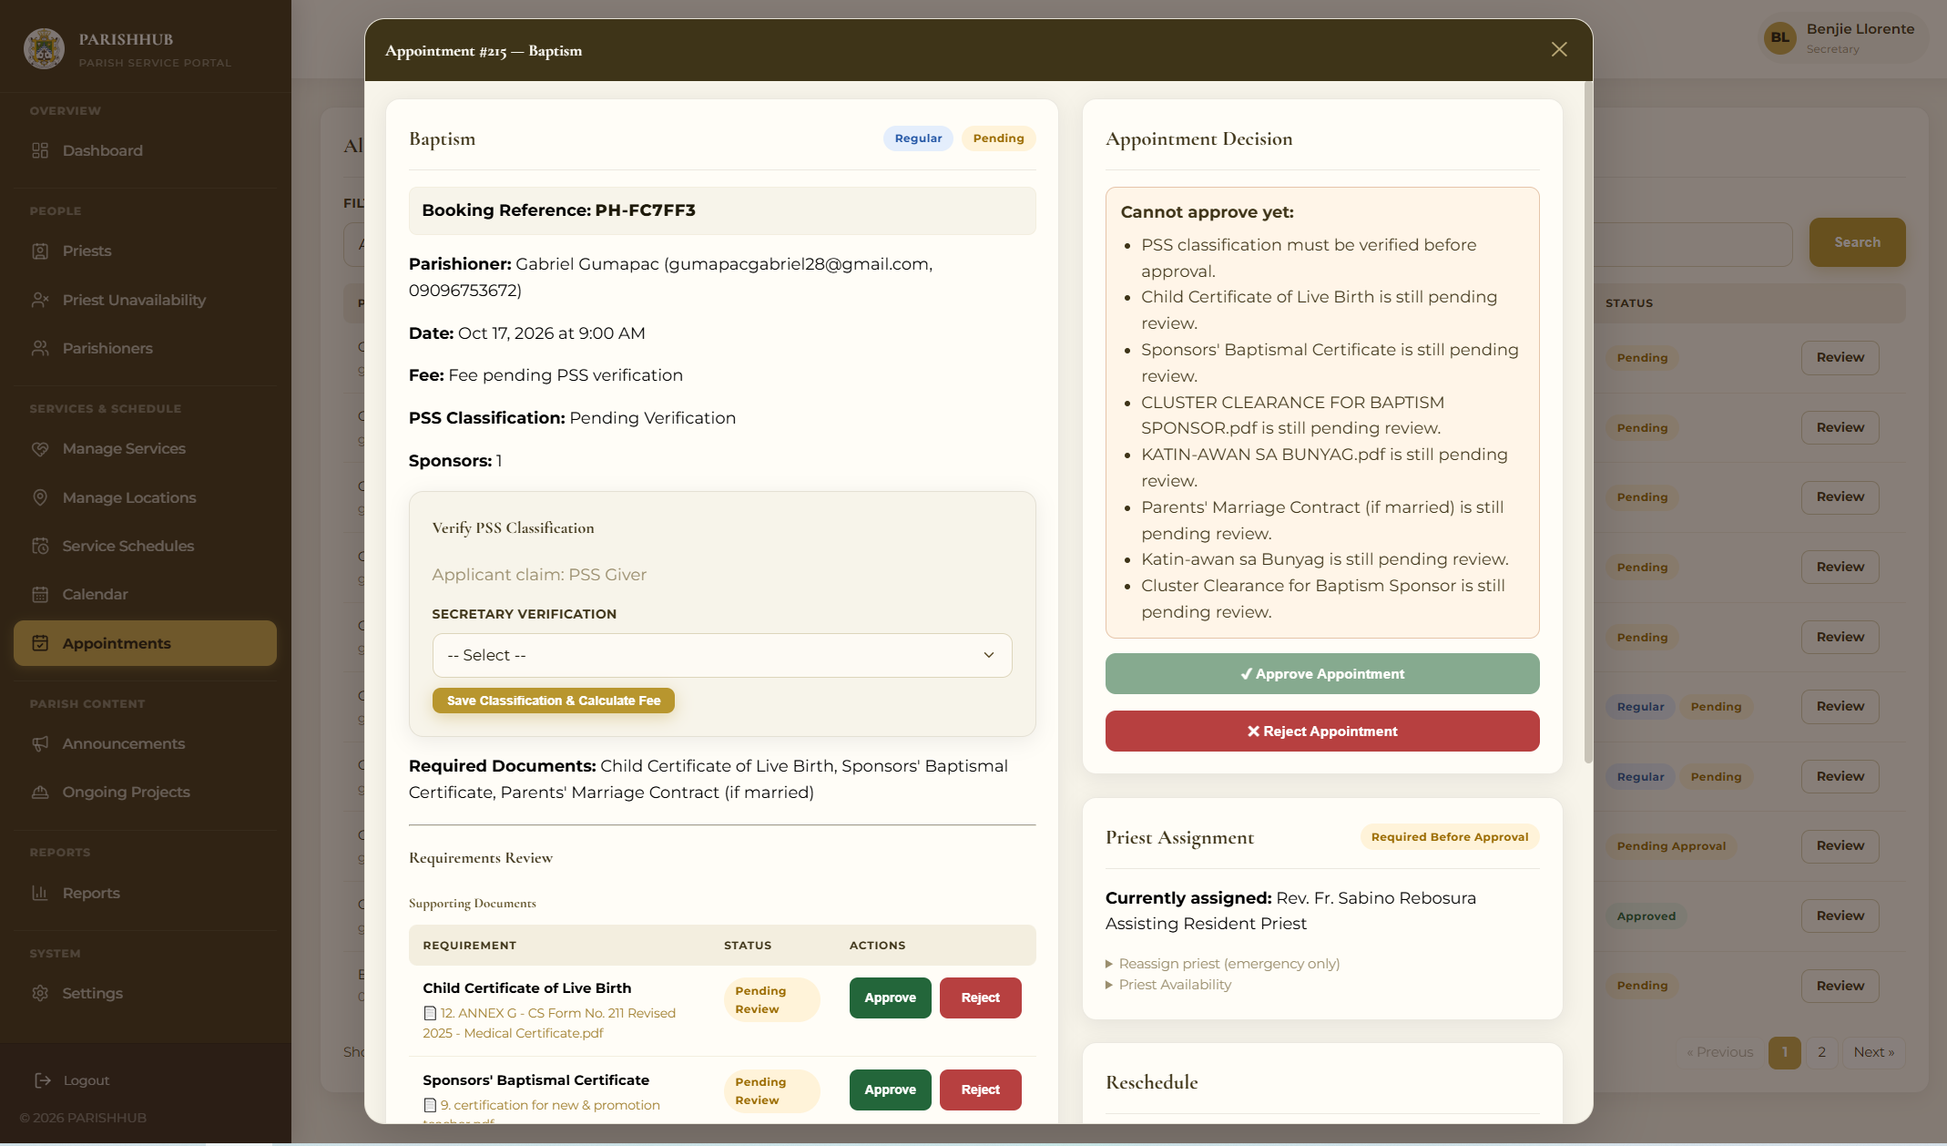
Preview 14: Appointment Review Page

Object ID: Calendar Management Page
Object Description: Secretary tool for managing the parish calendar.
A. GENERAL DESCRIPTION
This allows the secretary to view the parish calendar, add events, block dates, and see the scheduled appointments.
B. SCREEN LAYOUT
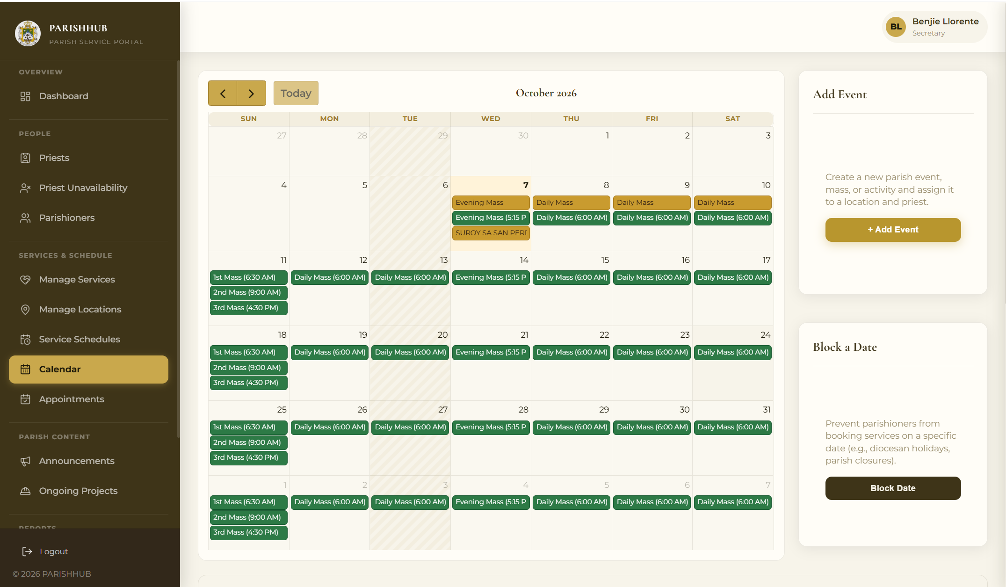
Preview 15: Calendar Management Page

Object ID: Cashier Transaction History
Object Description: List of all payments and transactions.
A. GENERAL DESCRIPTION
This allows the cashier to filter payments by date, method, and status, view payment details, confirm payments, record walk-in payments, and view official receipts.
B. SCREEN LAYOUT
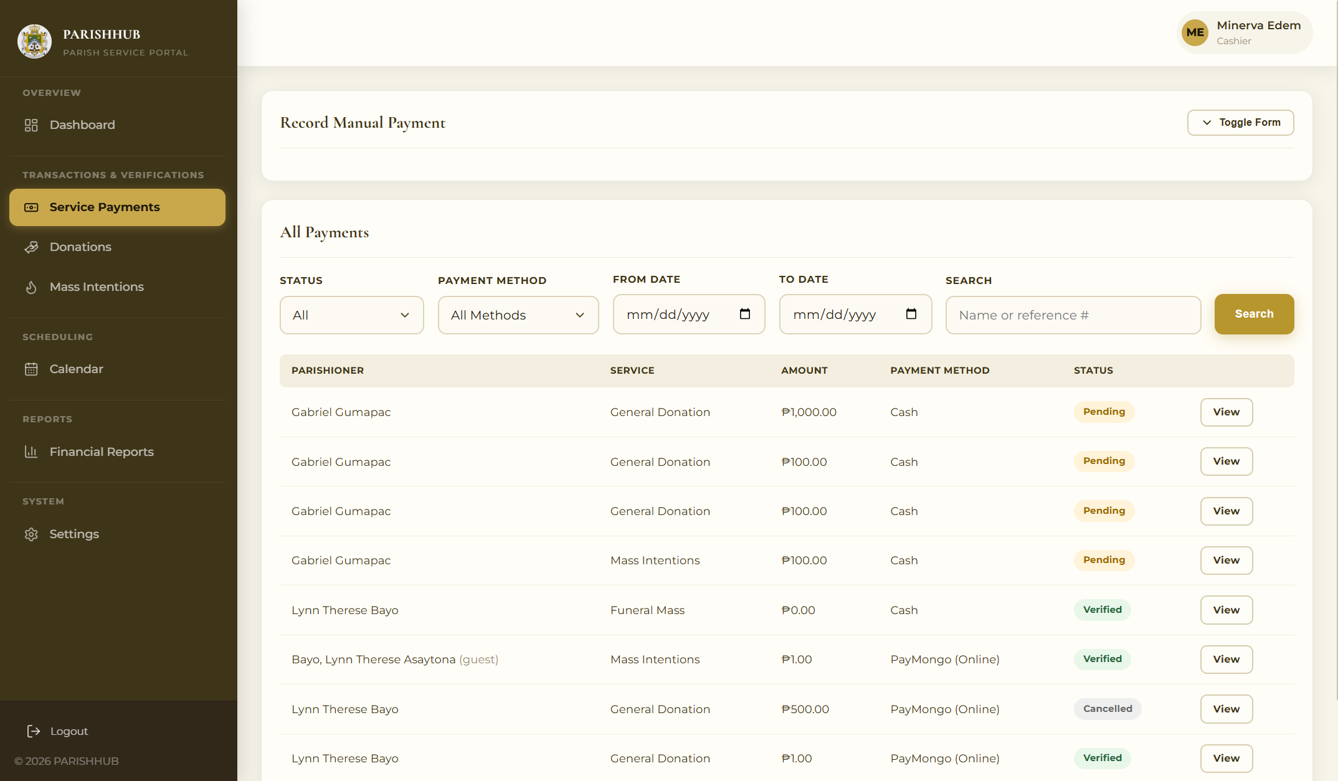
Preview 16: Cashier Transaction History

Object ID: Financial Reports Page
Object Description: Reports generation tool for the cashier and administrator.
A. GENERAL DESCRIPTION
This generates daily, weekly, monthly, and yearly reports of income, collections per service type, and donations, which can be printed.
B. SCREEN LAYOUT
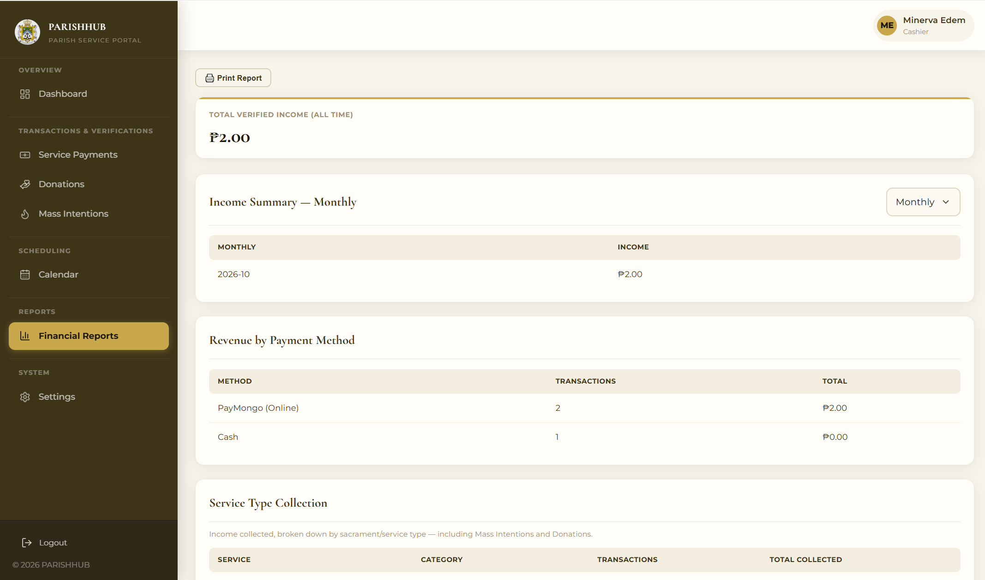
Preview 17: Financial Reports Page

Object ID: Mass Intentions Page
Object Description: List of Mass intentions per Mass.
A. GENERAL DESCRIPTION
This displays the confirmed Mass intentions grouped by date and Mass time and allows the list to be printed for reading during the Mass.
B. SCREEN LAYOUT
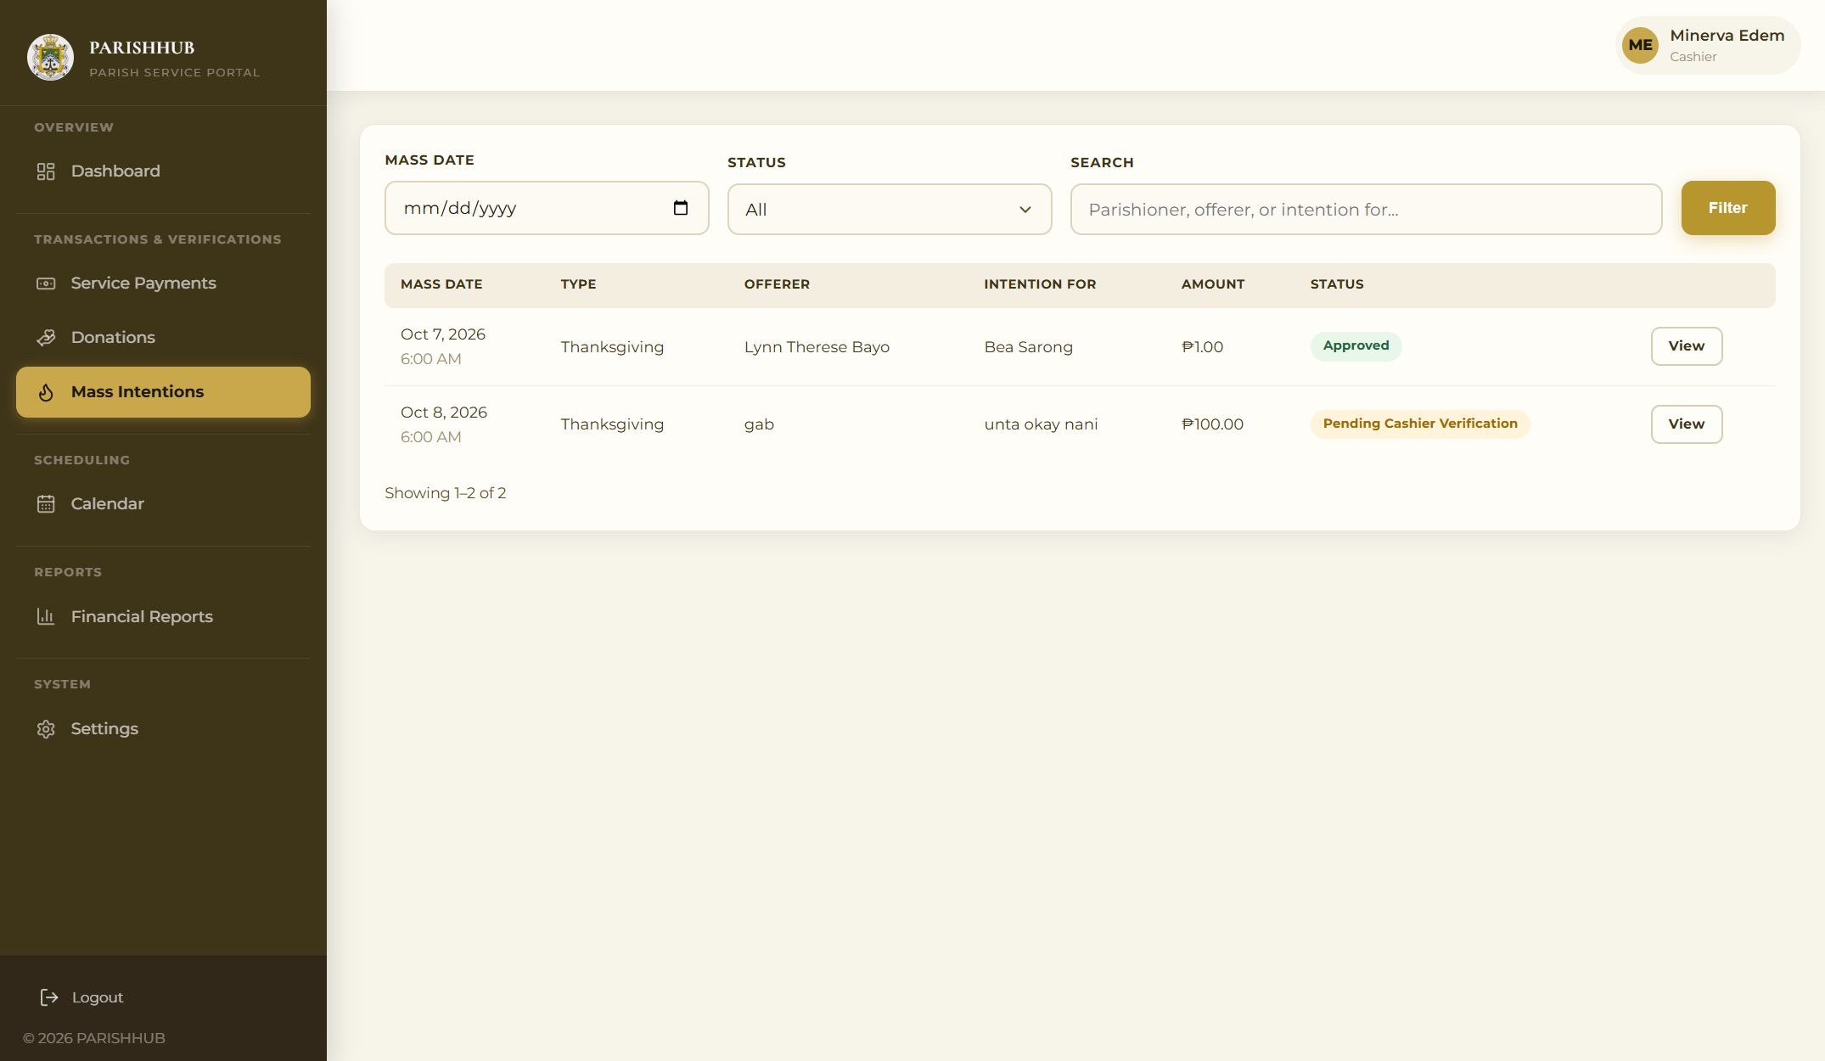
Preview 18: Mass Intentions Page

Object ID: Administrator Dashboard
Object Description: Centralized overview of the whole system.
A. GENERAL DESCRIPTION
This presents system-wide statistics, users by role, revenue, and recent activities for the parish priest.
B. SCREEN LAYOUT
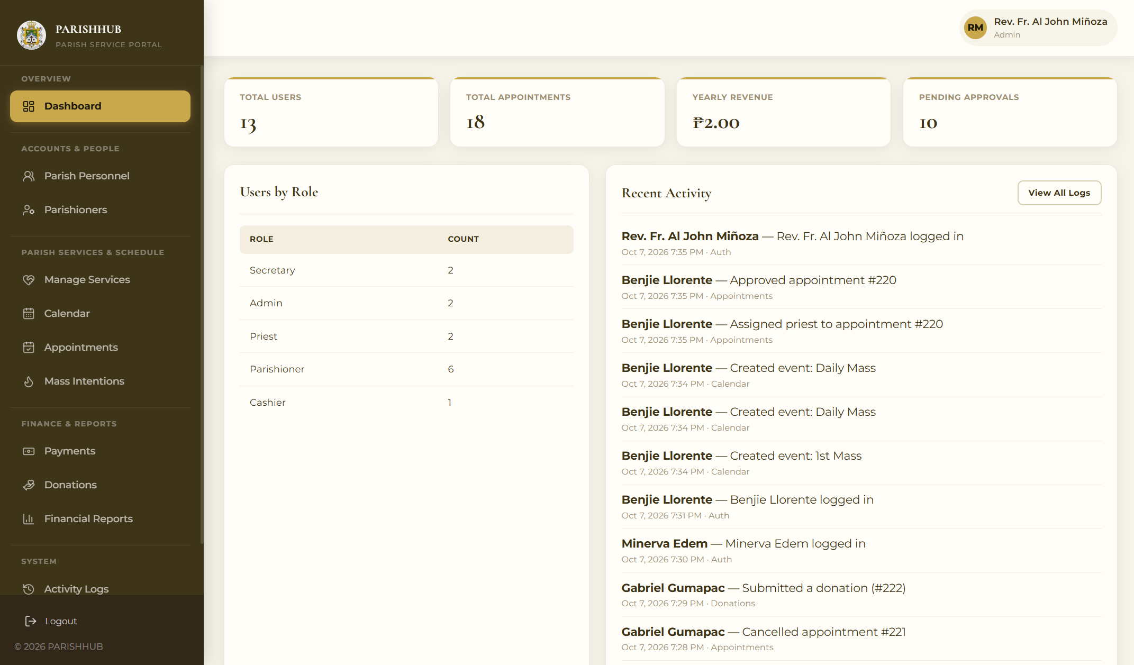
Preview 19: Administrator Dashboard

Object ID: Users and Roles Page
Object Description: Administrator tool for managing staff accounts.
A. GENERAL DESCRIPTION
This allows the administrator to add staff accounts and change their roles and status.
B. SCREEN LAYOUT
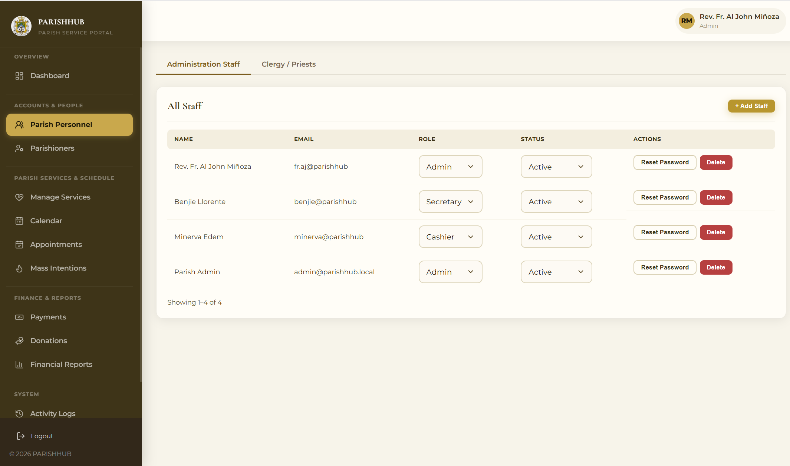
Preview 20: Users and Roles Page

Object ID: Activity Logs Page
Object Description: Audit trail of system actions.
A. GENERAL DESCRIPTION
This displays the actions performed in the system grouped by date and filtered by date range.
B. SCREEN LAYOUT
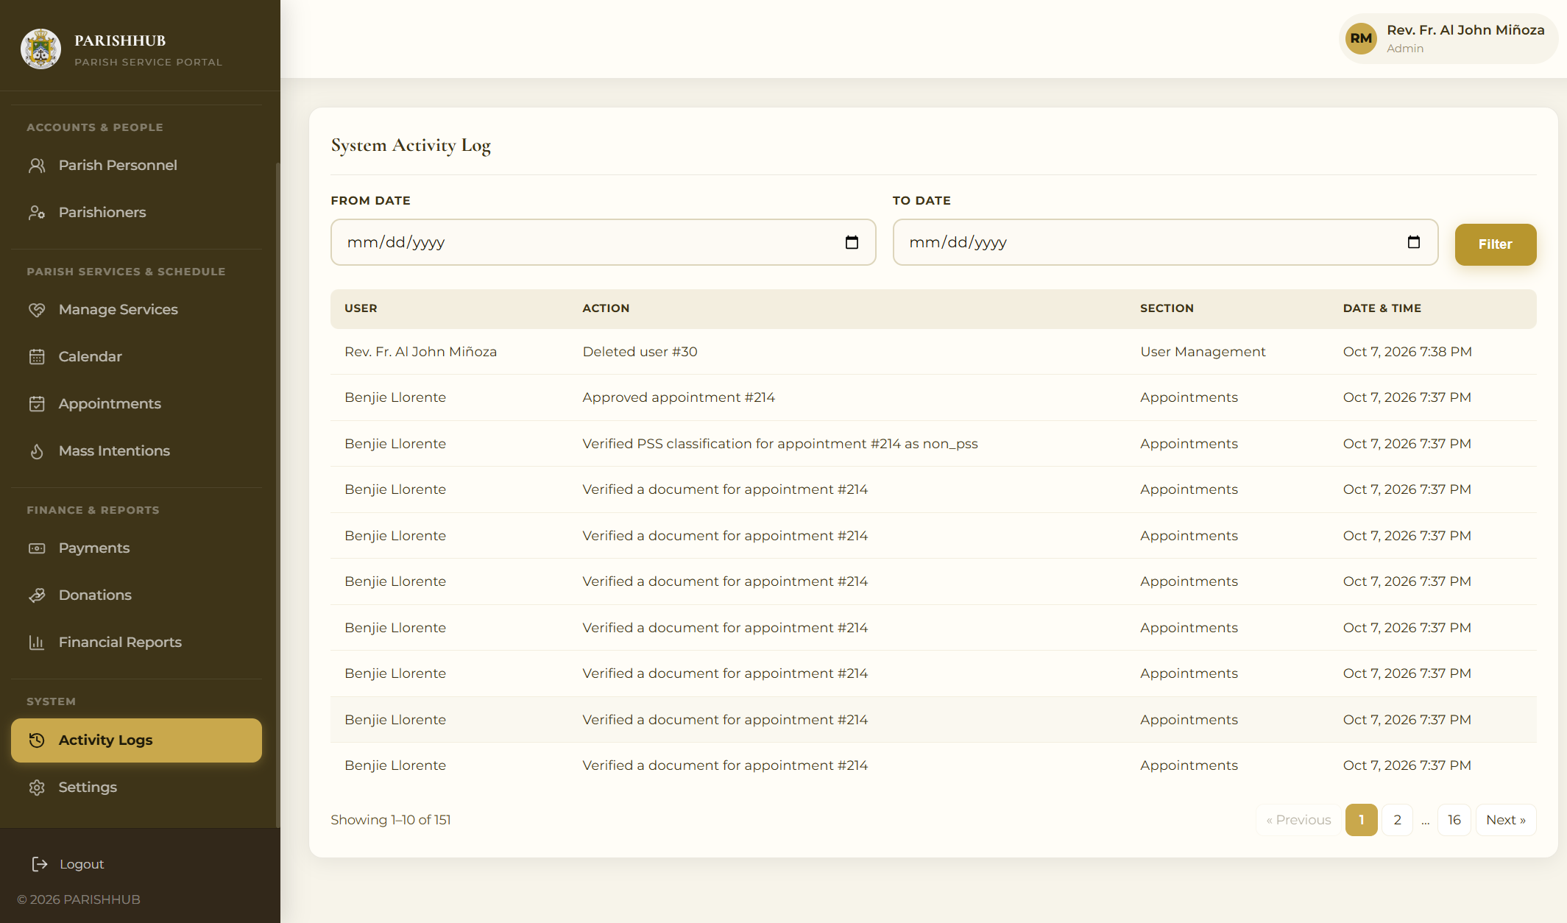
Preview 21: Activity Logs Page

Object ID: Priest Dashboard
Object Description: View only portal of the priest.
A. GENERAL DESCRIPTION
This displays the priest’s assigned appointments, the parish calendar, and the Mass intentions.
B. SCREEN LAYOUT
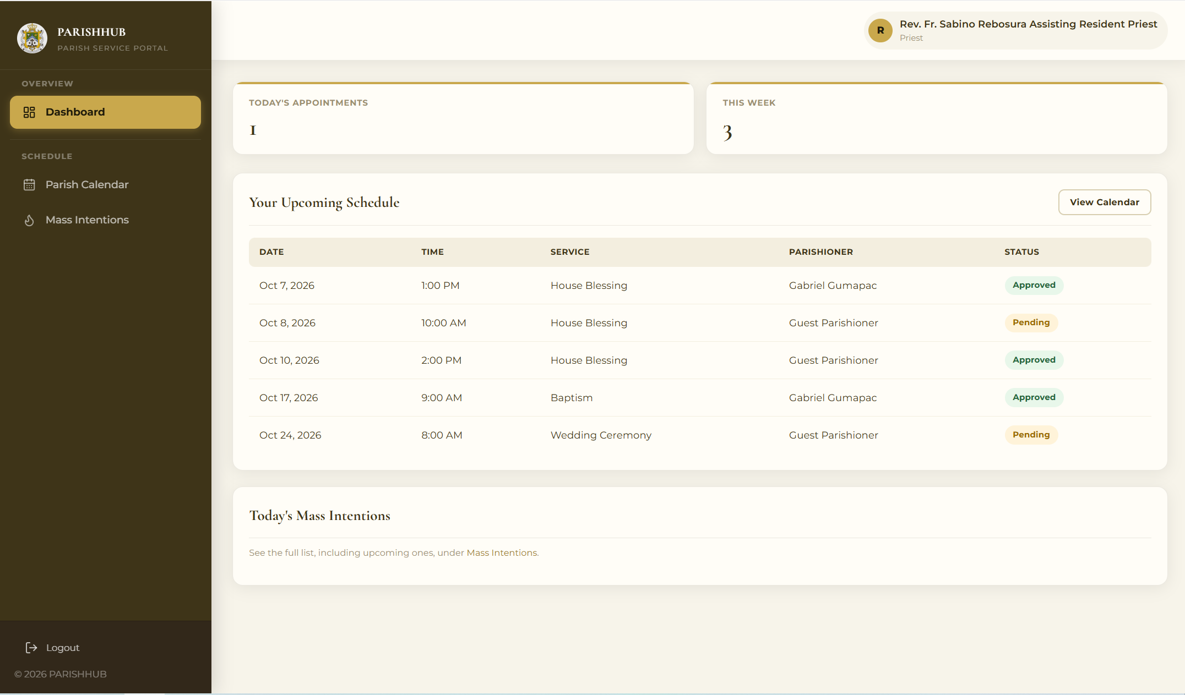
Preview 22: Priest Dashboard

Chapter 3
SUMMARY, CONCLUSIONS AND RECOMMENDATIONS
A. Summary
This study aimed to design and develop ParishHub: A Web-Based Service Management System to improve the efficiency, organization, accessibility, and reliability of parish service management at Our Lady of Mount Carmel Parish in Del Carmen Norte, Balilihan, Bohol. The system was designed to address the limitations of the manual process of requesting Mass intentions and parish services, scheduling, submitting requirements, paying, and keeping records. It sought to provide a centralized platform that integrates online service requests, Regular and Special scheduling, generated parish forms, document review, payment processing, official receipts, donations, announcements, notifications, and report generation.
The present process relies on chapel officers, personal visits to the parish office, paper forms, logbooks, and face-to-face transactions. This process requires parishioners to visit the parish office several times to inquire, submit requirements, and pay, and it requires the parish staff to manually record, check, and retrieve information, check schedules for conflicts, and prepare financial reports. As the number of requests increases, the manual process becomes more time-consuming and prone to errors.
Through the developed ParishHub system, parish transactions are centralized within a web-based platform where parishioners and guests can request services, generate the required forms, upload documents, pay online or in cash, donate, and monitor the status of their requests. The secretary benefits from organized request review, document verification, priest and schedule management, and service reports, while the cashier benefits from organized payment confirmation, automatic official receipts, and financial reports. The parish priest is able to oversee all parish transactions, users, and activity logs through a single dashboard.
B. Conclusions
Based on the findings of the study, ParishHub supports a more efficient management of parish services by providing a centralized and accessible platform for service requests, scheduling, document requirements, payments, donations, communication, and reporting. The rules-based scheduling engine prevents conflicts with Mass times, office days off, blocked dates, and priests’ schedules, while the automatic fee computation and official receipts improve the accuracy and transparency of parish collections.
The parish staff can centrally manage requests, documents, schedules, priests, payments, and reports, while parishioners can access parish services, generate the required forms, and receive updates without needing to visit the parish office repeatedly. The centralized management of information also supports more accurate monitoring and better decision-making. Overall, ParishHub supports more organized parish operations, easier access to records, and more convenient communication between the parish staff and the parishioners.
B. Recommendations
Based on the study, the following are recommended:
1. The ParishHub system should be implemented at Our Lady of Mount Carmel Parish to improve the accuracy, efficiency, and accessibility of parish services.
2. The parish priest, secretary, and cashier should undergo proper training on request review, document verification, scheduling, payment confirmation, and report generation to ensure the correct and consistent use of the system.
3. The parish should regularly inform parishioners, through announcements and chapel officers, on how to use the system, especially the online booking, Mass intention, and payment features.
4. Regular system maintenance, evaluation, and secure data backup should be conducted to maintain the security, performance, and reliability of the system.
5. Future researchers may add SMS notifications, e-signatures for the generated forms, an AI-assisted chatbot, and support for other parishes of the diocese.
TECHNOLOGY ACTION PLAN
ParishHub: A Web-Based Services Management System
Rationale
The existing process of Our Lady of Mount Carmel Parish relies on personal visits, paper forms, logbooks, and manual coordination, which can lead to delays, incomplete or misplaced records, scheduling conflicts, and difficulties in monitoring payments. The implementation of ParishHub provides a more centralized and organized approach to managing parish services. Through online service requests, rules-based scheduling, generated forms, payment monitoring, and centralized record management, the system reduces dependence on manual processes and supports more accessible and organized services for the parish staff and parishioners.
Objectives:
1. To implement ParishHub as a centralized platform for parish service requests, scheduling, payment monitoring, and record-keeping.
2. To provide proper training and orientation for the parish priest, secretary, and cashier to ensure the correct and effective use of the system.
3. To support the sustainable operation of the system through regular monitoring, maintenance, evaluation, and secure data backup and recovery.
Schedule of Implementation
ParishHub will be implemented after the completion of the necessary testing, final system review, and approval by the parish priest. Orientation and training of the parish staff will be conducted before the system is introduced to parishioners. During the initial implementation period, system performance and usage will be monitored to identify possible issues and necessary adjustments. After the system has demonstrated proper functionality and usability, it may be adopted as the primary platform for managing the parish services.
Mechanics of Implementation
The researchers will coordinate with the parish priest to present the system and demonstrate its major functions. Training sessions will be conducted for the secretary and cashier to familiarize them with request review, document verification, scheduling, priest management, payment confirmation, Mass intention printing, and report generation. Parishioners will be informed through parish announcements and the chapel officers. After the orientation and approval of the parish priest, the system will be introduced for operational use, and technical support, system monitoring, regular maintenance, and data backup will be provided to support its continuous and reliable operation.

Benefits
The implementation of ParishHub provides several benefits by reducing dependence on manual record-keeping and centralizing parish information within a single platform. It enables easier access to service requests, schedules, documents, and payment records, while providing parishioners with updated information on the status of their requests. The system also supports organized scheduling, accurate collections, transparent financial reporting, and convenient communication between the parish staff and the parishioners.

REFERENCES
Aguilar, M. R. B., Betonio, G. Y. M., Chan, K. C. L., Albina, E. M., & Caballero, A. R. (2024, May). Integrated Online Scheduling System for Church Services with SMS Notification and QR Code Recognition. In 2024 9th International Conference on Business and Industrial Research (ICBIR) (pp.1246-1251). IEEE. DOI: 10.1109/ICBIR61386.2024.10875795
Davis, F. D. (1989). Perceived usefulness, perceived ease of use, and user acceptance of information technology. MIS Quarterly, 13(3), 319-340. https://doi.org/10.2307/249008
DeLone, W. H., & McLean, E. R. (1992). Information System Success: The Quest for the Dependent Variable. Information Systems Research 3(1): 60-95. https://doi.org/10.1287/isre.3.1.60
Mayembe, M., & Phiri, J. (2025). Church Management System Based. In Proceedings of Tenth International Congress on Information and Communication Technology: ICICT 2025, London, Volume 7 (Vol. 7, p. 215). Springer Nature.
Olipas, C. N. P., Sawit, R. C. M., & Esperon, R. M. (2021). The design and assessment of a church records and information management system. International Journal of Research and Innovation in Applied Science, 6(1), 48-52.
Pulumbarit, J. P. (2025). Digitalization of church records (Phase I): A project management approach. Journal of Information Systems Engineering and Management, 10(20s), 666-676. https://doi.org/10.52783/jisem.v10i20s.3205 (ResearchGate)
Republic Act of the Philippines. (2000). Republic Act No. 8792. Electronic Commerce Act of 2000.
Republic Act of the Philippines. (2012). Republic Act No. 10173. Data Privacy Act of 2012.
Sherpa, T. N. (2022). A project report on church management system. SRM University Sikkim.
Sitorus, L., & Purba, V. Y. L. B. (2021). Santa Maria Ratu Rosari Parish Information System Tanjung Selamat Medan. KAKIFIKOM (Kumpulan Artikel Karya Ilmiah Fakultas Ilmu Komputer), 57-62.

Sutanto, A. C., Harnadi, B., & Chandrawati, T. B. (2025). Designing a Web-Based St. Mikael Church Information System. Journal of Business and Technology, 5(2), 78-85. DOI: https://doi.org/10.24167/jbt.v512.12257
Wiratama, J., & Desanti, R. I. (2021). Analysis and design of web-based information system for church congregations case study: church BNKP Pewarta. Ultima InfoSys: Jurnal llmu Sistem Informasi, 12(2), 115-120.

APPENDECIES

APPENDIX A
LETTER OF INTENT
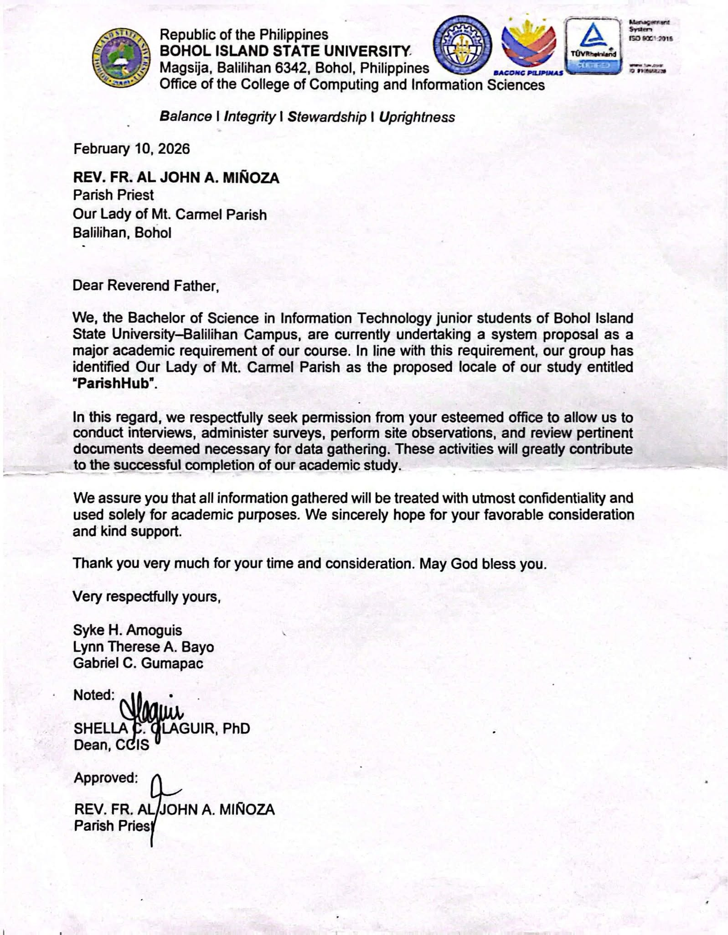
APPENDIX B
MODELING TOOLS
 | TERMINAL SYMBOL  ● Indicates the start and the end of a flowchart.  ● Shown as an oval or rounded rectangle labeled Start or End.
 | PROCESS SYMBOL  ● Symbol used for the processing of data into useful information.  ● Describes an action or operation performed by the system.
 | DATA SYMBOL  ● A parallelogram used to represent the input or output of data in a process.  ● Also used for the list of options of a menu.
 | DECISION SYMBOL  ● A decision or branching point.  ● Lines representing different decisions (Y or N) emerge from different points of the diamond.
 | OUTPUT / DISPLAY SYMBOL  ● Symbol used for displaying an output.  ● Represents operations like displaying a page, message, or information on the screen.
 | DATA STORE SYMBOL  ● Indicates where data is stored, such as a database table.  ● Shown as a cylinder in the flowcharts.
 | DATA FLOW SYMBOL  ● Represented by an arrow which shows the direction or movement of the flow of data in the system.
 | ON-PAGE CONNECTOR SYMBOL  ● Indicates that the flow continues where a matching symbol containing the same number has been placed on the same page.
DATA INPUT SYMBOL
●Indicates th at the flow continues where a matching symbol containing the same number has been placed on the same page.

APPENDIX C
INTERVIEW GUIDE / QUESTIONS
For the Parish Priest and Parish Staff
1. Can you describe how the parish currently receives and records requests for Mass intentions and other parish services?
2. What are the requirements, schedules, and fees of each parish service?
3. How do you check the schedules of the priests and the church to avoid conflicts?
4. How are payments recorded, and how are receipts and financial reports prepared?
5. What are the common reasons why a service request is rejected or rescheduled?
6. What difficulties do you encounter in retrieving records and updating parishioners about their requests?
7. What features would you like to see in the proposed ParishHub system?
For the Parishioners
1. How do you usually request a Mass intention or another parish service?
2. How many times do you usually need to visit the parish office to complete a request?
3. What difficulties do you encounter in submitting requirements and paying for parish services?
4. Would you be willing to request services and pay online through a website? Why or why not?

APPENDIX D
User’s Guide
This guide provides detailed steps for accessing and using ParishHub: A Web-Based Service Management System.
1. Prerequisites
Before using ParishHub, ensure that the following are available:
• Device: Desktop computer, laptop, tablet, or smartphone
• Internet Connection: Stable Wi-Fi, broadband, or mobile data connection
• Web Browser: A modern web browser such as Google Chrome, Microsoft Edge, Mozilla Firefox, or Safari
• ParishHub Website: Access to the official ParishHub web address
• Email Address and Mobile Number: Required when creating a parishioner account
2. Application Requirements
2.1 Hardware Requirements
• RAM: Minimum of 4 GB
• Processor: 1.5 GHz dual-core processor or higher
• Storage: At least 32 GB internal storage for the operating system and browser
• Mobile Display: 6-inch touchscreen display or higher
• Desktop/Laptop Display: 13-inch display with at least 1366 × 768 resolution
• Printer: For printing official receipts, generated forms, Mass intentions, and reports (parish office)
• Connectivity: Minimum of 5 Mbps broadband or stable 4G/LTE mobile data connection
2.2 Software Requirements
• Desktop Operating Systems: Windows, macOS, or Linux
• Mobile Operating Systems: Android or iOS
• Browser: A modern browser with JavaScript enabled
• Internet: Required to access and use the system
• PDF Reader: Required to open and print the generated forms and receipts
3. Accessing the Application
3.1 Accessing ParishHub Through a Web Browser
1. Connect the device to the Internet.
2. Open a supported web browser.
3. Enter the official ParishHub website address.
4. Wait for the ParishHub home page to load.
5. The user may view the services, calendar, and announcements, check the status of a request, or proceed to sign in or register.
3.2 Using ParishHub on a Mobile Phone
1. Open the ParishHub website using the browser of the phone.
2. Tap the menu icon to display the navigation menu.
3. Optionally, select Add to Home Screen in the browser menu to create a shortcut to ParishHub.
4. Creating a Parishioner Account
4.1 Parishioner Registration
1. Open the ParishHub website.
2. Click Create Account.
3. Enter the last name, first name, and middle name (optional).
4. Enter a valid email address and an 11-digit mobile number starting with 09.
5. Enter the birthdate, gender, and complete address.
6. Create a password with at least 8 characters and confirm it.
7. Review the information entered.
8. Click Create Account to complete the registration.
5. Logging In
1. Open ParishHub.
2. Click Login.
3. Enter the registered email address.
4. Enter the account password.
5. Click Login.
6. After successful authentication, the user will be redirected to the dashboard of his or her role.
6. Navigating the Application
6.1 Parishioner and Guest Functions
Parishioners may use ParishHub to:
• View their dashboard
• View the parish services, requirements, and fees
• Book a parish service using a Regular or Special schedule
• Fill out and generate the required parish forms
• Upload the required documents
• Submit a Mass intention with an offering
• Pay online through GCash, Maya, or card, or pay in cash
• View their appointments, documents, and official receipts
• Donate to the parish and its ongoing projects
• View the parish calendar, announcements, and notifications
• Manage their profile and password
Guests without an account may book a service, submit a Mass intention, or donate, and then use the reference code in the Check Status page to monitor the request and pay.
6.2 Secretary Functions
The secretary may use ParishHub to:
• View the secretary dashboard
• Review appointments, documents, and generated forms
• Verify the PSS classification of a request
• Approve or reject requests with a reason
• Assign priests, reschedule, confirm, and complete appointments
• Manage priests and priest unavailability
• Manage services and Regular schedules
• Manage the parish calendar and locations
• Publish announcements and ongoing projects
• View and update parishioner records
• Generate and print reports
6.3 Cashier Functions
The cashier may use ParishHub to:
• View the cashier dashboard
• Confirm payments and issue official receipts
• Record walk-in payments and donations
• Print the Mass intentions for each Mass
• Generate and print financial reports
6.4 Administrator and Priest Functions
The parish priest, as administrator, may use ParishHub to:
• View the administrator dashboard
• Manage staff accounts and roles
• Manage parishioner accounts
• Monitor appointments, Mass intentions, payments, and donations
• Generate financial reports
• Review the system activity logs
Assigned priests may view their assigned appointments, the parish calendar, and the Mass intentions.
7. Troubleshooting
7.1 Website Does Not Open
• Check the Internet connection.
• Refresh the browser.
• Close and reopen the browser.
• Verify that the correct ParishHub website address is being used.
• Try using another supported browser.
7.2 Login Problems
• Make sure the registered email address is entered correctly.
• Make sure the password is correct.
• If the account is inactive, contact the parish office.
7.3 Document Upload Fails
• Upload only JPG, PNG, or PDF files.
• Make sure that the file does not exceed 2 MB.
• Upload the document in portrait orientation.
• Check the Internet connection and try uploading again.
7.4 Payment Does Not Update Immediately
• Do not repeat a payment while the previous transaction is still processing.
• Refresh My Appointments after waiting briefly.
• For cash payments, wait for the cashier to confirm the payment.
• If the payment still does not appear, contact the parish office and provide the payment details.
7.5 Request Status Does Not Change
• Requests are updated after they are reviewed by the parish office.
• Check the notifications or the Check Status page.
• Contact the parish office for urgent concerns.
8. Support
For assistance, parishioners may use the available ParishHub support channels:
• Parish Chatbot: Available on the ParishHub website for frequently asked questions
• Check Status Page: Available to guests who have a reference code
• Parish Office: Available for concerns that require the assistance of the parish staff

Running and Navigation of the System
This manual serves as a guide for users of ParishHub by presenting step-by-step procedures for the major functions of the system. Visual illustrations are included to support each procedure.
Process Name: Home Page
Description: Displays the parish announcements, the Mass intentions for the day, and the available services.
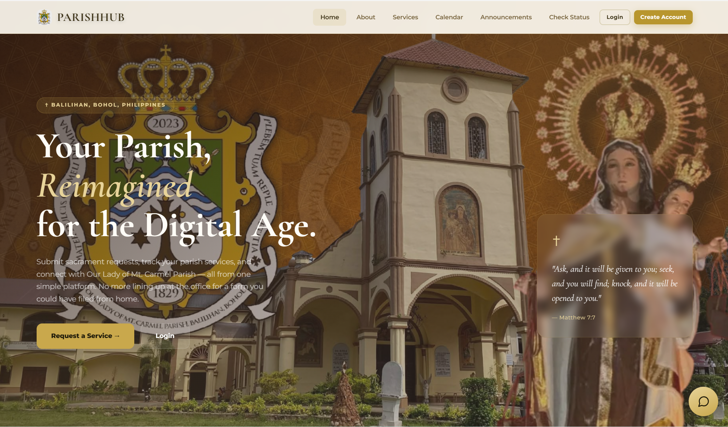
Procedure:
1. Open the ParishHub website.
2. View the announcements, Mass intentions, and services.
3. Select the needed menu at the top of the page.
Process Name: Check Request Status
Description: Allows guests to monitor a request using a reference code.
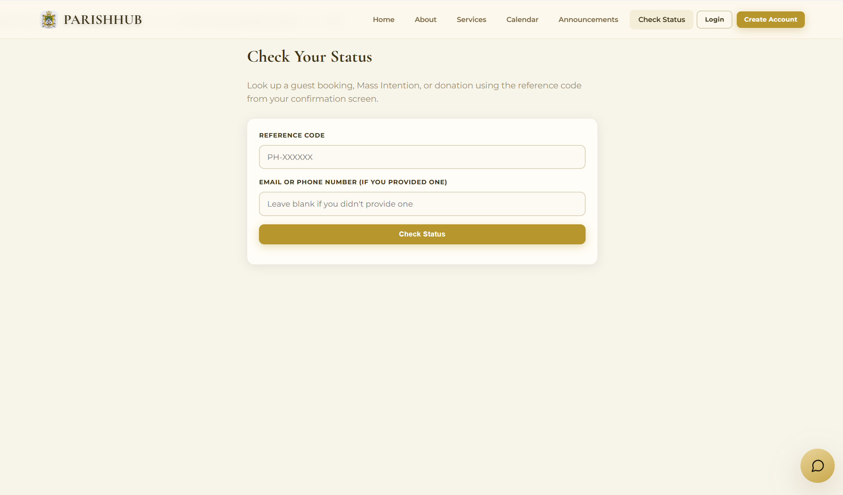
Procedure:
1. Click Check Status.
2. Enter the reference code.
3. Click Check Status.
4. View the status, documents, and payment of the request.

Process Name: Parishioner Registration
Description: Allows new parishioners to create an account.
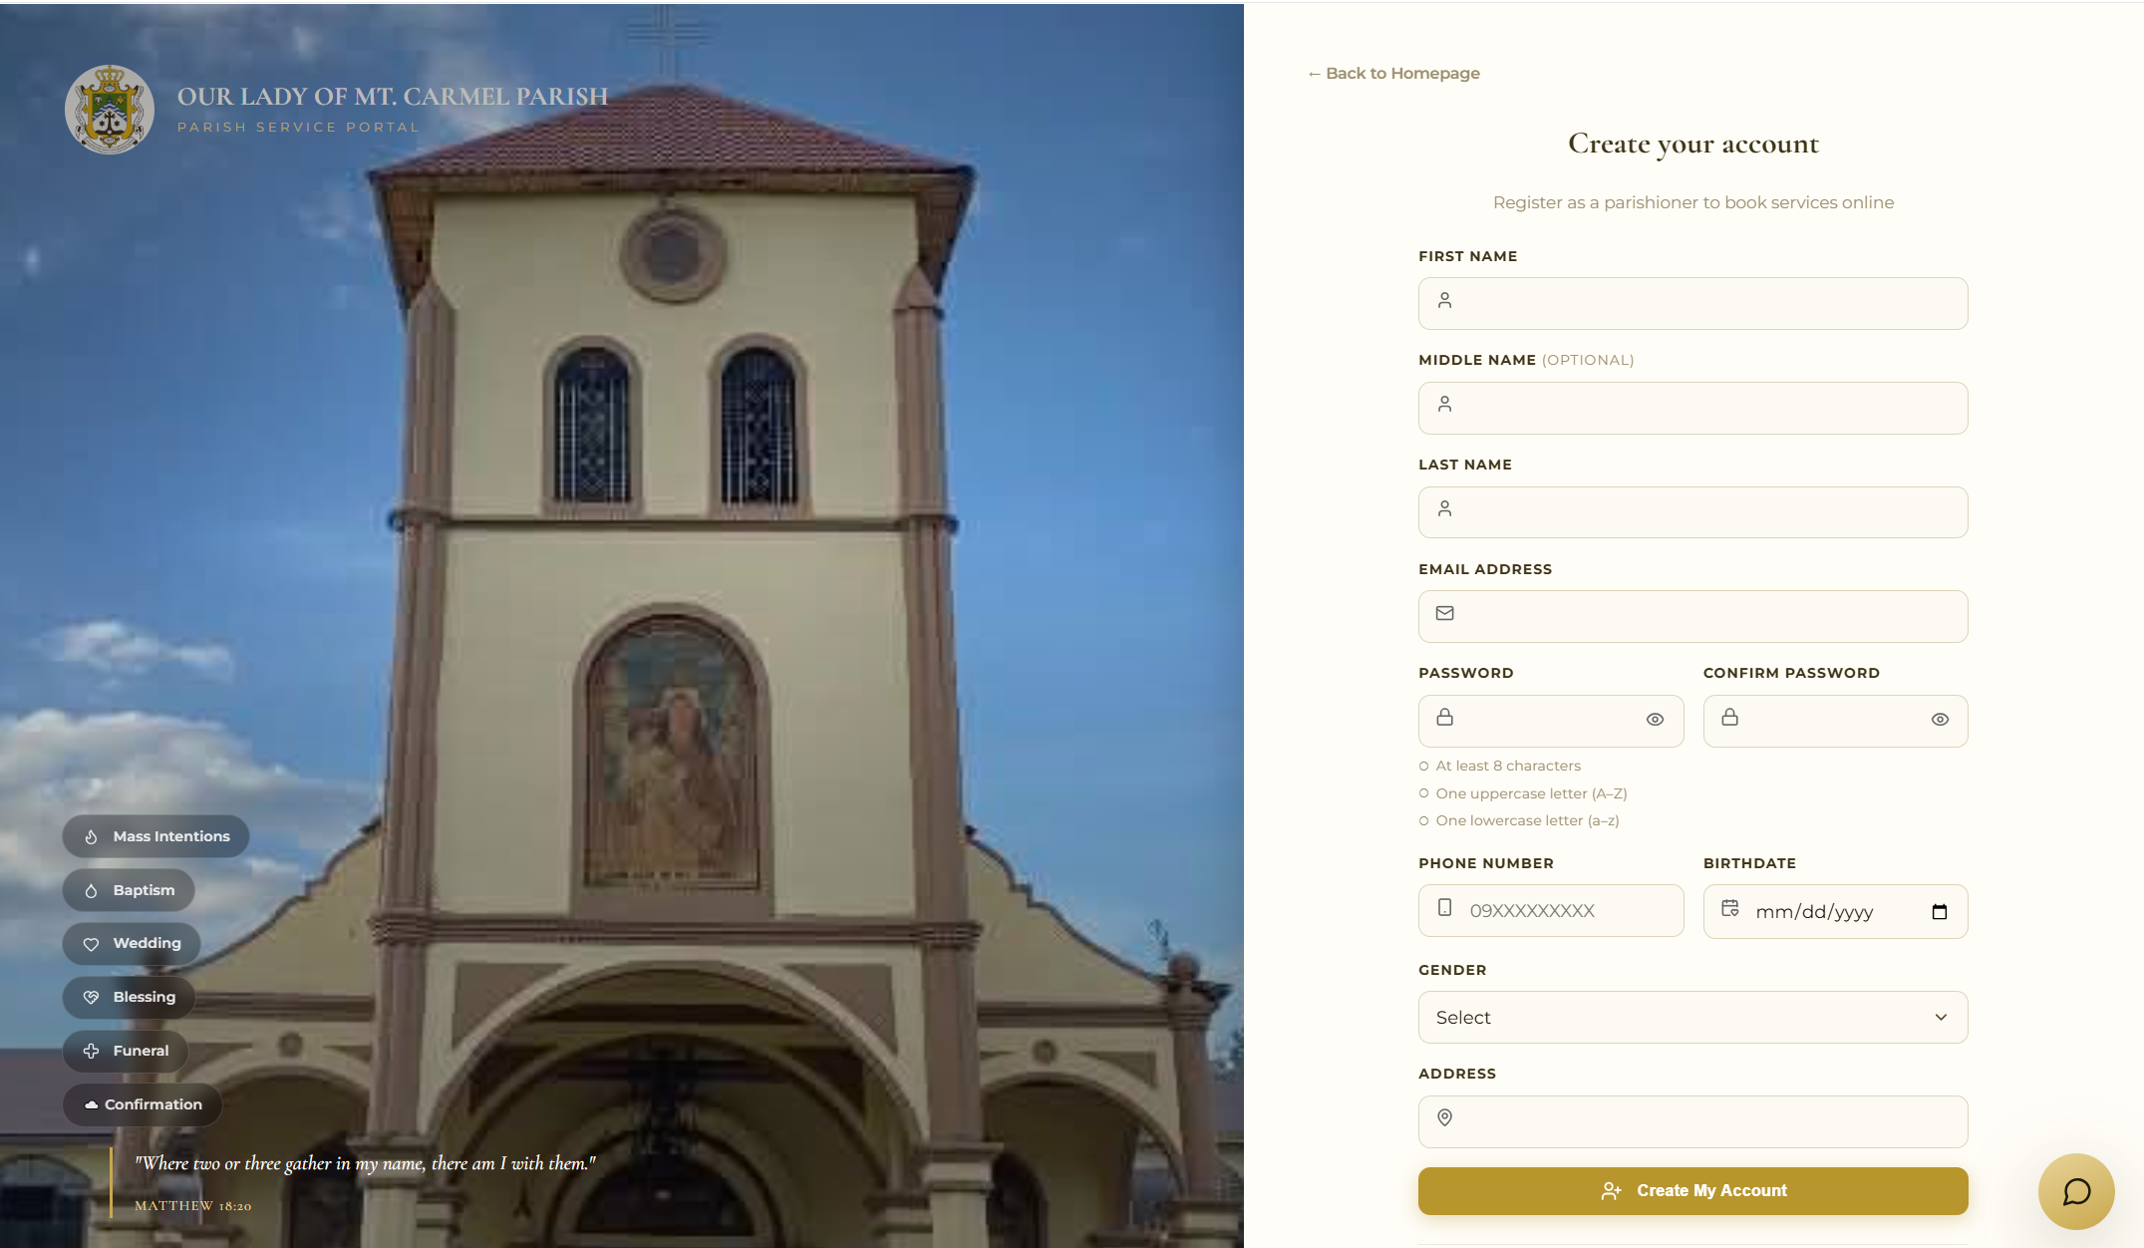
Procedure:
1. Click Create Account.
2. Enter the required information.
3. Create a password.
4. Click Create My Account.

Process Name: User Login
Description: Allows registered users to access their account.
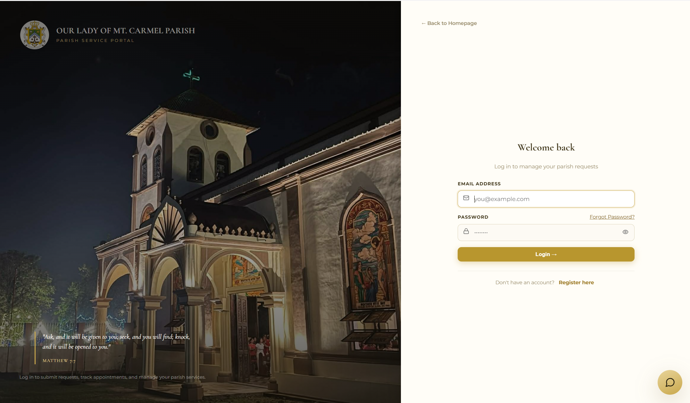
Procedure:
1. Click Log in.
2. Enter email and password.
3. Click Log in.
Process Name: Parishioner Dashboard
Description: Displays the parishioner’s upcoming appointments, announcements, and notifications.
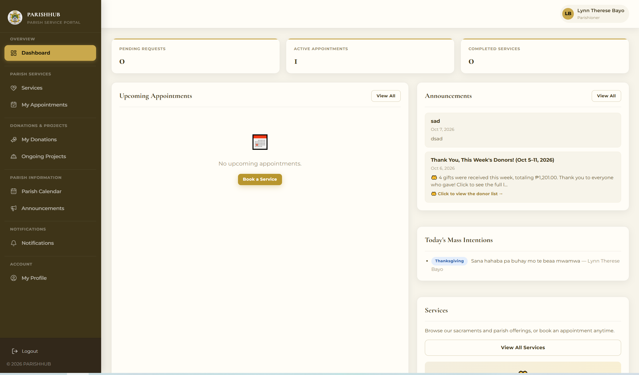
Procedure:
1. Log in to the parishioner account.
2. View the dashboard.
3. Select the needed menu.

Process Name: Book a Parish Service
Description: Allows parishioners to request a parish service
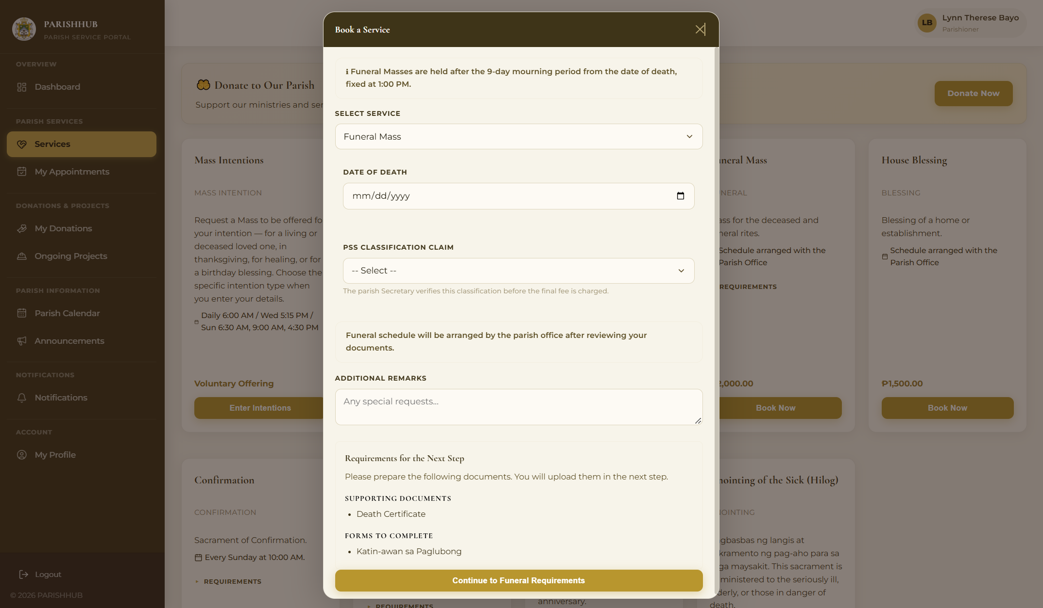
Procedure:
1. Click Services.
2. Click Book Now on the needed service.
3. Choose the schedule, date, time, and priest.
4. Fill out the forms and upload the required documents.
5. Click Submit Request

Process Name: Submit a Mass Intention
Description: Allows parishioners and guests to request a Mass intention.
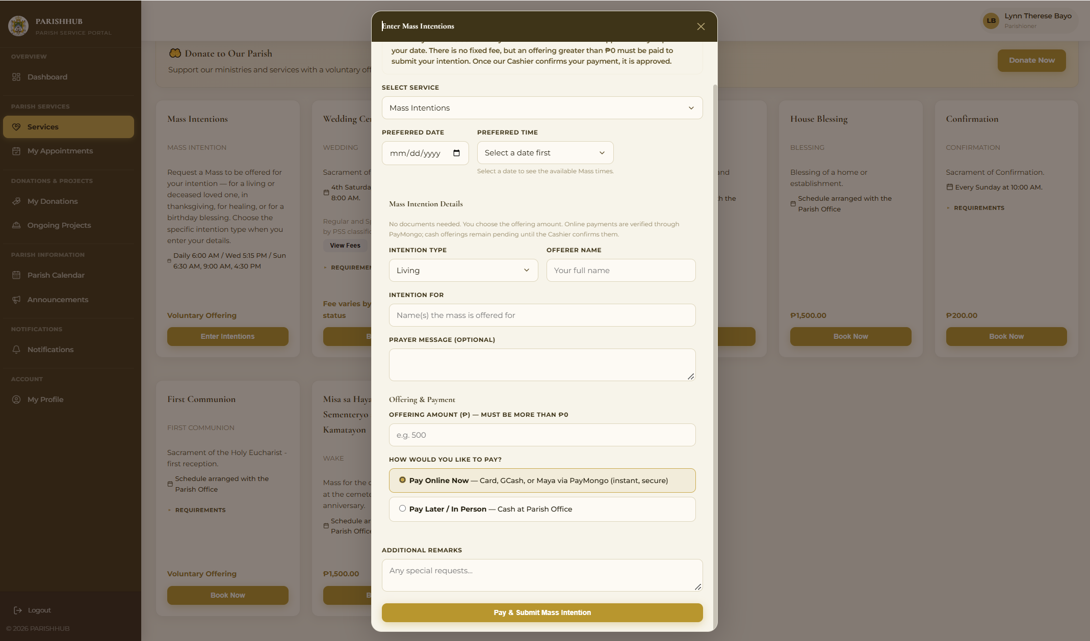
Procedure:
1. Click Services.
2. Click Enter Intention.
3. Select the date and Mass time.
4. Enter the intention details and the offering.
5. Choose the payment method and submit.

Process Name: My Appointments and Payment
Description: Displays the parishioner’s requests and allows payment of approved requests.
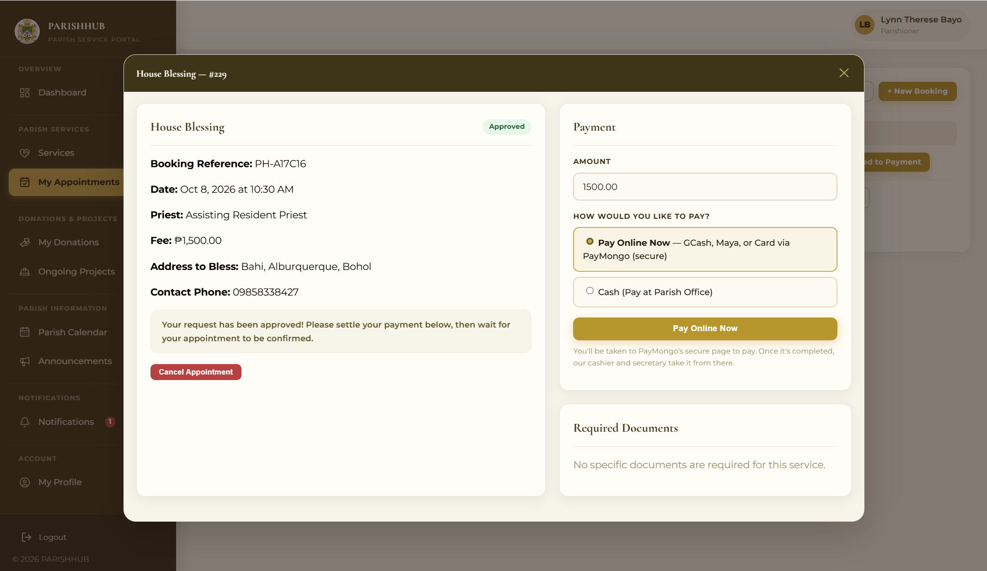
Procedure:
1. Click My Appointments.
2. Select an appointment.
3. Click Proceed to Payment.
4. Choose Pay Online or Pay in Cash.

Process Name: Donate to the Parish
Description: Allows parishioners and guests to donate to the parish.
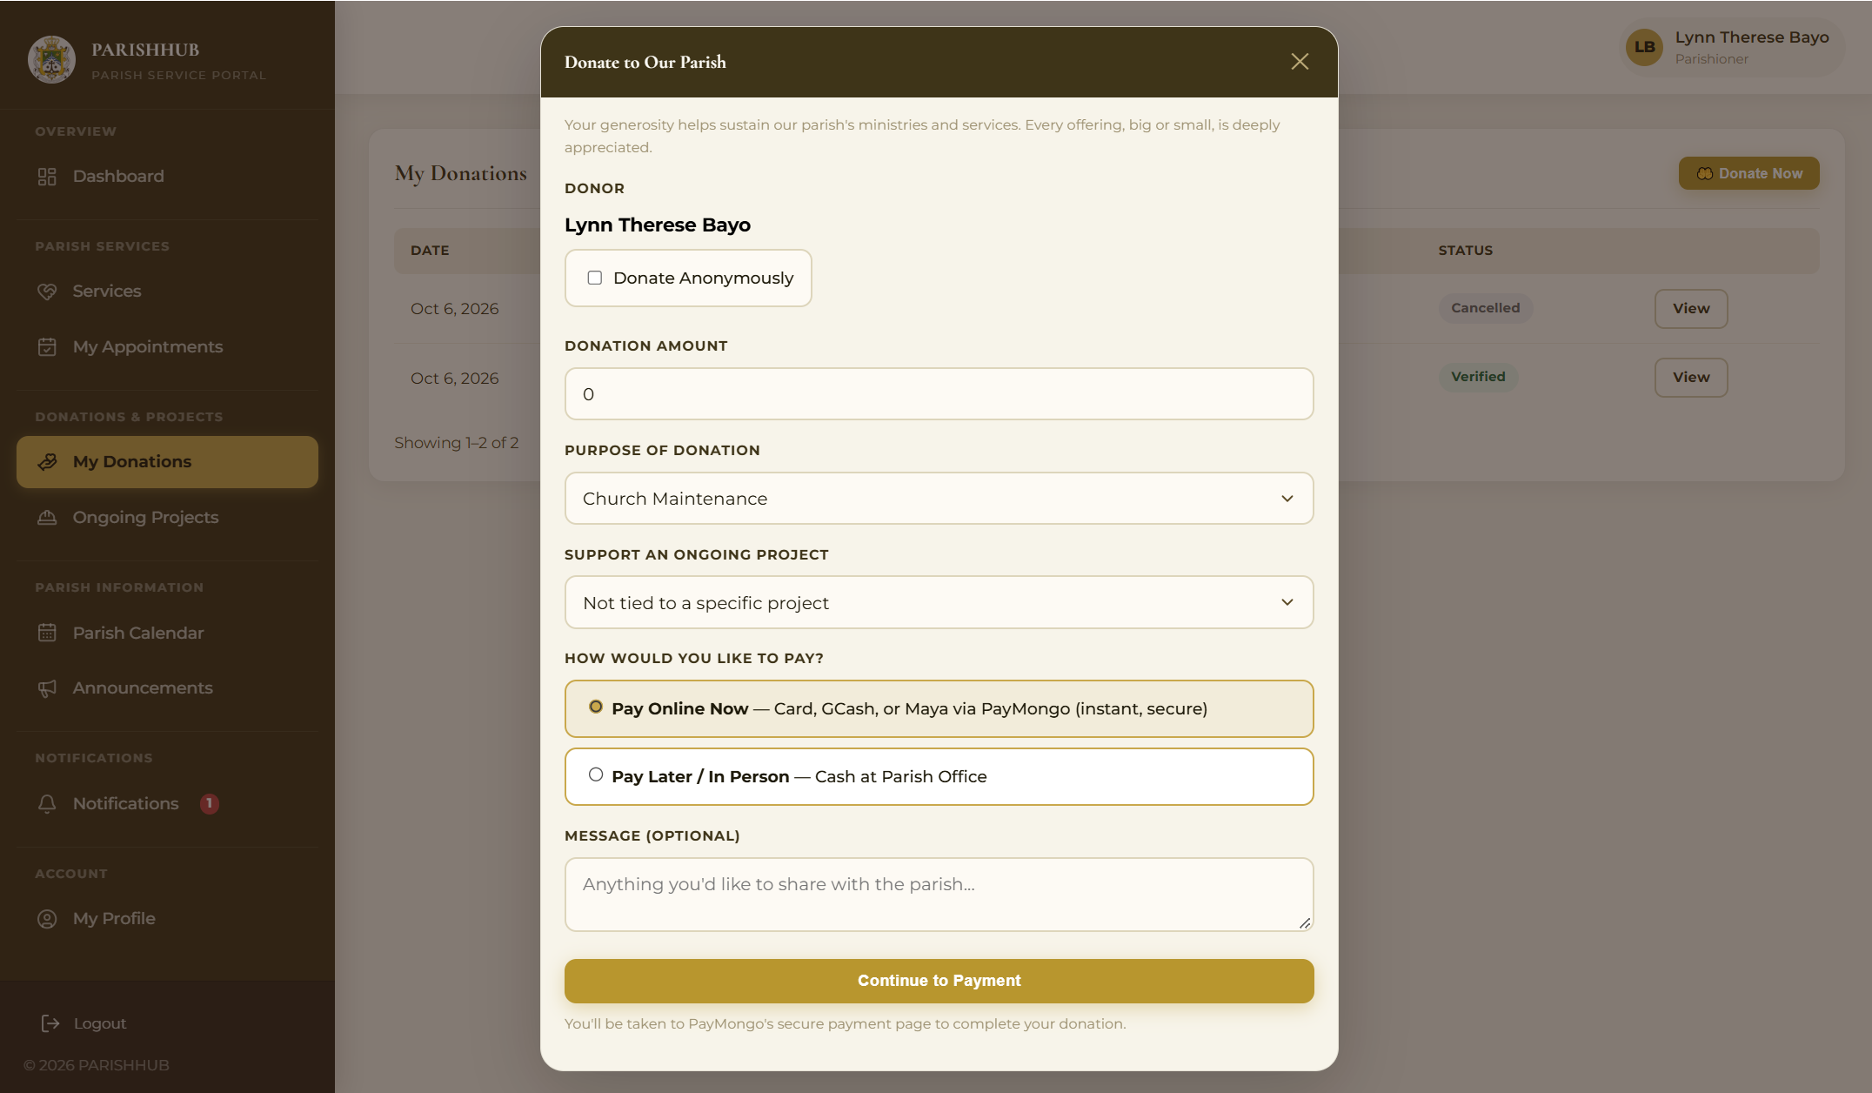
Procedure:
1. Click Donate Now.
2. Enter the amount, purpose, and project.
3. Choose the payment method.
4. Click Donate Now.

Process Name: Secretary Dashboard
Description: Displays the pending, todays, and weekly requests.
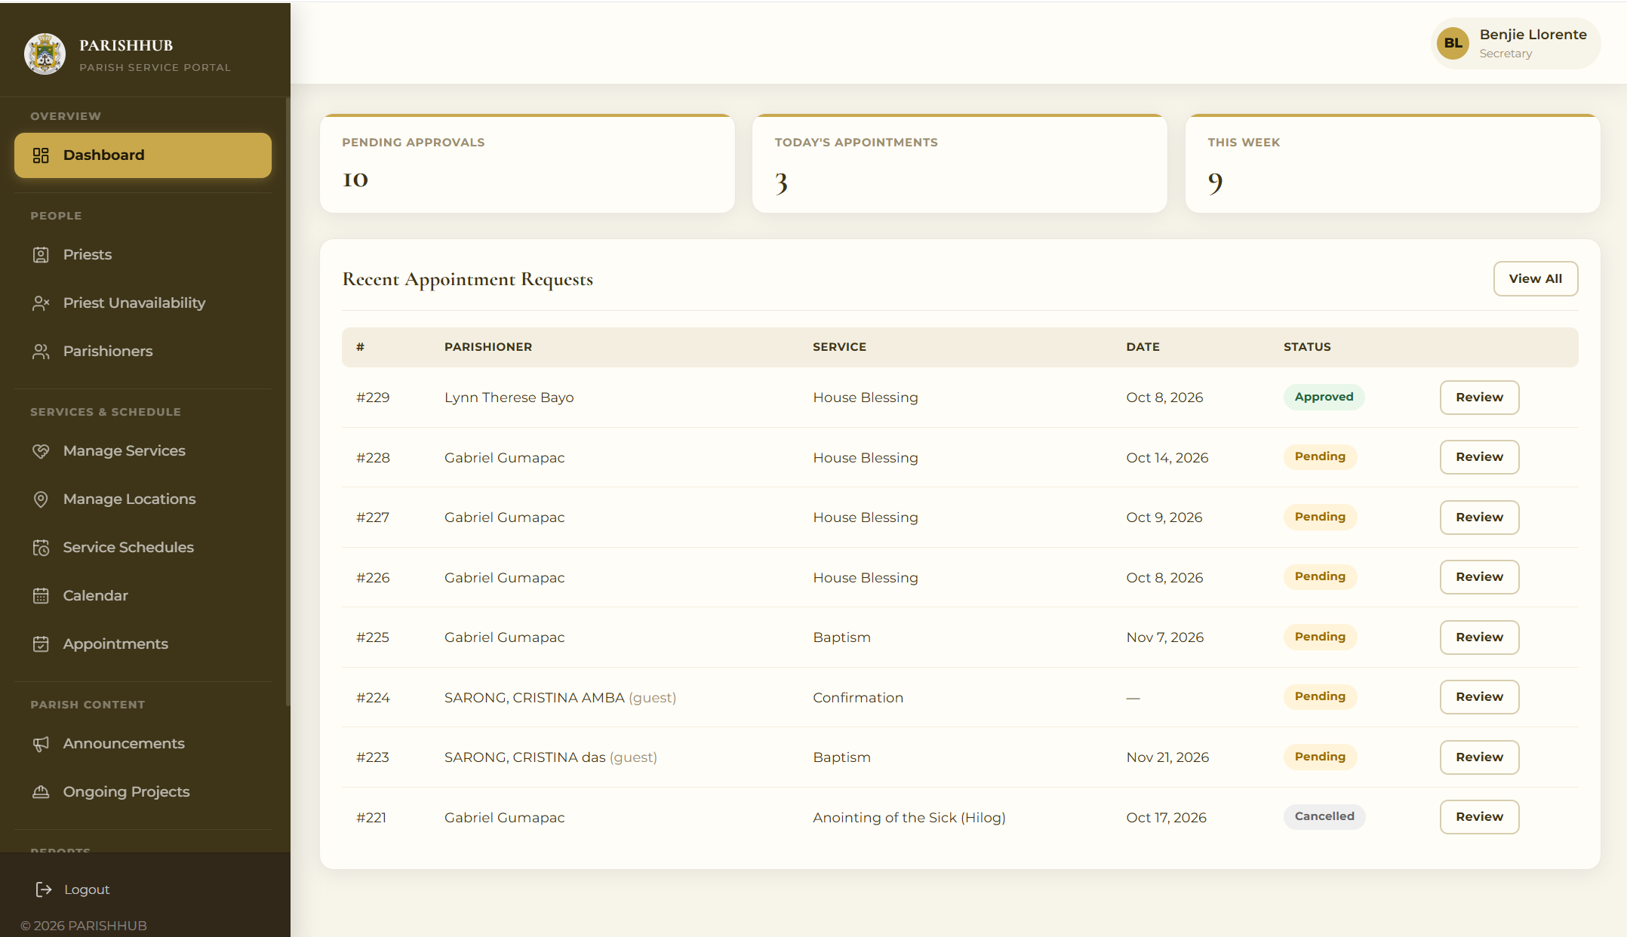
Procedure:
1. Log in as secretary.
2. View the dashboard.
3. Select the needed module.

Process Name: Appointment Review
Description: Allows the secretary to review, approve, or reject service requests.
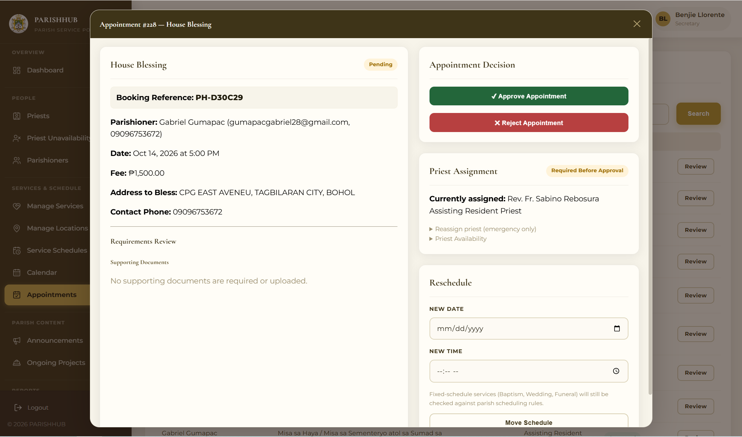
Procedure:
1. Click Appointments.
2. Click Review on a request.
3. Verify or reject the documents and the PSS classification.
4. Click Approve or Reject.

Process Name: Calendar Management
Description: Allows the secretary to add parish events and block dates.
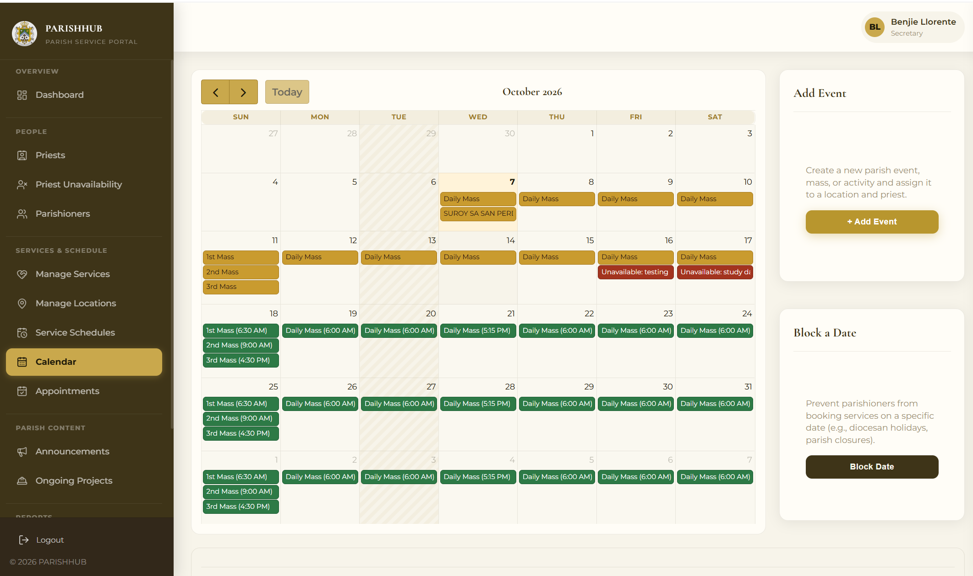
Procedure:
1. Click Calendar.
2. Click a date.
3. Add an event or block the date.
4. Click Save.

Process Name: Announcement Management
Description: Allows the secretary to create and publish announcements.
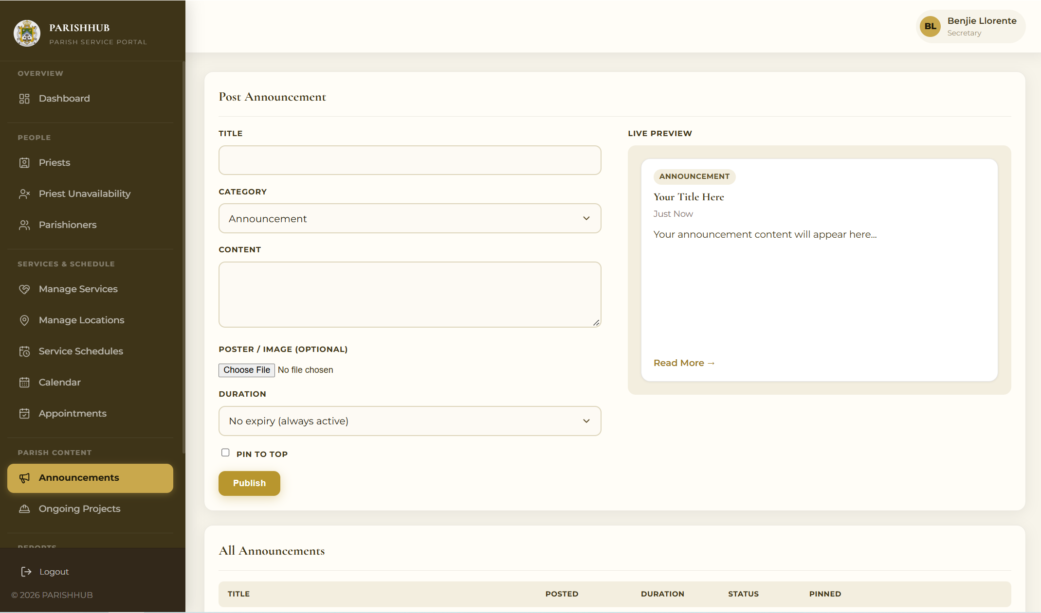
Procedure:
1. Click Announcements.
2. Create or select an announcement.
3. Enter the details.
4. Publish the announcement.

Process Name: Service Payment
Description: Allows the cashier to confirm payments and view receipts.
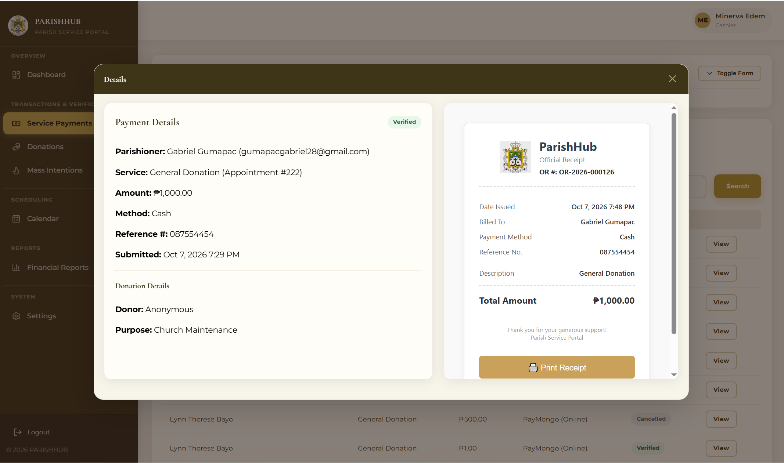
Procedure:
1. Click Service Payment.
2. Select a payment.
3. Click Confirm Payment.
4. View the official receipt.

Process Name: Financial Reports
Description: Allows the cashier and administrator to generate financial reports.
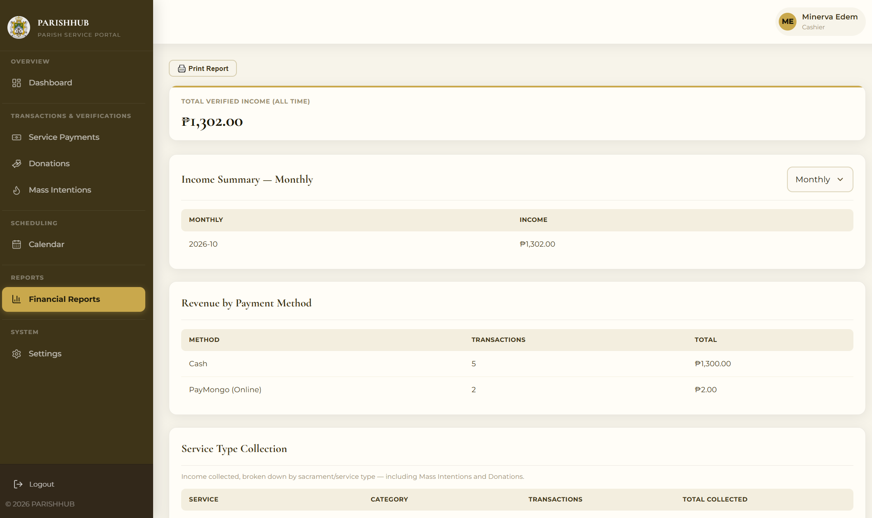
Procedure:
1. Click Financial Reports.
2. Select the report type and period.
3. View or print the report.

Process Name: Users and Roles
Description: Allows the administrator to manage staff accounts and roles.
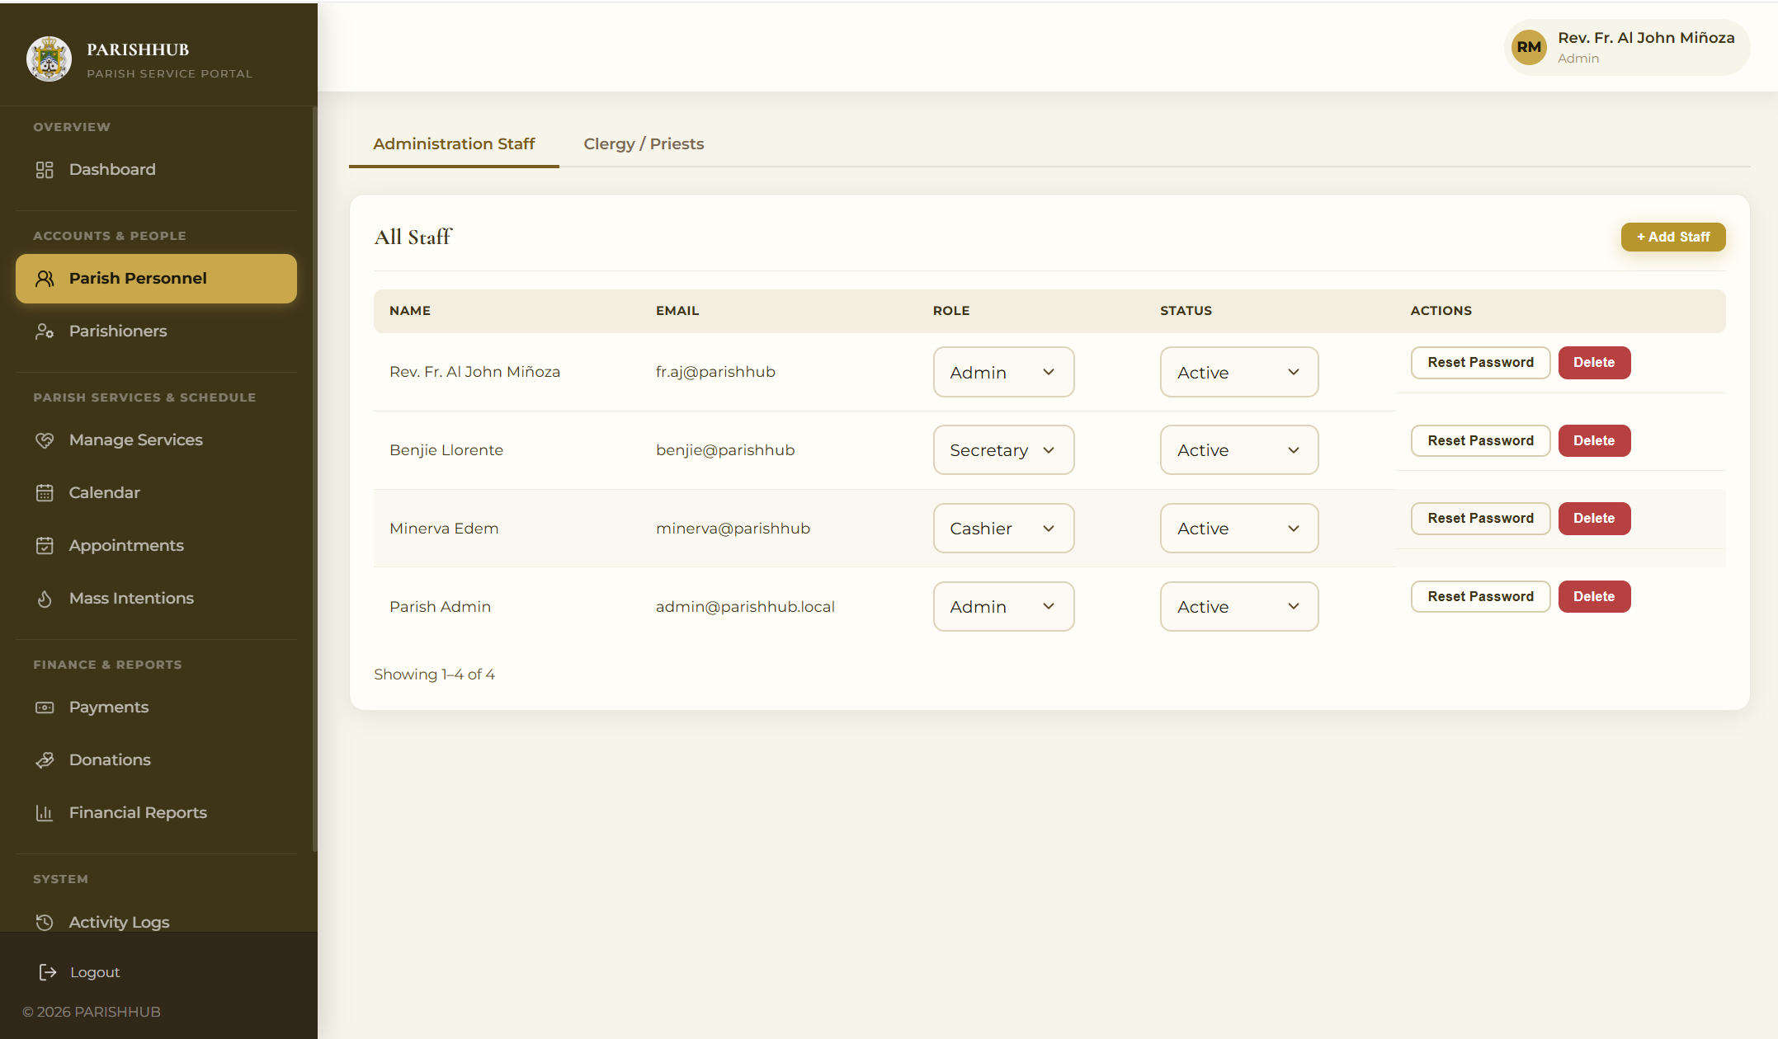
Procedure:
1. Click Users & Roles.
2. Add a staff account or change a role.
3. Confirm the changes.

Process Name: Activity Logs
Description: Allows the administrator to review the actions performed in the system.
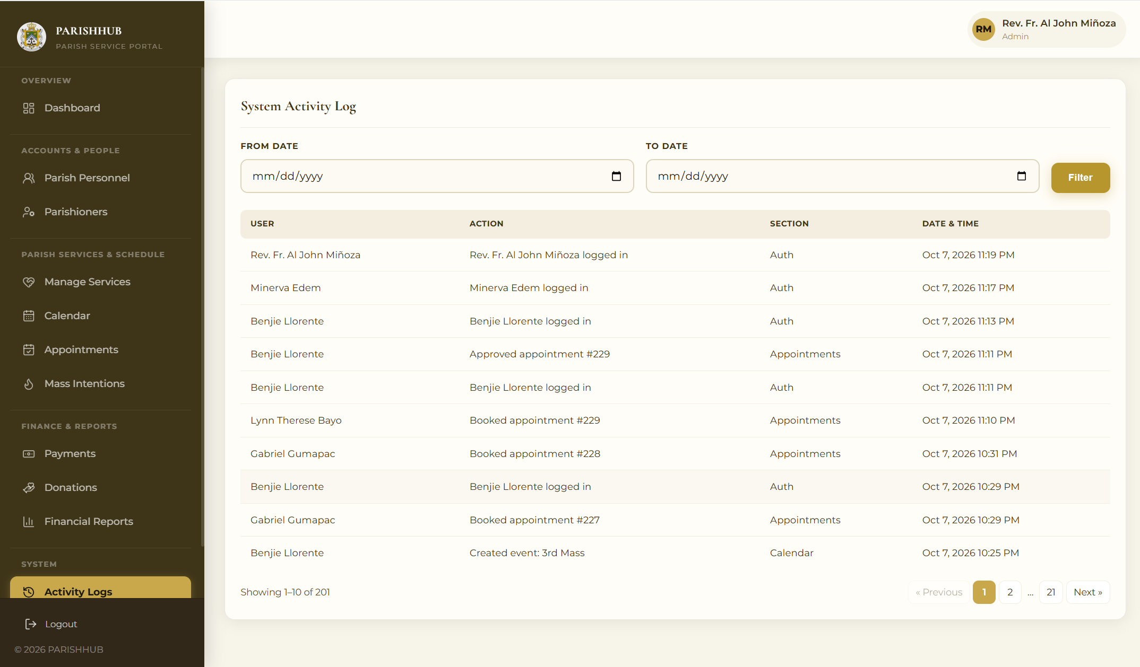
Procedure:
1. Click Activity Logs.
2. Select the date range.
3. View the logs.

Process Name: Priest Dashboard
Description: Allows priests to view their upcoming schedules
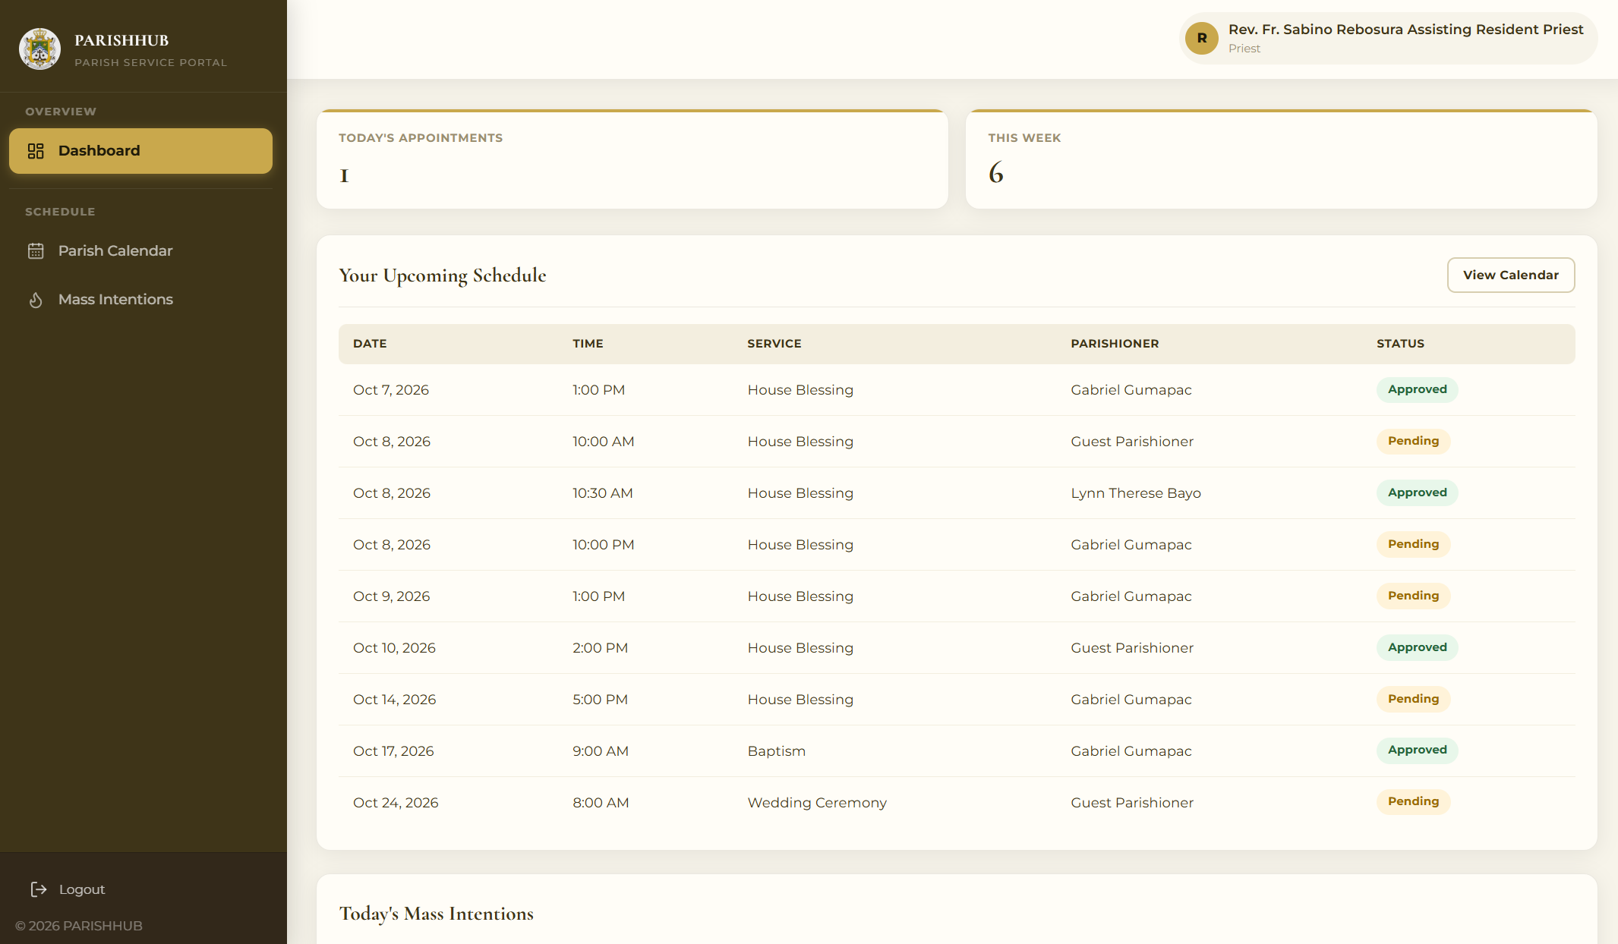
Procedure:
1. Log in as priest.
2. Click Dashboard
3. View the Upcoming schedules.

APPENDIX E
SOURCE CODE
1. User Authentication and Login
if ($_SERVER['REQUEST_METHOD'] === 'POST') {
verifyCsrf();
$email = trim($_POST['email'] ?? '');
$password = $_POST['password'] ?? '';

$stmt = db()->prepare(
"SELECT u.*, r.role_name FROM users u JOIN roles r ON u.role_id = r.role_id WHERE u.email = ? LIMIT 1"
);
$stmt->execute([$email]);
$user = $stmt->fetch();

if (!$user) {
keepOldInput(['email' => $email]);
flash('error', 'Incorrect email or password. Please try again.');
redirect(url('auth/login.php'));
}

if ($user['status'] !== 'active') {
keepOldInput(['email' => $email]);
flash('error', 'Your account is not active. Please contact the parish office.');
redirect(url('auth/login.php'));
}

if (!password_verify($password, $user['password'])) {
keepOldInput(['email' => $email]);
flash('error', 'Incorrect email or password. Please try again.');
redirect(url('auth/login.php'));
}

session_regenerate_id(true);

$_SESSION['user'] = [
'user_id' => (int) $user['user_id'],
'firstname' => $user['firstname'],
'lastname' => $user['lastname'],
'email' => $user['email'],
'role_id' => (int) $user['role_id'],
'role_name' => $user['role_name'],
];

logActivity((int) $user['user_id'], "{$user['firstname']} {$user['lastname']} logged in", 'Auth');

flash('success', 'Welcome back, ' . $user['firstname'] . '!');
redirect(redirectForRole($user['role_name']));
}
2. Account Registration
if ($password !== $confirm) {
keepOldInput($oldInputToKeep);
flash('error', 'Passwords do not match. Please re-enter them.');
redirect(url('auth/register.php'));
}
if (strlen($password) < 8) {
keepOldInput($oldInputToKeep);
flash('error', 'Password must be at least 8 characters.');
redirect(url('auth/register.php'));
}
if ($phone === '') {
keepOldInput($oldInputToKeep);
flash('error', 'Please enter your phone number.');
redirect(url('auth/register.php'));
}
if (!preg_match('/^09[0-9]{9}$/', $phone)) {
keepOldInput($oldInputToKeep);
flash('error', 'Phone number must be exactly 11 digits starting with 09.');
redirect(url('auth/register.php'));
}
$stmt = db()->prepare('SELECT user_id FROM users WHERE email = ?');
$stmt->execute([$email]);
if ($stmt->fetch()) {
keepOldInput($oldInputToKeep);
flash('error', 'An account with that email already exists.');
redirect(url('auth/register.php'));
}

$hash = password_hash($password, PASSWORD_BCRYPT);

db()->beginTransaction();
try {
$stmt = db()->prepare(
"INSERT INTO users (role_id, firstname, lastname, middlename, email, password, phone, address, birthdate, gender, status)
VALUES (1, ?, ?, ?, ?, ?, ?, ?, ?, ?, 'active')"
);
$stmt->execute([$firstname, $lastname, $middlename, $email, $hash, $phone, $address, $birthdate, $gender]);
$userId = db()->lastInsertId();

$stmt = db()->prepare('INSERT INTO parishioners (user_id) VALUES (?)');
$stmt->execute([$userId]);

db()->commit();
flash('success', 'Account created successfully! Please log in.');
redirect(url('auth/login.php'));
} catch (Throwable $e) {
db()->rollBack();
error_log($e->getMessage());
keepOldInput($oldInputToKeep);
flash('error', 'Registration failed. Please try again.');
redirect(url('auth/register.php'));
}
}
3. Role-Based Access Control and Security
function requireLogin(): void
{
sendNoCacheHeaders();
if (!isLoggedIn()) {
flash('error', 'Please log in to continue.');
redirect(url('auth/login.php'));
}
}

function requireRole(string ...$roles): void
{
requireLogin();
autoCancelExpiredUnpaidAppointments();
if (!in_array($_SESSION['user']['role_name'], $roles, true)) {
http_response_code(403);
include __DIR__ . '/../errors/403.php';
exit;
}
}

function redirectForRole(string $role): string
{
switch ($role) {
case 'Admin': return url('admin/dashboard.php');
case 'Secretary': return url('secretary/dashboard.php');
case 'Treasurer': return url('treasurer/dashboard.php');
case 'Priest': return url('priest/dashboard.php');
default: return url('parishioner/dashboard.php');
}
}
function csrfToken(): string
{
if (empty($_SESSION['csrf_token'])) {
$_SESSION['csrf_token'] = bin2hex(random_bytes(32));
}
return $_SESSION['csrf_token'];
}

function csrfField(): string
{
return '<input type="hidden" name="csrf_token" value="' . csrfToken() . '">';
}

function verifyCsrf(): void
{
$token = $_POST['csrf_token'] ?? '';
if (!$token || !hash_equals($_SESSION['csrf_token'] ?? '', $token)) {
http_response_code(419);
die('Session expired or invalid request token. Please go back and try again.');
}
}

4. Parish Service Scheduling Rules
function validateBooking(
string $category,
string $date,
string $time,
?string $dateOfDeath = null,
?string $scheduleType = null,
?int $serviceId = null
): array {
$time5 = substr($time, 0, 5);

if (isStaffDayOff($date, $time5)) {
return [
'valid' => false,
'message' => 'The parish office is closed every Monday afternoon and all day Tuesday (staff day off). Please choose another date.',
'forcedTime' => null,
];
}

switch ($category) {
case 'Baptism':
case 'Wedding':
case 'Blessing':
case 'Confirmation':
$effectiveType = $scheduleType ?? (in_array($category, ['Baptism', 'Wedding'], true) ? 'Regular' : 'Special');

if ($effectiveType === 'Regular') {
if (!$serviceId) {
$result = ['valid' => false, 'message' => 'Missing service selection for Regular scheduling.', 'forcedTime' => null];
break;
}
$result = matchesRegularSlot($serviceId, $date, $time);
break;
}
$result = ['valid' => true, 'message' => '', 'forcedTime' => null];
break;

case 'Funeral':
if (!$dateOfDeath) {
$result = [
'valid' => false,
'message' => 'Please provide the date of death so we can schedule the funeral Mass after the 9-day mourning period.',
'forcedTime' => null,
];
break;
}
$earliest = date('Y-m-d', strtotime($dateOfDeath . ' +9 days'));
if ($date < $earliest) {
$result = [
'valid' => false,
'message' => "Funeral Masses take place after the 9-day mourning period. The earliest available date based on the date of death is $earliest, at 1:00 PM.",
'forcedTime' => null,
];
break;
}
$result = ['valid' => true, 'message' => '', 'forcedTime' => '13:00:00'];
break;

case 'Mass Intention':
$slot = massIntentionSlotAvailability($date, $time5);
return ['valid' => $slot['available'], 'message' => (string) $slot['reason'], 'forcedTime' => null];

case 'First Communion':
default:
$result = ['valid' => true, 'message' => '', 'forcedTime' => null];
break;
}

if ($result['valid']) {
$effectiveTime = substr($result['forcedTime'] ?? $time, 0, 5);
if (in_array($effectiveTime, massTimesFor($date), true)) {
return [
'valid' => false,
'message' => 'That time is occupied by a scheduled Mass. Please choose another time outside Mass hours.',
'forcedTime' => null,
];
}
}

return $result;
}
5. Priest Availability
function priestIsAvailable(int $priestId, string $date, string $time, ?int $excludeAppointmentId = null): array
{
$time5 = substr($time, 0, 5);

$stmt = db()->prepare('SELECT full_name, title, status FROM priests WHERE priest_id = ?');
$stmt->execute([$priestId]);
$priest = $stmt->fetch();
if (!$priest) {
return ['available' => false, 'reason' => 'Priest not found.'];
}
if ($priest['status'] !== 'active') {
return ['available' => false, 'reason' => $priest['title'] . ' ' . $priest['full_name'] . ' is not currently available for new appointments.'];
}

$stmt = db()->prepare(
"SELECT reason, start_time, end_time FROM priest_unavailability
WHERE priest_id = ? AND unavailable_date = ?
AND (start_time IS NULL OR start_time <= ?) AND (end_time IS NULL OR end_time >= ?)"
);
$stmt->execute([$priestId, $date, $time5 . ':00', $time5 . ':00']);
$blocked = $stmt->fetch();
if ($blocked) {
$window = ($blocked['start_time'] === null && $blocked['end_time'] === null)
? 'that day'
: 'from ' . ($blocked['start_time'] ? date('g:i A', strtotime($blocked['start_time'])) : 'the start of the day')
. ' to ' . ($blocked['end_time'] ? date('g:i A', strtotime($blocked['end_time'])) : 'the end of the day');
return [
'available' => false,
'reason' => $priest['title'] . ' ' . $priest['full_name'] . ' is unavailable ' . $window . ($blocked['reason'] ? " ({$blocked['reason']})" : '') . '.',
'note' => $blocked['reason'] ?: 'Not available',
];
}

$sql = "SELECT a.appointment_id, s.service_name FROM appointments a
JOIN services s ON a.service_id = s.service_id
WHERE a.priest_id = ? AND a.appointment_date = ? AND a.appointment_time = ?
AND a.status_id NOT IN (3, 7)";
$params = [$priestId, $date, $time5];
if ($excludeAppointmentId !== null) {
$sql .= ' AND a.appointment_id != ?';
$params[] = $excludeAppointmentId;
}
$stmt = db()->prepare($sql);
$stmt->execute($params);
$conflict = $stmt->fetch();
if ($conflict) {
return [
'available' => false,
'reason' => $priest['title'] . ' ' . $priest['full_name'] . " is already booked for \"{$conflict['service_name']}\" (#{$conflict['appointment_id']}) at that exact date and time.",
];
}

return ['available' => true, 'reason' => null];
}
6. Mass Intention Schedule
function massIntentionSlotAvailability(string $date, string $time): array
{
$time5 = substr($time, 0, 5);
if (!preg_match('/^\d{4}-\d{2}-\d{2}$/', $date) || strtotime($date) === false) {
return ['available' => false, 'reason' => 'Please choose a valid date.'];
}
if (!isset(massIntentionTimesForDate($date)[$time5])) {
$isSunday = (int) date('w', strtotime($date)) === 0;
return ['available' => false, 'reason' => $isSunday
? 'On Sundays, Mass Intentions can only be offered at the 6:00 AM, 9:00 AM, or 4:00 PM Mass.'
: 'From Monday to Saturday, Mass Intentions can only be offered at the 6:00 AM Daily Mass.'];
}

$today = date('Y-m-d');
if ($date < $today || ($date === $today && $time5 <= date('H:i'))) {
return ['available' => false, 'reason' => 'That Mass has already passed.'];
}
if (isStaffDayOff($date, $time5)) {
return ['available' => false, 'reason' => 'The parish office is closed (Monday afternoons and all day Tuesday).'];
}

$stmt = db()->prepare('SELECT 1 FROM calendar WHERE calendar_date = ? AND is_blocked = 1');
$stmt->execute([$date]);
if ($stmt->fetchColumn()) {
return ['available' => false, 'reason' => 'This date is not available (blocked on the parish calendar).'];
}

$stmt = db()->prepare(
"SELECT 1 FROM appointments a JOIN services s ON a.service_id = s.service_id
WHERE a.appointment_date = ? AND a.appointment_time = ?
AND s.category NOT IN ('Mass Intention', 'Donation') AND a.status_id NOT IN (3, 7) LIMIT 1"
);
$stmt->execute([$date, $time5 . ':00']);
if ($stmt->fetchColumn()) {
return ['available' => false, 'reason' => 'Occupied — another parish service is scheduled at this time.'];
}

return ['available' => true, 'reason' => null];
}
7. Service Fee Computation
<?php
function feeRuleFor(string $category, ?string $scheduleType, string $classification): ?array
{
$scheduleType = in_array($category, ['Funeral','Wake'], true) ? 'Any' : ($scheduleType ?: 'Special');
$stmt = db()->prepare('SELECT * FROM service_fee_rules WHERE service_category = ? AND schedule_type = ? AND pss_classification = ?');
$stmt->execute([$category, $scheduleType, $classification]);
return $stmt->fetch() ?: null;
}

function calculateServiceFee(string $category, ?string $scheduleType, string $classification, int $sponsors = 0): ?array
{
$rule = feeRuleFor($category, $scheduleType, $classification);
if (!$rule) return null;
$additionalCount = max($sponsors - (int) $rule['included_sponsors'], 0);
$additionalFee = $additionalCount * (float) $rule['additional_sponsor_fee'];
$total = (float) $rule['base_fee'] + (float) $rule['priest_stipend'] + $additionalFee;
return ['base_fee'=>(float)$rule['base_fee'], 'priest_stipend'=>(float)$rule['priest_stipend'], 'additional_sponsor_count'=>$additionalCount, 'additional_sponsor_fee'=>$additionalFee, 'total'=>$total, 'classification'=>$classification, 'schedule_type'=>$scheduleType, 'sponsor_count'=>$sponsors];
}
8. Online Payment through PayMongo
$payMode = $_POST['pay_mode'] ?? '';
$methodId = null;
$reference = null;
if ($payMode === 'online') {
$methodId = 7;
if (!($amount > 0)) {
flash('error', 'There is nothing to pay online for this appointment.');
redirect($detailUrl);
}
} elseif ($payMode === 'cash') {
$methodId = 1;
} elseif ($payMode === 'manual') {
$methodId = (int) ($_POST['method_id'] ?? 0);
$reference = trim($_POST['payment_reference'] ?? '');
if (!in_array($methodId, [2, 3, 4], true) || strlen($reference) < 4) {
flash('error', 'Please choose GCash, Maya, or Bank Transfer and enter the payment reference number of your completed payment.');
redirect($detailUrl);
}
} else {
flash('error', 'Please choose how you would like to pay.');
redirect($detailUrl);
}

$pdo = db();
$pdo->beginTransaction();
try {
$stmt = $pdo->prepare(
"INSERT INTO payments (appointment_id, reference_number, amount, method_id, payment_status, payment_date)
VALUES (?, ?, ?, ?, 'pending', NOW())"
);
$stmt->execute([$appointmentId, $reference, $amount, $methodId]);
$paymentId = $pdo->lastInsertId();

if ($payMode === 'online') {
$returnBase = absoluteUrl('parishioner/payment-return.php') . '?appointment_id=' . $appointmentId;
$checkout = paymongoCreateCheckoutSession(
$amount,
$appointment['service_name'],
$returnBase . '&paid=1',
$returnBase . '&cancelled=1',
currentUser()['email'] ?? null
);
if (!$checkout['ok'] || !$checkout['checkout_url']) {
$pdo->rollBack();
error_log('PayMongo checkout session creation failed (service payment): ' . json_encode($checkout['raw'] ?? []));
flash('error', 'Could not start the online payment (' . ($checkout['error'] ?: 'please try again') . '). Nothing was charged.');
redirect($detailUrl);
}
$stmt = $pdo->prepare(
"INSERT INTO transactions (payment_id, gateway, gateway_transaction_id, status, raw_response) VALUES (?, 'paymongo', ?, 'pending', ?)"
);
$stmt->execute([$paymentId, $checkout['session_id'], json_encode($checkout['raw'])]);
$pdo->commit();
$_SESSION['pay_checkout'][$appointmentId] = true;
logActivity($userId, "Started an online payment for appointment #$appointmentId via PayMongo", 'Payments');
redirect($checkout['checkout_url']);
}
9. Payment Verification and Official Receipt
function verifyPaymentAndIssueReceipt(int $paymentId, ?int $verifiedByUserId, string $referenceNumber = ''): array
{
$pdo = db();
$pdo->beginTransaction();
try {
$updateStmt = $pdo->prepare(
"UPDATE payments SET payment_status='verified', reference_number=?, verified_by=?, verified_at=NOW()
WHERE payment_id=? AND payment_status='pending'"
);
$updateStmt->execute([$referenceNumber, $verifiedByUserId, $paymentId]);
if ($updateStmt->rowCount() === 0) {
$pdo->rollBack();
return ['ok' => false, 'message' => 'Payment already processed or not found.', 'receipt_number' => null];
}

$stmt = $pdo->prepare('SELECT * FROM payments WHERE payment_id = ?');
$stmt->execute([$paymentId]);
$payment = $stmt->fetch();

$pdo->prepare("UPDATE appointments SET status_id = 4 WHERE appointment_id = ?")->execute([$payment['appointment_id']]);

$receiptNumber = 'OR-' . date('Y') . '-' . str_pad((string) $paymentId, 6, '0', STR_PAD_LEFT);
$pdo->prepare("INSERT INTO official_receipts (payment_id, receipt_number, issued_by) VALUES (?, ?, ?)")
->execute([$paymentId, $receiptNumber, $verifiedByUserId]);

$stmt = $pdo->prepare('SELECT parishioner_id FROM appointments WHERE appointment_id = ?');
$stmt->execute([$payment['appointment_id']]);
$parId = $stmt->fetchColumn();
$stmt = $pdo->prepare('SELECT user_id FROM parishioners WHERE parishioner_id = ?');
$stmt->execute([$parId]);
$puid = $stmt->fetchColumn();

$pdo->prepare("INSERT INTO notifications (user_id, type, category, title, message) VALUES (?, 'website', 'payment', 'Payment Verified', ?)")
->execute([$puid, "Your payment (Ref: {$payment['reference_number']}) has been verified. Official Receipt $receiptNumber issued."]);

$stmt = $pdo->prepare(
"SELECT s.category FROM appointments a JOIN services s ON a.service_id = s.service_id WHERE a.appointment_id = ?"
);
$stmt->execute([$payment['appointment_id']]);
$isDonation = $stmt->fetchColumn() === 'Donation';

$pdo->commit();
if ($isDonation) {
syncWeeklyDonationAnnouncement($verifiedByUserId ?? $puid);
}
return ['ok' => true, 'message' => "Payment verified. Receipt $receiptNumber generated.", 'receipt_number' => $receiptNumber];
} catch (Throwable $e) {
$pdo->rollBack();
error_log($e->getMessage());
return ['ok' => false, 'message' => 'Failed to verify payment.', 'receipt_number' => null];
}
}

10. Document Validation
function validateUploadedFile(array $file): array
{
if (($file['error'] ?? UPLOAD_ERR_NO_FILE) !== UPLOAD_ERR_OK) {
return ['valid' => false, 'mime' => null, 'reason' => 'missing'];
}
if (empty($file['tmp_name']) || !is_uploaded_file($file['tmp_name'])) {
return ['valid' => false, 'mime' => null, 'reason' => 'unreadable'];
}
if (($file['size'] ?? 0) <= 0) {
return ['valid' => false, 'mime' => null, 'reason' => 'unreadable'];
}
if ((int) $file['size'] > (defined('MAX_DOCUMENT_UPLOAD_MB') ? MAX_DOCUMENT_UPLOAD_MB : 2) * 1024 * 1024) {
return ['valid' => false, 'mime' => null, 'reason' => 'too_large'];
}

$finfo = finfo_open(FILEINFO_MIME_TYPE);
$mime = finfo_file($finfo, $file['tmp_name']);
finfo_close($finfo);

if (!in_array($mime, ALLOWED_DOCUMENT_MIME_TYPES, true)) {
return ['valid' => false, 'mime' => $mime, 'reason' => 'invalid_type'];
}
$extension = strtolower(pathinfo((string) ($file['name'] ?? ''), PATHINFO_EXTENSION));
$validExtensions = match ($mime) {
'application/pdf' => ['pdf'],
'image/jpeg' => ['jpg', 'jpeg'],
'image/png' => ['png'],
default => [],
};
if (!in_array($extension, $validExtensions, true)) {
return ['valid' => false, 'mime' => $mime, 'reason' => 'invalid_type'];
}

if ($mime === 'application/pdf') {
$header = @file_get_contents($file['tmp_name'], false, null, 0, 5);
if ($header !== '%PDF-') {
return ['valid' => false, 'mime' => $mime, 'reason' => 'corrupted'];
}
return ['valid' => true, 'mime' => $mime, 'reason' => null];
}

$dimensions = @getimagesize($file['tmp_name']);
if ($dimensions === false) {
return ['valid' => false, 'mime' => $mime, 'reason' => 'corrupted'];
}
[$width, $height] = $dimensions;
if ($height < $width) {
return ['valid' => false, 'mime' => $mime, 'reason' => 'orientation'];
}

return ['valid' => true, 'mime' => $mime, 'reason' => null];
}

function documentValidationMessage(?string $reason): string
{
return match ($reason) {
'missing' => 'This document is required. Please choose a file to upload.',
'orientation' => 'Invalid document orientation. Please upload the required document in portrait orientation.',
'invalid_type' => 'Unsupported file type. Please upload a JPG, PNG, or PDF file.',
'corrupted' => 'This file could not be read — it may be corrupted. Please upload a different copy.',
'unreadable' => 'This file could not be uploaded. Please try again.',
'too_large' => 'This document exceeds the 2 MB file-size limit. Please choose a smaller file.',
default => 'Document validation failed. Please upload the correct required document.',
};
}

11. Automatic Cancellation of Unpaid Appointments
function autoCancelExpiredUnpaidAppointments(): void
{
if (($_SESSION['auto_cancel_ran_on'] ?? '') === date('Y-m-d')) {
return;
}
$_SESSION['auto_cancel_ran_on'] = date('Y-m-d');

try {
$stmt = db()->query(
"SELECT a.appointment_id, u.user_id, s.service_name
FROM appointments a
JOIN services s ON a.service_id = s.service_id
JOIN parishioners par ON a.parishioner_id = par.parishioner_id
JOIN users u ON par.user_id = u.user_id
WHERE a.status_id = 2
AND a.appointment_date < CURRENT_DATE
AND NOT EXISTS (
SELECT 1 FROM payments p
WHERE p.appointment_id = a.appointment_id AND p.payment_status IN ('pending', 'verified')
)"
);
$expired = $stmt->fetchAll();
if (empty($expired)) {
return;
}

$ids = array_column($expired, 'appointment_id');
$placeholders = implode(',', array_fill(0, count($ids), '?'));
db()->prepare(
"UPDATE appointments SET status_id = 7, cancelled_reason = 'Automatically cancelled — approved but never paid before the scheduled date.'
WHERE appointment_id IN ($placeholders)"
)->execute($ids);

foreach ($expired as $row) {
db()->prepare(
"INSERT INTO notifications (user_id, type, category, title, message) VALUES (?, 'website', 'appointment', 'Appointment Automatically Cancelled', ?)"
)->execute([
$row['user_id'],
"Your appointment for {$row['service_name']} (#{$row['appointment_id']}) was automatically cancelled — it was approved but never paid before the scheduled date.",
]);
logActivity(null, "Auto-cancelled appointment #{$row['appointment_id']} (approved but unpaid past its date)", 'Appointments');
}
} catch (Throwable $e) {
error_log('autoCancelExpiredUnpaidAppointments error: ' . $e->getMessage());
}
}

12. Activity Logging
function logActivity(?int $userId, string $action, string $module = 'General'): void
{
try {
$stmt = db()->prepare(
'INSERT INTO activity_logs (user_id, action, module, ip_address, user_agent) VALUES (?, ?, ?, ?, ?)'
);
$stmt->execute([
$userId,
$action,
$module,
$_SERVER['REMOTE_ADDR'] ?? null,
$_SERVER['HTTP_USER_AGENT'] ?? null,
]);
} catch (Throwable $e) {
error_log('Activity log error: ' . $e->getMessage());
}
}

RESEARCHERS BIODATA
PERSONAL DATA
Name : Lynn Therese A. Bayo
Nick Name : Therese
Date of Birth : October 3, 2005
Place of Birth : Cebu City
Home Address : Bahi, Alburquerque, Bohol
Email Address : lynntheresebayo@gmail.com
Civil Status : Single
Citizenship : Filipino
Father’s Name : Gerald Bayo
Mother’s Name : Juvy Bayo
EDUCATIONAL BACKGROUND
Elementary : Alburquerque Central Elementary School
East Poblacion, Alburquerque, Bohol
Secondary : San Roque National High School
East Poblacion, Alburquerque, Bohol
Tertiary : Bohol Island State University – Balilihan Campus
Magsija, Balilihan, Bohol
Motto : “In God We Trust”

RESEARCHERS BIODATA
PERSONAL DATA
Name : Syke H. Amoguis
Nick Name : Syke
Date of Birth : May 25, 2004
Place of Birth : Longpen Canawa
Home Address : Longpen Canawa, Candijay, Bohol
Email Address : amoguissyke@gmail.com
Civil Status : Single
Citizenship : Filipino
Father’s Name : Monico C. Amoguis
Mother’s Name : Benigna H. Amoguis
EDUCATIONAL BACKGROUND
Elementary : Canawa Elementary School
Longpen Canawa, Candijay, Bohol
Secondary : Tambongan National High School
Tambongan, Candijay, Bohol
Tertiary : Bohol Island State University – Balilihan Campus
Magsija, Balilihan, Bohol
Motto : “I can and I will.”

RESEARCHERS BIODATA
PERSONAL DATA
Name : Gabriel C. Gumapac
Nick Name : Gab
Date of Birth : February 2, 2005
Place of Birth : Tagbilaran City
Home Address : CPG East Ave. Tagbilaran City, Bohol
Email Address : gumapacgabriel28@gmail.com
Civil Status : Single
Citizenship : Filipino
Father’s Name : Samuel Gumapac
Mother’s Name : Silva Gumapac
EDUCATIONAL BACKGROUND
Elementary : City East Elementary School
Poblacion III, Tagbilaran City, Bohol
Secondary : Carmel Academy
Del Carmen Norte, Balilihan, Bohol
Tertiary : Bohol Island State University – Balilihan Campus
Magsija, Balilihan, Bohol
Motto : “Progress over perfection”

