Requirements:
- Only supported aligner so far is MOSAIK but it is easy to add your aligner of choice.
- So far the pipeline only supports PE-reads.
- Files must currently be named on format:
  - x.y.lanez_k.fastq
    - Ex: 10-7050.20101008A_hiseq2000.lane8_1.fastq
10-7050.20101008A_hiseq2000.lane8_2.fastq

Pipe hierarchy:

Master script: wgs_mosaik_wf_master.1.2.pl

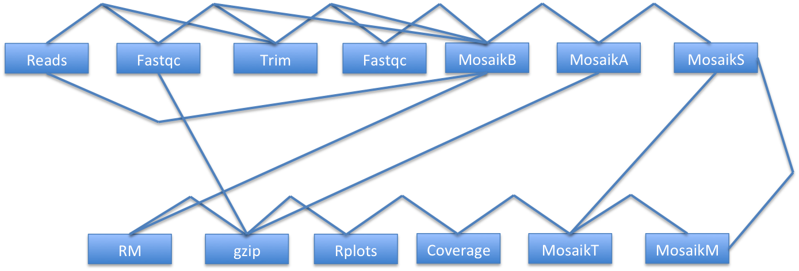

Each edge is an option to run that program. Several chains of programs are available.
You can check out the parameters by supplying flag: -h.

Data structure:

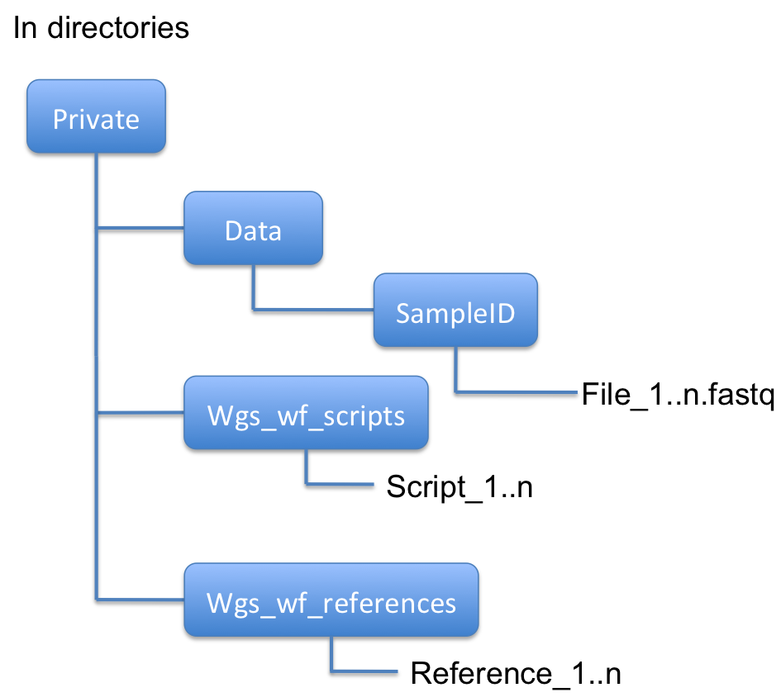

- Your in directory data folder should contain a sample id subfolder which in turn contains a fastq subfolder with your .fastq files. Specify it with –id.
  - Input directory supplied is the fastq directory
    - Ex: located in private → LHON/10-7050/fastq
      - Where LHON is the data folder and 10-7050 is the sample ID.
- You will need a folder that contains all the custom script files required by the pipeline. Specify it with –ids.

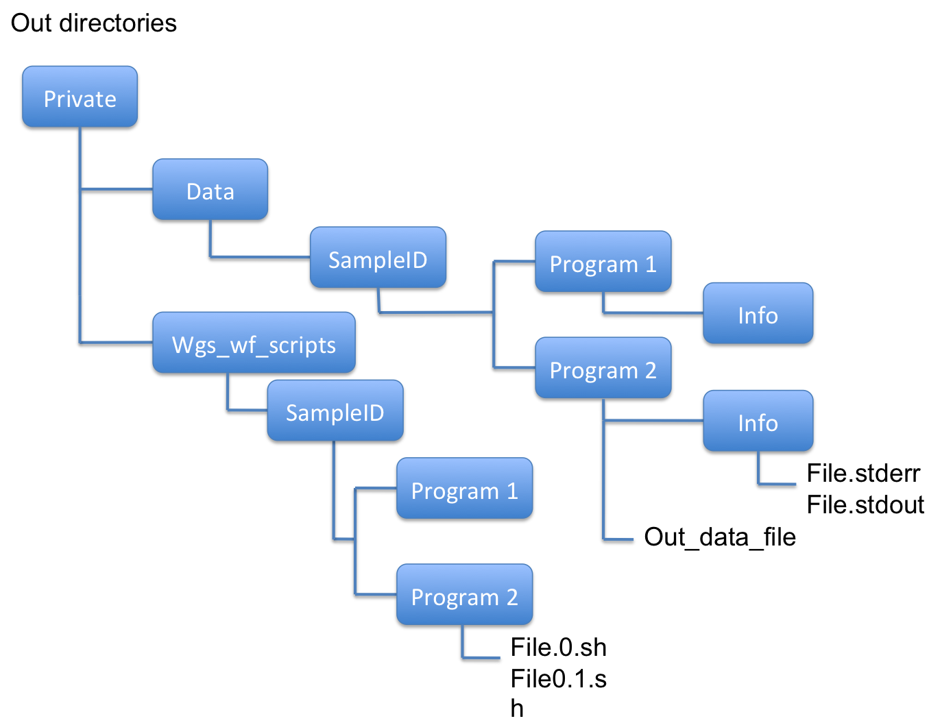
- The pipeline script will create a data folder if the one specified does not already exist. It will put all the out files from programs there. Specify the output data dir with –odf.
- If possible each programme that is executed will get a separate folder under the data folder. That folder will contain a subdirectory called info. All the stderr and stdout information from the runs will be gathered there.
- You can also specify an output directory to put all the sbatch files. It will write all the master script sbatch files to the output dir. Specify it with –ods.
- You will have to supply the pipeline with a reference dir. Specify it with –rd.

References:

- Reference directory must contain:
  - The mosaik reference file named cancat.db (whole genome)
  - The mosaik jump database named with the stub: concat_jdb_15
    - concat_jdb_15_keys.jmp
    - concat_jdb_15_meta.jmp
    - concat_jdb_15_positions.jmp
  - Exome bed-file:
    - CCDS-hg19.bed or similar
- Uppnex:
  - The mosaik data reference /bubo/nobackup/uppnex/reference/Homo_sapiens/GRCh37/program_files/mosaik/concat.dat

Scripts:

The following scripts must be located in the ids script directory:

- wgs_mosaik_wf_master.1.2.pl
- –pFQF: filter_fastq.pl
- –pCR: calculate_coverage_statistics.2.0.pl
- –pRCP:
  - Average_cov_chr.R
  - Coverage_bed_pileup_genome.R
  - Coverage_hist_by_Chr.R

Command line example:

perl wgs_wf_scripts/wgs_mosaik_wf_master.1.3.pl –id /bubo/proj/b2010080/private/LHON/10-7050/fastq –ids /bubo/proj/b2010080/private/wgs_wf_scripts -a b2010080 -s 10-7050_notrim -em henrik.stranneheim@scilifelab.se -odf /bubo/proj/b2010080/private/LHON/no_trim_data -ods /bubo/proj/b2010080/private/LHON/no_trim_scripts -pFQC 0 -pFQF 0 -pFQC2 0 -pGZ 0 -pRMMOB 0

- -h: Flag can be supplied to check out all parameters and their explanation
- -s: Sampleid must be supplied in the same order as the input directory
  - Ex: Input: -id LHON/10-7050,LHON/10-7052 → -s 10-7050,10-7052
- -pX: -p stands for program and then follows an akronym for the program.
  - 0 means do not execute
  - 1 means run execute
  - The default is to run the longest chain i.e. all programs.
- Flags for –id, -ids, -odf, -ods and –rd should be submitted with the whole path i.e. /bubo/proj/bXXXXXXX/private

