**************************Default**************************

catzip-icestorm
Risc-V servant
initial build
service
09/08/21

**************************Default**************************

devel@mypi3-20:~/WORKSPACE $ export WORKSPACE=/home/devel/WORKSPACE/
devel@mypi3-20:~/WORKSPACE $ export SERV=/home/devel/WORKSPACE/fusesoc_libraries/serv
devel@mypi3-20:~/WORKSPACE $ fusesoc run --target=verilator_tb servant --vcd --uart_baudrate=57600 --firmware=$SERV/sw/zephyr_hello.hex
INFO: Preparing ::serv:1.1.0
INFO: Preparing ::servant:1.1.0
INFO: Setting up project

INFO: Building simulation model
verilator -f servant_1.1.0.vc --trace
make -f Vservant_sim.mk
make[1]: Entering directory '/home/devel/WORKSPACE/build/servant_1.1.0/verilator_tb-verilator'
g++ -I. -MMD -I/usr/local/share/verilator/include -I/usr/local/share/verilator/include/vltstd -DVM_COVERAGE=0 -DVM_SC=0 -DVM_TRACE=1 -faligned-new -fcf-protection=none -Wno-bool-operation -Wno-sign-compare -Wno-uninitialized -Wno-unused-but-set-variable -Wno-unused-parameter -Wno-unused-variable -Wno-shadow -std=gnu++14 -Os -c -o servant_tb.o ../src/servant_1.1.0/bench/servant_tb.cpp
g++ -I. -MMD -I/usr/local/share/verilator/include -I/usr/local/share/verilator/include/vltstd -DVM_COVERAGE=0 -DVM_SC=0 -DVM_TRACE=1 -faligned-new -fcf-protection=none -Wno-bool-operation -Wno-sign-compare -Wno-uninitialized -Wno-unused-but-set-variable -Wno-unused-parameter -Wno-unused-variable -Wno-shadow -std=gnu++14 -Os -c -o verilated.o /usr/local/share/verilator/include/verilated.cpp
g++ -I. -MMD -I/usr/local/share/verilator/include -I/usr/local/share/verilator/include/vltstd -DVM_COVERAGE=0 -DVM_SC=0 -DVM_TRACE=1 -faligned-new -fcf-protection=none -Wno-bool-operation -Wno-sign-compare -Wno-uninitialized -Wno-unused-but-set-variable -Wno-unused-parameter -Wno-unused-variable -Wno-shadow -std=gnu++14 -Os -c -o verilated_dpi.o /usr/local/share/verilator/include/verilated_dpi.cpp
g++ -I. -MMD -I/usr/local/share/verilator/include -I/usr/local/share/verilator/include/vltstd -DVM_COVERAGE=0 -DVM_SC=0 -DVM_TRACE=1 -faligned-new -fcf-protection=none -Wno-bool-operation -Wno-sign-compare -Wno-uninitialized -Wno-unused-but-set-variable -Wno-unused-parameter -Wno-unused-variable -Wno-shadow -std=gnu++14 -Os -c -o verilated_vcd_c.o /usr/local/share/verilator/include/verilated_vcd_c.cpp
/usr/bin/perl /usr/local/share/verilator/bin/verilator_includer -DVL_INCLUDE_OPT=include Vservant_sim.cpp Vservant_sim_servant_sim.cpp Vservant_sim_servant__Mz1_MB2000_S1.cpp Vservant_sim_servant_ram__pi1.cpp Vservant_sim__Dpi.cpp Vservant_sim__Trace.cpp Vservant_sim__Slow.cpp Vservant_sim_servant_sim__Slow.cpp Vservant_sim_servant__Mz1_MB2000_S1__Slow.cpp Vservant_sim_servant_ram__pi1__Slow.cpp Vservant_sim__Syms.cpp Vservant_sim__Trace__Slow.cpp > Vservant_sim__ALL.cpp
g++ -I. -MMD -I/usr/local/share/verilator/include -I/usr/local/share/verilator/include/vltstd -DVM_COVERAGE=0 -DVM_SC=0 -DVM_TRACE=1 -faligned-new -fcf-protection=none -Wno-bool-operation -Wno-sign-compare -Wno-uninitialized -Wno-unused-but-set-variable -Wno-unused-parameter -Wno-unused-variable -Wno-shadow -std=gnu++14 -Os -c -o Vservant_sim__ALL.o Vservant_sim__ALL.cpp
Archive ar -cr Vservant_sim__ALL.a Vservant_sim__ALL.o
g++ servant_tb.o verilated.o verilated_dpi.o verilated_vcd_c.o Vservant_sim__ALL.a -o Vservant_sim
make[1]: Leaving directory '/home/devel/WORKSPACE/build/servant_1.1.0/verilator_tb-verilator'
INFO: Running
INFO: Running simulation
Loading RAM from /home/devel/WORKSPACE/fusesoc_libraries/serv/sw/zephyr_hello.hex
***** Booting Zephyr OS zephyr-v1.14.1-4-gc7c2d62513fe *****
Hello World! Service

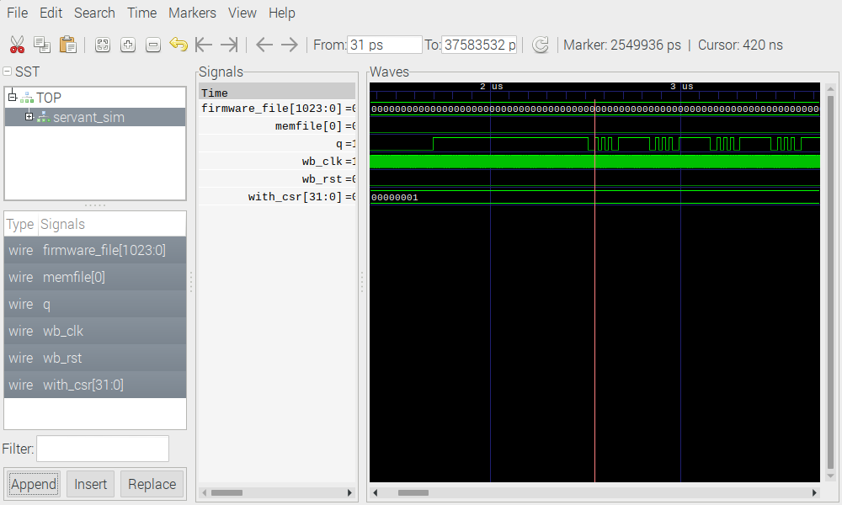
The image below is suppose to look like the first seven lines when the sudo config_cat ~/servant_1.1.0.bin. The first seven lines are when iCE40 FPGA is programmed with
sudo config_cat helloworld.bin in the testbuilds/catzip/rtl/uart folder.

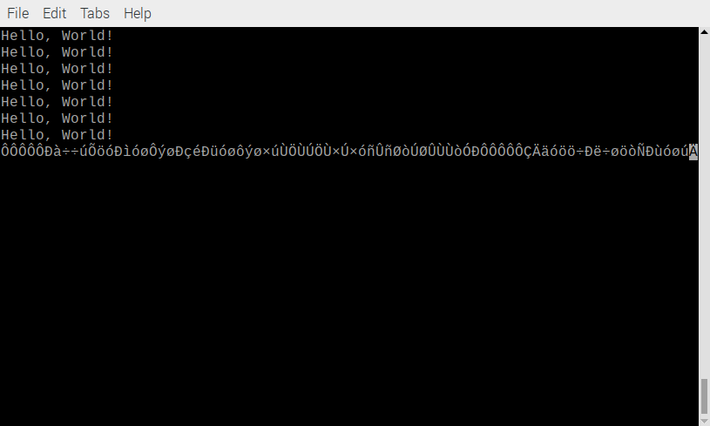

A pmodusb is connected to PM2 on Catboard.

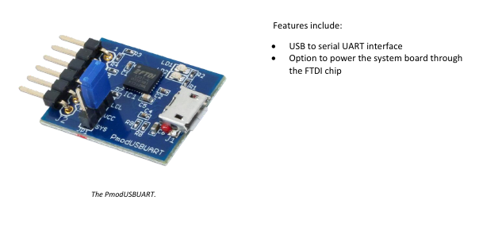

CatBoard
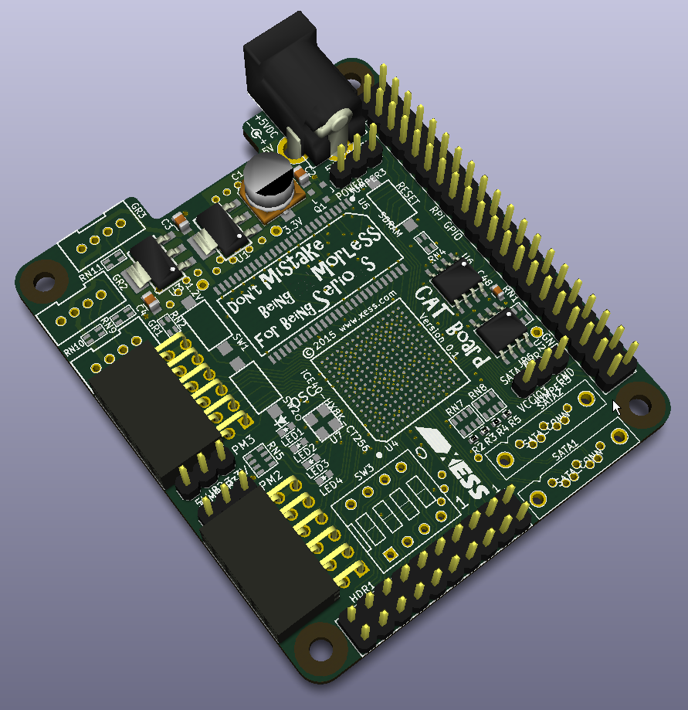

Raspberry Pi 3B+ is running Raspberry Pi OS.

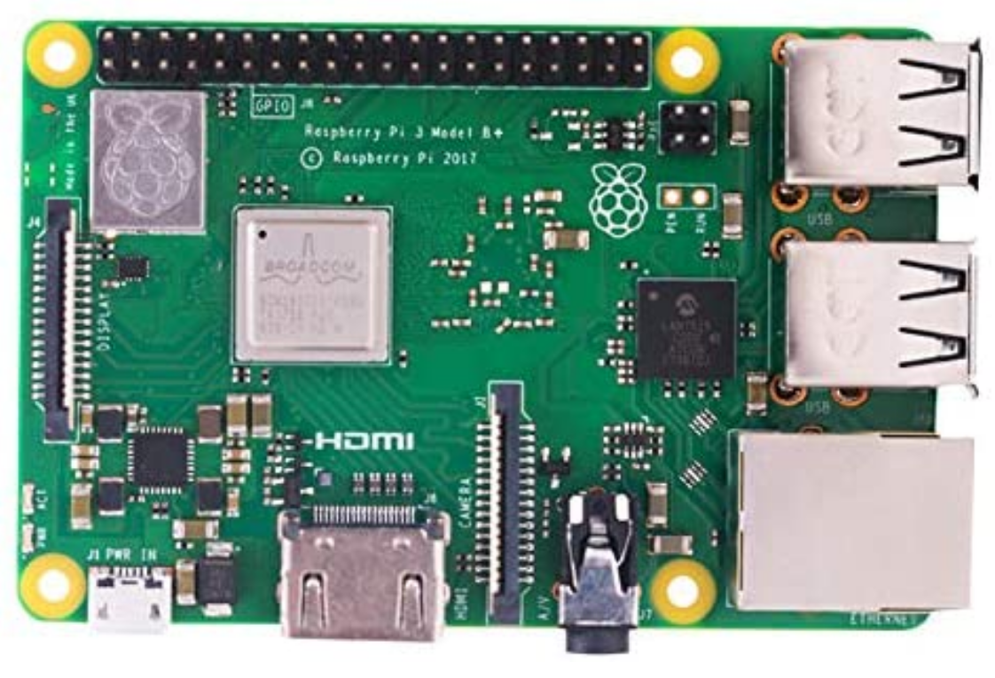

The USB is connected to The USB on Raspberry Pi3B+ which also has a catboard mounted on the 40 GPIO connector.

The serial port is setup as follows.

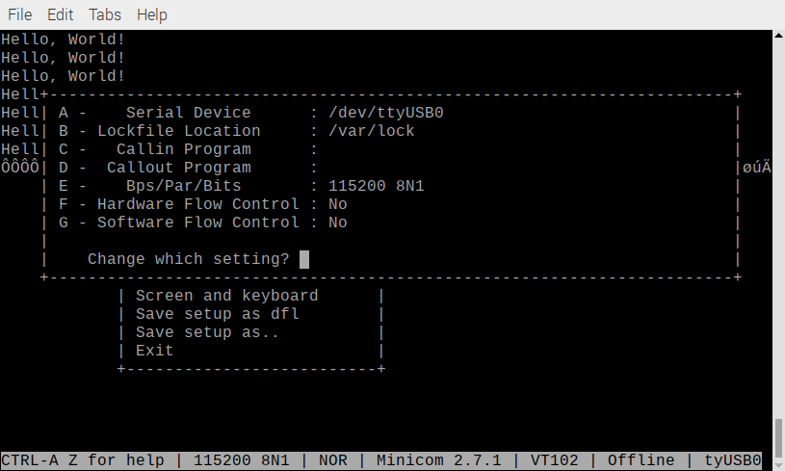
Other tools required are icestorm, yosys, nextpnr, and verilator.

Needed to install fusesoc

pip3 install --upgrade --user fusesoc

fusesoc --version
1.12.0

Forked https://github.com/olofk/serv

git clone git@github.com:develone/serv.git

Created a Pull request.

mkdir WORKSPACE

cd WORKSPACE/

export WORKSPACE=/home/devel/WORKSPACE/

echo $WORKSPACE
/home/devel/WORKSPACE/

export SERV=/home/devel/WORKSPACE/fusesoc_libraries/serv

echo $SERV
/home/devel/WORKSPACE/fusesoc_libraries/serv

fusesoc library add fusesoc_cores https://github.com/fusesoc/fusesoc-cores

fusesoc library add serv https://github.com/olofk/serv

cp ~/serv/servant.core ~/WORKSPACE/fusesoc_libraries/serv/
cp ~/serv/data/catzip.pcf ~/WORKSPACE/fusesoc_libraries/serv/data

fusesoc run --target=catzip servant creates the folder
build/servant_1.1.0/catzip-icestorm/
blinky.hex servant_1.1.0.bin servant_1.1.0.mk
edalize_yosys_procs.tcl servant_1.1.0.blif servant_1.1.0_next.asc
edalize_yosys_template.tcl servant_1.1.0.eda.yml yosys.log
Makefile servant_1.1.0.edif zephyr_hello.hex
next.log servant_1.1.0.json

serv/servant/service.v

`default_nettype none
module service
(
input wire i_clk,
output wire q);

parameter memfile = "zephyr_hello.hex";
parameter memsize = 8192;
parameter PLL = "NONE";

wire wb_clk;
wire wb_rst;

servant_clock_gen #(.PLL (PLL))
clock_gen
(.i_clk (i_clk),
.o_clk (wb_clk),
.o_rst (wb_rst));

servant
#(.memfile (memfile),
.memsize (memsize))
servant
(.wb_clk (wb_clk),
.wb_rst (wb_rst),
.q (q));

endmodule

serv/servant/servant_clock_gen.v

`default_nettype none
module servant_clock_gen
(
input wire i_clk,
output wire o_clk,
output wire o_rst);

parameter [79:0] PLL = "NONE";

generate
if ((PLL == "ICE40_CORE") || (PLL == "ICE40_PAD")) begin
ice40_pll #(.PLL (PLL)) pll
(.i_clk (i_clk),
.o_clk (o_clk),
.o_rst (o_rst));
end else begin
assign o_clk = i_clk;

reg [4:0] rst_reg = 5'b11111;

always @(posedge o_clk)
rst_reg <= {1'b0, rst_reg[4:1]};
assign o_rst = rst_reg[0];
end
endgenerate
endmodule

build/servant_1.1.0/src/servant-catzip_pll_1.1.0/pll.vh

/**
* PLL configuration
*
* This Verilog header file was generated automatically
* using the icepll tool from the IceStorm project.
* It is intended for use with FPGA primitives SB_PLL40_CORE,
* SB_PLL40_PAD, SB_PLL40_2_PAD, SB_PLL40_2F_CORE or SB_PLL40_2F_PAD.
* Use at your own risk.
*
* Given input frequency: 100.000 MHz
* Requested output frequency: 40.000 MHz
* Achieved output frequency: 40.000 MHz
*/

.FEEDBACK_PATH("SIMPLE"),
.DIVR(4'b0100), // DIVR = 4
.DIVF(7'b0011111), // DIVF = 31
.DIVQ(3'b100), // DIVQ = 4
.FILTER_RANGE(3'b010) // FILTER_RANGE = 2

serv/servant/servant.v
serv/servant/servant_abriter.v
serv/servant/servant_mux.v
serv/servant/servant_ram.v
serv/servant/servant_gpio.v
`default_nettype none
module servant
(
input wire wb_clk,
input wire wb_rst,
output wire q);

parameter memfile = "zephyr_hello.hex";
parameter memsize = 8192;
parameter reset_strategy = "MINI";
parameter sim = 0;
parameter with_csr = 1;

wire timer_irq;

wire [31:0] wb_ibus_adr;
wire wb_ibus_cyc;
wire [31:0] wb_ibus_rdt;
wire wb_ibus_ack;

wire [31:0] wb_dbus_adr;
wire [31:0] wb_dbus_dat;
wire [3:0] wb_dbus_sel;
wire wb_dbus_we;
wire wb_dbus_cyc;
wire [31:0] wb_dbus_rdt;
wire wb_dbus_ack;

wire [31:0] wb_dmem_adr;
wire [31:0] wb_dmem_dat;
wire [3:0] wb_dmem_sel;
wire wb_dmem_we;
wire wb_dmem_cyc;
wire [31:0] wb_dmem_rdt;
wire wb_dmem_ack;

wire [31:0] wb_mem_adr;
wire [31:0] wb_mem_dat;
wire [3:0] wb_mem_sel;
wire wb_mem_we;
wire wb_mem_cyc;
wire [31:0] wb_mem_rdt;
wire wb_mem_ack;

wire wb_gpio_dat;
wire wb_gpio_we;
wire wb_gpio_cyc;
wire wb_gpio_rdt;

wire [31:0] wb_timer_dat;
wire wb_timer_we;
wire wb_timer_cyc;
wire [31:0] wb_timer_rdt;

wire [31:0] mdu_rs1;
wire [31:0] mdu_rs2;
wire [ 2:0] mdu_op;
wire mdu_valid;
wire [31:0] mdu_rd;
wire mdu_ready;

servant_arbiter arbiter
(.i_wb_cpu_dbus_adr (wb_dmem_adr),
.i_wb_cpu_dbus_dat (wb_dmem_dat),
.i_wb_cpu_dbus_sel (wb_dmem_sel),
.i_wb_cpu_dbus_we (wb_dmem_we ),
.i_wb_cpu_dbus_cyc (wb_dmem_cyc),
.o_wb_cpu_dbus_rdt (wb_dmem_rdt),
.o_wb_cpu_dbus_ack (wb_dmem_ack),

.i_wb_cpu_ibus_adr (wb_ibus_adr),
.i_wb_cpu_ibus_cyc (wb_ibus_cyc),
.o_wb_cpu_ibus_rdt (wb_ibus_rdt),
.o_wb_cpu_ibus_ack (wb_ibus_ack),

.o_wb_cpu_adr (wb_mem_adr),
.o_wb_cpu_dat (wb_mem_dat),
.o_wb_cpu_sel (wb_mem_sel),
.o_wb_cpu_we (wb_mem_we ),
.o_wb_cpu_cyc (wb_mem_cyc),
.i_wb_cpu_rdt (wb_mem_rdt),
.i_wb_cpu_ack (wb_mem_ack));

servant_mux #(sim) servant_mux
(
.i_clk (wb_clk),
.i_rst (wb_rst & (reset_strategy != "NONE")),
.i_wb_cpu_adr (wb_dbus_adr),
.i_wb_cpu_dat (wb_dbus_dat),
.i_wb_cpu_sel (wb_dbus_sel),
.i_wb_cpu_we (wb_dbus_we),
.i_wb_cpu_cyc (wb_dbus_cyc),
.o_wb_cpu_rdt (wb_dbus_rdt),
.o_wb_cpu_ack (wb_dbus_ack),

.o_wb_mem_adr (wb_dmem_adr),
.o_wb_mem_dat (wb_dmem_dat),
.o_wb_mem_sel (wb_dmem_sel),
.o_wb_mem_we (wb_dmem_we),
.o_wb_mem_cyc (wb_dmem_cyc),
.i_wb_mem_rdt (wb_dmem_rdt),

.o_wb_gpio_dat (wb_gpio_dat),
.o_wb_gpio_we (wb_gpio_we),
.o_wb_gpio_cyc (wb_gpio_cyc),
.i_wb_gpio_rdt (wb_gpio_rdt),

.o_wb_timer_dat (wb_timer_dat),
.o_wb_timer_we (wb_timer_we),
.o_wb_timer_cyc (wb_timer_cyc),
.i_wb_timer_rdt (wb_timer_rdt));

servant_ram
#(.memfile (memfile),
.depth (memsize),
.RESET_STRATEGY (reset_strategy))
ram
(// Wishbone interface
.i_wb_clk (wb_clk),
.i_wb_rst (wb_rst),
.i_wb_adr (wb_mem_adr[$clog2(memsize)-1:2]),
.i_wb_cyc (wb_mem_cyc),
.i_wb_we (wb_mem_we) ,
.i_wb_sel (wb_mem_sel),
.i_wb_dat (wb_mem_dat),
.o_wb_rdt (wb_mem_rdt),
.o_wb_ack (wb_mem_ack));

generate
if (with_csr) begin
servant_timer
#(.RESET_STRATEGY (reset_strategy),
.WIDTH (32))
timer
(.i_clk (wb_clk),
.i_rst (wb_rst),
.o_irq (timer_irq),
.i_wb_cyc (wb_timer_cyc),
.i_wb_we (wb_timer_we) ,
.i_wb_dat (wb_timer_dat),
.o_wb_dat (wb_timer_rdt));
end else begin
assign wb_timer_rdt = 32'd0;
assign timer_irq = 1'b0;
end
endgenerate

servant_gpio gpio
(.i_wb_clk (wb_clk),
.i_wb_dat (wb_gpio_dat),
.i_wb_we (wb_gpio_we),
.i_wb_cyc (wb_gpio_cyc),
.o_wb_rdt (wb_gpio_rdt),
.o_gpio (q));

serv_rf_top
#(.RESET_PC (32'h0000_0000),
.RESET_STRATEGY (reset_strategy),
`ifdef MDU
.MDU(1),
`endif
.WITH_CSR (with_csr))
cpu
(
.clk (wb_clk),
.i_rst (wb_rst),
.i_timer_irq (timer_irq),
`ifdef RISCV_FORMAL
.rvfi_valid (),
.rvfi_order (),
.rvfi_insn (),
.rvfi_trap (),
.rvfi_halt (),
.rvfi_intr (),
.rvfi_mode (),
.rvfi_ixl (),
.rvfi_rs1_addr (),
.rvfi_rs2_addr (),
.rvfi_rs1_rdata (),
.rvfi_rs2_rdata (),
.rvfi_rd_addr (),
.rvfi_rd_wdata (),
.rvfi_pc_rdata (),
.rvfi_pc_wdata (),
.rvfi_mem_addr (),
.rvfi_mem_rmask (),
.rvfi_mem_wmask (),
.rvfi_mem_rdata (),
.rvfi_mem_wdata (),
`endif

.o_ibus_adr (wb_ibus_adr),
.o_ibus_cyc (wb_ibus_cyc),
.i_ibus_rdt (wb_ibus_rdt),
.i_ibus_ack (wb_ibus_ack),

.o_dbus_adr (wb_dbus_adr),
.o_dbus_dat (wb_dbus_dat),
.o_dbus_sel (wb_dbus_sel),
.o_dbus_we (wb_dbus_we),
.o_dbus_cyc (wb_dbus_cyc),
.i_dbus_rdt (wb_dbus_rdt),
.i_dbus_ack (wb_dbus_ack),

//Extension
.o_ext_rs1 (mdu_rs1),
.o_ext_rs2 (mdu_rs2),
.o_ext_funct3 (mdu_op),
.i_ext_rd (mdu_rd),
.i_ext_ready (mdu_ready),
//MDU
.o_mdu_valid (mdu_valid));

`ifdef MDU
mdu_top mdu_serv
(
.i_clk(wb_clk),
.i_rst(wb_rst),
.i_mdu_rs1(mdu_rs1),
.i_mdu_rs2(mdu_rs2),
.i_mdu_op(mdu_op),
.i_mdu_valid(mdu_valid),
.o_mdu_ready(mdu_ready),
.o_mdu_rd(mdu_rd));
`else
assign mdu_ready = 1'b0;
assign mdu_rd = 32'b0;
`endif

endmodule

serv/servant/servant_arbiter.v

/* Arbitrates between dbus and ibus accesses.
* Relies on the fact that not both masters are active at the same time
*/
module servant_arbiter
(
input wire [31:0] i_wb_cpu_dbus_adr,
input wire [31:0] i_wb_cpu_dbus_dat,
input wire [3:0] i_wb_cpu_dbus_sel,
input wire i_wb_cpu_dbus_we,
input wire i_wb_cpu_dbus_cyc,
output wire [31:0] o_wb_cpu_dbus_rdt,
output wire o_wb_cpu_dbus_ack,

input wire [31:0] i_wb_cpu_ibus_adr,
input wire i_wb_cpu_ibus_cyc,
output wire [31:0] o_wb_cpu_ibus_rdt,
output wire o_wb_cpu_ibus_ack,

output wire [31:0] o_wb_cpu_adr,
output wire [31:0] o_wb_cpu_dat,
output wire [3:0] o_wb_cpu_sel,
output wire o_wb_cpu_we,
output wire o_wb_cpu_cyc,
input wire [31:0] i_wb_cpu_rdt,
input wire i_wb_cpu_ack);

assign o_wb_cpu_dbus_rdt = i_wb_cpu_rdt;
assign o_wb_cpu_dbus_ack = i_wb_cpu_ack & !i_wb_cpu_ibus_cyc;

assign o_wb_cpu_ibus_rdt = i_wb_cpu_rdt;
assign o_wb_cpu_ibus_ack = i_wb_cpu_ack & i_wb_cpu_ibus_cyc;

assign o_wb_cpu_adr = i_wb_cpu_ibus_cyc ? i_wb_cpu_ibus_adr : i_wb_cpu_dbus_adr;
assign o_wb_cpu_dat = i_wb_cpu_dbus_dat;
assign o_wb_cpu_sel = i_wb_cpu_dbus_sel;
assign o_wb_cpu_we = i_wb_cpu_dbus_we & !i_wb_cpu_ibus_cyc;
assign o_wb_cpu_cyc = i_wb_cpu_ibus_cyc | i_wb_cpu_dbus_cyc;

endmodule

serv/servant/servant_mux.v

/* Arbitrates between dbus and ibus accesses.
* Relies on the fact that not both masters are active at the same time
*/
module servant_arbiter
(
input wire [31:0] i_wb_cpu_dbus_adr,
input wire [31:0] i_wb_cpu_dbus_dat,
input wire [3:0] i_wb_cpu_dbus_sel,
input wire i_wb_cpu_dbus_we,
input wire i_wb_cpu_dbus_cyc,
output wire [31:0] o_wb_cpu_dbus_rdt,
output wire o_wb_cpu_dbus_ack,

input wire [31:0] i_wb_cpu_ibus_adr,
input wire i_wb_cpu_ibus_cyc,
output wire [31:0] o_wb_cpu_ibus_rdt,
output wire o_wb_cpu_ibus_ack,

output wire [31:0] o_wb_cpu_adr,
output wire [31:0] o_wb_cpu_dat,
output wire [3:0] o_wb_cpu_sel,
output wire o_wb_cpu_we,
output wire o_wb_cpu_cyc,
input wire [31:0] i_wb_cpu_rdt,
input wire i_wb_cpu_ack);

assign o_wb_cpu_dbus_rdt = i_wb_cpu_rdt;
assign o_wb_cpu_dbus_ack = i_wb_cpu_ack & !i_wb_cpu_ibus_cyc;

assign o_wb_cpu_ibus_rdt = i_wb_cpu_rdt;
assign o_wb_cpu_ibus_ack = i_wb_cpu_ack & i_wb_cpu_ibus_cyc;

assign o_wb_cpu_adr = i_wb_cpu_ibus_cyc ? i_wb_cpu_ibus_adr : i_wb_cpu_dbus_adr;
assign o_wb_cpu_dat = i_wb_cpu_dbus_dat;
assign o_wb_cpu_sel = i_wb_cpu_dbus_sel;
assign o_wb_cpu_we = i_wb_cpu_dbus_we & !i_wb_cpu_ibus_cyc;
assign o_wb_cpu_cyc = i_wb_cpu_ibus_cyc | i_wb_cpu_dbus_cyc;

endmodule

serv/servant/servant_ram.v

/* Arbitrates between dbus and ibus accesses.
* Relies on the fact that not both masters are active at the same time
*/
module servant_arbiter
(
input wire [31:0] i_wb_cpu_dbus_adr,
input wire [31:0] i_wb_cpu_dbus_dat,
input wire [3:0] i_wb_cpu_dbus_sel,
input wire i_wb_cpu_dbus_we,
input wire i_wb_cpu_dbus_cyc,
output wire [31:0] o_wb_cpu_dbus_rdt,
output wire o_wb_cpu_dbus_ack,

input wire [31:0] i_wb_cpu_ibus_adr,
input wire i_wb_cpu_ibus_cyc,
output wire [31:0] o_wb_cpu_ibus_rdt,
output wire o_wb_cpu_ibus_ack,

output wire [31:0] o_wb_cpu_adr,
output wire [31:0] o_wb_cpu_dat,
output wire [3:0] o_wb_cpu_sel,
output wire o_wb_cpu_we,
output wire o_wb_cpu_cyc,
input wire [31:0] i_wb_cpu_rdt,
input wire i_wb_cpu_ack);

assign o_wb_cpu_dbus_rdt = i_wb_cpu_rdt;
assign o_wb_cpu_dbus_ack = i_wb_cpu_ack & !i_wb_cpu_ibus_cyc;

assign o_wb_cpu_ibus_rdt = i_wb_cpu_rdt;
assign o_wb_cpu_ibus_ack = i_wb_cpu_ack & i_wb_cpu_ibus_cyc;

assign o_wb_cpu_adr = i_wb_cpu_ibus_cyc ? i_wb_cpu_ibus_adr : i_wb_cpu_dbus_adr;
assign o_wb_cpu_dat = i_wb_cpu_dbus_dat;
assign o_wb_cpu_sel = i_wb_cpu_dbus_sel;
assign o_wb_cpu_we = i_wb_cpu_dbus_we & !i_wb_cpu_ibus_cyc;
assign o_wb_cpu_cyc = i_wb_cpu_ibus_cyc | i_wb_cpu_dbus_cyc;

endmodule

serv/servant/servant_gpio.v

module servant_gpio
(input wire i_wb_clk,
input wire i_wb_dat,
input wire i_wb_we,
input wire i_wb_cyc,
output reg o_wb_rdt,
output reg o_gpio);

always @(posedge i_wb_clk) begin
o_wb_rdt <= o_gpio;
if (i_wb_cyc & i_wb_we)
o_gpio <= i_wb_dat;
end
endmodule

