Introduction:
Many designers today are implementing embedded systems that require low cost non-volatile memory. Microchip has addressed this need with a full line of serial EEPROMs, in a variety of memory configurations, using the industry-standard 2- or 3-wire communication protocols.
Circuit Diagram
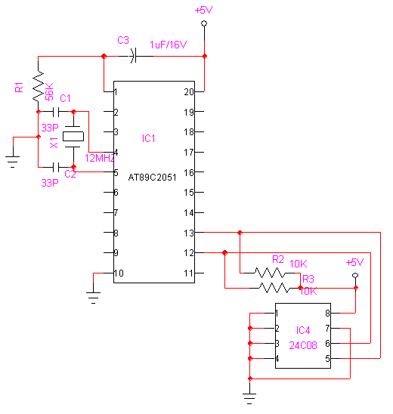

Code:
SDA1 EQU P1.1 ;SDA=PIN5
SCL1 EQU P1.0 ;SCL=PIN6

WTCMD EQU 10100000B ;WRITE DATA COMMAND
RDCMD EQU 10100001B ;READ DATA COMMAND

;%%%%%%%%%%%%%%%%%%%%%%%%%%%%%%%%%%%%%%%%%%%%%%%%%%%%%%%%%%%%%%%%%%%%%%%%%%%%%
; STORE A BYTE IN EEPROM (Data 8F in address location 2AH)
;%%%%%%%%%%%%%%%%%%%%%%%%%%%%%%%%%%%%%%%%%%%%%%%%%%%%%%%%%%%%%%%%%%%%%%%%%%%%%
MOV A,#WTCMD ;LOAD WRITE COMMAND
CALL OUTS ;SEND IT
MOV A,#2AH ;GET BYTE ADDRESS
CALL OUT ;SEND IT
MOV A,#8FH ;GET DATA
CALL OUT ;SEND IT
CALL STOP ;SEND STOP CONDITION
;%%%%%%%%%%%%%%%%%%%%%%%%%%%%%%%%%%%%%%%%%%%%%%%%%%%%%%%%%%%%%%%%%%%%%%%%%%%%%
; READ A BYTE FROM EEPROM FROM ADDRESS LOCATION 4DH
;%%%%%%%%%%%%%%%%%%%%%%%%%%%%%%%%%%%%%%%%%%%%%%%%%%%%%%%%%%%%%%%%%%%%%%%%%%%%%
MOV A,#WTCMD ;LOAD WRITE COMMAND TO SEND ADDRESS
CALL OUTS ;SEND IT
MOV A,#4DH ;GET LOW BYTE ADDRESS
CALL OUT ;SEND IT
CALL CREAD ;GET DATA BYTE
MOV A,R1
CALL MDELAY
RET
;***********************************************************************
; EEPROM ROUTINES
;***********************************************************************

;***********************************************************************
; THIS ROUTINE SENDS OUT CONTENTS OF THE ACCUMULATOR
; to the EEPROM and includes START condition. Refer to the data sheets
; for discussion of START and STOP conditions.
;***********************************************************************

OUTS: MOV R2,#8 ;LOOP COUNT -- EQUAL TO BIT COUNT
SETB SDA1 ;INSURE DATA IS HI
SETB SCL1 ;INSURE CLOCK IS HI
NOP ;NOTE 1
NOP
NOP
CLR SDA1 ;START CONDITION -- DATA = 0
NOP ;NOTE 1
NOP
NOP
CLR SCL1 ;CLOCK = 0
OTSLP: RLC A ;SHIFT BIT
JNC BITLS
SETB SDA1 ;DATA = 1
JMP OTSL1 ;CONTINUE
BITLS: CLR SDA1 ;DATA = 0
OTSL1: SETB SCL1 ;CLOCK HI
NOP ;NOTE 1
NOP
NOP

CLR SCL1 ;CLOCK LOW
DJNZ R2,OTSLP ;DECREMENT COUNTER
SETB SDA1 ;TURN PIN INTO INPUT
NOP ;NOTE 1

SETB SCL1 ;CLOCK ACK
NOP ;NOTE 1
NOP
NOP

CLR SCL1
RET

;**********************************************************************
; THIS ROUTINE SENDS OUT CONTENTS OF ACCUMLATOR TO EEPROM
; without sending a START condition.
;**********************************************************************

OUT: MOV R2,#8 ;LOOP COUNT -- EQUAL TO BIT COUNT
OTLP: RLC A ;SHIFT BIT
JNC BITL
SETB SDA1 ;DATA = 1
JMP OTL1 ;CONTINUE
BITL: CLR SDA1 ;DATA = 0
OTL1: SETB SCL1 ;CLOCK HI
NOP ;NOTE 1
NOP
NOP

CLR SCL1 ;CLOCK LOW
DJNZ R2,OTLP ;DECREMENT COUNTER
SETB SDA1 ;TURN PIN INTO INPUT
NOP ;NOTE 1

SETB SCL1 ;CLOCK ACK
NOP ;NOTE 1
NOP
NOP

CLR SCL1
RET

STOP: CLR SDA1 ;STOP CONDITION SET DATA LOW
NOP ;NOTE 1
NOP
NOP

SETB SCL1 ;SET CLOCK HI
NOP ;NOTE 1
NOP
NOP

SETB SDA1 ;SET DATA HIGH
RET
;*******************************************************************
; THIS ROUTINE READS A BYTE OF DATA FROM EEPROM
; From EEPROM current address pointer.
; Returns the data byte in R1
;*******************************************************************
CREAD: MOV A,#RDCMD ;LOAD READ COMMAND
CALL OUTS ;SEND IT
CALL IN ;READ DATA
MOV R1,A ;STORE DATA
CALL STOP ;SEND STOP CONDITION
RET

;**********************************************************************
; THIS ROUTINE READS IN A BYTE FROM THE EEPROM
; and stores it in the accumulator
;**********************************************************************

IN: MOV R2,#8 ;LOOP COUNT
SETB SDA1 ;SET DATA BIT HIGH FOR INPUT
INLP: CLR SCL1 ;CLOCK LOW
NOP ;NOTE 1
NOP
NOP
NOP

SETB SCL1 ;CLOCK HIGH
CLR C ;CLEAR CARRY
JNB SDA1,INL1 ;JUMP IF DATA = 0
CPL C ;SET CARRY IF DATA = 1
INL1: RLC A ;ROTATE DATA INTO ACCUMULATOR
DJNZ R2,INLP ;DECREMENT COUNTER
CLR SCL1 ;CLOCK LOW
RET

;*********************************************************************
; This routine test for WRITE DONE condition
; by testing for an ACK.
; This routine can be run as soon as a STOP condition
; has been generated after the last data byte has been sent
; to the EEPROM. The routine loops until an ACK is received from
; the EEPROM. No ACK will be received until the EEPROM is done with
; the write operation.
;*********************************************************************
ACKTST: MOV A,#WTCMD ;LOAD WRITE COMMAND TO SEND ADDRESS
MOV R2,#8 ;LOOP COUNT -- EQUAL TO BIT COUNT
CLR SDA1 ;START CONDITION -- DATA = 0
NOP ;NOTE 1
NOP
NOP

CLR SCL1 ;CLOCK = 0
AKTLP: RLC A ;SHIFT BIT
JNC AKTLS
SETB SDA1 ;DATA = 1
JMP AKTL1 ;CONTINUE
AKTLS: CLR SDA1 ;DATA = 0
AKTL1: SETB SCL1 ;CLOCK HI
NOP ;NOTE 1
NOP
NOP

CLR SCL1 ;CLOCK LOW
DJNZ R2,AKTLP ;DECREMENT COUNTER
SETB SDA1 ;TURN PIN INTO INPUT
NOP ;NOTE 1

SETB SCL1 ;CLOCK ACK
NOP ;NOTE 1
NOP
NOP

JNB SDA1,EXIT ;EXIT IF ACK (WRITE DONE)
JMP ACKTST ;START OVER
EXIT: CLR SCL1 ;CLOCK LOW
CLR SDA1 ;DATA LOW
NOP ;NOTE 1
NOP
NOP

SETB SCL1 ;CLOCK HIGH
NOP
NOP
SETB SDA1 ;STOP CONDITION
RET
;*********************************************************************

