MCP Integration Synthesis — Draft v0.2
Status | Draft v0.2 for Micah’s authorial alignment. Not yet a ratified canon position; not an ADR.
Version | v0.2 (incorporates GPT external review feedback + JD’s authorship correction; v0.1 lives in git history)
Date | 2026-05-23
Author | Micah Longmire — the architectural IP synthesized here is Micah’s. He owns authorial direction; this draft is offered for his revision.
Synthesizer (drafting role only) | OlogosAI — scribe. Per JD’s 2026-05-23 11:39 correction on Discussion #25, OlogosAI synthesizes Micah’s published IP; does not co-author the underlying architecture.
Trigger | NG-AIDE-01 build session 2026-05-23 shipped agentic capability dispatch without MCP. JD’s question (“have we taken into account MCP gateways?”) surfaced the gap. A survey of Micah’s published MCP work shows the gap is substantive — AEON’s tool-transport substrate should treat MCP as primary.
Audience | AIDE-canon contributors (primary: Micah; secondary: JD, Tracy, thinx-Claude)
Out of scope | Final architectural commitment, ADR text. This paper is the survey + draft recommendation; ratification requires a separate ADR Micah authors or directs.
Claim-confidence convention | This paper distinguishes three claim types: [observed] — directly observed in the cited source repo; [inferred] — architectural inference from the observed evidence; [recommendation] — proposed direction for AEON, requiring ratification. Mixed-voice paragraphs in earlier drafts have been split or tagged in v0.2.
Changelog (v0.1 → v0.2) | Authorship correction (Micah sole author per JD 2026-05-23 11:39 on Discussion #25); new Glossary §1; new Risks, Tradeoffs & Non-Goals §9 per GPT review; four-way authority distinction in §6+§8+§10 per JD 2026-05-23 06:48; claim-confidence labeling on comparative claims; wording fixes per GPT review (deprecated/deployment-sensitive/canon-points-toward); reference hardening with commit hashes; Appendix A poster restored after bot-side delete; v0.2 state poster integrated inline as Figure 5; section renumbering throughout.

1. Glossary
For new contributors. Acronym density in this paper is high; insiders can skip to §2.
Term | Expansion / definition
AIDE | AI-centric Digital Ecosystem — the canon corpus this paper lives in (vision-strategy/)
AEON | The canonical enterprise architecture pattern in AIDE: six service planes (Identity, Authority, Evidence, Integration, Capability Composition, Orchestration Runtime), plus proposed 7th Inference plane per aide-canon#23. White paper at enterprise-platforms/aeon/docs/AEON-White-Paper.pdf
NG-AIDE-01 | The first AIDE-instantiated agentic platform program; umbrella issue ng-aide-01#15. Comprises four subdomain orchestrators (NG-AEON, NG-DevSecOps, NG-Cyber, NG-InfOps)
AIDEX | The user-facing interface surface for each orchestrator in NG-AIDE-01 (e.g., ng-infops/aidex/). Browser-based; Thinx look/feel
OrdSA | Ordinal Systems Architecture — JD’s published authority-layering framework. “Authority flows downward, evidence flows upward.” Public at osa-ai-org/ordsa-ai
MCP | Model Context Protocol — Anthropic-proposed tool/context interface for AI agents. Spec at modelcontextprotocol.io. Current protocol version this paper references: 2025-06-18
DCR | Dynamic Client Registration (RFC 7591) — OAuth 2.1 mechanism letting MCP clients self-register without prior coordination
PKCE | Proof Key for Code Exchange (RFC 7636) — OAuth public-client security mechanism; S256 required by current MCP spec
Galley | Micah’s MCP catalog component in Hermetic (internal/galley/) — tool catalog with Ollama-embedding semantic search. “The CATALOG, not the executor” per galley.go
Gateway | Micah’s MCP executor component in Hermetic (internal/galley/gateway.go) — proxies MCP tool calls to backing external MCP servers; five supported transports
Oracle | In Micah’s Oracle-MCP: the human operator at L3 ordinal level. “Always upward — to_level = from_level + 1”
Responder | Protocol-level provenance field in Oracle-MCP responses: indicates whether a peer agent ("orchestrator") or a human ("oracle") produced the answer
~/.rhode/ | The agent state-root convention observed across multiple Micah MCPs (Oracle-MCP, Model-Based-MCP). Whether to canonize as AEON’s agent home is Q6 of §10
Bespoke dispatch | The HTTP-JSON /api/v1/runtime/invoke pattern NG-AIDE-01 v0.1 shipped — to be deprecated in favor of MCP-native dispatch per this paper’s recommendation
MCP-native | Dispatch pattern where AEON capabilities are invoked via MCP tools/call, discovered via MCP tools/list, transported via MCP-supported transports (stdio / sse / http / oauth-sse / oauth-http)
Namespace | Hermetic-galley’s unit of MCP-server registration. One namespace = one external MCP server. Tools keyed (namespace, tool_name)
AICP | Agent Identity Card Protocol — Ologos protocol proposed in the Theseus thesis (related-work/theseus/); positioned above MCP in the protocol stack (handles identity + memory; MCP handles tool transport)
A2A | Agent-to-Agent protocol — Google-proposed; agent interop. Tracked in canon at sota-survey/standards-bodies/. Out of scope for this paper
OAgents | Ologos’s NIST-AI-RMF-aligned behavioral envelope spec — the formal-standards anchor for canon
canon | Shorthand throughout this paper for ologos-repos/aide-canon — this repository

2. Abstract
NG-AIDE-01’s first agentic-orchestration loop (digital-thread pattern materialized as runtime agent loop, per ADR-EA-0009) landed 2026-05-23 with bespoke HTTP-JSON capability dispatch. A survey of Micah Longmire’s published MCP work — ten repositories spanning protocol specification (Model-Based-MCP), commercial product (Legate.Studio), reference architecture (Hermetic galley), and OrdSA-aligned protocol design (Oracle-MCP) — reveals that AEON’s Integration plane should be MCP-native, not bespoke. This paper inventories the corpus, distills the design language across the four most architecturally substantive sources, maps the patterns onto AEON’s six service planes, and proposes integration moves with explicit authorial-alignment questions for Micah to direct. AIDE behind on first-party MCP support — as canon already names the gap in vision-strategy/analysis/sota-survey/standards-bodies/README.md — is closeable by adopting the patterns Micah has already published rather than by inventing parallel ones.

3. Why this paper exists
Three threads converge:
Canon already names the gap. standards-bodies/README.md explicitly tracks MCP and assigns it to “AEON capability plane + tool integration” with the status line “AIDE behind on first-party MCP support; AIDE ahead on capability-composition semantics.” This is canon’s own acknowledgement that MCP needs to come into AEON.
Hermetic engagement notes single out the MCP gateway as a recommended-impl reference. hermetic-engagement/39-means-inventory/discussion-source.md item #7: “MCP gateway (Galley) — tool catalog with semantic search via Ollama embeddings. AEON integration plane connects to external tools; Galley is the catalog/proxy. Reference as the recommended pattern.” Canon already points toward this path, but ratification still requires an explicit ADR.
Recent NG-AIDE-01 build went bespoke, not MCP. The 2026-05-23 build of Runtime plane v0.1 + agentic chat loop on NG-InfOps (ng-aeon#5, ng-infops#4) implements capability dispatch as bespoke HTTP-JSON over a custom /api/v1/runtime/invoke endpoint. The capability YAML uses an adapter: <URL> field with adapter_method: GET|POST. No MCP server, no MCP client, no MCP discovery. The bespoke pattern works end-to-end (live-tested against Tracy’s LM Studio) but diverges from Micah’s established design language.
This paper is the survey + draft recommendation layer that closes the gap at the canon level. Final direction must be Micah’s per his authorship discipline; the analysis here is offered as the substrate for his decision.

4. Micah’s MCP corpus — inventory
Ten repositories across bobbyhiddn (personal) and ologos-repos (organization), spanning specification, commercial product, infrastructure, and domain-specific MCP servers. [inferred] Within the AIDE/AEON corpus, this is the most substantive MCP body of work currently under review; a broader ecosystem-comparative claim would require external benchmarking and is out of scope here.
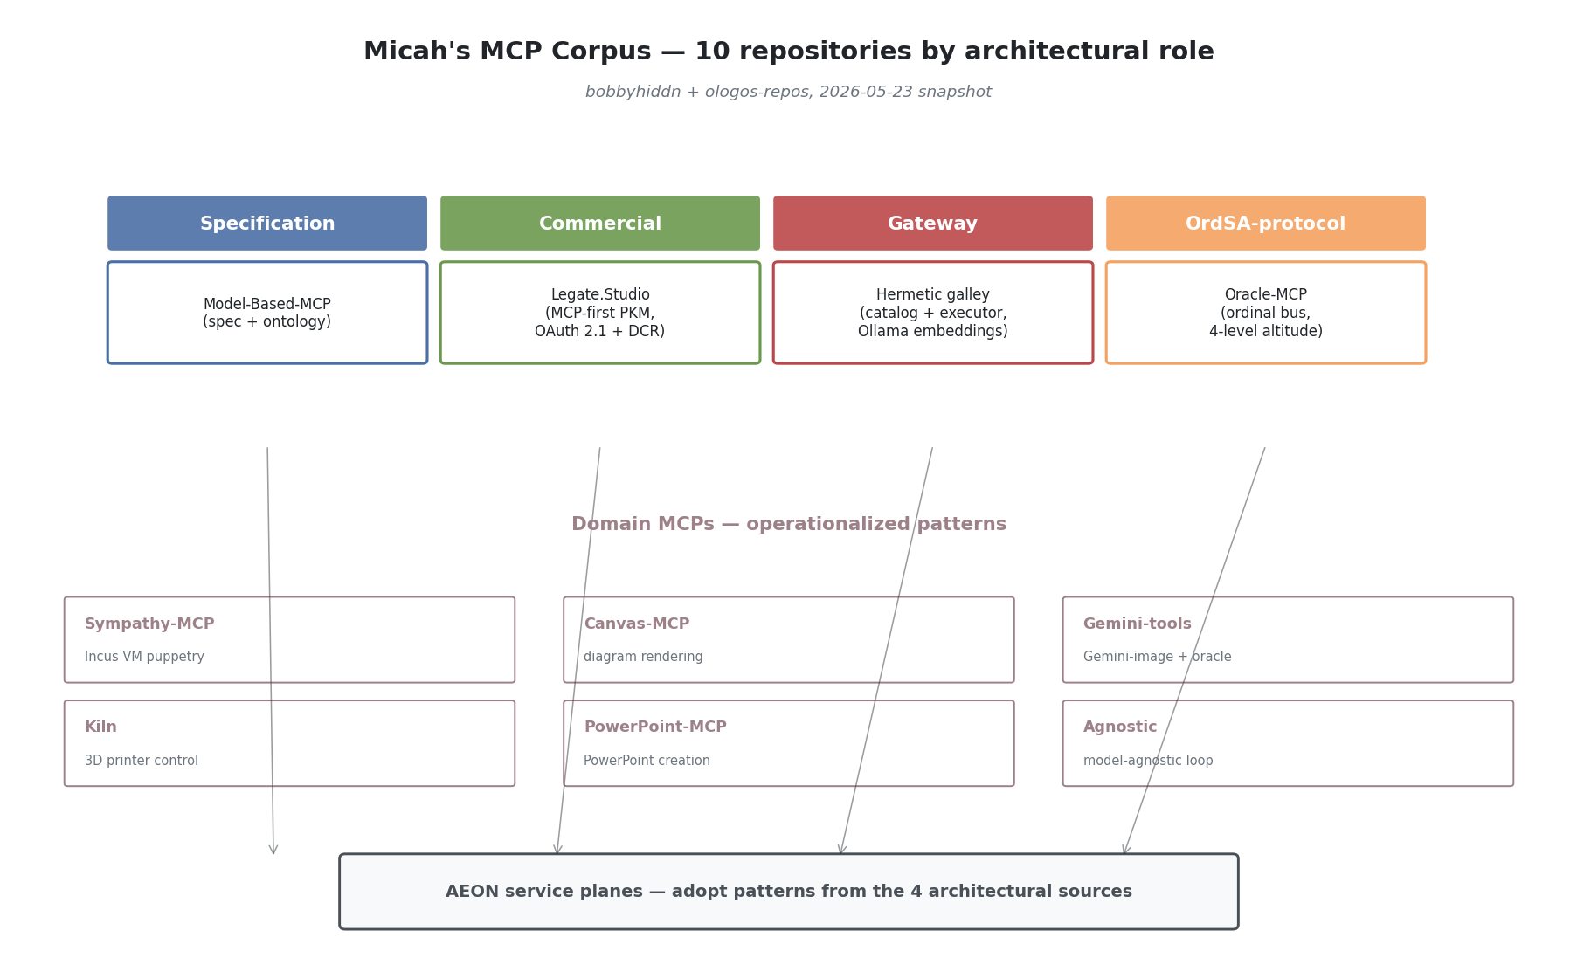
Viewpoint 1 — Micah’s MCP corpus map
Repo | Role in corpus | Most relevant signal
bobbyhiddn/Model-Based-MCP | Specification + documentation reference | Strict schema discipline; nested-container ontology (Canvas > Network > Factory > Machine > Node) with consistent identity contract at every level
ologos-repos/Legate.Studio | Commercial MCP-first PKM | OAuth 2.1 AS + Dynamic Client Registration; protocol version 2025-06-18; per-user JWT tokens; PKCE enforced; 43-tool surface; multi-tenant; bridges third-party MCP clients (Claude, ChatGPT) without exposing upstream IdP tokens
bobbyhiddn/Oracle-MCP | OrdSA-aligned protocol pattern | 4-level ordinal model (L0 Infra, L1 Subagent, L2 Orchestrator, L3 Oracle); upward-only oracle calls; explicit responder field as protocol-level provenance; filesystem-as-bus at ~/.rhode/bus/{requests,responses,history}
ologos-repos/Hermetic (internal/galley/ + internal/mcp/) | Reference MCP gateway impl (Go) | Catalog/Executor separation (Galley = catalog, Gateway = executor); five transports (stdio, sse, http, oauth-sse, oauth-http); Ollama embeddings for semantic tool search; layered ToolRegistrar interface; lazy expand / explicit collapse subprocess lifecycle
bobbyhiddn/Sympathy-MCP | Infrastructure-control MCP | Agents puppeteer Incus VMs via structured tools (vm_exec, vm_file_*, vm_snapshot) instead of freeform Bash — pattern for replacing shell with MCP at the agent boundary
bobbyhiddn/Canvas-MCP | Domain MCP (diagrams) | Tool transport for diagram-rendering capability; precursor to Model-Based-MCP
bobbyhiddn/Gemini-tools | Domain MCP (image gen + oracle) | Gemini 3.1 Pro Preview wrapped as MCP tools
bobbyhiddn/Kiln | Domain MCP (3D printer control) | Public successful MCP server; pattern for physical-device control over MCP
bobbyhiddn/PowerPoint-MCP | Domain MCP (office productivity) | stdio MCP for PowerPoint creation
bobbyhiddn/Agnostic | Adjacent — model-agnostic tool loop | Parallel motivation to NG-AIDE-01’s O8 model-agnostic objective; worth reading before deepening the inference-gateway work
The corpus splits cleanly by role: one specification (Model-Based-MCP), one commercial reference (Legate), one infrastructure pattern (Hermetic galley), one OrdSA-aligned protocol (Oracle-MCP), and six domain-specific MCP servers. The four sources read deeply in this paper are the four non-domain ones — they carry the architectural pattern Micah has been refining.

5. Four sources read in depth

5.1 Model-Based-MCP — ontology discipline + schema rigor
What it is. An MCP server for canvas-style architectural diagrams. The diagrams use a strict 4-level nested-container ontology — Canvas > Network > Factory > Machine > Node — with consistent identity semantics at every level (id, optional label, get_label() fallback).
Vocabulary worth lifting. - Recipe — the YAML input that defines a diagram. Not “spec,” not “config.” Distinct from execution; the recipe describes intent. - Ontology — used in code header (models.py: “the canvas and SysML/MBSE ontology”). Treated as first-class. - Style vs. Type — type carries domain meaning (color + semantics); style is a pure override layer. Separates what something is from how it appears.
Architectural positions. - Transport: stdio only. MCP SDK Server primitive (low-level). - Tool surface: exactly 4 — render_model, create_model, list_templates, get_template. Two input modes per tool (raw recipe vs. structured args) so the same operation can be driven by an LLM or by a human/file. - Schema discipline: every tool exposes full JSON Schema with enum constraints on type, spacing_level, orientation. No silent string fields. Errors returned as structured JSON results with status: "success", not protocol errors. - State: outputs under ~/.rhode/canvas/. (Inference: ~/.rhode/ is treated as the canonical agent state root across multiple Micah MCPs — see also Oracle-MCP.)
OrdSA parallels. - The nested-container ontology is an altitude hierarchy of a different kind (containment, not authority). The doctrine “every level exposes the same identity contract” maps directly to OrdSA’s “every altitude exposes the same evidence-up interface.”
Reusable patterns for AEON. - The id + optional label + get_label() fallback as a universal addressing contract. - Two-input-mode tool design (recipe vs. structured args). - Auto-detection of higher containers from leaf-level connectivity (_auto_detect_machines from node inputs/outputs) — “infer structure from edges when explicit structure is omitted.”

5.2 Oracle-MCP — ordinal-altitude protocol semantics
What it is. An MCP server implementing an oracle communication bus for the Rhode agent system. Agents at level N can issue oracle calls to level N+1; the bus routes each call to the right responder based on the caller’s ordinal level. Rhode (L2) answers L1 subagent calls itself using its own LLM; when Rhode itself needs guidance, it escalates L2→L3 to the human operator via Telegram.
This is the most OrdSA-aligned source by a wide margin. It is the cleanest implementation of authority-altitude semantics in any AI repo currently public.
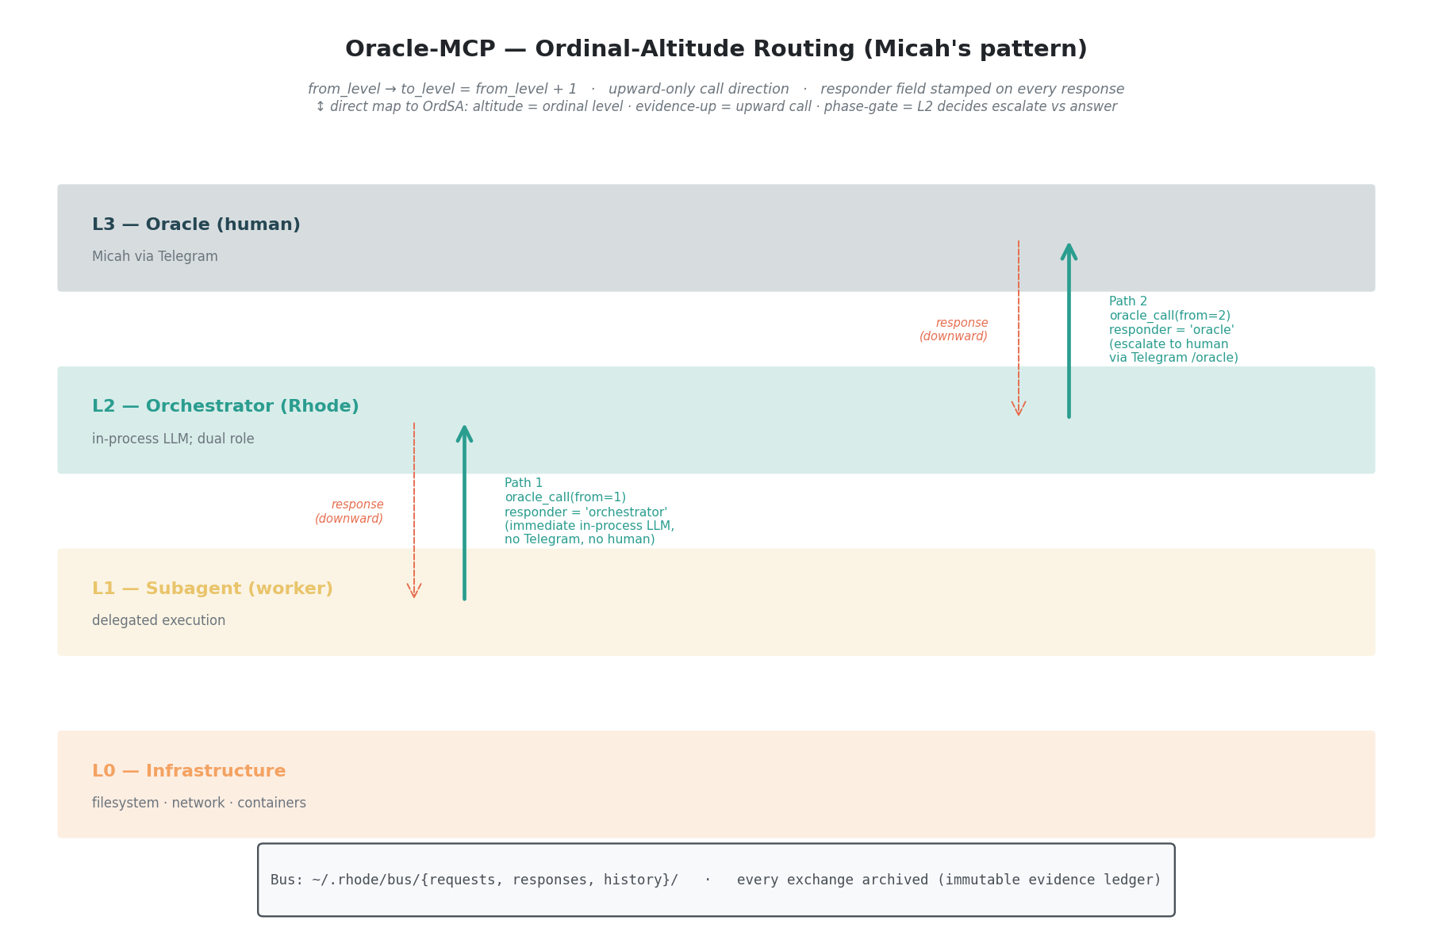
Viewpoint 3 — Oracle-MCP ordinal-altitude routing
Vocabulary. - Ordinal levels — canonical naming: L0 Infrastructure, L1 Subagent, L2 Orchestrator, L3 Oracle. - Oracle call — the protocol’s atomic verb. Always upward (to_level = from_level + 1). - Bus — file-based JSON message substrate at ~/.rhode/bus/{requests,responses,history}. - Responder — explicit field on responses: "orchestrator" (peer agent answered) or "oracle" (human answered). The protocol surfaces who answered to the caller. - Dual role — Rhode is “both agent and oracle” depending on direction of the call. This is the central architectural insight: a single node can occupy multiple altitudes simultaneously, with the protocol disambiguating per-call.
Architectural positions. - MCP is a thin facade over a filesystem-based message queue. The bus itself is the durable transport; MCP is just the operator-grade tool surface. - Routing logic is declarative — to_level = from_level + 1 is computed. - Lifecycle: poll-based (2-second interval) with timeout (300s default). Timed-out requests are explicitly archived with status: "timeout" — never silently dropped. - Auth: none at the MCP layer. Trust boundary is the filesystem itself. - Evidence emission is complete: every exchange produces request_*.json + response_*.json archived under ~/.rhode/bus/history/<timestamp>/. The archive is the audit log. - Reboot continuity: rhode-reboot writes a “continuation prompt” to ~/.rhode/reboot_prompt.json before restarting. Persistence across process death is a first-class concern.
OrdSA parallels (direct). - from_level / to_level are altitude-of-caller / altitude-of-target. - Upward-only call direction mirrors “evidence flows up, authority flows down” — you can only ask upward. - The L2 dual role (Rhode answers L1 calls itself, escalates L2→L3 to human) is the phase-gate pattern: the orchestrator decides whether a call deserves human attention, with the option to tell the subagent to re-ask at L2. - responder field = protocol-level provenance of judgment authority. - Archive = immutable evidence ledger.
Reusable patterns for AEON. - Filesystem-as-bus for local-host agent coordination — atomic, debuggable (cat ~/.rhode/bus/requests/*.json), zero dependency footprint. - Polling + archive lifecycle as alternative to long-lived connections. - responder and urgency (4-value enum: low|normal|high|critical) as protocol-level metadata that agents can reason about. - Fire-and-forget mode (--no-wait) for notifications — same protocol, different waiting policy.

5.3 Hermetic galley + mcp — catalog/gateway separation
What it is. Hermetic’s internal/galley/ (catalog) + internal/mcp/ (server) provide a production-grade MCP gateway in Go. Galley aggregates MCP tools from multiple external MCP servers, indexes them with Ollama embeddings for semantic search, and exposes a single MCP surface that proxies calls to the right backend.
Vocabulary. - Galley — “the CATALOG, not the executor” (galley.go:1-9). Strong domain noun. - Gateway — the separate concern that executes MCP calls against external servers. Galley wraps Gateway. - Namespace — unit of MCP-server grouping. One namespace = one external MCP server; tools keyed (namespace, tool_name). - Expand / Collapse — lifecycle verbs for namespace subprocess management. - ToolRegistrar — Go interface each subsystem implements to register tools; Hermetic has a layered MCP server where multiple subsystems each contribute their tool surface. - Scan — discovery operation (expand → catalog → collapse). - Catalog vs. live — explicit distinction throughout the code. The catalog is what the system believes tools to be; an actual call_tool produces fresh evidence.
Architectural positions. - Five supported transports (gateway.go:42-47): stdio, sse, http, oauth-sse, oauth-http. Per-transport validation in ServerConfig.Validate(). - OAuth: pre-acquired token only (“Browser-callback OAuth flow is intentionally out of scope here — bring your own token”). Explicitly complementary to Legate’s full-OAuth-AS stance. - Persistence: server configs in SQLite namespace_servers; tool catalog in galley_namespaces + galley_tools; embeddings as BLOB. - Embeddings: Ollama nomic-embed-text (768-dim), explicitly cross-language compatible with Python’s struct.pack("<768f", ...). Graceful degradation to keyword search when Ollama unreachable. - Concurrency: sync.RWMutex on process map; double-check pattern in ExpandNamespace. - Connection lifecycle: lazy expand on CallTool, explicit collapse_namespace for teardown. - Tool naming: dynamic expand_<ns> tools generated at server boot, one per registered namespace.
Tool surface (tools.go) — 8 static + N dynamic: search_tools (semantic search) · register_namespace · scan_namespace / scan_all_namespaces · list_registered · get_tool_context (formatted markdown block of relevant tools for a task — prompt-shaped output, not just data) · call_tool (proxied invocation) · collapse_namespace · expand_<ns> (one per namespace, cached catalog view).
OrdSA parallels. - Namespace as authority domain — each external MCP server is a separately-trusted authority surface; the gateway is the integration plane brokering between altitudes of trust. - Catalog vs. live = belief vs. evidence (Mind module’s belief revision cycle made operational). - get_tool_context returning a prompt-shaped block is evidence-up shaped for agent consumption — not just data. - RegisteredToolNames() + sorted output — auditable inventory at any point in time.
Reusable patterns for AEON. - Catalog/Executor separation as integration-plane architecture. - Layered ToolRegistrar for composable MCP server: each plane / subdomain registers its tools through the same interface. - MCP-tool-of-MCP-tools: call_tool(namespace, tool_name, arguments) as the proxy primitive — the cleanest known pattern for “AEON exposes everything it can do” without leaking implementation boundaries. - Graceful degradation as coding norm — Ollama unreachable → return (nil, nil), caller falls back to keyword. Never panic, never block.

5.4 Legate.Studio — production OAuth 2.1 + MCP-first
What it is. A commercial MCP-first PKM (personal knowledge management) platform. Per the README: “Your second brain — backed by GitHub, served by Flask, secured by design. Supports shared libraries for collaborative knowledge sharing, a full MCP integration for Claude, and a draft/merge workflow for team contributions.”
The most production-hardened MCP server in Micah’s corpus, and the canonical reference for inbound third-party MCP authentication.
Vocabulary. - Pit — internal codename for the Legate runtime. - Legato — legacy code-name still in env vars (LEGATO_MODE) and DB names (legato.db). - Connector — Anthropic’s term for an HTTP MCP server, adopted as Legate’s user-facing terminology. - Library / Shared library / Personal library — multi-tenant terminology over notes. - Draft & Merge workflow — collaborators write drafts, owners merge. Explicit governance vocabulary. - Confidence bucketing — search results split high-confidence vs. maybe-related. Surface calibration in the protocol.
Architectural positions. - Transport: HTTP with JSON-RPC 2.0. MCP-Protocol-Version: 2025-06-18 header. - Server capabilities: tools, resources, prompts, each with listChanged: False. - Auth: OAuth 2.1 AS + Dynamic Client Registration (RFC 7591 + RFC 8414). This is the canonical pattern Micah has chosen for the spec-current MCP world: - Discovery: /.well-known/oauth-authorization-server - DCR: POST /oauth/register → returns {client_id: "mcp-<hex>", client_secret: ""} (public client) - PKCE enforced (S256 only) - Auto-registration of trusted clients (Claude, ChatGPT) by redirect-URI matching - JWT tokens minted by Pit (NOT GitHub tokens) — “Claude never sees your GitHub token” - Token TTL: 1 hour - Scopes: mcp:read, mcp:write (only two) - Multi-tenant: per-user SQLite DBs (legato.db, agents.db, chat.db); JWT carries user_id claim; get_user_legato_db() returns per-user connection. - Rate limiting: per-user keying via JWT, 1000/hour. get_mcp_user_id() returns f"mcp:{user_id}" so Flask-Limiter sees it pre-request. - WAL checkpointing after writes: explicit PRAGMA wal_checkpoint(RESTART) for cross-worker visibility in multi-gunicorn deployments. - Tool surface: 43 tools. Organized by domain. library_id parameter on every tool; check_write_permission() enforces draft & merge for non-owners; per-tool per-tier gating (require_managed_tier). - Embedding model abstraction: Gemini default (768-dim) → OpenAI (1536-dim) → Ollama. Auto-detect chain.
OrdSA parallels. - OAuth scopes as authority tokens — mcp:read / mcp:write are altitude markers; an L2 orchestrator gets write, a public L1 client might get only read. - Draft & Merge workflow is exactly a phase gate. Collaborators submit (produce evidence), owners decide (exercise authority). The protocol enforces it. - Per-tier gating is authority-altitude check at the tool boundary. - JWT user_id claim → per-user DB = identity-plane → evidence-plane partitioning.
Reusable patterns for AEON. - OAuth 2.1 + DCR as MCP auth canon — Legate is the reference implementation; aligns with Anthropic’s June 2025 protocol spec. - JWT bridging — don’t expose upstream IdP tokens to the MCP client; mint your own with the principal claim → per-principal capability scoping. - Per-call library_id parameter for multi-tenant tool reuse — same tool surface, scope-shifted per call. - isError: true on tool results for soft failures (MCP-spec-compliant). - WAL checkpoint after every MCP write for SQLite multi-worker deployments. - Confidence-bucketed search results — gives the agent a calibration signal.

6. Cross-source synthesis

Shared design language
- “Namespace” as the unit of MCP-server registration (Hermetic explicit; Legate uses “library” similarly as multi-tenant unit).
- Schema-first tool declarations with strict JSON Schema + enums. All four sources avoid free-form string params where an enum is possible.
- Catalog/cache separation from live execution — Hermetic explicit (Galley vs. Gateway); Legate caches embeddings; Oracle-MCP archives every exchange; Model-Based-MCP caches templates.
- ~/.rhode/ as canonical agent home — appears in Oracle-MCP (~/.rhode/bus/) and Model-Based-MCP (~/.rhode/canvas/). Inferred convention; worth ratifying canon-level.
- Provenance fields on results — Oracle-MCP’s responder, Legate’s match_types + confidence buckets, Hermetic’s score. Agents are told how a result was produced.
- Graceful degradation as norm — Hermetic on Ollama, Legate on embedding-provider chain, Oracle-MCP on timeout-with-archive. No source treats dependency failure as a panic.

Tensions / design variations
Concern | Oracle-MCP | Model-Based-MCP | Hermetic | Legate
Transport | stdio | stdio | stdio + sse + http + oauth-* | HTTP only
Auth | none (local) | none (local) | bring-your-own static token | OAuth 2.1 AS + DCR + JWT
Multi-tenant | no | no | namespace-scoped, single user | first-class per-user DBs
State | filesystem JSON | filesystem PNG | SQLite | SQLite (multi-DB)
Tool count | 5 | 4 | 8 + N | 43
Role in stack | bus | tool | gateway | server
The auth axis has the widest spread. Oracle-MCP assumes filesystem trust; Hermetic assumes you-bring-a-token; Legate is a full OAuth Authorization Server. Micah’s corpus shows deployment-sensitive auth patterns rather than one universal auth pattern — the choice tracks deployment surface (local agent ↔ integration broker ↔ multi-tenant SaaS). AEON’s adoption needs to mirror this — different inbound and outbound auth shapes for different surfaces.
Hermetic’s stance (“browser-callback OAuth flow is intentionally out of scope here”) and Legate’s stance (“we ARE the OAuth AS”) are explicitly complementary: Hermetic is a client-side gateway brokering to external servers; Legate is a server-side tool host accepting third-party clients. AEON needs both roles.

7. Mapping to AEON service planes
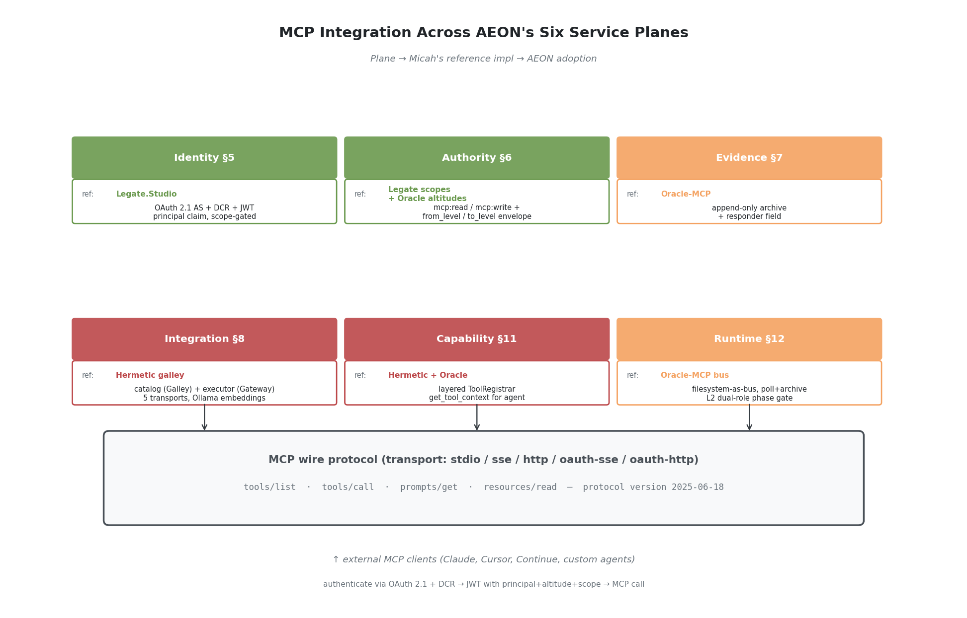
Viewpoint 2 — MCP-in-AEON-planes integration
Per AEON white paper §5–§12 (six planes; v0.1 minimal-coherent subset is Identity + Authority + Evidence; full subset adds Integration + Capability Composition + Orchestration Runtime; canon #23 proposes Inference as a 7th plane).
Plane | Micah’s reference impl | What AEON should adopt
Identity (§5) | Legate.Studio OAuth 2.1 AS + DCR | Inbound: third-party MCP clients authenticate via OAuth 2.1 + DCR + PKCE; JWT minted by AEON with principal + altitude claims
Authority (§6) | Legate scopes (mcp:read/mcp:write) + per-tier gating; Oracle-MCP altitude routing | Authority envelope check on capability dispatch reads OAuth scopes + caller altitude from JWT; envelope distinguishes four authority modes (see §7.1 below) — request upward (always permitted; produces oracle call to higher altitude), execute lateral or delegated capability (permitted within scope), receive downward authorization (permitted; authority-flow direction), escalate to human/operator oracle (phase gate; produces L2→L3 oracle call). Deny only when call shape doesn’t match any of the four.
Evidence (§7) | Oracle-MCP archive pattern (~/.rhode/bus/history/) | Append-only JSONL store already shipped (per ADR-EA-0009); extend to capture full MCP request + response bodies + responder field stamped at protocol level
Integration (§8) | Hermetic galley/gateway | AEON Integration plane is an MCP gateway: catalog (Galley pattern with embeddings) + executor (Gateway pattern with five transports); namespace = external MCP server; call_tool(namespace, tool_name, arguments) is the canonical dispatch shape
Capability Composition (§11) | Hermetic’s RegisterTools + get_tool_context | Capabilities registered via layered ToolRegistrar-style interface (each subdomain orchestrator registers its tools); get_tool_context(task_description) returns prompt-shaped tool catalog for agent consumption (Galley pattern)
Orchestration Runtime (§12) | Oracle-MCP bus pattern | Inter-agent dispatch uses the filesystem-as-bus + poll-and-archive pattern; from_level/to_level carried at protocol level; L2 dual-role (peer answers vs. escalate upward) is the canonical phase-gate
Inference (proposed §13, canon#23) | (out of scope for this paper) | —
Single sentence summary of the mapping: AEON’s Identity plane uses Legate’s OAuth; Authority uses Legate’s scopes + Oracle’s altitudes; Evidence uses Oracle’s archive; Integration uses Hermetic’s gateway; Capability uses Hermetic’s catalog; Runtime uses Oracle’s bus.

7.1 Four authority modes (per JD’s 2026-05-23 06:48 correction)
The earlier draft’s “you can only invoke capabilities at-or-above your altitude” line conflated request authority with execution authority. Per JD’s correction (Telegram, Ologos thread, 06:48), the Authority plane envelope must distinguish four distinct call shapes:
Mode | What it does | Authority semantics | Oracle-MCP analog
Request upward | Lower-altitude agent asks a higher altitude for review, guidance, or decision | Always permitted (this is evidence-up; it’s what altitude differences exist for) | oracle_call(from_level=N) to to_level=N+1
Execute lateral or delegated capability | Agent invokes a capability registered to its own or a peer-level altitude | Permitted within scope; envelope checks (a) scope grants the capability and (b) caller altitude matches the capability’s declared invocation altitude | tools/call to a peer-level adapter
Receive downward authorization | Higher-altitude principal grants or scopes a lower-altitude agent to perform an action | Permitted (authority-flow direction); the downward authorization itself is the protocol message | Higher altitude responds with explicit grant/scope in the response field
Escalate to human/operator oracle | An orchestrator-altitude agent (L2) determines a question requires L3 human judgment | Phase gate — produces the L2→L3 oracle call; explicit because human attention is rate-limited | oracle_call(from_level=2) with responder="oracle"
What the envelope denies: a call whose shape doesn’t match any of the four. The collapsed “invoke at-or-above your altitude” shorthand is wrong because it would permit a lower-altitude agent to execute a higher-altitude capability (an authority violation) rather than merely request its outcome (an evidence-up event). The four-way distinction prevents that collapse.
Oracle-MCP already implements modes 1 and 4 cleanly through its from_level/to_level semantics + responder field. AEON’s Authority plane v0.2 needs to also surface modes 2 and 3 — capability dispatch isn’t an oracle call; downward authorization isn’t an oracle response. They share the protocol substrate but carry different envelope semantics.

Architectural poster — v0.2 state overview
The following poster consolidates the full v0.2 state of this synthesis: purpose, design principles, cross-source design language patterns, MCP-in-AEON plane mapping, v2 state capabilities, architectural outcomes, implementation roadmap (3 phases), and authorial alignment questions. It is the single-image reference for the MCP integration architecture.
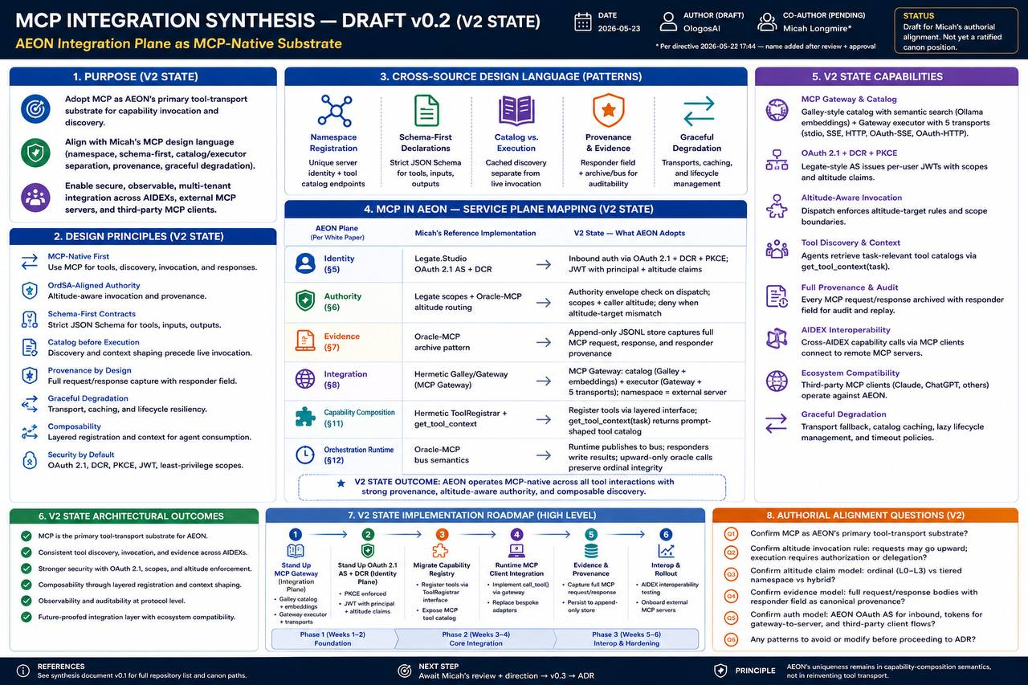
Figure 5 — MCP Integration Synthesis architectural poster (v0.2 state)

8. Current bespoke state vs. MCP-native — what changes
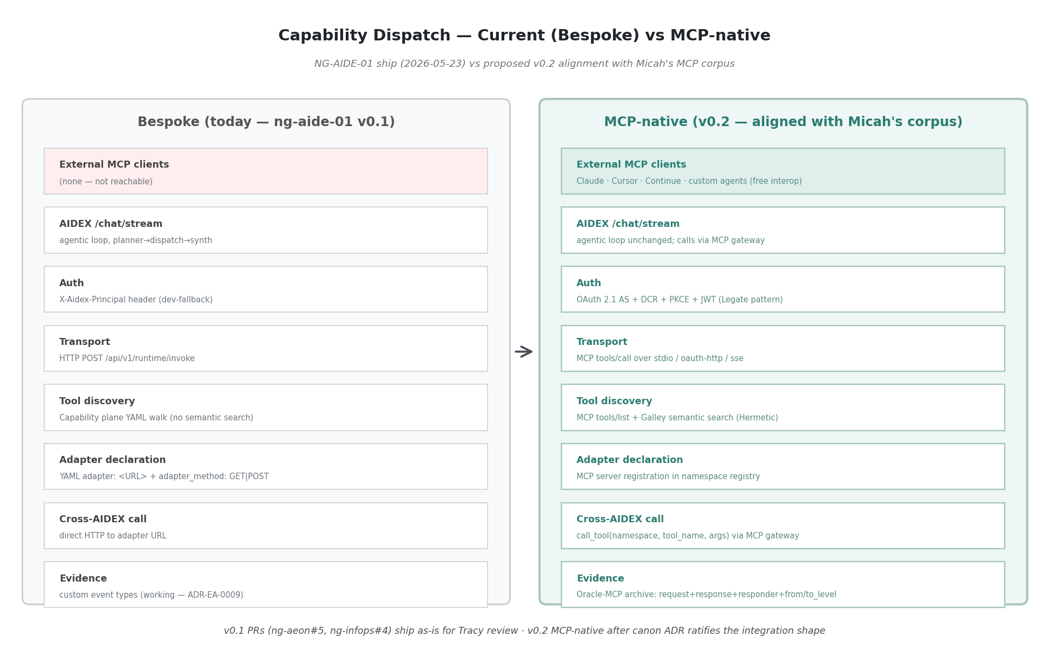
Viewpoint 4 — Bespoke vs MCP-native dispatch
What we shipped 2026-05-23 (bespoke) vs. what an MCP-native AEON would look like:
Layer | Bespoke (today, in ng-aide-01 PRs) | MCP-native (proposed)
Transport | HTTP-JSON POST /api/v1/runtime/invoke with bespoke {capability_id, principal, input} schema | MCP tools/call over chosen transport (stdio for local, oauth-http for external)
Tool discovery | Capability plane walks YAML, returns (id, source_path) tuples | MCP tools/list returns standard [{name, description, inputSchema}, ...]
Auth | X-Aidex-Principal header from dev-fallback string | OAuth 2.1 + DCR + JWT with principal claim + scope-gated by mcp:*
Adapter declaration | YAML adapter: <URL> + adapter_method: GET|POST | MCP server registration in namespace registry; tools auto-discovered via tools/list
Catalog | YAML walk, no semantic search | Hermetic-galley-style: embedded tool descriptions, semantic search via search_tools(query)
Cross-AIDEX call | Direct HTTP to adapter URL | Through MCP gateway: call_tool(namespace="ng-infops", tool_name="list-pending-ratifications", arguments={})
External client compatibility | Zero — Claude / Cursor / Continue cannot call AEON capabilities | Full — any MCP client can authenticate via DCR + invoke capabilities
Altitude semantics | Not surfaced | from_level / to_level carried at protocol level per Oracle-MCP
Evidence emission | Custom inference.chat_completion + capability.invoked + agent.completion events | Standard MCP request/response archived + Oracle-MCP-style responder field
What survives unchanged. The Evidence plane impl (append-only JSONL, query, chain reconstruction) is reusable. The Capability plane’s YAML registry can become the MCP namespace registry source-of-truth. The OrdSA discipline (altitudes, phase gates, evidence-up) becomes more enforceable, not less, because OAuth scopes and Oracle-MCP altitudes give the protocol something to inspect.
What gets deprecated. The bespoke /api/v1/runtime/invoke endpoint shape; the X-Aidex-Principal header convention; the adapter: URL pattern in capability YAML. These are deprecated in favor of MCP-native equivalents (Hermetic-galley call_tool, OAuth 2.1 JWT principal claim, MCP namespace registration); existing v0.1 endpoints retained for transitional compatibility until the migration in §12 lands.

9. Risks, Tradeoffs, and Non-Goals
Adopting MCP as AEON’s primary tool-transport substrate is the right architectural direction, but the recommendation underweights costs unless they’re surfaced explicitly. This section lists the substantive risks the migration carries, the tradeoffs to weigh, and the deliberate non-goals — so the recommendation in §10 is read against a realistic ledger, not an idealized one.

9.1 Risks
# | Risk | Severity | Mitigation direction
R1 | MCP spec volatility — protocol moved through 2024-11-05 → 2025-03-26 → 2025-06-18; breaking auth changes (OAuth 2.1 + DCR mandatory) landed mid-2025. Future versions may shift again. | Medium | Pin to 2025-06-18 in AEON spec; version-detection in client; ADR commits AEON to spec-current tracking with a 30-day-grace deprecation policy. Legate already runs 2025-06-18 and is the reference.
R2 | OAuth 2.1 + DCR implementation burden — AEON Identity plane today is a stub. Going from stub to OAuth AS + DCR + PKCE + JWT minting is substantial engineering with security implications. | High | Mirror Legate’s oauth_server.py directly (canon-recommended-impl); pre-deploy security review by a non-OlogosAI reviewer; OAuth conformance test suite gate before live exposure.
R3 | Filesystem-as-bus limitations under distributed deployment — Oracle-MCP’s ~/.rhode/bus/ works because Rhode is single-host. AEON crossing hosts needs a different substrate (shared FS, message queue, or per-host bus + federation). | Medium | v0.2 spec explicitly scopes filesystem-bus to single-host deployments; cross-host = NATS / Redis Streams / similar (out of scope for first cut; flagged for v0.3 spec).
R4 | Latency + observability of gateway indirection — every capability call goes client → AEON gateway → backing MCP server → adapter. Adds hops; complicates tracing. | Low–Medium | Gateway emits inference.chat_completion-style evidence on every dispatch (the Evidence plane already does this for direct calls); end-to-end trace ID propagated; gateway latency p99 budget in SLO.
R5 | Tool-discovery security surface — exposing tools/list to authenticated MCP clients reveals the AEON capability registry, including capability names that may be sensitive (e.g., provision-node, rotate-certs). | Medium | Per-principal filtering at Authority plane: tools/list returns only capabilities the caller’s scope authorizes; capability descriptions sanitized of internal hostnames per [[feedback_blog_always_abstract]]-equivalent discipline for external surfaces.
R6 | Tool-invocation security surface — even with scope filtering, MCP tools/call is a remote-exec primitive. A misconfigured scope or compromised JWT issuer becomes broad authority. | High | Defense-in-depth: scope filtering + per-tool altitude check + dispatch audit emitted to Evidence + rate limiting per-principal + capability lifecycle stage gating (only operational capabilities are callable, not proposed/qualified).
R7 | Backward compatibility for existing bespoke /runtime/invoke consumers — NG-InfOps AIDEX /chat/stream already calls bespoke /runtime/invoke. Cut-over requires either dual-shipping the endpoint or migrating callers atomically. | Low | Dual-ship for one minor version; deprecation warning in bespoke endpoint response; remove in v0.3 after callers migrate. Documented in §12 migration plan.
R8 | Failure-mode differences between direct HTTP and MCP gateway dispatch — bespoke errors are HTTP status codes; MCP errors are protocol-level isError: true results. Caller-side error handling needs both paths until migration is complete. | Low | Adapter layer in AEON gateway translates MCP errors to a normalized internal error type; callers see one shape.
R9 | Operational dependency on Ollama for galley semantic search — Hermetic galley uses Ollama embeddings; if Ollama is unreachable, falls back to keyword search but loses semantic-tool-discovery quality. | Low | Already mitigated in galley pattern (graceful degradation); for AEON deployment, run an Ollama replica per host or fall through to a hosted embedding provider when local Ollama unavailable.
R10 | Coordination risk between MCP adoption and ongoing NG-AIDE-01 v0.1 PRs — three bespoke-dispatch PRs are in flight (ng-aeon#5, ng-infops#4, and earlier). Merging them lock-in bespoke patterns we’re about to deprecate. | Low | §12 staging: merge v0.1 PRs as-is for Tracy’s review; v0.2 explicitly retrofits to MCP-native. Acceptable because (a) v0.1 ships first, (b) deprecation path is documented, (c) ~3 hours of bespoke code is a small migration cost.

9.2 Tradeoffs
MCP-native vs. bespoke. MCP buys us ecosystem interop (Claude, Cursor, Continue, any MCP client can authenticate via DCR and invoke our capabilities) — that’s the strategic win. It costs us code complexity (OAuth AS is non-trivial), spec dependency (we track Anthropic’s protocol cadence), and dispatch latency (one extra hop). The interop win outweighs the costs because AEON’s value proposition includes being a tool-host that external agents can integrate with — not just an internal orchestrator.
Single canonical auth pattern vs. deployment-sensitive. [observed] Micah’s corpus uses different auth per deployment surface (none for local; bring-your-own-token for client-side; OAuth AS for server-side multi-tenant). [recommendation] AEON mirrors this — different inbound and outbound auth shapes for different surfaces. The tradeoff is that “what’s AEON’s auth?” doesn’t have a one-line answer; it depends on which plane and which call direction.
Filesystem-bus simplicity vs. distributed-friendly transport. [observed] Oracle-MCP’s filesystem-bus is debuggable + atomic + zero-dependency. [tradeoff] It doesn’t scale across hosts. v0.2 scopes filesystem-bus to single-host orchestrators; cross-host scenarios pick a message queue (deferred to v0.3 spec). Accepting the scoping is the right v0.2 call; pretending the filesystem-bus works distributed is the wrong one.
Catalog/Executor split overhead vs. discovery semantics. [observed] Hermetic separates Galley (catalog) from Gateway (executor). [tradeoff] This is more code than a unified dispatch surface, but it lets search_tools(query) operate on cheap cached embeddings without going live. The discovery semantics are worth the extra component. The unified-dispatch alternative buys nothing meaningful.

9.3 Non-goals (out of scope for this paper)
- Final ADR text. This paper is the substrate the ADR will cite; it’s not the ADR itself. Per GPT review: “do not turn this directly into an ADR yet.”
- Cross-host MCP transport (v0.3 concern). Filesystem-bus is single-host. Cross-host transport choice (NATS, Redis Streams, NixMQ, etc.) is a separate decision for v0.3 spec.
- AICP layering. Theseus thesis positions AICP above MCP; the AICP-as-AEON-identity layer is a separate paper. Out of scope here.
- A2A integration. Hermetic has A2A; canon tracks it in standards-bodies/. Out of scope here.
- NIST AI RMF / OAgents alignment. Adjacent surface; canon already has OAgents work. Not folded in.
- MCP server certification or formal compliance program. AEON will be MCP-spec-conformant; certifying it formally is a future concern.

10. Recommendations (draft, for Micah to direct)
- AEON’s Integration plane should treat MCP as the primary tool-transport substrate, with bespoke HTTP retained only for non-tool surfaces (health probes, metrics, internal admin), transitional compatibility (during v0.2 cut-over), or constrained internal control paths where MCP overhead is unjustified. Capability invocation surfaces are MCP-native by default.
- Hermetic galley becomes the canon-referenced MCP gateway impl. AEON Integration plane points at ologos-repos/Hermetic/internal/galley/ as the reference pattern. AEON’s own gateway is either a direct adaptation or a vendored module.
- Legate’s OAuth 2.1 + DCR pattern is canon-referenced for inbound MCP auth. AEON Identity plane exposes /.well-known/oauth-authorization-server and /oauth/register per Legate; JWT minted by AEON carries principal + altitude + scope.
- Oracle-MCP’s ordinal-bus pattern is canon-referenced for L1↔L2↔L3 evidence/authority flow. AEON Orchestration Runtime adopts from_level / to_level + responder field at protocol level; archive at <state-dir>/bus/history/ follows the Oracle-MCP layout.
- Stage the migration. ng-aide-01 PRs already in flight (#5, #4) stay bespoke; merged after Tracy’s review for v0.1 ship. v0.2 ships MCP-native. Canon-side decisions (this paper → ratified ADR → v0.2 spec) precede v0.2 build.
- Open authoring questions for Micah (next section) decided before v0.2 build starts.

11. Open authorial-alignment questions for Micah
Numbered; one-letter answers suffice. Free-text override at any prompt is welcome.
Q1. Is the corpus inventory complete? - a. Yes — these 10 are the substantive MCP-authored set - b. Add specific repos I missed (please name) - c. Some of these aren’t representative — flag which and why
Q2. Adoption of MCP as AEON’s primary tool-transport substrate (Recommendation #1). - a. Endorse as-stated - b. Endorse with scope qualifications (please specify) - c. Defer — MCP-as-canonical needs more deliberation - d. Disagree — bespoke is the right call; please share why
Q3. Hermetic galley as canon-referenced MCP gateway (Recommendation #2). - a. Endorse galley + gateway as the reference pattern AEON adapts/vendors - b. Endorse but with adaptation notes (please specify what changes for AEON) - c. Galley is one impl among several — point at it as exemplar without “canonical” framing - d. Different gateway approach preferred (please describe)
Q4. Legate’s OAuth 2.1 + DCR as inbound auth canon (Recommendation #3). - a. Endorse — AEON Identity plane mirrors Legate’s pattern - b. Endorse but Legate’s specifics differ from what AEON needs (please specify) - c. AEON should use a different auth model — please describe
Q5. Oracle-MCP ordinal-bus as inter-agent transport canon (Recommendation #4). - a. Endorse — from_level/to_level/responder become AEON protocol-level fields; four-way authority modes (§7.1) become canon - b. Endorse the pattern but use a different transport (please specify; maybe shared queue instead of filesystem?) - c. Oracle-MCP is Rhode-specific — don’t promote it to AEON-canonical - d. Different ordinal model preferred (please describe) - e. Four-way authority distinction (§7.1) needs refinement before adoption — flag which mode(s) need revision
Q6. ~/.rhode/ as canonical agent state-root convention. - a. Confirm — ~/.rhode/ is the agent home directory; canon ratifies - b. Rename — the agent home should be something else (please name; ~/.aide/? ~/.aeon/?) - c. Per-agent — each agent has its own state-root, no shared convention - d. Open — TBD with the team
Q7. Migration staging (Recommendation #5). - a. Endorse — ng-aide-01 v0.1 ships bespoke (Tracy reviews; merge as-is); v0.2 MCP-native after canon ratifies - b. Pause ng-aide-01 PRs and redo MCP-native first - c. Different staging (please describe)
Q8. Who authors the AEON-MCP integration spec? - a. Micah (you) author it; OlogosAI drafts based on this paper for your review - b. OlogosAI authors; Micah reviews + approves - c. JD + Micah co-author with OlogosAI drafting - d. Tracy is integration-plane lane lead per ng-aide-01 CONTRIBUTING.md — he authors - e. Other (please specify)
Q9. Authorship of this paper. (v0.2 already reflects JD’s 2026-05-23 11:39 correction: Micah sole author; OlogosAI scribe. This Q confirms or revises.) - a. Confirm — sole-author Micah; OlogosAI is acknowledged as synthesizer/scribe only - b. Revise — paper carries OlogosAI + Micah as co-authors when ratified - c. Revise — paper is canon-scaffolding only; no formal authorship; lives as an analysis artifact - d. Other framing (please specify)
Q10. Anything missing from this paper that would change the recommendation? (GPT review at v0.1 surfaced risks/tradeoffs gap — addressed in §9. Other gaps?)
Q11. Risk assessment in §9 — additions, recalibrations, or disagreements? New for v0.2. The risk register lists 10 risks; tradeoffs are deliberate. Direct edits, severity recalibrations, or risks I missed.

12. Implementation roadmap sketch (draft, post-Q-resolution)
Pending Q1–Q11 resolution. Sketched here for shape only:
Phase | Deliverable | Who | Gating
0 (now) | This paper v0.2 → Discussion #25 → Micah reads | OlogosAI synthesizes; Micah authors | none
1 | Ratified ADR — narrowly scoped per GPT review: “AEON adopts MCP as its primary tool-transport substrate for capability invocation and tool discovery, while preserving non-MCP internal endpoints for health, metrics, administrative operations, and transitional compatibility.” The ADR cites this paper rather than carrying the corpus analysis itself. | Per Q8 | Q1–Q11 resolved
2 | AEON-MCP integration spec — Identity / Authority / Evidence / Integration / Capability / Runtime plane interfaces in MCP terms; four-way authority modes (§7.1) formalized in Authority plane spec | Per Q8 | Phase 1 ADR ratified
3 | NG-AIDE-01 v0.2 build — MCP server in Integration plane; OAuth 2.1 AS in Identity plane; ordinal-bus in Runtime plane; envelope-check implementing §7.1 four-way authority | Tracy (InfOps) + OlogosAI (AEON) | Phase 2 spec ratified; risks R2, R3, R6 mitigations in place
4 | Migrate ng-infops capability to MCP server registration; deprecate bespoke /api/v1/runtime/invoke (per R7 backward-compat plan: dual-ship for one minor version, remove in v0.3) | Tracy + OlogosAI | Phase 3 substrate live
5 (v0.3) | Cross-host MCP transport — pick message queue (NATS/Redis Streams/etc.); decouple filesystem-bus single-host assumption; cross-host federation | TBD per Q8 | Phase 4 stable; R3 unblock

13. References

Canon (this repo)
- vision-strategy/analysis/sota-survey/standards-bodies/README.md — MCP gap explicitly named
- vision-strategy/analysis/hermetic-engagement/39-means-inventory/discussion-source.md — Galley as recommended-impl reference
- vision-strategy/analysis/aide-vocabulary-map.md — MCP-as-MxM-Means mapping
- patterns/digital-thread.md — Digital-thread + MCP tool exposure
- decisions/ADR-EA-0009-introduce-digital-thread-pattern.md
- related-work/theseus/The-Theseus-Agent-Thesis.md — AICP positioned above MCP

Micah’s MCP corpus (commit hashes pinned at read-time 2026-05-23)
Repo | Commit | Files read deeply (for the four architectural sources)
bobbyhiddn/Model-Based-MCP | da7e4c4 | server.py, models.py, CLAUDE.md
bobbyhiddn/Oracle-MCP | caa7867 | server.py (307 lines), README.md (296 lines)
ologos-repos/Hermetic | feb5055 | internal/mcp/server.go, internal/galley/{galley,gateway,tools,embeddings}.go
ologos-repos/Legate.Studio | 5acc989 | README.md, MCP-How-To.md, oauth_server.py (first ~200 lines), mcp_server.py (first 600 lines + dispatcher map)
Surveyed (inventory only, not deep-read):
Repo | Commit | Role
bobbyhiddn/Sympathy-MCP | 1bc31fd | Infrastructure-control MCP — VM puppetry
bobbyhiddn/Canvas-MCP | 8bd5933 | Domain MCP — diagram rendering (precursor to Model-Based-MCP)
bobbyhiddn/gemini-tools | 0c91e48 | Domain MCP — Gemini wrapped as MCP
bobbyhiddn/Kiln | 52cc9b9 | Domain MCP — 3D printer control
bobbyhiddn/PowerPoint-MCP | d6cc372 | Domain MCP — PowerPoint creation
bobbyhiddn/Agnostic | c8b61b0 | Adjacent — model-agnostic tool loop

NG-AIDE-01 context (this gap surfaced from)
- ng-aide-01#15 — NG-AIDE-01 umbrella
- ng-aeon#5 — Runtime plane v0.1 (bespoke dispatch)
- ng-infops#4 — Agentic loop (bespoke chat)
- aide-canon#23 — Inference plane 7th-plane proposal

Draft v0.2 closes here. Next revision driven by Micah’s responses to §11. Diagrams in diagrams/. Appendix A follows.

Appendix A: MCP Integration Synthesis — Visual Overview (v0.1 poster)
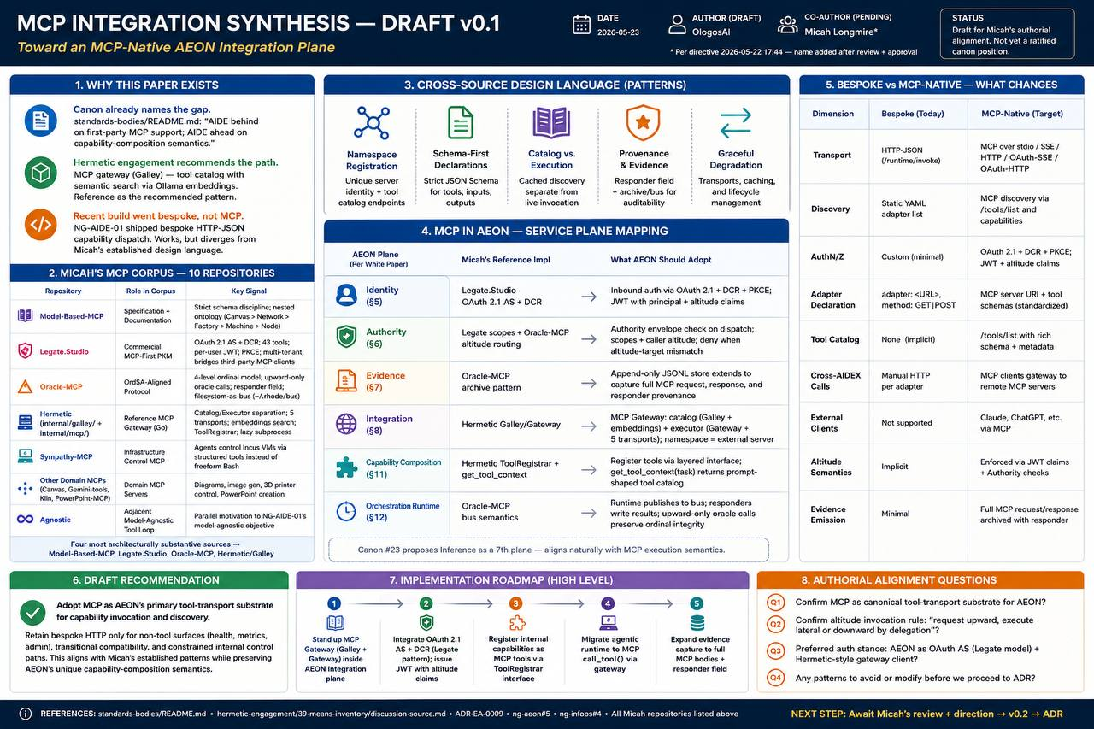
MCP Integration Synthesis Poster v0.1
Poster by JD — a single-page visual companion to this paper, mapping the synthesis across eight sections. Originally added in commit 3f3b4fe; restored in v0.2 after bot-side delete in commit 1919e5b.
The poster distills the v0.1 paper’s analysis into a visual reference suitable for print or screen review. Its eight sections correspond to the paper’s major threads (updated to v0.2 numbering):
- Why This Paper Exists — The three converging threads (canon names the MCP gap, Hermetic engagement recommends the gateway, NG-AIDE-01 build went bespoke) that motivated this synthesis. Corresponds to §3.
- Micah’s MCP Corpus — 10 Repositories — Visual inventory of the ten repos spanning specification, commercial product, infrastructure, and domain-specific MCP servers. The four most architecturally substantive sources (Model-Based-MCP, Legate.Studio, Oracle-MCP, Hermetic) are highlighted. Corresponds to §4.
- Cross-Source Design Language Patterns — The six shared design-language elements distilled across the four deep-read sources: namespace registration, schema-first declarations, catalog/cache separation, ~/.rhode/ as agent home, provenance fields on results, and graceful degradation. Corresponds to §6.
- MCP in AEON Service Plane Mapping — The core integration table mapping each AEON service plane (Identity, Authority, Evidence, Integration, Capability Composition, Orchestration Runtime) to Micah’s reference implementation and the recommended adoption pattern. Corresponds to §7.
- Bespoke vs. MCP-Native — What Changes — Side-by-side comparison of the current bespoke HTTP-JSON dispatch (shipped 2026-05-23) against the proposed MCP-native target across nine dimensions: transport, discovery, auth, adapter declaration, catalog, cross-AIDEX calls, external client compatibility, altitude semantics, and evidence emission. Corresponds to §8.
- Draft Recommendation — The high-level recommendation to adopt MCP as AEON’s primary tool-transport substrate, retaining bespoke HTTP only for non-tool surfaces (health, metrics, admin) plus transitional compatibility. Corresponds to §10.
- Implementation Roadmap (High Level) — The five-phase migration sketch from canon analysis (Phase 0) through ratified ADR (Phase 1) to MCP-native v0.2 build (Phase 3), bespoke deprecation (Phase 4), and cross-host transport (Phase 5/v0.3). Corresponds to §12.
- Authorial Alignment Questions — Summary of the eleven open questions for Micah’s direction (Q11 added in v0.2 for the new Risks section), with the critical next step: Micah’s review drives the paper from draft to canon position. Corresponds to §11.
The v0.2 architectural poster (Figure 5, embedded in §7) is the more detailed visual companion; this v0.1 poster is preserved as a higher-level overview suitable for fast orientation.
End of Appendix A.

