The Enterprise Agentic Platform Architecture
Control, Runtime, Experience, and Capability Planes for Governed AI Adoption
An enterprise-owned, four-plane architecture and a staged maturity model for adopting it
James D. Longmire
Northrop Grumman Fellow, Chief Architect – Digital Ecosystems
ORCID: 0009-0009-1383-7698 · Correspondence: jdlongmire@outlook.com
May 2026
This paper presents independent research and reflects the views of the author. It does not represent the position of any employer or program.

Contents

Abstract
Every enterprise is acquiring agentic AI whether or not it has decided to. Copilots, coding agents, and workflow automations are entering through vendor products, individual programs, and departmental initiatives. The capability is arriving on its own momentum. The only open question is whether the enterprise governs how that capability composes, or accepts whatever composition emerges by default.
This paper makes the case for the deliberate version of that choice. It argues that the agentic era requires an enterprise-owned platform architecture, separated into four planes with distinct responsibilities: a control plane that governs how agentic capability composes, a runtime plane that supplies the AI substrate, an experience plane that makes AI-enabled work accountable for the individual worker, and a capability plane that lets the enterprise own its business systems rather than rent them. The control-plane idea is now industry consensus; the major vendors and analysts converged on it over the last two quarters. The two claims that survive that consensus are the ones this paper rests on: that the control plane should be enterprise-owned rather than rented, and that the four planes should be composed as one architecture. The capability plane in particular is something no business-system vendor can offer, because it is the displacement of the vendor's own business.
The paper is written for a Chief Information Officer or Chief Technology Officer, and is addressed first to defense and highly regulated enterprises: those running classified or mission systems, those bound to demonstrate first-party auditability of all agentic operations, and those whose sovereignty posture makes vendor governance over their own operations unacceptable. For an enterprise without those pressures, a rented vendor control plane may be the rational choice, and the paper says so rather than posing as a universal prescription. It assumes no prior familiarity with the four platforms, presents the architecture at executive altitude, and lays out a staged maturity model whose first step, the decision actually on the table, is to fund a governed runtime with control-plane primitives plus a short discovery, not to commit to full transformation. The full platform specifications exist as companion works; this paper is the umbrella that makes them one strategy.

1. The Enterprise Decision
Consider what happens inside an enterprise today when a knowledge worker asks an AI assistant to do something consequential. In the familiar pattern of the last three decades, a person logged into a system, the system checked whether that person was allowed to do the thing, the person did it, and a log recorded that they did. The human was present at every step, and the human was the point of accountability. The enterprise could always answer the question that matters most under audit: who did this, and were they allowed to?
Agentic AI breaks that pattern. The new unit of work is not a person invoking a system. It is an agent acting on a person's behalf, often invoking tools, calling other agents, and touching multiple systems in sequence, faster than any human could supervise each step. The person delegated a goal; the agent assembled the work. When something goes wrong, or when a regulator asks who authorized a particular action buried three steps deep in an automated workflow, the enterprise that simply layered agents on top of its existing architecture often cannot answer. The accountability that used to live in the human at the keyboard has quietly dissolved into a system that was never designed to hold it.
This is not a distant problem. It is the predictable consequence of adopting agentic capability without the architecture to govern it, and it is happening across the industry now. The individual agentic products work. What fails is the enterprise's ability to govern how they compose: identity does not flow correctly from one agent to the next, authorization is enforced inconsistently by each product in its own way, evidence is scattered across logs that do not correlate, and workflows that cross system boundaries cannot be governed because no architectural layer composes them.
The decision in front of a technology executive is therefore not whether to adopt agentic AI. That decision is already being made continuously by the enterprise's own momentum. The decision is whether to build the architecture that governs agentic capability deliberately, or to accept the ungoverned composition that emerges when no one makes the choice. This paper argues for the deliberate version, and, just as importantly, argues that it can be adopted in stages rather than as a single overwhelming build. What the reader is asked to commit to is not a four-platform megaproject. It is a staged path with a small, fundable first step and a clear sequence after it.
This argument is no longer a lonely one. Over the last two quarters the major platform vendors and the leading analysts have converged on the same diagnosis: the enterprise needs a control plane to govern agentic capability. That convergence is a tailwind, and Section 2 treats it directly, including the one question the vendor consensus leaves unanswered, which is who should own the control plane.
One principle governs the staged path from the very first step, and it is worth stating plainly at the outset. The Level 1 Rule: no production agentic capability without identity binding, authority decisioning, and evidence capture. The accountability primitives are present before any agent acts, which means the enterprise never passes through a phase of ungoverned agentic deployment to be cleaned up later. Section 4 develops the rule; the reader should carry it from here.
One framing note before the argument proper. This paper is addressed first to defense and highly regulated enterprises, those running classified or mission systems, those bound to demonstrate first-party auditability of every agentic operation, and those whose sovereignty posture makes vendor governance over their own operations unacceptable. For those readers the case is strongest. For an enterprise without such pressures, a rented vendor control plane may be entirely rational, and Section 7 makes that boundary explicit rather than pretending the architecture suits everyone. The reader should hold that filter in mind throughout; the recommendation is conditional by design.

2. The Competitive Landscape
This section is a market snapshot as of May 2026 and will date faster than the rest of the paper. It is set apart deliberately; the architectural argument that follows does not depend on it. The claims below were checked against primary vendor announcements and tier-one analyst reporting, and the footnotes record the sources and their confidence level. A reader returning later should treat the architecture as durable and this section as a snapshot.
The central idea of this architecture, the enterprise control plane for agentic AI, is no longer novel. As of mid-2026, public vendor announcements and analyst commentary indicate convergence around agent identity, registry, observability, and governance as core platform capabilities. At Google Cloud Next, Google renamed its model platform to the Gemini Enterprise Agent Platform and presented agent identity, registry, gateway, and observability as a single governance control plane. At SAP Sapphire, SAP introduced a Business AI Platform structured as context, build, and governance layers, with a governance hub explicitly extending to non-SAP agents. Tier-one analysts framed the resulting buyer decision as an operating-model choice rather than a tooling choice. This convergence does not make enterprise ownership the consensus. It makes the control-plane problem the consensus. A strategy claiming to have originated the control plane would be dismissed on contact, and this paper claims no such thing: the control plane is validated, not invented here, and that validation is a tailwind. The differentiation lies in two places that survive the consensus.
The first is ownership. Every vendor control plane is one the enterprise rents. The consistent vendor strategy is to keep models and partners open at the edge while consolidating governance, identity, and observability at the center, and the center is the vendor's platform. No major vendor argues the control plane should be enterprise-owned, because none has the incentive to. For an enterprise whose regulatory exposure or sovereignty posture makes vendor governance over its own operations unacceptable, that is the whole question, and the market has left it unanswered. The ownership question also carries a dimension the vendor framing omits: a rented control plane is an exit the enterprise does not control, which matters acutely under geopolitical or regulatory scenarios where the ability to migrate off a foreign or commercial governance layer is itself a strategic requirement.
The second is holism across all four planes. The landscape has control-plane products, AI-runtime platforms, internal developer platforms, and worker-facing copilots, each addressing one or two of the four concerns. It has nothing that composes all four as one enterprise-owned architecture, and in particular nothing resembling the capability plane, for reasons Section 5 develops: no business-system vendor can propose displacing the rented business stack, because that stack is its business. Part of the holism is therefore not merely uncommon but structurally impossible for any incumbent to offer.
The honest counterweight is that the same consensus raises the bar on the build-versus-rent decision. Six months ago an enterprise-owned control plane competed against nothing comparable; today it competes against polished, credible vendor control planes shipping now. For a commercial enterprise without acute sovereignty or regulatory pressure, the vendor option may be the rational choice. The case for the enterprise-owned, four-plane architecture is strongest exactly where those pressures are highest, which is the defense and regulated-industry context this architecture was conceived in, and Section 7 states that condition as a precondition rather than assuming it.

3. The Four-Plane Architecture
The architecture organizes the enterprise's agentic capability into four planes. Each is a platform the enterprise owns. Each has a distinct responsibility. They compose into one architecture, but they are deliberately separable. The figure below shows how they relate; the sections that follow introduce each in turn, naming the function first and the platform second, because the function is what matters and the name is only a label.
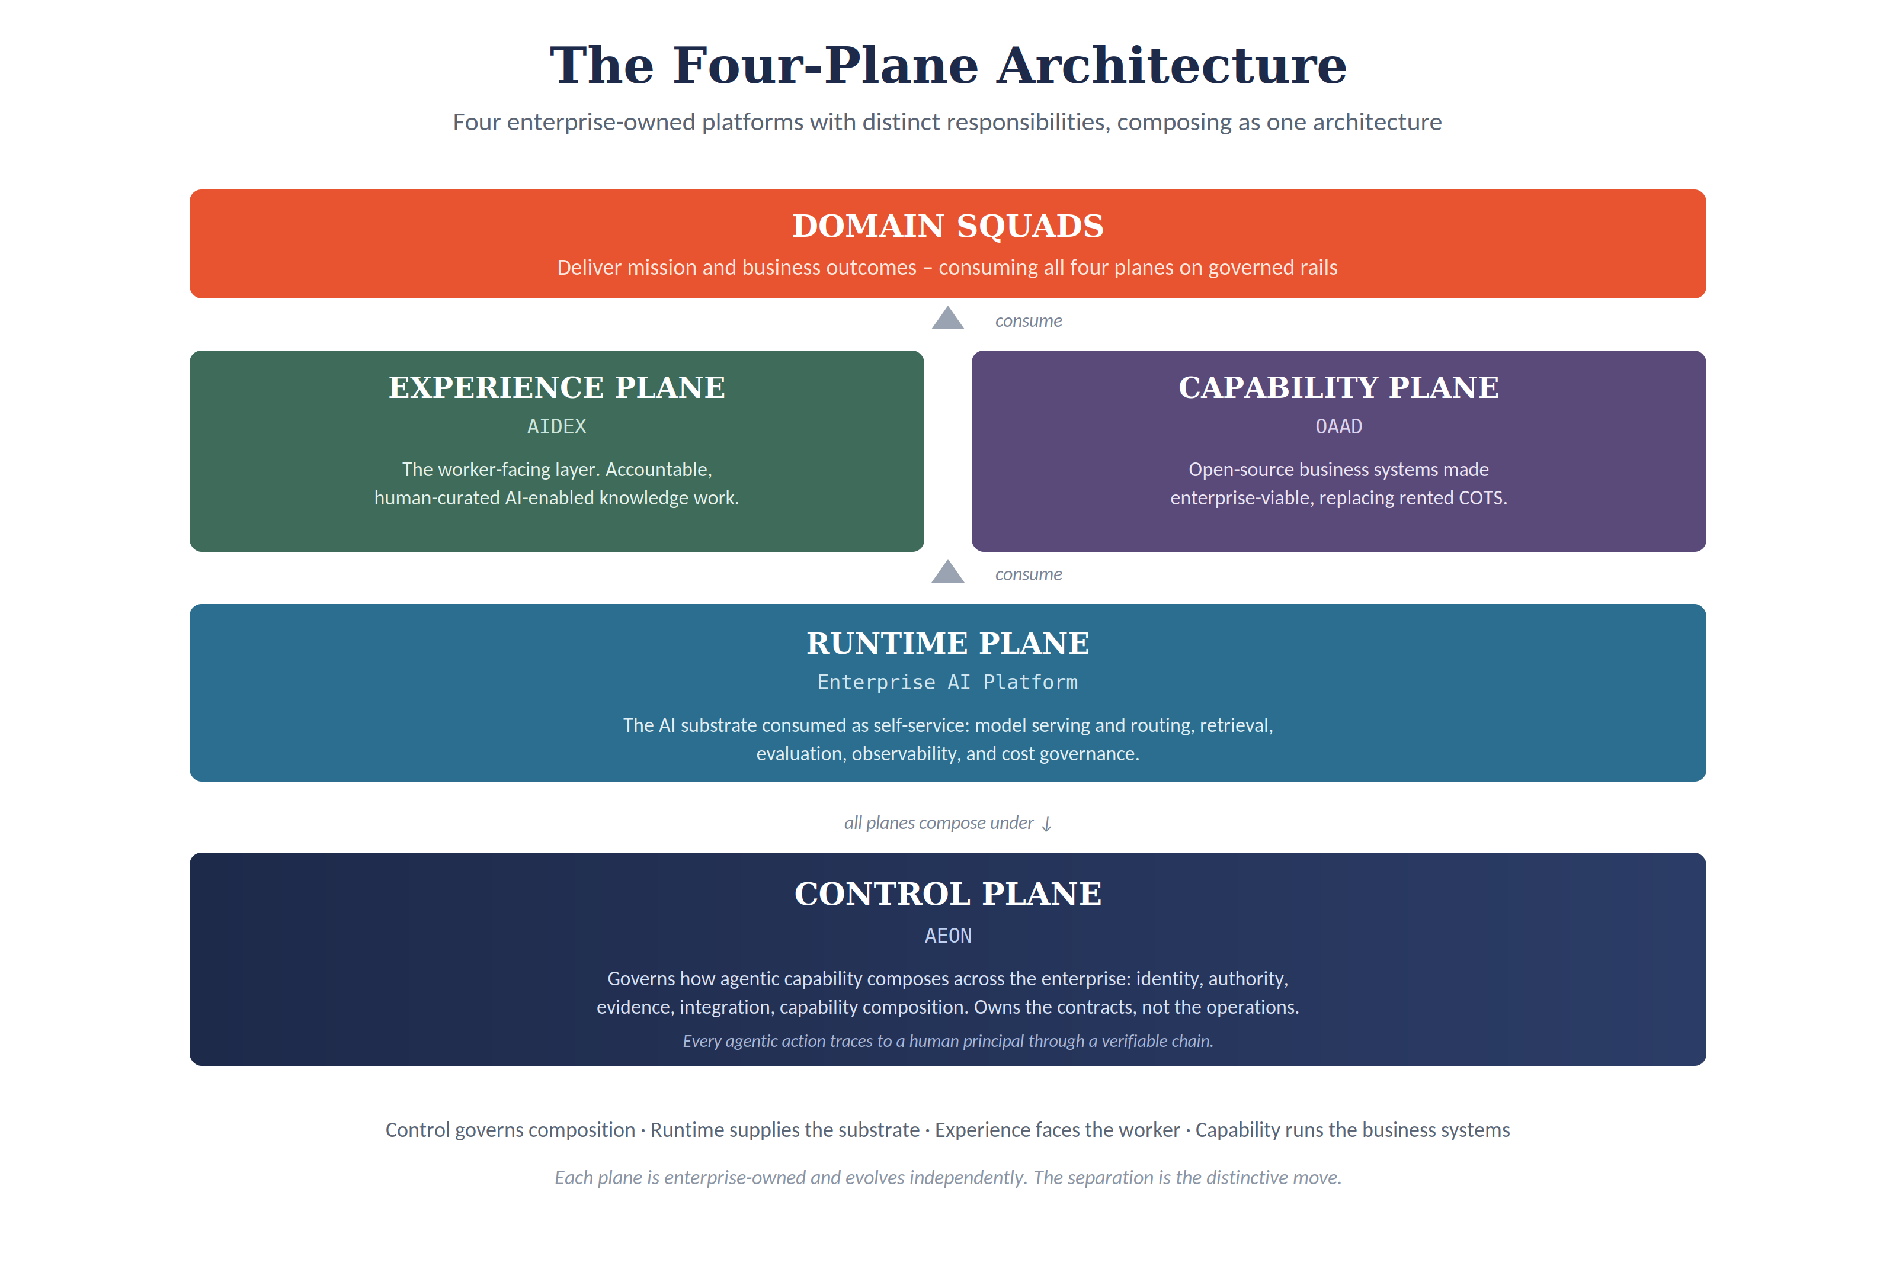
Figure 1. The four planes. Control governs composition; runtime supplies the substrate; experience faces the worker; capability runs the business systems. Domain squads consume all four to deliver outcomes.

3.1 The Control Plane
The problem it solves. When agents act on a person's behalf across multiple systems, something has to guarantee that every action traces back to a human who was allowed to authorize it. No individual system can do this, because the chain of authority breaks the moment it crosses from one system to the next.
What it is. The control plane is the architectural layer that governs how agentic capability composes across the enterprise. This architecture names it AEON. It owns five things: identity (who the human principal is, resolved consistently everywhere), authority (what that principal is permitted to do, evaluated at the moment of action), evidence (a correlated record of what happened, who authorized it, and what resulted), integration (the governed composition of workflows that cross system boundaries), and capability composition (the registry and lifecycle of what the enterprise can do).
What it owns, and what it does not. The control plane owns the contracts that every other plane consumes, and the runtime that coordinates composition. It deliberately does not run the other planes. It governs how they compose; it does not execute their work. This distinction is what keeps the control plane small and authoritative rather than sprawling and unaccountable.

3.2 The Runtime Plane
The problem it solves. Before an enterprise can govern AI or put it in front of workers, it needs a reliable, consistent AI substrate to build on. Without one, every team assembles its own, producing duplicated effort, inconsistent quality, runaway cost, and no common foundation to govern.
What it is. The runtime plane is the AI substrate, consumed as self-service by everything above it. This architecture calls it the Enterprise AI Platform. It provides model serving (including both open-weight models the enterprise hosts and commercial models accessed through a gateway), model routing by task and sensitivity, retrieval over enterprise data, evaluation, observability, and cost governance. It is built in the mold of an internal developer platform: golden paths that make a complex substrate consumable through a governed, self-service surface.
What it owns, and what it does not. It owns the substrate and the disciplines that keep it reliable and economical. It does not face the worker directly and it does not govern cross-enterprise composition; those are the experience and control planes. Of the four planes, the runtime is the one whose full specification is still to be written; this paper defines its scope provisionally and treats the detailed specification as companion work.

3.3 The Experience Plane
The problem it solves. An agent that does a worker's job without the worker remaining accountable for the result does not make the worker more productive; it displaces the worker's accountability into a system that cannot bear it. The enterprise needs AI-enabled work that keeps the human as the responsible party.
What it is. The experience plane is the worker-facing layer. This architecture calls it AIDEX. Its organizing discipline is Human-Curated, AI-Enabled practice, abbreviated HCAE: the AI substrate produces candidate material, and the human practitioner curates it into accountable output, remaining the locus of judgment and the signatory. Curation is not rubber-stamping; it is the continuous, expert engagement of selecting, revising, attributing, and signing. The plane captures that curation as it happens, so that consequential actions carry an explicit human confirmation and routine ones carry an appropriate, auditable level of review.
What it owns, and what it does not. It owns the worker's experience of AI-enabled work and the capture of accountable curation. It does not supply the AI substrate (that is the runtime) and it does not enforce enterprise-wide authority (that is the control plane); it consumes both. Its success also depends on partnerships outside technology, particularly with human resources and learning functions, addressed in Section 6.

3.4 The Capability Plane
The problem it solves. The enterprise's business systems (service management, customer relationship management, enterprise resource planning, and the rest) are largely rented from commercial vendors. As those vendors add agentic layers, the institutional intelligence the enterprise generates increasingly accrues to the vendor. The enterprise needs the option to own its business capability rather than rent it.
What it is. The capability plane is where the enterprise selectively replaces commercial off-the-shelf business systems with open-source systems made enterprise-viable through agentic orchestration and disciplined operations. This architecture calls it OAAD. Mature open-source alternatives exist today for nearly every commercial business-system domain; the historical gap was never raw capability but integration, operations, and governance at enterprise scale. The agentic and operational disciplines of this plane are what close that gap.
What it owns, and what it does not. It owns the open-source business systems the enterprise chooses to operate and the agentic and operational layers that make them viable. It is explicitly a selective and staged posture, not a wholesale rip-and-replace; Section 5 states the boundary precisely. It is the most operationally demanding of the four planes and, deliberately, the last to mature.

3.5 The Consumers: Domain Squads
The four planes exist to be used. The teams that actually deliver mission and business outcomes (call them domain squads) consume all four planes on governed rails: they build on the runtime, work through the experience layer, compose under the control plane, and operate the business systems the capability plane provides. The architecture is not the point; what the domain squads deliver with it is the point. Naming them here keeps the rest of the paper honest about who the architecture serves.

4. The Maturity Model
Presented as four platforms to build, this architecture sounds like an overwhelming, multi-year, all-or-nothing commitment. Presented as a maturity model, it becomes executable. The enterprise does not build four platforms at full maturity before any value appears. It matures through levels, each of which produces value on its own and prepares the next. The figure below shows the path.
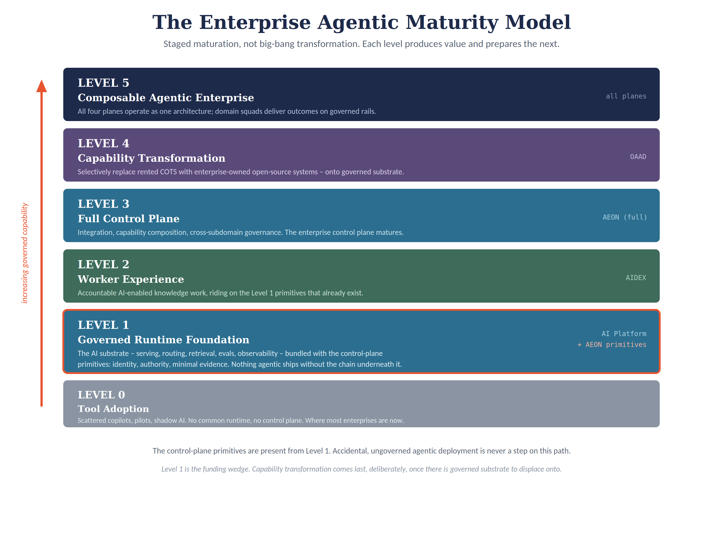
Figure 2. The maturity model. The control-plane primitives are present from Level 1, so ungoverned agentic deployment is never a step on the path. Level 1 is the funding wedge; capability transformation comes last.
Figure 2 matters because it dissolves the “big-bang” objection: no level requires the next, each pays for itself, and the governance primitives appear at the bottom rather than being bolted on at the top. A single design principle governs the whole ladder: no agentic capability ships without the accountability chain beneath it. Ungoverned agentic deployment is not an early phase to be cleaned up later; it is never a step on the path at all.
Level 0: Tool Adoption. Scattered copilots, local experiments, and disconnected pilots, with no common runtime and no control plane. This is where most enterprises are now. It carries real risk: shadow AI, cost leakage, audit gaps, and inconsistent adoption.
To make the difference concrete, consider an ordinary case. A copilot, asked to reconcile an invoice discrepancy, drafts and submits an adjustment to a financial record. At Level 0 the action goes through under whatever local credentials the copilot inherited; if an auditor later asks who authorized it and under what policy, the enterprise reconstructs the answer by hand across disconnected logs, often inconclusively. At Level 1 the same request runs through the runtime plane, the identity primitive binds the action to the human principal who invoked it, the authority primitive evaluates whether that principal may adjust financial records and routes the action for confirmation if it is consequential, and the evidence primitive records the principal, the decision, and the result in a single correlated chain. The copilot is just as useful; the difference is that the enterprise can now answer the audit question definitively, and the mis-authorized action is caught at the authority check rather than discovered after the fact. That difference is the entire point of bundling the primitives into Level 1.
Level 1: Governed Runtime Foundation. The enterprise stands up the runtime plane (model serving, routing, retrieval, evaluation, observability, cost governance) and, critically, bundles it with the control-plane primitives: identity, authority, and a minimal evidence record. This pairing is the most important design decision in the whole model, and it is captured as a rule: no production agentic capability without identity binding, authority decisioning, and evidence capture. From the very first governed deployment, every agentic action traces to a human principal through a verifiable chain. The enterprise never passes through a stage of ungoverned agentic capability, because the accountability primitives are present before any agent acts. Level 1 makes AI technically consumable and governable at once, and it is the natural funding wedge: its value is immediate and measurable. Indicative Level 1 metrics: the share of agentic actions carrying a complete identity-and-evidence chain (target: all of them), unit cost per request, and model-reuse rate across the enterprise.
Minimum Viable Level 1
Runtime substrate: model gateway with both an open-weight serving path and a commercial-model gateway; model routing by task and sensitivity; a retrieval (RAG) foundation; a prompt and workflow registry.
Quality and cost: an evaluation harness, observability across requests and agents, and FinOps telemetry for unit cost and consumption.
Control-plane primitives: identity binding to a human principal, authority decisioning at the moment of action, and evidence capture, integrated as hooks the runtime calls before and after each agentic action.

That list is the concrete content of the near-term funding ask. It is enough to make agentic capability consumable and governable at once, and deliberately no more; the full runtime and control-plane specifications are companion work, but nothing in the list is speculative or waiting on them.
Level 2: Worker Experience. The enterprise deploys the experience plane, putting accountable, human-curated AI-enabled work in front of selected knowledge roles. Because the Level 1 primitives already exist, the worker's curation of consequential actions is captured into a real evidence record from day one, rather than retrofitted later. The value here is concrete: faster onboarding, more consistent decisions, and knowledge that is captured rather than lost. Indicative Level 2 metrics: average time to curate a standard artifact, and reduction in time-to-productivity for a target role against its historical baseline.
Level 3: Full Control Plane. The enterprise matures the control plane from primitives into its full form: the integration of workflows across system boundaries, the registry and lifecycle of enterprise capabilities, and governed cross-domain composition. This is where the control plane becomes the enterprise control plane rather than a per-deployment safeguard. It is also, candidly, the level where funding is hardest to justify on productivity grounds alone, because its central value is governance certifiability and forensic capability, which are insurance against risk rather than a productivity gain. Indicative Level 3 metrics: mean time to reconstruct a multi-system agentic incident, and auditor findings related to agentic operations. Section 8 returns to how to make that case.
Level 4: Capability Transformation. With governed substrate, accountable experience, and a mature control plane in place, the enterprise begins selectively replacing rented commercial business systems with enterprise-owned open-source systems. This is the largest operational commitment and it comes last, deliberately, because it should be undertaken only onto governed substrate that already exists. Its strategic rationale, the ownership asymmetry that no vendor can match, is the subject of Section 5; here the point is only its position in the sequence. Starting here would be reckless; arriving here on a mature foundation is the point.
Level 5: Composable Agentic Enterprise. The four planes operate as one architecture. The enterprise owns its control plane, its runtime substrate, its worker experience, and its business-capability evolution, and its domain squads deliver outcomes on governed rails. At this level the enterprise is not merely using AI; it has become an agentic platform enterprise.
The essential property of this model is that each level is independently valuable and independently fundable. The enterprise can stop at any level and retain the value of everything below it. It can also pace each transition to the maturity it has actually demonstrated, rather than committing to a schedule it cannot sustain.

5. The Capability Plane: The Asymmetry No Vendor Can Match
Of the four planes, the capability plane carries the architecture's most durable strategic claim, and it deserves to be argued directly rather than left as the last step of the maturity model. The claim is structural, not merely competitive: the displacement of the rented business stack is something no business-system vendor can ever offer, because that stack is the vendor's business. SAP cannot sell an enterprise the path off SAP. Salesforce cannot sell the path off Salesforce. This does not imply early displacement of the ERP or financial core, which Section 5.2 places at the latest phase and only after discovery; it means the incumbent vendor cannot be the architect of the enterprise's business-system independence. The incumbents are doing the opposite, and the agentic transition is the moment they are using to do it.
The evidence is current and concrete. The agentic shift is being used to deepen vendor lock-in, not loosen it. The clearest case is SAP: under its 2026 API policy, third-party AI agents reach SAP data only through SAP-mediated agents under a protocol SAP defines, governs, and meters, and SAP's CEO defended the right to throttle high-volume agent traffic while describing the company's domain knowledge as an asset to protect. A tier-one analyst characterized the move as an attempt to become the gatekeeper of enterprise AI. The pattern is not uniform across vendors: reporting indicates Salesforce and ServiceNow have not imposed equivalent hard restrictions, steering agent traffic toward their own intelligence layers more quietly instead. But the direction is consistent, and the consequence is the same in every case: the institutional intelligence an enterprise generates as it operates, every refined workflow and handled edge case, increasingly accrues inside the vendor's schema. The agentic era, left to the vendors, is the era in which the enterprise's own operational learning becomes the vendor's moat.
The capability plane inverts that. It is the architectural posture in which the enterprise selectively replaces rented commercial systems with enterprise-owned open-source systems made viable through agentic orchestration and disciplined operations, so that the compounding intelligence accrues to the enterprise. Only the enterprise has the incentive to build this, which is precisely why it is differentiated: it is not that no vendor has gotten around to it, but that no vendor ever can.

5.1 The Capability Model
The argument becomes architecture, rather than advocacy, only when it is expressed as a capability model rather than a list of software. The unit of analysis is the business capability, not the tool. The model below takes the enterprise's Tier 1 business capabilities as its rows and assesses each on three dimensions: the system that typically delivers it today, the current ownership posture, and the candidacy and prudent phase for displacement. Candidacy reflects entanglement, the maturity of the open-source alternative, and regulatory exposure; phase is the maturity-model level at which displacement is prudent, never before a governed substrate exists to receive it.
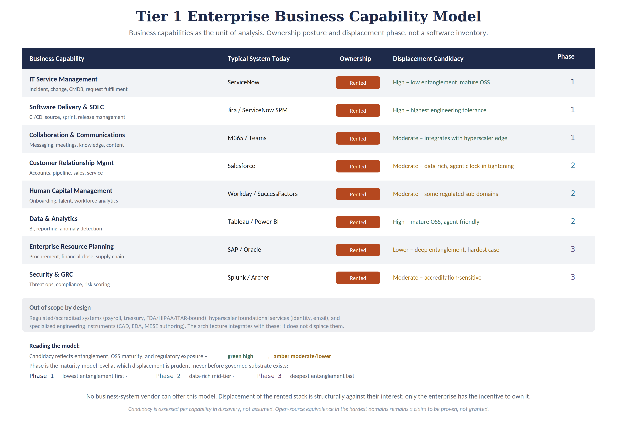
Figure 4. The Tier 1 business capability model. Capabilities are assessed for ownership posture and displacement phase. The model is the differentiator; a tool inventory is not.
Read as a model rather than a menu, three things follow. Displacement is sequenced by entanglement, so the lowest-risk capabilities (software delivery, IT service management, collaboration) lead and the deepest (enterprise resource planning, regulated security and compliance) follow only once the discipline is proven. Candidacy is assessed per capability in discovery, not asserted; the open-source equivalence of the hardest domains is a claim to be tested, not granted, and Section 8 keeps it on the risk register. And a clear boundary holds: regulated and accredited systems, hyperscaler foundational services, and specialized engineering instruments are integrated, not displaced. To be unambiguous about the case executives worry about most: nothing here recommends early replacement of the ERP or financial core. Those are discovery-validated candidates at the latest phase only, never a Level 1 or Level 2 move. A credible ownership thesis names its limits, and these are the limits.

5.2 The Posture: Compose First, Displace Selectively, Later
The capability plane is a selective and staged posture, not a wholesale rip-and-replace, and the distinction is the point on which an architecture like this most often becomes incoherent. In the early maturity levels, the architecture composes with the enterprise's existing commercial systems rather than replacing them; those systems remain the systems of record while the new planes add governance, a common runtime, and accountable experience on top. Only later, once a governed substrate is in place, does the enterprise begin to selectively displace specific capabilities where the case genuinely closes.
Wholesale replacement of the business stack as an early move would be both unnecessary and dangerous: unnecessary because the governance and experience value of the early levels does not require it, and dangerous because displacing business-critical systems before the governed substrate exists to receive them inverts the risk gradient the maturity model is designed to respect. The capability plane is the last mile of a long road, deliberately. Its strategic value is real and structural; its execution is the most demanding work in the architecture, which is exactly why it comes after the control, runtime, and experience planes are mature, not before.

6. The Operating Model and Platform Teams
Committing to this architecture is not only committing to a set of platforms. It is committing to the organization that builds and runs them. A technology executive's hardest question is rarely “is the architecture sound?” It is “who owns what, where do the boundaries sit, and how much scarce senior talent does this cost me?” This section answers that.
The four planes imply four platform teams, but they cannot be four equal, independent organizations, or the enterprise simply rebuilds the silos the architecture exists to defeat. The teams have deliberately different shapes, and one relationship holds them together. The figure below shows both.
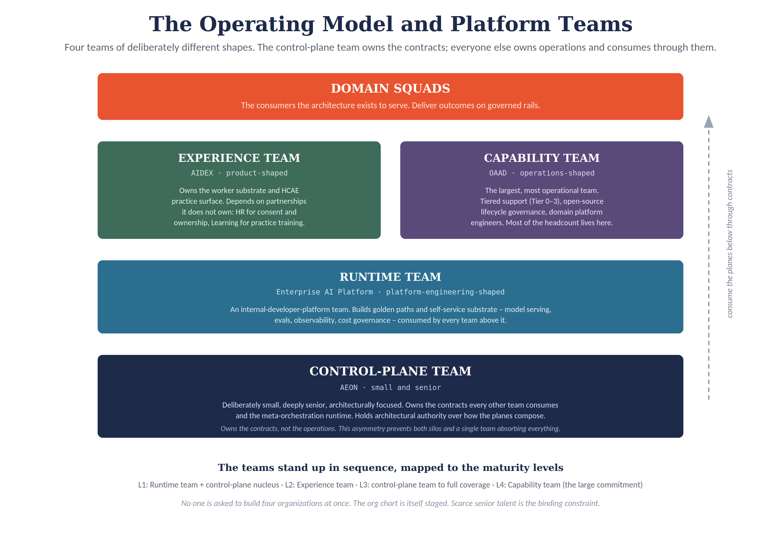
Figure 3. The platform teams. Their shapes differ by design, and the control-plane team owns the contracts the others consume. The teams also stand up in sequence, mapped to the maturity levels.

6.1 The Shift in the Work Itself
Before the teams make sense, the change in the work they do has to be named, because it is a change in kind rather than degree. For three decades the defining work of Enterprise IT was the management and integration of vendor products. The unit of work was the vendor relationship and the integration seam: select a commercial product, negotiate and manage the relationship, configure the product to the enterprise's processes, and build and maintain the connections between products. The core skill was procurement, configuration, and integration engineering. The artifact the organization produced was a working, connected estate of systems other parties had built. In that model Enterprise IT is the assembler and operator of rented capability; the intelligence lives in the vendor's product, and IT arranges and sustains it.
The agentic era moves the center of gravity of that work. The new unit is the AI-enabled system platform across its full lifecycle, and the decisive word is full. Under the commercial model the enterprise owned only a truncated lifecycle, select, configure, integrate, operate, patch, while the vendor carried the design, the hard engineering, the security accreditation, the roadmap, and the eventual sunset. The new operating model reabsorbs the lifecycle the vendor used to carry. The enterprise composes the substrate from open source, models, and the agentic layer that makes that substrate viable at scale, and then owns it through design, governance, deployment, evaluation, observability, continuous improvement, and retirement. The core skill shifts from procurement and integration to platform engineering, governance expressed as code, lifecycle operations, and the disciplined curation of agentic capability. The artifact is no longer a connected estate of rented products but a set of owned, governed, evolving platforms that encode the enterprise's own institutional practice.
Three things move together, which is what makes this a change in the organization's identity and not merely its task list. The unit of work moves from the vendor seam to the owned platform. The core skill moves from integrating what others built to engineering and governing what the enterprise builds. And the institutional intelligence the work produces changes hands, accruing to the enterprise rather than to the vendor's schema. This is the organizational form of the ownership argument the rest of the paper makes: the four planes are what the enterprise owns, the maturity model is how it gets there, and this shift is who Enterprise IT has to become for any of it to hold.
The shift is a change of center of gravity, not a total replacement, and the paper is careful on this point. The enterprise will continue to manage some commercial systems and to build integrations; the capability model in Section 5 keeps regulated cores, hyperscaler foundational services, and specialized instruments vendor-supplied by design. What changes is which work defines the organization. Vendor management and integration become supporting activities rather than the center; platform lifecycle ownership becomes the defining one. The teams described next are the organizational expression of that defining work.

6.2 Four Teams of Different Shapes
The control-plane team is small and deeply senior. It owns the contracts every other team consumes and the runtime that coordinates composition, and it holds architectural authority over how the planes fit together. It deliberately does not run the other planes' operations. Its value is judgment and coherence, not headcount; a small team of the right seniority produces more than a large team without control-plane experience.
The runtime team is shaped like a platform-engineering or internal-developer-platform team. It builds and operates the AI substrate as self-service golden paths consumed by everyone above it. Its discipline is reliability, developer experience, and cost governance.
The experience team is shaped more like a product team than an infrastructure team. It owns the worker-facing substrate and the human-curated practice surface. Distinctively, its success depends on partnerships it does not own: human resources, for the worker-ownership and consent commitments that accountable knowledge work requires, and the learning function, for the practice training that teaches workers how to curate rather than defer. The technology executive has to broker those partnerships; the team cannot manufacture them alone.
The capability team is the largest and most operational. It runs the open-source business systems, the tiered support model that answers the “who do I call when it breaks at two in the morning” question, the open-source lifecycle governance (patching, supply-chain compliance, upgrade choreography), and the domain platform engineers who own each system. Most of the architecture's headcount lives here, which is one more reason this plane matures last.

6.3 The Relationship That Holds Them Together
The pattern that prevents both failure modes (independent silos that do not compose, and a single team that absorbs everything and cannot be staffed) is an asymmetry: the control-plane team owns the contracts; every other team owns its own operations and consumes the planes below it through those contracts. Control governs composition. Runtime supplies the substrate. Experience and capability are consumers that compose under control. Domain squads consume all of it. When a contract decision is required, the control-plane team decides; when an operational decision within a plane is required, that plane's team decides. Neither overrides the other within the other's scope. This asymmetry is the organizational expression of the architectural separation, and it depends on genuine institutional backing for the control-plane team's authority, or the contracts are unenforceable.

6.4 The Teams Stand Up in Sequence
The enterprise is not asked to build four organizations at once. The org chart is itself staged, mapped to the maturity levels. Level 1 requires the runtime team and a small control-plane nucleus that owns the minimal primitives. Level 2 adds the experience team. Level 3 grows the control-plane team to full plane coverage. Level 4 stands up the capability organization, which is the large headcount commitment, deliberately last. This staging is what makes the talent demand survivable: the enterprise hires the first team and a sequence, not a standing army on day one.
Scarce senior talent is the binding constraint across all of this, and the paper does not pretend otherwise. The disciplines the control-plane and runtime teams require (identity engineering, policy-as-code, evidence engineering for agentic action, composition architecture) are scarce and expensive, and they often have to be recruited from outside the enterprise's current technology function. The staging mitigates the constraint by spreading the demand across years; it does not eliminate it. An enterprise that cannot recruit and retain this talent should weigh that honestly before committing, as Section 7 sets out.

7. Institutional Preconditions and Honest Costs
This architecture is not appropriate for every enterprise. It presumes institutional conditions that some organizations have, some can develop, and some neither have nor will. A technology executive should test the enterprise against these before committing, because partial commitment produces a partial architecture, which is worse than a deliberate decision to govern agentic capability some other way.
- A consolidated identity infrastructure. The control plane federates identity across the enterprise, but it can mediate a few authoritative identity sources, not dozens. An enterprise whose identity is fragmented across many uncoordinated systems has to consolidate before this architecture is tractable.
- Willingness to express policy as code. The control plane evaluates authority as executable policy at the moment of action. An enterprise whose policy lives entirely in documents and human review has to build the capacity to author policy jointly across legal, compliance, and technology functions in an executable form. This is a substantial program in its own right, and the willingness to undertake it is a precondition.
- A central architecture function with real authority. The control-plane team's contracts bind the other teams. An enterprise whose architecture function is purely advisory cannot enforce them. The function needs genuine authority over how the planes compose, backed by senior leadership.
- Tolerance for a multi-year horizon. This is a multi-year program before it reaches full maturity. An enterprise whose investment discipline cannot sustain a multi-year effort through budget cycles and leadership changes will abandon it partway, which is the worst outcome of all.
- The ability to recruit and retain scarce senior talent. As Section 6 sets out, the binding constraint is people. An enterprise that cannot assemble and sustain the teams, whether for reasons of compensation, location, or clearance, cannot staff the architecture.
These preconditions are an honest filter, not a sales obstacle. An enterprise that has them, or has a credible plan to develop them, is a candidate. An enterprise that lacks them and will not develop them should govern its agentic adoption through a less ambitious approach and accept the limitations, rather than committing to an architecture it cannot sustain. Stating this plainly is what makes the rest of the paper credible: the recommendation is conditional, and the conditions are real.
Where this architecture is, and is not, appropriate
Build and own when: the enterprise operates classified or mission systems; or is subject to regimes requiring first-party auditability of all agentic operations; or has sovereignty exposure that makes vendor governance over its own operations unacceptable; and can meet the five preconditions above.
Rent instead when: the enterprise has low regulatory and sovereignty exposure, values time-to-first-capability over ownership, or cannot sustain the multi-year horizon and senior-talent commitment. A vendor control plane is then the rational choice.
Either way: do not pass through a stage of ungoverned agentic capability. The minimal accountability primitives belong in place before agents act, whoever owns the platform underneath.

On cost, the honest framing is not that this architecture is cheaper than buying a vendor platform. It is that it trades recurring vendor licensing for owned platform-engineering capacity and a compounding institutional-intelligence asset. The vendor platform wins on time-to-first-capability and lower initial cost. This architecture wins on governability, on strategic optionality (the ability to replace any component without rebuilding the whole), and on where the institutional intelligence accrues. An enterprise should run that comparison with its own figures rather than accept a generic number from anyone, including this paper. The directional targets sometimes quoted for open-source displacement (large license reductions, multiplied delivery velocity) are exactly that, directional, and they require a genuine baseline before they mean anything. The discovery work that produces that baseline is part of the decision in Section 9.

8. The Live Risks
A strategy document that hides its weak points does its reader a disservice. Four risks are live, and a technology executive should weigh them with eyes open.
The open-source-equivalence claim is the softest link. It is true that mature open-source alternatives exist for nearly every commercial business-system domain. It is not yet demonstrated that they are enterprise-equivalent under real load, across the hardest domains, in every enterprise. The claim is strong for the lower-entanglement domains (software delivery, IT service management, collaboration) and weaker for the most demanding ones (enterprise resource planning and finance at scale). The maturity model mitigates this by placing capability transformation last and making it selective, but the executive should treat per-domain equivalence as something to be proven in discovery, not assumed.
The institutional-intelligence “moat” deserves the same scrutiny as the vendor critique. The argument that owned, accumulated workflow intelligence compounds into competitive advantage is genuinely strong against the vendor model, where that intelligence accrues to someone else. But whether the enterprise's own accumulated intelligence is a defensible moat, as opposed to a switching cost it has imposed on itself or a maintenance liability it now carries, warrants honest examination. The ownership argument is sound; the moat language should be held to the same standard of evidence as everything else.
The cost of four-plane separation is real and recurring. The separation that gives the architecture its strategic value also internalizes integration and operating work a vendor would otherwise absorb. This is a standing cost, not a one-time one, and it is the price of ownership and governability. An enterprise that wants those properties should pay it knowingly; an enterprise that does not value them highly should not.
Level 3 is the likely funding-stall point. The full control plane's value is governance certifiability and forensic capability, which are insurance against risks that have not yet materialized rather than productivity gains that show up on a chart. A pilot cannot demonstrate them in the way it can demonstrate onboarding compression at Level 2. The executive should anticipate that Level 3 will be the hardest level to fund and pre-arm its case accordingly: by entering the dependency of agentic governance on the control plane into the enterprise risk register, so that declining to fund it becomes an explicit, signed risk acceptance rather than a quiet reallocation, and by reporting the governance outcomes the control plane does produce (the time it takes to investigate an incident, the ability to certify compliance under agentic operation) on a regular cadence so the value is visible rather than invisible.
None of these risks is disqualifying. Each is a reason to proceed deliberately, to stage the commitment, and to keep the falsifiable claims under genuine test rather than assertion. That posture, holding the architecture's own claims to the standard it would apply to anyone else's, is what makes it trustworthy.

9. The Decision
The decision now is whether to fund a Level 1 governed runtime plus control-plane primitives and a short discovery. It is not whether to commit to the full four-plane transformation. Everything above Level 1 is a later decision, made with better information, and nothing in the near-term ask presumes it. The architecture is mature enough to commit to, the maturity model is sequenced enough to begin, and the first step is small enough to fund without betting the enterprise on the destination.
What is being committed now:
- Fund Level 1: the governed runtime foundation. Stand up the AI substrate (serving, routing, retrieval, evaluation, observability, cost governance) bundled with the control-plane primitives (identity, authority, minimal evidence). Concretely, this funds the runtime team and a small, senior control-plane nucleus. Target outcome: within six to twelve months, a set of governed agentic deployments in which every action carries a complete identity-and-evidence chain, with unit cost per request and model-reuse rate instrumented from the start.
- Authorize a focused discovery. Commission a short, disciplined discovery (on the order of weeks, not quarters) to produce the figures the full business case requires: current business-system spend by domain, a platform-engineering headcount model, migration cost estimates for the candidate domains, and the break-even horizon. This replaces directional targets with the enterprise's own numbers before anything beyond Level 1 is decided.
- Architect governance before capability. Establish the identity, authority, and evidence primitives and the contract model between platform teams before any agent acts in production. Treat governance as architecture to be designed, not policy to be written after the fact. This is the commitment that distinguishes this path from the accidental composition the architecture exists to prevent.
What is being pre-committed for later, contingent on the discovery and on Level 1 results:
- The institutional function and the multi-year horizon. Levels 2 and above require the central architecture function with real authority, the multi-year investment tolerance, and the senior talent set out in Section 7. The near-term decision is to test that commitment honestly in discovery, not to make it in full today. An enterprise that finds it cannot meet those preconditions should stop at the value Level 1 delivers rather than proceed and abandon the program partway, which is the one outcome to avoid.
The agentic era is arriving on its own timeline regardless of what any enterprise decides. The question is whether the enterprise meets it with an architecture that lets it govern what it adopts, or without one. This paper has argued for the deliberate, staged, enterprise-owned answer, and has tried to be as honest about its costs and risks as about its value. The first step is modest and self-justifying. The sequence after it is clear and conditional. The decision is whether to begin.

Companion Specifications
This paper is the umbrella. Each plane has, or will have, a fuller specification at implementer altitude. The table maps the companion works to their planes and to the maturity level at which each becomes primary; the reader deciding whether to proceed needs only this document, while the reader who has decided will find the depth in the companions.
Companion work | Plane | Primary at level | Status
AEON | Control | Level 1 (primitives), Level 3 (full) | Available
Enterprise AI Platform | Runtime | Level 1 | To be written; scope here
AIDEX | Experience | Level 2 | Available
OAAD | Capability | Level 4 | Available (brief)
Domain Delivery Playbook | (consumes all) | Level 5 | To be written
The detail behind each follows.
- Control plane (AEON). The full specification of the enterprise control plane: its identity, authority, evidence, integration, and capability-composition planes, its operating model, and its deployment across classification environments. Available as a companion paper.
- Runtime plane (Enterprise AI Platform). The substrate specification: model serving and routing, retrieval, evaluation, observability, and cost governance. Because the runtime is the Level 1 funding target, its minimum viable scope is defined in Section 4 of this paper; the full specification is to be written.
- Experience plane (AIDEX). The full specification of the worker-facing layer: the Human-Curated, AI-Enabled framework, the modularity model, knowledge continuity, and the deployment topology. Available as a companion paper.
- Capability plane (OAAD). The full strategy for open-source business-capability transformation: the open-source stack, the agentic fabric, the operating and lifecycle governance model, and the displacement roadmap. Available as a companion brief.
- Domain delivery playbook. The federated execution model by which domain squads consume all four planes to deliver outcomes. To be written.
Draft for discussion. Comments and challenges welcome.

Google Cloud, “Introducing Gemini Enterprise Agent Platform” and “Welcome to Google Cloud Next ’26,” Google Cloud Blog, April 2026. Google describes Agent Identity as assigning each agent a unique cryptographic ID for traceability and auditing, and Agent Platform as providing “a single control plane for governance.” Primary source (vendor announcement).
SAP, “SAP Unveils the Autonomous Enterprise,” SAP News Center, May 2026; CTO Philipp Herzig describes the Business AI Platform as three layers — context, build, and governance — with the SAP AI Agent Hub (on LeanIX) governing SAP and non-SAP agents. Primary source (vendor announcement).
Bain & Company, “Google Cloud Next 2026: The Agentic Enterprise Control Plane Comes into View,” April 2026. Bain frames the buyer’s decision as an operating-model choice rather than a tooling choice. Secondary source (analyst commentary).
C. Klein (SAP CEO), Q1 2026 investor call, as reported by The Register, “AI clause in new SAP API policy provokes lock-in concern,” 29 April 2026: SAP reserves the right to throttle “millions of calls coming towards an API” and describes its domain knowledge as “a great asset to protect.” Primary statement reported in secondary source.
Forrester, “SAP Is Attempting To Become The Gatekeeper Of Enterprise AI — CIOs Should Push Back,” May 2026: third-party AI agents reach SAP data only through SAP-mediated Joule agents under the A2A protocol. Note: reporting indicates Salesforce and ServiceNow have not imposed equivalent hard API restrictions, steering via their intelligence layers instead; the explicit-perimeter move is specific to SAP. Secondary source (analyst).
Source-validation note: the market claims in this section were checked against primary vendor announcements and tier-one analyst reporting in May 2026. They establish that the control-plane problem is now industry consensus; they do not establish that enterprise ownership of the control plane is consensus. URLs should be re-verified before external distribution, as this snapshot will date.

