Human-Curated, AI-Enabled:
A Framework for Reliable AI Deployment
James (JD) Longmire
Northrop Grumman Fellow (unaffiliated research)
ORCID: 0009-0009-1383-7698
jdlongmire@outlook.com
Developed under the ECAE (Expert-Curated, AI-Enabled) model described in this framework, with derivational contributions from Claude. Origination, judgment, and final authority on truth and validity remain with the human author.

Abstract
Enterprise AI projects fail at rates between 70% and 95%. The dominant response—more data, larger models, better retrieval—addresses the wrong problem. These are grounding-axis failures misdiagnosed as infrastructure problems. AI systems lack access to the purposes they serve and the wholes their outputs enter. Scaling cannot fix what scaling did not break.
The Human-Curated, AI-Enabled (HCAE) framework provides a design discipline for reliable deployment. Four tiers supply the grounding AI structurally lacks: User-Curated (UCAE) for low-stakes ideation, Professional-Curated (PCAE) for routine domain work, Expert-Curated (ECAE) for high-stakes analysis, and Synthesis-Curated (SCAE) for formally verifiable domains. The framework is a decision tool, not a maturity model; the goal is matching tier to task, not maximizing tier. Building on the AI Dunning-Kruger (AIDK) framework, this paper operationalizes structural epistemic limitations into deployment guidance, addressing hybrid deployments, tier transitions, and the three-axis model explaining why horizontal and vertical solutions alone cannot resolve reliability problems.
Keywords: artificial intelligence, large language models, deployment architecture, AI governance, HCAE framework, formal verification, epistemic grounding, enterprise AI

1. Introduction
The promise of enterprise AI has not matched the reality. Organizations invest billions in generative AI initiatives. The vast majority fail to deliver measurable value.
MIT's Project NANDA reports that 95% of enterprise AI pilots produce no measurable P&L impact (MIT Project NANDA, 2025). Gartner predicts that 30% of generative AI projects will be abandoned after proof of concept by the end of 2025, with over 40% of agentic AI projects canceled by 2027 due to escalating costs, unclear business value, or inadequate risk controls (Gartner, 2024, 2025). These are not isolated findings. Multiple independent sources consistently report failure rates between 70% and 95% across enterprise AI initiatives.
The standard diagnosis points to execution failures: poor data quality, mismatched expectations, governance gaps, insufficient training. The standard prescription follows: fix the data, manage expectations, strengthen governance, train users. These interventions operate on what this paper calls the horizontal axis. They concern getting the right information to the right place efficiently. They are legitimate engineering work. They are also insufficient.
This paper proposes an alternative diagnosis. Enterprise AI fails because organizations face grounding-axis problems and respond with horizontal-axis solutions. AI systems lack access to the purposes they serve (teleological blindness) and the wholes their outputs enter (mereological blindness). No amount of data, compute, or architectural refinement addresses this structural deficit. The solution space and the problem space do not intersect.
The Human-Curated, AI-Enabled (HCAE) framework provides a design discipline for addressing grounding-axis problems. It specifies deployment architectures that supply the grounding AI systems structurally lack, matching the level of human epistemic authority to the demands of the task.
The framework is a decision tool, not a maturity model. Higher tiers are not universally better. They are appropriate for different task profiles. The goal is matching deployment architecture to task requirements, not maximizing tier. UCAE is the right answer for brainstorming. PCAE is the right answer for routine professional work with genuine review. ECAE is the right answer for high-stakes analysis where formal specification is unavailable. SCAE is the right answer for formalizable domains where correctness is non-negotiable. Attempting the wrong tier for a given task produces either waste (over-deployment) or failure (under-deployment).
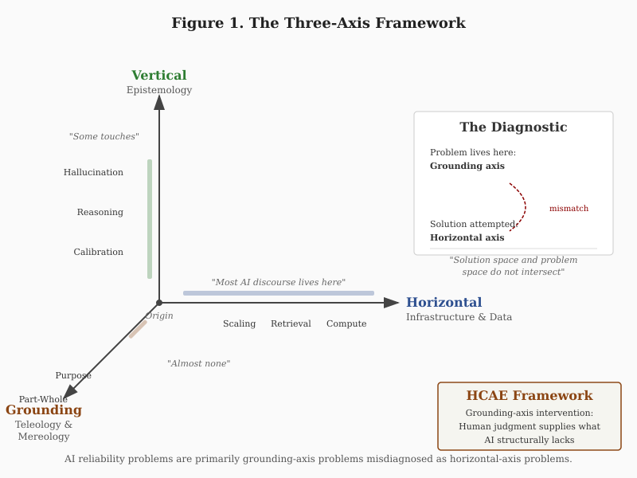
Figure 1. The Three-Axis Framework
The paper proceeds as follows. Section 2 establishes the theoretical foundations: the structural inevitability of hallucination, the incentive structures that perpetuate it, and the AIDK/IDKE constructs that explain how AI limitations interact with human limitations. Section 3 develops the four-tier HCAE framework, including hybrid deployments and tier transitions. Section 4 examines SCAE as the emerging frontier for high-assurance AI, including strengthening mechanisms for ECAE when SCAE is unavailable and worked examples of SCAE in practice. Section 5 integrates the framework with the three-axis model that explains why horizontal and vertical solutions alone are insufficient. Section 6 addresses the matching problem: how to select the appropriate tier for a given deployment. Section 7 discusses economic and regulatory implications. Section 8 concludes.

2. Theoretical Foundations

2.1 The Structural Inevitability of Hallucination
Large language models hallucinate. They produce confident, fluent, false outputs. This is not a bug awaiting correction but a structural feature of the architecture.
Xu, Jain, and Kankanhalli (2024) prove this formally. Using computability theory, they demonstrate that hallucination is inevitable for any computable LLM used as a general problem solver. The diagonalization argument establishes a lower bound: for any LLM, there exist queries on which it must either hallucinate or refuse to answer. This is not a limitation of current models awaiting architectural innovation. It is a mathematical constraint on the class of systems.
Banerjee, Agarwal, and Singla (2024) extend this analysis using Gödel's incompleteness theorem and undecidability arguments. They demonstrate that LLMs face fundamental trade-offs among truthfulness, information conservation, knowledge revelation, and coherence. No training regime, however sophisticated, can eliminate hallucination without sacrificing other desiderata. The authors' conclusion is stark: we must learn to live with hallucination rather than expecting to eliminate it.
These proofs establish that hallucination is not a temporary deficiency but a permanent feature. Scaling does not resolve it. Better data does not resolve it. Architectural refinement may reduce hallucination rates in specific domains but cannot eliminate the structural vulnerability. Any deployment strategy that assumes hallucination will be solved is building on false premises.

2.2 Incentive-Driven Persistence
Beyond structural inevitability, current training regimes actively incentivize hallucination.
Kalai, Nachum, Vempala, and Zhang (2025) analyze why language models hallucinate from an incentive perspective. Next-token prediction rewards fluent continuation regardless of truth value. Accuracy-only evaluations reward guessing over hedging. Reinforcement learning from human feedback (RLHF) amplifies fluency because human evaluators reward confident, well-structured responses even when those responses are wrong.
The training signal says: produce outputs that sound knowledgeable. The training signal does not say: produce outputs that are true. When these objectives conflict, the system optimizes for the former. A system trained to sound knowledgeable will, when it lacks knowledge, produce outputs that sound knowledgeable anyway. This is not malfunction. This is the system doing what it was trained to do.
The implication for deployment is direct. We cannot rely on the system to signal its own uncertainty accurately. Confidence is a learned behavior pattern, not a reliability indicator. Fluent outputs may be correct or incorrect with equal probability from the system's perspective. External verification is not optional. It is the only mechanism for distinguishing reliable from unreliable outputs.

2.3 The AI Dunning-Kruger Effect
The structural epistemic limitations of large language models have been formalized as the AI Dunning-Kruger effect (AIDK) in prior work (Longmire, 2026a).
AIDK is the condition in which AI systems produce outputs with uniform confidence regardless of actual reliability, lack mechanisms for detecting their own competence boundaries, and cannot self-correct through encounter with reality. Unlike human Dunning-Kruger effects, which are developmental and correctable through feedback, AIDK is architectural and permanent. The system has no access to truth conditions against which to calibrate.
The critical distinction is trajectory. Human overconfidence is a stage in a developmental process that reality can correct. The novice encounters failure, receives feedback, revises beliefs, and gradually calibrates confidence toward warrant. AI overconfidence is a permanent condition arising from categorical separation from reality. The model operates entirely within a derived symbolic space with no feedback loop to the world itself.
Calibration studies confirm this pattern. Kadavath et al. (2022) found that language models can be calibrated on multiple-choice tasks but this calibration does not transfer reliably to open-ended generation. The system expresses high confidence on queries it answers incorrectly at rates indistinguishable from queries it answers correctly. Confidence is not a reliability signal.

2.4 The Interactive Dunning-Kruger Effect
AIDK does not exist in isolation. When AI systems with structural epistemic limitations interact with humans who have their own epistemic limitations, an emergent phenomenon arises: the Interactive Dunning-Kruger Effect (IDKE) (Longmire, 2026a).
IDKE is the amplification of human epistemic overconfidence through interaction with AI systems that cannot assess their own reliability, resulting in confidence inflation untethered from warrant in both parties to the interaction.
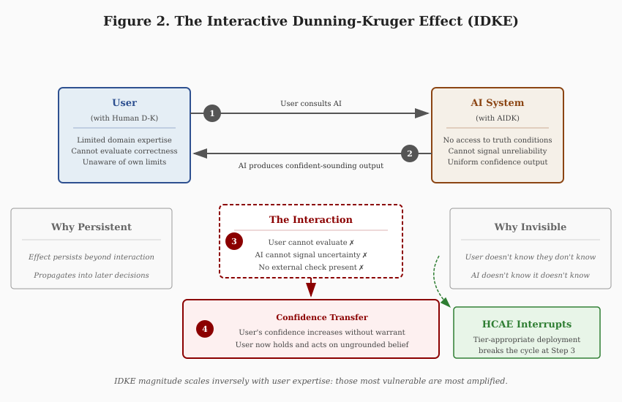
Figure 2. The Interactive Dunning-Kruger Effect (IDKE)
The mechanism operates through a predictable sequence. A user with limited domain expertise consults an AI system exhibiting AIDK. The AI produces confident-sounding output. The user cannot evaluate correctness. The AI cannot signal unreliability. The user's confidence increases without warrant. The user now holds and acts on ungrounded confidence.
Research on AI-assisted decision-making documents this pattern. Buçinca, Malaya, and Gajos (2021) found that people overrely on AI suggestions even when those suggestions are wrong, and that explanations do not reduce this overreliance and may increase it. Dell'Acqua et al. (2023) demonstrated a "jagged technological frontier" where AI creates a 19 percentage point performance drop when used outside its capability boundary. Consultants who blindly adopted AI output performed worse than those who maintained critical distance.
IDKE magnitude scales inversely with user expertise. Users with high domain expertise catch errors; AIDK effects are bounded by their judgment. Users with low domain expertise cannot evaluate outputs; AIDK fills the epistemic void and amplification is maximal. The people most vulnerable to epistemic overconfidence are most amplified by AI interaction.
The effect is invisible while occurring. Neither participant can detect IDKE in real time. The user does not know they do not know. The AI does not know it does not know. The confidence persists beyond the interaction and propagates into subsequent decisions.

2.5 From Diagnosis to Design
The AIDK framework establishes the structural diagnosis. The question for deployment is: what follows?
If AIDK is architectural rather than contingent, scaling cannot resolve it. If IDKE emerges from the interaction of AI and human limitations, deployment architecture must address both sides. If confidence transfer is invisible to participants, external structure must compensate for what internal awareness cannot provide.
The Human-Curated, AI-Enabled (HCAE) framework operationalizes these implications. It specifies deployment architectures that supply the epistemic grounding AI systems structurally lack, matching the level of human epistemic authority to the demands of the task.
The framework does not depend on AIDK and IDKE being precisely correct in every detail. It rests on the more basic claim that AI systems lack epistemic grounding and that human judgment must supply it. AIDK and IDKE elaborate why this matters and predict how failures manifest. If the constructs require revision in light of empirical findings, the framework's core logic remains intact.

3. The HCAE Framework
The Human-Curated, AI-Enabled (HCAE) framework stratifies AI deployment by the epistemic authority responsible for validating outputs. It rejects the undifferentiated notion of "human-in-the-loop" by recognizing that not all humans are capable of evaluating truth claims in all domains. The framework specifies who supplies grounding, what form that grounding takes, and how grounding adequacy must match task requirements.
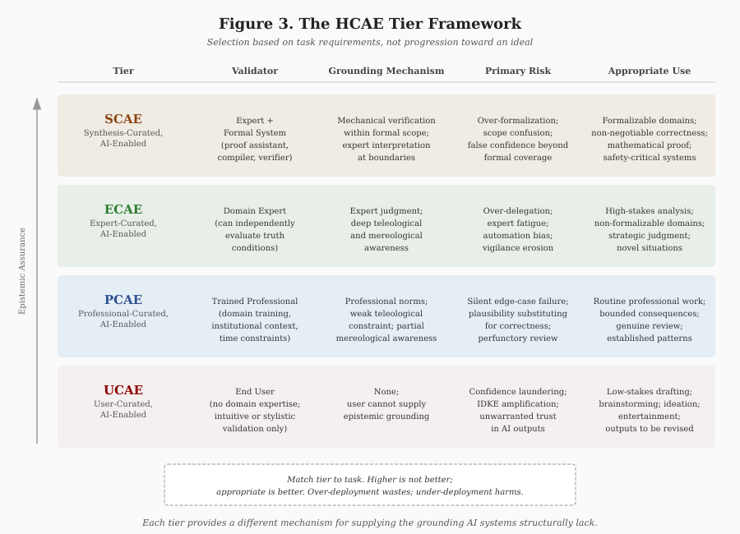
Figure 3. The HCAE Tier Framework

3.1 UCAE: User-Curated, AI-Enabled
At the lowest tier, the end user provides prompts and consumes outputs without possessing the domain expertise required to independently assess correctness.
Grounding mechanism: None. The user cannot supply epistemic grounding because they lack the expertise to evaluate whether outputs correspond to reality in the relevant domain.
Appropriate use: Low-stakes drafting, brainstorming, ideation, entertainment, early exploration. Contexts where being wrong is cheap and outputs will be substantially revised or discarded.
Primary risk: Confidence laundering. The user treats AI-generated content as more reliable than their own unaided judgment would produce, when in fact it may be less reliable because the AI's errors are harder to detect than one's own. IDKE is maximal at this tier.

3.2 PCAE: Professional-Curated, AI-Enabled
At the second tier, a trained professional reviews AI output within their field under time, scope, or institutional constraints.
Grounding mechanism: Professional training provides partial grounding. The professional can assess plausibility and catch obvious errors but may miss subtle failures outside their immediate experience or at the edges of their expertise.
Appropriate use: Routine professional work where review is genuine, consequences are bounded, and patterns are well-established. Document drafting, code review, research synthesis within familiar territory.
Primary risk: Silent edge-case failure. The professional's review catches typical errors but misses atypical ones. The failure mode is not obvious wrongness but plausible wrongness—outputs that pass professional inspection but are nonetheless incorrect in ways that matter.

3.3 ECAE: Expert-Curated, AI-Enabled
At the third tier, a domain expert with the capacity to independently evaluate truth conditions curates AI output.
Grounding mechanism: Expert judgment provides strong grounding. The expert can assess not only whether outputs are plausible but whether they are correct. They have the knowledge to catch errors that professionals would miss and the context to evaluate fit with larger purposes.
Appropriate use: High-stakes analysis where formal specification is unavailable or impractical. Strategic judgment, complex negotiations, novel clinical presentations, contested interpretations, any domain where getting it right matters and no formal verification is possible.
Primary risk: Over-delegation and automation bias. Experts are not immune to IDKE. They may defer to AI outputs in areas adjacent to their expertise, rely on AI for speed at the cost of scrutiny, or grow complacent as fluent outputs accumulate without obvious failures.

3.4 SCAE: Synthesis-Curated, AI-Enabled
At the highest tier, expert judgment is combined with a formal validation system such as a proof assistant, compiler, or test harness.
Grounding mechanism: Mechanical verification within formal scope. The formal system enforces constraints that no amount of fluency can bypass. Within the domain of specification, correctness is not a matter of opinion or expertise—it is mechanically verified.
Appropriate use: Domains where formal specification is possible and correctness is non-negotiable. Mathematical proof, safety-critical systems, regulatory compliance with codified rules, any domain where "probably correct" is insufficient.
Primary risk: Scope confusion. Formal verification guarantees correctness within the scope of specification. It does not guarantee that the specification captures what actually matters. The expert role at SCAE is ensuring that formal coverage matches real requirements—that the map corresponds to the territory.

4. SCAE as the Emerging Frontier
The Synthesis-Curated tier represents the highest epistemic assurance currently achievable for AI-assisted work. It combines the generative capacity of AI systems with the mechanical verification of formal systems. This section examines what SCAE requires, how to strengthen ECAE when SCAE is unavailable, and how SCAE operates in practice.
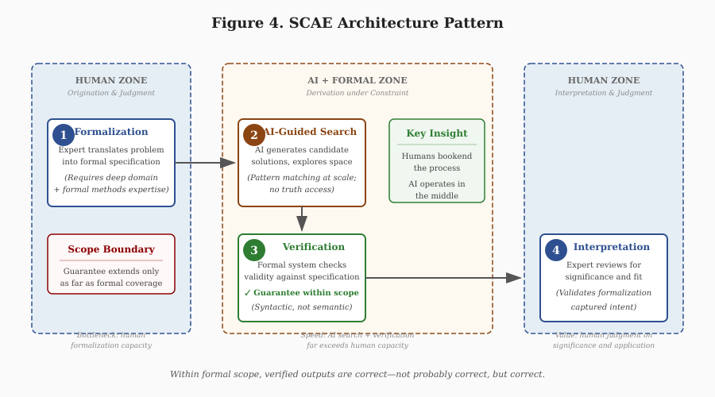
Figure 4. SCAE Architecture Pattern

4.1 The SCAE Architecture
SCAE deploys AI systems under mechanical constraint. The architecture has four components:
Human formalization. Experts translate requirements into formal specifications. This step requires both domain expertise (understanding what matters) and formal methods expertise (expressing it in verifiable terms). Formalization is the bottleneck. It cannot be automated because it requires judgment about what to specify.
AI-guided search. The AI system generates candidate solutions within the space defined by formal constraints. It proposes proofs, code implementations, compliance mappings—whatever the domain requires. The AI's contribution is search speed: exploring solution space faster than humans can.
Mechanical verification. A formal system (proof assistant, compiler, test harness, constraint solver) checks whether candidates satisfy specifications. This check is syntactic, not semantic. The verifier does not understand what the specification means; it confirms that formal derivation rules are satisfied.
Expert interpretation. Experts review verified outputs for significance and fit. A proof can be valid but uninteresting. Code can be correct but unmaintainable. Compliance can be technical but miss the regulation's purpose. The expert assesses whether formal success translates to real success.

5. Theoretical Integration: HCAE and the Three-Axis Framework
The HCAE tiers are not arbitrary categories chosen for convenience. They emerge from a deeper analysis of what makes AI systems reliable or unreliable. This section connects the tiered deployment framework to a three-axis model that distinguishes the dimensions along which AI systems succeed or fail.

5.1 The Three Axes
AI systems can be analyzed along three orthogonal dimensions:
Horizontal axis: Infrastructure and Data. This axis concerns getting the right information to the right place efficiently. Retrieval architecture, context management, scaling, cost optimization, data quality, pipeline reliability. Most current AI discourse operates on this axis. It is legitimate engineering work. It is also insufficient for reliability.
Vertical axis: Epistemology. This axis concerns whether the system reasons well about what it receives. Calibrated confidence, categorical precision, corrected priors, self-auditing capacity. Some AI research touches this axis, particularly work on calibration, hallucination reduction, and reasoning chains. It addresses reasoning quality without addressing grounding.
Grounding axis: Teleology and Mereology. This axis concerns what the system is for and how it relates to larger wholes. Teleology asks: what purpose does this serve? Mereology asks: how do parts relate to wholes? Almost no AI discourse addresses this axis. Yet it is where reliability problems actually live.

5.2 The Grounding Deficit
AI systems suffer from structural grounding deficits on both dimensions of the grounding axis:
Teleological blindness. The system has no representation of purpose. It produces outputs without access to what those outputs are for. It can be told a purpose in a prompt, but it cannot evaluate whether its outputs serve that purpose—it can only pattern-match to what purpose-serving outputs look like in training data.
Mereological blindness. The system has no representation of part-whole relationships. It produces components without access to the wholes those components must serve. A function may be locally correct but break the architecture. An answer may be accurate but miss the question's context. A document section may be well-written but undermine the document's purpose.

5.3 Hybrid Deployments and Tier Transitions
Most real deployments operate across multiple tiers depending on query characteristics. The escalation flow diagram illustrates how queries move through assessment, processing, and potential escalation when triggers are detected.
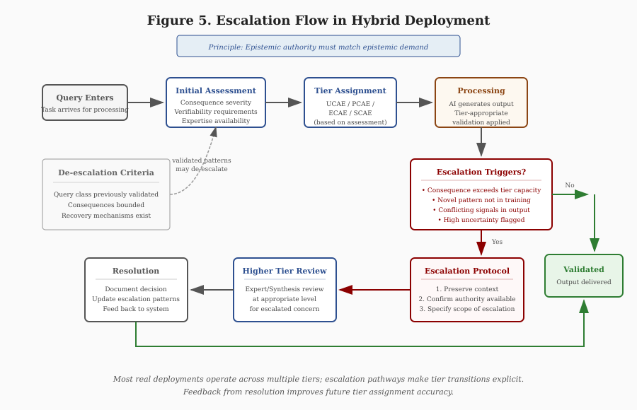
Figure 5. Escalation Flow in Hybrid Deployment
The principle governing tier transitions is simple: epistemic authority must match epistemic demand. When a query exceeds the current tier's capacity—because consequences are higher than anticipated, patterns are novel, outputs conflict, or uncertainty is high—escalation to a higher tier is required.
Escalation is not failure. It is the system working correctly. A deployment architecture that never escalates is either perfectly matched to all queries (unlikely) or failing to detect when escalation is needed (dangerous). Healthy deployments show escalation patterns that correlate with genuine difficulty.

6. The Matching Problem
The central practical question for HCAE deployment is tier selection: given a task, what tier does it require? This section provides structured guidance for the matching problem.

6.1 Assessment Dimensions
Five dimensions determine appropriate tier:
Consequence severity. What happens if the output is wrong? Minimal consequence (embarrassment, minor rework) permits UCAE. Moderate consequence (professional reputation, recoverable financial loss) requires PCAE minimum. Serious consequence (legal liability, significant financial loss, health impacts) requires ECAE minimum. Catastrophic consequence (irreversible harm, safety-critical failure, loss of life) requires SCAE where available; strengthened ECAE where not.
Verifiability. Can correctness be assessed, and by whom? Correctness obvious to any user permits UCAE. Correctness requiring professional training requires PCAE minimum. Correctness requiring deep domain expertise requires ECAE minimum. Correctness mechanically verifiable makes SCAE a candidate.
Expertise availability. Do qualified validators exist and are they available? Tier requirements must match actual organizational capacity. Requiring ECAE when no experts are available produces either process theater (nominal review without substance) or deployment paralysis (work stops awaiting unavailable validation).
Formal specifiability. Can correctness be expressed in terms a verification system can check? If correctness is subjective or context-dependent, SCAE is unavailable. If correctness is objective but not formalizable, SCAE is unavailable. If correctness is formalizable with mature tools, SCAE is a candidate.
Domain change rate. How quickly does the domain evolve? Stable domains with established knowledge support all tiers. Rapidly evolving domains may find formal coverage lagging; ECAE with continuous expert update may be the practical ceiling.

7. Economic and Regulatory Implications

7.1 The Economics of Grounding
HCAE reveals a fundamental economic reality: reliable AI requires human grounding, and human grounding has costs.
UCAE is cheap but unreliable. The cost is minimal, but so is the assurance. UCAE is economically appropriate only where the value at risk is correspondingly low.
PCAE scales with professional labor costs. Professional review adds cost proportional to professional compensation and time required. PCAE is economically appropriate where the value protected exceeds the review cost.
ECAE scales with expert scarcity. Expert review is expensive because experts are scarce. ECAE is economically appropriate for high-value tasks where expert judgment is essential and no formal alternative exists.
SCAE has high fixed costs and low marginal costs. Building formal infrastructure (specifications, tools, expertise) requires substantial investment. Once built, marginal verification is cheap. SCAE is economically appropriate where high-value tasks occur repeatedly within formal coverage.
Organizations that treat AI as a way to eliminate human labor costs misunderstand the technology. AI shifts where human judgment is required (from execution to validation) without eliminating the requirement. The economic benefit comes from amplification (one expert validating many AI-generated outputs) rather than replacement (no expert at all).

7.2 Regulatory Alignment
The HCAE framework aligns naturally with emerging regulatory approaches across multiple domains.
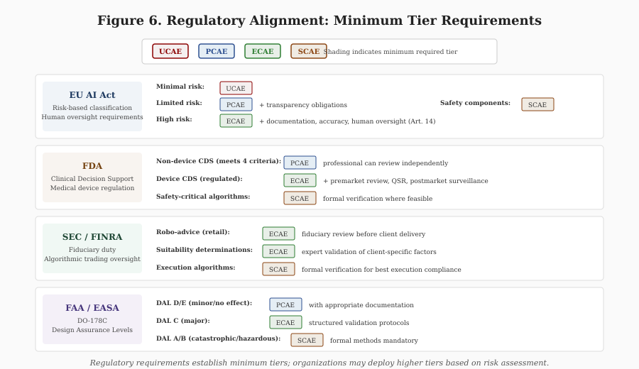
Figure 6. Regulatory Alignment: Minimum Tier Requirements
EU AI Act. The risk-based classification (minimal, limited, high, unacceptable risk) maps to tier-appropriate deployment. High-risk AI systems require documentation, human oversight, and accuracy obligations that ECAE or SCAE would provide. The HCAE framework provides concrete implementation guidance for these requirements.
Sector-specific regulation. Healthcare (FDA), finance (SEC/FINRA), aviation (FAA/EASA), and other regulated domains increasingly require validation of AI outputs. HCAE tiers map to regulatory expectations: PCAE for routine applications with professional oversight, ECAE for clinical decision support with physician review, SCAE for safety-critical systems with formal verification.
Liability frameworks. As AI-related litigation increases, deployment tier becomes relevant to liability assessment. Organizations that deployed at inappropriate tiers (low tier for high-stakes task) face exposure. Organizations that documented appropriate tier selection and validation have defensible positions.
The regulatory landscape is evolving. HCAE provides a framework that anticipates regulatory direction and positions organizations for compliance regardless of specific requirements that emerge.

8. Conclusion
Enterprise AI fails at rates between 70% and 95% because organizations face grounding-axis problems and apply horizontal-axis solutions. AI systems lack access to the purposes they serve and the wholes their outputs enter. Scaling cannot fix this structural deficit. Grounding must be supplied externally.
The HCAE framework provides the design discipline: UCAE for low-stakes ideation, PCAE for routine professional work, ECAE for high-stakes analysis, SCAE for formally verifiable domains. The framework is a toolkit, not a ladder. The goal is fit between tier and task.
The three-axis model explains why alternatives fail. Horizontal solutions (more infrastructure) cannot address grounding problems. Vertical solutions (better reasoning) improve quality without supplying grounding. Only grounding-axis interventions address the structural deficit.
The path forward is design discipline that acknowledges what AI systems are: powerful tools for generation and search that require human grounding. The choice is not between AI and no AI. The choice is between AI deployed with appropriate grounding and the 70-95% failure rates that characterize deployment without it. HCAE shows how to do better.

References
Banerjee, S., Agarwal, A., & Singla, S. (2024). LLMs will always hallucinate, and we need to live with this. arXiv:2409.05746. https://arxiv.org/abs/2409.05746
Buçinca, Z., Malaya, M. B., & Gajos, K. Z. (2021). To trust or to think: Cognitive forcing functions can reduce overreliance on AI in AI-assisted decision-making. Proceedings of the ACM on Human-Computer Interaction, 5(CSCW1), 1-21.
Dell'Acqua, F., McFowland, E., Mollick, E. R., Lifshitz-Assaf, H., Kellogg, K., Rajendran, S., ... & Lakhani, K. R. (2023). Navigating the jagged technological frontier: Field experimental evidence of the effects of AI on knowledge worker productivity and quality. Harvard Business School Working Paper 24-013.
Gartner. (2024). Gartner predicts 30% of generative AI projects will be abandoned after proof of concept by end of 2025. Press release.
Gartner. (2025). Gartner predicts more than 40% of AI-agent projects will be canceled by 2027. Press release.
Hubert, T., et al. (2024). AlphaProof: Formal mathematical reasoning with reinforcement learning. Google DeepMind Technical Report.
Kadavath, S., et al. (2022). Language models (mostly) know what they know. arXiv:2207.05221.
Kalai, A. T., Nachum, O., Vempala, S., & Zhang, C. (2025). Why language models hallucinate: An incentive analysis. arXiv preprint.
Longmire, J. (2026a). AI Dunning-Kruger (AIDK): Structural epistemic limits of large language models. Zenodo. https://doi.org/10.5281/zenodo.18316059
MIT Project NANDA. (2025). Enterprise AI adoption and value realization study. MIT Sloan School of Management.
Xu, Z., Jain, S., & Kankanhalli, M. (2024). Hallucination is inevitable: An innate limitation of large language models. arXiv:2401.11817. https://arxiv.org/abs/2401.11817

