Year 9 Science Common Assessment 2
Term 1
9C1 Periodic Table, 9P1 Electrostatic and Electric Current

Date of Assessment:
Wednesday, 11th November 2026

Description of Assessment:
10 multiple choice questions
35 marks short structured questions and alternative to practical questions

Focus of Assessment:
9C1 Periodic Table
C1.3 Group 1
C1.4 Group 7
C1.5 Group 0
C1.6 Ionic bonds
C1.7 Covalent bonds

9P1 Electrostatic and Electric Current
P1.1 Circuit Symbols
P1.2 Circuits & Current
P1.2 Circuits & Current
P1.4 Voltage
P1.5 Resistance

As science is a hierarchically evolving subject, students are likely to encounter skills from previous studies in science within their assessment. So students are encouraged to address any previously identified gaps in their knowledge as part of their assessment preparation.

Skills being assessed:
- Knowledge with understanding
- Scientific vocabulary
- Handling information and problem-solving
- Experimental skills

Suggested Revision Approaches:

- End of Chapter questions from Learner’s textbook
- Questions from Workbook
- Reflect on notes from lessons in exercise books and Google Classroom - possibly make revision notes/flash cards from these
- Useful websites such as BBC Bitesize for summary notes and little quizzes
- Success criteria printed in your notebook for these chapters

9C1 Periodic Table

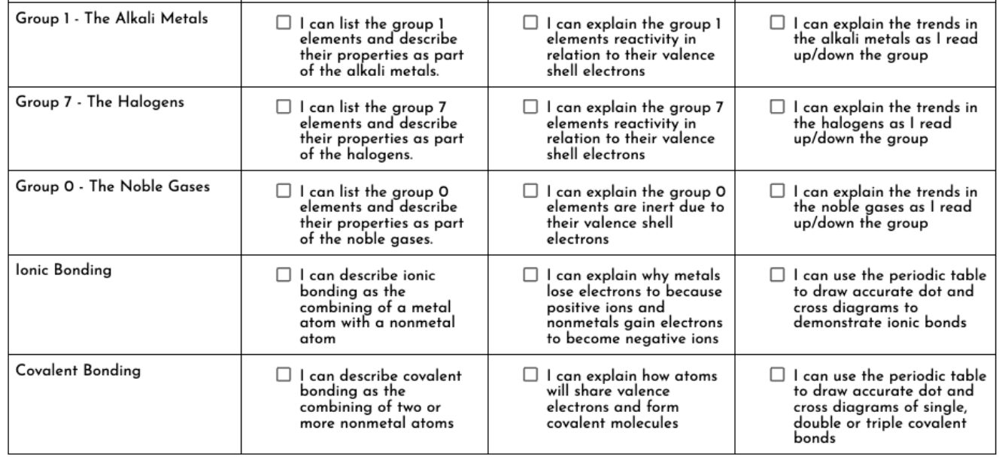

9P1 Electrostatic and Electric Current
