Tutorial 0: Basic Map Editing

Requirements
You will need a mouse that has three buttons and a scroll wheel. Note that the third button is usually accomplished by depressing the scroll wheel.

Starting the editor
For Linux users, run the mapeditor.sh script file, or run the command

./emptyclip -mapeditor

For Windows users, double-click the Empty Clip Mapeditor icon in the Empty Clip folder.

1. Loading a tile set
Tile sets are used to organize map textures and optimize the use of texture memory by only loading the textures a level needs.
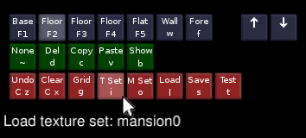

Left-click the Tile Set icon, or hit the i key. Type in mansion0 and hit enter.

2. Loading a monster set
Monster sets are used to organize monsters and optimize the use of texture memory by only loading the monster textures a level needs.
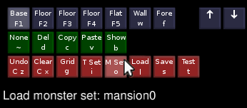

Click the Monster Set icon, or hit the o key. Type in mansion0 and hit enter.

3. Layers
Layers are used to order tile blocks when multiple blocks overlap. There are four layers used for floors, one for flat walls, one for regular walls, and one for foreground textures.
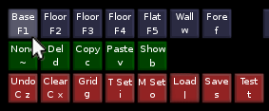

4. Base Blocks
Base blocks are usually the first thing you do when creating a new map. This defines the default floor texture, and has the special property of being able to be overwritten in the depth buffer. (more on this later)
Select the Base layer by hitting F1, or clicking the Base layer icon. Then select a grass texture from the palette by left-clicking one of the icons.
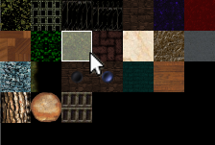

Now lay down a large base block. To do this, zoom out by using the scroll wheel on your mouse to get a better view. Then hold the left mouse button and drag a box in the main map window.
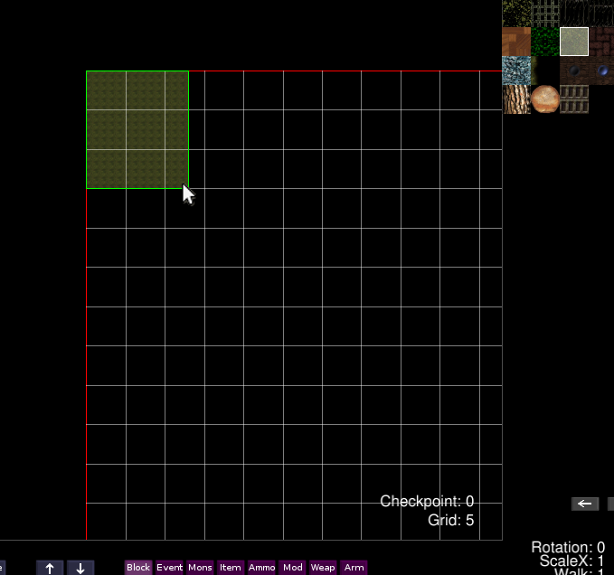

If you make a mistake, you can hit ctrl-z to undo the last block. Alternatively, you can middle-click a block to select it, then hit d, or click the delete icon to remove it.
You can pan the map around by right-clicking an area on the map. You can also pan around while creating a block, so you don't have to zoom out to create large blocks.

5. Second layer floors
Second layer floors are usually reserved for roads and floors inside buildings.
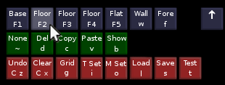

Select the second layer by hitting F2 or clicking the Floor Layer icon pictured above.
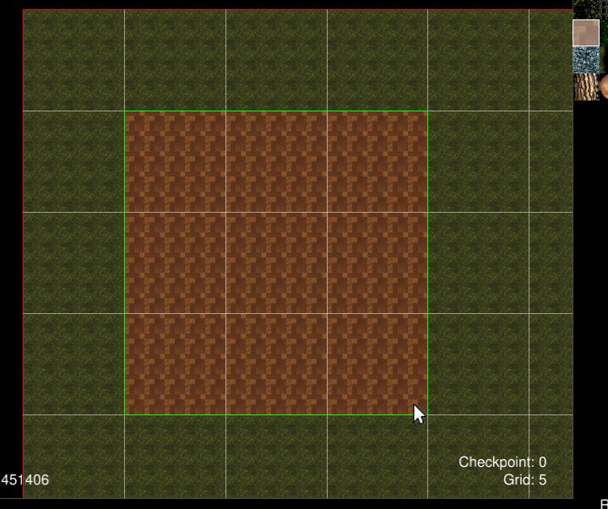
Select a wood texture and create a block as shown below.

6. Walls
Walls are used to create structure and limit vision. You can neither shoot through them nor walk passed them.
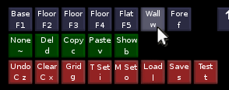

Select the wall layer by hitting W or clicking the Wall Layer icon.
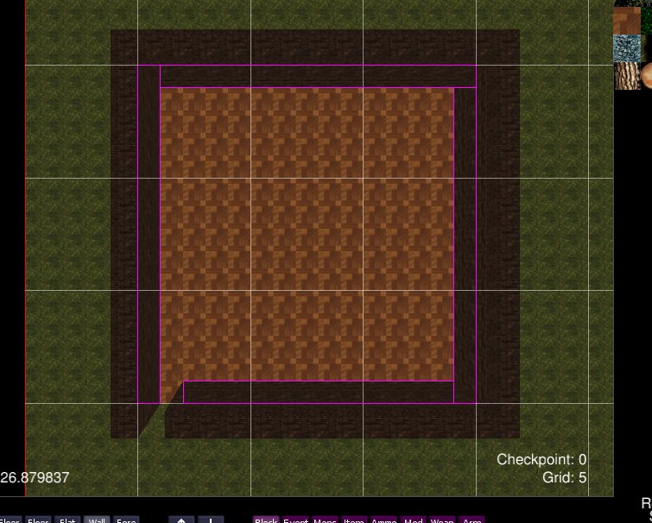
Select a brick texture and create four walls as shown below.

You can enable Highlight Block mode by hitting b or clicking the show icon. This will outline all blocks on the current layer with a purple border. This makes it easier to see where walls and other objects fall on the grid.
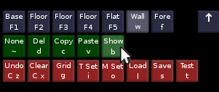

7. Flat Walls
Flat walls are used to create fences, gates, and doors. You can shoot through them, but can't walk passed them.
Select the Flat Layer by hitting F5 or clicking the Flat Wall icon.

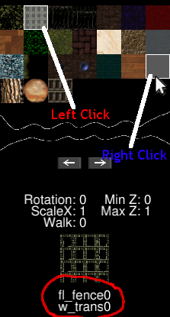
8. Creating a Door

The first thing you need to do is set an alternate texture. Left-click a fence texture. Then right-click the transparent texture. You should see the identifier names of the two textures in the information box.
This tells the game what texture to switch to after the door has been opened.

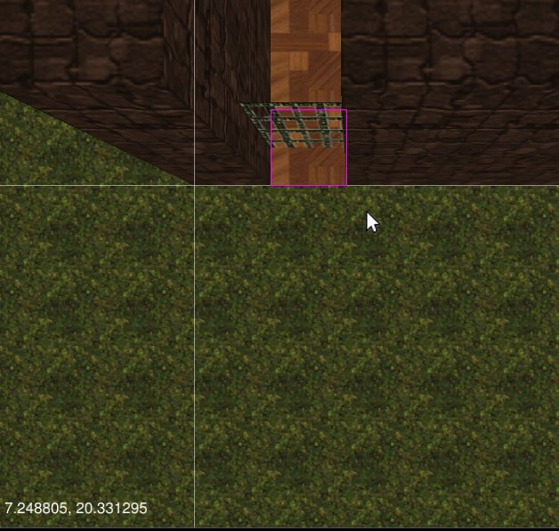

Place a single block in the opening to the house as pictured above.

8. Door events
Door events allow you to toggle the state of doors.
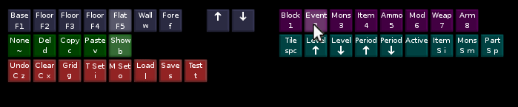
Select event mode by hitting 2 or clicking the Event Mode icon.
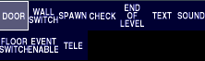

Select the door event from the event palette.
Make sure the Flat Wall layer is selected. Left-click the tile where the flat door is to place the event.
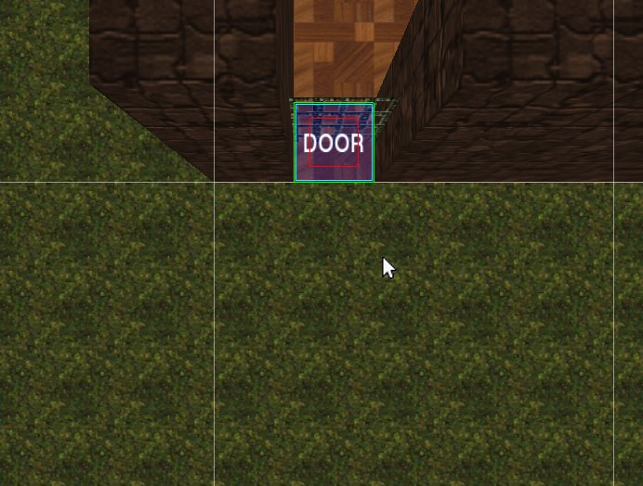

Middle-click the door event pictured above to select it. The editor window should look like this when you're done. The red box shows which tile will get affected and the green outline tells you which block will get a texture change when the door is opened.

9. Checkpoint events
Checkpoints are used to save your character in the game. They also dictate the starting position for the map. Select the checkpoint event from the event palette and place the event near the entrance to the house.
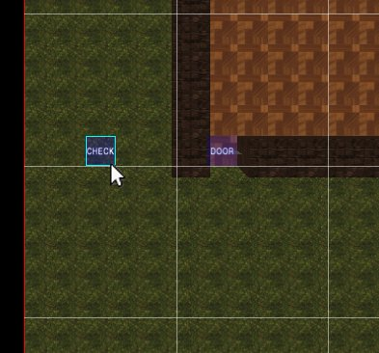

10. Weapons
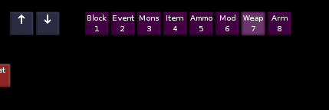

Select weapon mode by hitting 7 or clicking the Weapon Mode icon. Then select a weapon from the weapon palette.
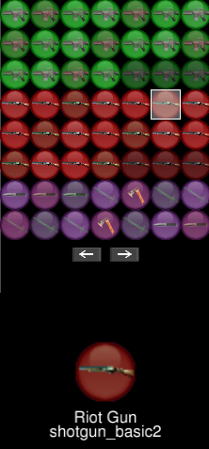
Place the weapon near the starting position.

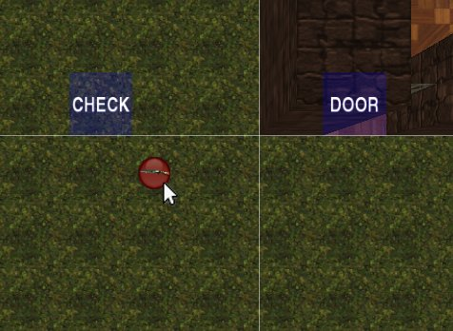
You can hold middle-click on the object to move it around after you've place it down. To delete it, middle-click it to select it, then hit d or click the Delete icon.

10. Items
Select item mode by hitting 4 or clicking the Item Mode icon. Select a medkit from the list and place a few down near the starting position.
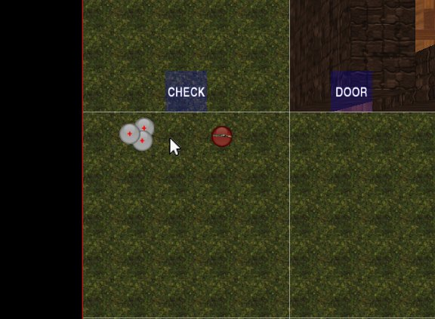

11. Spawn Event
Spawns are used to spawn monsters and treasure chests.
Select event mode again and select the spawn event from the palette.
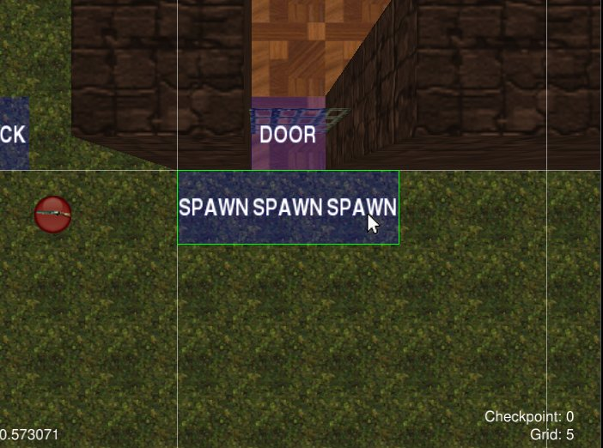
Create a spawn event on the map by holding down the left mouse button and dragging it to create a box.
Middle-click the event on the map window to select it.
The event will be outlined by a cyan border if it's selected.
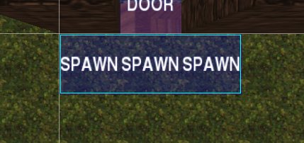

There are two ways to specify what monster to spawn. The first way is to click the Monster Event icon or hit shift+i while the event is selected. You can then type in the identifier for the monster.
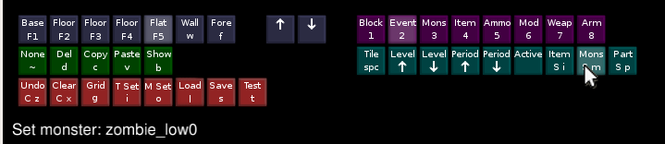
An easier way is to select it from the monster palette. While the event is selected, select Monster Mode by hitting 3 or clicking the Monster Mode icon. Then right-click the desired monster. This will populate the monster field for the event.
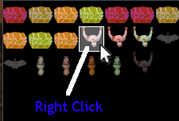

Finally, the event needs to know where to spawn the monster. While the event is selected, use spacebar to specify tiles where the monster should spawn.
Your map should look something like this when you're done.
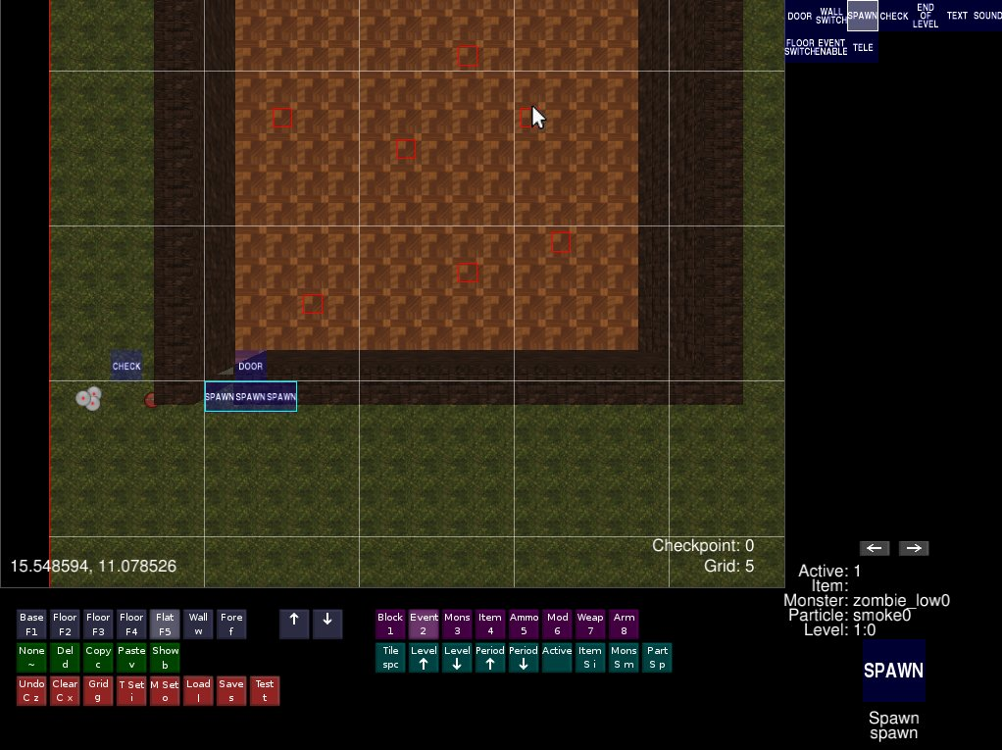
To test your level, hit t or click the Test icon.
To save your level, hit s or click the Save icon. Type in a name and hit enter.

