**INTRODUCTION TO JAVA**

**ACTIVITY 3 – FUNCTIONS**

1. **PlayThatTuneDeluxe => StairwayToHeaven (1/8, ¼, 1/2 , 1, 2)**
   1. Done. Modified function note(**int** pitch, **double** t) to add new harmonics
2. **Calendar**

OUTPUT

February 2016

S M Tu W Th F S

1 2 3 4 5 6

7 8 9 10 11 12 13

14 15 16 17 18 19 20

21 22 23 24 25 26 27

28 29

1. **Sierpinski (Calculate black triangle area)**

OUTPUT (Level 1)

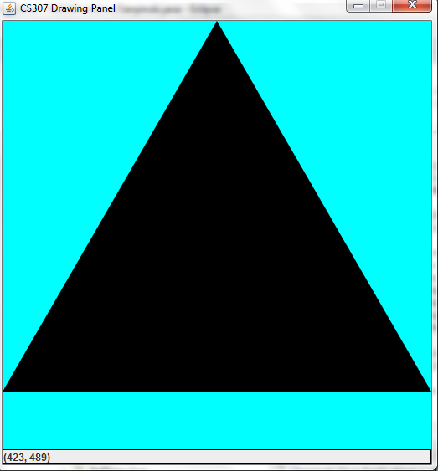

What level do you want? 1

No. of black inverted triangles: 1

No. of upright white triangles: 0

Total Black Area = 113408.0

OUTPUT (Level 3)

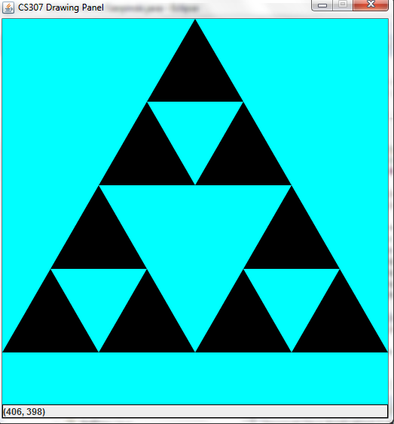

What level do you want? 3

No. of black inverted triangles: 9

No. of upright white triangles: 4

Total Black Area = 63936.0

OUTPUT (Level 5)

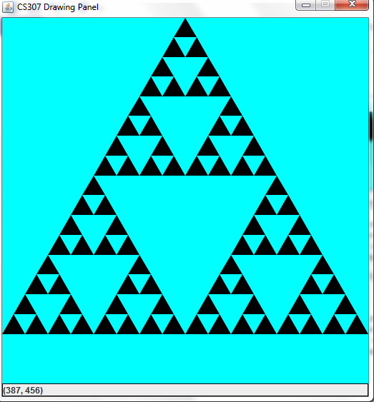

What level do you want? 5

No. of black inverted triangles: 81

No. of upright white triangles: 40

Total Black Area = 36288.0

1. **Diamond Tile (Modified to draw a Chess Board**

OUTPUT (N = 6)

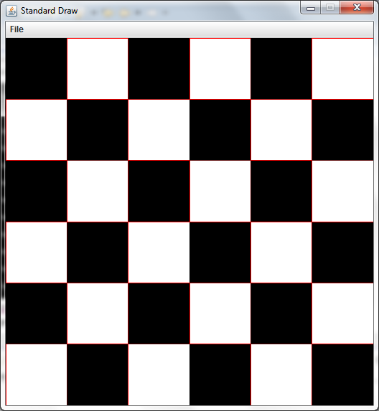

1. **HexTile + Pascal Triangle**

OUTPUT:

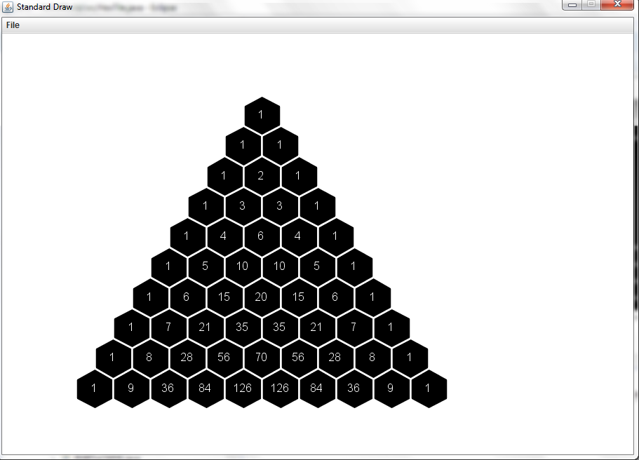

1. **IBM Digit Verification**

Done => See result on code

1. **SawTooth**

OTUPUT:

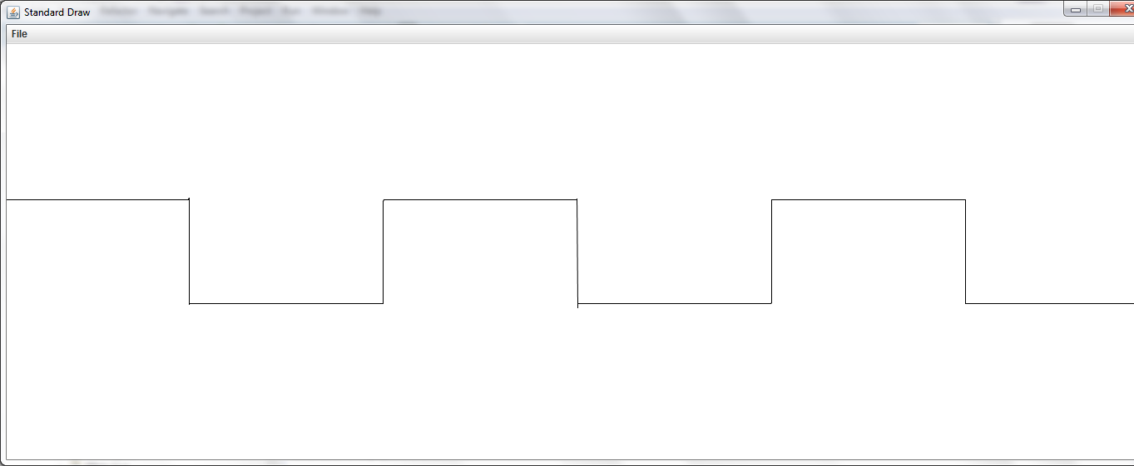

1. **IFS.java**

OUTPUT

