**INTRODUCTION TO JAVA**

**ACTIVITY 5: OBJECT ORIENTED PROGRAMMING (PART 1)**

**Section 3.1 Data Types**

**Exercises**

1. Write a program [FourChargeClient.java](http://introcs.cs.princeton.edu/java/31datatype/FourChargeClient.java.html) that takes a double command-line argument r, creates four Charge objects that are each distance r from the center of the screen (.5, .5), and prints the potential at location (.25, .5) due to the combined four charges. All four charges should have the same unit charge.

Output:

**total potential = 1.5239509122751547E11**

1. Write a program [Hex2Decimal.java](http://introcs.cs.princeton.edu/java/31datatype/Hex2Decimal.java.html) that converts from a hexadecimal string (using A-F for the digits 11-15) to decimal.

*Answer*: the following solution uses several string library methods and Horner's method.

|  |
| --- |
| public static int hex2decimal(String s) {  String digits = "0123456789ABCDEF";  s = s.toUpperCase();  int val = 0;  for (int i = 0; i < s.length(); i++) {  char c = s.charAt(i);  int d = digits.indexOf(c);  val = 16*val + d;  }  return val;  } |

Alternate solution: Integer.parseInt(String s, int radix). More robust, and works with negative integers.

Creates function:

public static int hex2decimal2(String s){

return Integer.*parseInt*(s, 16);

}

#### Creative Exercises

1. **VIN numbers.** A [VIN number](http://www.mathnotes.com/aw_IDnumber.html) is a 17-character string that uniquely identifies a motor vehicle. It also encodes the manufacturer and attributes of the vehicle. To guard against accidentally entering an incorrect VIN number, the VIN number incorporates a check digit (the 9th character). Each letter and number is assigned a value between 0 and 9. The check digit is chosen so to be the weighted sum of the values mod 11, using the symbol X if the remainder is 10.

|  |
| --- |
| A B C D E F G H I J K L M N O P Q R S T U V W X Y Z  1 2 3 4 5 6 7 8 - 1 2 3 4 5 - 7 - 9 2 3 4 5 6 7 8 9  1st 2nd 3rd 4th 5th 6th 7th 8th 9th 10 11 12 13 14 15 16 17  8 7 6 5 4 3 2 10 0 9 8 7 6 5 4 3 2 |

For example the check digit of the partial VIN number 1FA-CP45E-?-LF192944 is X because the weighted sum is 373 and 373 mod 11 is 10.

|  |
| --- |
| 1 F A C P 4 5 E X L F 1 9 2 9 4 4  1 6 1 3 7 4 5 5 - 3 6 1 9 2 9 4 4  8 7 6 5 4 3 2 10 - 9 8 7 6 5 4 3 2  ------------------------------------------------------------------  8 42 6 15 28 12 10 50 - 27 48 7 54 10 36 12 8 |

Write a program [VIN.java](http://introcs.cs.princeton.edu/java/31datatype/VIN.java.html) that takes a command line string and determines whether or not it is a valid VIN number. Allow the input to be entered with upper or lower case, and allow dashes to be inserted. Do thorough error checking, e.g., that the string is the right length, that no illegal characters are used (I, O, Q), etc.

**DONE**

**59. Flip horizontally.** Write a program [FlipX.java](http://introcs.cs.princeton.edu/java/31datatype/FlipX.java.html) that takes a command line argument which is the name of a JPG or PNG file, displays it in a window, flips the image horizontally, and displays the resulting image in the window. We illustrate using standard computer graphics test images - [baboon.jpg](http://introcs.cs.princeton.edu/java/31datatype/baboon.jpg) and[peppers.jpg](http://introcs.cs.princeton.edu/java/31datatype/peppers.jpg).

Output:

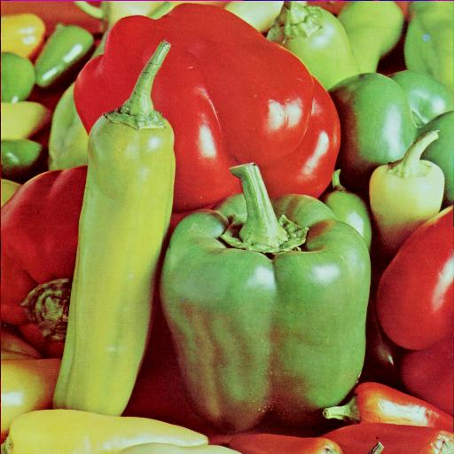 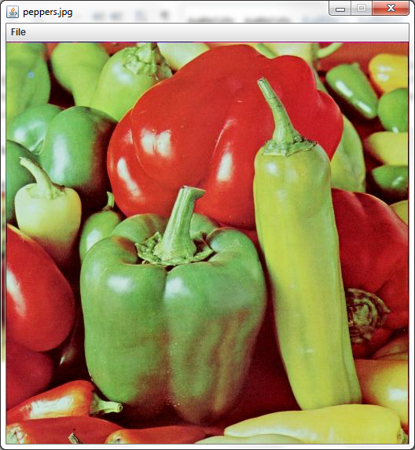

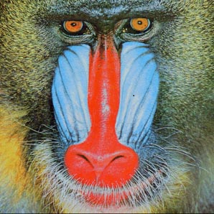 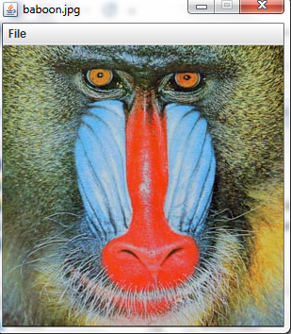

**60. Color separation.** Write a program [ColorSeparation.java](http://introcs.cs.princeton.edu/java/31datatype/ColorSeparation.java.html) that takes the name of an image file as a command line input, and creates three images, one that contains only the red components, one for green, and one for blue.

Output:

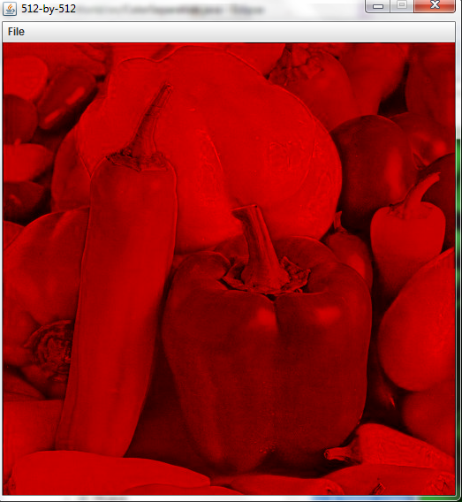 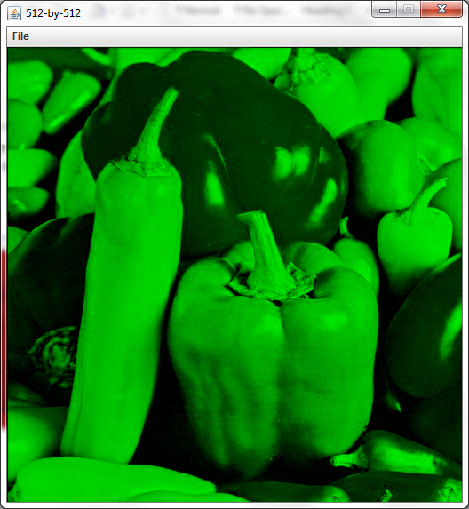 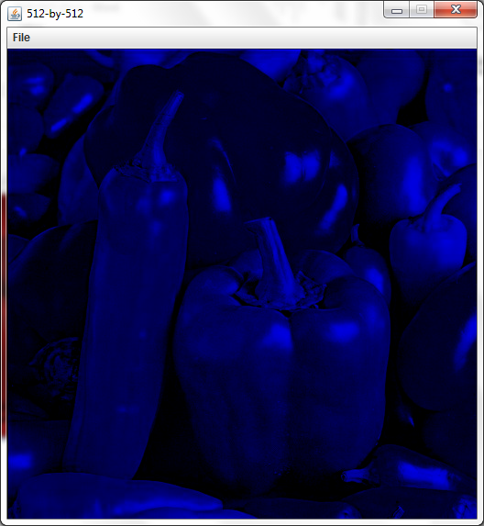

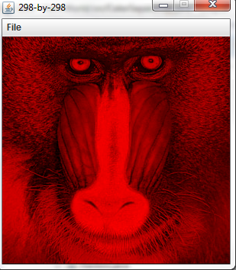 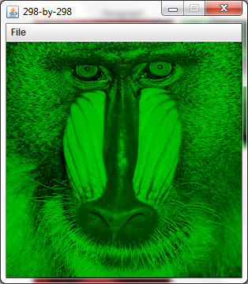 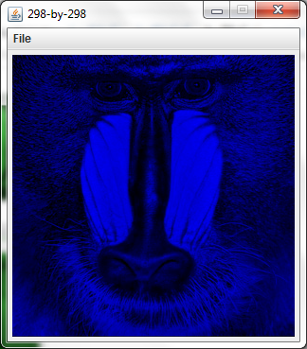

#### Web exercises

1. **wget.** Write a program [Wget.java](http://introcs.cs.princeton.edu/java/31datatype/Wget.java.html) that takes the name of a URL as a command-line argument and saves the referenced file using the same filename.

**DONE**

1. **Capitalize.** Write a program [Capitalize.java](http://introcs.cs.princeton.edu/java/31datatype/Capitalize.java.html) that reads in text from standard input and capitalizes each word (make first letter uppercase and make the remaining letters lowercase).

Output:

now is the time for all good

Now Is The Time For All Good

to be or not to be that is the question

To Be Or Not To Be That Is The Question

**Section 3.2 Creating Data Types**

#### Exercises

1. Why does program [Bug1.java](http://introcs.cs.princeton.edu/java/32class/Bug1.java.html) create a java.lang.NullPointerException when executed?

|  |
| --- |
| public class Bug1 {  private String s;  public void Bug1() { s = "hello"; }  public String toString() { return s.toUpperCase(); }  public static void main(String[] args) {  Bug1 x = new Bug1();  StdOut.println(x);  }  } |

Answer: the programmer probably intended to make the no argument constructor set the string to hello. However, it has a return type (void) so it is an ordinary instance method instead of a constructor. It just happens to have the same name as the class.

Note: The method Bug1 that returns “void” has the same name of the class, so it should be the constructor and shouldn’t had a return type.

**public** Bug1() {

System.***out***.println("here");

s = "hello";

}

Output:

Here

HELLO

1. Write a program [RootsOfUnity.java](http://introcs.cs.princeton.edu/java/32class/RootsOfUnity.java.html) that takes a command line argument N and uses Complex to compute and print out the N Nth roots of unity.

Done

22. Write a program [ColorMandelbrot.java](http://introcs.cs.princeton.edu/java/32class/ColorMandelbrot.java.html) that plots a color version of the Mandelbrot set. Read in a 256-by-3 array of color values from standar input into an array, and then use the ith color if the Mandelbrot function takes i iterations. Use the data file [mandel.txt](http://introcs.cs.princeton.edu/java/32class/mandel.txt) as an example.

Output:

-1.5 -1.0 2.0 2.0

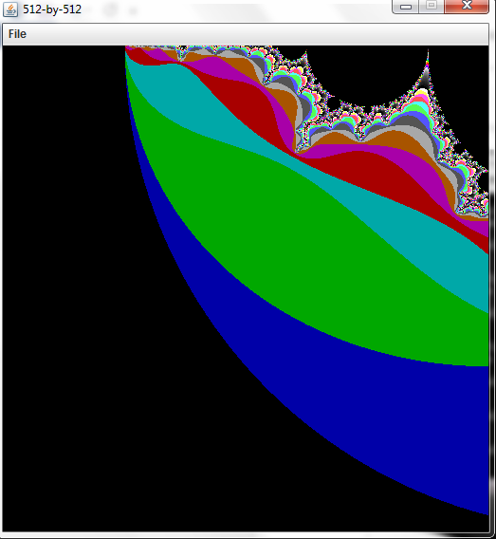

0.10259 -0.641 0.0086 0.0086

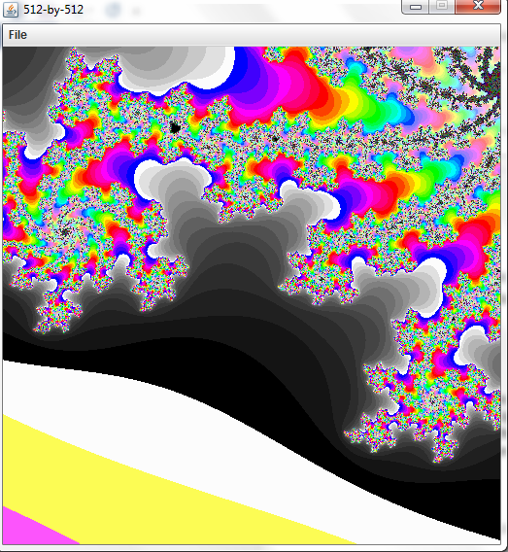

#### Creative Exercises

1. **Rational numbers.** Create a data type [Rational.java](http://introcs.cs.princeton.edu/java/32class/Rational.java.html) and [BigRational.java](http://introcs.cs.princeton.edu/java/32class/BigRational.java.html) for positive rational numbers.

Done

1. **Rational numbers.** Modify [Rational.java](http://introcs.cs.princeton.edu/java/32class/Rational.java.html) to provide support for negative rationals and zero.

Done

Output:

1/3

5/6

1

28/51

17/899

0

-1/6

-5/6

**35. Koch snowflake with rainbow of colors.**

The Koch snowflake of order n consists of three copies of the Koch curve of over n. We draw the three Koch curves one after the other, but rotate 120° clockwise in between. Below are the Koch snowflakes of order 0, 1, 2, and 3. Write a program [KochRainbow.java](http://introcs.cs.princeton.edu/java/32class/KochRainbow.java.html) that plotsthe Koch snowflake in a continuous spectrum of colors from red, to orange, yellow, green, blue, and indigo, and violet.

Output:

